FINAL PROJECT
END-TO-END REAL-TIME
DATA ANALYTICS PLATFORM
SMART CAMPUS: CLASSROOM MONITORING AND ANALYTICS
Course: Real-Time Data Analysis
Prepared by:
Ayazhan Temirbolatova
Aliya Kuanysh
Astana IT University
2026

Executive Summary
This project presents a small production-oriented analytics platform for monitoring indoor conditions in university classrooms. It integrates continuous event generation, micro-batch ingestion, validation, rolling analytics, rule-based anomaly detection, machine-learning inference, parallel processing, visualization, and persistent storage in one reproducible Python system.
The experiment processed 5,400 timestamped events from six simulated sensors across three classrooms. The input represents 900 polling cycles at a nominal 10-second interval. Three room partitions were handled by three worker processes. The observed throughput was 110.88 events/second, with mean batch latency of 53.95 ms and P95 latency of 71.45 ms.
The Random Forest model predicts whether the next reading is at risk of violating the comfort rule. On the held-out test split, accuracy was 98.96%, F1 was 99.44%, and ROC-AUC was 0.9955. Rule-based detection identified all 10 labelled fault events in the generated test stream. These results describe synthetic data and do not establish real-world sensor accuracy.

Report Contents
- 1. Introduction and Problem Statement
- 2. Technology and Method Selection
- 3. System Requirements and Architecture
- 4. Data Source and Acquisition
- 5. Stream-Processing Pipeline
- 6. Real-Time Analytics and Visualization
- 7. Time-Series Analysis and Anomaly Detection
- 8. Machine-Learning Component
- 9. Distributed Stream-Processing Design
- 10. Experimental Setup and Results
- 11. Performance and Scalability Analysis
- 12. Limitations and Future Improvements
- 13. Conclusion
- 14. References

1. Introduction and Problem Statement
Universities operate many classrooms with changing occupancy, indoor air quality, temperature, humidity, and electricity demand. These variables influence comfort, concentration, equipment operation, and facility costs. If measurements are collected only at the end of a class or reviewed manually, a ventilation or equipment issue may remain unnoticed while it is occurring.
The project addresses this problem by designing a Smart Campus monitoring pipeline. The system receives timestamped sensor events and transforms them into operational indicators. It identifies unusual readings, estimates the likelihood that the next reading will violate a comfort condition, and makes current and historical information available through a dashboard.
The system is intentionally scoped as a reproducible classroom-scale prototype. It simulates three rooms and two sensors per room, giving six sensor streams. Each event includes a timestamp, poll identifier, room and sensor identifiers, temperature, humidity, CO₂ concentration, occupancy, and power consumption. The generator also inserts known fault scenarios to make anomaly detection measurable.

Project Objectives
- Build a continuous timestamped event source and document its schema.
- Clean and transform incoming records incrementally in micro-batches.
- Calculate rolling indicators and minute-level aggregates.
- Detect high CO₂, critical CO₂, out-of-range temperature, and power spikes.
- Train and evaluate a model for next-reading classroom risk.
- Demonstrate room partitioning and multiple processing workers.
- Persist raw and processed data and provide a reproducible dashboard.
The central engineering objective is integration: all components operate as one end-to-end pipeline rather than independent course exercises.

2. Technology and Method Selection
Technology | Role in the project | Reason for selection
Python 3 | Main implementation language | Required by the assignment; supports data engineering and ML.
Pandas / NumPy | Cleaning, rolling windows, aggregation | Concise tabular processing and numerical operations.
scikit-learn | Random Forest classifier and metrics | Reproducible model training and evaluation.
ProcessPoolExecutor | Parallel room workers | Demonstrates partitioning and concurrent processing on one machine.
SQLite | Persistent event and summary storage | Embedded relational database with no separate server.
Streamlit + Plotly | Interactive dashboard | Fast local dashboard with interactive charts.
Matplotlib | Report figures | Static figures for technical documentation.
Kafka, Spark, and Flink are listed as recommended technologies in the assignment, not mandatory requirements. This implementation uses Python multiprocessing to demonstrate a producer–consumer style architecture and room-based partitions without requiring a separate distributed cluster. The design keeps the worker boundary explicit, so a message broker or distributed engine could replace the local executor in a later version.

Method Selection
A micro-batch approach is used: each polling cycle produces six events, which are grouped by room and sent to workers. Rolling statistics use the previous 30 readings per sensor. Since each sensor reports every 10 seconds, this window represents approximately five minutes. Rule-based anomaly detection is transparent and suitable for known operational thresholds. Random Forest is selected for the next-reading risk classification because it can model nonlinear interactions between occupancy, temperature, humidity, CO₂, and power.

3. System Requirements and Architecture
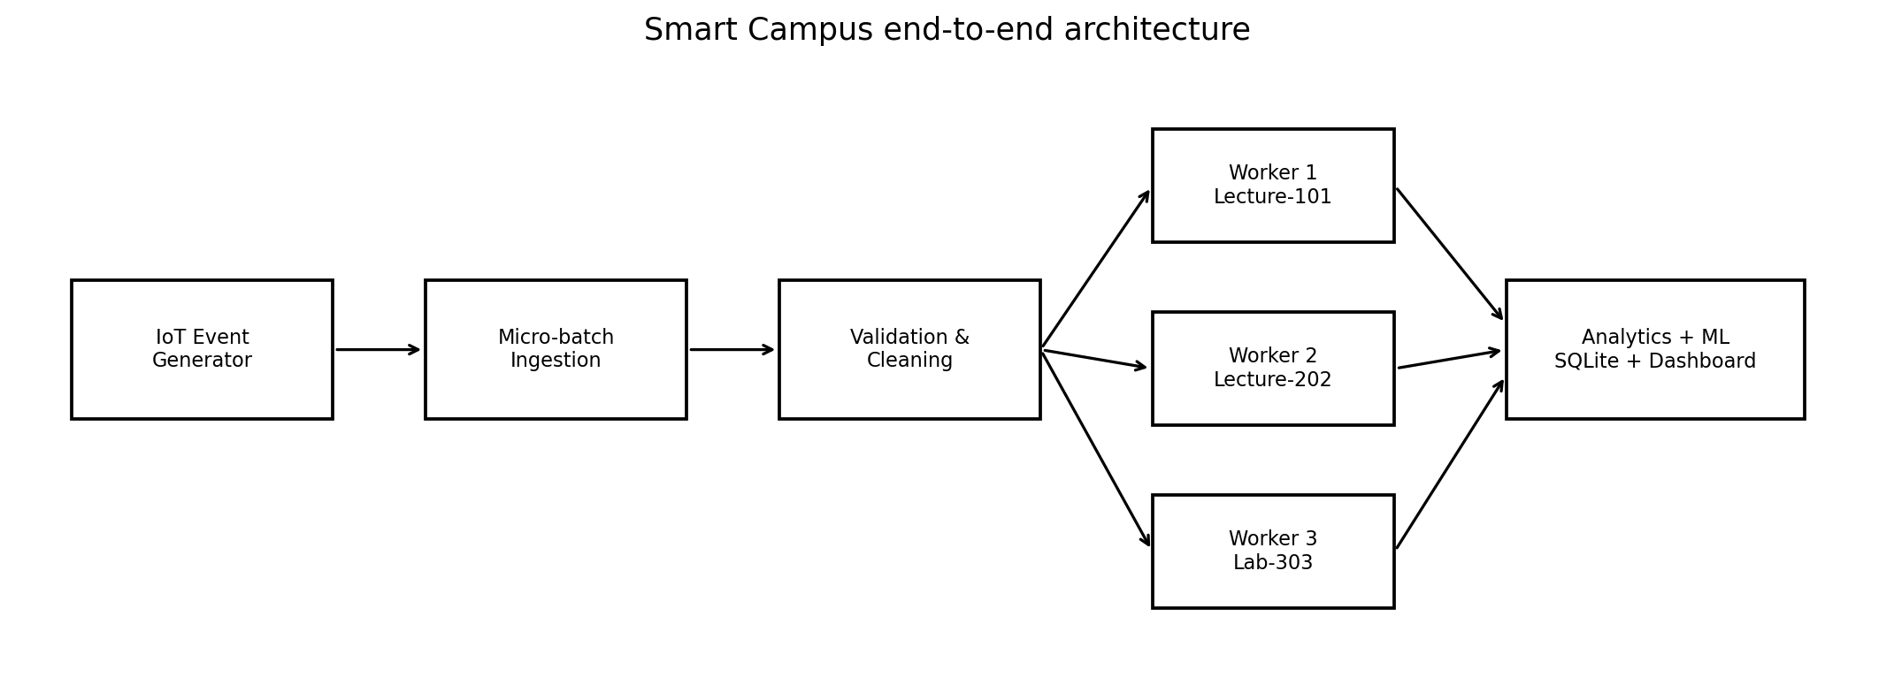
Figure 1. End-to-end Smart Campus architecture.

Functional Requirements
- Receive timestamped records from the event generator.
- Reject invalid timestamps and physically implausible values; remove duplicates.
- Calculate rolling mean, standard deviation, z-score, and CO₂ rate of change.
- Generate anomaly flags and minute-level room summaries.
- Predict next-reading risk using a trained Random Forest model.
- Store events, alerts, and aggregates in SQLite and CSV outputs.
- Display time-series and current-state information in a dashboard.

Non-Functional Requirements
- Reproducibility through a fixed random seed and documented run commands.
- Measurable throughput and latency.
- Separation of generator, processing, worker, storage, ML, and dashboard modules.
- Graceful operation on a standard laptop without a cluster.
The architecture has a clear data path. The generator produces a stream, the pipeline ingests one poll at a time, and the cleaning stage validates the records. Events are partitioned by room_id. Each worker uses the previous 30 observations as rolling context, enriches the new batch, and returns only the new events. The main process merges results, persists them, and builds the final evaluation outputs.

4. Data Source and Acquisition
The data source is a deterministic synthetic IoT generator implemented in src/generator.py. Synthetic generation was selected because no live university sensor endpoint or authorised campus telemetry feed was provided. The generator models three classrooms—Lecture-101, Lecture-202, and Lab-303—with two sensors per room.
Field | Type | Description
timestamp | ISO timestamp | UTC event time
poll_id | Integer | Polling-cycle identifier
room_id | String | Classroom identifier
sensor_id | String | Unique sensor identifier
temperature_c | Float | Temperature in Celsius
humidity_pct | Float | Relative humidity percentage
co2_ppm | Float | CO₂ concentration in ppm
occupancy | Integer | Estimated number of occupants
power_kw | Float | Room power consumption in kW
injected_anomaly | Binary | Known synthetic fault label for evaluation
The completed experiment generated 5,400 events in 900 polls. At 10 seconds per poll, the stream represents 2.5 hours of simulated operation. A fixed seed (42) makes the generated stream reproducible.
The generator includes controlled fault events: a room-level CO₂ excursion, an out-of-range temperature reading, and an electrical power spike. These events are labelled so that the anomaly detector can be evaluated against known injected faults. The labels are not used as model features.

Data Quality
The schema includes event time and stable identifiers, which allow duplicate detection and chronological grouping. The processing layer converts timestamps to UTC, coerces numeric values, replaces physically implausible measurements with missing values, and marks rows with unresolved missing values as incomplete. Duplicate sensor-timestamp pairs are removed.

5. Stream-Processing Pipeline
The stream processor handles one poll at a time. Each poll is a micro-batch containing the current observations from all six sensors. The pipeline does not require loading an external stream into memory: the same processing interface can be connected to a replay source or, in a future version, to MQTT or Kafka.

Processing Stages
Stage | Operation | Output
Ingestion | Read one poll from generator | Six timestamped events
Validation | Parse timestamps; check numeric ranges | Validated rows
Cleaning | Remove duplicates; fill gaps up to two readings | Clean rows + quality flag
Transformation | Compute rolling features and rates | Enriched events
Detection | Apply threshold-based rules | Anomaly flag and reason
Aggregation | Group by minute and room | Minute-level summary
Persistence | Write events and summaries | SQLite and CSV files
For each numeric field, physical bounds are applied before analysis. Temperature outside −10 to 50 °C, humidity outside 0–100%, CO₂ outside 300–5000 ppm, occupancy outside 0–1000, and power outside 0–100 kW are treated as invalid sensor values. Missing values are forward-filled for no more than two consecutive observations per sensor. Longer gaps remain incomplete.
Rolling features are calculated using the previous 30 readings per sensor. The worker receives the last 30 raw records as context so that the rolling window continues across micro-batch boundaries. This is important: without persistent context, a batch containing only the newest readings would not contain enough history to calculate a meaningful rolling statistic.

6. Real-Time Analytics and Visualization
The platform calculates rolling mean and standard deviation for temperature, humidity, CO₂, and power. A z-score measures how far the current observation is from the preceding window mean in units of standard deviation. A standard-deviation floor prevents very small historical variation from producing unstable z-scores. The CO₂ rate of change is calculated from a short lagged difference and expressed per minute.
Minute-level aggregates are grouped by room. They include event count, average CO₂, average temperature, average occupancy, total power consumption, and anomaly count. These indicators support operational questions such as which room has the highest average CO₂, whether occupancy is associated with energy demand, and whether alerts are concentrated in a particular room.
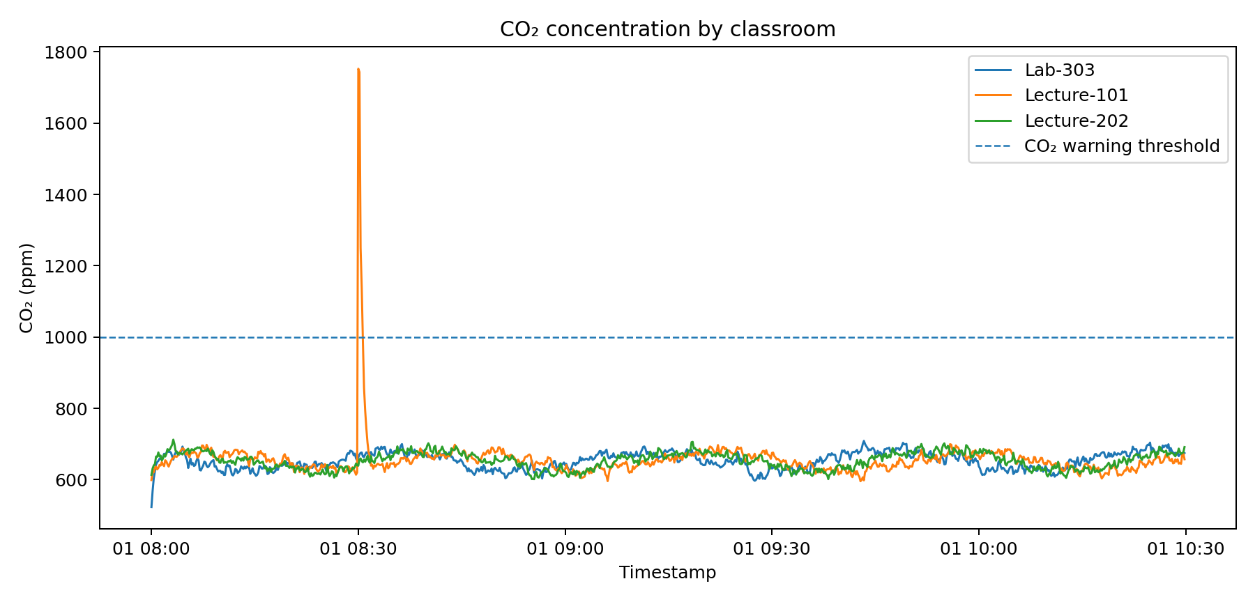
Figure 2. Generated CO₂ time series by classroom. The dashed line represents the 1,000 ppm warning threshold.
The Streamlit dashboard presents event counts, average CO₂, alert counts, and average occupancy as summary metrics. It also displays a CO₂ time-series chart, an occupancy-versus-power scatter plot, a latest-readings table, and an anomaly log. The dashboard reads the persisted SQLite database; after a pipeline run, the page can be refreshed to display the latest stored records.

7. Time-Series Analysis and Anomaly Detection
Time-series analysis is necessary because classroom conditions change with occupancy and time. A single reading does not show whether CO₂ is rising, whether temperature is stable, or whether an observation is unusual relative to recent behaviour. The five-minute rolling window was selected to smooth short-lived noise while remaining responsive to classroom changes. Minute-level aggregation provides a compact operational view.

Anomaly Rules
Rule | Condition | Operational meaning
CO2_HIGH | CO₂ ≥ 1,000 ppm and < 1,500 ppm | Ventilation warning
CO2_CRITICAL | CO₂ ≥ 1,500 ppm | Critical air-quality event
TEMP_OUT_OF_RANGE | Temperature outside 18–28 °C | Possible thermal-control issue
POWER_SPIKE | Power > 3.0 kW | Unexpected electrical load
The generated test stream contained 10 labelled fault events. The rule-based detector flagged 10 events. Against the known synthetic labels, precision was 100.00%, recall was 100.00%, and F1 was 100.00%. The confusion matrix was TN=5390, FP=0, FN=0, TP=10.
The perfect score is expected for a controlled simulation in which injected faults were designed to match the selected rules. It must not be interpreted as proof of perfect detection in a real building. Real deployment would require independent fault labels, threshold calibration, and evaluation across different seasons and room types.

8. Machine-Learning Component
The machine-learning task is next-reading risk classification. The model estimates whether the next observation from a sensor will violate the comfort rule. The current feature vector contains temperature, humidity, CO₂, occupancy, and power. The target is derived from the next chronological comfort flag for the same sensor. A target value of 1 indicates at-risk and 0 indicates comfortable.
The comfort rule used to construct the label is CO₂ no greater than 1,000 ppm and temperature between 20 and 24 °C. The prediction is therefore a short-horizon operational risk estimate, not a medical or regulatory safety certification. The Random Forest pipeline uses median imputation and 160 trees with a maximum depth of 9. A fixed random state is used for reproducibility.
Metric | Test result
Accuracy | 98.96%
Precision (risk class) | 99.68%
Recall (risk class) | 99.21%
F1-score | 99.44%
ROC-AUC | 0.9955
Training / test rows | 4050 / 1350
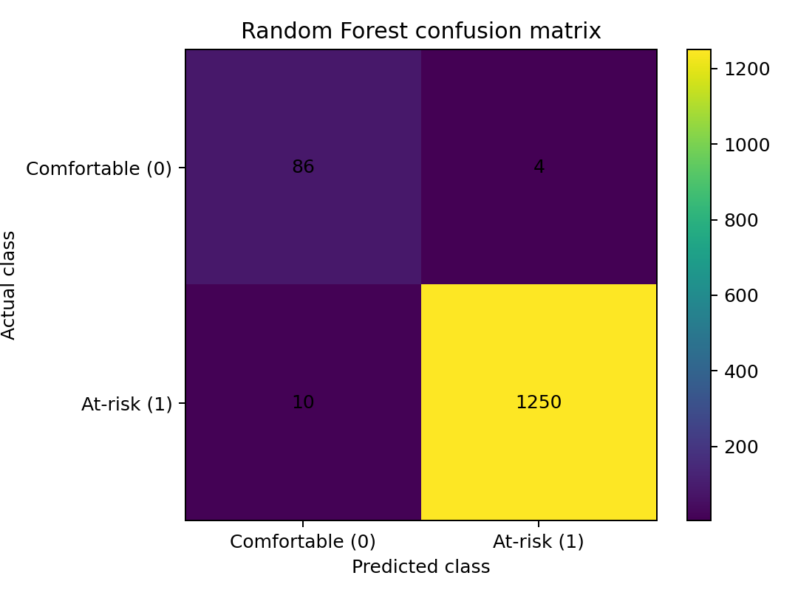
Figure 3. Confusion matrix for the held-out test split.
The model achieved strong results on this generated dataset. The test split contains 1,350 rows. Because the data are simulated and adjacent time points can be correlated, the random train/test split may provide an optimistic estimate compared with a strict time-based or room-held-out evaluation. A future study should use chronological and room-based holdouts.

9. Distributed Stream-Processing Design
The platform demonstrates distributed-processing concepts through room-based partitioning and multiple worker processes. Each micro-batch is grouped by room_id. The three room partitions are submitted to a ProcessPoolExecutor with three worker processes. A worker independently validates and cleans its room partition, combines the new events with the room's rolling history, calculates indicators, and returns the current batch.
The main process merges the worker outputs, measures batch latency, stores processed events, and updates the room history. The partition key is appropriate because each room has independent sensor streams and rolling state. Keeping all observations from a room in the same logical partition also avoids mixing unrelated classroom histories.

Why Multiprocessing?
Python multiprocessing can execute CPU-bound work in separate processes and makes the worker boundary explicit. The executor is created once for the run rather than recreated for every poll. This reduces process-startup overhead and makes the design closer to a persistent worker pool. It is still a single-machine demonstration: it does not provide multi-node fault tolerance, broker offsets, or cluster-level resource scheduling.

Scaling Path
- Replace the generator with MQTT or Kafka ingestion.
- Use a stable partition key such as room_id in the broker.
- Move workers to a stream-processing framework such as Spark Structured Streaming or Flink.
- Store durable event history in PostgreSQL or object storage.
- Add checkpointing and recovery for rolling state.

10. Experimental Setup and Results
The experiment used the fixed-seed generator with 900 polls, six sensor streams, three classrooms, and a 10-second nominal polling interval. This produced 5,400 events. The complete stream was processed in room-partitioned mode with three worker processes. The pipeline wrote raw data, processed events, alerts, minute summaries, and a SQLite database.
Experiment item | Value
Generated events | 5,400
Polling cycles | 900
Rooms / sensors | 3 / 6
Workers | 3
Processing mode | room-partitioned multiprocessing
Simulated time span | 2.5 hours
Unit tests | 3 passed
The anomaly detector identified all labelled fault events in the synthetic stream. The Random Forest achieved accuracy of 98.96%, precision of 99.68%, recall of 99.21%, F1 of 99.44%, and ROC-AUC of 0.9955 on the held-out test set. The classification target is the next-reading risk flag; class 1 denotes at-risk.
The results show that all required modules can be integrated into a repeatable workflow. They also show why evaluation must be interpreted in the context of the data generator: the rules and the labels were designed together, and the ML model learns patterns from a controlled synthetic environment.

11. Performance and Scalability Analysis
The measured pipeline runtime was 48.702 seconds for 5,400 events. Throughput was 110.88 events per second. Mean micro-batch latency was 53.95 ms, P95 latency was 71.45 ms, and maximum observed batch latency was 162.14 ms.
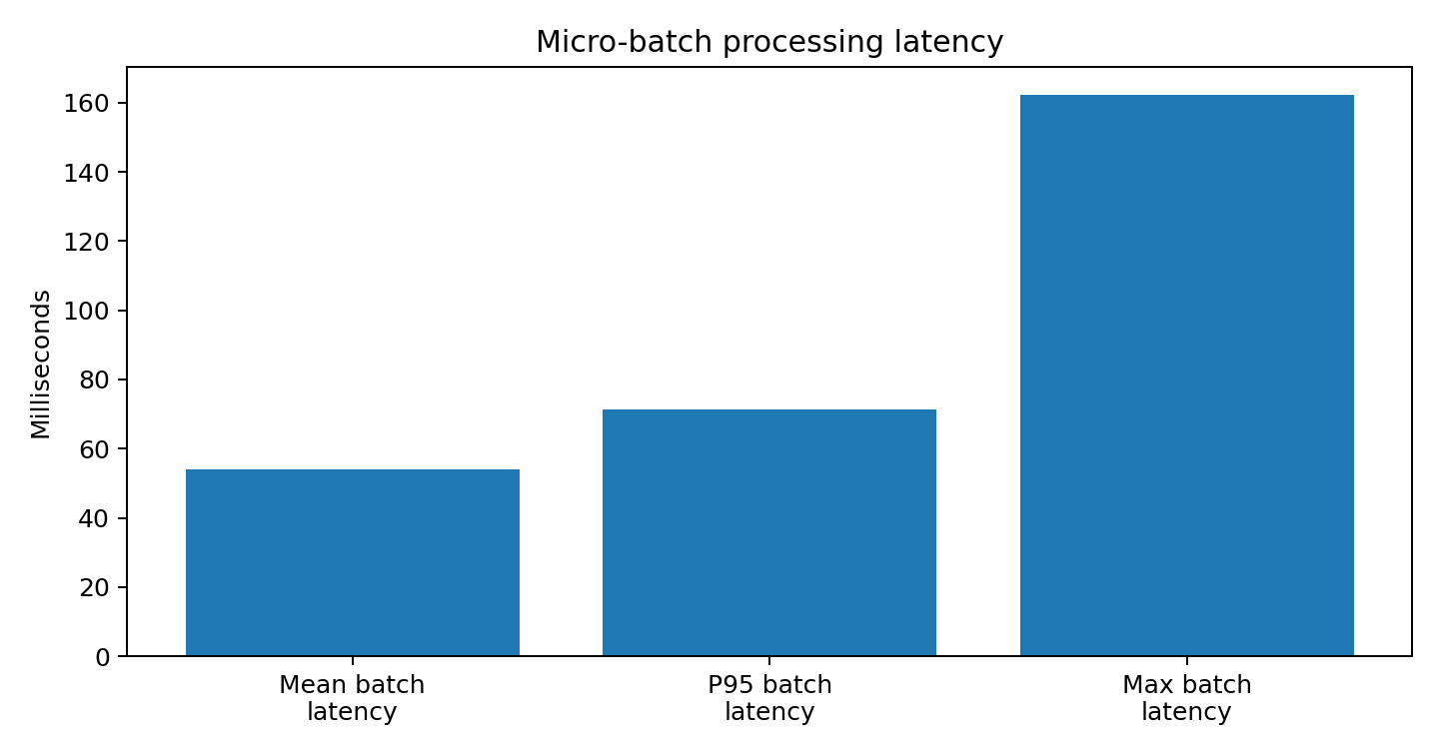
Figure 4. Mean, P95, and maximum processing latency per six-event micro-batch.
The input generator produces one poll every 10 seconds in the simulated operating model. The measured mean batch-processing latency is substantially below this interval, so the local prototype has processing headroom for the current six-sensor workload. This comparison is a local benchmark, not a capacity guarantee for a production deployment.

Potential Bottlenecks
- SQLite writes are performed locally and may become a bottleneck at higher event rates.
- Each micro-batch is small; process communication overhead can dominate at very low event volumes.
- The rolling state is held in memory and must be checkpointed for recovery.
- The dashboard reads stored records and is not a push-based streaming UI.
Scalability should be tested with more rooms, sensors, higher event frequency, and longer retention. A production benchmark should also measure end-to-end delay from event creation to dashboard visibility, not only processing time.

12. Limitations and Future Improvements
- Synthetic data: measurements and fault patterns are generated, not collected from actual campus devices.
- Controlled anomaly labels: the injected fault scenarios are known in advance, which makes rule-based evaluation easier than real-world monitoring.
- Threshold assumptions: CO₂, temperature, humidity, and power thresholds are illustrative and require review against campus policy and sensor specifications.
- Model validation: a random split may overestimate generalisation because nearby observations are temporally related. Use time-based and room-held-out evaluation in future work.
- Local parallelism: ProcessPoolExecutor demonstrates parallel workers on one machine, not a distributed multi-node cluster.
- State recovery: rolling history is stored in process memory; a restart resets the rolling context.
- Dashboard refresh: the current dashboard reads SQLite and requires manual refresh after new data are written.

Future Work
- Connect real IoT devices through MQTT or Kafka and validate timestamps at ingestion.
- Add persistent state/checkpointing and explicit sensor-offline detection.
- Evaluate Isolation Forest or a robust statistical detector alongside threshold rules.
- Use chronological cross-validation and hold out an entire classroom for generalisation testing.
- Add alert lifecycle management, notification delivery, authentication, and role-based access.
- Deploy the dashboard and processing service in Docker with monitoring and logs.

13. Conclusion
The Smart Campus project implements an integrated real-time analytics workflow for classroom monitoring. It combines timestamped event generation, micro-batch processing, data quality checks, rolling indicators, anomaly detection, next-reading risk classification, room-partitioned multiprocessing, visualization, performance measurement, and SQLite persistence.
The final experiment processed 5,400 events from six simulated sensors across three classrooms. The measured throughput was 110.88 events per second, with a mean batch latency of 53.95 ms. The Random Forest reached 98.96% accuracy and 0.9955 ROC-AUC on the synthetic held-out test set. The rule-based detector identified all ten labelled synthetic fault events.
The project meets the integration objective by connecting the required components into one executable system with reproducible instructions. Its main limitation is the use of simulated measurements. The next step toward practical deployment is to connect authorised real sensors, calibrate thresholds, and evaluate the model on temporally and geographically independent data.

14. References
- Python Software Foundation. Python 3 Documentation: concurrent.futures — Launching parallel tasks. https://docs.python.org/3/library/concurrent.futures.html
- pandas development team. pandas Documentation. https://pandas.pydata.org/docs/
- NumPy Developers. NumPy Documentation. https://numpy.org/doc/
- Pedregosa, F. et al. (2011). Scikit-learn: Machine Learning in Python. Journal of Machine Learning Research, 12, 2825–2830.
- scikit-learn developers. RandomForestClassifier Documentation. https://scikit-learn.org/stable/modules/generated/sklearn.ensemble.RandomForestClassifier.html
- SQLite Consortium. SQLite Documentation. https://www.sqlite.org/docs.html
- Streamlit, Inc. Streamlit Documentation. https://docs.streamlit.io/
- Plotly Technologies Inc. Plotly Python Graphing Library. https://plotly.com/python/
- Breiman, L. (2001). Random Forests. Machine Learning, 45, 5–32.

