MIDTERM PROJECT
Real-Time Data Collection and Stream Processing System
IoT Temperature and Humidity Monitoring
Temirbolatova Ayazhan, Kuanysh Aliya

Technologies: Python, Pandas, NumPy, Matplotlib
Coverage: Weeks 1- 4
Dataset: reproducible simulated sensor stream

1. Introduction
The purpose of this project is to demonstrate a practical real-time data pipeline that continuously acquires incoming records, processes them incrementally, computes real-time statistics, detects basic events or anomalies, displays updated results, and stores processed data for later analysis. The assignment requires a realistic streaming scenario, timestamped data, incremental acquisition, Pandas and NumPy processing, at least three indicators, rule-based detection, continuous output, reproducibility, and a technical report.
An IoT environmental monitoring scenario was selected. A sensor reports temperature and relative humidity once per simulated second. The stream is generated locally, which makes the project reproducible and avoids dependence on an external API during demonstration. The generator also contains deterministic abnormal periods so that the anomaly detector can be tested directly.

2. Real-Time Data Scenario and Data Schema
The system represents a sensor installed in a smart building or laboratory. Its task is to monitor environmental conditions and flag values that may indicate equipment problems, overheating, or excessive humidity.
Field | Type | Frequency | Meaning
timestamp | ISO datetime | 1/sec | Time of the reading
sensor_id | string | 1/sec | Unique sensor identifier
temperature_c | float | 1/sec | Temperature in °C
humidity_pct | float | 1/sec | Relative humidity (%)
The input stream contains 120 records. The generator uses seed 42, so the same records can be regenerated. Normal values are produced from smooth sinusoidal patterns plus small random noise. Temperature is intentionally increased for a short interval and humidity is increased during another interval to provide known test cases for the detector.

3. Data Acquisition and Incremental Processing
The generator exposes a Python iterator named generate_stream(). It yields one dictionary at a time rather than returning the complete dataset to the processor. This models incremental acquisition: the processor receives a record, processes it, updates its state, and then waits for the next record. The main program can add a delay between records to make the streaming behavior visible in a live demonstration.
The processor converts the single record into a one-row Pandas DataFrame, coerces numeric fields to numeric types, parses the timestamp, and drops incomplete records. A fixed-size deque stores only the latest ten valid observations. This bounded window prevents the analysis state from growing without limit while retaining the recent information needed for rolling statistics.

4. Pandas and NumPy Real-Time Analysis
Pandas is used for structured record handling, timestamp conversion, numeric cleaning, tabular storage, CSV output, and final inspection. NumPy is used for numeric aggregation inside the active window.
10-record moving average of temperature - smooths short-term noise.
10-record rolling standard deviation - measures short-term variability.
Window minimum and maximum temperature -identifies recent extremes.
Cumulative event count -tracks how many anomalies have been detected.
Local temperature z-score - compares the newest value with preceding observations.
The project therefore exceeds the minimum requirement of three real-time indicators. All indicators are recalculated as each new record arrives, so the values shown in the console correspond to the current state of the stream.

5. Rule-Based Event and Anomaly Detection
The detector uses transparent rules rather than an opaque machine-learning model. A temperature reading is flagged when it is below 15°C or above 30°C. Humidity is flagged when it is above 85%. After sufficient observations are available, a local temperature z-score with absolute value at least 3 is also treated as an anomaly.
Each detected condition is stored in event_type, while the anomaly column stores a Boolean result. The cumulative event_count increases whenever a record triggers one or more rules. This makes the detector easy to audit and suitable for a first stream-processing implementation.

6. Results and Demonstration
The generated dataset contains 120 records. The processing run detected 15 anomalous records. The maximum observed temperature was 35.88°C and the maximum humidity was 88.85%.
Sample of processed results:

timestamp | temperature_c | humidity_pct | temperature_moving_avg | rolling_temperature_std | event_count | anomaly | event_type
2026-10-01T12:01:5 | 22.324 | 49.912 | 21.439 | 0.6664909601787565 | 15 | False
2026-10-01T12:01:5 | 21.305 | 49.229 | 21.4752 | 0.6481464032145831 | 15 | False
2026-10-01T12:01:5 | 22.58 | 52.549 | 21.694 | 0.6139596077919136 | 15 | False
2026-10-01T12:01:5 | 22.387 | 49.909 | 21.8168 | 0.6174698049297636 | 15 | False
2026-10-01T12:01:5 | 21.855 | 48.275 | 21.906699999999997 | 0.5470239574278261 | 15 | False
2026-10-01T12:01:5 | 22.404 | 50.399 | 21.896099999999997 | 0.5361496899187762 | 15 | False
2026-10-01T12:01:5 | 22.687 | 49.039 | 22.067400000000003 | 0.4854258336759592 | 15 | False
2026-10-01T12:01:5 | 22.177 | 48.711 | 22.1092 | 0.4749538503896984 | 15 | False
During the live-style demonstration, each processed record is printed with its timestamp, current temperature, humidity, moving average, and cumulative event count. The anomaly status changes immediately when a rule is triggered. The full processed stream is then written to processed_results.csv.

7. Visualization
The visualization plots the raw temperature stream and its 10-record moving average. Detected anomalies are marked separately. This gives a simple visual explanation of both the underlying signal and the points selected by the rule-based detector.
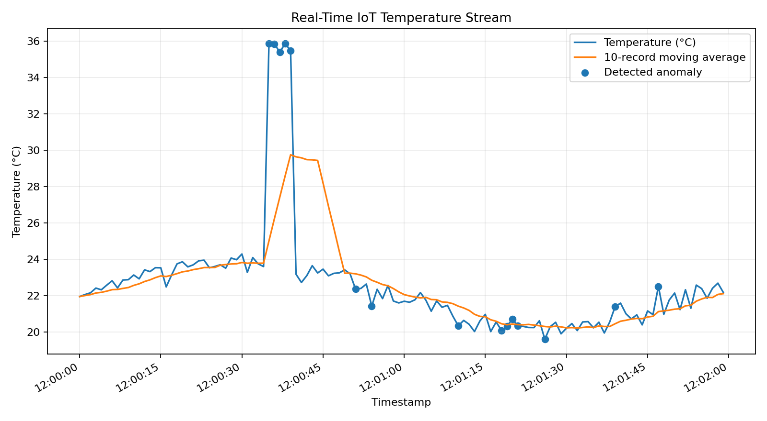
Real-time temperature stream, moving average, and detected anomalies.

8. Storage and Reproducibility
Two CSV artifacts are retained. input_stream.csv stores the reproducible incoming records, while processed_results.csv stores the derived indicators and anomaly decisions. The fixed random seed and deterministic anomaly injection allow the same input and output behavior to be reproduced. The README provides installation and execution instructions and explains the project structure.

9. Limitations and Possible Improvements
The source is simulated rather than connected to a physical sensor or external API. This is intentional because the assignment permits a generated stream when a live source is unavailable. A production implementation could replace the generator with MQTT, Kafka, an HTTP API, or a database consumer without changing the core processor interface.
Further improvements could include multiple sensors, configurable thresholds, persistent streaming storage, automatic alert delivery, richer dashboards, and statistical or machine-learning anomaly detection. The current implementation focuses on the core Weeks 1- 4 learning outcomes: Python streaming, acquisition, incremental processing, Pandas/NumPy analysis, and basic event detection.

10. Conclusion
The completed system satisfies the required real-time processing workflow. It defines a realistic IoT scenario and schema, creates timestamped data, acquires records incrementally, applies Pandas and NumPy transformations, calculates more than three real-time indicators, detects anomalies using explicit rules, displays continuously updated results, stores processed data, and produces a table and visualization. The modular source code, README, reproducible generator, dataset, processed results, and technical report together provide a complete demonstration package.

Appendix A. Requirement Coverage Matrix
Requirement | Evidence
Realistic scenario + source/schema/frequency/meaning | IoT temperature/humidity; schema table; 1 record/sec
Timestamped data + generator | generator.py + data/input_stream.csv
Incremental acquisition | generate_stream() yields one record at a time
Pandas + NumPy processing | processor.py
At least 3 real-time indicators | moving average, std, min/max, event count, z-score
Rule-based anomaly detector | temperature/humidity thresholds + z-score
Continuously updated output | console output for every incoming record
Store processed results | processed_results.csv
Logical Python modules | generator, processor, visualization, main
README | README.md
Technical report 5-7 pages | this report
Demonstration | run command with optional delay
Table + visualization | report table + realtime_visualization.png

