**Factura**

|  |  |
| --- | --- |
| Emisor: | Receptor |
| GRUPO CCCH DE MEXICO, S.A. DE C.V. | DISTRIBUIDORA DE MOTORES Y REFACC. DIESEL DE PUEBLA, S.A. |
| Chopo 3-E No. Ext: No. Int: Colonia: Villas del Descanso Jiutepec Jiutepec Morelos Mexico | BLVD. CARMEN SERDAN No. Ext: 50 No. Int: Colonia: SANTA MARIA LA RIVER PUEBLA MEXICO |
| Lugar de Expedición: Jiutepec, Morelos |  |
| Régimen Fiscal: Régimen General de Ley Persona Moral |  |

|  |  |  |
| --- | --- | --- |
| Folio Fiscal: | Fecha / Hora de Emisión | No. De Certificado Digital |
| 04A75E9F-FE1F-4393-AFA8-C2D65DE36031 | 2016-01-25 16:27:18 | 00001000000301011323 |

|  |  |  |  |  |
| --- | --- | --- | --- | --- |
| Cantidad | Unidad | Concepto(s) | Precio Unitario | Importe |
| 4 | Pieza | ${conceptos#1} | ${precio_unitario#1} | 736.94 |
| 3 | Pieza | ${conceptos#2} | ${precio_unitario#2} | 589.40 |
| 3 | Pieza | ${conceptos#3} | ${precio_unitario#3} | 352.08 |
| 2 | Pieza | ${conceptos#4} | ${precio_unitario#4} | 85.12 |
| 2 | Pieza | ${conceptos#5} | ${precio_unitario#5} | 578.40 |
| 2 | Pieza | ${conceptos#6} | ${precio_unitario#6} | 663.47 |
| 1 | Pieza | ${conceptos#7} | ${precio_unitario#7} | 554.36 |
| 2 | Pieza | ${conceptos#8} | ${precio_unitario#8} | 950.65 |
| 2 | Pieza | ${conceptos#9} | ${precio_unitario#9} | 4164.20 |

|  |  |
| --- | --- |
| Subtotal | $8674.62 |
| IVA 16% |  |
| Total | $5534.41 |

|  |  |  |  |  |
| --- | --- | --- | --- | --- |
| Forma de Pago: | Método de Pago: | Banco: | Cuenta: | Condiciones de Pago: |
| Pago en una sola exhibición | TRASNFERENCIA ,CHEQUE | SANTANDER | Cuenta |  |

**Cadena Original del complemento de Certificación Digital del SAT**



**Sello Digital del CDFI**

E9aYMCaMNwO7fmahTKK6jiXFgtrj2yoy4nGOP01J33jDHrawlEP8iuopBsBqGnr7e0MGw8IIHLfyHPkv+gNya1iT0Xf6kwnIPbmCvi4OHzeVJwARSpbNoTJ2/TWb3lo4+89Y6RnP8USRDPZ27441xQQzkI+ram2kRu4g+L6I3II=

**Sello Digital del SAT**

PC1DbBgFcIvRBIF3NL+OIcONWyYmkaU4yvRM4xCTCYl7yrQuyZRrRB3RmRIc6WDGFFE3IkEeWMX4M3LJz5GJHUgYy4MzA+6jOlpRzQKPnFVoiu8tBsbErrquyLFh7pmArq9h4FWhbvqmfpmnJAHumFXsVmBsTBYmbCzOWJV6W+w=

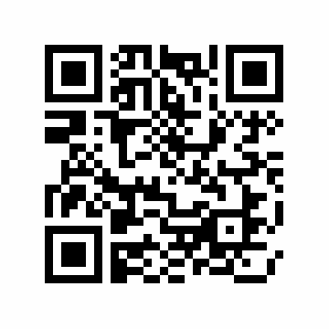

|  |  |
| --- | --- |
| Fecha / Hora de Certificación | Número de Serie Certificado del SAT |
| 2016-01-25 16:27:18 | 100754 |