計算機網路實務作業4: Samba共享資料夾
學號： 4090E002 姓名：陳冠甫
參考文件：https://www.server-world.info/en/note?os=CentOS_8&p=samba&f=1
https://www.techrepublic.com/article/how-to-connect-to-linux-samba-shares-from-windows-10/

1. 安裝套件：
[root@smb ~]# dnf -y install samba
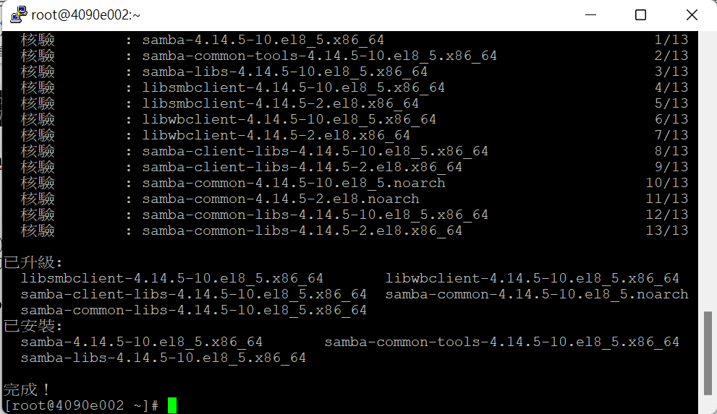
2. 創建共享資料夾
[root@smb ~]# mkdir /home/share
[root@smb ~]# chmod 777 /home/share
3. 設定組態：
[root@smb ~]# vi /etc/samba/smb.conf
[global]
# line 7 : add (set charset)
unix charset = UTF-8
# change (Windows default)
workgroup = WORKGROUP
security = user
# add (IP addresses you allow to access)
hosts allow = 127. 192.168.43.
# add (no authentication)
map to guest = Bad User

.....
.....

# add to the end
# any Share name you like
[Share]
# specify shared directory
path = /home/share
# allow writing
writable = yes
# allow guest user (nobody)
guest ok = yes
# looks all as guest user
guest only = yes
# set permission [777] when file created
force create mode = 777
# set permission [777] when folder created
force directory mode = 777
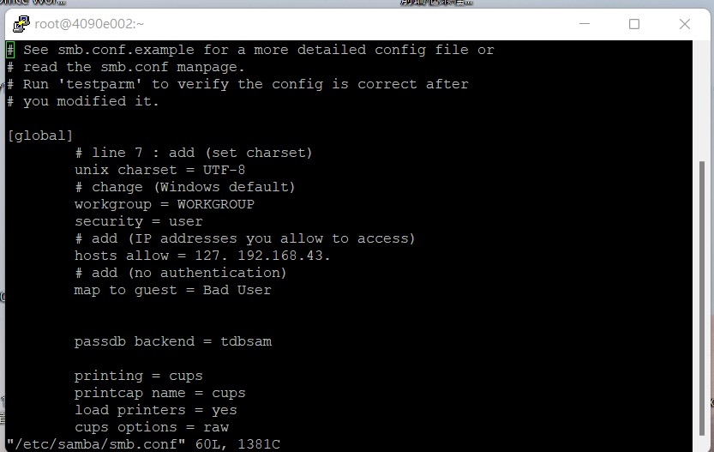
4. 啟動samba服務
[root@smb ~]# systemctl enable --now smb
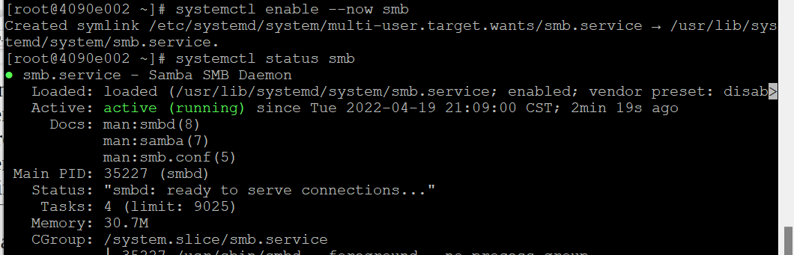
5. 若使用SELinux，修改分享資料夾的SELinux的政策：
[root@smb ~]# setsebool -P samba_enable_home_dirs on
[root@smb ~]# chcon -t samba_share_t /home/share
Note that if the shared directory will only be accessed through Samba, then it should be labeled samba_share_t, which gives Samba read and write access.
Samba can also serve files labeled with the SELinux types public_content_t (readonly) and public_content_rw_t (read-write). For the public share, we are going to use the public_content_rw_t type.

6. 設定防火牆，允許samba服務
[root@smb ~]# firewall-cmd --add-service=samba --permanent
[root@smb ~]# firewall-cmd --reload
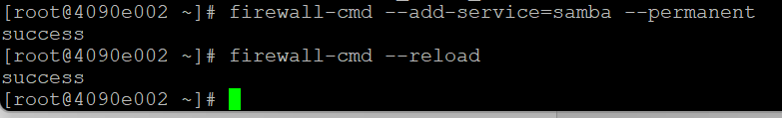

Windows用戶端連線分享的資料夾：
打開檔案總管：本機→ 新增一個網路位置
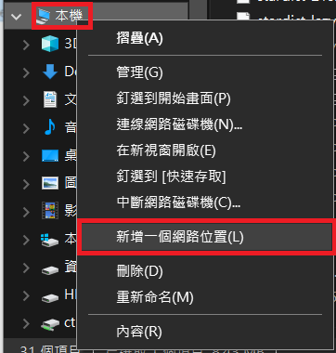

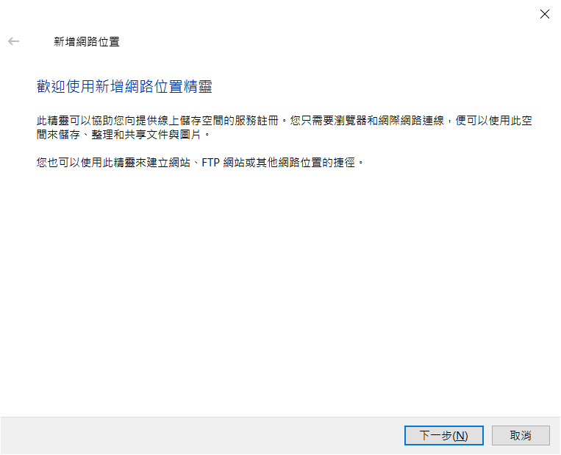

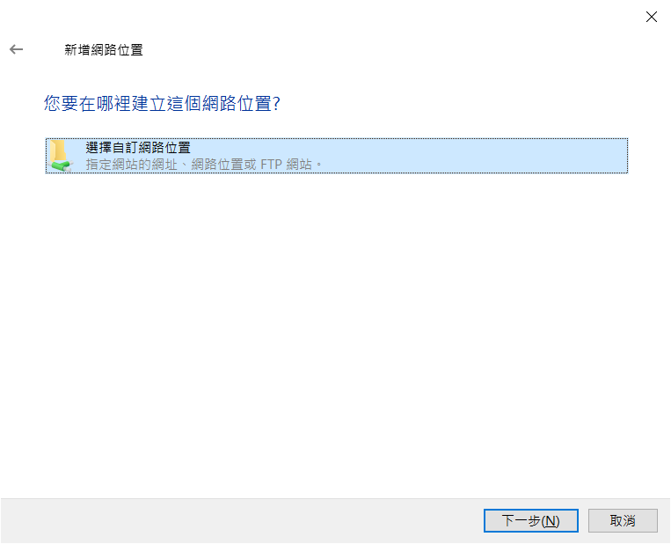

//SERVER_IP/SHARE
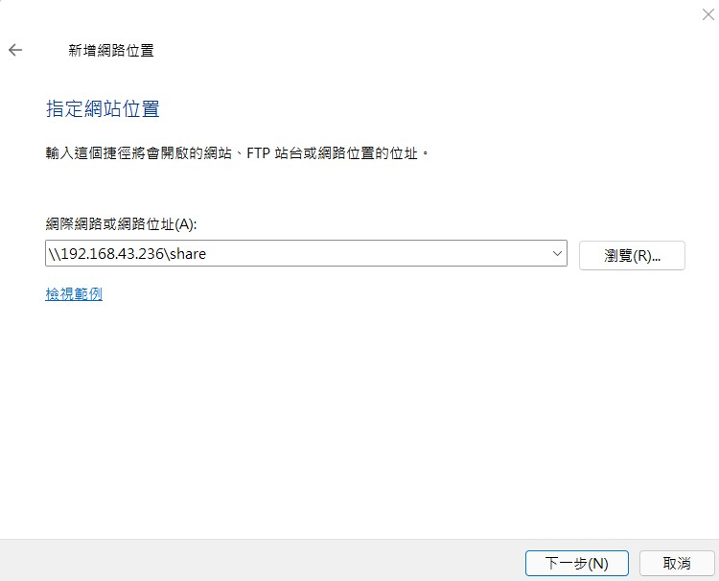
Enter
以nobody帳號，密碼也是nobody登入
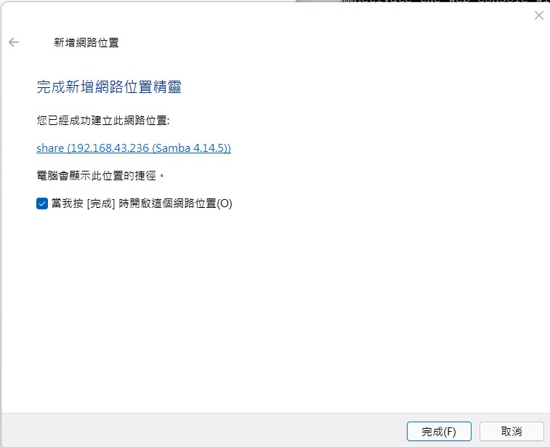

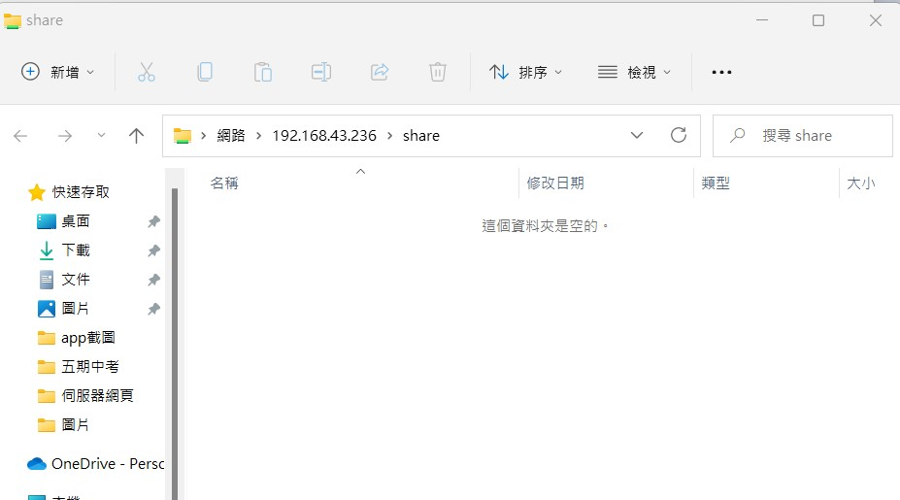
隨便創建一個檔案：
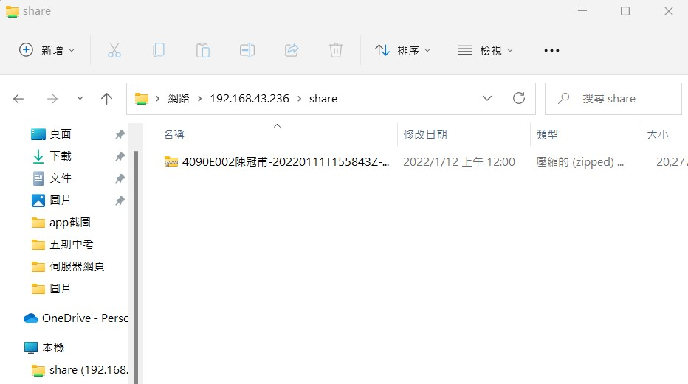
在本機共享資料夾可以看見新增的檔案：
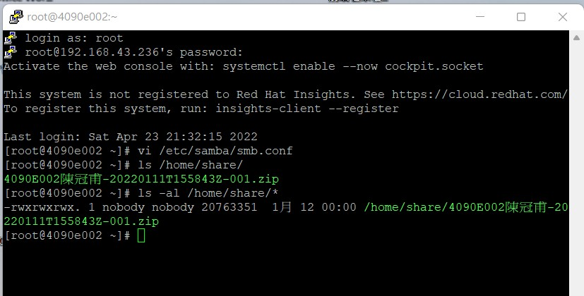
要刪除共享資料夾，只需右鍵點擊共享資料夾，然後選刪除。

要連線共享資料夾，也可以右鍵點擊本機之後，「連線網路磁碟機」：
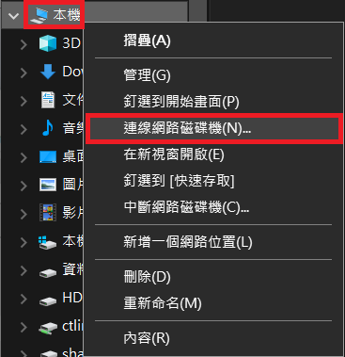

進階設定：
要限制使用者存取，請參考：https://www.server-world.info/en/note?os=CentOS_8&p=samba&f=2
要從Linux連線共享資料夾，請參考：https://www.server-world.info/en/note?os=CentOS_8&p=samba&f=3

