0. How it works — read this page first
The system is a shared, attributable record of what happened to a product as it moves between organisations. It does not replace anyone’s ERP; it records claims and makes them checkable.
Writing a claim (Figures 4 and 12). A participant signs an EPCIS event and submits it with a client-generated identifier. The platform validates the profile and the signature, then persists the event and enqueues an archive intent in one transaction. Workers encrypt the payload under a fresh data key, wrapped by a consortium key held outside the platform, write the ciphertext to an archive in another control domain, and record the holder’s signature over the stored bytes. That acknowledgement is what allows a receipt to be issued. Every thirty minutes the relayer commits a Merkle root over the receipted events to a public chain. An event becomes CONFIRMED only when both have happened: an outside holder has signed for the bytes, and the root is final.
Reading a claim (Figure 2). Every read goes through one entrance, QueryPort, which enforces scope, non-collapsing and watermark. Lineage is derived once into an indexed table, so a recall traversal is a bounded recursive query rather than a walk through the archive. Consumers never reach the application: they read versioned snapshots from a CDN, which is why a media-driven burst costs the origin almost nothing.
Who owns what. Four accounts: the platform, the trustee (archive and keys), the regulator’s analytics workspace, and the regulator’s evidence mirror. The operator can read consortium plaintext — an authorised capability, not an accident — but it cannot read private evidence, forge a holder’s signature, or rewrite a confirmed batch without detection.
What it deliberately does not do. Decide whether a claim is true, execute recalls, or hold raw telemetry.
The claim the rest of this report defends. No single party — not the operator, not the archive, not a regulator — can silently rewrite confirmed history. Sections 1–4 establish it; Section 5 tests it and names where it falls short.

1. Project context
An agricultural product moves through independent businesses, each keeping its own record of what it received, did and passed on. Nothing joins those records: a regulator reconstructing a recall asks each business in turn and gets a different identifier scheme, time zone and idea of “batch”, so the answer arrives in weeks while the product is on shelves. What is missing is a shared, attributable record a small producer can join cheaply and a regulator can trust without trusting its host.

1.1 Who it serves, what it covers, and why that changes the design — rubric 1.1–1.3
Objectives. Publish a claim cheaply, including offline (O1); make confirmed history tamper-evident to parties who distrust the operator (O2); let a regulator scope an incident quickly and defensibly (O3); give consumers a truthful view (O4); keep commercial detail and private evidence off the record (O5); run on a small team (O6); take device evidence without becoming a device platform (O7); screen regulatory risk with ML optional (O8).
Counterparties. Six parties exchange claims through the system; each constrains it.
ID | Party | What they need
S1 | Producer, grower, packer | Low-cost offline capture; signing without a corporate PKI
S2 | Processor | Transformation claims with quantities; no imposed mass-balance verdict
S3 | Distributor, cold chain | Two-sided handover; summaries, not raw telemetry
S4 | Retailer | Fast, conservative recall scope; a cacheable public view
S5 | Consumer | QR entry; “confirmed”, “pending” and “no record” kept distinct
S6 | Regulator officer | Read access, case-scoped evidence, signed findings, audit trail
The rest are parties to the design, not users of it: analytics (S7), governance (S8), the operator (S9), archive and key trustees (S10), courts and auditors (S11), device vendors (S12) — each surfacing once, where its interest bites (§2.3, §4.5).
Scope. Six boundaries are easy to confuse, and each is deliberate.
Mistaken for | It is instead
An ERP, WMS or quality system | A record of claims; participants keep their own systems
An adjudicator | It stores competing claims side by side and never picks one
A recall executor | It establishes scope and evidence; the businesses execute the recall
A device platform | Devices are organisation delegations publishing summaries
A payment or settlement system | No money moves; pricing and settlement are out of scope
A certification or customs system | Certificates enter as private evidence; a border adds a legal regime
Consumers as data producers, recycling operators and marketing or BI are outside for the same reason: each would change the system’s category, or it is met inside the Insights module.
Failure modes. Five shape the architecture: no consortium exists to operate validators, so a permissioned ledger cannot be built (R1, R3); the operator becomes the single point of trust unless history verifies from outside it (R2); evidence may not survive a legal process (R3); an immutable log may breach privacy law (R5); scope creeps into ERP, inventory or adjudication (R6). Two are stated, not solved: smallholders left out (R4) and false or collusive claims (R10). Not attempted: state-level adversaries, build-pipeline and quantum attacks (a security programme, not an architecture decision), bankruptcy, and fraudulent onboarding (a named residual risk).
Constraints. A blockchain is mandatory (C1); Australian and NSW law applies (C2); participants’ systems must interoperate (C3); connectivity is intermittent (C4); 200 organisations and 10 000 events/day (C5); a small operating team (C6); no production access (C7). Delivery follows: one region, cloud only, PWA only, no contracted archive operator at launch.
Why these change the design. The stakeholders fall into three clusters; device vendors (S12) are argued in §4.6.
Participants (S1–S5) with C4 force an integration tier. With only large manufacturers, an ERP integration and a corporate key would do; because the smallest tier must publish, capture is browser-first, the queue survives offline, the key never leaves the device and identifiers are client-generated.
The regulator (S6, S7) forces a boundary that would otherwise be invisible. Analytics inside the platform’s account would let the operator read every rule and finding; it runs in the regulator’s own account instead.
Trust infrastructure (S8–S11) forces the record out of the operator’s hands. Cost is served, unilateral control is not — hence the external archive, the non-platform key holder and verification that needs no cooperation.
R1 and R3 eliminate the permissioned ledger, which would fit the evidence requirement but needs validators this project does not have. C1 and C2 are in tension — a public chain is mandatory, personal data must stay correctable — and the resolution follows: commitments on chain, ciphertext off it, personal data in the mutable layer.

2. Requirements analysis
The three gaps of Section 1 become obligations here: what must be checkable, what must stay unreadable, and what must survive loss.
Identifiers trace to the stakeholders S1–S12 and objectives O1–O8 in Section 1.

2.1 System qualities, and the scenarios that test them — rubric 2.1–2.2
Eleven qualities drive the design. Four decide its shape — integrity (S6, S9, S11), privacy (S1, S5, S6), availability (S4–S6) and analysability (S1–S4, S6); the other seven constrain how it is built. Each row states the requirement as a measurable test, the scenario that exercises it, and the risk if it is not met.
ID | Quality | Requirement and measure | Scenario | Risk if unaddressed
SQ-1 | Integrity | A confirmed event cannot be altered or removed undetectably; detectable from published proofs alone | QS-1: an operator deletes a batch, and the missing batch breaks the chain sequence | History is only as trustworthy as its host
SQ-2 | Non-repudiation | Attribution survives rotation, revocation and suspension; verifiable from event and registry history alone | QS-2: a three-year-old event is verified after two key rotations and a suspension | Old claims become unattributable after a key compromise
SQ-3 | Availability | One dependency lost degrades a capability, never to a false “no record”; fault injection yields a declared state | QS-3: a recall runs at 02:00 during an archive outage | A safety query answers “nothing found” exactly when it matters
SQ-4 | Performance | 5 000 requests/s at the CDN; 10 000 synchronous edges, exported beyond | QS-4: 5 000 scans/s arrive after a television item | The origin melts during the one incident everyone watches
SQ-5 | Recoverability | RPO 0 for receipted events; database ≤ 5 min; RTO ≤ 4 h; regional rebuild ≤ 24 h | QS-5: the platform account is lost after a receipt | Confirmed history dies with the platform
SQ-6 | Usability and accessibility | Under three minutes at 2G; WCAG 2.2 AA; 200 % text; label plus icon per field | QS-6: a grower with no signal for 36 hours captures four events on a low-end phone | Coverage collapses in exactly the tiers the regulator needs
SQ-7 | Privacy | No natural-person reference and no private content in the shared record | QS-7: a regulator requests a packer’s lab report; QS-8: operations try to read findings | An immutable log becomes an unlawful personal-data store
SQ-8 | Interoperability | Interpretable from profile and canonicalisation version alone; replaceable chain | QS-10: the chosen chain becomes uneconomic | Every participant needs a lossy mapping, and migration becomes a rewrite
SQ-9 | Auditability | Every state change and disclosure attributable; replay reproduces derivation and advisories | QS-9: two processors claim one input lot | Conflicts cannot be defended or replayed
SQ-10 | Cost and operability | One application, one managed database, no self-managed cluster; topology and monthly estimate documented | Checked by inspection of the deployment views (§4.3) | The pilot needs a platform team per region
SQ-11 | Device evidence | Profile-required summaries with provenance; raw telemetry stays private | QS-12: a reefer exceeds its limit for 40 minutes | Raw telemetry enters the record, or evidence is missing where it matters
SQ-12 | Regulatory screening | Signed, versioned rules; ML optional; a rule runs at a watermark and traces to its version | QS-11: a case is opened while the workspace is under maintenance | Screening is either platform-owned or absent
SQ-13 | Analysability | Every insight view states its watermark and scope; figures reproduce from the projection | QS-13: a product line is reviewed at yesterday’s watermark | Insight becomes a second, disagreeing read path
Rejected while setting these requirements: database plus WORM backup (leaves the operator the sole verifier); a permissioned ledger (needs validators this project does not have, R1); per-employee signing keys (puts natural persons into an immutable record, R5); synchronous calls to every dependency on the read path; a graph database from day one; field-level encryption inside the shared record (the platform would still hold the keys); and a separate dashboard database. Business plausibility — yield, mass balance, fraud — is deliberately not adjudicated at admission: a rule that rejected an event because a quantity looked wrong would make the platform an adjudicator without authority. The decisions that address each risk are argued in §4.1, and the alternatives that survive as alternatives are revisited in §5.1.

2.2 The data: elements, scenarios, storage — rubric 2.3–2.4
Six requirements shape the data model: interpretable from its profile (DM-1); no readable private content on the platform (DM-2); one authoritative source with rebuildable copies (DM-3); retention per class with a defensible deletion record (DM-4); no natural-person identifiers (DM-5); reproducible regulatory outputs (DM-6). The scenarios below then fix validation, storage, access and retention, so each is stated where it arises rather than listed separately.
Elements. One or two per group are tabulated; the rest are named after the table and follow the same rules. Format and length are enforced at admission, and source names the originating party.
Element | Format | Length | Description | Source | Serves
captureRecordId | UUID v4 | 36 | Idempotency key for one submission | Participant | DM-3, S1
eventTime | ISO 8601 with offset | 30 | Business time asserted by the publisher | Publisher | DM-1, SQ-9
epcList, quantityList | EPC URIs / {class, quantity, uom} | ≤ 255 per entry | Instance and lot identifiers with quantities | Publisher | DM-1, O3
quantity, uom | Decimal 18,6 / UN/CEFACT | 22 / 3 | Asserted quantity and unit | Publisher | S2
profileId, profileVersion | Slug / semver | 64 / 20 | Validation profile and version | Governance | DM-1, SQ-8
signerOrganisationId | UUID v5 | 36 | Organisation accountable for the claim | Registry | SQ-2, DM-5
canonicalPayloadDigest | SHA-256 hex | 64 | The value actually signed | Platform | SQ-1
plaintextCommitment | SHA-256 hex | 64 | Salted commitment to off-platform content | Owner | DM-2, SQ-7
findingId, ruleVersion, dataWatermark | UUID, semver, uint64 | 36, 20, 20 | Finding identity and the inputs it used | Regulator | DM-6, SQ-9
Named but not tabulated: the EPCIS business fields (action, bizStep, disposition, bizLocation, readPoint, sourceList/destinationList, bizTransactionList, epcClass, parentID, transformationID); the versioning pair (canonicalisationVersion, edgeDerivationVersion); the signature set (keyId, signatureValue, signatureAlgorithm, assertedSignedAt); custodyMode; the anchoring set (ArchiveAckDigest, ciphertextDigest, merkleLeafIndex, batchId, merkleRoot, transactionRef, inclusionProof); evidence state (availabilityStatus, retentionPolicyId); and regulatory output (severity, disclosureScope, expiresAt, regulatorSignature). Each is EPCIS/CBV-defined or profile-declared, typed and length-bounded at admission.
Scenarios. Each one fixes a requirement that would otherwise be a design preference.
- DS-1 Seven-year recall. A retail lot is traced to a farm block seven years later. Forces: append-only canonical tables, indexed lineage edges, and the profile version kept with the event (storage).
- DS-2 Competing claims. Two processors consume one lot. Forces: no uniqueness on lineage, and a query layer that returns both rather than picking one (representability, not validation).
- DS-3 Laboratory report. A regulator requests a packer’s report. Forces: only a commitment and a storage mode on the platform, with content encrypted by its owner (access).
- DS-4 Scan at peak. 5 000 scans/s after a television item. Forces: public reads served from versioned objects at the edge, never by joining canonical tables (access, storage).
- DS-5 Retention under hold. A batch expires during a dispute. Forces: deletion as a recorded transition executed by three parties, with a signed record anchored (retention).
- DS-6 Offline capture, revoked key. Events arrive after a key rotation. Forces: idempotent ingestion and a review state, because “invalid” and “not yet established” are different facts (ingestion, validation).
DS-3 and DS-4 fix the three visibility classes — public projection, consortium trace, owner-held private evidence, with no middle tier — and access binds per request to an explicit acting organisation. DS-6 fixes validation’s two classes: admission blocks the write, while structural representability only shapes how the projection presents the data. Business plausibility stays out of admission, because a rule that rejected an event for an odd quantity would make the platform an adjudicator.
Storage. One managed relational database holds submission state, registries, the outbox, a queryable materialisation and rebuildable projections. It is relational because EPCIS fields are typed and constrained, admission needs one atomic step across event, idempotency claim and outbox, DS-1’s traversal is a bounded recursive query, and reporting is set-oriented; it must therefore provide exact decimal arithmetic, referential integrity, semi-structured extension columns, point-in-time recovery and row-level predicates. Rejected: a document store (loses cross-event constraints and multi-row transactions), a graph database as the record (the graph is derived and must stay verifiable), and event sourcing for the whole application (profiles and job state are not events).

2.3 Cloud adoption — rubric 2.5–2.6
Participants want no infrastructure and no capital spend: a browser is enough, and a small producer will not run a server to join a supply chain. The operator wants the same — a small team (C6) cannot patch a cluster. The regulator wants its workspace to run where the platform cannot read it.
Four scenarios decide the service model. QS-4 (5 000 scans/s after a television item) asks who serves the bytes: an origin cannot, so delivery is a CDN service, not a server. DS-3 (a regulator requests a packer’s report) asks who holds the content: not the platform, so object storage sits under a separate provider. QS-8 asks who operates the workspace, and C6 how much is operated at all.
Capability | Deciding scenario | Service model | What we do not run
Application and workers | C6 | PaaS, one managed container | Orchestrator, node patching
Relational database | C6 | PaaS, replica and storage autoscaling | Failover, backups, tuning
Public snapshot delivery | QS-4 | SaaS, CDN over object storage | Edge PoPs, certificates
Archive | DS-3 | SaaS, object storage under a separate provider | Media, replication
Key management | DS-3 | SaaS, managed KMS in the trustee’s account | HSM estate, key ceremonies
Chain anchoring | QS-4 | Public network, paid per transaction | Validators, nodes
Analytics runtime | QS-8 | PaaS, in the regulator’s account | Platform operational access
Identity | C6 | SaaS, external identity provider | Credential store, MFA estate
Rejected: IaaS with a self-managed cluster — C6 makes it a second job; a shared tenant for analytics — QS-7 makes the separation unverifiable; on-premises object storage — it returns the archive to the operator’s account (D1); origin-only delivery — QS-4 makes the origin the bottleneck.
Residency, exit and cost follow from the same choices: Australian regions, standard PostgreSQL, portable formats.

2.4 Security, privacy and regulation — rubric 2.7–2.8
Every write is authorised against an organisation, a role and a delegation, bound per request (SP-1), and every canonical event is non-repudiable across rotation and revocation (SP-2). High-impact governance changes need dual control and apply only once anchored (SP-5); reads are audited per organisation and staff access needs recorded break-glass (SP-6); analytics cannot pull arbitrary private evidence, and findings are private by default (SP-7). The system states what it does not protect against (SP-8).
Integrity is guaranteed by the public chain. A Merkle root is committed every thirty minutes, and any third party can verify an event against it without asking the platform (NSW Food Act 2003; Food Standards Code).
Confidentiality is a three-tier tradeoff. Public projection, consortium trace, owner-held private evidence, with no middle tier. The platform reads consortium plaintext because recall traversal needs it, and never reads private content — the owner grants sharing (SP-3) — while no natural-person identifier enters the immutable record (SP-4). Privacy Act 1988 and the APPs; NSW PPIP Act 1998.
Availability comes from read/write separation. Writes fail closed and retry idempotently; reads come from the materialised copy with an explicit degradation state, so a recall query during an archive or chain outage returns a labelled partial result rather than a silent miss (Food Act 2003 recall powers).
Appendix B maps each obligation behind those citations to where the design answers it.

2.5 Device evidence and regulatory screening — rubric 2.B, bonus
IoT-1 summaries, not telemetry; IoT-2 devices as organisation delegations, not accounts; IoT-3 collection at the edge, availability at the platform, verifiability at the archive. The cold-chain loop is local, so the platform’s alarm is post-confirmation.
AI-1 deterministic rules first, versioned and signed by the regulator, with ML optional and never gating a write; AI-2 every finding names its rule or model version and its input watermark; AI-3 no model output becomes a recall decision without a signed assessment.
IS-1 Cold-chain excursion. The participant’s system alarms and acts; a summary and reference ride on the receiving claim; the platform is not the primary alarm path. IS-2 Cross-assertion anomaly. The regulator’s rules produce a private finding over confirmed claims; the platform supplies minimised data and cannot read the rule.
Alternative | Why rejected
Raw telemetry on the platform | Turns the trace into a time-series warehouse; privacy exposure; unmanageable retention
Platform-side real-time alerting | Adds a hard latency requirement and duplicates the participant’s control loop
ML in the write path | Makes a model an adjudicator; training data belongs in the regulator’s domain

3. Architecture views
Each view answers one question and narrows the previous one: the context fixes the boundary, the container view opens it, the component views open the two containers that carry the guarantees, and the code views show the types that make those guarantees enforceable. Section 4 explains why; this section states what the structure is.

3.1 The view set — the roadmap for rubric 3.1–3.10
View | Scope | Figures
Context | The system, its users and external systems | 1
Containers | Runnable units, responsibilities, interactions | 2, 3
Components | Traceability Core, the relayer, the analytics workspace | 4, 5, 6
Code | Major classes, one interface, three enumerations | 7, 8
Names are stable across views; relationships carry intent, and transport strings appear only where the protocol is architecturally relevant. Diagrams are generated from versioned source, so report and repository cannot drift.

3.2 System context — rubric 3.1
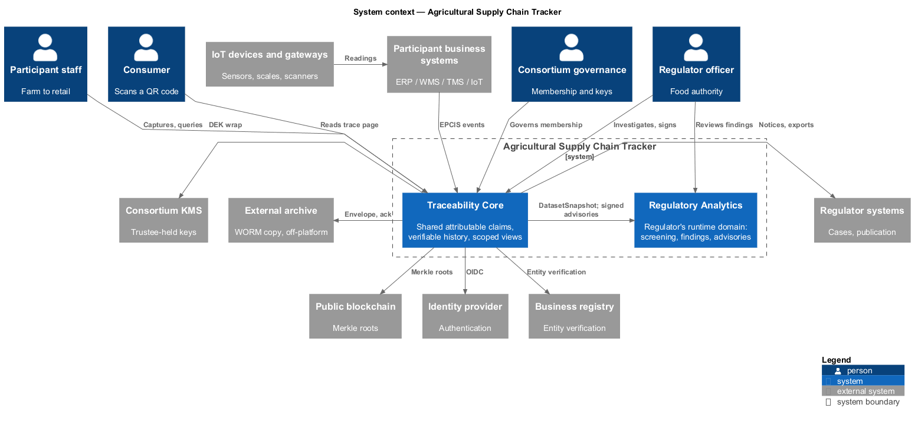
Figure 1 — System context
Figure 1 — Two peer subsystems, four groups of users, eight external systems.
One boundary, two peer subsystems. Traceability Core holds the shared record; Regulatory Analytics holds the regulator’s rule domain. They are peers: the platform cannot author rules, and analytics cannot rewrite the trace. The archive, the consortium KMS, the chain and the regulator’s case systems sit outside, because their value comes from not being in the operator’s account.
Devices attach to participants, not to the platform. Sensors feed the participant’s own systems, which publish EPCIS events. A device is a delegation of an organisation — allowed devices, locations and event types — not a platform user. What enters the shared record is a profile-declared summary (min/max/mean, excursion duration, alarm, with units and a time window) carried as an ordinary extension field; raw readings stay with the participant behind a reference and a salted commitment. Collection and alarming are therefore local, availability is the platform’s, and verifiability is the archive’s — one owner per tier (IoT-1…3, 4.B).
Identity arrives on two lines. Humans authenticate through an external identity provider; an organisation’s legal identity is verified once against a business registry. Neither is issued by the platform, which is what makes the organisation, not the person, the unit of accountability.

3.3 Containers — rubric 3.2–3.4
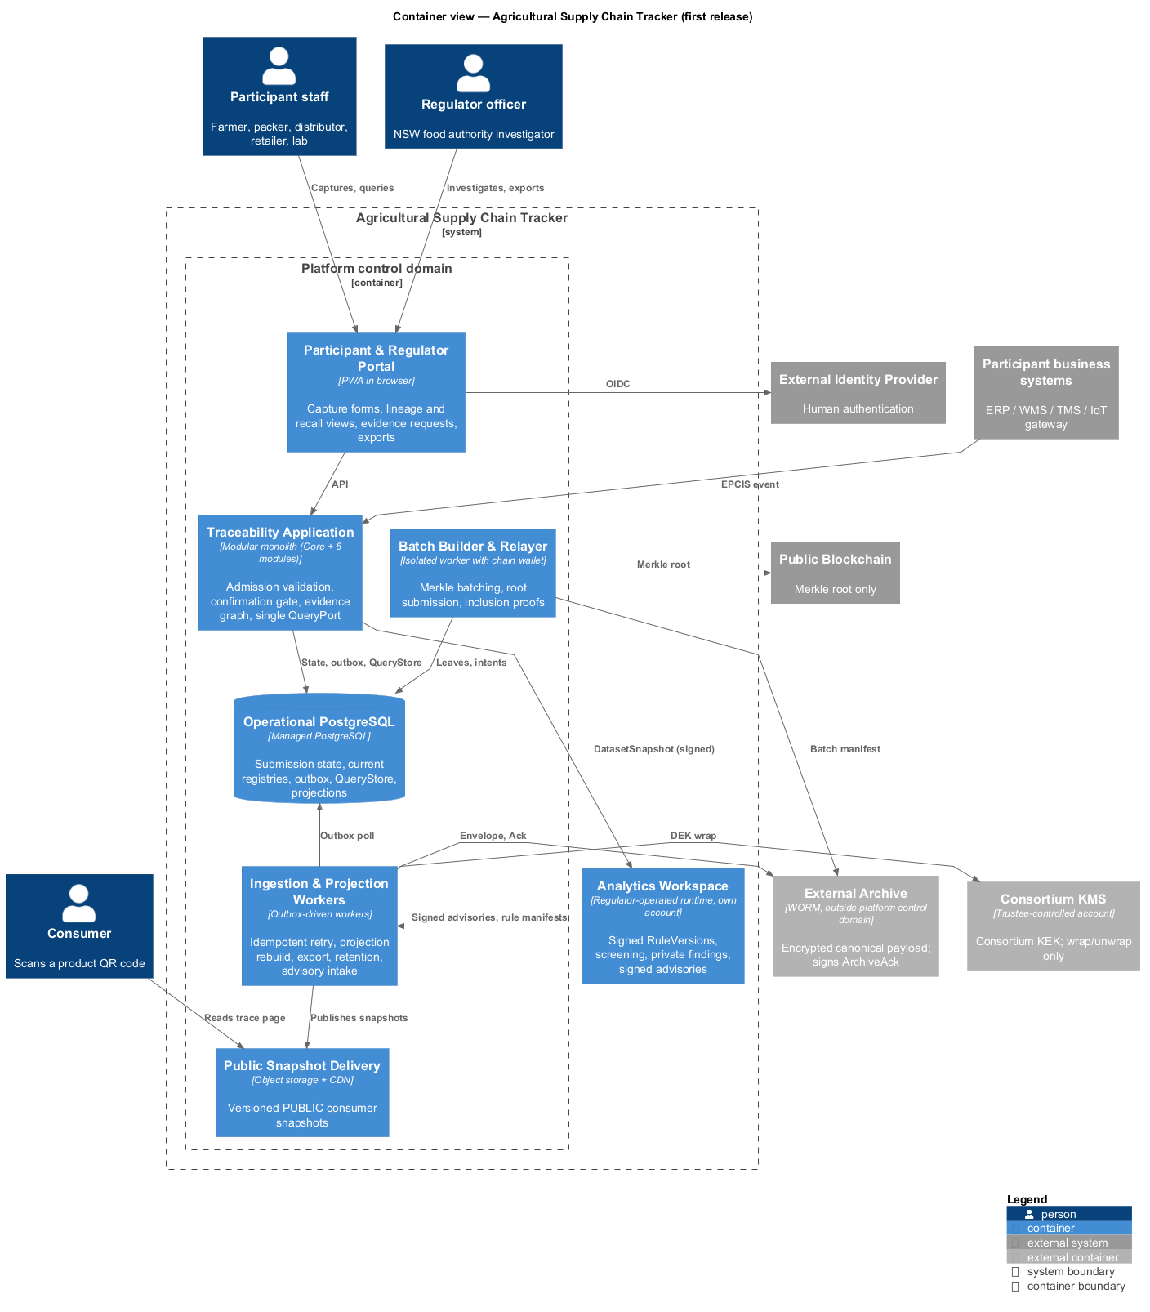
Figure 2 — Container view
Figure 2 — Containers of the platform control domain, and the external systems they depend on.
Container | Responsibility
Participant & Regulator Portal | Role-specific capture, handover confirmation, recall execution, scan-to-trace, insight views, evidence requests
Traceability Application | Admission, the confirmation gate, evidence graph, the single read entrance
Ingestion & Projection Workers | Archive writes, projection rebuild, exports, retention, advisory intake
Batch Builder & Relayer | Leaf allocation, Merkle batching, root submission, inclusion proofs
Operational PostgreSQL | Submission state, registries, outbox, the plaintext query copy, projections
Public Snapshot Delivery | Versioned public snapshots at the edge
Analytics Workspace | Regulator’s rules, screening, private findings, signed advisories
Two boundaries are easy to misread. The database holds a plaintext copy of confirmed events (QueryStore), not only indexes: online lineage cannot afford to decrypt on every hop. That copy is rebuildable, excluded from the recovery guarantee and read-audited. The Analytics Workspace sits inside the system boundary but outside the platform control domain, in the regulator’s own account; only signed messages cross into it.
Four flows cross the boundary. Capture: a signed event reaches the application, which validates it and persists state with an archive intent in one transaction; workers obtain a wrapped key, write the envelope and record the acknowledgement; the relayer batches the leaf. Read: portal queries go through the query interface and the plaintext copy only. Public delivery: workers publish versioned snapshots and the CDN serves them, so consumers never reach the application. Cross-tenant: the application exports a minimised dataset and receives signed advisories and rule manifests.
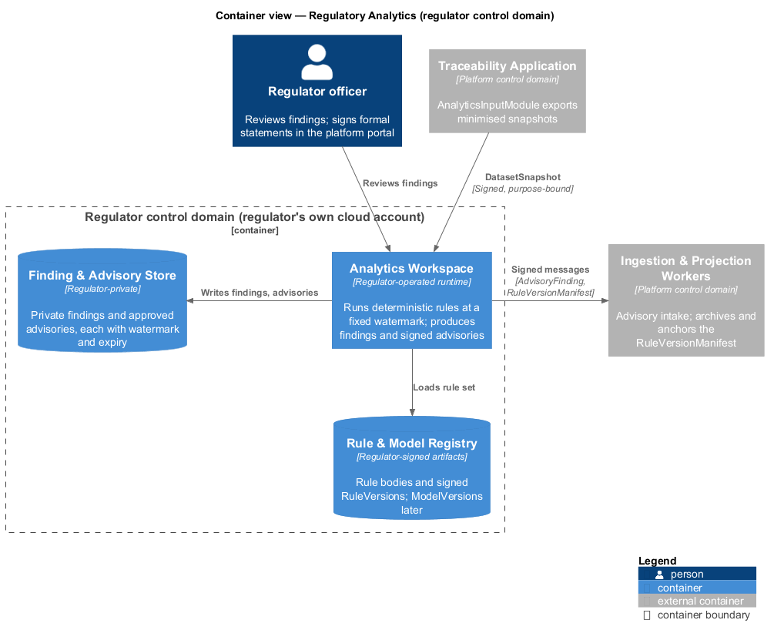
Figure 3 — Analytics containers
Figure 3 — The workspace, its rule registry and its finding store.
The separation is the point of this view: the platform can deploy artefacts into the regulator’s account but cannot read from or operate it, so “the platform cannot see the rules or the findings” is an IAM fact rather than a promise. That contract — what dataset may leave, what may return — is why the subsystem is modelled to component and code level instead of being drawn as a black box.

3.4 Components — rubric 3.5–3.7
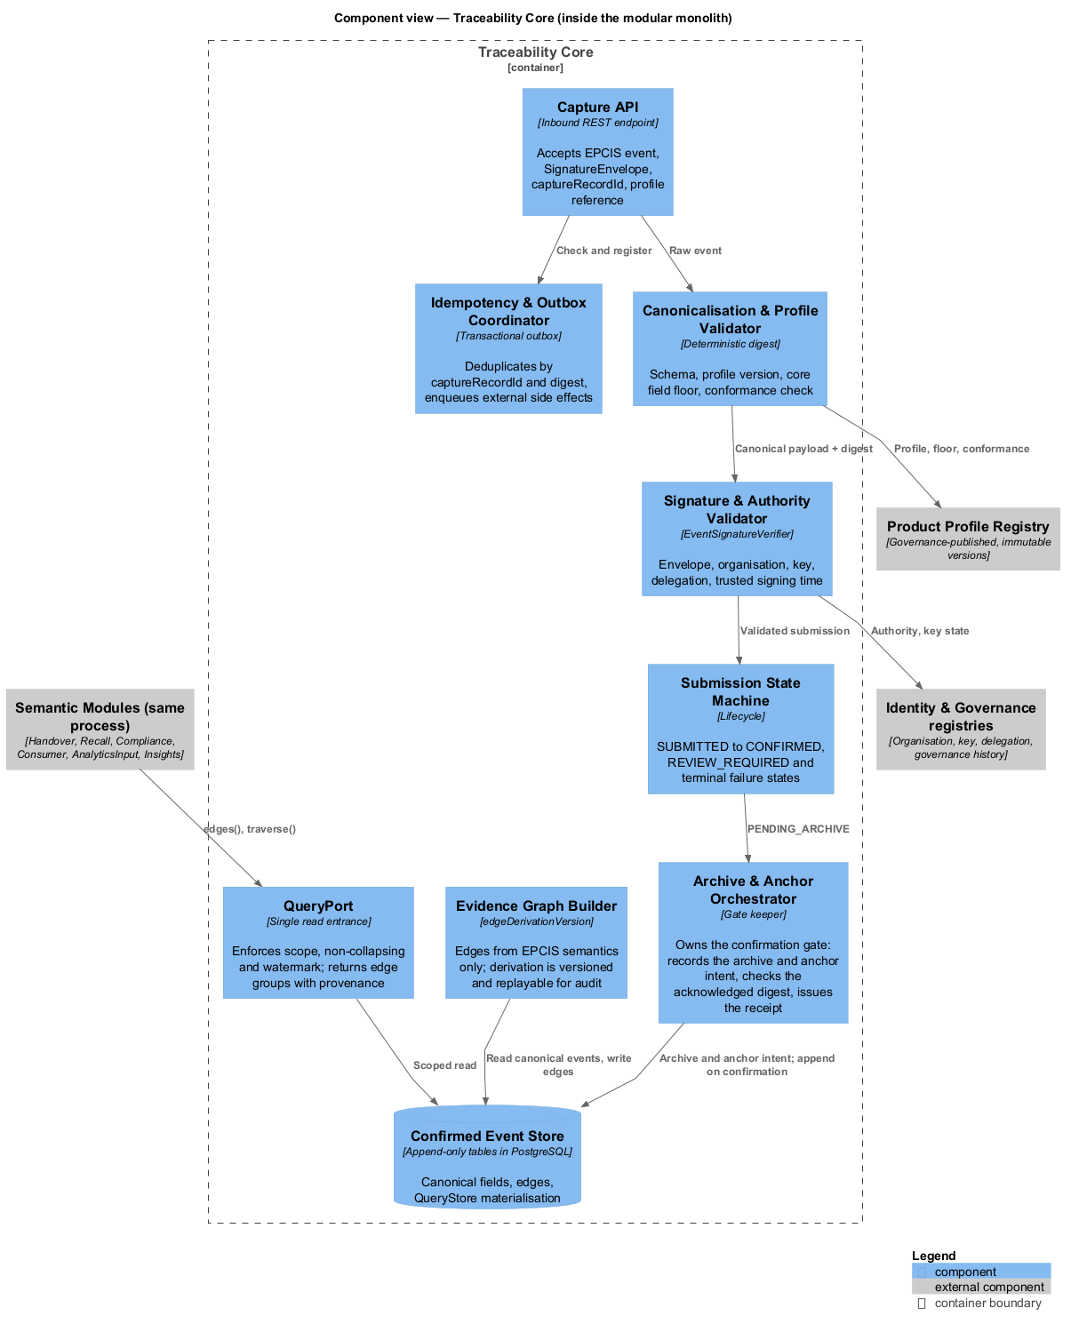
Figure 4 — Traceability Core
Figure 4 — Components of Traceability Core, with the modules that consume its read interface.
The core has one write path and one read entrance. Nine components: Capture API, Idempotency & Outbox Coordinator, Canonicalisation & Profile Validator, Signature & Authority Validator, Submission State Machine, Archive & Anchor Orchestrator, Evidence Graph Builder, Confirmed Event Store and QueryPort. Three properties carry the argument: the orchestrator owns the confirmation gate and records the archive intent, while the worker role of the same image executes it; QueryPort exposes two graph-shaped operations, edges() and a bounded traverse(), and no operation that returns a business status; the store is append-only, so a correction is a new event.
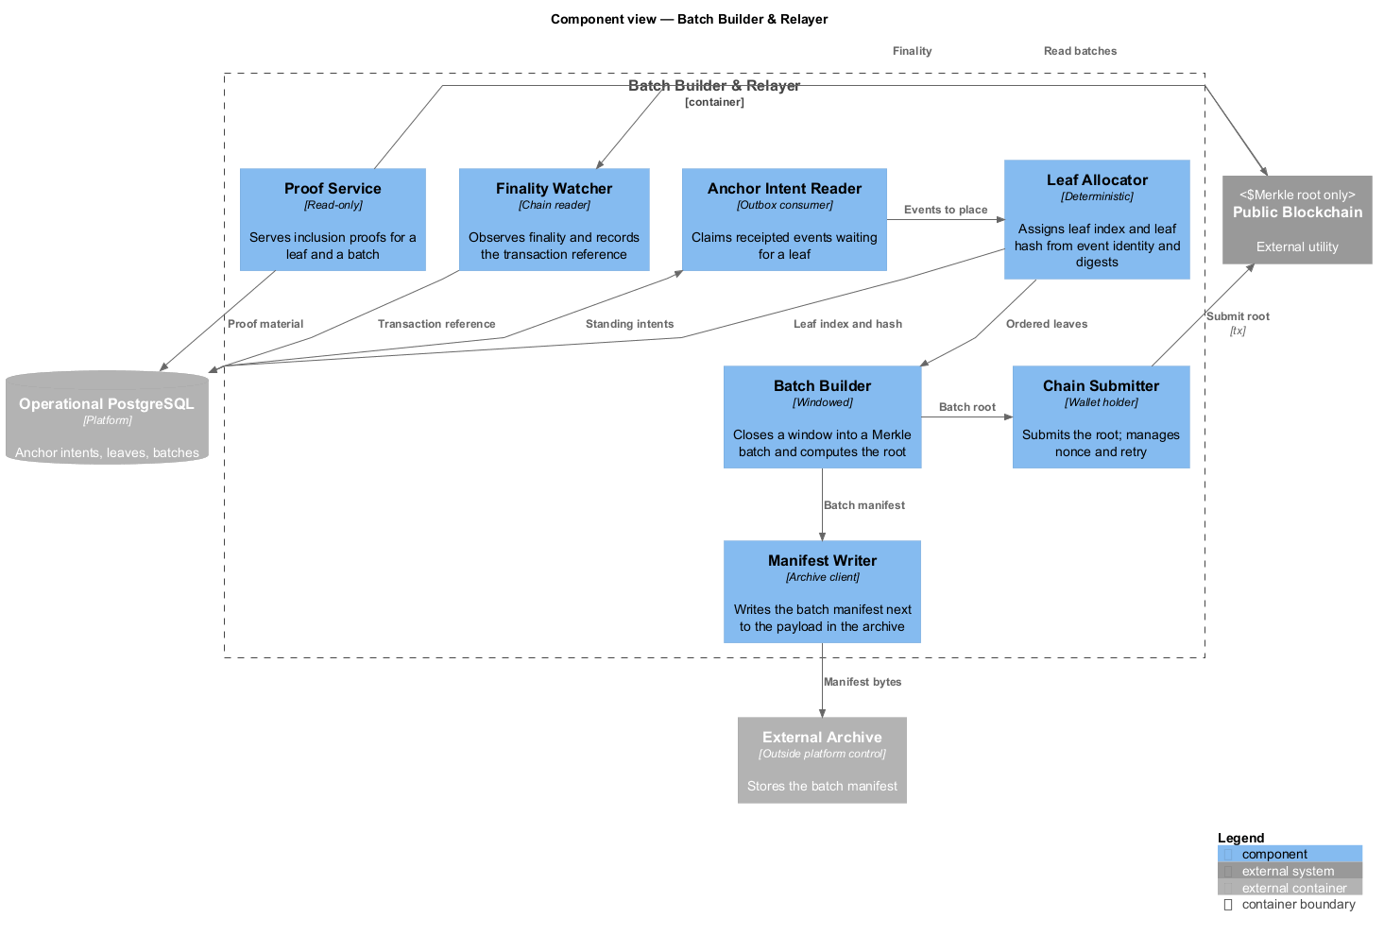
Figure 5 — Relayer components
Figure 5 — Components of the relayer, the only container that touches a chain.
The relayer is drawn separately because it is the only container with a credential that can spend money and write to a public network. Six of its seven components need no private key; only Chain Submitter does. Leaf allocation is deterministic, so a retry cannot create a second leaf for the same event, and the manifest writer places the batch manifest beside the payload, which is what lets recovery reconstruct which batch held an event without the platform database.
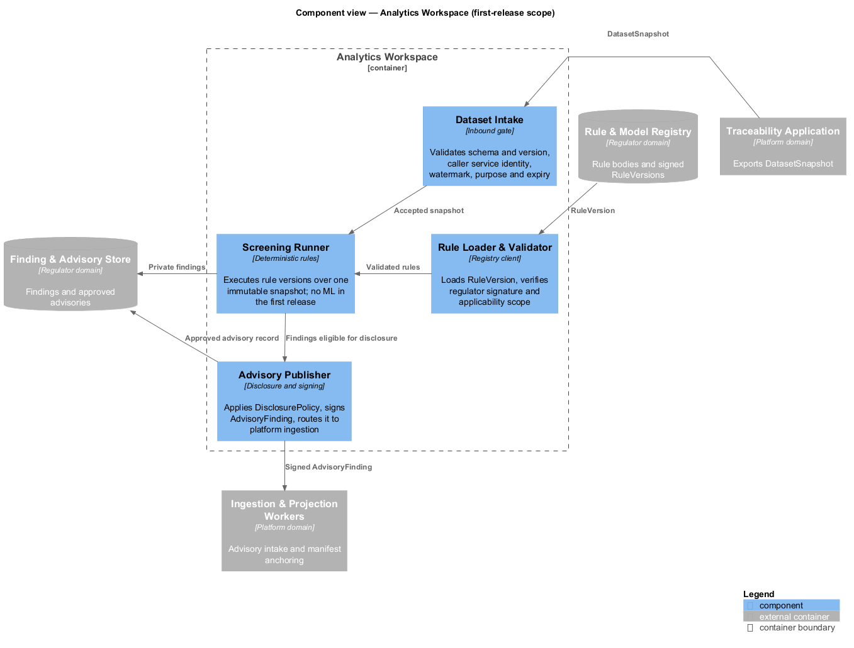
Figure 6 — Analytics Workspace components
Figure 6 — Four components, inside the regulator’s account.
Dataset Intake is the only entrance; Rule Loader & Validator verifies the regulator’s signature and the rule’s applicability, not its content; Screening Runner runs deterministic rules over one snapshot at one watermark; Advisory Publisher applies the disclosure policy and signs. There is no model loader and no review queue in the first release, because it runs deterministic rules only.

3.5 Code — rubric 3.8–3.9
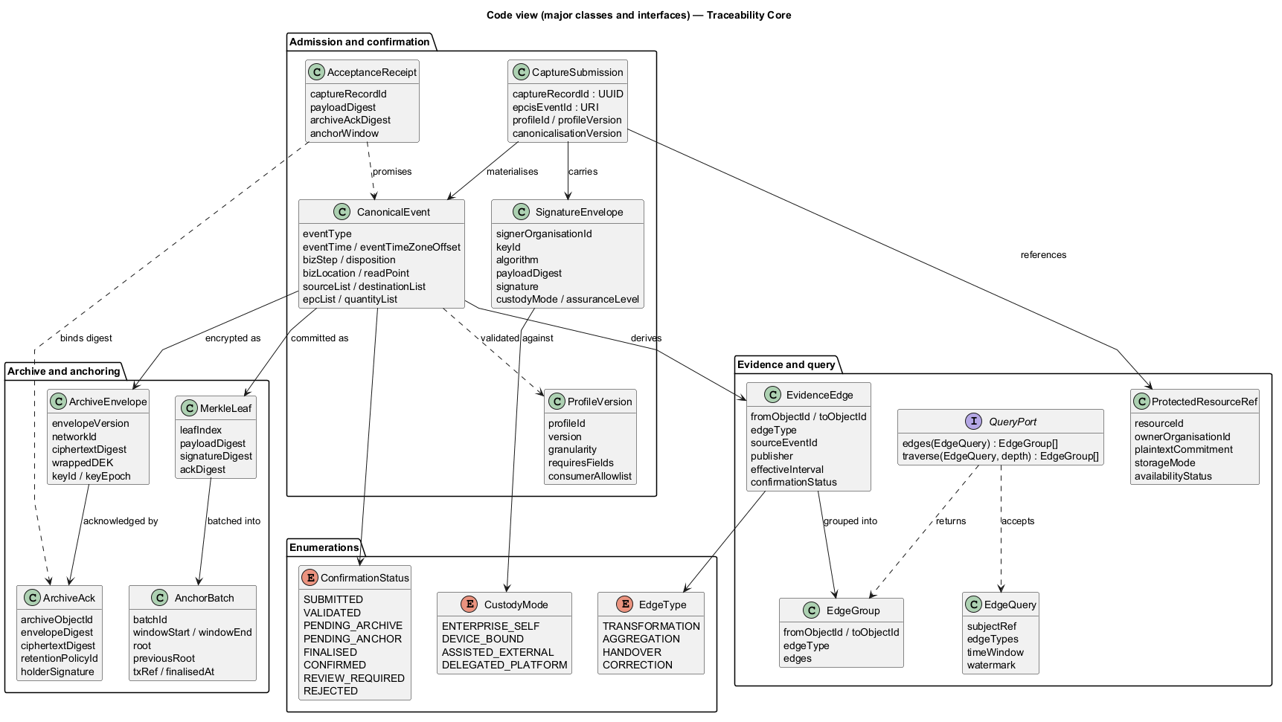
Figure 7 — Core code view
Figure 7 — Thirteen classes, one interface, three enumerations.
Four properties are visible in the type model. SignatureEnvelope has no natural-person field, so attribution cannot acquire an employee reference. AcceptanceReceipt binds the ArchiveAck digest, so a receipt can only exist once an outside holder has confirmed persistence. QueryPort returns edge groups, never a business status, so no caller bypasses scope, non-collapsing or watermark. ProtectedResourceRef holds a salted commitment and a storage mode, never content. The three enumerations are published values: once in use, a value cannot be silently added or removed.
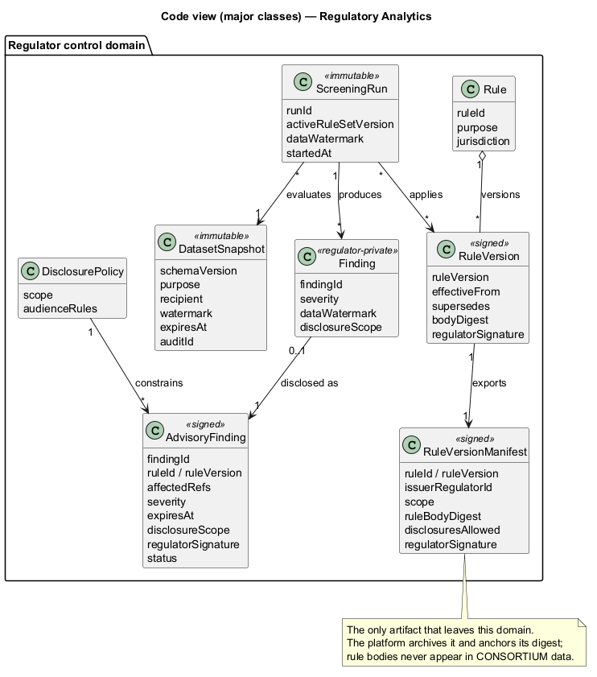
Figure 8 — Analytics code view
Figure 8 — Eight classes. RuleVersionManifest is the only artefact of the rule domain that leaves the regulator’s account, and it carries only a digest of the rule body. Finding and AdvisoryFinding share a findingId, so an advisory is a disclosure of an existing finding and a retraction is the same identifier re-signed; DisclosurePolicy constrains advisories, not findings.

3.6 Cross-view consistency — rubric 3.10
Every class is produced by one component and belongs to one container of Figure 2; Appendix A.2 is the full mapping. Consistency is maintained by four rules rather than by review: one name per element across views, one owning component per class, one interface per trust boundary, and enumerations treated as published contracts rather than implementation detail.

3.7 What these views deliberately do not model — no rubric row
Screens, routes and component state of the portal (they change weekly); persistence mapping (§2.2 and §4.2); and generated clients, except where they are the contract. Deployment and dynamic behaviour are Section 4, where they are used as evidence.

4. Architectural rationale and decision-making
Section 3 says what the structure is. This section records the decisions behind it: one sentence each, the reason, and — only where a plausible alternative existed — what was rejected instead.

4.1 How the application is cut — rubric 4.1–4.5
- One deployable, split by role rather than by service. A service per concern would add a broker, sagas and an operational platform to serve 10 000 events/day.
- One write path, with an outbox. State, idempotency claim and archive intent commit together, so a crash resumes instead of duplicating; the alternative is two-phase commit across services.
- One read entrance. Modules read only through QueryPort, so scope, non-collapsing and watermark cannot be bypassed by a caller that reads tables directly.
- Append-only canonical records, everything else derived. Lineage, recall and public views rebuild from the log, which is what makes the record verifiable and replayable.
- Notarised anchoring. A public Merkle root every thirty minutes proves existence to anyone; it does not prove truth, and it is why a permissioned ledger was unnecessary.
- A port at every external edge. Archive, KMS, chain and identity change through adapters, and the leaf binds digests rather than chain specifics — a direct SDK call would have locked both in.
- Signature and authority are separate checks. A verifier checks the signature; a resolver decides whether that organisation was authorised then, so rotation never invalidates history.
- The signer is isolated. Only the relayer holds the chain wallet, and it cannot read payloads; embedding the wallet in the application would enlarge the key-exposure surface.
Those decisions are tactics. The quality each serves (rubric 4.1) and the pattern it forms (rubric 4.2–4.3) are named here, with the alternative the pattern replaced.
Pattern | Where it appears | Quality served | Rejected instead
Modular monolith, layered inside | The one deployable | Operability (SQ-10), modifiability | Services: broker, sagas, platform team (§5.1, A4)
Ports and adapters at every external edge | Archive, KMS, chain, identity | Replaceability (SQ-8) | Direct SDK calls bind the leaf to one chain
Transactional outbox | Admission through to archive | Reliability, RPO 0 (SQ-5) | Two-phase commit across services
Read model derived from the log | QueryStore, public snapshots | Performance (SQ-4), privacy (SQ-7) | Decrypt per hop; per-field policy on immutable records
State machine with anchored transitions | ConfirmationStatus | Integrity (SQ-1), auditability (SQ-9) | A boolean processed flag
Versioned contracts, published enumerations | Profiles, code view | Interoperability (SQ-8) | Free-form strings, silent value drift
Five named smells, checked one by one (rubric 4.5).
Smell | Where it would appear | Evidence it does not
Feature concentration | One application holding admission, the gate, the graph and reads | Nine components split by reason to change: Capture API validates, the orchestrator gates, QueryPort reads
Scattered functionality | Lineage or scope rules computed per module | One Evidence Graph Builder; every read passes QueryPort
Dense structure | The core component graph | Acyclic; QueryPort is the only fan-in and the orchestrator the only gate
Cyclic dependency | Application and workers | One direction — admission enqueues, workers execute, no callback
Unstable dependency | Chain, archive and KMS SDKs | All behind ports; the core imports no vendor package
SOLID is visible where it matters (rubric 4.4): responsibilities split by reason to change, a new custody mode arrives as an addition, four modes share one envelope, the read interface has two operations, and dependencies point at interfaces.

4.2 What is authoritative, what is rebuildable — rubric 4.6–4.10
D1. The archive is the copy of record; the database is not. No single party, including the operator, may be able to destroy confirmed history, which is what makes RPO 0 possible (DM-3). A database plus WORM backup in the operator’s own account would leave the operator as the sole verifier.
Data role | Container | Rebuildable?
Operational record | Operational PostgreSQL | Yes, from canonical events
Queryable canonical copy | PostgreSQL (QueryStore) | Yes; excluded from recovery
Authoritative payload | External archive | No — the copy of record
Public mart | Snapshot origin plus CDN | Yes
Analytical mart | Insights materialised views | Yes
Regulatory data | Analytics stores, regulator account | Rules signed; findings evidential
D2–D4. The read model, the classes and the deletion rule. A plaintext copy stays in the platform because lineage cannot decrypt per hop; three visibility classes exist and no middle tier, because per-field policy cannot be enforced on an immutable record; retention is per class and deletion needs three parties, so nobody deletes history alone (DM-4).
D5. One relational database, append-only canonical tables. EPCIS fields are typed, admission needs one atomic step, traversal is a bounded recursive query and reporting is set-oriented (DM-1, SQ-4). A document store would lose cross-event constraints and multi-row transactions, a graph database would make the derived graph the truth, and event sourcing would model profiles and job state as events they are not.
The model that follows: a submission materialises one canonical event; an event validates against one profile version, is acknowledged by one or more holders, commits as one leaf and references zero or more evidence records; a batch holds many leaves and chains to its predecessor.
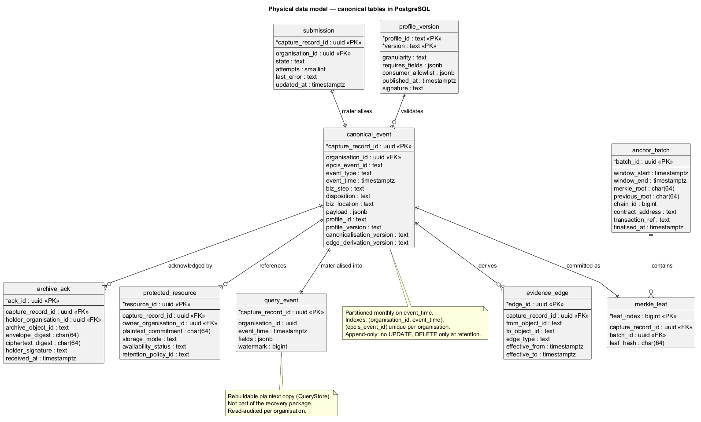
Figure 9 — Physical data model
Figure 9 — Eight tables; the constraints that matter are named below.
Five constraints matter: capture_record_id is the primary key of submission and canonical event, so idempotency identity is identity; merkle_leaf is unique on capture_record_id, which makes anchoring idempotent; canonical_event is partitioned monthly and append-only; payload holds only fields the platform does not query; row-level predicates on organisation_id back the scope filter.
D6. Analytics eats a minimised snapshot and returns messages. The platform must not be able to read rules or findings, and the regulator must not need raw tables (Figure 1). A platform-hosted tenant would give one administrator both.
D7. No warehouse or lake at pilot scale. 10 000 events/day is served by materialised views; a warehouse adds a second consistency boundary and a lake would duplicate private content. Revisit when volume or query mix changes.
These decisions satisfy DM-1 to DM-6: interpretability travels with the event, private content never lands, the archive is authoritative, retention is a recorded state machine, no natural-person field exists, and findings carry their rule version and watermark.

4.3 Where it runs, and who owns it — rubric 4.11–4.15
C1. Managed services, one image running as application or worker. A small team has no operations capacity; IaaS with a self-managed cluster would move patching, HA and backup onto it.
C2. Four accounts, delivered declaratively. This is what makes “the platform can deploy into the regulator’s account but cannot read from or operate it” a property of the pipeline; one account would put an administrator in reach of every control plane.
C3. One region with warm copies, one primary with a reader, and an isolated relayer. The availability target is met without active-active; the relayer holds the only credential that can spend money, so it has no inbound path and a single instance.
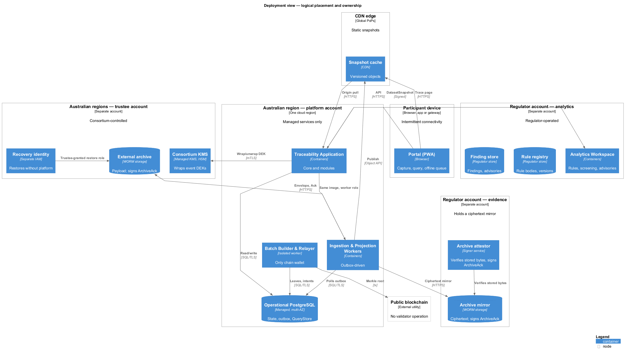
Figure 10 — Logical deployment
Figure 10 — Logical placement: which control domain owns which node.
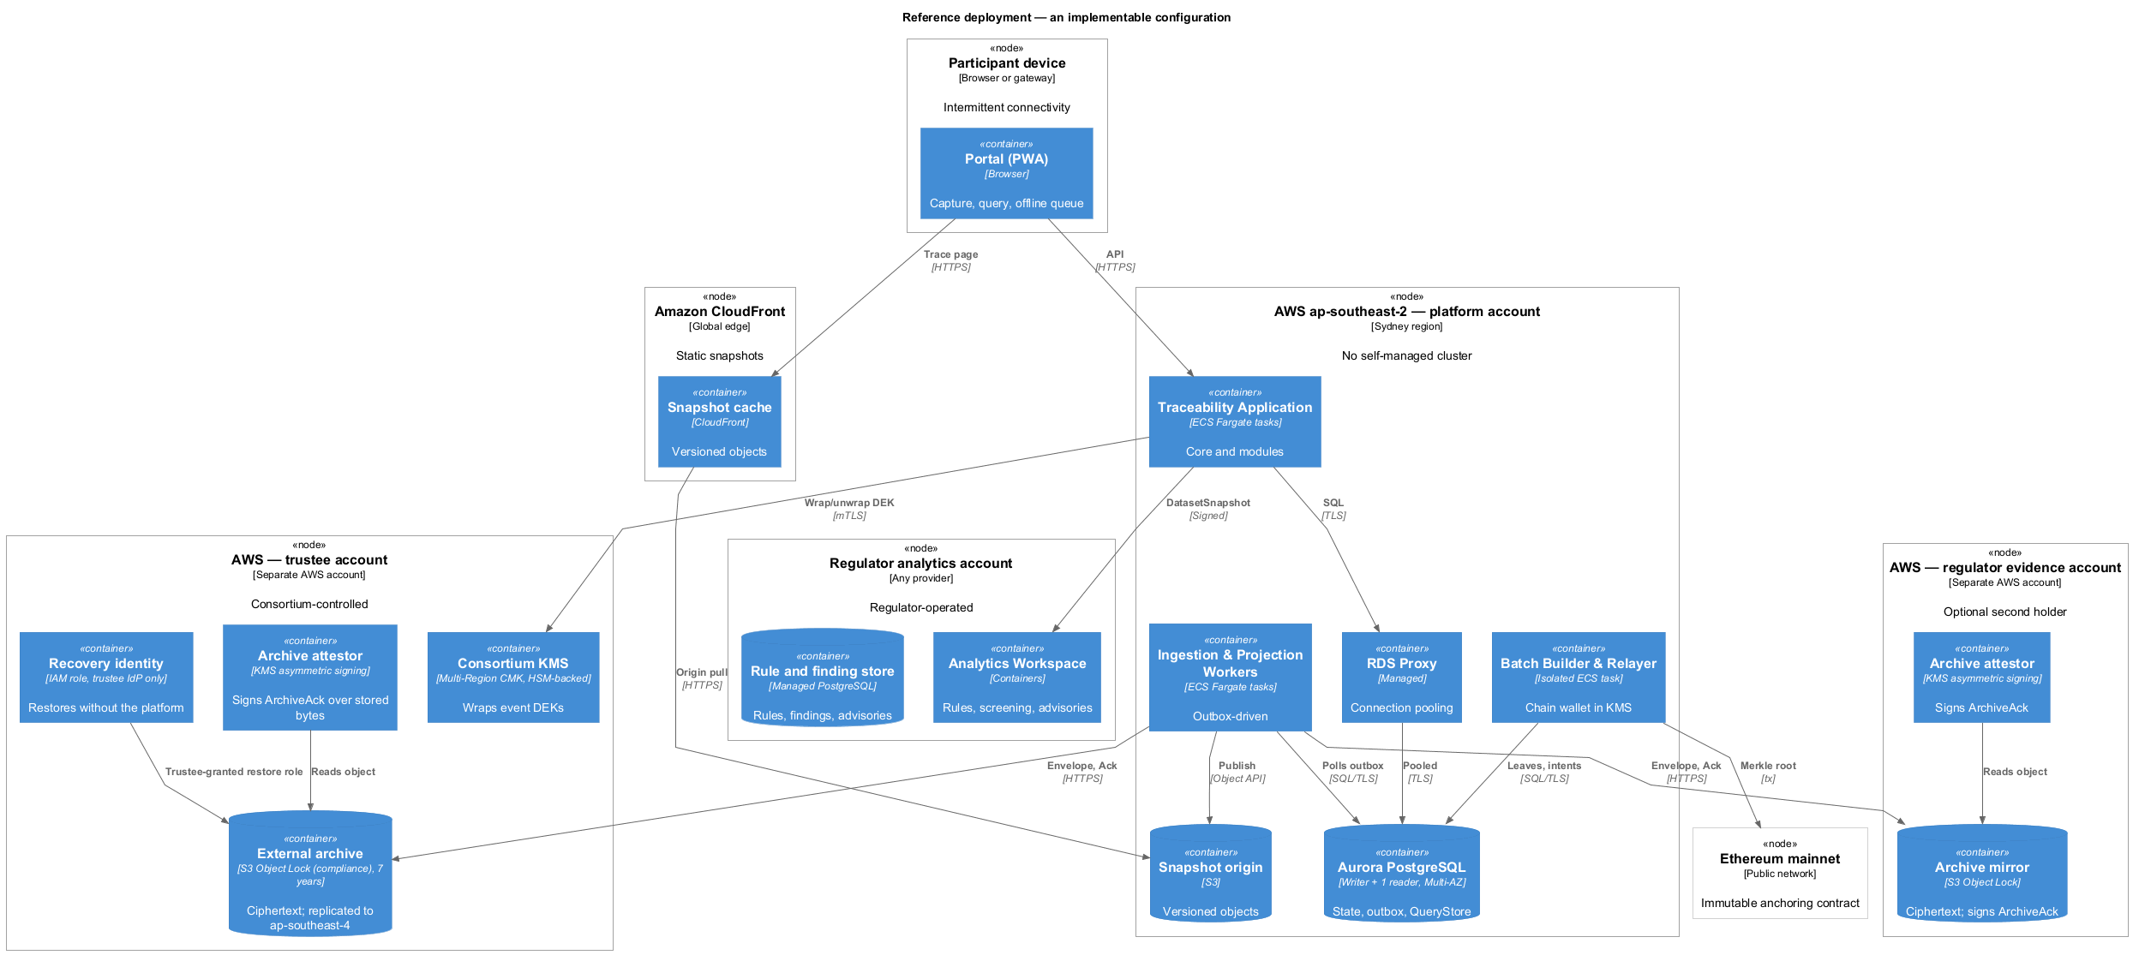
Figure 11 — Reference deployment
Figure 11 — A configuration that can be procured and built.
The logical view answers who owns what; the reference view answers what we would buy. Seven workloads, each with one credential and one scaling unit: application and workers on request rate and outbox lag, the database as a managed primary with a reader, archive and KMS in a trustee account, public delivery behind a CDN.

4.4 The write path and the recall path — rubric 4.16–4.17
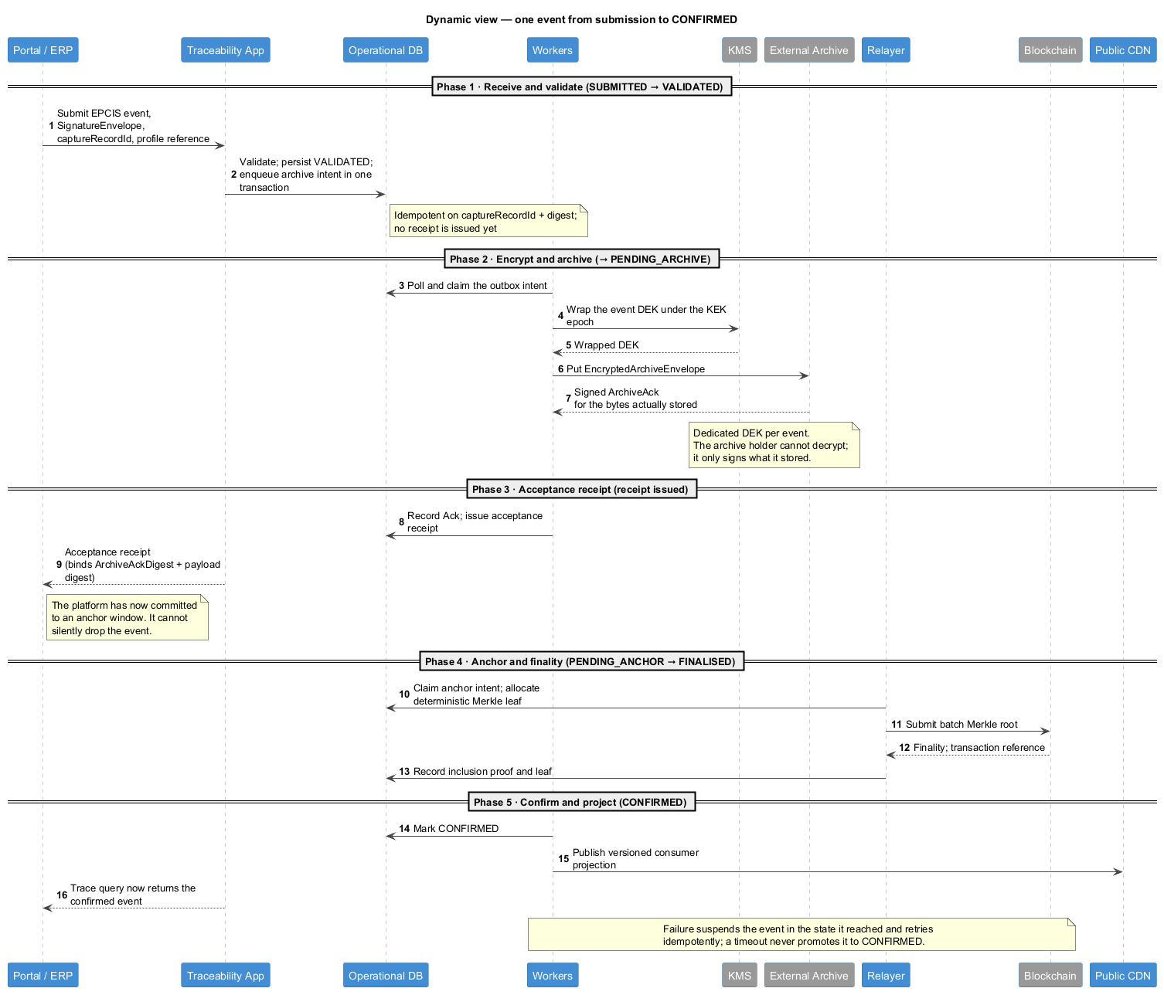
Figure 12 — Dynamic view: event acceptance
Figure 12 — One event from submission to confirmed visibility, in five phases and sixteen steps.
The ordering is the argument: a receipt follows an outside holder’s signature, and confirmation follows finality. No timeout promotes an event, and a failure suspends it where it stands.
Steps | Data crossing | Classification | Boundary crossed
1–2 | Canonical event, signature, identifiers | Consortium | Participant to platform
4–7 | DEK, envelope, ciphertext, acknowledgement | Consortium (encrypted) | Platform to KMS and holder
8–9 | Receipt; anchor intent and leaf | Consortium | Platform to participant
10–13 | Merkle root, transaction reference, inclusion proof | Public commitment | Platform to chain
14–15 | Versioned public projection | Public | Platform to CDN
16 | Trace page for the submitter | Consortium | Application to portal
Step 16 is the submitter reading the event back; the consumer read comes from the CDN at step 15 and never reaches the application.
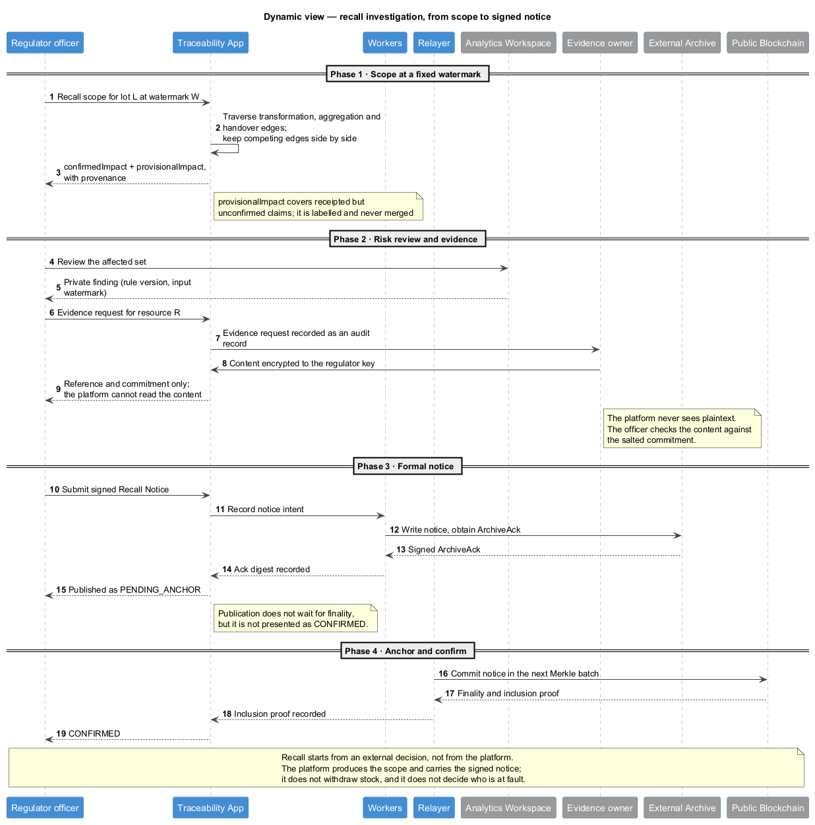
Figure 13 — Dynamic view: recall investigation
Figure 13 — Scope at a watermark, evidence request, signed notice.
The recall path is where privacy is decided: scope at a fixed watermark with provisional claims kept apart, an evidence request that becomes an audit record rather than a data pull, and a notice published as PENDING_ANCHOR before it is CONFIRMED.

4.5 What is protected, and what is accepted — rubric 4.18–4.20
S1. An event is confirmed only after a signature from outside the platform’s account. Otherwise the operator can manufacture a confirmed claim; a platform-signed timestamp would do exactly that.
S2. Each event has its own data key, wrapped by a consortium key held outside the platform. The archive then holds ciphertext it cannot read, so compromising the archive is not disclosing content; a platform-held KEK would make the archive’s independence decorative.
S3. One envelope covers four custody modes, and authority is judged as of signing time. Rotation or a later compromise must not invalidate history; a format per mode and status-at-check-time would.
S4. Private evidence never reaches the platform, and no natural-person field enters the record. The platform cannot be compelled to hand over what it does not hold, and deletion never has to negotiate with an immutable log; field-level encryption on the platform would leave it holding the keys.
S5. Staff have no standing access; break-glass is dual-approved, recorded and anchored. The insider is the highest-privilege threat, and a refusal is itself evidence.
S6. Every principal that can write, read or disclose gets one enforced entry point. Participant-facing (API, portal, onboarding), leaving the account (archive, key service, chain, regulator) and internal (staff, evidence owner) each cross once, which is why STRIDE is a coverage check rather than a generator.
Category | Threat | Mitigation | Residual
Spoofing | A participant claims to be another; a device claims another’s identity | Envelope bound to a verified organisation and key; acting organisation; device delegations | Compromised participant credentials
Tampering | A row or a batch is altered or skipped | Signed digest; append-only; roots commit to the previous root; consistency proofs | Finality is asynchronous
Repudiation | A publisher denies an event; the operator denies an advisory | Non-repudiable signatures; key history; issuer keeps its copy | Keys held by third parties shift the question
Information disclosure | Private evidence leaks; a member reads outside scope | Content never on platform; owner-encrypted recipients; scope at the single read entrance | Metadata and access patterns
Denial of service | Event flood; a holder set that never acknowledges | Quotas, backpressure, bounded queues; two configured holders | A sustained flood degrades others
Elevation of privilege | An operator reads plaintext; a regulator reaches evidence | No standing access; case-scoped grants; anchored access record | A compromised break-glass path is a high-severity incident
Accepted, per requirement: compromised credentials (SP-1), provider-held keys (SP-2), metadata (SP-3), indirect identification (SP-4), colluding approvers (SP-5), a runtime that reads consortium plaintext (SP-6), a compelled regulator mirror (SP-7). SP-8 states the rest in the interface.
No personal field in the record means deletion never negotiates with immutability; content off the platform means there is nothing to compel; classification by construction means no “sensitive but shared” tier can appear. Three risks remain stated rather than mitigated: a compromised runtime, a resourced colluder, and a holder’s own legal obligations.

4.6 Device evidence and screening, in the architecture — rubric 4.B, bonus
AI. Screening runs in the regulator’s workspace over signed rule versions: a model is an alternative implementation of the same interface, which is why the first release has no model loader. Every finding carries its rule or model version and input watermark, so it reproduces; no output becomes an action without an officer’s signature. Rejected: ML at admission (makes a model an adjudicator) and training on the platform’s own copy.
IoT. The boundary sits at the participant: profile-required summaries enter the record, raw readings stay behind a commitment, and devices are organisation delegations rather than users. Collection and alarming are local, availability is the platform’s, verifiability is the archive’s. Rejected: raw telemetry upload and platform-side real-time alerting, which would duplicate the participant’s control loop.

5. Architecture evaluation and alternatives
This section tests the promises made in Sections 1–4 against what the architecture delivers, and names where they fall short.

5.1 How well it does — rubric 5.1–5.4

The objectives, and how each is met — rubric 5.1–5.2
ID | Business objective | Source | Verdict | Evidence and residual gap
BO-1 | An immutable, attributable record of every stage | brief 1 | Met | Envelope, holder-signed acknowledgement, Merkle inclusion; collusion is detectable, not prevented
BO-2 | Farmers, distributors, retailers and consumers all act, not only read | brief 2, 7 | Met, conditionally | Browser capture, offline queue, device-bound signing, WCAG 2.2 AA; a keyless device drafts and signs later
BO-3 | A regulator establishes incident scope quickly and defensibly | brief 5 | Met | Traversal at a watermark with per-edge provenance, cited to the Food Act and Code (Appendix B)
BO-4 | Consumers see a truthful, current-enough view | brief 2 | Met | Versioned snapshots with explicit states; a cached snapshot can lag a notice
BO-5 | Commercial and personal data are not exposed | implied | Met, with residual risk | Content off-platform with owner-chosen recipients; metadata stays visible
BO-6 | Growth across products and regions without a rebuild | brief 4 | Partly met | Profiles are additive; a region still needs a deployment and governance step
BO-7 | Operable by a small team at pilot scale | C6 | Met at pilot scale | Managed services, one deployable; two more operated environments exist
BO-8 | Device evidence without handing over raw telemetry | brief 3 | Met, conditionally | Collection and alarming stay local; summaries are attributable, coverage follows instrumentation
BO-9 | Regulatory screening as a capability, ML optional | bonus | Met structurally | Analytics at all three C4 levels; depends on the regulator operating its runtime
BO-10 | Supply-chain insight is readable, not merely queryable | brief 6 | Partly met | Aggregation and scope designed; the view layer is a thin client, not specified
The evidentiary objectives are met strongly; both Partly met rows are what the design cannot close alone — a second region is a governance act, and a view layer is a client this report does not specify.

ATAM: what breaks, what does not, what trades off — rubric 5.3
ATAM rather than HAZOP: no physical process is controlled, and failure modes are already enumerated as lifecycle states.
Driver | Quality | Scenario | Importance | Difficulty
BO-1 | Integrity | QS-1 operator deletes a batch | H | H
BO-1 | Non-repudiation | QS-2 event verified after two rotations | H | M
BO-1 | Recoverability | QS-5 account lost after a receipt | H | H
BO-3 | Availability | QS-3 recall during an archive outage | H | H
BO-4 | Performance | QS-4 5 000 scans/s after a media story | H | M
BO-2 | Usability | QS-6 capture with 36 hours without signal | H | M
BO-5 | Confidentiality | QS-7 evidence request; QS-8 operations cannot read findings | H | H/M
BO-9 | Availability | QS-11 analytics down while a case is open | H | M
Risks. The confirmation gate depends on parties outside the design: a holder or the chain can stall ingestion, and one relayer holds the only wallet (quorum of one, outbox buffering, key in KMS, deterministic leaves allow re-anchoring). A flat read scope leaves admission as the only confidentiality control (entity verification, sponsor, dual approval). The regulator may not operate its runtime (analytics is optional). A regional loss can take 24 hours, a target proven only by drill. The field floor grows and burdens the smallest participants; retirement is a gap.
Non-risks. A monolith that will not scale — 10 000 events/day is one write every eight seconds. Chain cost exploding — one transaction per window. A plaintext copy contradicting privacy — it holds what the platform may already read, is rebuildable, and never holds private content. An immutable log defeating deletion — no natural-person field enters it.
Trade-offs. Finality versus freshness: a shorter window improves visibility and raises cost; the provisional plane is the compromise. Shared visibility versus confidentiality: a narrower scope would strengthen confidentiality and weaken the recall-authority story. Evidentiary strength versus forensics: hosting private content would help investigations and destroy the privacy claim.

What else could have been built — rubric 5.4
A1 — Permissioned consortium ledger. Four to seven validators with BFT consensus give seconds-level finality and finer privacy, but need four independent operators with HSMs, on-call and a charter; none exists (R1). It wins if an industry body funds them.
A2 — Trusted timestamping plus a transparency log. WORM storage, RFC 3161 timestamps per batch digest and roots in an auditor-co-signed append-only log: two or three trusted institutions instead of a public network, far cheaper, and the strongest fallback. It wins if chain cost, finality variance or policy makes a public network untenable.
A3 — Layer-2 anchoring. The same envelope, leaves and proofs under a rollup: cost down by orders of magnitude and faster confirmation, at the price of a sequencer and a seven-year bet on that L2.
A4 — Microservices with an event bus. The same responsibilities as separate services with per-service databases: independent scaling, paid for with sagas, a broker, a registry and a platform team. Cost without benefit at 10 000 events/day.
Criterion | Chosen | A1 | A2 | A3 | A4
External verifiability | Any third party | Members only | TSA plus auditor | Public via L2 | Same as chosen
Independence | Holder, KMS, chain | Validator set | TSA and log operator | Same as chosen | Same as chosen
Operational burden | Low | High | Lowest | Low | High
Feasibility now (C6) | High | Low | High | High | Medium
Indicative annual cost | Cloud plus A$40–80k anchoring | Staff plus infrastructure | Cloud plus TSA fees | Cloud plus negligible anchoring | Cloud plus platform team
The chosen design is not the best in the abstract but the cheapest that keeps BO-1’s promise without institutions that do not exist. Every alternative changes the edges, not the core.

Appendix A — Traceability
This appendix carries the two matrices that the body refers to, because they are reference material: a reader consults them to check a link, not to understand the design.

A.1 Quality requirement to mechanism to component
Requirement | Mechanism | Where it lives
SQ-1 Integrity | Append-only records, signed digest, external acknowledgement, Merkle inclusion, verifiable batch sequence | Orchestrator; relayer; archive
SQ-2 Non-repudiation | One envelope for all custody modes; key history retained; acceptance-time authority kept separate from cryptographic validity | Signature & Authority Validator
SQ-3 Availability | Fail-closed writes with idempotent retry; reads from materialised data; analytics never in the write path | State machine; workers; outbox
SQ-4 Performance | Edge snapshots; lineage from the plaintext query copy; bounded synchronous traversal | Snapshot delivery; QueryStore; QueryPort
SQ-5 Recoverability | The archive, not the database, is the copy of record; a recovery identity outside the platform rebuilds | Archive; recovery identity
SQ-6 Usability and accessibility | Browser-first capture, durable offline queue, client-generated identifiers, device-bound signing | Portal; CaptureSubmission
SQ-7 Privacy | Three visibility classes with no middle tier; content off-platform behind a salted commitment; no natural-person field | ProtectedResourceRef; SignatureEnvelope
SQ-8 Interoperability | EPCIS 2.0 / CBV; versioned profiles; chain-agnostic leaves | Canonicalisation; profile registry
SQ-9 Auditability | Watermarks on every projection; replayable derivation; findings bound to rule version and watermark | QueryPort; graph builder; manifest
SQ-10 Cost | One modular application, one managed database, no broker, batched anchoring | Container and deployment views
SQ-11 Device evidence | Summary fields declared by the profile, carried as extension fields, raw data behind a reference | Profile validator; ProtectedResourceRef
SQ-12 Regulatory screening | Signed rule versions run in the regulator’s workspace; the advisory returns as a signed message | Analytics workspace
SQ-13 Analysability | Aggregates materialised over the confirmed projection at a watermark, under the same scope rules | Insights module

A.2 Class to component to container
Component | Container | Classes
Capture API, Idempotency | Traceability Application | CaptureSubmission, ProtectedResourceRef
Canonicalisation, Signature Validator | Traceability Application | CanonicalEvent, ProfileVersion, SignatureEnvelope
Archive & Anchor Orchestrator | Traceability Application | ArchiveEnvelope, ArchiveAck, MerkleLeaf, AnchorBatch, AcceptanceReceipt
Store, Graph Builder, QueryPort | Traceability Application | EvidenceEdge, EdgeType, EdgeQuery, EdgeGroup
Anchor Intent Reader, Leaf Allocator, Batch Builder, Chain Submitter, Finality Watcher | Batch Builder & Relayer | — (operates on MerkleLeaf, AnchorBatch)
Analytics Workspace components | Analytics Workspace | DatasetSnapshot, ScreeningRun, Rule, RuleVersion, RuleVersionManifest, Finding, AdvisoryFinding, DisclosurePolicy

Appendix B — Regulation
The body cites obligations in passing. This appendix says what each citation requires and where the design answers it.
Obligation | What it requires | Where the design answers it
Food safety duties and recall powers (NSW Food Act 2003; Food Standards Code) | Conservative recall traversal, signed official notices, and a clear split between “possibly affected” and “confirmed unsafe” | Recall scope at a fixed watermark with provisional set labelled (BO-3); signed notices as canonical events
Australian Privacy Principles; NSW PPIP Act 1998 | No personal identifiers in an immutable trace, minimisation at ingestion, correction and deletion in the mutable layer | Three visibility classes; no natural-person field in the event model; private evidence off-platform (SP-3, SP-4)
Records retention and legal hold | Per-class retention, terminal deletion states, defensible deletion records | Retention state machine, three-party deletion, anchored deletion record (2.3–2.4)
Evidentiary expectations | Chain of custody, authentication, reproducible derivation | Signed declarations, holder acknowledgement, inclusion and consistency proofs, replayable derivation (SQ-1, SQ-9)
Government procurement and residency | Australian regions for non-public data; analytics in the regulator’s own account | Sydney primary with Melbourne copies; four accounts (2.5–2.6, 4.14)

