E-COMPANION

TABLES

Table A1 Airlines in the Dataset
No. | Airline | First quarter in the sample | Last quarter in the sample | Total quarters in the sample
1 | AIRTRAN | 2004 Q1 | 2011 Q1 | 33
2 | ALASKA | 2004 Q1 | 2019 Q4 | 64
3 | ALEEGIANT | 2018 Q1 | 2019 Q4 | 8
4 | AMERICA WEST | 2004 Q1 | 2005 Q4 | 8
5 | AMERICAN | 2004 Q1 | 2019 Q4 | 64
6 | ATA | 2004 Q1 | 2006 Q4 | 12
7 | ATLANTIC SOUTHEAST | 2004 Q1 | 2011 Q4 | 32
8 | COMAIR | 2004 Q1 | 2010 Q4 | 28
9 | CONTINENTAL | 2004 Q1 | 2011 Q4 | 32
10 | DELTA | 2004 Q1 | 2019 Q4 | 64
11 | ENDEAVOR | 2010 Q4 | 2019 Q4 | 13
12 | ENVOY | 2004 Q1 | 2019 Q4 | 56
13 | EXPRESSJET | 2004 Q1 | 2019 Q4 | 62
14 | FRONTIER | 2005 Q2 | 2019 Q4 | 59
15 | HAWAIIAN | 2004 Q1 | 2019 Q4 | 64
16 | INDEPENDENCE | 2004 Q1 | 2005 Q4 | 8
17 | JETBLUE | 2004 Q1 | 2019 Q4 | 64
18 | MESA | 2006 Q1 | 2019 Q4 | 40
19 | NORTHWEST | 2004 Q1 | 2009 Q4 | 24
20 | PSA | 2018 Q1 | 2019 Q4 | 8
21 | REPLUBLIC | 2018 Q1 | 2019 Q4 | 8
22 | SKYWEST | 2004 Q1 | 2019 Q4 | 64
23 | SOUTHWEST | 2004 Q1 | 2019 Q4 | 64
24 | SPIRIT | 2015 Q1 | 2019 Q4 | 20
25 | UNITED | 2004 Q1 | 2019 Q4 | 64
26 | US AIRWAYS | 2004 Q1 | 2015 Q2 | 41
27 | VIRGIN AMERICA | 2012 Q1 | 2017 Q4 | 24

Table A2 Correlation Matrix (All variables have been log-transformed)
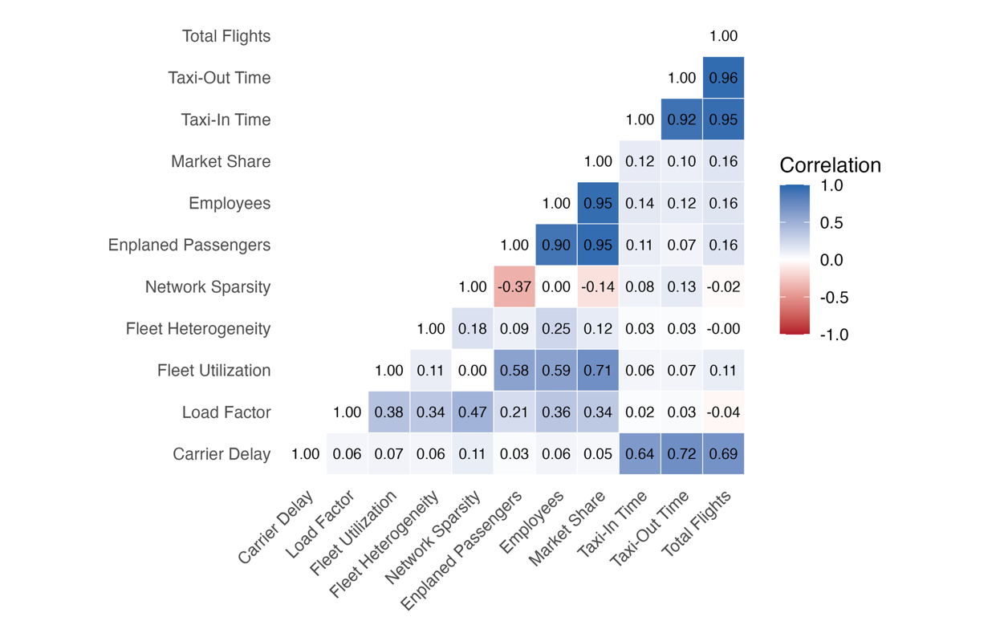

Table A3 Estimating Without Controls
Dependent variable is carrier-controllable delays (Without Controls)
l Wave relative to mergers | $$\hat{μ_{l}}$$ | Standard Error | t-Value
-6 | 0.01 | 0.09 | 0.09
-5 | 0.05 | 0.08 | 0.64
-4 | 0.06 | 0.05 | 1.22
-3 | 0.02 | 0.08 | 0.27
-2 | 0.05 | 0.06 | 0.83
-1 | 0.02 | 0.08 | 0.28
1 | 0.48* | 0.23 | 2.14
2 | 0.34* | 0.16 | 2.17
3 | 0.30° | 0.16 | 1.80
4 | 0.42* | 0.17 | 2.44
5 | 0.49** | 0.13 | 3.65
6 | 0.42** | 0.12 | 3.64
7 | 0.42** | 0.12 | 3.40
8 | 0.39* | 0.14 | 2.69
9 | 0.34* | 0.14 | 2.43
10 | 0.37* | 0.14 | 2.62
11 | 0.52*** | 0.09 | 5.97
12 | 0.55*** | 0.12 | 4.46
13 | 0.48*** | 0.11 | 4.34
14 | 0.32** | 0.11 | 3.02
15 | 0.29* | 0.11 | 2.68
16 | 0.40*** | 0.10 | 4.00
17 | 0.26$°$ | 0.13 | 2.05
18 | 0.17 | 0.18 | 0.90
19 | 0.18 | 0.16 | 1.11
20 | 0.19 | 0.25 | 0.77
Fixed Effects Included: Carrier, Occasion, Route, Year, Quarter.
R² = 0.548, Observation = 167,323
P value: *** 0.001, ** 0.01, * 0.05, $°$0.1. $\hat{μ_{l}}$ are coefficients estimated using stacked regression. Standard errors clustered at carrier level.

Table A4 Using 32 Post-quarters
Dependent variable is carrier-controllable delays
l Wave relative to mergers | $$\hat{μ_{l}}$$ | Standard Error | t-Value | l Wave relative to mergers | $$\hat{μ_{l}}$$ | Standard Error | t-Value
-6 | 0.11 | 0.12 | 0.94 | 14 | 0.16* | 0.06 | 2.79
-5 | 0.12 | 0.08 | 1.42 | 15 | 0.16* | 0.06 | 2.77
-4 | 0.12 | 0.07 | 1.73 | 16 | 0.23*** | 0.06 | 3.67
-3 | 0.07 | 0.08 | 0.89 | 17 | 0.11 | 0.11 | 1.04
-2 | 0.11 | 0.09 | 1.25 | 18 | -0.15 | 0.17 | -0.89
-1 | 0.02 | 0.07 | 0.29 | 19 | -0.15 | 0.17 | -0.92
1 | 0.16* | 0.06 | 2.44 | 20 | -0.12 | 0.16 | -0.73
2 | 0.22** | 0.07 | 3.07 | 21 | -0.18 | 0.16 | -1.16
3 | 0.22* | 0.08 | 2.90 | 22 | -0.20 | 0.23 | -0.86
4 | 0.24* | 0.10 | 2.39 | 23 | -0.14 | 0.18 | -0.77
5 | 0.31* | 0.11 | 2.89 | 24 | 0.08 | 0.15 | 0.49
6 | 0.33* | 0.11 | 2.84 | 25 | 0.09 | 0.16 | 0.57
7 | 0.21* | 0.09 | 2.34 | 26 | 0.08 | 0.23 | 0.36
8 | 0.35* | 0.15 | 2.37 | 27 | -0.10 | 0.24 | -0.44
9 | 0.28$°$ | 0.14 | 1.96 | 28 | 0.16 | 0.20 | 0.79
10 | 0.33* | 0.11 | 2.96 | 29 | 0.11 | 0.22 | 0.53
11 | 0.29*** | 0.07 | 4.00 | 31 | 0.10 | 0.28 | 0.34
12 | 0.32* | 0.14 | 2.21 | 31 | 0.06 | 0.29 | 0.22
13 | 0.28* | 0.13 | 2.22 | 32 | -0.14 | 0.20 | -0.68
Fixed Effects Included: Carrier, Occasion, Route, Year, Quarter. Control variables outputs omitted in reporting.
R² = 0.686, Observation = 216,115
P value: *** 0.001, ** 0.01, * 0.05, $°$0.1. $\hat{μ_{l}}$ are coefficients estimated using stacked regression. Standard errors clustered at carrier level.
Table A5 Using Carrier-induced Delays as a Percentage of Total Delays
Dependent variable is % of carrier-controllable delays out of total delays
l Wave relative to mergers | $$\hat{μ_{l}}$$ | Standard Error | t-Value
-6 | 0.00 | 0.05 | 0.05
-5 | 0.02 | 0.06 | 0.31
-4 | -0.02 | 0.05 | -0.35
-3 | -0.01 | 0.05 | -0.17
-2 | 0.02 | 0.02 | 1.01
-1 | 0.02 | 0.02 | 0.90
1 | 0.11* | 0.04 | 2.44
2 | 0.10* | 0.04 | 2.38
3 | 0.10*** | 0.02 | 6.24
4 | 0.13* | 0.05 | 2.75
5 | 0.11* | 0.05 | 2.15
6 | 0.14*** | 0.04 | 4.03
7 | 0.13** | 0.04 | 3.39
8 | 0.15* | 0.05 | 2.73
9 | 0.13** | 0.04 | 3.22
10 | 0.09* | 0.04 | 2.39
11 | 0.09* | 0.04 | 2.65
12 | 0.12** | 0.03 | 3.73
13 | 0.10** | 0.03 | 3.68
14 | 0.10*** | 0.02 | 4.95
15 | 0.09*** | 0.02 | 4.00
16 | 0.10* | 0.04 | 2.23
17 | 0.07*** | 0.02 | 3.79
18 | 0.05** | 0.02 | 3.20
19 | 0.02 | 0.02 | 1.00
20 | 0.00 | 0.02 | -0.24
Fixed Effects Included: Carrier, Occasion, Route, Year, Quarter. Control variables outputs omitted in reporting.
R² = 0.597, Observation = 215,811
P value: *** 0.001, ** 0.01, * 0.05, $°$0.1. $\hat{μ_{l}}$ are coefficients estimated using stacked regression. Standard errors clustered at carrier level.

Table A6 Static Effect of Mergers on Target—Estimated using Stacked Regression
Variables | δ^{DD} | Standard Error |  | t-Value
Dependent variable is carrier-controllable delays
Treated | 0.06 | 0.11 | 0.50
Load factor | 3.31$°$ | 1.82 | 1.82
Fleet Utilization | -0.08 | 0.30 | -0.27
Fleet Heterogeneity | 0.02 | 0.04 | 0.58
Network Sparsity | 0.11 | 0.28 | 0.37
# of Enplaned Passengers | 0.79 | 0.82 | 0.96
# of Employees | 0.43 | 0.45 | 0.95
Market Share | -1.40 | 1.03 | -1.36
Taxi In (Min) | 0.14** | 0.04 | 3.43
Taxi Out (Min) | 0.54** | 0.14 | 3.86
Total Flights | 0.23 | 0.14 | 1.68
Fixed Effects Included: Carrier, Occasion, Route, Year, Quarter
R² = 0.667 Observations = 66,772
P value: *** 0.001, ** 0.01, * 0.05, $°$0.1. δ^{DD} are coefficients estimated using stacked regression. SE clustered at carrier level.

Table A7 Long Term Effect of Mergers on Target—Estimated using Stacked Regression
Dependent variable is carrier-controllable delays
Panel A (Time Indicators) |  |  |  | Panel B (Control Variables)
l Wave relative to mergers | $$\hat{μ_{l}}$$ | Standard Error | t-Value | Control Variables | $$β$$ | Standard Error | t-Value
-6 | 0.39 | 0.33 | 1.17 | Load factor | 2.78$°$ | 1.55 | 1.80
-5 | 0.40 | 0.34 | 1.16 | Fleet Utilization | -0.09 | 0.21 | -0.43
-4 | 0.41$°$ | 0.22 | 1.88 | Fleet Heterogeneity | -0.01 | 0.04 | -0.13
-3 | 0.42* | 0.19 | 2.21 | Network Sparsity | -0.10 | 0.29 | -0.35
-2 | 0.22 | 0.20 | 1.08 | # of Enplaned Passengers | 1.47* | 0.60 | 2.44
-1 | 0.07 | 0.21 | 0.33 | # of Employees | -0.03 | 0.47 | -0.07
1 | 0.26 | 0.16 | 1.62 | Market Share | -1.78* | 0.73 | -2.45
2 | 0.13 | 0.13 | 0.95 | Taxi In (Min) | 0.14* | 0.06 | 2.33
3 | 0.13 | 0.13 | 1.01 | Taxi Out (Min) | 0.64*** | 0.13 | 4.90
4 | 0.17 | 0.13 | 1.26 | Total Flights | 0.13 | 0.15 | 0.86
5 | -0.03 | 0.14 | -0.24
6 | -0.10 | 0.13 | -0.80
7 | -0.08 | 0.11 | -0.72
8 | 0.01 | 0.11 | 0.11
9 | -0.25* | 0.10 | -2.44
10 | -0.06 | 0.06 | -1.01
Fixed Effects Included: Carrier, Occasion, Route, Year, Quarter
R² = 0.681, Observation = 66,527
P value: *** 0.001, ** 0.01, * 0.05, $°$0.1. $\hat{μ_{l}}$ are coefficients for time indicators. Standard errors clustered at carrier level.

Table A8 Merger Impact on Legacy Carriers VS Low-cost Carriers
Dependent variable is carrier-controllable delays
Panel A (Legacy) |  |  |  |  | Panel B (LCC)
l Wave relative to mergers | $$\hat{μ_{l}}$$ | Standard Error | t-Value | l Wave relative to mergers |  | $$\hat{μ_{l}}$$ | Standard Error | t-Value
-6 | 0.00 | 0.05 | 0.03 | -6 |  | -0.02 | 0.09 | -0.26
-5 | 0.04 | 0.06 | 0.63 | -5 |  | 0.06 | 0.09 | 0.66
-4 | -0.01 | 0.06 | -0.20 | -4 |  | -0.01 | 0.20 | -0.05
-3 | 0.06 | 0.08 | 0.82 | -3 |  | -0.01 | 0.19 | -0.06
-2 | 0.13 | 0.11 | 1.17 | -2 |  | 0.10 | 0.07 | 1.40
-1 | 0.07 | 0.09 | 0.76 | -1 |  | 0.04 | 0.09 | 0.44
1 | 0.40* | 0.18 | 2.26 | 1 |  | -0.34*** | 0.06 | -5.61
2 | 0.42* | 0.18 | 2.33 | 2 |  | -0.58*** | 0.10 | -5.70
3 | 0.48$°$ | 0.23 | 2.07 | 3 |  | -0.62** | 0.18 | -3.47
4 | 0.52** | 0.16 | 3.22 | 4 |  | -0.59*** | 0.08 | -6.99
5 | 0.66** | 0.20 | 3.24 | 5 |  | -0.47*** | 0.11 | -4.10
6 | 0.66** | 0.20 | 3.29 | 6 |  | -0.45*** | 0.09 | -4.87
7 | 0.65* | 0.23 | 2.77 | 7 |  | -0.52*** | 0.12 | -4.20
8 | 0.55* | 0.20 | 2.72 | 8 |  | -0.64*** | 0.11 | -5.79
9 | 0.50$°$ | 0.22 | 2.27 | 9 |  | -0.56*** | 0.09 | -5.96
10 | 0.55$°$ | 0.29 | 1.91 | 10 |  | -0.43** | 0.16 | -2.76
11 | 0.64* | 0.25 | 2.61 | 11 |  | -0.25$°$ | 0.13 | -1.87
12 | 0.61*** | 0.17 | 3.61 | 12 |  | -0.48** | 0.14 | -3.47
13 | 0.64** | 0.21 | 3.14 | 13 |  | -0.48*** | 0.13 | -3.61
14 | 0.43$°$ | 0.24 | 1.81 | 14 |  | -0.66*** | 0.16 | -4.07
15 | 0.43$°$ | 0.23 | 1.87 | 15 |  | -0.60** | 0.19 | -3.21
16 | 0.46* | 0.22 | 2.10 | 16 |  | -0.72*** | 0.19 | -3.83
17 | 0.49$°$ | 0.28 | 1.73 | 17 |  | -0.78** | 0.25 | -3.15
18 | 0.42 | 0.33 | 1.27 | 18 |  | -0.97** | 0.30 | -3.23
19 | 0.26 | 0.36 | 0.73 | 19 |  | -0.95* | 0.35 | -2.76
20 | 0.44 | 0.27 | 1.62 | 20 |  | -1.02** | 0.33 | -3.12
Fixed Effects Included: Carrier, Occasion, Route, Year, Quarter. Control variables outputs omitted in reporting.
R² = 0.695 , Observation = 150, 87 |  |  |  |  | R² = 0.686 , Observation = 84,173
P value: *** 0.001, ** 0.01, * 0.05, $°$0.1. $\hat{μ_{l}}$ are coefficients estimated using stacked regression. Standard errors clustered at carrier level.

Table A9 Merger Impact Estimated in Delay Quantiles
Dependent variable is carrier-controllable delays
 | 0-25th |  | 25-50th |  | 50-75th |  | 75th+
l Wave relative to mergers | $$\hat{μ_{l}}$$ | Standard Error | $$\hat{μ_{l}}$$ | Standard Error | $$\hat{μ_{l}}$$ | Standard Error | $$\hat{μ_{l}}$$ | Standard Error
-6 | 0.10$°$ | 0.06 | 0.02 | 0.01 | 0.05 | 0.03 | 0.07 | 0.05
-5 | 0.11 | 0.08 | 0.04 | 0.02 | 0.06* | 0.02 | 0.04 | 0.04
-4 | 0.10* | 0.04 | 0.02 | 0.01 | 0.02 | 0.03 | 0.01 | 0.04
-3 | 0.05 | 0.07 | 0.04 | 0.01 | 0.04 | 0.02 | 0.03 | 0.04
-2 | 0.06 | 0.06 | 0.05* | 0.01 | 0.01 | 0.02 | -0.03 | 0.07
-1 | 0.05 | 0.08 | 0.01 | 0.02 | 0.02$°$ | 0.01 | -0.05 | 0.04
1 | 0.10$°$ | 0.06 | 0.04$°$ | 0.02 | 0.01 | 0.01 | -0.01 | 0.03
2 | 0.04 | 0.06 | 0.03$°$ | 0.01 | 0.03* | 0.01 | -0.07 | 0.06
3 | 0.11 | 0.09 | 0.02 | 0.02 | 0.02 | 0.02 | -0.11** | 0.05
4 | 0.03 | 0.08 | 0.05* | 0.02 | 0.05** | 0.02 | 0.00 | 0.06
5 | 0.15* | 0.07 | 0.06* | 0.02 | 0.04$°$ | 0.02 | -0.02 | 0.04
6 | 0.21** | 0.06 | 0.08** | 0.02 | 0.03 | 0.02 | -0.08 | 0.06
7 | 0.22** | 0.08 | 0.05*** | 0.01 | 0.02 | 0.01 | -0.04 | 0.06
8 | 0.18** | 0.07 | 0.05* | 0.02 | 0.03$°$ | 0.02 | 0.05 | 0.06
9 | 0.20** | 0.08 | 0.05** | 0.02 | 0.00 | 0.02 | 0.02 | 0.07
10 | 0.23*** | 0.05 | 0.05$°$ | 0.03 | 0.01 | 0.02 | 0.09 | 0.07
11 | 0.19** | 0.06 | 0.07** | 0.02 | 0.04* | 0.01 | 0.13 | 0.08
12 | 0.26*** | 0.06 | 0.04* | 0.02 | 0.04* | 0.01 | 0.16** | 0.06
13 | 0.23** | 0.08 | 0.05** | 0.02 | 0.03 | 0.02 | 0.11* | 0.06
14 | 0.15** | 0.04 | 0.04** | 0.01 | 0.00 | 0.01 | -0.02 | 0.07
15 | 0.16** | 0.06 | 0.04* | 0.02 | -0.01 | 0.01 | 0.00 | 0.05
16 | 0.14** | 0.05 | 0.02 | 0.01 | -0.01 | 0.02 | 0.11* | 0.06
17 | 0.12 | 0.08 | 0.02 | 0.03 | -0.02 | 0.02 | 0.05 | 0.07
18 | 0.05 | 0.13 | 0.03$°$ | 0.02 | -0.01 | 0.02 | -0.02 | 0.09
19 | 0.11 | 0.07 | 0.02 | 0.03 | -0.03 | 0.02 | -0.02 | 0.08
20 | 0.00 | 0.16 | 0.02 | 0.03 | -0.02 | 0.01 | 0.01 | 0.07
Fixed Effects Included: Carrier, Occasion, Route, Year, Quarter. Control variables outputs omitted in reporting.
 | R² = 0.756, Observation = 43,177 |  | R² = 0.967, Observation = 52,698 |  | R² = 0.977, Observation = 56,409 |  | R² = 0.899,  Observation = 67,188
P value: *** 0.001, ** 0.01, * 0.05, $°$0.1. $\hat{μ_{l}}$ are coefficients of time indicators.. Standard errors clustered at carrier level.
Note: t-Value omitted to fit the table.

Table A10 Number of Mergers of Each Acquirer 1970 – 2019
Carrier | # of U.S. domestic MA deals since 1970 | Domestic Mergers/Acquisitions Counted
AA (American Airlines) | 4 | Trans Caribbean (1971, domestic by incorporation though Caribbean-focused), AirCal (1987), Reno Air (1999), US Airways (2013)
DL (Delta Air Lines) | 3 | Northeast Airlines (1972), Western Airlines (1987), Northwest Airlines (2008)
UA (United Airlines) | 1 | Continental Airlines (2010)
HP (America West) | 1 | US Airways (2005; created today’s US Airways Group that merged later with AA)
AS (Alaska Airlines) | 2 | Jet America (1987), Virgin America (2016; U.S. carrier)
XE (ExpressJet) | 1 | Atlantic Southeast Airlines (2011, both regional U.S. carriers under SkyWest/ExpressJet consolidation)
F9 (Frontier Airlines) | 1 | MidWest Airlines (2011)
WN (Southwest Airlines) | 3 | Muse Air (1985), Morris Air (1993), AirTran Airways (2011)

Table A11 Merger Impact on Carrier-induced Delays Estimated by Carrier Merger Experience
Dependent variable is carrier-controllable delays
 | First Timer |  | Two Mergers |  |  | Three Mergers |  |  | Four Mergers
l Wave relative to mergers | $$\hat{μ_{l}}$$ | Standard Error | $$\hat{μ_{l}}$$ | Standard Error | $$\hat{μ_{l}}$$ |  | Standard Error | $$\hat{μ_{l}}$$ |  | Standard Error
-6 | 0.17** | 0.04 | 0.05 | 0.01 | 0.21* |  | 0.06 | 0.05 |  | 0.04
-5 | 0.19* | 0.04 | 0.03 | 0.01 | 0.20* |  | 0.06 | 0.02 |  | 0.05
-4 | 0.21** | 0.03 | 0.05 | 0.01 | 0.20* |  | 0.05 | -0.03 |  | 0.04
-3 | 0.18** | 0.05 | -0.02 | 0.05 | 0.20* |  | 0.06 | 0.06 |  | 0.12
-2 | -0.11 | 0.09 | -0.19* | 0.07 | 0.00 |  | 0.05 | 0.05 |  | 0.05
-1 | -0.21* | 0.10 | -0.09 | 0.05 | -0.04 |  | 0.07 | -0.05 |  | 0.06
1 | -0.33*** | 0.04 | -0.21*** | 0.02 | -0.04 |  | 0.03 | 0.16*** |  | 0.02
2 | -0.60*** | 0.14 | -0.42** | 0.13 | -0.29$°$ |  | 0.16 | -0.04 |  | 0.13
3 | -0.47** | 0.13 | -0.50* | 0.19 | -0.39** |  | 0.14 | -0.22 |  | 0.15
4 | -0.47** | 0.13 | -0.69*** | 0.14 | -0.53*** |  | 0.12 | 0.23* |  | 0.10
5 | -0.39** | 0.15 | -0.47** | 0.13 | -0.32** |  | 0.11 | 0.42*** |  | 0.06
6 | -0.51* | 0.21 | -0.39*** | 0.06 | -0.54** |  | -0.17 | 0.29* |  | 0.13
7 | -0.53** | 0.18 | -0.52*** | 0.08 | -0.58*** |  | 0.07 | 0.13 |  | 0.15
8 | -0.63** | 0.18 | -0.50*** | 0.10 | -0.41** |  | 0.11 | 0.52*** |  | 0.12
9 | -0.69** | 0.22 | -0.62*** | 0.11 | -0.29* |  | 0.11 | 0.39** |  | 0.12
10 | -0.78** | 0.21 | -0.61*** | 0.13 | -0.01 |  | 0.12 | 0.38** |  | 0.12
11 | -0.53** | 0.17 | -0.40** | 0.11 | 0.09 |  | 0.09 | 0.38** |  | 0.10
12 | -0.39$°$ | 0.21 | -0.46** | 0.15 | -0.11 |  | 0.15 | 0.38* |  | 0.14
13 | -0.48* | 0.20 | -0.41* | 0.19 | -0.09 |  | 0.18 | 0.40** |  | 0.13
14 | -0.79** | 0.24 | -0.60** | 0.16 | -0.32* |  | 0.13 | 0.10 |  | 0.15
15 | -0.75** | 0.23 | -0.68** | 0.18 | -0.30* |  | 0.13 | 0.05 |  | 0.16
16 | -0.73*** | 0.14 | -0.53** | 0.18 | -0.06 |  | 0.11 | 0.43** |  | 0.11
17 | -0.80** | 0.18 | -0.71** | 0.22 | 0.03 |  | 0.15 | 0.25$°$ |  | 0.14
18 | -0.93** | 0.22 | -0.81** | 0.26 | -0.20 |  | 0.20 | -0.03 |  | 0.20
19 | -1.05** | 0.28 | -0.75** | 0.30 | -0.13 |  | 0.22 | -0.02 |  | 0.22
20 | -0.70** | 0.31 | -1.18** | 0.31 | -0.38 |  | 0.22 | 0.09 |  | 0.24
Fixed Effects Included: Carrier, Occasion, Route, Year, Quarter. Control variables outputs omitted in reporting.
 | R² = 0.682,  Observation = 89,085 |  | R² = 0.685,  Observation = 49,522 |  |  | R² = 0.699,  Observation = 116,141 |  |  | R² = 0.687,  Observation = 71,468
P value: *** 0.001, ** 0.01, * 0.05, $°$0.1. $\hat{μ_{l}}$ are coefficients of time indicators.. Standard errors clustered at carrier level.
Note: t-Value omitted to fit the table.

Table A12 Robustness Tests – Using Classic TWFE Event Study and Using Total Delays as DV
 | Panel A (Original Data) |  |  |  | Panel B (Stacked Clean Data)
 | Estimated in TWFE |  |  |  | Estimated in Stacked Regression
 | Dependent variable is carrier-controllable delays |  |  |  | Dependent variable is Total Delays
l Wave | $$\hat{μ_{l}}$$ | SE | t-Value | $$\hat{μ_{l}}$$ |  | SE | t-Value
-6 | 0.00 | 0.16 | 0.03 | -0.06 |  | 0.07 | -0.77
-5 | 0.14 | 0.15 | 0.92 | 0.01 |  | 0.06 | 0.11
-4 | 0.07 | 0.10 | 0.69 | 0.05 |  | 0.04 | 1.34
-3 | -0.05 | 0.09 | -0.59 | 0.09$°$ |  | 0.05 | 1.87
-2 | 0.13 | 0.08 | 1.55 | 0.09 |  | 0.07 | 1.26
-1 | 0.01 | 0.07 | 0.17 | 0.07 |  | 0.06 | 1.22
1 | 0.06 | 0.08 | 0.81 | 0.17$°$ |  | 0.09 | 1.94
2 | 0.01 | 0.12 | 0.12 | 0.07 |  | 0.10 | 0.70
3 | 0.07 | 0.14 | 0.50 | 0.10 |  | 0.14 | 0.76
4 | 0.14 | 0.13 | 1.14 | 0.17 |  | 0.12 | 1.43
5 | 0.08 | 0.14 | 0.59 | 0.17 |  | 0.10 | 1.71
6 | 0.15 | 0.15 | 0.99 | 0.15$°$ |  | 0.08 | 1.84
7 | 0.04 | 0.16 | 0.23 | 0.13 |  | 0.13 | 0.98
8 | 0.02 | 0.12 | 0.14 | 0.10 |  | 0.09 | 1.20
9 | 0.01 | 0.11 | 0.11 | 0.13 |  | 0.08 | 1.63
10 | 0.04 | 0.09 | 0.44 | 0.21* |  | 0.09 | 2.26
11 | 0.11 | 0.11 | 1.01 | 0.28** |  | 0.08 | 3.79
12 | 0.00 | 0.12 | 0.03 | 0.19 |  | 0.13 | 1.48
13 | 0.09 | 0.11 | 0.85 | 0.24$°$ |  | 0.11 | 2.09
14 | -0.01 | 0.11 | -0.14 | 0.09 |  | 0.09 | 1.03
15 | -0.06 | 0.11 | -0.50 | 0.09 |  | 0.10 | 0.87
16 | 0.03 | 0.09 | 0.31 | 0.08 |  | 0.09 | 0.88
17 | 0.00 | 0.10 | 0.03 | 0.15 |  | 0.11 | 1.33
18 | -0.02 | 0.12 | -0.13 | 0.04 |  | 0.08 | 0.54
19 | -0.08 | 0.14 | -0.60 | 0.01 |  | 0.10 | 0.14
20 | -0.04 | 0.12 | -0.32 | 0.11 |  | 0.16 | 0.66
 | R² = 0.617 Observation = 333,394 |  |  |  | R² = 0.982 Observation = 168,301
All control variables included but omitted to save space
Fixed Effects Included: Carrier, Occasion, Route, Year, Quarter
P value: *** 0.001, ** 0.01, * 0.05, $°$0.1.
Panel A of Table 11 shows the results of a classic TWFE event study using the original data (carrier-induced delays as the outcome), while Panel B presents the results of a stacked regression using stacked data (total delays as the outcome).

Table A13 Comparing Different Estimators – Using Event Window of –6 to 20 for All Estimators
Dependent variable is carrier-controllable delays
 | Stacked Regression |  |  | Callaway and Sant’Anna |  | Sun and Abraham
l wave | $$\hat{μ_{l}}$$ | SE | t-stat | $$\hat{μ_{l}}$$ | SE | $$\hat{μ_{l}}$$ | SE | t-stat
-6 | 0.12 | 0.12 | 1.06 | 0.11 | 0.07 | 0.10 | 0.07 | 1.43
-5 | 0.11 | 0.07 | 1.55 | 0.09 | 0.06 | 0.08 | 0.06 | 1.33
-4 | 0.10$°$ | 0.05 | 2.00 | 0.05 | 0.08 | 0.06 | 0.07 | 0.90
-3 | 0.05 | 0.07 | 0.77 | 0.04 | 0.11 | 0.04 | 0.06 | 0.66
-2 | 0.11 | 0.08 | 1.39 | 0.07 | 0.08 | 0.07 | 0.07 | 0.94
-1 | -0.02 | 0.05 | -0.49 | 0.08 | 0.07 | 0.09 | 0.08 | 1.14
1 | 0.23$°$ | 0.12 | 1.90 | 0.04 | 0.07 | 0.09 | 0.08 | 1.14
2 | 0.13 | 0.09 | 1.38 | 0.15$°$ | 0.07 | 0.24* | 0.09 | 2.68
3 | 0.17 | 0.12 | 1.51 | 0.21* | 0.07 | 0.24* | 0.09 | 2.67
4 | 0.20$°$ | 0.11 | 1.93 | 0.30* | 0.08 | 0.32** | 0.08 | 3.97
5 | 0.32* | 0.12 | 2.61 | 0.26* | 0.08 | 0.37*** | 0.08 | 4.64
6 | 0.33** | 0.10 | 3.40 | 0.47** | 0.09 | 0.47*** | 0.07 | 6.70
7 | 0.32** | 0.10 | 3.11 | 0.38** | 0.10 | 0.38*** | 0.09 | 4.26
8 | 0.26* | 0.11 | 2.39 | 0.30** | 0.07 | 0.37*** | 0.06 | 6.11
9 | 0.21$°$ | 0.11 | 1.96 | 0.32* | 0.08 | 0.35*** | 0.06 | 5.77
10 | 0.28* | 0.13 | 2.19 | 0.53** | 0.10 | 0.61*** | 0.10 | 6.13
11 | 0.38*** | 0.09 | 4.40 | 0.55*** | 0.14 | 0.64*** | 0.11 | 5.80
12 | 0.33** | 0.11 | 2.93 | 0.43*** | 0.11 | 0.43*** | 0.09 | 4.73
13 | 0.35*** | 0.09 | 4.02 | 0.38*** | 0.11 | 0.43** | 0.11 | 3.94
14 | 0.15* | 0.07 | 2.26 | 0.23** | 0.13 | 0.26* | 0.11 | 2.39
15 | 0.13$°$ | 0.07 | 1.83 | 0.24* | 0.11 | 0.20* | 0.09 | 2.25
16 | 0.19* | 0.07 | 2.64 | 0.25* | 0.10 | 0.21* | 0.08 | 2.56
17 | 0.15 | 0.11 | 1.38 | 0.25° | 0.12 | 0.25* | 0.12 | 2.06
18 | 0.06 | 0.15 | 0.43 | 0.19 | 0.10 | 0.15 | 0.11 | 1.37
19 | 0.01 | 0.16 | 0.05 | 0.08 | 0.11 | 0.06 | 0.11 | 0.55
20 | 0.01 | 0.19 | 0.06 | 0.08 | 0.09 | 0.10 | 0.12 | 0.81
R² | 0.695 |  |  | NA |  | 0.614
# of observations |  |  | 226,956 |  |  | 111, 201 | 111,201
All control variables included but omitted in reporting to fit the table
Fixed Effects Included: Fixed Effects Included: Carrier, Occasion, Route, Year, Quarter
P value: *** 0.001, ** 0.01, * 0.05, $°$0.1
Note: Callaway and Sant’Anna estimator does not report t statistics.
$\hat{μ_{l}}$ are coefficients for time indicators. Standard errors clustered at carrier level.

FIGURES

Figure A1 Comparing Trendlines With and Without Controls
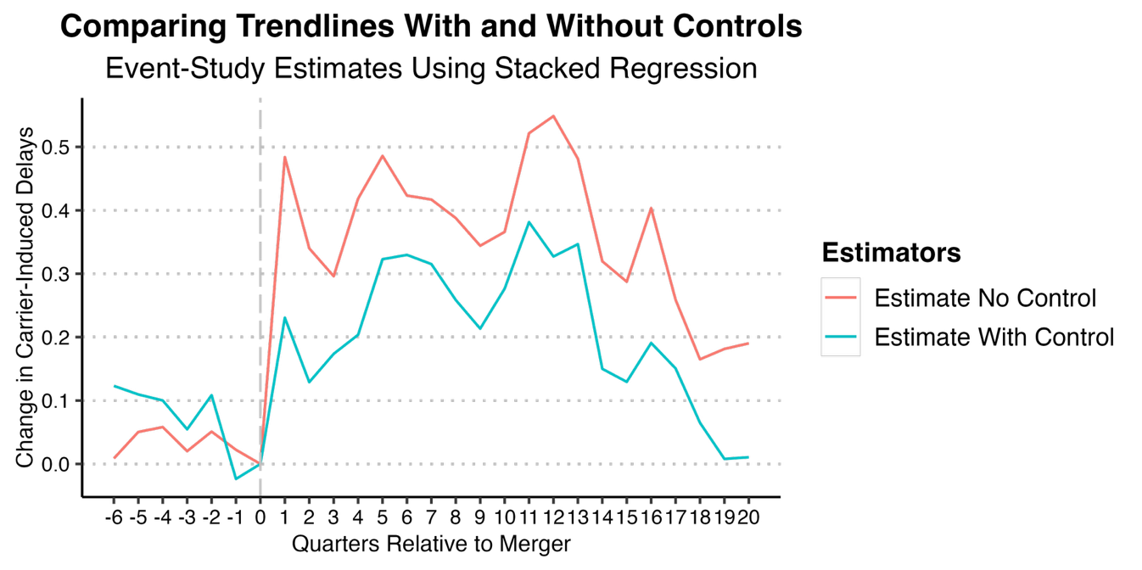

Figure A2 Estimating 32 Post Quarters
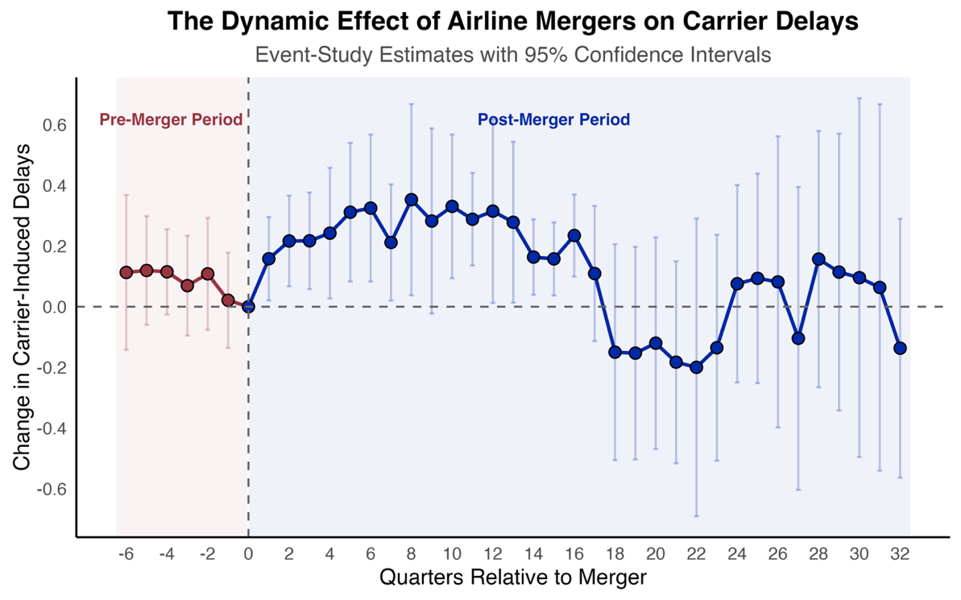

Figure A3 Using Carrier-induced Delays as a Percentage of Total Delays
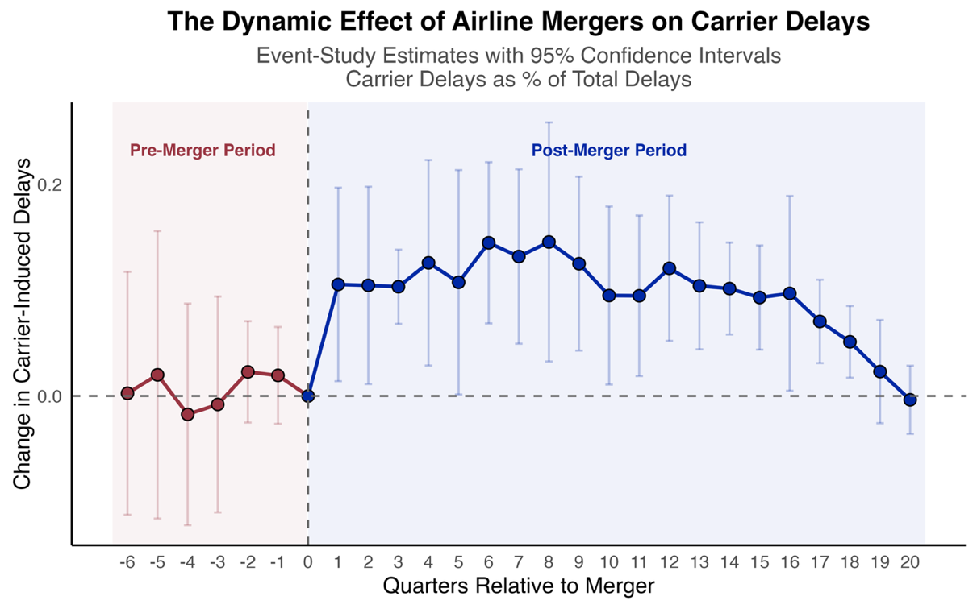
Figure A4 Using Monthly Level Data to Estimate Treatment Effect
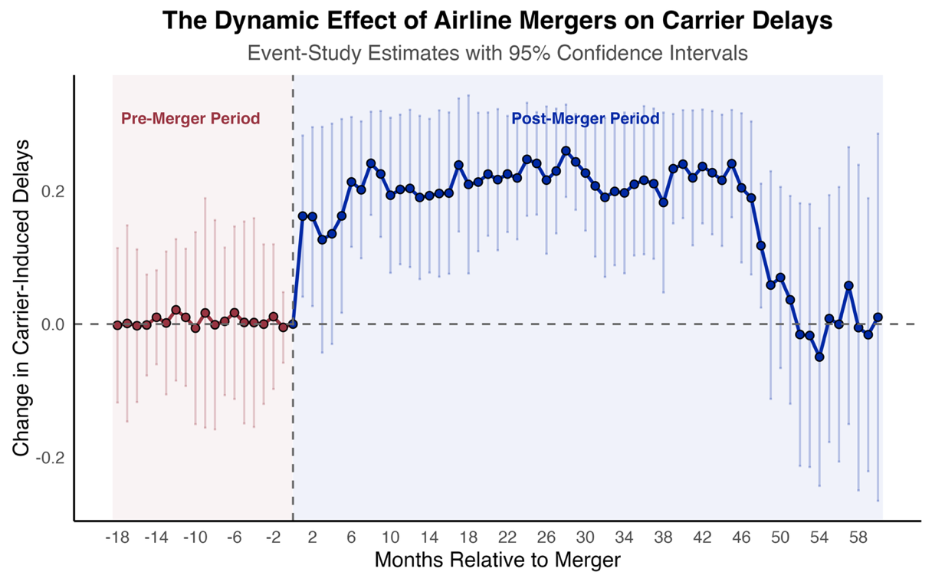

APPENDIX

Appendix 1 The Impact of Mergers in the U.S. Airline Industry

Authors | Impact of Mergers | Mergers Examined | Time Period Before and After Mergers | Level of Analysis | Method | Main Findings
Bilotkach 2011 | Flight frequency | America West-US in 2005 | Two years before and two years after | Carrier-airport | GLS and 2SLS | Flight frequency decreased at a diminishing rate following mergers.
Bilotkach et al. 2013 | Flight frequency | Delta-Northwest in 2009 | Two years before and two years after | Route | Difference-in-difference | Flight frequency increased in some hubs but decreased in others.
Borenstein 1990 | Fare | Northwest–Republic and Trans World–Ozark in 1986 | One year before and one year after | Route | ANOVA | Price increases for the Northwest–Republic merger of about 10% in total. Largely insignificant results for the Trans World–Ozark merger.
Carlton et al. 1980 | Consumer welfare | North Central-Southern in 1976 | 1976 the merger year | City-carrier | Logit regression | Consumer welfare gains following mergers in terms of shorter travelling time.
Carlton et al. 2019 | Fare | Delta-Northwest in 2009; American-US in 2013; United-Continental in 2010 | Two years before and two years after | Route | Difference-in-difference | Mergers did not increase fares.
Flouris and Swidler 2004 | Stock market response | American–Trans World in 2001 | 10 occasions before and after the announcement date | Carrier | Event study | Equity value declined more than 30% following the merger.
Gong and Firth 2006 | Stock market response | 15 mergers between 1985 and 2001 | 5 days centered on the announcement event. | Carrier | Event study | Marginally positive abnormal return for bidders and highly positive abnormal return for target around the 1st public announcement of the merger.
González et al. (2024) | Carrier Delays | Three Mergers: US-America West; Delta-Northwest; United-Continental | -20 to 40 months | Carrier-route | Event study | Carrier delays follow an inverted U shaped curve. Delays increased in the 2nd year post merger.
Hüschelrath and Müllera 2014 | Fare | America West-US in 2005 | Two years before and two years after | Route-airport and Route-carrier | Difference-in-difference | Average prices increased substantially following mergers.
Hüschelrath and Müllera 2015 | Fare | Delta-Northwest in 2009 | 15 years before and two years after | Route | Panel Data Fixed effects | Short-term price increases of about 11% on overlapping routes and about 10% on non-overlapping routes. Downward trend in price increase of about 3% on the affected routes in the long run.
Jain 2015 | Fare | 7 recent mergers | One year before and one year after | Route | Panel Data Fixed effects | The merger wave has increased overall prices by 2.3-5.9%
Jordan 1988 | Operating expenses and profit; flight frequency | 24 mergers between 1985 and 1987 | Eight years before and one to two years after | Carrier | Descriptive statistics | Operating expenses of the merged carriers increased which had an adverse effects on profits. Flight frequency of the merged firms either declined or grew more slowly compared with non-merging firms.
Kim and Singal 1993 | Fare | 14 mergers between 1985 and 1988 | One quarter before and one quarter | Route | Difference-in-difference | Relative fares on the merging firms’ routes rose by about 9.4%.
Knapp 1990 | Market power | 9 mergers in 1986 | 20 days prior and 10  days after announcement | Carrier | Event study | Abnormal return movement of rival and merging firms predicts increased firm control over fares, supporting the market power hypothesis about mergers.
Kwoka and Shumilkina 2010 | Fare | US Air-Piedmont in 1987 | One year before and one year after | Route | Difference-in-difference | Prices rose by 5.0 to 6.0 per cent on routes that one carrier served and the other was a potential entrant. Price rose by 9 1 to 10.2 percent where the two carriers had been direct competitors.
Lichtenberg and Kim 1989 | Unit cost; Price | 5 mergers between 1970 and 1984 | 2.5 years before and after | Carrier | Difference-in-difference | Mergers were associated with reductions in unit cost and increase in fares.
Luo 2014 | Fare | Delta-Northwest in 2009 | 2008Q1 as before and 2010Q2 as after | Airport-route | OLS | The merger only generated a small fare increase.
Morrison 1996 | Fare and competition | Northwest–Republic and Trans World–Ozark in 1986;  US Air-Piedmont in 1987 | Eight to nine years before and after | Route | OLS | 2.5% increase for the Northwest-Republic merger and 15.3% decreases for the Trans World-Ozark merger. The US-Piedmont merger had long-run fare increases averaging nearly 23%.
Morrison and Winston 1989 | Consumer welfare | 6 mergers between1986-1987 | 1983 as the pre-merger period; fitted values for post-merger | Route | Logit regression | Half of the mergers increases consumer welfare (i.e., more cities served, more frequent flier mileage, and fare loss). Half of the mergers reduced consumer welfare (i.e., fare increase).
Moss and Mitchell 2012 | Fare | Delta-Northwest in 2009; United-Continental in 2010 | One year before and 2011 as after | Route | Descriptive statistics | Fare increases more than 10% over the pre- to post-merger period.
Peters 2006 | Fare | 5 mergers between 1986 to 1987 | One year before and one year after | Route | Simulation and 2SLS | Fare increased following mergers.
Prince and Simon 2017 | On time performance | 5 recent mergers | Three years before and up to five years after | Carrier-route | Difference-in-difference | In the short run, very limited evidence of worsened OTP; in the long run, travel time does not worsen, and even appears to improve relative to pre-merger levels.
Rupp and Tan 2019 | On time performance | 4 recent mergers | Four quarters before and four quarter after | Carrier-route | Difference-in-difference | Shorter travel times following mergers.
Ryerson and Kim 2014 | Fuel consumption | Delta-Northwest in 2009; United-Continental in 2010 | Feb 2004 and Feb 2012 | Aircraft | Hierarchical Cluster Analysis | Fuel savings achieved by both merged airline networks, ranging from 25% to 28%.
Schosser and Wittmer 2015 | Cost synergy and revenue synergy | 6 large international mergers between 2003 and 2012, including two U.S. mergers (Delta-Northwest 2009;  United-Continental 2010) | First five years post mergers. | Carrier | Case study | North American airlines expect more revenue synergies than cost synergies from airline mergers.
Shaw and Ivy 1994 | Network structure | 15 simulated mergers | 1990Q4 | City-carrier level | Network analysis | Three network patterns (single carrier dominant, overlapping, and complementary) are identified in the study.
Shen 2017 | Market competition and fare | United-Continental in 2010 | 4 years before and 3 years after | Route | Difference-in-difference | Price increased by 7.8% following the merger.
Singal 1996a | Interaction between multimarket contact and fare | 14 mergers between 1985 and 1988. | One quarter before and one quarter after | Route | Difference-in-difference | Airfares rise in proportion to rise in multimarket contact. Changes in concentration also contributes to rise in fares.
Singal 1996b | Stock market response and fare | 14 mergers between 1985 and 1988 | Four different event periods are used for estimation: - 1 to 0, - 1 to + 1, - 3 to + 1, and - 5 to + 1, relative to the merger announcement date. | Route | Event study | Enhancement of market power by airline mergers is supported both by stock prices and product prices.
Steven et al. 2016 | On time performance;  Lost bags;  Involuntary denied boarding | Northwest-Delta in 2009; United-Continental in 2010;  Southwest-Air Tran in 2011 | 2004 - 2013: 5-7 years before and 2-4 years after | Route | Difference-in-difference | 1. Service deterioration in the immediate years following the mergers. However, these service deterioration fades away for both flight cancellations and mishandled bags after the sixth quarter following the merger.  2. Deteriorations in both OTP and involuntary boarding denials persist well into the third year after mergers.
Vaze et al. 2017 | Fare; flight frequency | 5 recent mergers | One year before and one year after for three mergers. One year before and 2 quarters after for the other two mergers. | Carrier-route | Difference-in-difference | Consumer welfare gains in regions dominated by the larger carrier in the merger, and welfare losses in highly concentrated markets following legacy mergers.
Werden et al. 1991 | Fare | Northwest–Republic and Trans World–Ozark in 1986 | One year before and one year after | Route-city | OLS | Substantial increases in market power (i.e., fare increases) following mergers.
- Notes: All mergers in this table are U.S. airline mergers.
Bilotkach, V. 2011. Multimarket contact and intensity of competition: evidence from an airline merger. Review of Industrial Organization, 38, 95-115.
Bilotkach, V., Fageda, X., Flores-Fillol, R. 2013. Airline consolidation and the distribution of traffic between primary and secondary hubs. regional science and urban economics, 43(6), 951-963.
Borenstein, S. 1990. Airline mergers, airport dominance, and market power. The American Economic Review, 80(2), 400-404.
Carlton, D.W., Landes, W.M., Posner, R.A. 1980. Benefits and costs of airline mergers: A case study. The Bell Journal of Economics, 65-83.
Carlton, D., Israel, M., MacSwain, I., Orlov, E. 2019. Are legacy airline mergers pro-or anti-competitive? Evidence from recent US airline mergers. International Journal of Industrial Organization, 62, 58-95.
Flouris, T., Swidler, S. 2004. American airlines’ takeover of TWA: an ex-post analysis of financial market information. Journal of Air Transport Management, 10(3), 173-180.
Gong, S.X., Firth, M. 2006. The competitive effects of airline mergers and acquisitions: More capital market evidence. Journal of Air Transportation, 11(1), 88.
González, J., Lemus, J., Marshall, G. 2024. Mergers and organizational disruption: Evidence from the US airline industry. Journal of Economics & Management Strategy, 33(1), 111-130.
Hüschelrath, K., Müller, K. 2014. Airline networks, mergers, and consumer welfare. Journal of Transport Economics and Policy, 48(3), 385-407.
Hüschelrath, K., Müller, K. 2015. Market power, efficiencies, and entry evidence from an airline merger. Managerial and Decision Economics, 36(4), 239-255.
Jain, V. 2015. What did the wave bring?: Short-term price effect of the us airline merger wave (2009-2012). Journal of Economic Policy and Research, 10(2), 49.
Jordan, W.A. 1988. Problems stemming from airline mergers and acquisitions. Transportation Journal, 9-30.
Kim, E.H., Singal, V. 1993. Mergers and market power: Evidence from the airline industry. The American Economic Review, 549-569.
Knapp, W. 1990. Event analysis of air carrier mergers and acquisitions. The Review of Economics and Statistics, 703-707.
Kwoka, J., Shumilkina, E. 2010. The price effect of eliminating potential competition: Evidence from an airline merger. The Journal of Industrial Economics, 58(4), 767-793.
Lichtenberg, F.R., Kim, M. 1989. The effects of mergers on prices, costs, and capacity utilization in the US air transportation industry, 1970-84. Working Paper.
Luo, D. 2014. The price effects of the Delta/Northwest airline merger. Review of Industrial Organization, 44, 27-48.
Morrison, S.A. 1996. Airline mergers: A longer view. Journal of Transport economics and Policy, 237-250.
Morrison, S.A., Winston, C. 1989. Airline deregulation and public policy. Science, 245(4919), 707-711.
Moss, D.L., Mitchell, K. 2012. The Proposed Merger of US Airways and American Airlines: The Rush to Closed Airline Systems. Working Paper.
Peters, C. 2006. Evaluating the performance of merger simulation: Evidence from the US airline industry. The Journal of Law and Economics, 49(2), 627-649.
Prince, J.T., Simon, D.H. 2017. The impact of mergers on quality provision: Evidence from the airline industry. The Journal of Industrial Economics, 65(2), 336-362.
Rupp, N.G., Tan, K.M. 2019. Mergers and product quality: a silver lining from de‐hubbing in the US airline industry. Contemporary Economic Policy, 37(4), 652-672.
Ryerson, M.S., Kim, H. 2014. The impact of airline mergers and hub reorganization on aviation fuel consumption. Journal of Cleaner Production, 85, 395-407.
Schosser, M., Wittmer, A. 2015. Cost and revenue synergies in airline mergers–Examining geographical differences. Journal of Air Transport Management, 47, 142-153.
Shaw, S.L., Ivy, R.L. 1994. Airline mergers and their effect on network structure. Journal of Transport Geography, 2(4), 234-246.
Shen, Y. 2017. Market competition and market price: Evidence from United/Continental airline merger. Economics of transportation, 10, 1-7.
Singal, V. 1996a. Airline mergers and multimarket contact. Managerial and Decision Economics, 17(6), 559-574.
Singal, V. 1996b. Airline mergers and competition: An integration of stock and product price effects. Journal of Business, 233-268.
Steven, A.B., Yazdi, A.A., Dresner, M. 2016. Mergers and service quality in the airline industry: A silver lining for air travelers?. Transportation Research Part E: Logistics and Transportation Review, 89, 1-13.
Vaze, V., Luo, T., Harder, R. 2017. Impacts of airline mergers on passenger welfare. Transportation Research Part E: Logistics and Transportation Review, 101, 130-154.
Werden, G.J., Joskow, A.S., Johnson, R.L. 1991. The effects of mergers on price and output: Two case studies from the airline industry. Managerial and Decision Economics, 12(5), 341-352.

Appendix 2 Sources for Determining Merger Announcement Dates and Completion Dates

America West/US Airways (2005)
On May 19, 2005, America West Holdings Corporation announced it would acquire the Arlington, Virginia-based US Airways Group.
The merger was completed on September 27, 2005.
https://www.flightglobal.com/america-west-us-airways-complete-merger/62936.article
WIKI: Sep 27 2005
Delta/Northwest (2009)
April 14, 2008, both Delta and Northwest Airlines announced that they would merge to create the world's largest airline under the Delta name
Ten years after final approval of the Delta-Northwest merger on Oct. 29, 2008,
https://news.delta.com/one-great-airline-10-years-later-merger-set-stage-deltas-climb-industry-heights#:~:text=Ten%20years%20after%20final%20approval,transition%20as%20Northwest's%20last%20CEO.
Delta and Northwest's operating certificates were merged on December 31, 2009 (WIKI)
Ground operations and reservations systems were combined on January 31, 2010 (WIKI)
Frontier/Midwest (2010)
The owner of both airlines, Republic Airways Holdings (RJET), announced Tuesday (April 13, 2010) that it will unite the two regional carriers under the Frontier brand and expand its Denver and Milwaukee hubs.
https://money.cnn.com/2010/04/13/news/companies/frontier/index.htm?postversion=2010041313
On going
https://archive.jsonline.com/business/94936499.html/
https://www.travelersunited.org/one-airline-two-airfares-the-not-quite-yet-merger-of-midwest-and-frontier/
Completed on Oct 1, 2010
https://archive.jsonline.com/business/104153729.html/
United/Continental (2010)
UAL Corp.'s United Airlines announced on Monday (May 3, 2010) it will merge with Continental Airlines
https://money.cnn.com/2010/05/03/news/companies/United_Continental_merge/
Completed on Oct 1, 2010
https://www.sec.gov/Archives/edgar/data/100517/000119312510222185/dex991.htm
ExpressJet/Atlantic Southeast (2011)
Atlantic Southeast parent SkyWest Inc. announced the deal Wednesday (Aug 4, 2010)
https://www.ajc.com/business/atlantic-southeast-airlines-combine-with-expressjet/UdLeHNROkhIik0lrtptYEI/
The merger is expected to be completed by December 31, 2011
Effective Dec. 31, 2011, the combined airline will operate solely as ExpressJet Airlines
https://www.stgeorgeutah.com/news/archive/2011/11/19/skywest-subsidiary-atlantic-southeast-airlines-granted-approval-to-create-worlds-largest-regional-airline/#.YilEi3rMK3A
Southwest/Air Tran (2011)
Southwest Airlines, the nation’s biggest low-cost carrier, said in a surprise announcement on Monday (Sep 27, 2010) that it had agreed to buy its smaller rival AirTran Airways for $1.4 billion
https://www.nytimes.com/2010/09/28/business/28air.html
On May 2, 2011, Southwest Airlines closed on its purchase of all of the outstanding common stock of AirTran Holdings, Inc. (NYSE: AAI)
https://www.southwestairlinesinvestorrelations.com/stock-information/airtran-acquisition
American/US Airways (2013)
The February 14 2013 (an appropriate date) announcement that American Airlines and US Airways intend to merge had been expected
https://www.usnews.com/opinion/blogs/economic-intelligence/2013/03/01/whats-behind-the-american-airlines-us-airways-merger
Completed on Dec 9, 2013
https://www.theguardian.com/business/2013/dec/09/american-us-airways-merge-worlds-biggest-airlines#:~:text=American%20and%20US%20Airways%20officially%20merge%20to%20create%20world's%20biggest%20airline,-This%20article%20is&text=The%20world's%20biggest%20airline%20was,government%2C%20rivals%20and%20consumer%20groups.
Alaska/Virgin America (2016)
Alaska Air Group and Virgin America today (April 4, 2016) announced that their boards of directors have unanimously approved a definitive merger agreement
https://investor.alaskaair.com/news-releases/news-release-details/alaska-air-group-acquire-virgin-america-creating-west-coasts
Alaska Air Group Inc. (NYSE: ALK) today (Dec 14 2016) announced it has closed its acquisition of Virgin America
https://newsroom.alaskaair.com/2016-12-14-Alaska-Air-Group-closes-acquisition-of-Virgin-America-becomes-the-5th-largest-U-S-airline

Appendix 3 Recent POMJ Studies using TWFE DiD Regressions

No. | Journal | Author | Susceptible to Biased Estimates | Static Effect | Dynamic Effect | Variation in Treatment Timing | Include Never-Treated Units
1 | POM | Akturk and Ketzenberg 2022 |  | Y |  | N | Y
2 | POM | Ba et al. 2022 | Y | Y |  | Y | Y
3 | POM | Cheng et al. 2023 | Y | Y |  | Y | N
4 | POM | Ergin et al. 2022 | Y |  | Y | Y | Y
5 | POM | Hu et al. 2023 | Y | Y |  | Y | Y
6 | POM | KC and Kim 2022 |  | Y |  | N | Y
7 | POM | KC et al. 2022 | Y | Y |  | Y | Y
8 | POM | Klöckner et al. 2022 |  |  | Y
9 | POM | Kokkodis et al. 2022 | Y | Y |  | Y | N
10 | POM | Lee et al. 2022 |  | Y |  | N | Y
11 | POM | Li et al. 2022 | Y | Y |  | Y | N
12 | POM | Lo et al. 2022 |  |  | Y
13 | POM | Pan and Qiu 2022
14 | POM | Pu 2022 |  | Y |  | N | Y
15 | POM | Qiu et al. 2022a | Y |  | Y | Y | Y
16 | POM | Qiu et al. 2022b |  | Y |  | N | N
17 | POM | Song et al. 2023 | Y | Y |  | Y | Y
18 | POM | Wang 2022 | Y | Y | Y | Y | Y
19 | POM | Wang et al. 2023 |  | Y |  | N | Y
20 | POM | Zhou and Wan 2022 |  | Y | Y | N | Y
Notes: This table is not an exhaustive list.

Akturk, M.S., Ketzenberg, M.2022. Impact of competitor store closures on a major retailer. Production and Operations Management, 31(2), 715-730.
Ba, S., He, S., Lee, S.Y. 2022. Mobile app adoption and its differential impact on consumer shopping behavior. Production and Operations Management, 31(2), 764-780.
Cheng, S., Lin, P., Tan, Y., Zhang, Y. 2023. “High” innovators? Marijuana legalization and regional innovation. Production and Operations Management, 32(3), 685-703.
Ergin, E., Gümüş, M., Yang, N. 2022. An Empirical Analysis of Intra‐Firm Product Substitutability in Fashion Retailing. Production and Operations Management, 31(2), 607-621.
Hu, W., Skowronski, K., Dong, Y., Shou, Y. 2023. Mergers and acquisitions in supply bases. Production and Operations Management, 32(4), 1059-1078.
Kc, D., Kim, T. 2022. Impact of universal healthcare on patient choice and quality of care. Production and Operations Management, 31(5), 2167-2184.
Kc, D., Kim, T.T., Liu, J. 2022. Electronic prescription monitoring and the opioid epidemic. Production and Operations Management, 31(11), 4057-4074.
Klöckner, M., Schmidt, C.G., Wagner, S.M. 2022. When blockchain creates shareholder value: empirical evidence from international firm announcements. Production and Operations Management, 31(1), 46-64.
Kokkodis, M., Lappas, T., Kane, G.C. 2022. Optional purchase verification in e‐commerce platforms: More representative product ratings and higher quality reviews. Production and Operations Management, 31(7), 2943-2961.
Lee, H.S., Kesavan, S., Kuhnen, C. 2022. When do group incentives for retail store managers work?. Production and Operations Management, 31(8), 3077-3095.
Li, Z., Liang, C., Hong, Y., Zhang, Z. 2022. How do on‐demand ridesharing services affect traffic congestion? The moderating role of urban compactness. Production and Operations Management, 31(1), 239-258.
Lo, C.K., Tang, C.S., Zhou, Y. 2022. Do polluting firms suffer long term? Can government use data‐driven inspection policies to catch polluters?. Production and Operations Management, 31(12), 4351-4363.
Pan, Y., Qiu, L. 2022. How ride‐sharing is shaping public transit system: A counterfactual estimator approach. Production and Operations Management, 31(3), 906-927.
Pu, J. 2022. Do online communities improve job performance in the geographically dispersed organization?. Production and Operations Management, 31(2), 403-421.
Qiu, L., Liu, R., Jin, Y., Ding, C., Fan, Y., Yeung, A.C. 2022. Impact of credit default swaps on firms’ operational efficiency. Production and Operations Management, 31(9), 3611-3631.
Qiu, L., Kumar, S., Sen, A., Sinha, A.P. 2022. Impact of the Hospital Readmission Reduction Program on hospital readmission and mortality: An economic analysis. Production and Operations Management, 31(5), 2341-2360.
Song, S., Dong, Y., Kull, T., Carter, C., Xu, K. 2023. Supply chain leakage of greenhouse gas emissions and supplier innovation. Production and Operations Management, 32(3), 882-903.
Wang, G. 2022. Stay at home to stay safe: Effectiveness of stay‐at‐home orders in containing the COVID‐19 pandemic. Production and Operations Management, 31(5), 2289-2305.
Wang, L., Huang, N., Hong, Y., Liu, L., Guo, X., Chen, G. 2023. Voice‐based AI in call center customer service: A natural field experiment. Production and Operations Management, 32(4), 1002-1018.
Zhou, Z., Wan, X. 2022. Does the sharing economy technology disrupt incumbents? Exploring the influences of mobile digital freight matching platforms on road freight logistics firms. Production and Operations Management, 31(1), 117-137.

Appendix 4 Causal Forest Methodology
This section describes the empirical strategy used to estimate heterogeneous merger effects on carrier-induced delays. We combine fixed-effects residualization with an honest causal forest to obtain nonparametric conditional average treatment effects (CATEs) along a key operational dimension: route distance.
Our approach builds on recent advances in flexible causal-inference methods that estimate heterogeneous treatment effects in high-dimensional settings. Following Wager and Athey (2018) and Athey, Tibshirani, and Wager (2019), we use an honest causal forest to recover variation in merger effects across the spatial structure of the airline network. The residualization strategy follows Robinson (1988) and the partialling-out logic implemented in double/debiased machine learning (Chernozhukov et al. 2018), ensuring that the causal forest receives orthogonalized signals stripped of fixed effects and operational covariates. This design parallels recent empirical applications in industrial organization and operations—e.g., Alder (2025) on port capacity shocks, Egger et al. (2023) on trade network frictions, and Martincus and Blyde (2013) on shipping delays—where flexible ML tools help uncover non-linear treatment heterogeneity.
Route distance serves as a theoretically grounded heterogeneity dimension: prior work shows that delay propagation, network congestion, and operational complementarity vary sharply with spatial scale (Brueckner 2003; Mayer & Sinai 2003; Giroud & Rauh 2019). By combining forest-based CATE estimation with binned-means and smoothed visualizations, our approach reveals nonparametric patterns that conventional difference-in-differences models cannot detect. This integration of modern causal ML with transportation economics yields a granular, data-driven view of how competitive responses to mergers vary along the geographic and operational structure of the U.S. air transportation network.

Data Preparation and Treatment Definition
The analysis proceeds on a flight-level panel from which we exclude all target airlines during a merger (for example, US, NW, CO, VX) and focus only on the acquirers to ensure that identification is driven solely by competitors’ behavioral responses. For each merging carrier $i$, we define an “ever-treated” indicator and construct treatment timing based on the carrier’s first period of merger event. For each observation $i$ associated with carrier $c$ on route $r$ at time $t$, we define the relative merger timing as
$${\text{Relative Occasion}}_{icrt}=\left\{\begin{matrix}{\text{Occasion Dummy}}_{icrt}-{\text{First Treat}}_{c}, & c∈T, \\ 0, & c∈C,\end{matrix}\right.$$
where $T$ is the set of treated carriers. The post-merger treatment indicator is
$$W_{icrt}=1​\left\{c∈T, t≥{\text{FirstTreat}}_{c}\right\}$$
where $t$ denotes the occasion index. The outcome variable is the log of count of carrier-induced delays,
$$Y_{it}=log({\text{CarrierDelay}}_{it})$$
The key heterogeneity dimension is the log of route distance, which we denote by $log({\text{Distance}}_{it})$.

Residualization and Orthogonalization
Because causal forests do not natively accommodate high-dimensional fixed effects, we follow an orthogonalization procedure. Specifically, we regress the outcome and treatment on a rich set of pre-merger covariates (all control variables in Table 4 in the main body) and absorb carrier and route fixed effects. Formally, we estimate
$$Y_{it}=g(X_{it})+α_{i}+γ_{od}+ε_{it},$$
$$W_{it}=h(X_{it})+α_{i}+γ_{od}+η_{it},$$
where $X_{it}$ is the vector of observed controls, $α_{i}$ are carrier fixed effects, and $γ_{od}$ are origin-destination fixed effects. We then compute the residualized variables
$${\tilde{Y}}_{it}=Y_{it}-\hat{g}(X_{it})-{\hat{α}}_{i}-{\hat{γ}}_{od},$$
$${\tilde{W}}_{it}=W_{it}-\hat{h}(X_{it})-{\hat{α}}_{i}-{\hat{γ}}_{od},$$
and restrict the estimation sample to observations for which ${\tilde{Y}}_{it}$, ${\tilde{W}}_{it}$, and $X_{it}$ are jointly observed. This procedure isolates the quasi-experimental variation available for estimating heterogeneous treatment effects.

Causal Forest Estimation
We estimate treatment heterogeneity using an honest causal forest with 4,000 trees. The forest takes as inputs the residualized outcome ${\tilde{Y}}_{it}$, the residualized treatment ${\tilde{W}}_{it}$, and the vector of heterogeneity covariates $X_{it}$. The causal forest estimates a function
$$τ(x)=E\left[{\tilde{Y}}_{it}(1)-{\tilde{Y}}_{it}(0)∣X_{it}=x\right],$$
Each honest causal tree partitions the covariate space and estimates a leaf-specific effect:
τl=i∈Ll​WiYii∈Ll​Wi2
The forest averages across $B$ trees:
$$\hat{τ}(x)=\frac{1}{B}\sum_{b=1}^{B}{{\hat{τ}}_{T_{b}}}(x)=\sum_{i=1}^{n}{α_{i}}(x) ψ_{i},$$
where $α_{i}(x)$ are forest weights and $ψ_{i}$ are doubly robust scores.
The average treatment effect (ATE) is
$$\hat{τ}=\frac{1}{n}\sum_{i=1}^{n}{\hat{τ}}(X_{i})$$

Distance-Based Heterogeneity Visualization
We characterize the distance–CATE relationship using two complementary approaches. First, we plot a nonparametric smoother (LOESS) of the predicted CATEs against log route distance to reveal continuous heterogeneity in merger effects (plot omitted). Second, we partition the log-distance distribution into different bins based on DOT distance band and, for each bin $b$, compute the mean predicted CATE
τb=1nbi∈b​τi,
and its standard error, where $n_{b}$ is the number of observations in bin $b$. The resulting binned-means plot presents mean effects with 95% confidence intervals. These visualizations provide a clear, interpretable representation of how merger effects vary across the spatial and operational structure of the airline network.

Robustness Tests
We conduct several robustness checks to ensure that the estimated distance CATE patterns are not artifacts of model specification, residualization choices, or binning procedures.
First, we use alternative residualization strategies. We re-estimate residuals using carrier and time fixed effects instead of carrier-route fixed effects. Wel also separate residualization models for pre-merger and post-merger subsamples. Lastly, we use Lasso-based residualization (following Belloni et al. 2014) to validate control selection. Across specifications, the shape of the CATE–distance curve remains stable. Second, we re-fit causal forests using 2,000 and 6,000 trees, reduced subsample fractions, and alternative splitting rules (variance-based versus pseudo-outcome-based). In all cases, estimated CATEs correlate > 0.93 with the baseline predictions, and the binned-means plot exhibits the same qualitative pattern. Third, we exclude all control variables and re-estimate the causal forest. Distance continues to emerge as the dominant source of heterogeneity, and the distance CATE profile remains nearly identical. Next, we adopt alternative binning procedures. We verify robustness by using equal-frequency bins (quantile bins); 20 and 40 bin partitions; and median CATEs instead of means. The distance–CATE relationship is invariant to these choices, and confidence-interval width changes only mechanically with bin size. Lastly, we remove extreme CATE values by trimming extreme CATE observations (top and bottom 1%) to ensure that the LOESS smoother is not influenced by outliers. Patterns of heterogeneity remain unchanged.
Collectively, these robustness checks indicate that the documented CATE–distance relationship is highly stable and not sensitive to forest tuning, residualization, or aggregation procedures.

