THE IMPACT OF MERGERS ON AIRLINE ON-TIME PERFORMANCE
A Re-examination of the U.S. Airline Industry

ABSTRACT
Despite frequent carrier consolidation in the U.S. airline industry, evidence regarding its operational consequences remains mixed. We re-examine the impact of mergers on on-time performance (OTP) using a panel dataset from 2004 to 2019, employing stacked regression to address Two-Way Fixed Effects (TWFE) biases in staggered difference-in-difference (DiD) designs. We further refine OTP measurement by isolating “carrier-induced delays”—delays explicitly within carrier’s control—to prevent Type II errors associated with aggregate delay metrics confounded by weather and other delays. Our analysis reveals a distinct “worsen-then-recover” trajectory: acquirers experience sustained OTP deterioration for four years post-merger before stabilizing, whereas target airlines remain stable. We also uncover significant heterogeneity underlying these effects. Legacy carriers suffer sharp performance declines, while Low-Cost Carriers (LCCs) exhibit post-merger improvements. We also document a “competence trap”: carriers with best pre-merger performance suffer the largest proportional declines, and frequent acquirers perform significantly worse than first-timers. Additionally, causal forest estimation reveals that delay propagation is most pronounced on short-to-medium haul routes (250–1,000 miles). Theoretically, we ground these findings in organizational learning, arguing that initial deterioration stems from “negative learning”, where reliance on pre-existing solutions creates integration frictions. By rigorously examining mechanisms underlying the impact of mergers, this study offers actionable insights for airline executives, policymakers, and industry analysts.

Keywords: airline merger, on-time performance, staggered difference-in-difference, stacked regression

THE IMPACT OF MERGERS ON AIRLINE ON-TIME PERFORMANCE
A Re-examination of the U.S. Airline Industry

1. INTRODUCTION
Since deregulation in 1978, the U.S. airline industry has undergone numerous mergers (Singal 1996a, Singal 1996b, Department of Transportation 2024). Consequently, researchers have extensively studied the effects of U.S. airline mergers. However, these studies have primarily concentrated on market competition factors, such as fares, flight frequency, and stock market response (Appendix 1 in E-companion). Only recently have researchers begun to examine the impact of mergers on service quality, particularly on-time performance (OTP) (Steven et al. 2016, Prince and Simon 2017, Rupp and Tan 2019, González et al. 2024). As a crucial aspect of air travel service quality, OTP helps travelers make informed booking decisions and travel plans (McCartney 2010). Unfortunately, existing research on the effects of mergers on OTP has yielded mixed and conflicting results. Steven et al. (2016) found that OTP deteriorated for up to three years following a merger. In contrast, Rupp and Tan (2019) demonstrated that OTP improved immediately within the four quarters after mergers. Prince and Simon (2017) found, however, that consumer travel time remains unaffected before it eventually improves. González et al. (2024) revealed that carrier delay follows a nonlinear trajectory. These mixed and conflicting findings are both intriguing and warrant further analysis. Therefore, the overarching goal of the current study is to re-examine the effect of mergers on OTP, thereby contributing to the accumulation of knowledge in the airline merger literature.
Among the few studies that have investigated the impact of mergers on OTP, various OTP measures have been compiled, including on-time arrivals (Steven et al. 2016, Rupp and Tan 2019), elapsed travel time (Prince and Simon 2017), and carrier delays in minutes (González et al. 2024). The Department of Transportation (DOT) reports a flight as on time if it arrives within 15 minutes of its scheduled arrival time, regardless of the cause of the delay—and this is where most extant research has shown deficiencies. DOT identifies five different causes of arrival delays: carrier delay, weather delay, national aviation system delay, security delay, and late-arriving aircraft delay. When assessing merger impact on OTP, we believe that only carrier delay, which is under the carrier’s control (DOT 2024), should be considered a potential impact of mergers, while almost all related research has included all five causes of delays to assess merger impact on OTP, likely leading to biased causal inferences, especially given carrier delay accounts for only 28.1% of all delays in our data. Nicolae et al. (2017) also reported that carrier delay accounts for 27.7% of total delays in their data. Therefore, including non-carrier-related delays to assess merger impact on OTP may produce biased results, which could contribute to the mixed findings in the literature. Only two recent studies focused on carrier-induced delays to assess merger impact (Scotti et al. 2016, González et al. 2024). Accordingly, our first research objective is to re-examine the impact of mergers on carrier-induced delays, continuing to draw researchers’ attention to this issue.
In addition, most research investigating merger impact on OTP (Steven et al. 2016, Prince and Simon 2017, Rupp and Tan 2019) has only adopted binary measures, meaning a dummy variable of 1 was assigned to all post-merger periods and 0 otherwise. A binary measure captures only the overall average effect of mergers for the entire post-merger period, and this average effect is accordingly named “static effect” in the literature (Sun and Abraham 2021). However, researchers and decision-makers may be more interested in understanding how the effect of mergers unfolds over time (Sun and Abraham 2021). The effect of mergers over time is termed the “dynamic effect” or “event study” in the literature. Most airline merger research has not examined the dynamic effect of mergers. Therefore, the second objective of our study is to investigate the dynamic effect of mergers on OTP, revealing how this effect evolves over time and providing a more nuanced picture of merger impact for airline policymakers.
Furthermore, the only study (at the time of writing) that specifically focused on carrier delays to examine the dynamic effects of mergers on OTP unfortunately still employs a traditional two-way fixed-effects (TWFE) event study methodology (González et al. 2024). However, the latest advancements in econometrics have shown that TWFE event study yields biased estimates and misleading inferences when there are multiple time periods with variations in treatment timing, also known as staggered difference-in-difference (DiD) design (Baker et al. 2022). González et al. (2024) investigated three airline mergers occurring at different times—a typical staggered DiD design—thus their results may be susceptible to biased outcomes. Other related airline merger studies, although they only estimated static effects of mergers on OTP, also fall within the category of staggered designs and are likewise susceptible to biased estimates (Baker et al. 2022). Therefore, utilizing TWFE in a staggered design may be another factor contributing to the mixed findings in the literature. To this end, we employ the latest econometric estimators to revisit the effect of mergers on OTP and determine whether the new method yields novel findings. This is our third research objective—we introduce the latest econometric estimator to assess treatment effects in a staggered DiD design, not only to the airline research community but also to the broader operations management field, aiming to draw researchers’ attention to this issue and enhance research rigor for the entire community.
Lastly, all related airline merger research merely presented statistical findings without further exploring the mechanisms that may explain an airline’s post-merger performance. For example, both Steven et al. (2016) and Rupp and Tan (2019) revealed a linear relationship between the effect of mergers on OTP, with the former showing a negative effect and the latter a positive one. However, both Prince and Simon (2017) and González et al. (2024) found a non-linear relationship of the same effect. These mixed relationships require further analysis and explanation. However, previous studies have not yet explored the mechanisms underlying why post-merger performance exhibits these specific relationships. We explore mechanisms that may explain carriers’ post-merger performance. This is our last research objective.
To examine our research objectives, we collect data from DOT and study eight recent U.S. airline mergers. Applying the latest method from the econometrics field to build a stacked regression, we show that post-merger OTP performance follows a “worsen-then-improve” trajectory, different from existing findings. First, contrary to Rupp and Tan (2019), who found that OTP improved in the immediate four quarters following mergers, our results indicate that OTP worsened in the first year following mergers. Second, unlike Prince and Simon (2017), whose findings suggest that travel time was not impacted in the 1-2 years post-merger and even improved in the 3-5 years post-merger, we show that after a merger, OTP deteriorates from year one post-merger up to end of year four. Next, while Steven et al. (2016) estimated a static negative effect on OTP for a three-year window post-merger, we show that this negative effect is not static: OTP follows a “worsen-then-improve” trajectory post-merger. Lastly, although González et al. (2024) also found a similar trajectory by using minutes of carrier delays as the outcome, their study suggests that OTP deteriorates only during the second year post-merger. Differently, our results, using the number of carrier delays, reveal that OTP deteriorates from year one through the end of year four post-merger. As the DOT’s primary delay metric defines a flight as “delayed” if the delay exceeds 15 minutes, our approach more closely aligns with DOT regulatory monitoring and provides more practical insights.
We further explore the mechanisms driving the “worsen-then-improve” trajectory through the lens of organizational learning and heterogeneity analysis. Theoretically, we posit that the initial deterioration stems from “negative learning”, where managers apply pre-existing solutions to novel integration conflicts, leading to performance deteriorations before new, integrative knowledge is developed. Empirically, we find that this disruption is highly heterogeneous. Legacy carriers experience sharp OTP declines, while Low-Cost Carriers (LCCs) actually improve their OTP post-merger. Carriers with the best pre-merger on-time performance demonstrate the largest post-merger deterioration in delays, whereas carriers with already poor pre-merger performance show little post-merger deterioration. In addition, “experience” does not guarantee success: frequent acquirers (those experiencing three or four mergers) show the largest declines in performance, suggesting that merger fatigue may outweigh learning benefits. Finally, using causal forest estimation, we show that delay propagation is most pronounced on short-to-medium haul routes (250–1,000 miles), where operational coupling is tightest.
Given the already mixed findings regarding the merger effect on OTP in the existing literature, we conduct several robustness tests to ensure our research does not add another layer of “noise” to the literature. We first test the parallel trend assumption using the latest method in econometrics. Our results indicate that the parallel trend assumption holds in our data. Next, we use merger announcement date as a placebo test to assess whether the announcement has a statistically significant impact on OTP. Our results show that merger announcement does not impact OTP. Next, we compare the results of a conventional TWFE event study with those of the latest econometrics method, finding that the conventional TWFE event study yields a Type II error. We also replace carrier-induced delays with total delays and found that this approach also leads to a Type-II error. Lastly, we use two latest alternative estimators (Callaway and Sant’Anna 2021, Sun and Abraham 2021) to assess the treatment effect, and our results still remain robust.
Our study advances the literature on airline mergers through distinct methodological and empirical contributions. Methodologically, we enhance research rigor by employing stacked regression to correct for TWFE biases in staggered designs and by refining the measure of on-time performance to isolate “carrier-induced delays”, thereby avoiding Type II errors associated with weather and other confounded delay metrics. Empirically, we document a distinct “worsen-then-recover” trajectory in which acquirers experience sustained operational deterioration for four years post-merger, whereas target airlines remain stable. We further disentangle this aggregate effect by uncovering critical heterogeneities: we find that operational disruptions are most severe for legacy carriers, carriers with better pre-merger performance, frequent acquirers, and short-to-medium haul routes, whereas LCCs and first-time acquirers actually achieve post-merger improvements.
2. LITERATURE REVIEW
2.1 Mergers in the U.S. Airline Industry – Background Information
Although airline mergers predate the 1978 industry deregulation (Lichtenberg and Kim 1989), a significant number of U.S. airline mergers occurred after deregulation, which can be categorized into two waves: an initial wave in the 1980s immediately following deregulation and a second wave that began in the late 1990s. The first wave saw a sharp increase in merger activities, with 27 mergers recorded from 1985 to 1988 (Singal 1996a, 1996b). This period featured two main types of mergers: those between small carriers, such as the Braniff–Florida Express merger in 1988, and those between mega and small carriers, such as the American Airlines and Air Cal merger in 1987. Additionally, this phase was notable for repeated mergers involving the same carrier in a short time frame, as seen in the case of Piedmont Airlines, which merged with Empire in 1986 and later with US Air in 1988.
The second merger wave, which began in the late 1990s, witnessed a reduced frequency of mergers, with only 20 instances occurring between 1999 and 2019. Unlike the first wave, the second wave began to feature mergers among mega carriers, notably Delta–Northwest in 2008, United–Continental in 2010, and American–US Airways in 2013, leading to the consolidation of the industry into three legacy mega-carriers: Delta, United, and American (DOT 2024).

2.2 Operational Performance Implications of Mergers in the U.S. Airline Industry
In response to the call for examining more recent U.S. airline mergers to provide current managerial insights (Hüschelrath and Müller 2014), we focus on eight recent U.S. airline mergers. While research on U.S. airline mergers has explored various implications for operational performance, such as OTP (Steven et al. 2016, Rupp and Tan 2019), travel time (Prince and Simon 2017), and carrier delays (González et al. 2024), there remains a need to further explore this topic.
First, when examining the impact of mergers on airline OTP, most previous studies have unfortunately conflated merger-induced operational effects with other influences that are beyond the control of the merged carriers. Table 1 below illustrates this in detail. In Table 1, a United Airlines aircraft with the tail number N343UA completed six flights on January 5, 2004. DOT measures delayed/on-time flights in minutes by assessing departure and arrival delays. Regarding departure delays, DOT does not specify the exact reasons (Nicolae et al. 2017). For example, on January 5, 2004, N343UA flew from DEN to RNO and experienced a 24-minute departure delay. The only information available is that on the DEN→RNO route operated by United Airlines on January 5, 2004, there was a 24-minute departure delay at the origin DEN. Was this 24-minute departure delay caused by the airline, by the airport, or by the weather? Unfortunately, DOT does not offer any further details. Therefore, using departure delay, even spill-adjusted departure delay (Nicolae et al. 2017), to measure merger impact fails to isolate merger effects from other effects, such as the effects of weather delays, which are unrelated to merger itself.
Table 1 Schedule of UA Aircraft with Tail Number N339UA on January 05, 2004
However, for arrival delays, which are frequently used to measure merger impact on OTP (Steven et al. 2016, Rupp and Tan 2019), DOT breaks down them into five different categories: Arrival Delay = Carrier Delay + Weather Delay + National Aviation System (NAS) Delay + Security Delay + Late Arriving Aircraft Delay. For example, on the same DEN→RNO route on January 5, 2024, there was a 33-minute arrival delay at the destination RNO: 33 minutes Arrival Delay = 17 minutes Carrier Delay + 9 minutes NAS Delay + 7 minutes Late Arriving Aircraft Delay. DOT reports a flight as on-time if it arrives within 15 minutes of its scheduled arrival time. Therefore, the flight on the route DEN→RNO on January 5, 2024, would be reported as late, which is acceptable when included to assess merger impact, since carrier-induced delay itself is already 17 minutes on this route, exceeding the 15-minute threshold. However, it would become questionable if another route, BOS→ORD, is included to assess merger impact on OTP. The reason is that the 27-minute arrival delay on the BOS→ORD route is solely caused by NAS delay, such as air traffic control, which should be independent of the merger event itself. An extreme case is weather delay. Nicolae et al. (2017) reported that weather delays account for 45.5% of all delays in their data, while our data show 42% weather delays. Including the 40+% weather delays to assess merger impact on OTP would most likely yield biased causal inferences, as weather should be completely unrelated to airline mergers. A similar argument could also be made regarding the use of travel time (elapsed time between scheduled departure time and actual arrival time, Prince and Simon 2017), as weather delay, NAS delay, and security delay also impact actual arrival time, although these delays are irrelevant to mergers.
Due to the concerns discussed above, we choose to use carrier delay as our OTP measure, more specifically, the number of carrier delays, to more closely align with DOT’s delay monitoring threshold of 15 minutes. DOT defines carrier delay as “the cause of the cancellation or delay was due to circumstances within the airline’s control (e.g., maintenance or crew problems, etc.).” Among all causes of arrival delays, carrier delay should most accurately reflect the potential merger impact that is within carriers’ control, as issues such as crew shortages, maintenance challenges, and operational integration problems have been widely documented to affect merged carriers for years following a merger (Mouawad 2012, Josephs 2018).
Second, all previous research studying the effects of mergers on OTP adopts TWFE DiD regression and presents mixed findings: while Steven et al. (2016) found a negative impact of mergers on OTP, Rupp and Tan (2019) presented an opposite finding; while Prince and Simon (2017) showed a piecewise function of the impact of mergers on OTP, González et al. (2024) revealed a nonlinear trajectory on the same relationship. Given that all these previous studies used TWFE and considering the recent advancement from econometrics that TWFE yields biased estimates and misleading inferences in staggered DiD designs (Callaway and Sant’Anna 2021), we find it essential to re-examine this topic to increase research rigor and provide more accurate insights for managers and policymakers in the airline industry.
Third, among the few airline studies that have investigated the impact of mergers on OTP, either a binary measure was used—namely, a dummy variable of 1 assigned to all post-merger periods and 0 otherwise (Steven et al. 2016)—or a simplified dummy coding was implemented, where two years post-merger was coded as one dummy and three to five years post-merger as another dummy (Prince and Simon 2017). These previous measures only capture the overall average effect of mergers, which is accordingly named “static effect” in the literature (Sun and Abraham 2021). However, policymakers may be more interested in knowing how the effect of mergers evolves over time (Sun and Abraham 2021). The effect of mergers over time is known as the “dynamic effect” or “event study” in the literature. Only one study has explored the dynamic effect of mergers on OTP (González et al. 2024), but this study still employs TWFE. Therefore, we find it necessary to re-investigate both the static and dynamic effects using the latest estimators to enhance research rigor while providing more relevant managerial insights.

3. DATA

3.1 Data Handling
We collect relevant data from the Department of Transportation (DOT). To avoid the impact of 9/11, the change in DOT’s reporting format in 2003, and the global pandemic beginning in 2020, we construct a panel dataset from 2004Q1 to 2019Q4, consisting of 64 quarters in total. On-time performance data is available at flight-day-route-carrier level. During these 64 quarters, we observe 34,514,934 rows of data. Following the majority of most recent airline literature (Appendix 1 in E-companion), we aggregate our analysis at the carrier-route-quarter level. After the official merger completion date, DOT still allows a grace period for the acquirer and the target to report to DOT as two separate carriers until they eventually report as one. At the route level, therefore, necessary data cleaning is required. A route is defined as a one-way origin-destination pair in our study, following the convention in related literature. We handle three different route-level scenarios for the two merging carriers. First, on those routes where both the acquirer and the target operate under their individual carrier brands both before and after the merger, we retain those routes as long as they continue reporting to DOT as two separate carriers. This helps estimate the merger impact for both the acquirer and the target. Second, on those routes where both the acquirer and the target operate under their individual brands before the merger but operate under the acquirer’s brand post-merger, we assign these routes, both before and after the merger, to the acquirer by taking a weighted average of the pre-merger data (Prince and Simon 2017). Third, on those routes where only the target operates before the merger but changes to operate under the acquirer’s brand post-merger, we reassign these routes, both before and after the merger, to the target until the quarter when these routes are eventually reported to DOT under the acquirer’s name. After the three-step route reclassification process, we have 27 carriers in our data, 467,481 carrier-route-quarter observations, and 9,661 unique origin-destination pairs. Table A1 (E-companion) summarizes the list of carriers in our data.
3.2 Measures

On-Time Performance
As discussed in the previous session, we elect to use the number of carrier delays to measure the impact of airline mergers on OTP as only this measure is within carriers’ control and probably can best reflect any impact that truly resulted from a merger between two carriers. We use carrier-induced delays in this article to refer to carrier delays to more specifically define the nature of the delay. This variable is measured as number of carrier-induced delays at the carrier-quarter-route level.

Merger Event

To determine the merger dates for the merged carriers, we review various news bulletins (Appendix 2 in E-companion), such as airline news releases and CNN, and identify eight recent mergers that occurred from 2008 to 2016, as shown in Table 2. After the official merger completion date, DOT allows a grace period during which the acquirer and the target can still report as two separate carriers. Table 2 illustrates that the acquirer and the target continued to report to the DOT as two separate carriers for up to 10 quarters during the grace period, which enables us to estimate the impact of mergers on both the acquirer and the target.
Control Variables
To address potential endogeneity bias, an area of challenge in airline research (Scotti and Dresner 2015), we control for factors that might influence the relationships between mergers and carriers’ OTP following current practices in the airline literature (Appendix 1 E-companion). We briefly discuss the reasons to include the following control variables.
First, several operational factors may affect carriers’ OTP. Load factor refers to how full an aircraft is. A fully loaded aircraft might require longer boarding times, which will consequently affect OTP. Similarly, fleet utilization, i.e., highly-utilized versus lowly-utilized aircraft, may expect different OTP due to very different routes and schedules. Fleet heterogeneity and network sparsity, two frequently used measures in airline research, may also impact individual carriers’ OTP. Second, human factors can impact OTP as well. The number of enplaned passengers directly impacts OTP. A greater number of passengers imposes greater operational challenges, potentially leading to worsened OTP. Additionally, the airline industry is labor-intensive, and an airline’s ground operational efficiency—a key contributor to OTP—heavily depends on the number of employees, with ground staff accounting for 85% of an airline’s workforce (DOT 2024). Third, market share has a direct influence on OTP. A greater market share indicates more complex networks to manage, which may hinder carriers from achieving better OTP. Fourth, ground operations and congestion, such as taxi-in time, taxi-out time, and the total number of flights at origin and destination airports, will also affect OTP. Therefore, we include all aforementioned variables in our analysis. Table 3 defines each variable and its data source. Table A2 in E-companion presents a correlation matrix. Following established econometric practices (Wooldridge 2010) and current airline merger literature, we also control for carrier fixed effects, time fixed effects, and route fixed effects.
Table 2 List of Merged Carriers
Carrier | Merger Announcement Date | Merger Completion Date | Merger Completion Quarter | Quarters Before Mergers – Acquirer | Quarters Before Mergers – Target | Quarters After Mergers – Acquirer | Quarters After Mergers – Target
Alaska/Virgin America | April 4, 2016 | December 14, 2016 | 2016Q4 | 51 | 19 | 12 | 7
America West/US Airways | May 19, 2005 | September 27, 2005 | 2005Q3 | 6 | 6 | 2 | -
American/US Airways | February 14, 2013 | December 9, 2013 | 2013Q4 | 39 | 39 | 24 | 7
Delta/Northwest | April 14, 2008 | October 29, 2008 | 2008Q4 | 17 | 19 | 44 | 4
ExpressJet/Atlantic Southeast | August 4, 2010 | December 31, 2011 | 2011Q4 | 31 | 31 | 30 | 3
Frontier/Midwest | April 13, 2010 | October 1, 2010 | 2010Q4 | 27 | 27 | 36 | -
Southwest/Air Tran | September 27, 2010 | May 2, 2011 | 2011Q2 | 29 | 29 | 33 | 10
United/Continental | May 3, 2010 | October 1, 2010 | 2010Q4 | 27 | 27 | 36 | 4
Note: First carrier is the acquirer.
Table 3 Variables Used in Analysis
Variable | Definition | Data Source
Carrier Delays | Number of carrier delays. The cause of the cancellation or delay was due to circumstances within the airline’s control (e.g. maintenance or crew problems, etc.). | DOT On-time Reporting On-time Performance
Load Factor | Revenue passenger miles divided by available seat miles | DOT Schedule T1
Fleet Utilization | Block Aircraft Hours divided by Aircraft Days | DOT Schedule P52
Fleet Heterogeneity | Blau index of different aircraft types within an airline’s fleet in each quarter | DOT Schedule T100
Network Sparsity | Sum of squared proportions of flights originating from each airport in an airline’s network in each quarter | DOT Schedule T100
Enplaned Passengers | Number of enplaned passengers | DOT Schedule T1 in Form 41
Full-time Employees | Number of Full-Time Equivalent Employees | DOT Schedule P1(a) in Form 41
Market Share | The ratio of a carrier's quarterly revenue passenger miles to the sum of revenue passenger miles of total carriers in that quarter | DOT Schedule T1 in Form 41
Taxi-In | Taxi-in time at destination airport | DOT On-time Reporting On-time Performance
Taxi-Out | Taxi-out time at origin airport | DOT On-time Reporting On-time Performance
Total Number of Flights | Total number of flights at origin and destination airports | DOT On-time Reporting On-time Performance

4. METHODOLOGY – STAGGERED DIFFERENCE-IN-DIFFERENCE DESIGN
From Tables 2, we see that our data includes eight acquirers and eight targets that have merged, along with 12 carriers that have not experienced any mergers (Table A1 E-companion). This provides us with a natural experiment for drawing causal inferences about the effects of mergers. In econometric terminology, the merger event is known as the “treatment”; carriers that have experienced mergers in our data are referred to as “treated” units or “eventually-treated” units, while carriers that have never experienced mergers in our data are called “control” units or “never-treated” units. The impact of a merger on the carriers that experienced merger events is referred to as the “treatment effect.” Table 2 also shows that the eight mergers occurred at different times—commonly referred to as “staggered design,” which means there is variation in treatment timing (i.e., different merger dates) across multiple time periods (i.e., 64 quarters). Note that the current study is a single airline industry study (Tsikriktsis 2007, Alan and Lapré 2018) in which 27 carriers comprise the total available population based on DOT data.
Also known as a quasi-experiment, natural experiment research design is widely applied in the OM field by using two-way fixed effects (TWFE) Difference-in-Difference (DiD) regression to draw causal inferences about treatment effects (Appendix 3 E-companion). However, with recent advancements in econometrics, TWFE DiD regression has been shown to produce biased estimates in a staggered design (Callaway and Sant’Anna 2021, Baker et al. 2022). Selecting an appropriate method and estimator is critical for providing relevant insights to decision-makers in the airline industry. Therefore, we explain the rationale behind our choice of method in this section. Existing airline merger literature (Appendix 1 E-companion) either examines an average effect or a long-term effect, not both effects. To address the call from Baker et al. (2022) that “static DiD estimates should be accompanied by event-study estimates that trace out the timing of outcome differences between treated and control units” (p. 394), we simultaneously investigate these two effects in our study.
4.1 Static Effect—the Average Effect
Static effect estimates a single, time-invariant treatment effect and answers the following question: What is the average treatment effect for all units that have participated in the treatment up to time period T? (Sun and Abraham 2021). Most extant airline merger research estimates the static effect of mergers on OTP using TWFE DiD regressions (Steven et al. 2016, Prince and Simon 2017, Rupp and Tan 2019). A standard static specification, in its simplest form, is illustrated in Equation 1.
Y_{it} = α_{i} + λ_{t} + δ^{DD}D_{it} +ε_{it} Equation 1
α_{i} is the unit or group fixed effect while λ_{t} is the time fixed effect. ε_{it} are error terms. D_{it} is a binary variable taking the value of 1 if unit i is treated in time period t and taking the value of 0 otherwise. The parameter of interest in the static specification is δ^{DD}, which is typically interpreted as the overall treatment effect for all units that have participated in the treatment up to a certain period T.
When computing static effect from staggered DiD design, ordinary least squares (OLS) effectively conducts four different comparisons: early-treated groups VS never-treated groups, later-treated groups VS never-treated groups, early-treated groups VS later-treated groups, and later-treated groups VS early-treated groups (the latter groups are controls). If there are no never-treated control groups, then OLS effectively conducts two comparisons: early-treated groups VS later-treated groups, and later-treated groups VS early-treated groups. OLS then computes the average treatment effect using variance-based weights from each 2×2 comparison. The potential problematic comparison is the later-treated groups VS the early-treated groups, where the early-treated groups are used as controls. The reason is that when used as controls, early-treated groups have already received treatments, so the changes in these groups over time may result from the treatment itself. Therefore, the comparison is not valid. In other words, early-treated groups are not “clean controls” and the later-treated groups VS early-treated groups are not a clean 2×2 design.
We use our data as an example to decompose TWFE weights following Goodman-Bacon (2021) to further illustrate the potential problems in the static TWFE specification. As Bacon decomposition requires balanced panel data, we construct a balanced panel using available data for carriers that have been involved in mergers only, i.e., we did not include non-treated groups for this illustration as treated VS non-treated groups are clean controls. We use carrier-induced delays to decompose TWFE weights into all possible 2$×$2 DiD estimates from pooled OLS regression in Figure 1: Early treated (as treatment) compared to later treated (as controls) as one group; and later treated (as treatment) compared to early treated (as controls) as another group. Each gray dot represents a comparison between treatment-timing cohorts. For example, ExpressJet experiencing a merger event in 2011Q4 compared to Frontier experiencing a merger event in 2010Q4. The bold blue line represents the weighted average of all these gray dots in each group. We observe that both weighted averages are slightly above 0. The total weights applied by TWFE to each group are labeled as “Total Weights” in the chart title. The weights applied by TWFE to the early VS later group are 52%, and the weights applied by TWFE to the later VS early group are 48%. Then, the overall average treatment effect (ATT) across groups is the weighted sum of each weighted average of all comparisons. The problematic 2$×$2 comparisons, in this illustrative data, are those later treated VS early treated comparisons, which receive a weight of 48% in the TWFE estimate. The potential contamination and biased estimate for the static single average treatment effect would arise from these 48% of comparisons.

Figure 1 Goodman-Bacon (2021) Decomposition – Carrier-Induced Delays
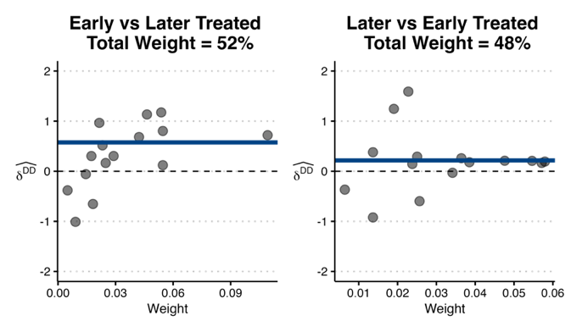
Notes: Figure 1 reports the decomposition of the weights of TWFE static regression for carrier-induced delays. TWFE computes all possible 2×2 DiD estimates from pooled OLS regression in two categories: Early treated (as treatment) compared to later treated (as controls), later treated (as treatment) compared to early treated (as controls). Each gray dot represents a comparison between treatment-timing cohorts. The blue thick line is the weighted average of all comparisons in each group. The total weights applied by TWFE to each group is labeled as “Total Weights” in the chart title. The ATT, overall average treatment effect across groups, is the weighted sum of each weighted average.

4.2 Dynamic Effect – The Long-Term Effect
Long-term effect seeks to explore how the treatment effect evolves over time. This is typically known as the dynamic effect. Often referred to as event study methodology, dynamic effect allows treatment effects to vary over time non-parametrically and is a widespread practice to test the dynamic treatment effect of policy intervention (Sun and Abraham 2021, Baker et al. 2022). Researchers typically are interested in estimating the coefficients of relative time indicators after the treatment. These coefficients are interpreted as the average treatment effect at different lengths of exposure to the treatment. The baseline model of a standard dynamic effect is illustrated in Equation 2:
Y_{it} = α_{i} + λt + $\sum_{l=-K}^{-1}{{{}_{l}D}_{it}^{l}}$ + $\sum_{l=0}^{L}{{{}_{l}D}_{it}^{l}}$ + βX_{it} +ε_{it} Equation 2
α_{i} and λt are vectors of carrier fixed effects and time fixed effects respectively. X_{it} is the vector of time-varying control variables and ε_{it} is the error term. $D_{it}^{l}$ is a set of relative time indicators. l = (–K, ... , L) represents the length of time periods relative to the time period when the merger occurred, such as (–2, –1, 0, 1, 2, 3) where 0 is when the merger started, –2 is two time periods before the merger, and 2 is two time periods after the merger. In an event study specification, it is necessary to exclude some relative time periods to avoid multicollinearity. The most common practice is to exclude relative periods close to the initial treatment such as t = 0 (Sun and Abraham 2021). In the current study, time period of t = 0 was accordingly omitted to avoid multicollinearity. $\sum_{l=-K}^{-1}{{{}_{l}D}_{it}^{l}}$, therefore, captures the time periods up to the first quarter before merger. $\sum_{l=1}^{L}{{{}_{l}D}_{it}^{l}}$ represents the time periods after merger (l = 1). The main parameters of interest in Equation 2 are the ${}_{l}s$which captures the differences in the outcome Y_{it} between treated and untreated carriers l time periods apart from merger completion date.
Recent advancements in econometrics also reveal major pitfalls of TWFE regression for dynamic treatment effects when there is variation in treatment timing and treatment heterogeneity (Callaway and Sant’Anna 2021, Baker et al. 2022). A decomposition of the regression coefficient $\sum_{l=0}^{L}{{{}_{l}D}_{it}^{l}}$ on the relative time indicators reveal that these coefficients are a linear combination of the average treatment effect from its own time period as well as from other relative time periods (Sun and Abraham 2021). In addition, the weights associated with these coefficients are non-linear functions of the distribution of the groups, and these weights are prone to the issue of negative weights (Sun and Abraham 2021). These two factors together contaminate the estimation of $\sum_{l=0}^{L}{{{}_{l}D}_{it}^{l}}$.
4.3 Methodology
Given the known pitfalls of TWFE estimator, different alternatives have been proposed. Although the econometrics literature has settled on the drawbacks of TWFE DiD in estimating treatment effects in a staggered design, which alternative estimator is the best still remains developing. The advancement of econometrics may continue to further this topic. However, at the time of writing, following a group of growing econometrics literature, we recommend three alternatives that can be used to avoid the potential bias associated with TWFE in a staggered design: Callaway and Sant’Anna (2021), Sun and Abraham (2021), and Stacked Regression (Deshpande and Li 2019, Cengiz et al. 2019). The commonality of these three alternatives is that they all modify those units that can serve as effective controls (i.e., avoid using already-treated units as effective controls). The difference between the three alternatives is that neither Callaway and Sant’Anna (2021) nor Sun and Abraham (2021) requires data restructuring, while stacked regression requires researchers to restructure the data. In this study, we elect to use stacked regression to estimate the effects of mergers, as this alternative may be the most familiar to empirical researchers. Next, we explain how stacked regression works when used to estimate Equation 2.
Note that stacked regression per se is not an estimator. Stacked regression also estimates the model using TWFE but modifies the data such that only clean control groups are used in the regression to avoid the contamination issues. The only difference between applying TWFE directly to the original data and applying TWFE to a stacked data is that the stacked data defines all variables in a clean, event-specific manner, i.e., already-treated units are not used as effective controls. Reviewing the event window of recent airline mergers (Appendix 1 E-companion), we elect to estimate merger effect up to 20 quarters (5 years) after merger and 6 quarters before merger as our main analysis. Table 4 illustrates the stacked data used in our analysis. We first create a unique data identifier (column dt in Table 4) for each carrier. Data identifier is different from carrier identifier (column Carriercode in Table 4). United Airlines was assigned a data identifier 26 as is shown in the column dt in Table 4. United merged with Continental on October 1, 2010 (2010Q4)—the 28th occasion in our data, which accordingly is coded as 0 relative occasion (rel_occasion column) representing the quarter when the merger event occurred. Because we elect to estimate merger effect 6 quarters prior and 20 quarters post-merger, the Occasion column starts from 22 (6 quarters prior to the merger occasion 28) and ends at 46 (20 quarters after the merger occasion 28); while the relative occasion column (rel_occasion) accordingly starts from –6 to 20. Relative time indicators (columns rel_–6 .... rel_20) are the l time periods in Equation 2. The time period when merger occurred (rel_0) was omitted in estimation to avoid multicollinearity.
Table 4 Illustrative Stacked Data using United Airline as an Example
Carriercode | Occasion | rel_occasion | dt | rel_-6 | rel__-5 | ... rel_19 | rel_20
21 | 22 | -6 | 26 | 1 | 0 | 0 | 0
21 | 23 | -5 | 26 | 0 | 1 | 0 | 0
21 | ... | ... | ... | ... | ... | ... | ...
21 | 27 | -1 | 26 | 0 | 0 | 0 | 0
21 | 28 | 0 | 26 | 0 | 0 | 0 | 0
21 | 29 | 1 | 26 | 0 | 0 | 0 | 0
21 | 30 | 2 | 26 | 0 | 0 | 0 | 0
21 | 31 | 3 | 26 | 0 | 0 | 0 | 0
21 | ... | ... | ... | ... | ... | ... | ...
21 | 44 | 18 | 26 | 0 | 0 | 0 | 0
21 | 45 | 19 | 26 | 0 | 0 | 1 | 0
21 | 46 | 20 | 26 | 0 | 0 | 0 | 1
To use stacked regression, we need to create clean stacked data. First, we need to identify all possible clean 2$×$2 comparable carriers for United Airlines. Among the remaining carriers that are eligible to be compared with United Airlines as clean controls, Alaska and Frontier were identified as clean effective controls for United based on the criteria of: 1) the timing of the merger event; and 2) the pre-6 and post-20 quarter time window. Then, all relevant variables for Alaska and Frontier were constructed in the same way as those for United, i.e., the three carriers have the exact same data table shown in Table 4. Next, the three data tables of United, Alaska, and Frontier are stacked together in a long format. As we have eight mergers, the same process repeats for the remaining acquirers. The final data to be used for regression is a stacked data consisting of all possible clean 2$×$2 comparisons for all eight acquirers. Hence, the name “stacked” regression. When TWFE estimates each clean 2$×$2 dataset, the unit and time fixed effects (α_{i} and λt) are saturated with dataset indicators. Then, TWFE applies variance weighting to combine the treatment effects across groups and time periods (Deshpande and Li 2019, Cengiz et al. 2019), thus avoiding the contamination issues. Step-by-step details on how to build stacked data are provided in the supplementary R code and interested readers can refer to the R code for more information.

5. ANALYSIS
All analysis in the current study was conducted in R 4.5.1. How each model was constructed and tested was also provided in the supplementary R code. From Table 2, we see that target airlines continue to report to DOT as a separate carrier up to 10 quarters during the post-merger grace period, which enables us to estimate the merger impact for both the acquirer and the target. Following our literature review on airline mergers, we assess both the static effect and the dynamic effect (event study) of the merger’s impact.

5.1 Impact of Mergers on OTP for Acquirers
5.1.1 Static Effect—Acquirer
We first estimate the static effect for acquirers using our stacked data. All analysis in the current study was estimated using data up to 6 quarters prior-merger and 20 quarters post-merger. We create a dummy variable “Treated” and assign all 20 post-merger quarters as 1 and all 6 pre-merger quarters as 0. Therefore, the variable “Treated” captures the static effect. Table 5 presents the results. In our stacked regression, all statistical inferences use clustered standard errors at the carrier level to account for autocorrelation in the data (Wooldridge 2010). From Table 5, we see that using 20 post-merger quarters as the time period to measure merger impact, the static effect (Treated, δ^{DD} = 0.03, t = 0.46) is not statistically significant for acquirers. Therefore, we can conclude that when measured by 20 post-merger quarters and measured by average effect during these 20 quarters, there is no statistically significant impact on OTP for acquirers following a merger.
Table 5 Static Effect of Merger on Acquirers – Estimated using Stacked Regression
Variables | δ^{DD} | Standard Error | t-Value
Dependent variable is carrier-controllable delays
Treated | 0.03 | 0.08 | 0.46
Load factor | 3.06* | 1.28 | 2.40
Fleet Utilization | 0.15 | 0.09 | 1.73
Fleet Heterogeneity | 0.04 | 0.11 | 0.37
Network Sparsity | -0.50*** | 0.09 | -5.34
# of Enplaned Passengers | 0.72$°$ | 0.38 | 1.91
# of Employees | 0.62* | 0.25 | 2.46
Market Share | -1.17$°$ | 0.59 | -1.97
Taxi In (Min) | 0.09* | 0.03 | 2.74
Taxi Out (Min) | 0.59*** | 0.08 | 7.74
Total Flights | 0.27* | 0.10 | 2.72
Fixed Effects Included: Carrier, Occasion, Route, Year, Quarter
R² = 0.616 Observations = 333,394
P value: *** 0.001, ** 0.01, * 0.05, $°$0.1
δ^{DD} are coefficients estimated using stacked regression. SE clustered at carrier level.

5.1.2 Dynamic Effect – Acquirer
Researchers and policymakers may be more interested in knowing how the merger effect unravels over time. Therefore, we continue to estimate the dynamic effect of mergers on OTP. We estimate Equation 2 using our stacked data. Figure 2 and Table 6 report the results. In Figure 2 (and the rest of the Figures in this paper), red dots and red dashed lines represent point estimates and 95% confidence bands for pre-treatment periods. Blue dots and blue dashed lines represent point estimates and 95% confidence bands for post-treatment periods. Standard errors are clustered at the carrier level.
Figure 2 Long Term Effect of Mergers on Acquirers—Estimated using Stacked Regression
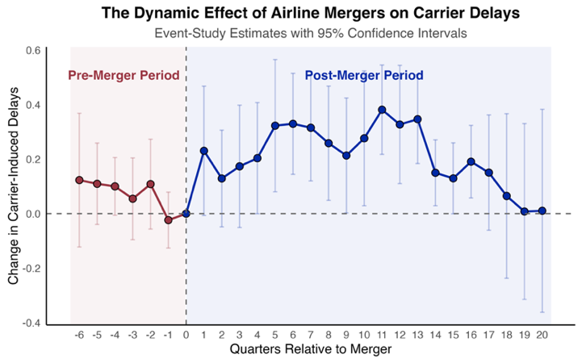
Notes: Figure 2 reports estimates and confidence intervals for the dynamic effects of merges on carrier-induced delays for acquirers. Standard errors are clustered at the carrier level. Red dots and red bars represent point estimates and 95% confidence bands for pre-treatment periods. Blue dots and blue bars represent post-treatment periods.
Table 6 Long Term Effect of Mergers on Acquirers—Estimated using Stacked Regression
Dependent variable is carrier-controllable delays
Panel A (Time Indicators) |  |  |  | Panel B (Control Variables)
l Wave relative to mergers | $$\hat{μ_{l}}$$ | Standard Error | t-Value | Control Variables | $$β$$ | Standard Error | t-Value
-6 | 0.12 | 0.12 | 1.06 | Load factor | 3.60*** | 0.84 | 4.30
-5 | 0.11 | 0.07 | 1.55 | Fleet Utilization | 0.33 | 0.23 | 1.44
-4 | 0.10$°$ | 0.05 | 2.00 | Fleet Heterogeneity | -0.11 | 0.07 | -1.65
-3 | 0.05 | 0.07 | 0.77 | Network Sparsity | -0.68*** | 0.16 | -4.31
-2 | 0.11 | 0.08 | 1.39 | # of Enplaned Passengers | 1.80** | 0.55 | 3.25
-1 | -0.02 | 0.05 | -0.49 | # of Employees | 0.68** | 0.22 | 3.17
1 | 0.23$°$ | 0.12 | 1.90 | Market Share | -2.29** | 0.60 | -3.80
2 | 0.13 | 0.09 | 1.38 | Taxi In (Min) | 0.07 | 0.05 | 1.59
3 | 0.17 | 0.12 | 1.51 | Taxi Out (Min) | 0.60*** | 0.07 | 8.53
4 | 0.20$°$ | 0.11 | 1.93 | Total Flights | 0.27* | 0.10 | 2.76
5 | 0.32* | 0.12 | 2.61
6 | 0.33** | 0.10 | 3.40
7 | 0.32** | 0.10 | 3.11
8 | 0.26* | 0.11 | 2.39
9 | 0.21$°$ | 0.11 | 1.96
10 | 0.28* | 0.13 | 2.19
11 | 0.38*** | 0.09 | 4.40
12 | 0.33** | 0.11 | 2.93
13 | 0.35*** | 0.09 | 4.02
14 | 0.15* | 0.07 | 2.26
15 | 0.13$°$ | 0.07 | 1.83
16 | 0.19* | 0.07 | 2.64
17 | 0.15 | 0.11 | 1.38
18 | 0.06 | 0.15 | 0.43
19 | 0.01 | 0.16 | 0.05
20 | 0.01 | 0.19 | 0.06
Fixed Effects Included: Carrier, Occasion, Route, Year, Quarter
R² = 0.695 , Observation = 226,956
P value: *** 0.001, ** 0.01, * 0.05, $°$0.1. $\hat{μ_{l}}$ are coefficients for time indicators. Standard errors clustered at carrier level.
From Table 6, we see that except for Occasions 2-3 and 17-20, the coefficients of the remaining post-merger occasions are statistically significant. Therefore, despite an insignificant static effect, the story is entirely different when estimated using an event study methodology. After eliminating other delays that cannot be attributed to carriers, such as security, weather, and national aviation system delays, our results differ distinctly from extant airline merger research. When OTP was narrowed down to carrier-induced delays only, we see that in the four quarters following merger, OTP worsened in two quarters (i.e., carrier-induced delay increased), in contrast to Rupp and Tan (2019), who reported that OTP (measured by all categories of delays) improved immediately in the four quarters following mergers. Prince and Simon (2017) used travel time (including non-carrier-induced time) to measure OTP and found that in 1-2 years post-merger, travel time was not impacted; in 3-5 years post-merger, travel time even shortened. By contrast, our results indicate that OTP continues to worsen (carrier-induced delays continue to increase) from the end of year one through the end of year four post-merger, and the effect becomes non-significant starting from year five. While Steven et al. (2016) estimated a single negative static effect, we show how the effect evolves quarter by quarter over time. In González et al.’s (2024) results, where minutes of delay were used as the outcome, OTP worsened only in the second year post-merger; our results, however, indicate that OTP worsened from year one through the end of year four. Despite some differences in statistical significance on a few occasions, our results are robust when estimated without including any controls (Table A3, Figure A1 in E-companion); when using 32 post-quarters (Table A4, Figure A2); using number of carrier-induced delays as a percentage of total number of delays (Table A5, Figure A3); and using monthly data (Figure A4).

5.2 Impact of Mergers on OTP for Target
As DOT allows a grace period for both the acquirer and the target to continue reporting as two independent carriers after the official merger completion date, we can utilize this grace period to model merger impact on the target as well, which was not examined in airline merger literature before. Target airlines continue to report to DOT as an independent carrier from 0 to 10 quarters (Table 2). 0 indicates that the target airline immediately reported to DOT under the acquirer’s brand. We follow the same process of constructing stacked data for target airlines as described in Section 4.3. Note that the maximum post-merger quarters reported by target airlines under their own brand are 10 quarters. As a result, we estimate a maximum 10 post-quarter effects for the target airlines.
5.2.1 Static Effect of Mergers on Target Airlines
Table A6 (E-companion) reports the static effect of 10 post-merger quarters for the target airlines. The coefficient (δ^{DD} = 0.06, t = 0.50) is statistically insignificant. Therefore, we can conclude that when measured by 10 post-merger quarters and measured by the average effect during these 10 quarters, there is no statistically significant impact on OTP for target airlines following a merger.
5.2.2 Dynamic Effect of Mergers on Target Airlines
For an event study analysis of the merger impact on target airlines, we estimate up to 10 quarters post-merger. Figure 3 and Table A7 (E-companion) report the results. Apart from a significant post-merger occasion 9, all other coefficients are statistically insignificant. Therefore, we can conclude that for target airlines, there is no strong statistical evidence to support that OTP of target airlines has been impacted following a merger.
Figure 3 Long Term Effect of Mergers on Target—Estimated using Stacked Regression
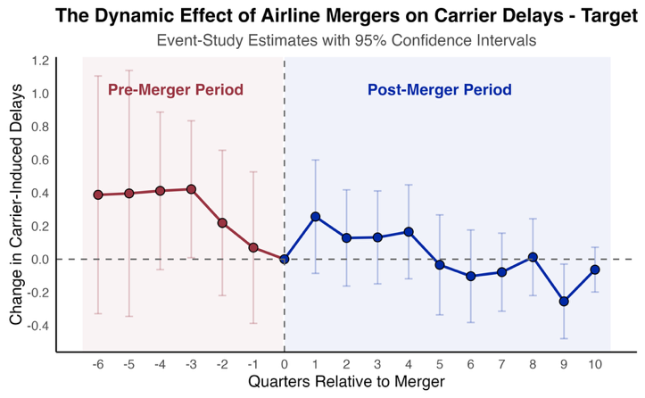
Notes: Figure 3 reports estimates and confidence intervals for the dynamic effects of merges on carrier-induced delays for targets. Standard errors are clustered at the carrier level. Red dots and red bars represent point estimates and 95% confidence bands for pre-treatment periods. Blue dots and blue bars represent post-treatment periods.

6. MECHANISM
6.1 Theoretical Exploration of the Nonlinear Post-merger Trajectory
Section 5.1.2 reveals that the impact of mergers on acquirers’ OTP, measured by carrier-induced delays, follows a nonlinear pattern: performance first deteriorates, then stabilizes for a while, before eventually improving. We explain why post-merger OTP follows this pattern from both operational and theoretical perspectives.
From an operational perspective, post-merger operations integration relies heavily upon existing documentation to transfer explicit knowledge. These well-documented operational procedures standard to the airline industry should facilitate knowledge transfer. However, the sheer volume of these operational procedures could become a barrier to operations integration for two reasons. First, operations integration encompasses “thousands of procedures used by pilots and flight dispatchers, gate agents, flight attendants and ground crew” (Mouawad 2012, p. 3), which will take time to synchronize. It is highly unlikely that the two carriers can finish integrating these “thousands of procedures” within a short period of time, i.e., two different sets of operations procedures run simultaneously after the merger (Mouawad 2012). Unsynchronized operational procedures, unfortunately, negatively impact operational performance. For example, United Airlines officially completed its merger with Continental Airlines on October 1st, 2010. Two years after its merger with Continental, United Airlines “still grapples with myriad problems in integrating the two airlines” and “the result has been hobbled operations” (Mouawad 2012): worst operational record among the nation’s top 15 airlines; highest rate of delayed flights; and a 6% below industry average rate of on-time arrivals (77.5%). Second, the integration of the two sets of operational procedures is likely to create conflict between the two merging carriers. One of the most significant challenges United Airlines faced after its acquisition of Continental was reconciling the two carriers’ conflicting goals (Mouawad 2012). Conflicting goals have been found to lead to subpar performance (Miller 1996). Therefore, in addition to unsynchronized operational procedures, conflicting goals may exacerbate the already hobbled operational performance.
As long as operations integration has not been completed, the two concurrent operational procedures may continue to yield subpar operational performance. However, once the two carriers complete their operational integration by streamlining all processes, the operational performance of the newly merged carrier should begin to improve. We explain this process using the learning-by-doing concept from the management discipline. The learning-by-doing concept (Levitt and March 1988) predicts that changes generally cause performance to deteriorate before it ultimately improves. In a merger, two carriers can be expected to learn from each other’s operational procedures during the integration process, and out of this should arise new solutions to post-merger problems. Operations managers from each side come to the merger immersed in their respective operational procedures, with previously developed solutions readily applicable to various issues. When coping with new problems post-merger, operations managers from each side may tend to refer to their previously developed solutions to address post-merger challenges. However, resorting to pre-developed solutions can result in negative learning outcomes (March et al. 1991), which may manifest themselves as deteriorated operational performance. March et al. (1991) observed that after repeated negative learning outcomes resulting from relying upon pre-existing solutions, organizations (operations managers in our case) begin to develop new integrative knowledge to adjust and correct their actions. Once created, this new form of knowledge can be retained in the new organization’s memory (i.e., knowledge retention) to handle post-merger challenges (Levy 2011). Operational performance, thereby, should coincidentally start to improve.
6.2 Other Mechanisms Potentially Explaining the Post-Merger Trajectory
In this section, we explore various mechanisms of the nonlinear post-merger trajectory, hoping to provide more nuanced findings to enrich both our theoretical contributions and managerial insights. We focus on acquirers only.
6.2.1 Legacy VS LCC Carriers
The airline industry is characterized by two distinctive groups of carriers: legacy carriers and low-cost carriers (LCCs). We first explore the differentiating effect of mergers on these two groups of carriers. We split our data into legacy carriers and LCCs and estimate Equation 2 using stacked data for the two carrier groups. Figure 4 and Table A8 (E-companion) report the results.
Figure 4 Heterogeneous Effects of Mergers on Carrier-Induced Delays: Legacy VS LCCs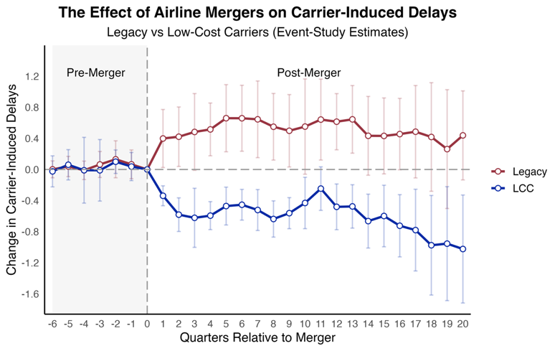
Notes: Figure 4 reports estimates and confidence intervals for the dynamic effects of merges on carrier-induced delays by carrier type. Standard errors are clustered at the carrier level. Red dots and red bars represent point estimates and 95% confidence bands for pre-treatment periods. Blue dots and blue bars represent post-treatment periods.

From Figure 4, we see that before the merger, both groups exhibit coefficients tightly centered around zero with overlapping confidence intervals, indicating no differential pre-trends in delays prior to the merger between the two groups of carriers. Immediately after the merger, however, legacy carriers experience a sharp increase in delays (statistically significant coefficients through t = 1–17), while LCCs exhibit a pronounced decline (statistically significant coefficients through t = 1–20). These opposite movements imply that merger consolidation generates substantial operational disruptions for legacy carriers but coincides with improved punctuality for LCCs. From roughly 3 to 12 quarters after the merger, legacy carriers maintain large positive coefficients—implying sizable proportional increases in delays—whereas LCCs persistently show negative coefficients, indicating proportional reductions in delays. The gap between the two groups remains wide and stable. The effects of mergers begin to attenuate after approximately 15 quarters for legacy carriers, while LCCs keep improving on delays. In short, we see that airline mergers have persistent and asymmetric effects: legacy carriers experience substantial proportional increases in carrier-induced delays, while LCCs see proportional improvements.
6.2.2 Heterogeneous Analysis by Pre-Merger Delay Quartiles
Next, we explore the heterogeneity in the dynamic effects of mergers on delays by grouping carrier–route–quarter observations into quantiles based on carriers’ pre-merger delay performance. Using only pre-merger data, we construct a variable, “delay rate,” for each carrier–route–quarter observation. Delay rate is calculated as the number of carrier-induced delays divided by the total flights at that route. Then, we compute the empirical quartiles of the delay rate into four quartile groups: 0–25th, 25–50th, 50–75th, and 75th+ percentiles. Because the quartile breaks are based solely on pre-merger actuals, the group assignments are predetermined with respect to merger treatment and are, therefore, not contaminated by post-merger dynamics. We then estimate separate stacked event-study regressions for each quartile group. Figure 5 and Table A9 (E-companion) report the results.
Figure 5 Heterogeneous Merger Effects Across Delay Quantiles
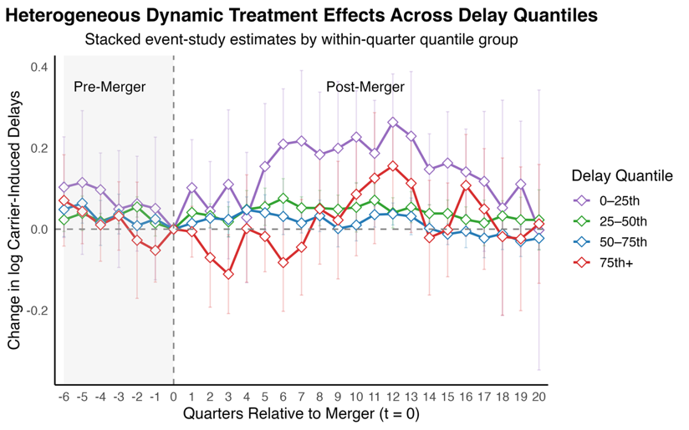
Notes: Figure 5 estimates are obtained from stacked event-study regressions with carrier, route, year, quarter, and occasion fixed effects. Delay quantiles are defined within each quarter based on pre-treatment carrier-induced delays. Shaded bands denote 95% confidence intervals. All control variables are included but omitted for brevity.

Looking at the post-merger periods, a clear ordering emerges immediately after mergers: lowest-delay quartiles (0–25th) experience the largest proportional increases in carrier-induced delays (with most of the post-merger effects statistically significant), peaking around 0.20–0.30 log points. The 25–50th quartile, despite its relatively flat post-merger trend, also shows small, statistically significant increases in delays in most post-merger occasions. The 50–75th quartile shows minimal post-merger effects: only a few post-merger effects are statistically significant, with most of the coefficients remaining close to zero throughout the post-merger horizon. The highest-delay quartile (75th+) appears the most volatile, yet only four of its post-merger effects are statistically significant. Combined, our delay quartiles analysis reveals strong and systematic heterogeneity in merger impacts: for acquirers, those routes with initially strong operational performance (0–25th and 25-50th delay quartiles) are most disrupted by merger consolidations, while those already performing poorly (50-75th and 75th+ quartiles) exhibit limited incremental performance deterioration. In other words, our results suggest that mergers disproportionately disrupt carriers’ route performance: airline routes with the best pre-merger on-time performance suffer the largest proportional increases in carrier-induced delays, while those with middling or higher delay levels experience little to no additional disruption.
6.2.3 The Role of Experience
We now examine whether prior merger experience affects post-merger performance. Organizational learning theory predicts that an acquirer with prior merger experience may perform better with each additional merger. For the eight acquirers, we count the total number of merger events each acquirer has experienced from 1970 to 2019 (Table A10 E-companion), including the mergers identified in Table 2. Four carriers experienced only one merger; one carrier experienced two mergers; two carriers experienced three mergers; and one carrier experienced four mergers. We then estimate the treatment effect for each of these four groups of carriers to assess how prior merger experience impacts the eight mergers identified in Table 2. Figure 6 and Table A11 (E-companion) report the results.
Figure 6 Heterogeneous Merger Effects Based on Carrier Merger Experience
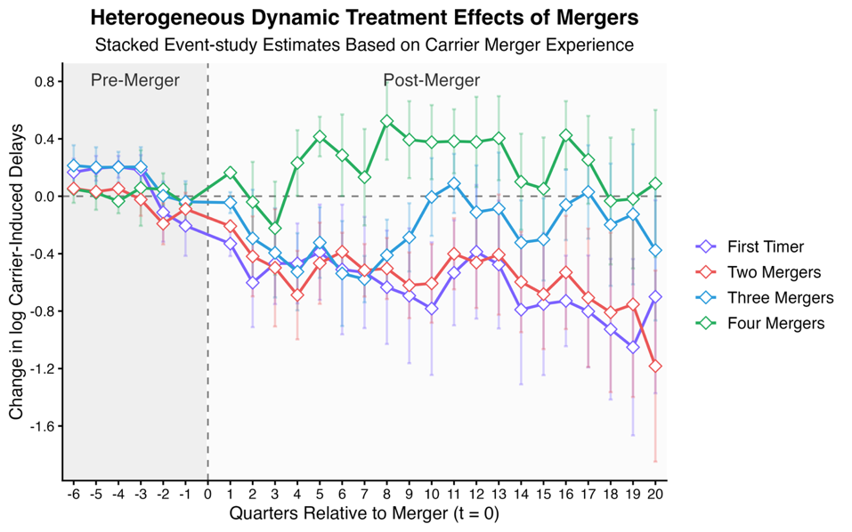
Notes: Figure 6 estimates obtained from stacked event-study regressions with carrier, route, year, quarter, and occasion fixed effects. Carriers are grouped by the number of prior mergers experienced including the focal merger. Confidence intervals are based on heteroskedasticity-robust standard errors, and all control variables are included though omitted from the figure for brevity.

Across all groups, the pre-merger estimates either lie close to zero or remain relatively flat, indicating no systematic differences in pre-treatment trends across carriers with varying merger histories. However, a clear ordering emerges immediately after the merger. Carriers experiencing their first merger exhibit a large proportional decline in delays beginning in quarter 1, and this decline persists across all post-merger periods (all post-merger estimates are statistically significant). Similarly, carriers with two merger experiences also demonstrate substantial reductions in delays across all post-merger periods (all post-merger estimates are statistically significant), with a trendline similar to that of carriers with only one merger. Carriers with three mergers, however, show only a moderate decline in delays during approximately the first nine quarters post-merger. After that, the post-merger trendline for this group of carriers starts to rise, although most of the coefficients are statistically non-significant. Lastly, carriers with four merger experiences behave very differently compared with the other three groups: they demonstrate a proportional increase in delays immediately after the merger. Despite some fluctuations, this increase in delays persists and remains relatively stable over the next 10–12 quarters until the effect attenuates approximately from the 4th year post-merger.
Combined, we see that first-timers and twice-merged carriers maintain the largest proportional decreases in carrier-induced delays, while carriers with three mergers register moderate and more volatile improvements. In contrast, carriers that have undergone four mergers consistently exhibit elevated post-merger delays. These findings suggest that less merger-experienced carriers may benefit more from mergers with respect to operational performance. Without further analysis, we hypothesize that merger fatigue, accumulated organizational complexity, and repeated integration frictions resulting from multiple mergers may undermine operational reliability for experienced acquirers, whereas first-time or infrequent acquirers may execute cleaner post-merger integrations and operate with greater slack, allowing them to achieve better post-merger operational performance. Our findings reinforce the notion in March et al. (1991) in that repeated acquirers may tend to rely on pre-existing solutions to cope with challenges in each new merger, which could result in negative learning outcomes, i.e., worsened performance.
6.2.4 Heterogeneity of Merger Effects by Route Distance
We now explore merger effects at the route level. Our dataset contains 9,661 unique routes. Estimating the treatment effect for each route is computationally challenging with the DiD estimator. Instead, we utilize an emerging machine learning technique—causal forest—for this analysis. A similar technique for estimating treatment effects is presented in Wang et al. (2021). Detailed procedures for our method are provided in Appendix 4 of E-companion. After estimating the conditional average treatment effect (CATE) at the route level, rather than plotting the treatment effects for all 9,661 routes, we partition routes by distance band according to DOT’s distance bands and, for each bin, compute the mean predicted CATE. Figure 7 reports the mean effects with 95% confidence intervals in each DOT distance band. Such a visualization can provide a clearer and more interpretable representation of how merger effects vary across the spatial structure of the airline network compared with plotting all effects of all 9,661 routes.
Figure 7 not only plots the estimated CATEs across the DOT’s route-distance bands, but it also reports the number of distinct routes estimated in each band. The results show a strong and systematic difference in treatment effects across distance bands, despite all routes witnessing increases in delays. For extra-short routes (< 250 miles), the estimated effect is small, indicating that shorter-distance flights may be dominated by fixed ground-time operations that leave little room for additional delay propagation. The three short-to-medium distance bands (250-499, 500-749, 750-999 miles), which have the densest number of routes, also show the largest effects among all distance bands, with the effect peaking at the 250-499 mile band and progressively declining thereafter. This may reflect the fact that this portion of the airline network is the busiest in terms of aircraft rotations, gate allocations, and schedule connectivity. Due to potentially tightly coupled operational activities in these distance bands, routes in these bands are most vulnerable to operational disruptions in the event of mergers. Beyond 1000 miles, the magnitude of the effects, although still positive, becomes smaller again, suggesting that longer routes—with greater airborne slack and potentially less frequent turns—are better able to absorb or buffer merger-driven integration frictions. Taken together, our evidence indicates that merger-induced delay propagation is most severe on short-to-medium haul routes (250–1000 miles) while extra short (<250 miles) and long-haul routes (>1000 miles) are not as severely impacted, despite the fact that they also suffer from increased delays. The corresponding route counts in each distance band also highlight that the segments with the largest estimated effects also represent the bulk of domestic commercial activities.
Figure 7 Heterogeneous Merger Effects Across DOT Distance Bands
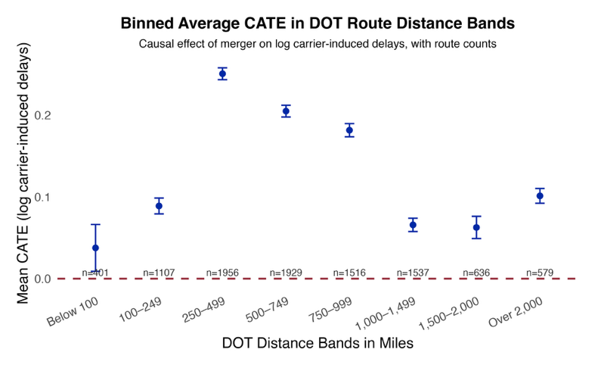
Notes: CATEs are estimated using a causal forest applied to residualized outcomes and treatments with carrier and occasion fixed effects. DOT mileage bin categories are used. Route counts represent the number of distinct origin–destination routes in each bin. Error bars denote 95% confidence intervals based on honest forest variance estimates.
To sum up, the non-linear post-merger trajectory observed in Figure 2 is mainly driven by: 1) legacy carriers, instead of LCCs; 2) carriers with better per-merger operational performance; 3) carriers with the most experience in mergers; and 4) short-to-medium haul routes from 250 to 1000 miles.

7. PARALLEL TREND ASSUMPTION AND ROBUSTNESS TESTS
7.1 The Parallel Trend Assumption
The validity of all DiD designs relies on the parallel trend assumption (i.e., the control group and the treatment group should trend at similar paces on the outcome variable before the treatment). There are two common practices to test the parallel trend assumption in the OM field. The first practice is to compare the trendline of the average outcome on the control group and the treatment group before the treatment to visually detect if the two trendlines are trending in parallel. However, visually parallel trendlines do not equal to statistical significance. Therefore, a more commonly used practice is to test the coefficients on the leads (i.e., relative time indicators leading to the treatment) using an event study. If no statistical significance is found on the leads, researchers normally conclude that there is no statistical difference between the trend of the treatment group and the trend of the control group before the treatment. Hence, the parallel trend assumption holds.
Recent econometrics advancement heavily advises against using the event study to test the coefficients on leads as a statistical test to prove parallel trend. The first reason is that the conventional TWFE event study has been proven to produce biased estimates on relative time indicators of both leads and lags in a staggered design, leading to either Type I or Type II errors. Baker et al. (2022) showed that in a staggered design, the TWFE event study failed to detect a pre-trend when there is actually one and falsely claimed a pre-trend when there is no pre-trend. Second, even modern DID estimators that have corrected all TWFE biases, such as Sun and Abraham (2021), still do not claim that these estimators can be readily used to test for the parallel trend. This is mainly due to the fact that testing coefficients on leads suffers from 1) low statistical power (Roth 2022); 2) multiple testing problem (Callaway and Sant’Anna 2021). For example, Sun and Abraham (2021) noted that, even when the parallel trend assumption holds, the pretreatment coefficient may still be nonzero (p. 182 and Section 3.7). Therefore, alternatives to testing the parallel trend have been proposed, such as the placebo test (de Chaisemartin and D’Haultfoeuille 2020), using bootstrapped confidence bands (Callaway and Sant’Anna 2021), sensitivity analysis (Rambachan and Roth 2023), and Robust OLS-based pre-trend test (Borusyak et al. 2024). Both de Chaisemartin and D’Haultfoeuille (2020) and Borusyak et al. (2024) use only pre-event data for the test, while Rambachan and Roth (2023) focus more on how the conclusion can change if this assumption is violated. We did not find evidence of violation of this assumption using these alternatives, and we report one test result below.
de Chaisemartin and D’Haultfoeuille (2020) proposed a placebo estimator (${DID}_{M}^{pl}$) to test for pretrends which “essentially compares the outcome’s evolution from t − 2 to t − 1, in groups that switch and do not switch treatment between t − 1 and t” (p. 2989). In our case, ${DID}_{M}^{pl}$ computes the change in carrier-induced delay between carriers experiencing mergers and those not experiencing mergers one time period before the merger event. We also extend ${DID}_{M}^{pl}$ and compute ${DID}_{M}^{pl,2}$, ${DID}_{M}^{pl,3},$ and up to ${DID}_{M}^{pl,6}$, which compares the change in carrier-induced delays two, three, and up to six periods before the merger event. We report the results in Figure 8 and Table 7. We see from Table 7 that the estimates of all the six placebo estimates are not significantly different from 0, indicating that the parallel trend assumption was not violated: carriers who engaged in mergers do not experience different trends before the merger event compared with the carriers who did not experience mergers.
Figure 8 Parallel Trend Assumption Test  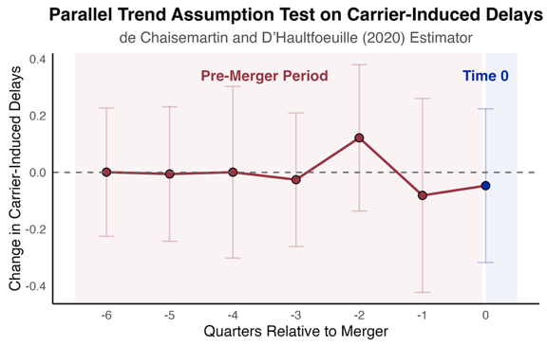  Notes: Figure 8 reports estimates and confidence intervals of DID_{M} and six placebos. Standard errors are clustered at the carrier level. | Table 7 Parallel Trend Assumption Test  Notes: This table reports the estimates for the four placebos.  P value: *** 0.001, ** 0.01, * 0.05, $°$0.1
   | Estimate | Standard Error
  $${DID}_{M}^{pl}$$ | -0.081 | 0.174
  $${DID}_{M}^{pl,2}$$ | 0.121 | 0.131
  $${DID}_{M}^{pl,3}$$ | -0.025 | 0.120
  $${DID}_{M}^{pl,4}$$ | 0.001 | 0.154
  $${DID}_{M}^{pl,5}$$ | -0.005 | 0.120
  $${DID}_{M}^{pl,6}$$ | 0.001 | 0.115
  (Covariates included in model but omitted in reporting)

7.2 Placebo Test Using Merger Announcement Date
From Table 2, we see that the time gap between the merger announcement date and the merger completion date spans over 1-3 quarters. Carriers may initiate integration after the merger announcement date, potentially triggering a treatment effect before the official merger completion date used in our analysis. Therefore, we use merger announcement dates as a placebo “treatment” timing to run a placebo test. We run placebo tests for the dynamic effect for both the acquirer and the target, and our results indicate that there is no strong statistical evidence supporting the impact of the merger announcement on OTP. We show the graph of the placebo test for acquirers in Figure 9. The associated table is omitted to save space.
Figure 9 Using Merger Dates as a Placebo to Test the Long-term Effect for Acquirers
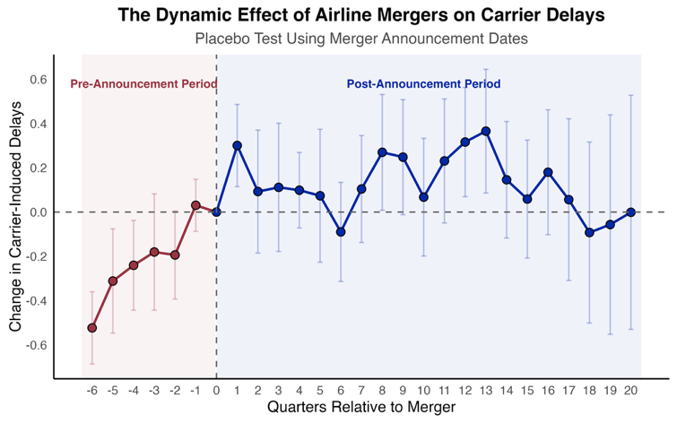
Notes: Figure 9 reports estimates and confidence intervals for the dynamic effects of merges on carrier-induced delays using merger announcement dates as the event dates. Standard errors are clustered at the carrier level. Red dots and red bars represent point estimates and 95% confidence bands for pre-treatment periods. Blue dots and blue bars represent post-treatment periods.
7.3 Testing for Potential Biases
Recent econometrics literature has established that using TWFE to estimate treatment effects in a staggered design leads to biased results, whereas most related airline merger studies we investigated adopted conventional TWFE; therefore, they are susceptible to biased results. We also notice that almost all related airline merger research (Appendix 1 E-companion) has included all five causes of delays when assessing merger impact on operational performance, which potentially results in biased estimates. Therefore, we conduct additional robustness tests in this section to test for the source of bias. The first test employs a classic TWFE event study approach to estimate the treatment effect, using the original data. In other words, already-treated units were included as controls. The second test uses clean stacked data and stacked regression to ensure non-biased estimates. However, in the second test, carrier-induced delays were replaced with total delays. This way, we can better determine the source of bias.
The results of the two robustness tests are presented in Figure 10 and Table A12 (E-companion). Left graph in Figure 10 shows the results of a classic TWFE event study using the original data (carrier-induced delays as the outcome), while right graph presents the results of using total delays as the outcome but estimated on clean stacked data. In the left graph, none of the coefficients for the time indicators are statistically significant. This indicates that applying the classic TWFE event study in a staggered design leads to a Type II error in our case: despite a positive and significant actual treatment effect, TWFE produces non-significant estimates. This underscores the importance of using modern estimators in staggered designs, as researchers might otherwise dismiss insignificant findings from TWFE, failing to provide policymakers with crucial insights on treatment effects that are actually statistically significant (Baker et al., 2022). Furthermore, the magnitude of treatment effects estimated by TWFE is much smaller (–0.08 to 0.15) compared to the unbiased estimates (0.13 to 0.38 in Table 6). Turning to the right graph where the data is clean and the statistical estimates are unbiased, we see that when total delays are used as the outcome, despite a similar nonlinear trajectory, only a couple of time-indicators show significant estimates while all other times indicators have statistically non-significant estimates. This suggests that including irrelevant delays, such as weather delays, also results in a Type II error. Additionally, the magnitude of treatment effects with total delays is also smaller (0.01 to 0.23) than the unbiased estimates.
Figure 10 Robustness Tests—Using Classic TWFE Event Study and Using Total Delays as DV
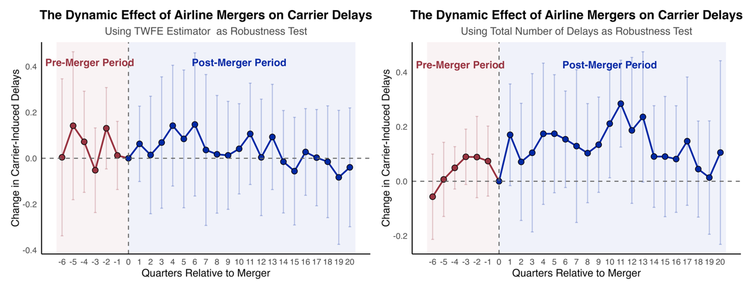
Notes: Figure 10 reports two robustness tests. Left plot shows the results of a classic TWFE event study using the original data (carrier-induced delays as the outcome). Right plot presents the results of a stacked regression using stacked data (total delays as the outcome).

7.4 Comparing Different Estimators
At the time of writing, although the econometrics literature has settled on the fact that traditional TWFE event study produces biased estimates in a staggered design, which alternative estimator is the best remains developing. However, three alternative methods have been proposed: Callaway and Sant’Anna (2021) estimator, Sun and Abraham (2021) estimator, and stacked regression method. In this section, we test the other two estimators as our current study uses the stacked regression method.
As our main analysis in Section 5 employs an event window of –6 to 20 quarters, we also use the same event window for the other two estimators (Callaway and Sant’Anna 2021, Sun and Abraham 2021) and overlay the plots of these two alternative estimators with that of the stacked regression in Figure 11 (model outputs in Table A13 E-companion). We observe that apart from the coefficients at l = 1 (due to the default omitted occasion to avoid multicollinearity), the three estimators show similar post-merger trajectory, confirming our main finding and reinforcing the recent econometric advancement that when data is correctly specified, all these alternative estimators should produce similar results (Baker et al. 2022).
Figure 11 Dynamic Effect of Mergers on Acquirers – Comparing Alternative Estimators
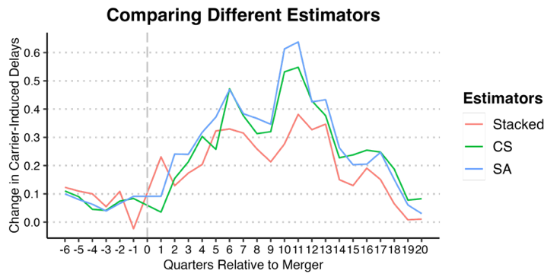
Notes: Figure 11 reports the comparison of event study estimates among three different estimators. Stacked refers to stacked regression estimates. CS refers to Callaway and Sant’Anna (2021) estimates. SA refers to Sun and Abraham (2021) estimates. Same event window -6 to 20 was estimated for all three estimators.

8. CONTRIBUTION AND FUTURE RESEARCH
8.1 Contribution
Our study makes several distinct theoretical contributions to the literature of airline mergers and operational performance. First, we answer the call for increased research rigor by adopting modern econometric estimators to address the known biases of TWFE in staggered DiD designs. Prior literature on airline OTP has predominantly relied on static TWFE specifications and/or TWFE event studies. By utilizing stacked regression, we ensure our control groups are “clean” (not previously treated), thereby avoiding the contamination and negative weighting issues inherent in standard TWFE when treatment timing varies. Furthermore, we refine the measurement of OTP by isolating “carrier-induced delays”—delays within the airline’s control—rather than using total delays or travel times, which conflate merger effects with exogenous factors such as weather delays. Our analysis demonstrates that including these irrelevant delays can lead to Type II errors, masking statistically significant merger impacts.
Second, we provide a more nuanced understanding of the temporal evolution of post-merger performance. While previous studies have offered mixed findings—ranging from negative static effects to immediate post-merger improvements—our dynamic analysis reveals a distinct “worsen-then-improve” performance trajectory for acquirers. We find that acquirers experience a sustained deterioration in OTP (increased carrier-induced delays) from the first year through the fourth year post-merger, stabilizing only after year five. Additionally, we exploit DOT’s reporting grace period to evaluate merger impacts on target airlines. Contrary to the disruptions faced by acquirers, we find no strong statistical evidence that the OTP of target airlines is significantly impacted following a merger.
Third, we contribute to the literature on organizational learning and merger integration by uncovering significant heterogeneity in merger outcomes. We show that the nonlinear effect is driven by specific carrier types and operational contexts. We find a divergence between legacy carriers and LCCs: legacy carriers experience substantial operational disruptions, whereas LCCs exhibit post-merger improvements in punctuality. Our results also show that mergers disproportionately disrupt high-performing carriers. Carriers with the best pre-merger OTP suffer the largest proportional increases in delays, while already poor-performing carriers see little additional deterioration. From an organizational learning perspective, our findings also challenge the assumption that experience improves outcomes: we find that “first-timer” acquirers achieve the best post-merger OTP improvements, whereas frequent acquirers (those with three or four mergers) consistently exhibit elevated delays. This suggests that merger complexity and fatigue may outweigh the benefits of accumulated experience. Lastly, using causal forest inference, we reveal that delay propagation is most severe on short-to-medium haul routes (250–1,000 miles), likely due to tighter coupling of operations and reduced airborne slack compared to long-haul flights.
Managerially, our findings offer actionable insights for airline executives, policymakers, and industry analysts, directly addressing the operational “valley of death” that often follows large consolidations. Various stakeholders can apply our findings to specific operational contexts to mitigate the disruptions documented in recent industry reports.
For airline executives, our findings provide a roadmap for operational integration following mergers. First, our study documents a predictable deterioration in carrier-induced delays lasting up to four years. Executives must calibrate investor and passenger expectations for a 3-4 year operational transition period to manage the “worsen-then-recover” curve. This period coincides with what Jhunjhunwala et al. (2025) describe as the necessary phase of “fortifying financial resilience” and “executing strategic consolidation”. To protect its brand, carriers should proactively adjust block times and reduce utilization rates during this window, rather than aggressively scheduling for synergies that have not yet materialized. Second, our analysis reveals a counterintuitive finding: frequent acquirers (those with three and four mergers) suffer worse post-merger performance than first-timers. This suggests “merger fatigue” and reliance on outdated playbooks can degrade operational reliability. Executives, accordingly, should resist the urge to simply “copy-paste” integration strategies from prior mergers. Instead, they must treat each merger as a novel operational challenge. As Cornwall et al. (2025) note, modern airline planning requires a shift from static scheduling to dynamic, scenario-based modeling. We recommend establishing fresh, dedicated integration teams for each merger transaction rather than relying solely on legacy personnel who may be entrenched in past practices. Lastly, we identified that route distances between 250 and 1,000 miles suffer the most severe delay propagation, likely due to tighter aircraft rotations and limited airborne slack. Operations managers should effectively “ring-fence” these short-to-medium haul routes during the integration phase. This may involve allocating higher reserve crew ratios and spare aircraft specifically to these sectors. Cornwall et al. (2025)’s findings on modernizing planning highlight the value of “digital twins” to model such constraints; our results pinpoint where in the network these digital simulations are most critical.
For regulators such as the DOJ and DOT, our findings can help improve precision in monitoring post-merger performance. First, current regulatory reviews often rely on “static” effects or total on-time performance, which we show leads to Type II errors because weather and other delays mask carrier-specific failures. Accordingly, we recommend DOT to adopt “carrier-induced delay” as the primary metric for post-merger monitoring, rather than relying on general arrival delay. This aligns with the DOT’s 2024 push for greater transparency in airline fees and services. By isolating delays within the airline’s control, regulators can enforce more meaningful accountability during the critical grace period. Second, we find that target airlines generally maintain their performance levels post-merger, whereas acquirers suffer significantly. Therefore, regulatory monitoring resources should be disproportionately focused on the acquirer’s legacy network rather than the target’s. The stability of the target carrier suggests that “operational contagion” flows primarily from the complexity of absorbing new assets rather than from the assets themselves.
For industry associations such as IATA and A4A (Airlines for America), our study can help to enhance industry resilience. First, contrary to a common narrative that all consolidation harms service, we find that LCC–led mergers actually lead to improved punctuality. Industry bodies can therefore use this finding to advocate for distinct regulatory treatment of LCC consolidations. As the LCC sector faces profitability headwinds and rising costs, our results suggest that consolidation in this sector may be a viable mechanism to restore operational health, rather than a threat to it. Second, as numerous industry reports suggest (Mouawad 2012, Josephs 2018), coupled with our learning-by-doing theorization in Section 6.1, post-merger integration of workforce remains the primary friction point. We recommend an industry-wide standard for “integration readiness" that prioritizes labor agreement harmonization before operational blending. As noted in Deloitte’s (2025) outlook, “siloed teams with misaligned priorities” are a key barrier to efficiency. Our findings underscore that without resolving these human-factor conflicts, the theoretical benefits of network density following mergers will be lost to operational chaos.
8.2 Limitations and Future Research
Like all studies, our research has several limitations that also open avenues for future research. First, responding to Hüschelrath and Müller’s (2014) call to examine more recent mergers, we focused on eight recent mergers and did not analyze those from the 1980s and 1990s. Future research could adopt a longitudinal approach, analyzing merger waves over a longer time frame to investigate how the impacts on post-merger performance have evolved over time, using other modern estimators, e.g., repeated treatment of the same carrier. This will also complement our analysis of prior merger experience, in which we used only the number of prior mergers. It will be interesting to see the results if these merger experiences are modeled using longitudinal data.
Our study focuses exclusively on the impact of mergers on operational performance; future research could extend this analysis by investigating post-merger financial performance. It is reasonable to hypothesize that the restructuring process immediately after a merger may initially harm financial performance before eventually achieving synergies and leading to improvement. Additionally, future studies could estimate the effects of mergers on consumer welfare, such as the impact on airfares. With the emergence of new econometric estimators that more rigorously address potential biases in staggered designs, applying these methods to analyze impacts on fares could yield fresh and more accurate insights into how mergers influence pricing and consumer welfare. Lastly, future research could also focus on the economic impact of mergers. We find that carrier-induced delays persist from end of year one to end of year four following mergers. How do these delays translate into economic impact? This will be another interesting and pragmatic research topic.

REFERENCES
Alan, Y., Lapré, M.A. 2018. Investigating operational predictors of future financial distress in the US airline industry. Production and Operations Management, 27(4), 734-755.
Baker, A.C., Larcker, D.F., Wang, C.C. 2022. How much should we trust staggered difference-in-differences estimates?. Journal of Financial Economics, 144(2), 370-395.
Borusyak, K., Jaravel, X. and Spiess, J., 2024. Revisiting event-study designs: robust and efficient estimation. Review of Economic Studies, 91(6), 3253-3285.
Callaway, B., Sant’Anna, P.H. 2021. Difference-in-differences with multiple time periods. Journal of Econometrics, 225(2), 200-230.
Cengiz, D., Dube, A., Lindner, A., Zipperer, B. 2019. The effect of minimum wages on low-wage jobs. The Quarterly Journal of Economics, 134(3), 1405-1454.
Cornwall, T., Krishnan V., Keane, M. 2025. How to modernize airline planning. McKinsey & Company. https://www.mckinsey.com/industries/travel/our-insights/how-to-modernize-airline-planning.
De Chaisemartin, C., d’Haultfoeuille, X. 2020. Two-way fixed effects estimators with heterogeneous treatment effects. American Economic Review, 110(9), 2964-2996.
Deloitte Consulting LLP. 2025. CEO Compass: Deloitte Global’s 2025 Airline CEO Survey. https://www.deloitte.com/us/en/insights/industry/transportation/ceo-global-airline-survey.html.
Department of Transportation. 2024. Data directory: list of databases. https://www.transtats.bts.gov/DataIndex.asp. Accessed January 10, 2025.
Deshpande, M., Li, Y. 2019. Who is screened out? Application costs and the targeting of disability programs. American Economic Journal: Economic Policy, 11(4), 213-248.
Dresner, M., Xu, K. 1995. Customer Service, Customer Satisfaction, and Corporate Performance in the Service Sector. Journal of Business Logistics, 16(1).
González, J., Lemus, J., Marshall, G. 2024. Mergers and organizational disruption: Evidence from the US airline industry. Journal of Economics & Management Strategy, 33(1), 111-130.
Goodman-Bacon, A. 2021. Difference-in-differences with variation in treatment timing. Journal of Econometrics, 225(2), 254-277.
Hüschelrath, K., Müller, K. 2014. Airline networks, mergers, and consumer welfare. Journal of Transport Economics and Policy, 48(3), 385-407.
Jhunjhunwala P., Hansell G., Colombo A., Levine A. 2025. The Real Engines of Value Creation in Airlines. Boston Consulting Group. https://www.bcg.com/publications/2025/the-real-engines-of-value-creation-in-airlines.
Josephs, L. 2018. Years after airline mergers, flight attendants are finally flying together. CNBC, October 1, 2018.
Levy, M. 2011. Knowledge retention: minimizing organizational business loss. Journal of Knowledge Management, 15(4), 582-600.
Lichtenberg, F.R., Kim, M. 1989. The effects of mergers on prices, costs, and capacity utilization in the US air transportation industry, 1970-84. National Bureau of Economic Research.
March, J.G., Sproull, L.S., Tamuz, M. 1991. Learning from samples of one or fewer. Organization Science, 2(1), 1-13.
McCartney, S. 2010. An airline report card: Fewer delays, hassles last year, but bumpy times may be ahead. Wall Street Journal. January 7, D1–D3.
Miller, D. 1996. A preliminary typology of organizational learning: Synthesizing the literature. Journal of Management, 22(3), 485-505.
Mouawad, J. 2012. For United, Big Problems at Biggest Airline. New York Times, November 28, 2012.
Nicolae, M., Arıkan, M., Deshpande, V., Ferguson, M. 2017. Do bags fly free? An empirical analysis of the operational implications of airline baggage fees. Management Science, 63(10), 3187-3206.
Prince, J.T., Simon, D.H. 2017. The impact of mergers on quality provision: Evidence from the airline industry. The Journal of Industrial Economics, 65(2), 336-362.
Rambachan, A. and Roth, J. 2023. A more credible approach to parallel trends. Review of Economic Studies, 90(5), 2555-2591.
Rupp, N.G., Tan, K.M. 2019. Mergers and product quality: a silver lining from de‐hubbing in the US airline industry. Contemporary Economic Policy, 37(4), 652-672.
Scotti, D., Dresner, M. 2015. The impact of baggage fees on passenger demand on US air routes. Transport Policy, 43, 4-10.
Scotti, D., Dresner, M., Martini, G. 2016. Baggage fees, operational performance and customer satisfaction in the US air transport industry. Journal of Air Transport Management, 55, 139-146.
Singal, V. 1996a. Airline mergers and multimarket contact. Managerial and Decision Economics, 17(6), 559-574.
Singal, V. 1996b. Airline mergers and competition: An integration of stock and product price effects. Journal of Business, 233-268.
Steven, B., Yazdi, A., Dresner, M. 2016. Mergers and service quality in the airline industry: A silver lining for air travelers?. Transportation Research Part E: Logistics and Transportation Review, 89, 1-13.
Sun, L., Abraham, S. 2021. Estimating dynamic treatment effects in event studies with heterogeneous treatment effects. Journal of Econometrics, 225(2), 175-199.
Tsikriktsis, N. 2007. The effect of operational performance and focus on profitability: A longitudinal study of the US airline industry. Manufacturing & Service Operations Management, 9(4), 506-517.
Wang, G., Li, J. and Hopp, W.J. 2022. An instrumental variable forest approach for detecting heterogeneous treatment effects in observational studies. Management Science, 68(5), 3399-3418.
Wooldridge, J.M., 2010. Econometric analysis of cross section and panel data. MIT press.

