# hello.py - http://www.graphviz.org/content/hello
from graphviz import Digraph
g = Digraph('G', filename='hello.gv')
g.edge('Hello', 'World')
g.view()
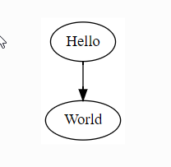

# process.py - http://www.graphviz.org/content/process
from graphviz import Graph
g = Graph('G', filename='process.gv', engine='sfdp')
g.edge('run', 'intr')
g.edge('intr', 'runbl')
g.edge('runbl', 'run')
g.edge('run', 'kernel')
g.edge('kernel', 'zombie')
g.edge('kernel', 'sleep')
g.edge('kernel', 'runmem')
g.edge('sleep', 'swap')
g.edge('swap', 'runswap')
g.edge('runswap', 'new')
g.edge('runswap', 'runmem')
g.edge('new', 'runmem')
g.edge('sleep', 'runmem')
g.view()

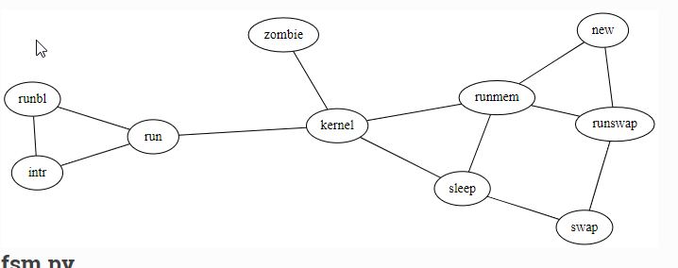

# fsm.py - http://www.graphviz.org/content/fsm
from graphviz import Digraph
f = Digraph('finite_state_machine', filename='fsm.gv')
f.attr(rankdir='LR', size='8,5')
f.attr('node', shape='doublecircle')
f.node('LR_0')
f.node('LR_3')
f.node('LR_4')
f.node('LR_8')
f.attr('node', shape='circle')
f.edge('LR_0', 'LR_2', label='SS(B)')
f.edge('LR_0', 'LR_1', label='SS(S)')
f.edge('LR_1', 'LR_3', label='S($end)')
f.edge('LR_2', 'LR_6', label='SS(b)')
f.edge('LR_2', 'LR_5', label='SS(a)')
f.edge('LR_2', 'LR_4', label='S(A)')
f.edge('LR_5', 'LR_7', label='S(b)')
f.edge('LR_5', 'LR_5', label='S(a)')
f.edge('LR_6', 'LR_6', label='S(b)')
f.edge('LR_6', 'LR_5', label='S(a)')
f.edge('LR_7', 'LR_8', label='S(b)')
f.edge('LR_7', 'LR_5', label='S(a)')
f.edge('LR_8', 'LR_6', label='S(b)')
f.edge('LR_8', 'LR_5', label='S(a)')
f.view()
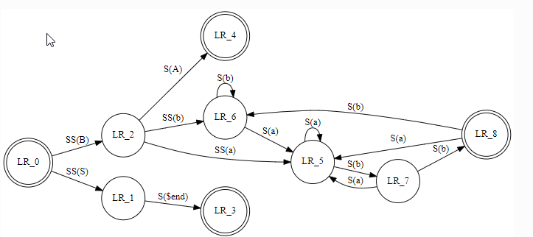

# cluster.py - http://www.graphviz.org/content/cluster
from graphviz import Digraph
g = Digraph('G', filename='cluster.gv')
# NOTE: the subgraph name needs to begin with 'cluster' (all lowercase)# so that Graphviz recognizes it as a special cluster subgraph
with g.subgraph(name='cluster_0') as c:
c.attr(style='filled')
c.attr(color='lightgrey')
c.node_attr.update(style='filled', color='white')
c.edges([('a0', 'a1'), ('a1', 'a2'), ('a2', 'a3')])
c.attr(label='process #1')
with g.subgraph(name='cluster_1') as c:
c.node_attr.update(style='filled')
c.edges([('b0', 'b1'), ('b1', 'b2'), ('b2', 'b3')])
c.attr(label='process #2')
c.attr(color='blue')
g.edge('start', 'a0')
g.edge('start', 'b0')
g.edge('a1', 'b3')
g.edge('b2', 'a3')
g.edge('a3', 'a0')
g.edge('a3', 'end')
g.edge('b3', 'end')
g.node('start', shape='Mdiamond')g.node('end', shape='Msquare')
g.view()

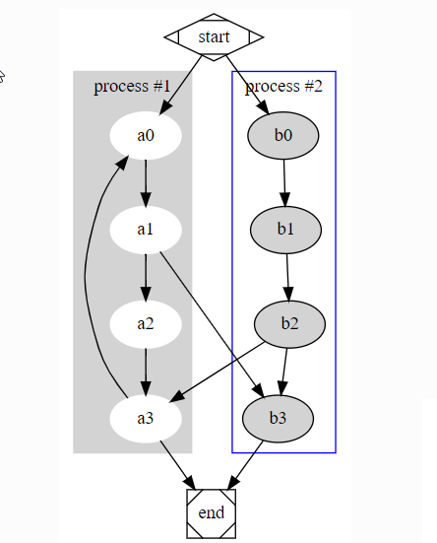

# er.py - http://www.graphviz.org/content/ER
from graphviz import Graph
e = Graph('ER', filename='er.gv', engine='neato')
e.attr('node', shape='box')
e.node('course')
e.node('institute')
e.node('student')
e.attr('node', shape='ellipse')
e.node('name0', label='name')
e.node('name1', label='name')
e.node('name2', label='name')
e.node('code')
e.node('grade')
e.node('number')
e.attr('node', shape='diamond', style='filled', color='lightgrey')
e.node('C-I')
e.node('S-C')e.node('S-I')
e.edge('name0', 'course')
e.edge('code', 'course')
e.edge('course', 'C-I', label='n', len='1.00')
e.edge('C-I', 'institute', label='1', len='1.00')
e.edge('institute', 'name1')
e.edge('institute', 'S-I', label='1', len='1.00')
e.edge('S-I', 'student', label='n', len='1.00')
e.edge('student', 'grade')
e.edge('student', 'name2')
e.edge('student', 'number')
e.edge('student', 'S-C', label='m', len='1.00')
e.edge('S-C', 'course', label='n', len='1.00')
e.attr(label=r'\n\nEntity Relation Diagram\ndrawn by NEATO')
e.attr(fontsize='20')
e.view()
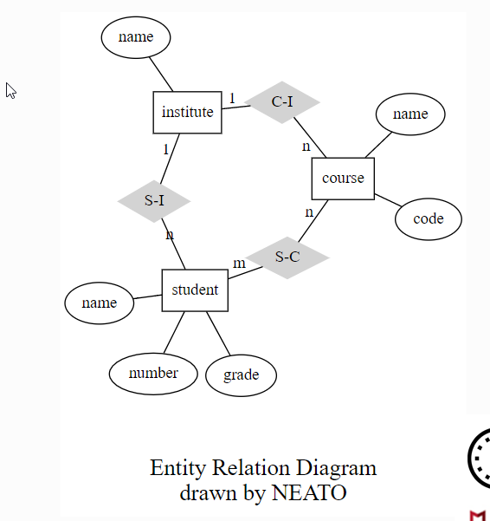

# unix.py - http://www.graphviz.org/content/unix
from graphviz import Digraph
u = Digraph('unix', filename='unix.gv')
u.attr(size='6,6')
u.node_attr.update(color='lightblue2', style='filled')
u.edge('5th Edition', '6th Edition')
u.edge('5th Edition', 'PWB 1.0')
u.edge('6th Edition', 'LSX')
u.edge('6th Edition', '1 BSD')
u.edge('6th Edition', 'Mini Unix')
u.edge('6th Edition', 'Wollongong')
u.edge('6th Edition', 'Interdata')
u.edge('Interdata', 'Unix/TS 3.0')
u.edge('Interdata', 'PWB 2.0')
u.edge('Interdata', '7th Edition')
u.edge('7th Edition', '8th Edition')
u.edge('7th Edition', '32V')
u.edge('7th Edition', 'V7M')
u.edge('7th Edition', 'Ultrix-11')
u.edge('7th Edition', 'Xenix')
u.edge('7th Edition', 'UniPlus+')
u.edge('V7M', 'Ultrix-11')
u.edge('8th Edition', '9th Edition')
u.edge('1 BSD', '2 BSD')
u.edge('2 BSD', '2.8 BSD')
u.edge('2.8 BSD', 'Ultrix-11')
u.edge('2.8 BSD', '2.9 BSD')
u.edge('32V', '3 BSD')
u.edge('3 BSD', '4 BSD')
u.edge('4 BSD', '4.1 BSD')
u.edge('4.1 BSD', '4.2 BSD')
u.edge('4.1 BSD', '2.8 BSD')
u.edge('4.1 BSD', '8th Edition')
u.edge('4.2 BSD', '4.3 BSD')
u.edge('4.2 BSD', 'Ultrix-32')
u.edge('PWB 1.0', 'PWB 1.2')
u.edge('PWB 1.0', 'USG 1.0')
u.edge('PWB 1.2', 'PWB 2.0')
u.edge('USG 1.0', 'CB Unix 1')
u.edge('USG 1.0', 'USG 2.0')
u.edge('CB Unix 1', 'CB Unix 2')
u.edge('CB Unix 2', 'CB Unix 3')
u.edge('CB Unix 3', 'Unix/TS++')
u.edge('CB Unix 3', 'PDP-11 Sys V')
u.edge('USG 2.0', 'USG 3.0')
u.edge('USG 3.0', 'Unix/TS 3.0')
u.edge('PWB 2.0', 'Unix/TS 3.0')
u.edge('Unix/TS 1.0', 'Unix/TS 3.0')
u.edge('Unix/TS 3.0', 'TS 4.0')
u.edge('Unix/TS++', 'TS 4.0')
u.edge('CB Unix 3', 'TS 4.0')
u.edge('TS 4.0', 'System V.0')
u.edge('System V.0', 'System V.2')
u.edge('System V.2', 'System V.3')
u.view()
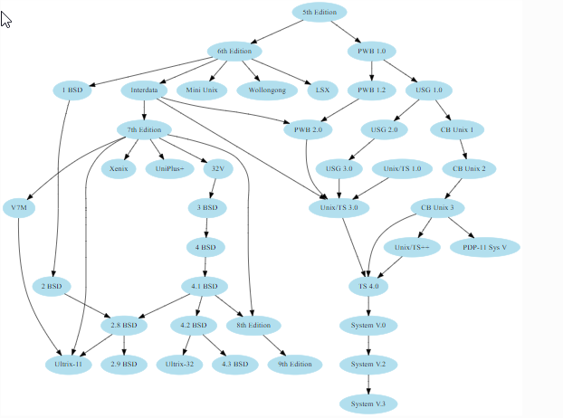

# structs.py - http://www.graphviz.org/doc/info/shapes.html#html
from graphviz import Digraph
s = Digraph('structs', node_attr={'shape': 'plaintext'})
s.node('struct1', '''<
<TABLE BORDER="0" CELLBORDER="1" CELLSPACING="0">
<TR>
<TD>left</TD>
<TD PORT="f1">middle</TD>
<TD PORT="f2">right</TD>
</TR>
</TABLE>>''')
s.node('struct2', '''<
<TABLE BORDER="0" CELLBORDER="1" CELLSPACING="0">
<TR>
<TD PORT="f0">one</TD>
<TD>two</TD>
</TR></TABLE>>''')
s.node('struct3', '''<
<TABLE BORDER="0" CELLBORDER="1" CELLSPACING="0" CELLPADDING="4">
<TR>
<TD ROWSPAN="3">hello<BR/>world</TD>
<TD COLSPAN="3">b</TD>
<TD ROWSPAN="3">g</TD>
<TD ROWSPAN="3">h</TD>
</TR>
<TR>
<TD>c</TD>
<TD PORT="here">d</TD>
<TD>e</TD>
</TR>

<TR>
<TD COLSPAN="3">f</TD>
</TR></TABLE>>''')
s.edges([('struct1:f1', 'struct2:f0'), ('struct1:f2', 'struct3:here')])
s.view()
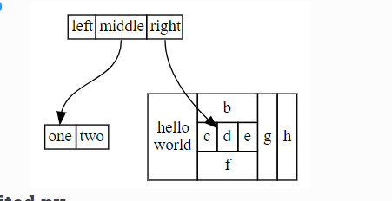

# structs_revisited.py - http://www.graphviz.org/pdf/dotguide.pdf Figure 12
from graphviz import Digraph
s = Digraph('structs', filename='structs_revisited.gv', node_attr={'shape': 'record'})
s.node('struct1', '<f0> left|<f1> middle|<f2> right')
s.node('struct2', '<f0> one|<f1> two')
s.node('struct3', r'hello\nworld |{ b |{c|<here> d|e}| f}| g | h')
s.edges([('struct1:f1', 'struct2:f0'), ('struct1:f2', 'struct3:here')])
s.view()
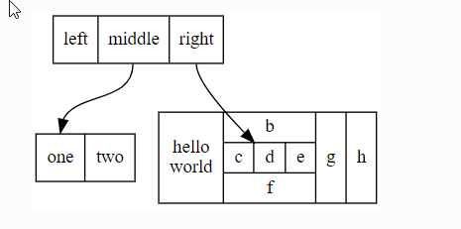

# btree.py - http://www.graphviz.org/pdf/dotguide.pdf Figure 13
from graphviz import Digraph, nohtml
g = Digraph('g', filename='btree.gv', node_attr={'shape': 'record', 'height': '.1'})
g.node('node0', nohtml('<f0> |<f1> G|<f2>'))
g.node('node1', nohtml('<f0> |<f1> E|<f2>'))
g.node('node2', nohtml('<f0> |<f1> B|<f2>'))
g.node('node3', nohtml('<f0> |<f1> F|<f2>'))
g.node('node4', nohtml('<f0> |<f1> R|<f2>'))
g.node('node5', nohtml('<f0> |<f1> H|<f2>'))
g.node('node6', nohtml('<f0> |<f1> Y|<f2>'))
g.node('node7', nohtml('<f0> |<f1> A|<f2>'))
g.node('node8', nohtml('<f0> |<f1> C|<f2>'))
g.edge('node0:f2', 'node4:f1')
g.edge('node0:f0', 'node1:f1')
g.edge('node1:f0', 'node2:f1')
g.edge('node1:f2', 'node3:f1')
g.edge('node2:f2', 'node8:f1')
g.edge('node2:f0', 'node7:f1')
g.edge('node4:f2', 'node6:f1')
g.edge('node4:f0', 'node5:f1')
g.view()
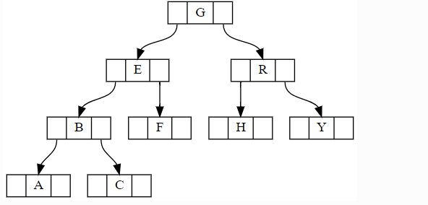

# traffic_lights.py - http://www.graphviz.org/content/traffic_lights
from graphviz import Digraph
t = Digraph('TrafficLights', filename='traffic_lights.gv', engine='neato')
t.attr('node', shape='box')for i in (2, 1):
t.node('gy%d' % i)
t.node('yr%d' % i)
t.node('rg%d' % i)
t.attr('node', shape='circle', fixedsize='true', width='0.9')for i in (2, 1):
t.node('green%d' % i)
t.node('yellow%d' % i)
t.node('red%d' % i)
t.node('safe%d' % i)
for i, j in [(2, 1), (1, 2)]:
t.edge('gy%d' % i, 'yellow%d' % i)
t.edge('rg%d' % i, 'green%d' % i)
t.edge('yr%d' % i, 'safe%d' % j)
t.edge('yr%d' % i, 'red%d' % i)
t.edge('safe%d' % i, 'rg%d' % i)
t.edge('green%d' % i, 'gy%d' % i)
t.edge('yellow%d' % i, 'yr%d' % i)
t.edge('red%d' % i, 'rg%d' % i)
t.attr(overlap='false')
t.attr(label=r'PetriNet Model TrafficLights\n'
r'Extracted from ConceptBase and layed out by Graphviz')
t.attr(fontsize='12')
t.view()

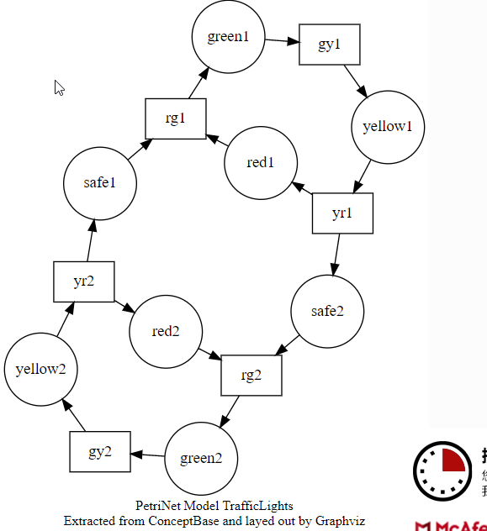

# fdpclust.py - http://www.graphviz.org/content/fdpclust
from graphviz import Graph
g = Graph('G', filename='fdpclust.gv', engine='fdp')
g.node('e')
with g.subgraph(name='clusterA') as a:
a.edge('a', 'b')
with a.subgraph(name='clusterC') as c:
c.edge('C', 'D')
with g.subgraph(name='clusterB') as b:
b.edge('d', 'f')
g.edge('d', 'D')
g.edge('e', 'clusterB')
g.edge('clusterC', 'clusterB')
g.view()
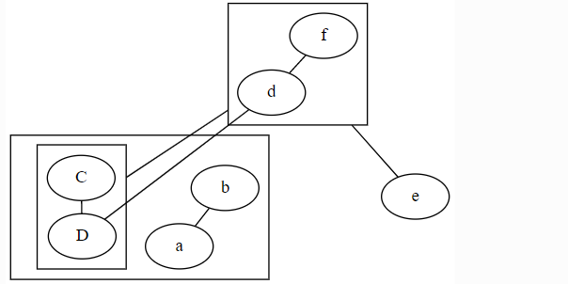

# cluster_edge.py - http://www.graphviz.org/pdf/dotguide.pdf Figure 20
from graphviz import Digraph
g = Digraph('G', filename='cluster_edge.gv')
g.attr(compound='true')
with g.subgraph(name='cluster0') as c:
c.edges(['ab', 'ac', 'bd', 'cd'])
with g.subgraph(name='cluster1') as c:
c.edges(['eg', 'ef'])
g.edge('b', 'f', lhead='cluster1')
g.edge('d', 'e')
g.edge('c', 'g', ltail='cluster0', lhead='cluster1')
g.edge('c', 'e', ltail='cluster0')
g.edge('d', 'h')
g.view()
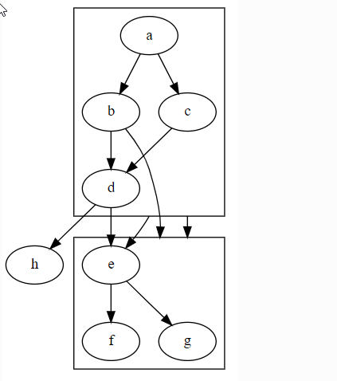

# http://www.graphviz.org/Gallery/gradient/g_c_n.html
from graphviz import Graph
g = Graph('G', filename='g_c_n.gv')
g.attr(bgcolor='purple:pink', label='agraph', fontcolor='white')
with g.subgraph(name='cluster1') as c:
c.attr(fillcolor='blue:cyan', label='acluster', fontcolor='white',
style='filled', gradientangle='270')
c.attr('node', shape='box', fillcolor='red:yellow',
style='filled', gradientangle='90')
c.node('anode')
g.view()
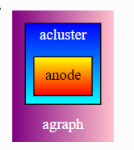

# angles.py - http://www.graphviz.org/Gallery/gradient/angles.html
from graphviz import Digraph
g = Digraph('G', filename='angles.gv')g.attr(bgcolor='blue')
with g.subgraph(name='cluster_1') as c:
c.attr(fontcolor='white')
c.attr('node', shape='circle', style='filled', fillcolor='white:black',
gradientangle='360', label='n9:360', fontcolor='black')
c.node('n9')
for i, a in zip(range(8, 0, -1), range(360 - 45, -1, -45)):
c.attr('node', gradientangle='%d' % a, label='n%d:%d' % (i, a))
c.node('n%d' % i)
c.attr(label='Linear Angle Variations (white to black gradient)')
with g.subgraph(name='cluster_2') as c:
c.attr(fontcolor='white')
c.attr('node', shape='circle', style='radial', fillcolor='white:black',
gradientangle='360', label='n18:360', fontcolor='black')
c.node('n18')
for i, a in zip(range(17, 9, -1), range(360 - 45, -1, -45)):
c.attr('node', gradientangle='%d' % a, label='n%d:%d' % (i, a))
c.node('n%d' % i)
c.attr(label='Radial Angle Variations (white to black gradient)')
g.edge('n5', 'n14')
g.view()

