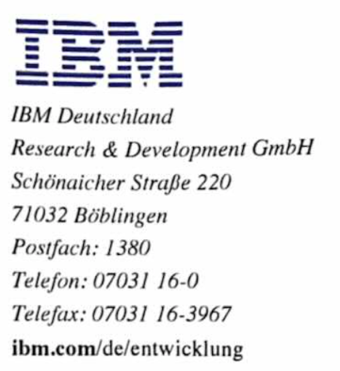

Achievement

(This is the English translation of document “IBM-Praktikum-Zeugnis-Kuang-Yu-Li.pdf” with Google Translate)

Mr. Kuang-Yu Li, born on August 1st, 1991, was employed as an intern in the IBM Z firmware development department in our company from April 1st, 2021 to September 30th, 2021.

As part of a voluntary internship, Mr. Li deals with the improvement and adaptation of existing development environments for the development of our IBM Z firmware simulator.

The aim of the internship was to provide a development environment that is compatible with the IBM Z architecture and allows decentralized development. In addition, the environment should be a support for unit tests including visualization. In the first step, Mr. Li dealt with the analysis of existing development environments, as well as with various possible solutions for the given problem. He chose a solution based on a web-based development environment. In the next step, he checked the solution he had chosen on an infrastructure with Docker, Kubernetes and OpenShift with the aim of providing a readily available solution. He then made the solution available in the form of a Docker container with automation scripts, various plugins and software components compiled by him for the IBM Z architecture, as well as configuration files.

Mr. Li always carried out all tasks during his internship very independently and reliably as well as with great accuracy and systematics.

When organizing his tasks, he always proceeded systematically and very structured. Here he benefited from his quick comprehension and communication skills.

Mr. Li has extensive and up-to-date knowledge in his and related areas. He was able to apply the knowledge he had acquired at the university safely and appropriately in practice.

He showed extraordinary commitment, identified himself at all times with the tasks assigned to him and carried out these actively and purposefully.

Mr. Li always made excellent use of his acquired professional skills.

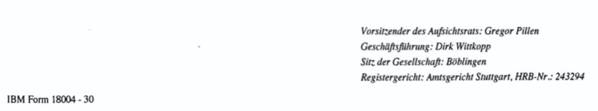



His results always fully met the goals set.

We got to know Mr. Li as an extremely committed, reliable and competent intern, who always met our expectations to our highest satisfaction and achieved the goals of the training in every respect.

His behavior towards superiors and colleagues was always exemplary and contributed in every respect to a very good and trusting cooperation.

The cooperation and willingness to cooperate on the part of Mr. Li was always exemplary.

Mr. Li's voluntary internship ended at the end of the agreed contract period on September 30, 2021.

We would like to thank Mr. Li for his consistently excellent performance during his internship and wish him every success and all the best in his further professional and personal life.

