All the documents should be controlled documents by manufacturer, with unique document number, version，date, authorizer, etc.
以下文件请以受控文件格式提供，也就是需要有一个唯一的文件编号。

There are 6 document requirement of functional safety project according to IEC 60730-1 annex H:
根据IEC 60730-1，功能安全要求如以下5点：

- Block diagram of BMS system
BMS的电路原理图

- Hardware FMEA analysis (base on the safety function of over temperature, over current, over voltage etc.). Please let client fill the following table.
硬件的FMEA分析（基于过温、过流、过压这些安全功能进行分析）请填下面的表格
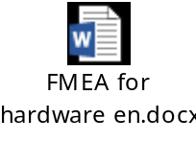
- MCU hardware fault analysis(based on table H.1). I have summarized the Class B requirement in word document “MCU failure analysis.docx”. Client need to provide the corresponding segment of coding in “Document reference for applied measures” and “Document reference for applied test” column in “MCU failure analysis.docx”. The suggested/example solution of requirement can be found in Table H.1 column” Example of acceptable measures”.
MCU的故障分析（基于IEC60730表格H.1）。由于软件只需要满足Class B的要求，我已经把需要分析的MCU故障列出在“MCU failure analysis.docx”文件中。表格H.1的” Example of acceptable measures”一列，针对每种故障提供了建议的解决方法。你们需要在“MCU failure analysis.docx”文件的“Document reference for applied measures” 和 “Document reference for applied test” 两列下面提供对应的代码段或者程序名字或者文件名字。 其中，“Document reference for applied measures”一列需要列出在BMS中实际运行的检测故障的代码段或者程序名字或者文件名字，“Document reference for applied test”一列要填你们用于测试前一列故障检测程序的测试用例代码段或者程序名字或者文件名字。
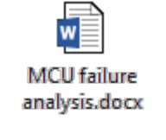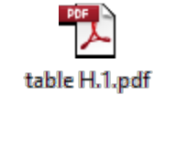
- Component single fault analysis (based on table H.24). Client need to analyse the single component fault (short circuit or open circuit) that would impact the safety function of over temperature, over current, over voltage etc. The failure mode of components can be found in document “table H.24.pdf”. Client should provide the result of analysis in document “component single fault analysis.docx”.
元件单一故障分析（基于IEC60730表格H.24）。 你们需要按照表H.24列出的元件单一故障模式分析/实际测试会影响过温、过流、过压等实现安全功能的电路。元件的故障模式请参考表H.24。分析和测试结果请填在下面的“component single fault analysis.docx”文件中。
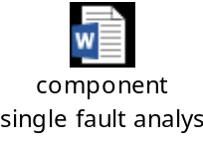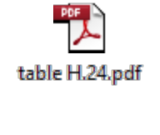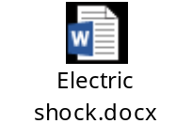
- Software specification, including development environment description of software.
软件规格书，包括软件的开发环境、实现的功能等等。
- Hazard analyses and risk assessment of Electric shock
风险评估：分析样品设计之前可能发生的失效模式，样品设计之后做了哪些优化措施，并声明Class of control function

