KUAN XING
http://www.ee.mtu.edu/~kxing
kuanslove@gmail.com | (206)605-7679 | 1809B Woodmar Dr, Houghton, MI USA 49931

SUMMARY
- M.S graduate in Computer Engineering, interest involves Web/Mobile Application development
- 2 semesters (8 months) internship as software developer with individual full-stack web project and system module integration team work accomplished
- Skillset : Linux/Windows, Java, AndroidSDK, Python, HTML5, JavaScript, jQuery, Ajax, XML, JSON, BootStrap, NodeJS, CSS, PHP, LibGDX, SQL, Git, Ruby, AMAZON-EC2, Apache

EDUCATION
- Michigan Technological University  M.S in Computer Engineering |  | Sep 2011 ~ Dec 2013  MI, USA
- Civil Aviation University of China  B.S in Electronic Information Engineering |  | Sep 2003 ~ May 2007  Tianjin, China

EXPERIENCE
- SRS Pharmacy, Inc  Software Developer Intern |  | Jan 2013 ~ Aug 2013  MI, USA
- Developed new patient signature converting module for existing system. Skill and tools include C++, PostgreSQL, LibGD, Shell, CVS, Centos5. We use Git as source control and my part of module has been merged into master branch.
- Developed new patient SMS message informing GUI module for existing system. Skill and tools include C++, PostgreSQL, wxWidgets, Centos5.
- Developed RESTful Ajax support single page web application. Skill and tools include Node.js, HTML5, jQuery, CSS, PostgreSQL, Ubuntu12.04. This is individual project, I implemented Ubuntu Server / PostgreSQl setup, wrote server application with Node.js framework (Express.js+pg) and all front-end Ajax request and DOM operation to fulfill no-refresh single page with jQuery.

PROJECT S
- Please refer to project list from page 2

PROJECT LIST
- Android Development
- Team Chrysler MindTrekker game
A team work developed Android Tablet Driving Game for Chrysler MindTrekker program using Android Java SDK, LibGDX Physics Engine.
GIT: https://github.com/kuanslove/TeamChrysler
GIT: https://github.com/kuanslove/minigame


- My Mobile APP CV
An navigation drawer layout app, which involves activity switch, message passing, layout configuration, navigation drawer usage, ListView, Adapter and Fragment utilities.
GIT: https://github.com/kuanslove/CVApp

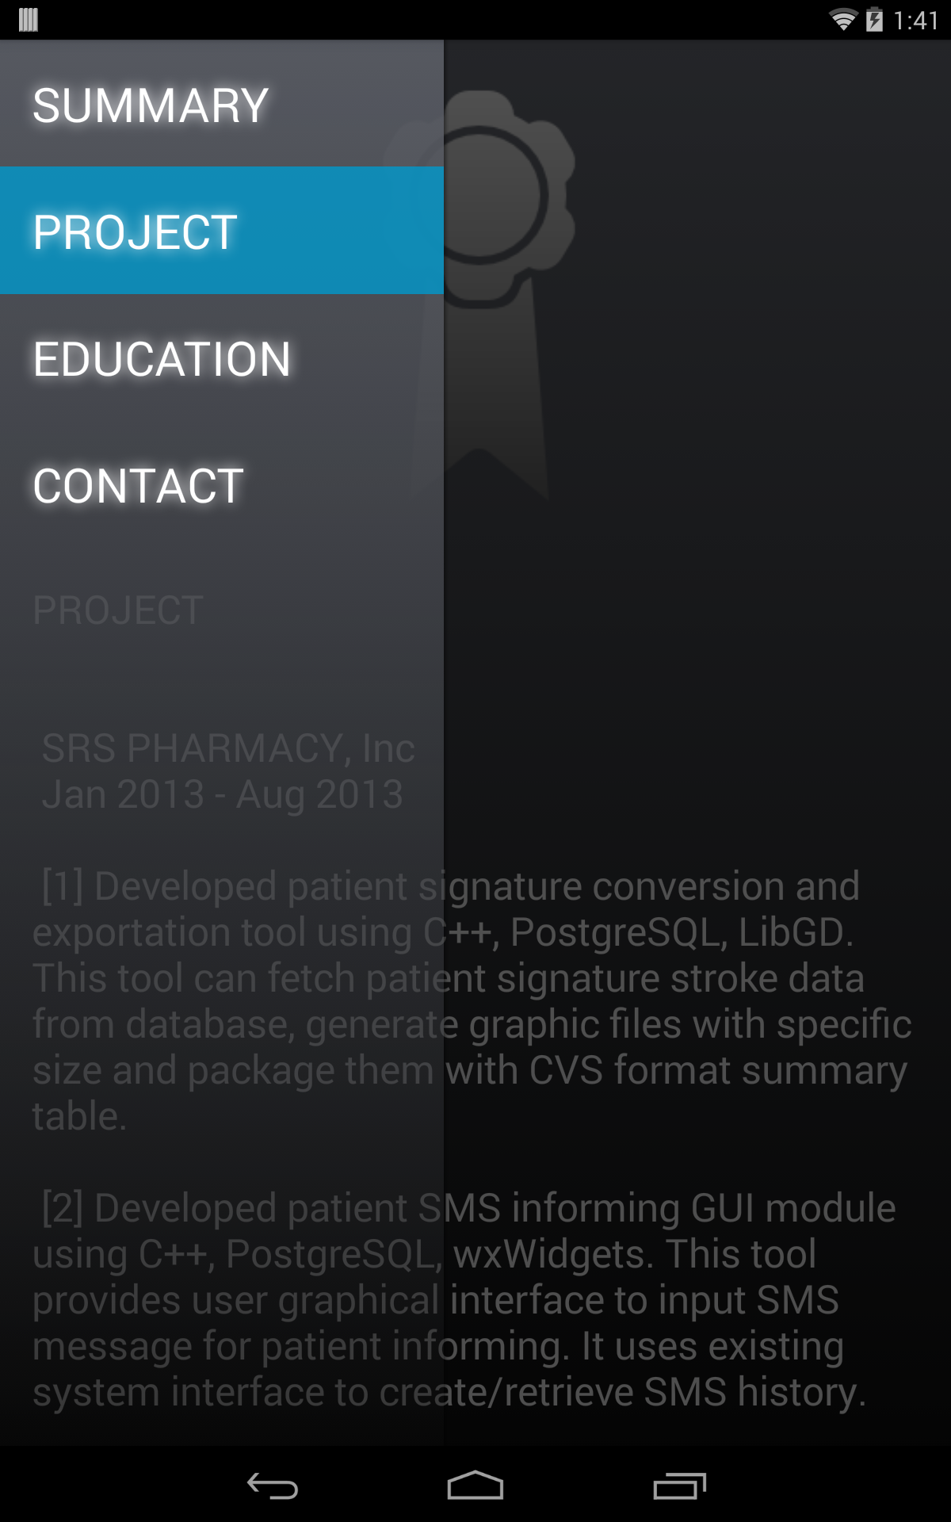

PROJECT LIST
- Web Development
- Online Grocery Store
Full Ajax Online Store Website using Node.js, HTML5, jQuery, CSS, providing user/admin interface for management.
GIT: https://github.com/kuanslove/OGS
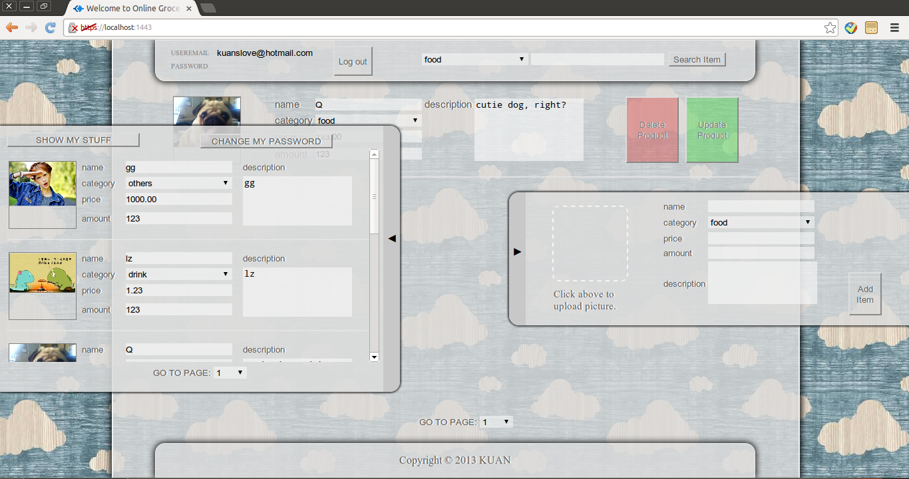
- Personal Homepage
A Bootstrap3 supported personal website to host my Resume.
http://www.ee.mtu.edu/~kxing
