kuan旧的Motion Chart with D3.js

Kuan Xing
Michigan Technological University

Abstract
D3.js is a JavaScript library for manipulating DOM elements based on data. D3 helps people bring data to life using HTML, SVG and CSS. In this project, I plan to use D3 to build a motion chart to reflect the population, wealth and age change of countries with year stamp interaction[1].
Keywords: JavaScript, data visualization, D3.

1 Introduction
Data Visualization is very important for efficient data presentation, when there is huge data, a visual communication method may be the best way to show the pattern, trend, group or quantity. We can say, data visualization provide an efficient way for people to read, analyze and process data. For example, when there is a lot of statistical data about a company's revenue, it is really hard to find out which part could be the most profitable business from those boring tables. However, if we can turn this information into graphic expression base on the data, then it becomes much easier for people to find out the focus area, and furthermore, we can directly manipulate these data to adjust their distribution so that we can make investment decision better. At the same time, with networking and web technology advanced, more and more people choose to present data online, HTML provides the essential capability to utilize graphics on line, modern browser is supporting more and more forms that can be integrated into HTML, such as SVG which is a great graphics format used for visual operation. To make the data and visualization integrated, we can use JavaScript to connect the data domain and the graphic domain, however, to use JavaScript to manipulate DOM elements costs a lot of work, sometimes, it is exhaustive. D3 is one of the libraries which provides interface to simplify those operation on elements. In this project , I will use it to build a motion chart which can present the change in wealth and population of countries chronically with user interaction.

2 Preparation

2.1 Required tools and availability
Since we plan to present this project on a local laptop, we are going to use either Windows or Linux system to run this project. For now, only the IE whose version <10 dose not support the SVG format, so we prefer to use Firefox or Chrome. In case the connection is not well, we include the script in the local folder. For the developing environment, we choose build-in console of Chrome and Geany to develop the code.

2.2 Qualifications
To implement this project, we need to learn the syntax and common usage of D3.js, currently we already master the basic usage of JavaScript and important working concepts of D3.js in manipulating DOM elements. We are able to position element, adjust common attribution of elements and transition effects of elements. All those mentioned above are the basic unit operations of D3 visualization.

3 Project Scheme

3.1 General Objective
The final result is a motion chart, the axis will stand for the age and wealth of the country. We will use SVG circle elements to indicate countries, the area of the circle will stand for the population. The motion of those SVG circle stands for the wealth and age change in according to year, so we can get a general trend concept with the year moving forward.

3.2 Technical Focus
This motion chart will focus on three main parts: 1) the data source and data binding. 2) SVG elements manipulation, such as position, style change. 3) User interaction, because we will implement a dynamic visualization with year changing, and we use mouse cursor hover callback function to fulfill that feature.
In 1), we learn that D3.js can import external data source into a page, and D3 provides several format to accept. We need to figure out the detail structure which is included in those data file, and to make sure D3 can recognize them.
In 2), we need to control the size and position, by scaling and mapping from the data value domain to style value domain, we can process the data using linear mapping to turn into proper graphics parameter of SVG elements.
In 3), D3 provides user the abilities to deal with different kinds of events such as mouse click, hover, key press, mouse scroll. We plan to build event function and bind it to some specific elements to response to user mouse cursor hover event.

3.3 Detail Implementation
Understand the DOM structure. The first thing that d3 can do is to operate the DOM elements, so it is important to know how the elements are organized in a web page document.

In d3

4 Expected Result
Show final result of this dynamic data visualization, the compatibility on different browsers.
The final result is expected to look like this:

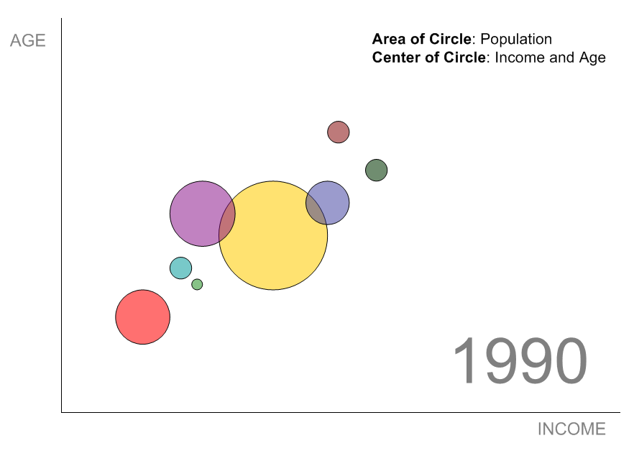
When moving the mouse cursor on year part, we can change the year shown on this figure and load different set of data according to the year, thus we can get a dynamical figure about the data change over years.

5 References
- Mike Bostock's github wiki page. https://github.com/mbostock/d3/wiki
- "D3: Data-Driven Documents", Michael Bostock, Vadim Ogievetsky and Jeffrey Heer, http://vis.stanford.edu/files/2011-D3-InfoVis.pdfvis.stanford.edu/files/2011-D3-InfoVis.pdf
- Stanford Vis group, http://vis.stanford.edu/papers/d3
- "D3 tutorial", http://alignedleft.com/tutorials/d3/
- "D3 for Beginners Part I: Thinking in D3" ,Joe Golike, http://www.youtube.com/watch?v=TT11gTQAbcU
- "D3 for Beginners Part II:Developing in D3", Vadim Ogievetsky, http://www.youtube.com/watch?v=RXhucjpsNqA
- "D3 for Mere Mortals", Luke Francl, August 2011, http://www.recursion.org/d3-for-mere-mortals/

