SRS Pharmacy System
Web Project Report

ONLINE GROCERY STORE
Table of Content

Introduction
Goal & Objectives
Design Considerations
Constraints
Environment
User Requirements
Functional Requirements
User Interface Design
Homepage Layout
Invalid Request Handling page
Administration page Layout
Administration & Maintenance

Goal & Objective
The whole project is a single-page type application, mainly functioned in two parts: user operation and owner administration. For user operation: user can browse stuffs in each category which is presented in form of drop-down box, the front-end interface can dynamically load updated information from server side, user can drag down and up to browse content and switch among different categories. User can also get ability to add stuff to lists by logging in. System will record user stuff information and update according content. The administration operation of the owner can perform actions such as category/user management, this system will provide a management interface to administrator, on that management
page, it lists current category and users for administrator to revise their attribution.

Design Considerations

Main constraints are focus in detail technical implementation and DB schema planning. This project need plenty of client side tech such as jQuey and the structure of data entity model is crucial for efficiently using and communicating with server side.
The normal user can not register, administrator will handle all user register works .

Environment

This project will need jQuery and Express.js(Node.js based framework) to implement Client side and server side, using node.js build-in server to host application, OS platform is Linux, currently test target is Ubuntu 12.04.

User Requirements (Ref.1)

# Requirement
U-1 User can browse stuff information during store hours
U-2 User can search products in each category
U-3 User can log in to get authentication
U-4 User can upload sales information on store hours
A-1 Administrator can log into management page
A-2 Administrator can use admin page to update category info
A-3 Administrator can use admin page to update user info

Functional Requirements (Ref.2)

# Requirement
F-1 System can implement stuff searching by stuff name and stuff description keyword
F-2 System can implement category and user searching by according ID

User Interface Design

Home Page Layout

When user enters, a user guide shown, giving user a brief introduction about the function of home page.
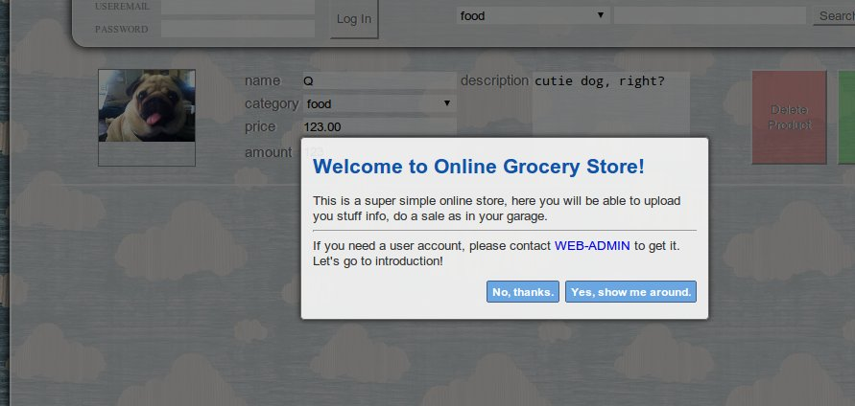
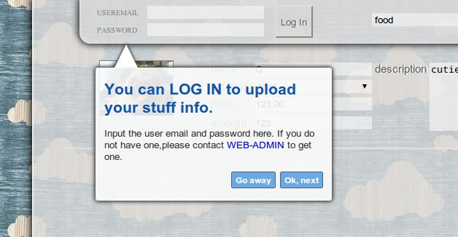
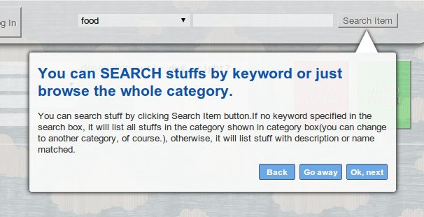

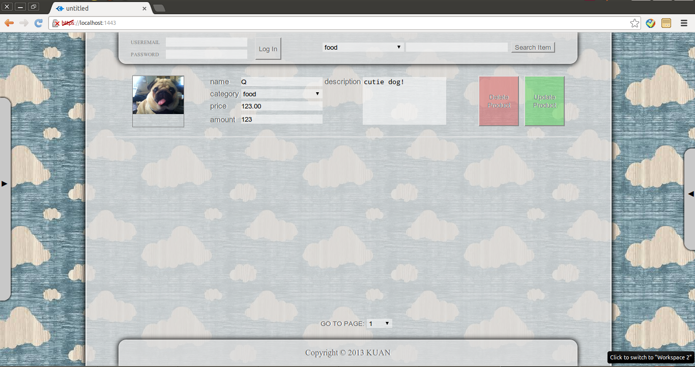

Invalid request handling page

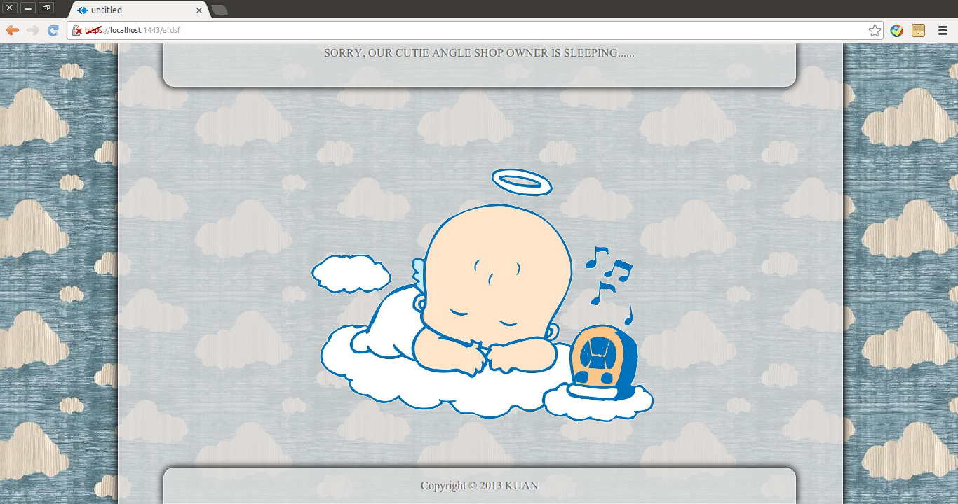

Administration Page

When user enters, a user guide shown, giving user a brief introduction about the function of home page( similar to home page user guide).

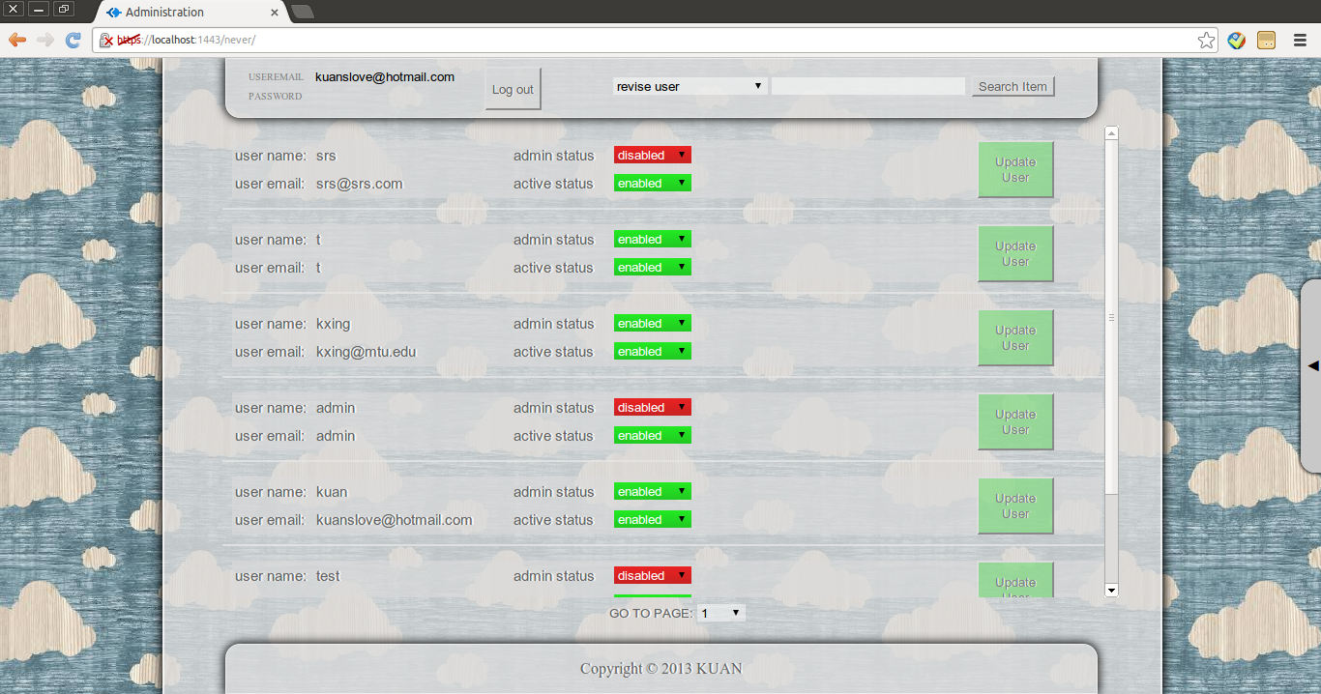
Administration & Maintenance

Security

Current version dose not involve payment transaction, no personal financial info protection needed. This project enables user editing function, which requires server side user identity authentication. We use general user login procedure to verify user registered email and password and save this login status in server session for further operation authentication.
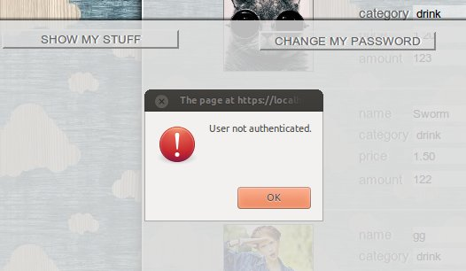
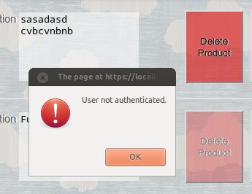

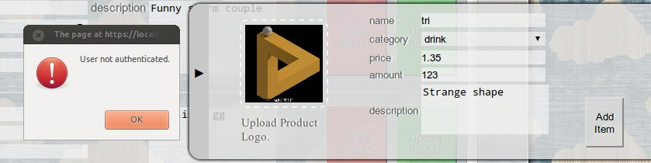

Another security is setting up SSL support server. Using https to visit this web.

Ref.1
U-1 User can browse stuff information during store hours

U-2 User can search products in each category

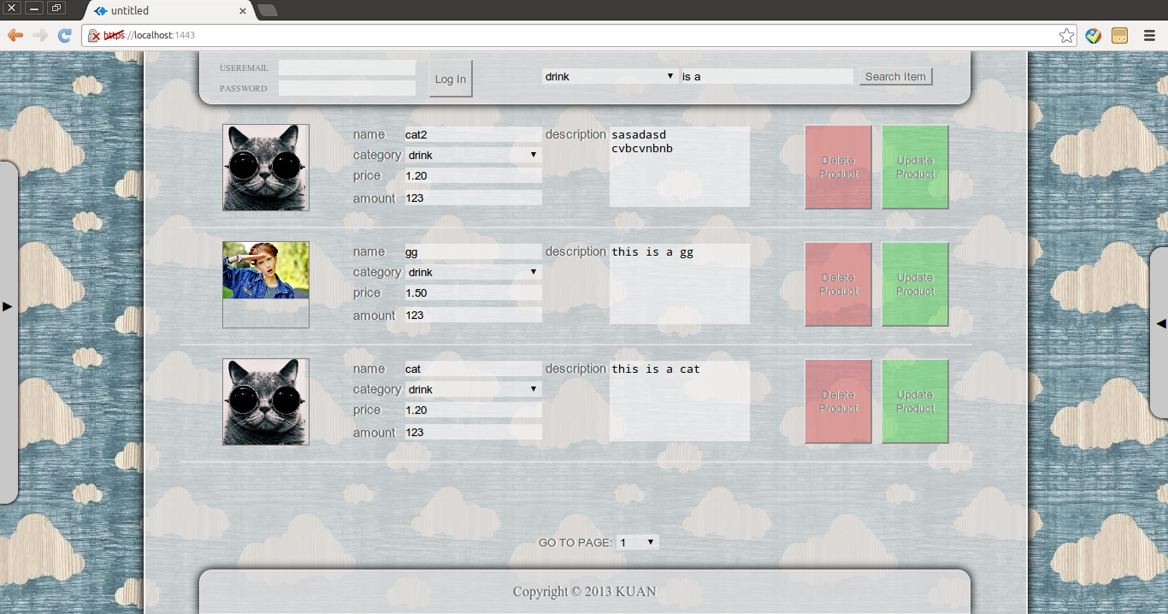

U-3 User can log in to get authentication

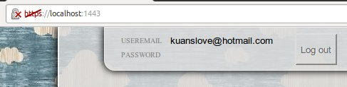
U-4 User can upload sales information on store hours

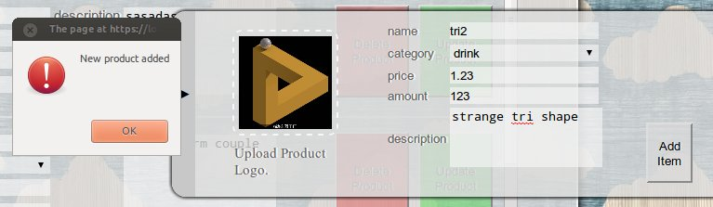
A-1 Administrator can log into management page

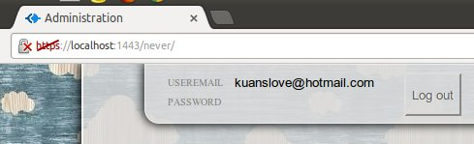

A-2 Administrator can use admin page to update category info

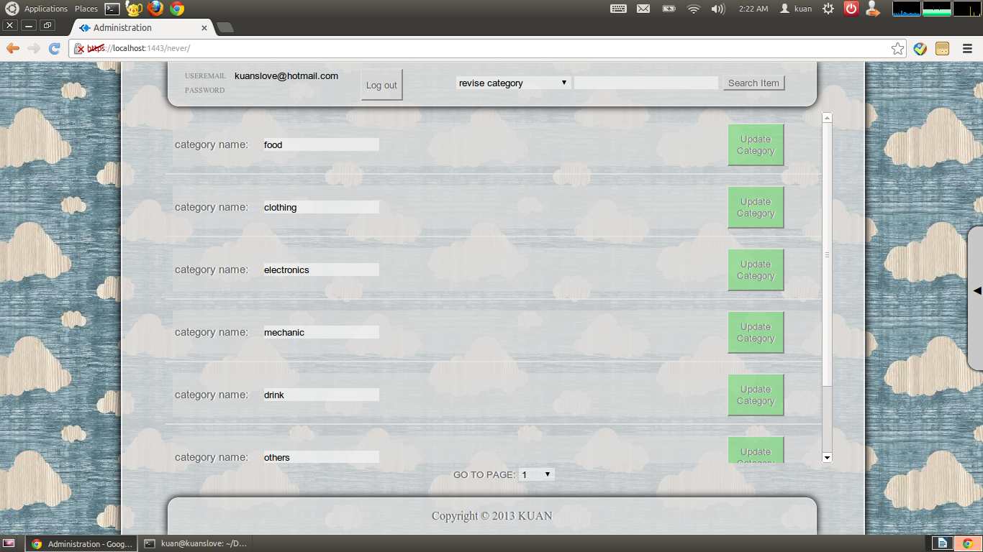
A-3 Administrator can use admin page to update user info

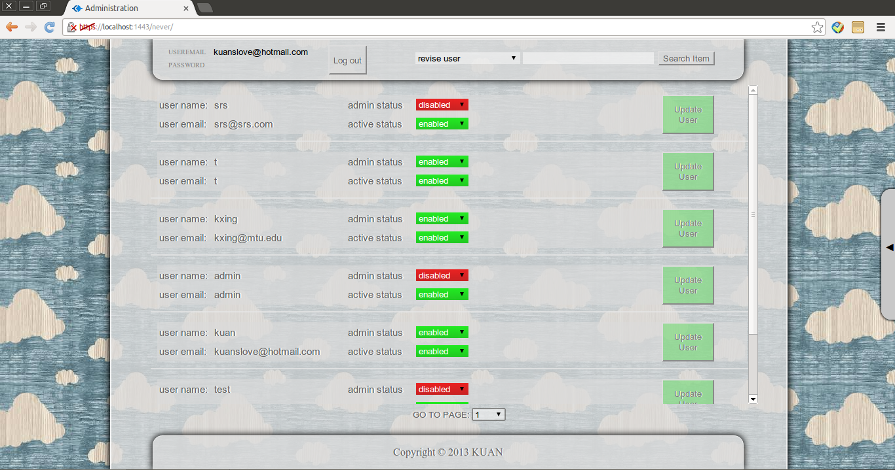

F-1 System can implement stuff searching by stuff name and stuff description keyword

F-2 System can implement category and user searching by according ID



