SRS Pharmacy System
Software Design Specification

Online Grocery Store

Table of Content

SRS Pharmacy Systems
Software Design Specification
Online Grocery Store
Introduction
History
Scope
Goal & Objectives
Design Considerations
Constraints
Environment
User Requirements
Functional Requirements
Work flow & Architecture
Use cases
Site Map
Hardware and Software Requirements
DataBase Schema
Database Definition
Entity Relationship Diagram
User Interface Design
Homepage Layout
Administration & Maintenance
Updates, Upgrades, and Patched

Introduction

History
The online shopping has had a long history, but most of them is too official and complicated for small daily business like grocery store or convenient store. And the forum and BBS sometimes is too general-purposed for sales. This project is aiming to implement an online grocery store prototype, which can provide those small shop owner a fast simple way to present their stuffs.

Scope
This project should implement an online shop which can provide users feature like browsing stuff lists by category and show according detail of specific stuff and ability to upload their own stuff information. Meanwhile, it also can provide the shop owner administration power to clean up the store configuration such as category, users and stuffs.

Goal & Objective
The whole project is a single-page type application, mainly functioned in two parts: user operation and owner administration. For user operation: user can browse stuffs in each category which is presented in form of tab, the front-end interface can dynamically load updated information from server side and change content in according tab, user can drag down and up to browse content and switch among different categories. User can also get ability to add stuff to lists by logging in. System will record user stuff information and update according content. The administration operation of the owner can perform actions such as category/user management, this system will provide a management interface to administrator, on that management page, it lists current category and users for administrator to revise their availability.

Design Considerations

Constraints
Main constraints are focus in detail technical implementation and DB schema planning. This project need plenty of client side tech such as jQuey and the structure of data entity model is crucial for efficiently using and communicating with server side.

Environment
This project will need jQuery and Express.js(Node.js based framework) to implement Client side and server side, using node.js build-in server to host application, OS platform is Linux, currently test target is Ubuntu 12.10 and CentOS 6.4.

User Requirements
# | Requirement | Priority
U-1 | User can browse stuff information during store hours | M
U-2 | User can search products in each category tab | M
U-3 | User can log in to get authentication | M
U-4 | User can upload sales information on store hours | M
U-5 | System can show user recent updated information | D
U-6 | System can provide user public chatting interface | O
A-1 | Administrator can log into management page | M
A-2 | Administrator can use admin page to update category info | M
A-3 | Administrator can use admin page to update user info | M

Priorities:
M - Manditory
D - Desirable
O - Optional

Functional Requirements
# | Requirement | Priority
F-1 | System maintains 99.9% up time | M
F-2 | System can implement stuff searching by stuff name and stuff description keyword | M
F-3 | System can implement category and user searching by according ID | M

Work flow & Architecture

Use Cases
Ref to Attachment.

Site Map
Domain:3000/
/
User Operation Page

A single page application which list stuffs in each category for user and allow user to log in to upload stuff info in same page
/admin
Administration Operation page

A single page application which allow administrator to log in to update user info and category info.

Hardware and Software Requirements
This application can be supposed to run in both Windows and Linux platform. No high performance computer is required because there is no computation density requirement for information retrieving currently. General Laptop or desktop with 1GB RAM or more is recommended.

Node.js version>=0.10
Re to http://nodejs.org/

Express.js version >=3.0.
Ref to http://expressjs.com/guide.html

jQuery version >=1.09
Ref to https://developers.google.com/speed/libraries/devguide#jquery

PostgreSQL database is utilized to comply with current SRS standard
PostgreSQL version>=9.0 is recommended

Database Schema

Database Definition
Table Name | Field Name | Data Type | Field Description
product | id | serial  primary key | Unique Product ID
product | name | varchar[100] | Product name
product | desc | varchar[250] | Product description
product | img_id | integer | Associated image ID
product | user_id | integer | Owner ID
product | category_id | integer | Category ID
product | amnt | integer | In-Stock amount
product | price | double precision | Unit price
product | date_reg | date | Product register date
product | date_rev | date | Product revise date
product | n_a | Boolean y/n | Availability

Table Name | Field Name | Data Type | Field Description
user | id | serial  primary key | Unique User ID
user | name | varchar [50] | User real name
user | email | varchar [50] | User email
user | pswd | varchar [20] | User password
user | role | integer | Admin or User
user | n_a | Boolean y/n | Availability

Table Name | Field Name | Data Type | Field Description
category | id | serial  primary key | Unique category ID
category | name | varchar [30] | Category Name
category | n_a | Boolean y/n | Availability

Table Name | Field Name | Data Type | Field Description
image | id | serial  primary key | Unique category ID
image | data | varchar [30] | Category Name
image | user_id | integer | Owner ID
image | category_id | integer | Category ID
image | product_id | integer | Product ID
image | n_a | Boolean y/n | Availability

Entity Relationship Diagram

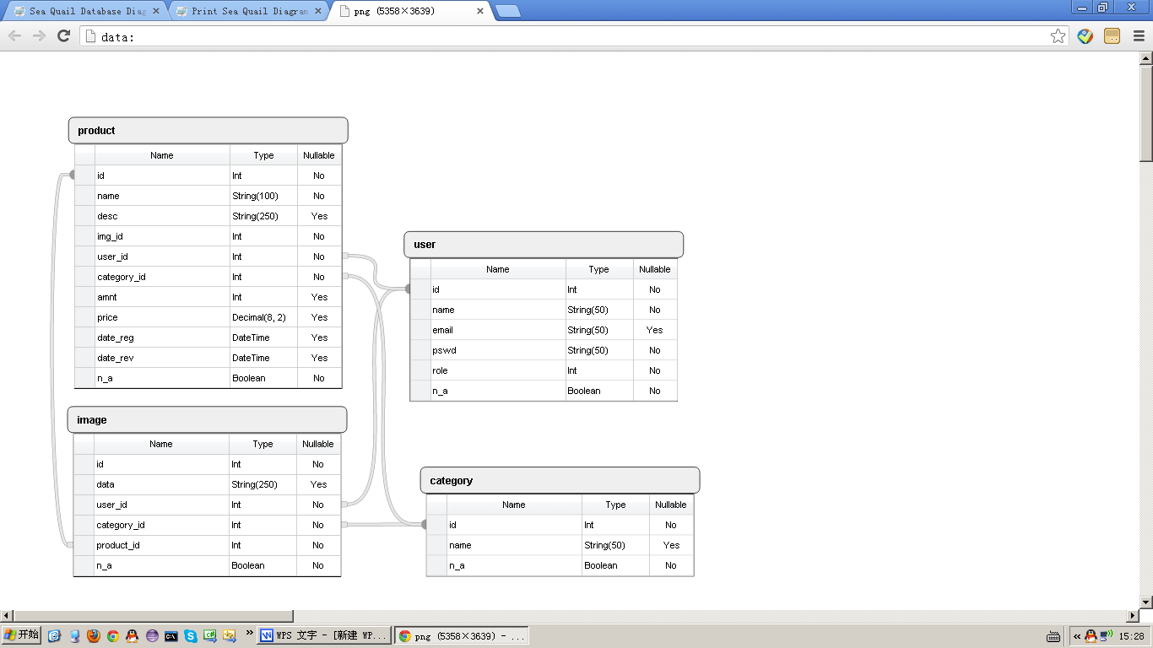

User Interface Design

Homepage Layout
Search by name or description
Search Box
amount
DEL
name
Clothes
Electronic
Misc
category
Food
price
description
Log In
Password
Email

Stuff List for each category
User owned stuff list
EDIT
SAVE

The home page layout is mainly for general users. In this page, user can navigate each category by dragging down according tab and search specific item by input its name or description keywords on the top part of each tab.

In the bottom part of this page, it is user login area, which authenticates and provides user access to add new stuff to category or edit existing product.

Administration Page Layout
Search Box
Edit by list
Search Button
Category Result item
X
S
User Result item
X
Product Result item
X

In the administration page, the administrator can choose edit category, user or products by selecting them in Edit by list, the search result will display list below.
If no keyword in Search box, the result will be all records of category, user, or products.

Administration & Maintenance

Security
Current version dose not involve payment transaction, no personal financial info protection needed. This project enables user editing function, which requires server side user identity authentication. We use general user login procedure to verify user registered email and password and save this login status in server session for further operation authentication.
The general authentication schema:

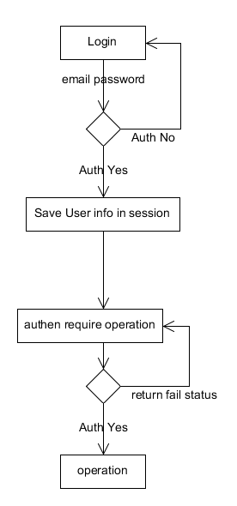
Another security is setting up SSL support server. Using https to visit this web.

Performance Monitoring
Current design is add website visiting counter to record the traffic and monitoring alive status of web.

Use Case Action Procedure
- Normal user page
Client side
Document ready:
- Query products data
- Callback render with return data in all category tab
- Render user login panel
Search button click.
- Query product data with keyword
- Callback render with return data in according category tab
Login button click
- Query verification info and user posted data by sending our user email and password
- If authenticated, render posted product list with return data, render product editing panel. Otherwise, keep in login page.
Product editing panel image canvas click
- Upload image to browser and render it in canvas
Product editing panel Add button click
- Post product panel info query to server
- If authenticated and query succeed, render user posted list and according category list. Logout link click
- Send logout request to server and return login panel layout.
Server side
Initial Connection:
- Retrieve category info from database, pass to template engine render the basic page view and response.
Product query with category ID but without product keyword arrives:
- Retrieve all products in request’s category ID
Product query with category ID and product keyword arrives:
- Retrieve required products in request’s category ID
Login query
- Retrieve user info from database, if matched, store user info in server session object and return this object with product list of this user info.
Add new product query
- Extract data from request form data and save into product table.

Use Case Action Procedure
2. Administrator page
Client side
Login query
- Query verification info and user posted data by sending our user email and password
- If authenticated, show management console page which include search text box, search-by list, search button and management list.
Search button click with nothing in search text box.
[NOTE]: search text box is only for product searching
1. Category or User selected in select-by list
- Query all categories or users and render result list
- Product selected in select-by box
- Do nothing.
Search button click with keyword in search text box.
[NOTE]: search text box is only for product searching
1. Category or User selected in select-by list
- Query all categories or users and render result list
- Product selected in select-by box
- Query products in all category with the keyword
Category, user and product delete button click
- Sent delete query with according ID to server.
- If deletion succeed, remove that item with return ID.
Category edit button click
- Turn category name into editable mode and sent update query with category ID to server.
Server side
Login query
- Retrieve user info from database, if matched, store user info in server session object. Render admin page and return.
Search query
- Check request type, retrieve according info from database and return.
Delete query
- Set according record n_a status to n.
Update query
- Update record with ID in request.

Use Case
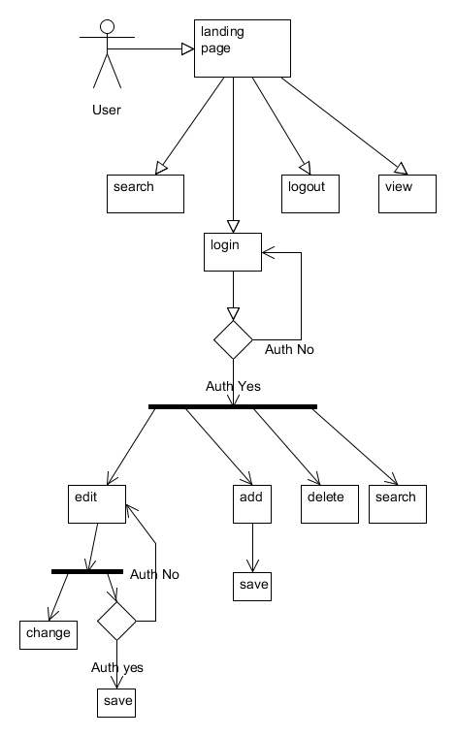

Use Case
