機率與統計HW1 資訊乙114 何寬羿 C34104032

(1.20)

(a)

|  |  |  |
| --- | --- | --- |
| Double-Stem-And-Leaf- Plot for the life span of fruit flies | | |
| Stem | Leaf | Frequency |
| 0* | 34 | 2 |
| 0. | 56667777777889999 | 17 |
| 1* | 0000001223333344 | 16 |
| 1. | 5566788899 | 10 |
| 2* | 034 | 3 |
| 2. | 7 | 1 |
| 3* | 2 | 1 |

(b)

Add up all the frequency from (a):

2+17+16+10+3+1+1 = 50

|  |  |  |  |
| --- | --- | --- | --- |
| Relative Frequency Distribution | | | |
| Class interval  (sec-sec) | Class midpoint  (sec) | Frequency, f | Relative Frequency |
| 0-4 | 2 (= (0+4)/2) | 2 | 0.04 (= 2/50) |
| 5-9 | 7 | 17 | 0.34 |
| 10-14 | 12 | 16 | 0.32 |
| 15-19 | 17 | 10 | 0.20 |
| 20-24 | 22 | 3 | 0.06 |
| 24-29 | 27 | 1 | 0.02 |
| 30-34 | 32 | 1 | 0.02 |

(c)

(d)

median = (10+11)/2 = 10.5 (sec)

(2.10)

(a) F: safe, N: not safe，Sample Space有2^3種elements

S = {FFF, FFN, FNF, NFF, FNN, NNF, NFN, NNN}

(b) Elements in event E, number of F must more than 1

E = {FFF, FFN, FNF, NFF}

(c)

For all the elements in this event, the second river is F(safe).

(2.20)

(a) region 6

M’∩T’∩V

(b) region 2

M∩V∩T’

(c) region 5 or 6

either M or V means (M XOR V)

(M XOR V)∩T’

(d) region 4 or 5 or 7 or 8

V’

(2.38)

(a) 6! = 720種

(b) 先排列情侶，每對情侶中的兩人亦可換位

3! × (23) = 48種

(c) 左邊三個女生排列，右邊三個男生排列

3! × 3! = 36種

(1.25)

(a) Sample Mean = 33.31 (%)

calculated by Matlab: 

(b) Sample Median = 26.35 (%)

calculated by Matlab: 

(c) Relative Frequency Histogram

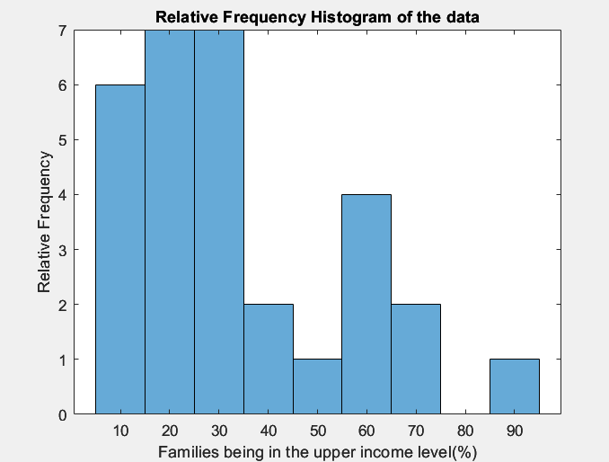

(d) 10% trimmed mean = 30.9708 (%)

calculated by Matlab

**比起原始的平均值(a)，刪掉一些outliers後，10% trimmed mean 更靠近中位數(b)(往(c)圖表的左側偏移)。這是因為原始數據的Data Distribution是呈現

Right-Skewed的，即資料較集中在(c)圖表中左側的位置。

(1.30)

Box Plot for the data

