機率與統計 HW2 資訊乙114 何寬羿 C34104032

2.66

(a) The prob. that the accident occurred on the graveyard shift

= 2% + 30% = 32%

(b) The prob. that the accident occurred due to human error

= 32% + 25% + 30% = 87%

(c) The prob. that the accident occurred due to unsafe conditions

= 5% + 6% + 2% = 13%

(d) The prob. that the accident occurred on either the evening or the graveyard shift

= (6% + 25%) + (2% + 30%) = 63%

2.82

P(H) = 0.2, P(W) = 0.28, P(H∩W) = 0.15

(a) = P(H ∪ W) = 0.2 + 0.28 – 0.15 = 0.33

(b) = P(W | H) = P(H∩W)/ P(H) = 0.15/ 0.2 = 0.75

(c) = P(H | W’) = P(H∩W’)/ P(W’) = (P(H) - P(H∩W)) / P(W’)

= (0.2 – 0.15) / 0.72 = $\frac{5}{72}(≒0.069)$

2.90

(a) P(A∩B∩C) = P(C|A∩B)*P(B|A)*P(A) = 0.20*0.75*0.3 = 0.045

(b) by Venn Diagram: P(B’∩C) = P(A∩B’∩C) + P(A’∩B’∩C)

= P(C|A∩B’ )*P(B’|A)*P(A) + P(C|A’∩B’)*P(B’|A’)*P(A’)

= 0.80*(1-0.75)*0.3 + 0.90*(1-0.20)*0.7 = 0.564

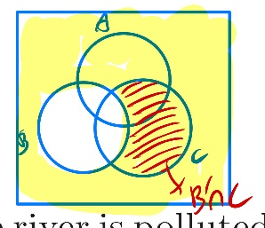

(c) by Venn Diagram: P(C) = P(A∩B’∩C) + P(A∩B∩C) + P(A’∩B∩C) + P(A’∩B’∩C)

= 0.80*0.25*0.3 + 0.045 + P(C| A’∩B)*P(B|A’)*P(A’) + 0.90*0.80*0.7

= 0.06 + 0.045 + 0.021 + 0.504 = 0.63

(d) P(A| C∩B’) = P(A∩B’∩C) / P(C∩B’) = 0.06/0.564 = $\frac{5}{47}(≒0.106)$

2.100

Sum up “Caused by other human errors” in the three station = 7 + 7 + 5 = 19

“Caused by other human errors & in station C” = 5

Answer is 5/19 = $\frac{5}{19} (≒0.263)$

2.126

(a) P(Union | New Company) = 13 / (13+10) = $\frac{13}{23} (≒0.565)$

(b) P(Unemployed | Union) = 2 / (40+13+4+2) = $\frac{2}{59} (≒0.034)$

----------------------------------------------------------------------------------------------------------------

Matlab

1. (b) => by the function from 1.(a)

Relative Frequency Histogram

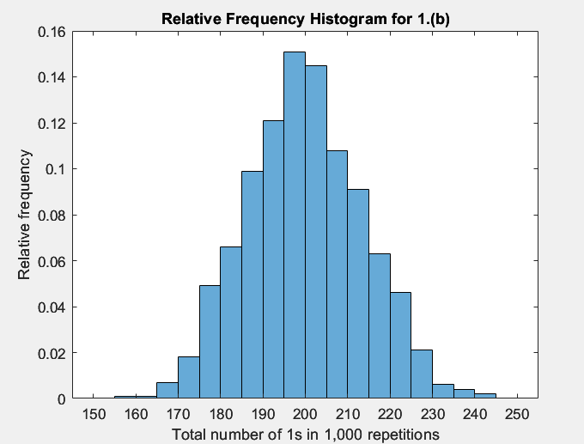

1000 numbers saved in a .m file => HW2_1b_1000num.m

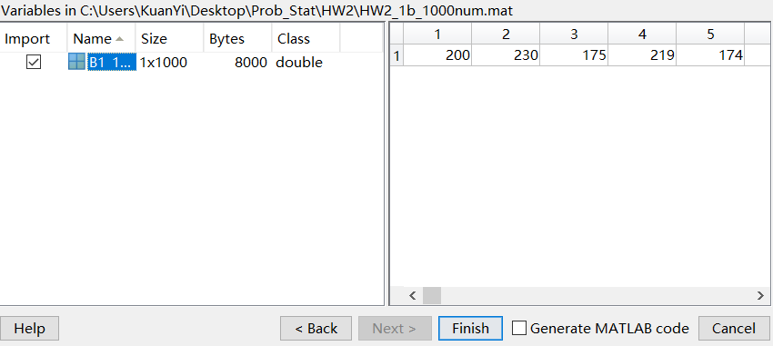

1. (c)

10 numbers(P(B3|A)) saved as a .m file => HW2_1c_10num.m

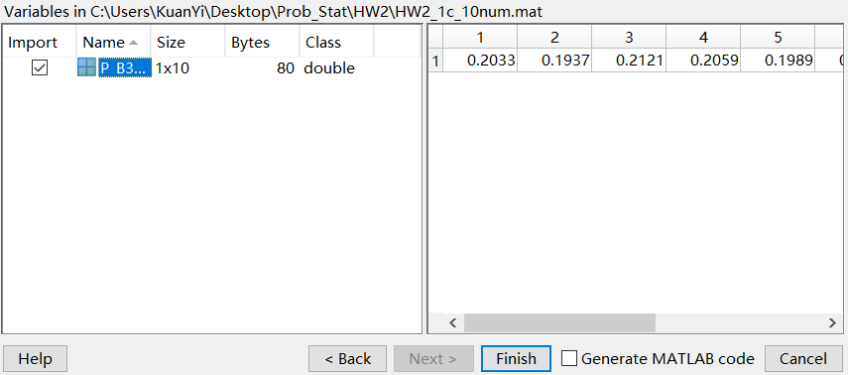

Compare to theoretical value of P(B3|A) on text book = 10/49.

First, calculate the mean value of 10 trials(the 10 numbers) = P_B3_A_average.

The theoretical value is around 0.2041.

And the moment I run the my program, P_B3_A_average = 0.2042(may change every time, but around 0.2)

=> very close to the theoretical value, thus this simulation program is reliable.