機率與統計 HW7 何寬羿 資訊114 C34104032

Textbook exercise:

(7.12)

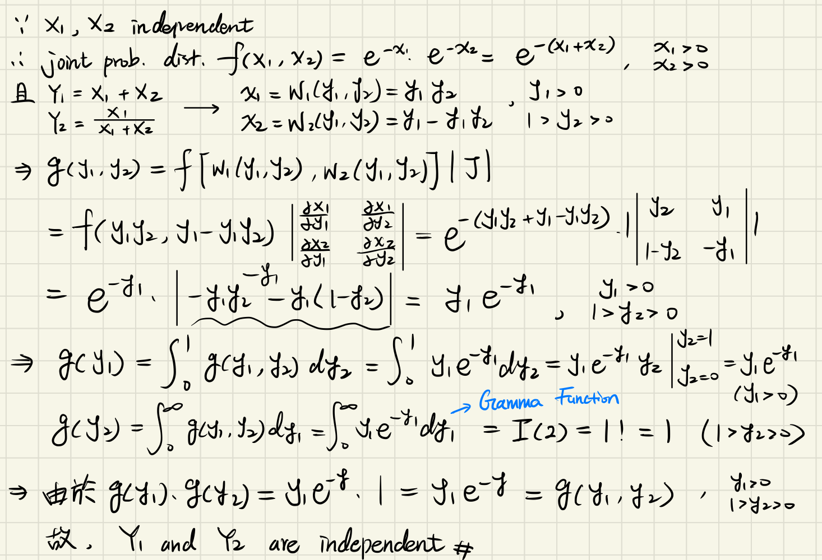

(7.14)

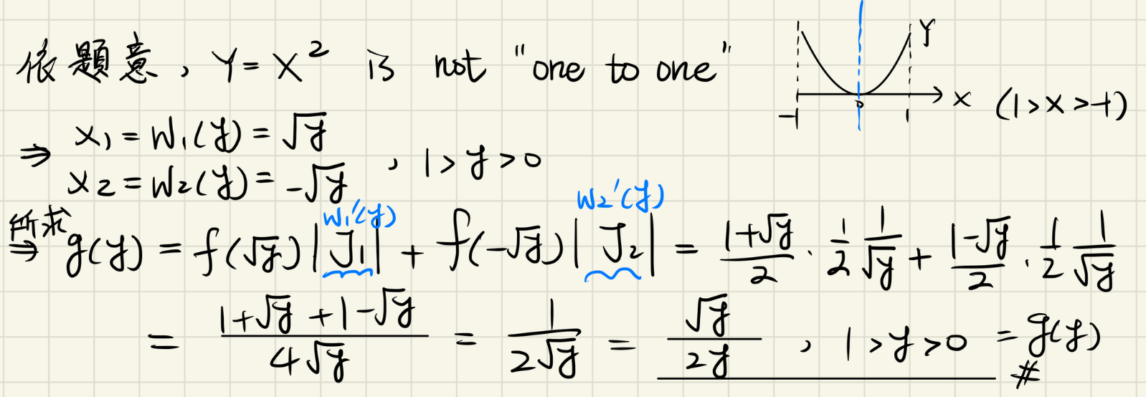

g(y) = 0, elsewhere.

(7.18)

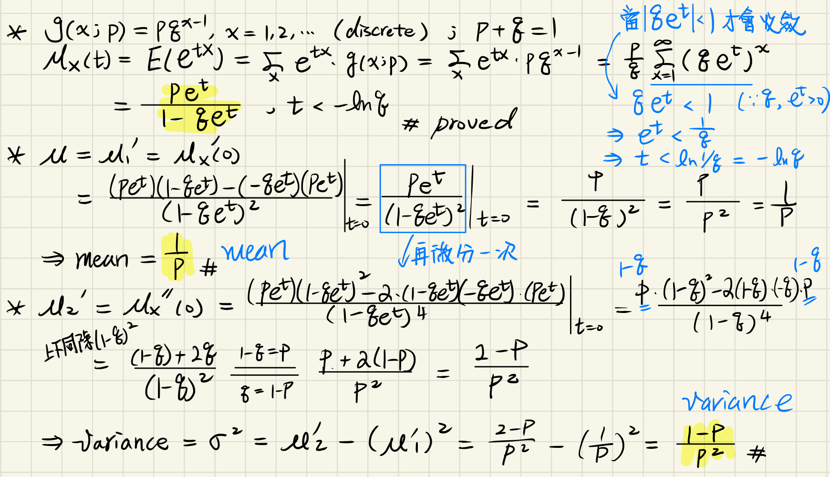

(7.22)

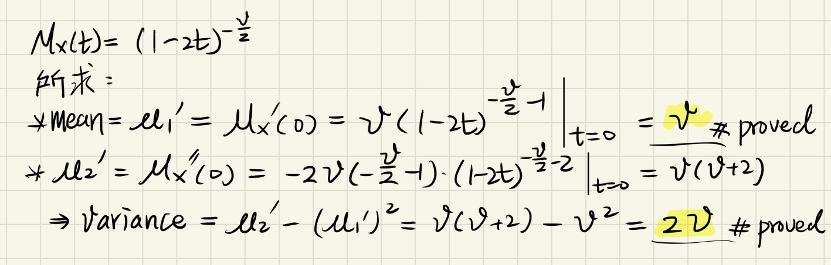

Matlab

1.(a) Function 已實作在HW7_1a.m

1.(b)

(histograms are normalized to values of probability density function for ease of comparison with a normal distribution.)

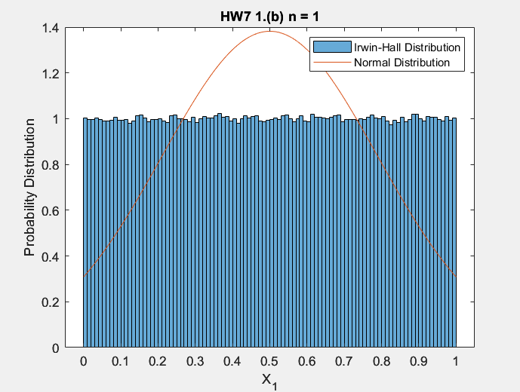

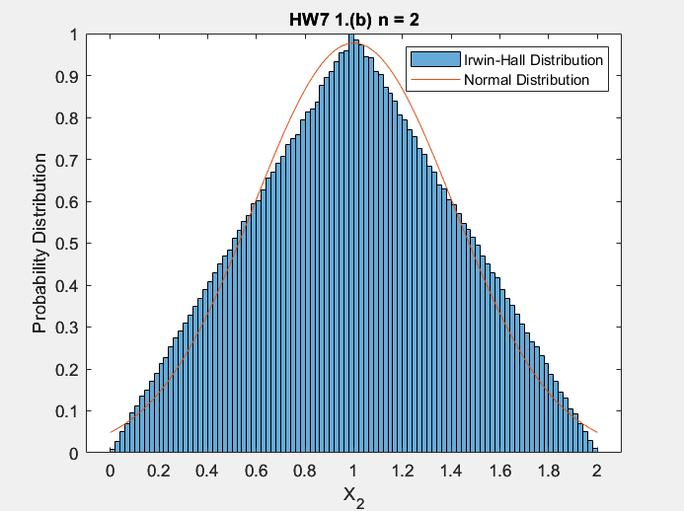

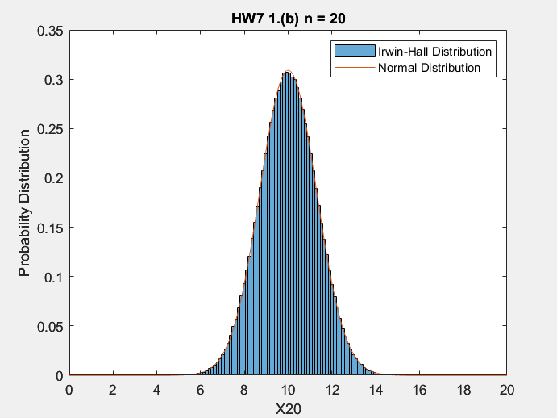

% When n is too small, the errors of using a Irwin-Hall distribution

% to approximate a normal distribution will be very large. That is, the

% approximation is bad when n is small.(When n = 1, two distributions are

% completely different; when n = 2, the approximation is slightly better,

% but still do not look like normal distribution.).

%

% However, when n is huge enough(like the case n = 20 above),

% the approximation will be great, the errors are small.

% Also, this is a good example to demonstrate the central limit theorem.

% when n is huge enough, Irwin-Hall Dist.(Originally not normal dist.)

% will be like Normal Dist.