Approval Procedure

CA-AP-001-2019 | Approval Procedure | V 1.0 | July 2019

Document Revision History

Date | Version | Pages | Revision | Author
July 2019 | 1 | All | First Draft | GDS

Contents
Document Revision History 2
Applicable Laws and Regulations 4
Applicable Standards and Guidance 4
Introduction 5
Overview 6
Procedural Steps 7
Step 1 7
Step 2 8
Step 3 8
Step 4 8
Step 5 8
Step 6 9
Step 7 9
Step 7a 9
Step 8 9
Step 8a 9
Step 8b 10
Step 9 10
Step 10 10

Applicable Laws and Regulations
GDPR - The General Data Protection Regulation (EU) 2016/679 (GDPR)
eIDAS - "REGULATION (EU) No 910/2014 OF THE EUROPEAN PARLIAMENT AND OF THE COUNCIL of 23 July 2014 on electronic identification and trust services for electronic transactions in the internal market and repealing Directive 1999/93/EC"
AML
…

Applicable Standards and Guidance
Good Practice Guide (GPG) 45, version 4.1.1
Good Practice Guide (GPG) 44
ISO/IEC 27001 — Information technology - Security Techniques - Information security management systems — Requirements.
ISO/IEC 27002 — Code of practice for information security controls
ISO/IEC 29115:2013 Information technology -- Security techniques -- Entity authentication assurance framework
ISO/IEC 27011 — Information security management guidelines for telecommunications organizations based on ISO/IEC 27002
ISO/IEC 27013 — Guideline on the integrated implementation of ISO/IEC 27001 and ISO/IEC 20000-1 (derived from ITIL)
ISO/IEC 27014 — Information security governance.
ISO/IEC 27017 — Code of practice for information security controls based on ISO/IEC 27002 for cloud services
ISO/IEC 27018 — Code of practice for protection of personally identifiable information (PII) in public clouds acting as PII processors
NIST 800 series including: SP 800-63-3 Digital Identity Guidelines, SP 800-63A Enrollment and Identity Proofing, SP 800-63B Authentication and Lifecycle Management and SP 800-63C Federation and Assertions
…

Introduction
This document provides an overview of the Approval Procedure to achieve trust status as a Potential Provider to the <…> Trust Framework.
For the avoidance of doubt, references to ‘you’ in this document shall be references to the Potential Provider submitting an Approval application.
There are three levels of trust status that a Potential Provider may apply to the Authoritative Body for: Self-Assessment, Approval or Full Certification. The following diagram shows the pathways for these:

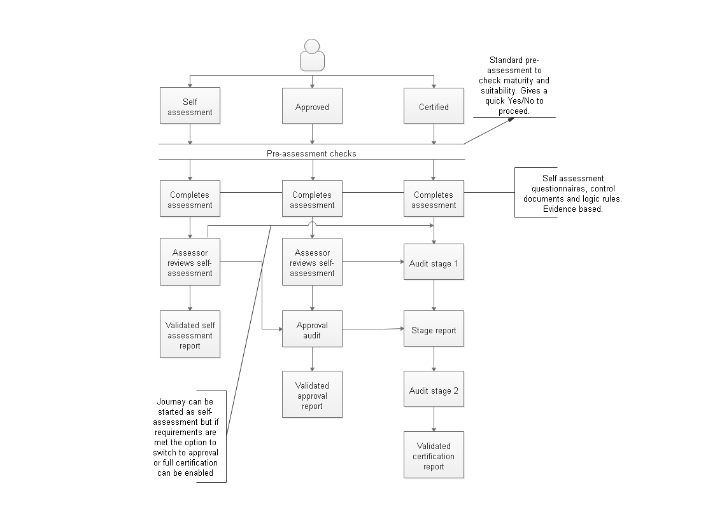
Figure 1 - Process Map
As shown in the process map, a Potential Provider can begin an Approval process but if you decide that you meet the requirements for Full Certification you can switch to applying for that level of trust status. Alternatively, you may find that when completing the Approval assessment that at the present time you do not score highly enough to continue with Approval status application in which case you might wish to consider the Self-assessment process.
Guidance:
The decision to switch from Approval to Full Certification should only be made in consultation with the independent auditor as the requirements for Full Certification requires increased controls, evidence and two in-depth audits.
Should you wish to consider Self-assessment instead of Approval consult with the independent auditor.

Overview
The Approval procedure is intended to ensure that Potential Providers offer a service that meets the minimum required standard in the mandatory aspects of the requirement and can produce evidence that they can offer high quality and secure services. This is measured by a criteria set that is assessed by an independent auditor.
Independent auditors are bound by international auditing standards and conform to the principles of auditing.
The steps that you need to undertake to make an application to the authoritative body are:

Step 1 – Register and download application pack
Step 2 – Complete pre-assessment
Step 3 – Select an independent auditor
Step 4 – Complete the self-assessment report, questionnaire, statement of conformity and outline specification with required evidence.
Step 5 – Submit self-assessment report, questionnaire, statement of conformity and outline specification to the independent auditor
Step 6 – Complete Full Service Description
Step 7 – Submit the Full Service Description to the independent auditor
Step 7a – Auditor will plan onsite Audit
Step 8 – You will host audit
Step 8a – Auditor performs onsite Audit
Step 8b – Auditor compiles audit report and makes recommendation to your organisation and to the Framework Authoritative Body
Step 9 – Complete the full application pack
Step 10 – Authoritative Body provides you with their decision

Procedural Steps

Step 1
You must first register your interest with the authoritative body.
Download the following documents that will form your full application
CA-AF-001-2019 | Application Form
CA-PA-001-2019 | Pre-assessment Document
CA-PAC-001-2019 | Pre-assessment Criteria

The Pre-assessment document [CA-PA-001-2019] gives guidance on how to carry out a pre-assessment and [CA-PAC-001-2019] Pre-assessment criteria allows you to determine if you meet the minimum standard required. This is so that you can make a decision on whether to proceed at this time with your application.

CA-AP-001-2019 | Approval Procedure

CA-QC-001-2019 | Questionnaires and Controls Document
CA-AAC-001-2019 | Approval criteria report

CA-SDF-001-2019 | Full Service Description template
CA-SDO-001-2019 | Outline Service Description template

CA-SC-001-2019 | Statement of Conformity

CA-FTC-001-2019 | Terms and conditions of the Framework

CA-LOAA-001-2019 | List of Approved Auditors and Assessors

Download the profiles relevant for the service you are providing
FS-BAP-001-2019 | Base Profile *
FS-ARP-001-2019 | Attribute Registration Profile
FS-CMP-001-2019 | Credential Management Profile
FS-CVP-001-2019 | Credential Validation Profile
FS-IPP-001-2019 | Identity Provider Profile
FS-IRP-001-2019 | Identity Registration Profile

- The Base Profile is mandatory for all Potential Providers.
It covers such topics as:
Business Probity
Management Competence
Management and security policies and procedures
Assurance of technical infrastructure;
Competencies and suitability of personnel
External relationships and these include:
Externally provided Trust Services and Service Components;
Relationships with suppliers of technology, equipment and general support services;
Service-related policies and procedures.

You will need to refer to the requirements and criteria outlined in the Base Profile [FS-BAP-001-2019] and the relevant technical profiles in order to carry out the pre-assessment and complete the Pre-assessment Document [CA-PA-001-2019], Questionnaire and Controls Document [CA-QC-001-2019] and Self-assessment Report [CA-SAC-001-2019].

Step 2
Complete the Pre-assessment Document [CA-PA-001-2019] using Pre-assessment Criteria [CA-PAC-001-2019].
The pre-assessment criteria checks are there for you to determine your readiness to go ahead with a full application.

Step 3
Select an independent auditor from the List of Approved Auditors and Assessors [CA-LOAA-001-2019].
You need to make a formal approach to the independent auditor and between you agree the engagement.
You need to provide the independent auditor with the results of your Pre-Assessment Document [CA-PA-001-2019]. The auditor on receiving the Pre-assessment Document will check that the pre-assessment you have sent scores highly enough to proceed with the next stages of the application.
The independent auditor will confirm the evidence that is required for the next stage of the application.

Step 4
You must now complete the Approval Criteria Report [CA-AAC-001-2019] and Questionnaire and Controls Document [CA-QC-001-2019] answering all questions and providing supporting evidence as outlined in these documents and as advised by the independent auditor.
You must complete the Statement of Conformity [CA-SC-001-2019] and provide evidence that the areas of compliance required are satisfied by your organisation.
You must complete the Outline Service Description [CA-SDO-001-2019] for the service you intend to deliver.

Step 5
Once you have completed the:
- Approval Criteria Report [CA-AAC-001-2019]
- Questionnaire and Controls Document [CA-QC-001-2019]
- Statement of Conformity [CA-SC-001-2019] and
- Outline Service Description [CA-SDO-001-2019]
return these to the independent auditor.
On receipt of these the auditor will make an independent assessment and provide you with feedback.

Step 6
You now need to complete the Full Service Description [CA-SDF-001-2019] the independent auditor will provide assistance on this where required to ensure that all information that is necessary is completed correctly. However, the auditor can only advise and will not make recommendations that in any way places them in a position where their independence or integrity can be called into question.

Step 7
Once the Full Service Description [CA-SDF-001-2019] is complete and you are confident that all evidence required is available return this to the independent auditor.

Step 7a
The independent auditor will review all the documentation you have supplied. Once this is done the independent auditor will contact you to arrange to carry out an on-site audit.

Step 8
You will be required to host an on-site audit as planned by the auditor in Step 7a.

Guidance
An on-site audit of this type should take at least one full working day depending on your readiness. The auditor will be testing areas of risk and ensuring that safeguards and controls are in place and implemented to a level that provides appropriate security. It is advised that when negotiating the date for the on-site audit that you can be sure that all necessary participants will be available and all resources to be checked are in place. If you have any concerns that this will not be the case you should alert the independent auditor to that situation and re-arrange the audit date.

Step 8a
Auditor performs onsite Audit
Guidance
The auditor will have sent you an agenda for the on-site audit with proposed start and finish times. This will be accompanied by the suggested participants and the required asset and test criteria that will be assessed. Ensure that all items for inspection are ready and available. It is likely that the independent auditor will halt or cancel the audit should items of significance not be accessible.

Step 8b
Auditor compiles an Approval Audit Report [CA-APAR-001-2019] which is sent to the Trust Framework’s Authoritative Body with a recommendation as to whether your proposed service meets the criteria for Approval status.
The independent auditor will at the same time notify you with their recommendation. If it is a successful recommendation you will be asked to complete the full application ready to submit to the Trust Framework’s Authoritative Body.

Step 9
You need to complete the Application Form [CA-AF-001-2019] and agree and sign the Terms and Conditions for the Trust Framework [CA-FTC-001-2019].
You will submit this to the Trust Framework’s Authoritative Body.
Your completed application must include:
CA-AF-001-2019 | Application Form
CA-PA-001-2019 | Pre-assessment Document
CA-QC-001-2019 | Questionnaires and Controls Document
CA-AAC-001-2019 | Approval Criteria Report
CA-SDF-001-2019 | Full Service Description
CA-SDO-001-2019 | Outline Service Description
CA-SC-001-2019 | Statement of Conformity
CA-FTC-001-2019 | Terms and Conditions of the Framework

Step 10
Upon receipt of your application pack the Trust Framework’s Authoritative Body will make a decision based on the information you and the independent auditor has supplied. You will be notified within xxxxx weeks of their decision.

