**Models (models.py from app folder):**

class Topic(models.Model): top\_name = models.CharField(max\_length=264, unique=True) def \_\_str\_\_(self): return self.top\_nameclass Webpage(models.Model): topic = models.ForeignKey(Topic, on\_delete=models.CASCADE) name = models.CharField(max\_length=264, unique=True) url = models.URLField(unique=True) def \_\_str\_\_(self): return self.name

**IMPORTANT:** Variable with „ .ForeignKey” must have on\_delete=models.SOMETHING ([https://docs.djangoproject.com/en/1.11/ref/models/fields/#django.db.models.ForeignKey.on\_delet](https://docs.djangoproject.com/en/1.11/ref/models/fields/" \l "django.db.models.ForeignKey.on_delete)e)

**1. Migrations (db creation with created models)**

**Commands in Project folder:**

C:\\Tutorial\[Project name]

1. python manage.py migrate
2. python manage.py makemigrations [app name]
3. python manage.py migrate

**2. Register models (admin interface)**

//[app folder]/admin.py

from django.contrib import admin  
 from first\_app.models import AccessRecord, Topic, Webpage   
  
 admin.site.register(AccessRecord)  
 admin.site.register(Topic)  
 admin.site.register(Webpage)

**3. Create „superuser” (for data protection)**

Command on project level:

python manage.py createsuperuser – name, e-mail, password

**4. Django admin interface**

1. python manage.py runserver (project level)
2. http://127.0.0.1:8000/admin
3. Log in as „superuser”

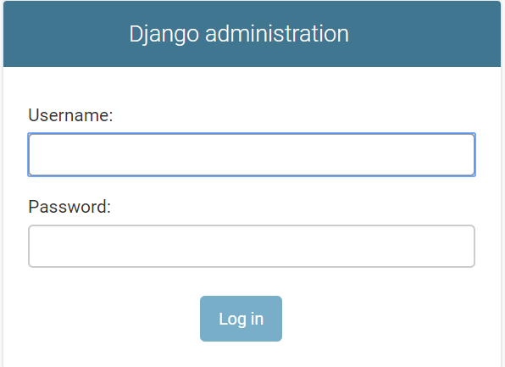

**ERROR:**

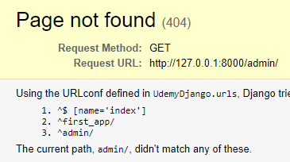

**Solution:**

**urls.py → /admin/ should be first! (**https://stackoverflow.com/questions/39805624/django- admin-page-not-found-404)

**OR**

urls.py →**from** path(r'^admin/', admin.site.urls) **change on** url(r'^admin/', admin.site.urls)

**Shell – interaction with created database**

(Project folder)

1. Open shell:

python manage.py shell

2. Importing model (shell command):

from [app\_name].models import Topic #name of model – class in fact

3. Add some variable to model:

t = Topic(top\_name = „Social Network”)

t.save() #save to db

print(Topic.objects.all()) #check added variable

quit() #escape shell interface – +z does the same