First Milestone: Indexes, papers and first toying with datasets
Cheetsheat:

1. NDVI (Normalized Difference Vegetation Index)
Bands Used: Near-Infrared (NIR) and Red (R)
Formula:
NDVI = $\frac{NIR - R}{NIR + R}$
Application: Standard indicator for plant vigor and biomass estimation.
Limitation: Prone to saturation in dense canopies.

2. GNDVI (Green NDVI)
Bands Used: Near-Infrared (NIR) and Green (G)
Formula:
GNDVI = $\frac{NIR - G}{NIR + G}$
Application: Highly sensitive to chlorophyll concentration.
Advantage: Better than NDVI in dense, late-stage crop canopies.

3. NDRE (Normalized Difference Red Edge)
Bands Used: Near-Infrared (NIR) and Red Edge (RE)
Formula:
NDRE = $\frac{NIR - RE}{NIR + RE}$
Application: State-of-the-art for precision agriculture.
Advantage: Early detection of nitrogen deficiency and water/disease stress.

Papers:
„An Effective Process to Use Drones for Above-Ground Biomass Estimation in Agroforestry Landscapes” (Andsera Adugna Mekonen, 2025, Italy Naples)
1. Project Relevance & Core Objective
This study provides a validated, end-to-end methodology for estimating Above-Ground Biomass (AGB) in complex agroforestry environments. It is directly applicable to our project because it utilizes the exact same hardware (DJI Mavic 3M) and focuses on the same multispectral vegetation indices (NDVI, GNDVI, NDRE) to analyze plant health and structure.
2. Recommended Flight Parameters
To ensure scientific accuracy and high-quality data, the authors established the following optimal flight configuration:
- Altitude: 25 meters. This is the sweet spot providing an excellent Ground Sampling Distance (1.1 cm/pixel for multispectral bands) without excessively prolonging the mission time.
- Image Overlap: 80% front-lap and 70% side-lap. High overlap is crucial for accurate 3D reconstruction and orthomosaic generation without spatial distortion.
- Timing & Weather: Flights must be conducted between 10:00 and 12:00 under clear skies. This minimizes shadow artifacts, which can artificially distort reflectance values and lower the vegetation indices.
- Navigation: Terrain-follow mode enabled at a speed of 3–5 m/s to maintain a consistent altitude over uneven ground.
3. Data Processing & Software Stack
The study outlines a clear, replicable, and cost-effective software pipeline:
- Mission Planning: DJI Pilot 2.
- Photogrammetry: DJI Terra (used for radiometric calibration and stitching images into multispectral orthomosaics).
- GIS Analysis: QGIS. The researchers used the Zonal Statistics tool to extract pixel-level index values for individual tree canopies based on the generated maps.
- Predictive Modeling: Python (Scikit-learn library) for machine learning regression.
4. Key Findings & Vegetation Indices (VIs) Performance
- Superiority of Red-Edge: The most crucial finding for our project is that GNDVI and NDRE (which utilize the Green and Red-Edge spectral bands) were the most influential and reliable predictors for biomass. They outperformed standard NDVI, which tends to saturate in dense vegetation.
- High Accuracy: By combining structural data (plant height) with these spectral indices, the machine learning models achieved excellent predictive accuracy. The Decision Tree Regression model reached R^2 = 0.95, and the Random Forest model reached R^2 = 0.78.
5. Actionable Takeaways for Our Project
- We can safely replicate this exact flight profile (25 m altitude, 80/70% overlap, midday flights) as our baseline methodology.
- We should heavily prioritize the analysis of GNDVI and NDRE over basic NDVI to achieve better sensitivity to chlorophyll content in our specific crops/vegetation.

"UAV Remote Sensing Technology for Wheat Growth Monitoring in Precision Agriculture: Comparison of Data Quality and Growth Parameter Inversion" (Jikai Liu et al., 2025, China)
1. Project Relevance & Core Objective This study provides a comprehensive comparison of three DJI drones (including our specific hardware: the DJI Mavic 3M) for crop monitoring. It is highly relevant because it explores the relationship between raw sensor image quality and the actual ability to predict key crop traits like Above-Ground Biomass (AGB), Plant Nitrogen Content (PNC), and SPAD (chlorophyll/pigment levels). It also highlights the importance of combining spectral data with image texture.
2. Recommended Flight Parameters (The "How-To") To ensure comparability and high-quality data across different sensors, the authors utilized a very dense flight plan:
- Altitude: 30 meters. This provides a great balance between coverage and extremely high spatial resolution (0.8 cm for RGB, 1.2 cm for MS).
- Image Overlap: 90% front-lap and 85% side-lap. Extremely high overlap ensures flawless stitching and geometric correction.
- Timing & Weather: Flights were conducted between 11:00 am and 2:00 pm under clear, cloudless skies to ensure stable solar radiation intensity.
- Navigation: Speed set to 3 m/s using a grid flight path.
3. Data Processing & Software Stack The study utilized a professional workflow for extracting complex features from drone imagery:
- Mission Planning: DJI GS Pro.
- Photogrammetry: DJI Terra (used for 2D map reconstruction, radiometric calibration using reflectance cloths, and geometric correction).
- Feature Extraction: ENVI software was used to extract Texture Features (TFs) using the GLCM (Grey level co-occurrence matrices) method.
- Predictive Modeling & Feature Selection: R software (caret package). They used Recursive Feature Elimination to filter out redundant data before feeding it into Machine Learning algorithms (like Random Forest, SVR, PLSR).
4. Key Findings & Vegetation Indices (VIs) Performance
- Pixel Quality vs. Predictive Power: While the Mavic 3M proved to have the absolute best pixel-scale image quality (higher resolution, better spatial clarity, wider Field of View), this did not automatically guarantee the best modeling accuracy compared to older drones.
- MS vs. RGB strengths: Multispectral (MS) sensors were significantly better at predicting Biomass (AGB) and Nitrogen (PNC). However, RGB sensors surprisingly outperformed MS sensors when estimating SPAD (leaf pigments).
- The Power of Texture: The study proved that relying solely on Spectral Features (like NDVI or NDRE) is not enough. Combining Spectral Features with Texture Features —which describe the physical roughness and patterns of the canopy—yields the highest accuracy for complex traits like Nitrogen content.
5. Actionable Takeaways for Our Project
- Adopt the Flight Profile: We can use the 30 m altitude with 90/85% overlap as a reference for highly detailed plot-scale mapping.
- Don't Just Look at Colors, Look at Texture: When extracting data in QGIS/ENVI, we should not limit ourselves to just calculating indices (NDVI, GNDVI). We should also extract Texture Features (GLCM) from our M3M imagery, as it significantly boosts machine learning model stability.
- Filter Your Data: Before building any models, we should use feature selection algorithms (like RFE) to find out which specific indices and textures actually matter for our specific crop, dropping the redundant ones.

“Temporal Dynamics of UAV Multispectral Vegetation Indices for Accurate Machine Learning-Based Wheat Yield Prediction” (Kešelj et al., 2026)
1. Experimental Design & Ground Truth (How to create data variability)
To train an AI model effectively, it needs to see both healthy and stressed plants. The authors achieved this through controlled field design:
- Crop Species: Winter Wheat (5 European cultivars: NS Epoha, NS Futura, NS Igra, NS Obala, NS Rajna).
- Plot Design: The field was divided into 400 micro-plots (5x10 m).
- Induced Variability: They applied 20 different NPK (Nitrogen, Phosphorus, Potassium) fertilization combinations. This forced artificial differences in crop health, resulting in a massive yield variance (from a poor 2.26 t/ha to an excellent 9.65 t/ha). Takeaway: If our project involves predicting yield or health, we need a field with known variability (e.g., different fertilizer zones or naturally varying soil).
2. Machine Learning Models Evaluated (The "Brain")
Using the Python PyCaret library, the authors tested 25 regression algorithms simultaneously using 65 calculated Vegetation Indices as input features.
- The Winners (Ensemble / Tree-Based Models):
These models easily handled the complex, non-linear relationships between multispectral light and plant yield.
  - Random Forest Regressor: The absolute best performer. It achieved the highest accuracy (R^2 = 0.952) and the lowest error (RMSE = 0.44 t/ha).
  - LightGBM (Light Gradient Boosting Machine): Delivered almost identical high accuracy but trained much faster, making it highly computationally efficient.
  - Extra Trees Regressor and Gradient Boosting Regressor.
- The Average Performers:
  - XGBoost, AdaBoost, KNN (K-Nearest Neighbors), and SVR (Support Vector Regression) provided decent but less stable results.
- The Losers (Linear & Kernel Models):
  - Linear Regression, Lasso, Ridge, Elastic Net. Takeaway: Do not use simple linear regression for multispectral drone data. The relationship between crop color and yield is too complex for basic linear math.
3. Optimal Flight Timing (The "When")
The study proves that when you fly is more important than what you fly. They conducted 15 flights across the BBCH phenological scale:
- BBCH 20–39 (Tillering to Stem Elongation): Too early. The models performed poorly because the crop canopy was not fully developed.
- BBCH 49–55 (Heading): Accuracy started to improve significantly.
- BBCH 61–69 (Flowering Phase): The Golden Window. This is when prediction accuracy peaked. During full flowering, the multispectral indices (chlorophyll, biomass) perfectly correlate with the plant's ultimate yield potential.
- BBCH 71–89 (Dough/Maturation Phase): Accuracy dropped again. As plants turn yellow and dry out (senescence), they lose their distinct multispectral "signature."
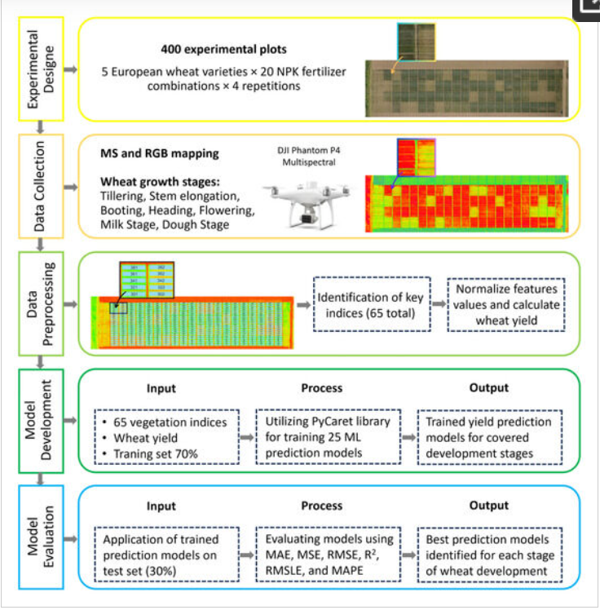
Data:
E38surveysolutions - raw
https://e38surveysolutions.com/blogs/news/mavic-3-multispectral-data?srsltid=AfmBOoq38k9C1yrT8V1SEuksaqTycG56I5m6VO-mpAt7EriVObeo73va
https://drive.google.com/drive/u/1/folders/1eDVeas9HyxG7DV0-G77nwYcE66iCQRzE

Sample Kaggle – calculated
https://www.kaggle.com/datasets/datasetengineer/crop-health-and-environmental-stress-dataset
"A dataset of aligned RGB and multispectral UAV imagery for semantic segmentation of weedy rice" (Van-Hoa Nguyen et al., 2025, Vietnam)
https://data.mendeley.com/datasets/vt4s83pxx6/1/files/cabb5f66-e3f2-4e17-85cb-21c2b2930d07

Analysis of a small dataset:

