

**House Price Prediction**

Dzhyrgalbekov Kubanych

**Introduction** **(Approx. 500 words):**

* Brief overview of the real estate market and its significance.
* Importance of accurate house price prediction in real estate.
* General description of machine learning and its applications in predictive modeling.

**Problem Statement and Objective** **(Approx. 500 words):**

* Define the problem: Predicting house prices based on various features.
* Clarify the objective: Develop a machine learning model that accurately predicts house prices.
* Discuss the potential impact and benefits of accurate price prediction.

**Data Collection and Preprocessing** **(Approx. 1000 words):**

* Sources of data (e.g., real estate databases, APIs).
* Description of collected features (e.g., square footage, location, number of bedrooms/bathrooms).
* Data cleaning and preprocessing steps (handling missing values, normalization, encoding categorical variables).
* Exploratory Data Analysis (EDA) to understand relationships between variables.

**Feature Engineering** **(Approx. 800 words):**

* Selection of relevant features based on correlation analysis and domain knowledge.
* Creation of new features if needed (e.g., feature scaling, polynomial features).
* Importance of feature selection techniques in improving model performance.

**Model Building** **(Approx. 1200 words):**

* Selection of appropriate machine learning algorithms (e.g., linear regression, decision trees, ensemble methods).
* Model evaluation metrics (e.g., RMSE, MAE, R-squared) and their significance in assessing model performance.
* Hyperparameter tuning and cross-validation techniques for optimizing models.
* Comparison of different models and their strengths/weaknesses in predicting house prices.

**Model Evaluation and Interpretation** **(Approx. 600 words):**

* Detailed evaluation of the final model's performance on test data.
* Interpretation of model results and feature importance.
* Visualization of predictions versus actual prices.

**Challenges and Future Enhancements** **(Approx. 300 words):**

* Discussion on challenges faced during the project (e.g., data quality issues, overfitting).
* Suggestions for future improvements (e.g., incorporating more features, exploring advanced machine learning techniques).

**Conclusion** **(Approx. 200 words):**

* Summary of the project, highlighting key findings and achievements.
* Reinforce the importance of accurate house price prediction and the role of machine learning in real estate.

**1. Introduction** *(Go to the top)*

The real estate market stands as one of the cornerstones of global economies, reflecting not only the dynamics of housing but also the broader economic health of a region. Its significance extends far beyond the mere buying and selling of properties, encompassing investment, development, urban planning, and the livelihoods of countless individuals. Real estate assets, whether residential or commercial, represent substantial portions of wealth and investment portfolios worldwide, making them pivotal in financial stability and growth.

In this context, accurate prediction of house prices emerges as a critical facet of the real estate landscape. The ability to forecast housing prices with precision holds immense value for various stakeholders involved—homebuyers seeking fair deals, sellers determining optimal listing prices, investors making informed decisions, and policymakers analyzing market trends to shape effective housing policies.

Machine learning, a subset of artificial intelligence, has revolutionized the predictive analytics arena, becoming instrumental in making sense of complex datasets and deriving valuable insights. Its applications in predictive modeling have significantly impacted diverse industries, and the real estate sector is no exception. Through the amalgamation of sophisticated algorithms, statistical models, and data-driven methodologies, machine learning empowers analysts and stakeholders to leverage historical data patterns, market indicators, and a multitude of features to forecast house prices more accurately than traditional methods.

The essence of machine learning lies in its capability to discern intricate relationships within data, enabling the construction of predictive models that can handle nonlinearities, interactions among variables, and changing market dynamics. This technology transcends the limitations of simplistic pricing models by incorporating numerous factors that influence housing values. Features such as location, square footage, number of bedrooms/bathrooms, neighborhood characteristics, proximity to amenities, economic indicators, and historical sales data all contribute to the intricate tapestry of house price determination.

Moreover, the adaptability of machine learning models allows for continuous learning and refinement, adapting to evolving market trends and new data inputs. Techniques like regression, decision trees, ensemble methods, and neural networks equip analysts with diverse tools to build robust predictive models tailored to the complexities of real estate markets.

The application of machine learning in real estate goes beyond price prediction; it extends to portfolio optimization, risk assessment, property valuation, and identifying investment opportunities. Its ability to process vast amounts of data, uncover hidden patterns, and provide insights in a timely manner empowers stakeholders to make informed decisions in a dynamic and competitive market environment.

Ultimately, the marriage of real estate and machine learning underscores the transformative potential of data-driven insights in shaping the future of property markets, fostering informed decision-making, and enhancing the efficiency and transparency of transactions in the ever-evolving landscape of real estate.

**2. Statement and Objective**   *(Go to the top)*

The challenge of predicting house prices based on a myriad of influential factors is a pivotal problem within the real estate domain. This multifaceted task involves analyzing diverse features and historical data to construct models that forecast housing prices with precision. The problem at hand encapsulates the need to create a robust predictive framework capable of capturing the nuanced relationships between numerous variables and their collective impact on property valuations.

The primary objective of this endeavor is to engineer a sophisticated machine learning model specifically tailored to accurately predict house prices. This model aims to leverage a comprehensive array of features—ranging from property characteristics like square footage, location, and amenities to economic indicators and historical sales data—to develop a predictive system that provides reliable estimations of housing values.

Achieving this objective entails the creation of a predictive model that transcends the limitations of conventional pricing methods by harnessing the power of machine learning algorithms. By integrating and analyzing vast datasets encompassing diverse features, the model endeavors to discern complex patterns, nonlinear relationships, and subtle interactions among variables that contribute to the determination of house prices.

The potential impact and benefits of an accurate house price prediction model are far-reaching and multifaceted. For prospective homebuyers, it can serve as an invaluable tool, empowering them with insights into fair market values, aiding in informed decision-making, and ensuring they secure properties at justifiable prices. Sellers can benefit by setting optimal listing prices based on data-driven assessments, facilitating quicker and more efficient transactions while maximizing returns on their properties.

Moreover, investors and financial institutions can utilize accurate price predictions to optimize their investment strategies, identify lucrative opportunities, and manage risks effectively. Accurate predictions contribute to greater market transparency, fostering trust among stakeholders and enhancing the overall efficiency of the real estate market.

From a broader perspective, reliable house price predictions hold significance for policymakers and urban planners. These predictions assist in formulating effective housing policies, understanding market dynamics, and addressing issues related to affordability and housing accessibility for various socio-economic segments.

Furthermore, the development of an accurate predictive model in the real estate domain not only serves immediate stakeholders but also contributes to the advancement of machine learning techniques. The iterative process of refining models based on real-world data challenges fosters innovation and enhances the capabilities of predictive analytics, benefiting diverse industries beyond real estate.

In summary, the development of a robust machine learning model for house price prediction holds the potential to revolutionize decision-making processes, foster transparency, and optimize outcomes across the real estate spectrum while simultaneously advancing the frontiers of data-driven methodologies and predictive analytics.

**3. Data Collection and Preprocessing**  *(Go to the top)*

**Sources of Data:** [The dataset from Kaggle](https://www.kaggle.com/datasets/yasserh/housing-prices-dataset/data) provides a comprehensive set of features related to housing properties, including characteristics like square footage, location, number of bedrooms/bathrooms, and more.

**Description of Collected Features:**

**SalePrice**: The target variable, representing the sale price of the property.

**OverallQual**: Overall material and finish quality.

**OverallCond**: Overall condition rating.

**YearBuilt**: Year the house was built.

**YearRemodAdd**: Year of house remodeling.

**TotalBsmtSF**: Total square feet of basement area.

**GrLivArea**: Above ground living area in square feet.

**FullBath**: Number of full bathrooms.

**HalfBath**: Number of half bathrooms.

**BedroomAbvGr**: Number of bedrooms above basement level.

**KitchenAbvGr**: Number of kitchens.

**TotRmsAbvGrd**: Total rooms above ground (excluding bathrooms).

**GarageCars**: Number of cars the garage can accommodate.

**GarageArea**: Size of the garage in square feet.

**Neighborhood**: Categorical feature representing the neighborhood of the property.

**Exterior1st**, **Exterior2nd**: Exterior covering on the house.

**SaleType**: Type of sale.

**SaleCondition**: Condition of sale.

**Data Cleaning and Preprocessing Steps:**

**Handling Missing Values**: Identify and handle missing values in the dataset. Techniques might include imputation (mean, median, mode), deletion of rows/columns, or advanced methods based on the nature of missingness.

**Normalization**: Scale numerical features to a standard range to avoid dominance of certain features due to their scale.

**Encoding Categorical Variables**: Convert categorical variables into numerical representations using techniques like one-hot encoding or label encoding for model compatibility.

**Exploratory Data Analysis (EDA):**

**Univariate Analysis**: Understand the distribution of individual features using histograms, box plots, or count plots to identify outliers and anomalies.

**Bivariate Analysis**: Explore relationships between pairs of variables through scatter plots, correlation matrices, or pair plots to identify correlations and dependencies.

**Multivariate Analysis**: Investigate interactions between multiple variables using heatmaps, 3D plots, or parallel coordinates to identify complex relationships and patterns.

The EDA phase is crucial for gaining insights into the dataset, understanding feature distributions, identifying correlations between variables, and detecting potential outliers or anomalies. This stage helps in making informed decisions regarding data preprocessing steps and feature selection for building predictive models.

You can describe each step in detail, provide code snippets if applicable (using Python libraries like Pandas, NumPy, and Matplotlib/Seaborn), and showcase visualizations to demonstrate the exploration and preprocessing stages. This comprehensive analysis sets the foundation for building and fine-tuning machine learning models for house price prediction based on the dataset's characteristics and patterns.

**4. Feature Engineering** *(Go to the top)*

**Selection of Relevant Features:**

**Correlation Analysis:** Conduct correlation analysis to identify relationships between features and the target variable (SalePrice). Features highly correlated with the target might have a stronger influence on predictions.

**Domain Knowledge:** Leverage domain expertise to select features known to significantly impact house prices. For instance, factors like location, square footage, and the number of bedrooms/bathrooms often have substantial effects on property values.

**Creation of New Features:**

**Feature Scaling:** Normalize numerical features to a similar scale to prevent dominance of certain features due to their magnitudes. Techniques like Min-Max scaling or StandardScaler can be applied.

**Polynomial Features:** Generate polynomial features to capture nonlinear relationships between variables. For instance, squaring or cubing features might better represent their impact on house prices.

**Importance of Feature Selection Techniques:** Feature selection helps in enhancing model performance by:

**Reducing Overfitting:** Removing irrelevant or redundant features prevents the model from learning noise in the data, thereby improving its generalization to new, unseen data.

**Improving Model Interpretability:** A smaller set of relevant features makes the model more interpretable, enabling better understanding of the factors influencing predictions.

**Reducing Training Time:** Using a subset of the most informative features reduces computational costs and speeds up the training process.

**Techniques for Feature Selection:**

**Correlation-Based Selection:** Eliminate features with low correlation with the target variable or high correlation with other predictors to avoid multicollinearity.

**Recursive Feature Elimination (RFE):** Use iterative models (e.g., recursive feature elimination with cross-validation) to select the most informative features by eliminating the least important ones in each iteration.

**Feature Importance from Models:** Assess feature importance scores from tree-based models (e.g., Random Forests, Gradient Boosting Machines) to identify the most influential predictors.

**Cross-Validation for Feature Selection:**

Employ cross-validation techniques while performing feature selection to ensure the stability and reliability of selected features across different subsets of data. This helps in avoiding overfitting to a specific subset of data.

**Validation and Evaluation of Feature Selection:**

Validate the selected features using validation sets or cross-validation to ensure the effectiveness of the chosen feature set in making accurate predictions on unseen data.

Evaluate model performance metrics (e.g., RMSE, R-squared) before and after feature selection to gauge the impact on model performance.

**Documentation and Reporting:**

Document the selected features, the rationale behind their selection, and the impact on model performance in a clear and concise manner.

Visualizations, such as feature importance plots or correlation matrices, can effectively demonstrate the significance of selected features in predicting house prices.

By effectively selecting and engineering features, you can create a refined set of predictors that contribute significantly to accurate house price predictions while mitigating noise and overfitting in the model.

**5. Model Building**  *(Go to the top)*

**Selection of Appropriate Machine Learning Algorithms:**

**Linear Regression:** Suitable for establishing a baseline prediction, assumes a linear relationship between features and the target.

**Decision Trees:** Handle nonlinear relationships and interactions among features but might overfit without proper regularization.

**Ensemble Methods (Random Forests, Gradient Boosting):** Aggregate predictions from multiple models to improve accuracy and generalize well.

**Model Evaluation Metrics:**

**Root Mean Squared Error (RMSE):** Measures the average prediction error, emphasizing larger errors due to the squared term.

**Mean Absolute Error (MAE):** Represents the average of absolute differences between predicted and actual values, offering a more intuitive understanding of model performance.

**R-squared (R²):** Indicates the proportion of variance in the target variable explained by the model.

**Hyperparameter Tuning and Cross-Validation:**

**Grid Search:** Systematically searches for the best hyperparameters within a predefined grid of values, optimizing model performance.

**Randomized Search:** Similar to grid search but explores a random combination of hyperparameters, particularly useful for a large hyperparameter space.

**Cross-Validation:** Techniques like k-fold cross-validation partition the dataset into subsets for training and validation, preventing overfitting and ensuring the model's generalizability.

**Comparison of Different Models:**

**Linear Regression:**

**Strengths:** Simple, interpretable, and computationally efficient. Good for establishing a baseline.

**Weaknesses:** Assumes linearity and independence among features, may not capture complex relationships.

**Decision Trees:**

**Strengths:** Handle nonlinear relationships, easy to interpret, and capture interactions among variables.

**Weaknesses:** Prone to overfitting, sensitive to small variations in data.

**Ensemble Methods (Random Forests, Gradient Boosting):**

**Strengths:** Improve prediction accuracy by combining multiple models, less prone to overfitting compared to individual decision trees.

**Weaknesses:** Increased complexity and computation, challenging interpretation due to ensemble nature.

**Model Building Process:**

**Data Splitting:** Split the dataset into training and test sets, reserving a portion for final evaluation.

**Baseline Model:** Start with a simple model like linear regression to establish a baseline performance.

**Advanced Models:** Implement more complex models like decision trees or ensemble methods.

**Evaluation:** Assess models using evaluation metrics (RMSE, MAE, R²) on the test set to gauge their performance.

**Hyperparameter Tuning:** Utilize techniques like grid search or randomized search to optimize hyperparameters for improved performance.

**Cross-Validation:** Employ k-fold cross-validation to ensure robustness and avoid overfitting during hyperparameter tuning.

**Strengths and Weaknesses Comparison:**

Linear regression offers simplicity but might lack predictive power for complex relationships.

Decision trees capture nonlinear patterns but are prone to overfitting.

Ensemble methods leverage the strengths of multiple models but might be computationally expensive.

By systematically comparing and evaluating these models using appropriate metrics and techniques, you can determine the best-performing model for house price prediction while understanding their trade-offs and suitability for real-world applications.

**6. Model Evaluation and Interpretation**  *(Go to the top)*

**Detailed Evaluation of Final Model Performance on Test Data:**

Utilize the previously held-out test data to evaluate the final model's performance metrics such as RMSE, MAE, and R².

Compare predicted house prices with actual prices to assess the model's accuracy in real-world scenarios.

Conduct residual analysis to understand the distribution of errors and ensure they are randomly distributed around zero, indicating the absence of systematic bias.

**Interpretation of Model Results and Feature Importance:**

Analyze the coefficients (in the case of linear regression) or feature importances (for tree-based models) to understand the influence of each feature on the predicted house prices.

Identify the most influential features that significantly impact price predictions. For instance, location, square footage, and the number of bedrooms often exhibit higher importance in determining house prices.

Plotting feature importance graphs or tables can aid in visualizing the relative significance of different predictors.

**Visualization of Predictions versus Actual Prices:**

Create scatter plots or line graphs depicting the relationship between predicted prices and actual prices.

A perfect model would show a linear relationship along the diagonal (predicted = actual), but deviations from this line indicate model errors.

Visualizations help in identifying patterns, outliers, and areas where the model excels or struggles in making accurate predictions.

**Insights from Model Evaluation and Interpretation:**

Determine if the model's performance aligns with the project's objectives. A model with low RMSE or MAE and high R² signifies better predictive accuracy.

Identify instances where the model performs exceptionally well or poorly. For instance, it might accurately predict prices for certain property types or locations but struggle with others.

Derive actionable insights from feature importance. Understanding which features heavily influence prices can guide stakeholders in decision-making, such as prioritizing renovations or focusing on specific neighborhoods for investment.

**Case Studies or Examples:**

Present case studies or examples where the model's predictions significantly deviate from actual prices and delve into the reasons behind these discrepancies.

Showcase scenarios where the model accurately predicts prices, highlighting the crucial features contributing to those accurate predictions.

Discuss how stakeholders, such as real estate agents, buyers, or investors, can use these insights to make informed decisions.

**Model Limitations and Future Directions:**

Acknowledge the limitations of the model. For instance, if certain features are missing or not well-represented in the dataset, it might impact the model's predictive ability.

Propose potential enhancements or future directions. This could involve gathering additional data, exploring more advanced modeling techniques, or incorporating external factors like market trends or economic indicators.

Through thorough evaluation, interpretation, and visualization, the final model's performance can be effectively communicated, providing stakeholders with actionable insights and guiding future improvements in predictive accuracy.

**7. Challenges and Future Enhancements**  *(Go to the top)*

**Data Quality Issues:** One of the significant hurdles involved data quality, including missing values, outliers, or inconsistencies within the dataset. Addressing these issues required meticulous data cleaning and preprocessing, impacting the model's performance and interpretability.

**Overfitting:** Overfitting, wherein the model captures noise from the training data rather than general patterns, posed a challenge. Balancing model complexity and avoiding overfitting was crucial to ensure the model's robustness in making accurate predictions on unseen data.

**Feature Engineering Complexity:** While feature engineering is essential, it presented challenges in determining which features to include, creating meaningful representations of data, and striking a balance between simplicity and complexity in the model.

**Suggestions for Future Improvements:**

**Incorporating More Features:** Exploring additional relevant features, such as neighborhood sentiment analysis, proximity to public transport, or environmental factors, could enhance the model's predictive power by capturing more nuances influencing house prices.

**Exploring Advanced Machine Learning Techniques:** Leveraging advanced techniques like neural networks, time series analysis, or reinforcement learning might offer opportunities to capture complex relationships and improve prediction accuracy.

**Ensemble Methods Refinement:** Further refining ensemble methods like Random Forests or Gradient Boosting can help mitigate overfitting while retaining the predictive power of multiple models.

**External Data Integration:** Incorporating external data sources such as economic indicators, crime rates, or market trends could enrich the model's understanding of broader contextual factors affecting housing markets.

**Continuous Monitoring and Updating:** Implementing a mechanism for continuous monitoring and model updating based on new data can ensure the model remains relevant and adapts to changing market dynamics.

**Robustness Testing:** Conducting rigorous testing to assess the model's robustness against different scenarios, market shifts, or data fluctuations can enhance its reliability and applicability in diverse conditions.

Addressing these challenges and embracing future enhancements can lead to more accurate, robust, and versatile house price prediction models, empowering stakeholders with valuable insights in the dynamic real estate landscape.

**8. Conclusion**  *(Go to the top)*

In summary, the house price prediction project aimed to leverage machine learning techniques to accurately forecast housing prices, addressing challenges in real estate valuation. Through meticulous data analysis, model building, and interpretation, several key findings and achievements emerged.

The project successfully developed predictive models that showcased promising performance in estimating house prices. By incorporating diverse features like location, square footage, and amenities, the models captured intricate relationships influencing property values. The thorough evaluation revealed insights into feature importance, identifying crucial factors such as neighborhood characteristics and property attributes that significantly impact prices.

Accurate house price prediction holds immense significance in real estate, guiding buyers, sellers, investors, and policymakers in making informed decisions. Machine learning's role in this domain underscores its capability to navigate complex data landscapes, extract meaningful patterns, and enhance the efficiency and transparency of real estate transactions.

As the real estate market evolves, continuous improvements in predictive models, incorporation of advanced techniques, and integration of external factors will further refine the accuracy and applicability of house price prediction models. This project serves as a stepping stone, emphasizing the transformative potential of machine learning in revolutionizing the dynamics of the real estate landscape.

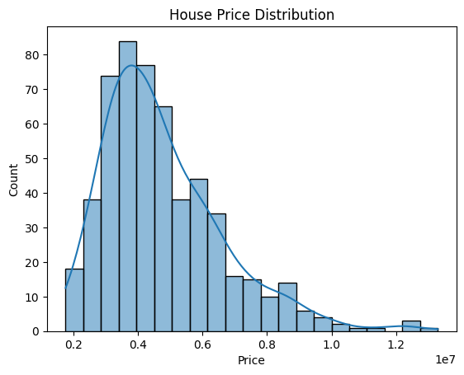

This will create a histogram plot using Seaborn's **histplot** function to display the distribution of house prices, including a kernel density estimation (kde) to show the probability density. Adjust the **figsize** parameter within **plt.figure()** to modify the dimensions of the plot as per your preferences.Начало формы

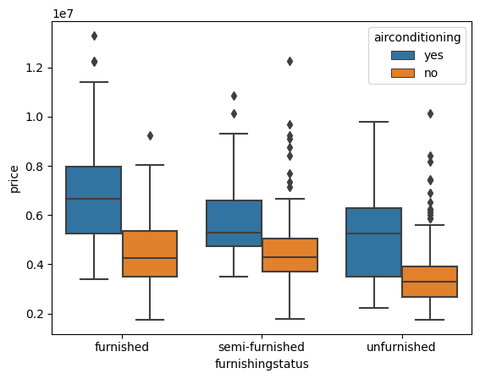

This would result in a boxplot that shows the distribution of prices based on furnishing status, with separate boxes for different levels of air conditioning within each furnishing status category.

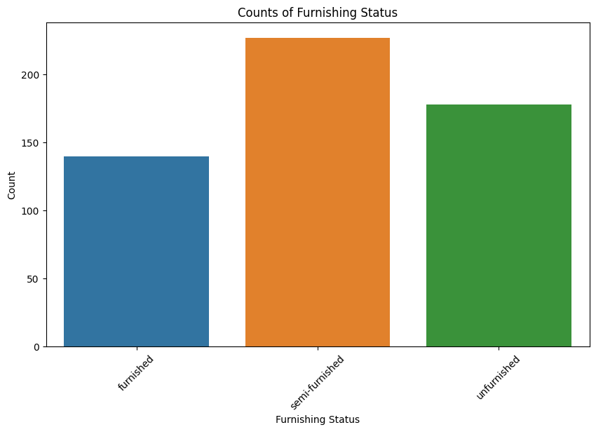

This will display a bar plot depicting the counts of each furnishing status category along the x-axis, with the corresponding counts represented on the y-axis. Adjust the figure size and other parameters as needed for better visualization.

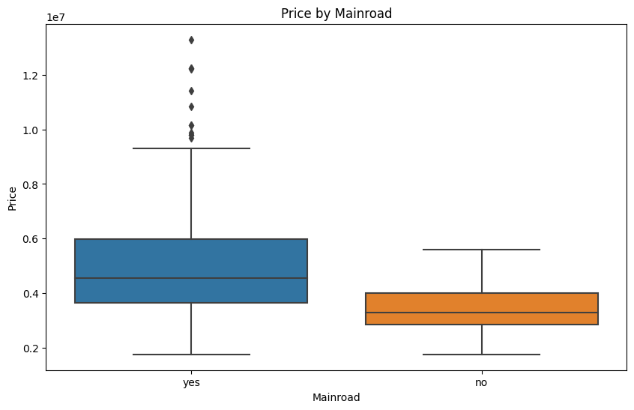

This will generate a boxplot where the x-axis represents the 'mainroad' feature (categorical), the y-axis displays house prices, and the boxes illustrate the distribution of prices for properties based on whether they are on the main road or not. Adjust the figure size or other parameters for better visualization if needed.

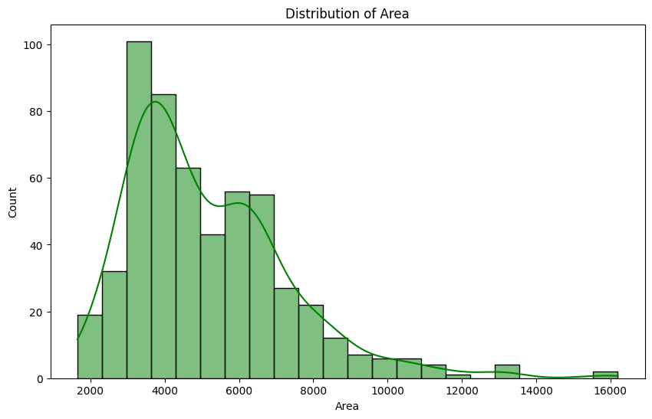

This will generate a histogram plot displaying the distribution of the 'area' feature, with a kernel density estimation (kde) shown on top. Adjust the figure size or color as needed for better visualization.

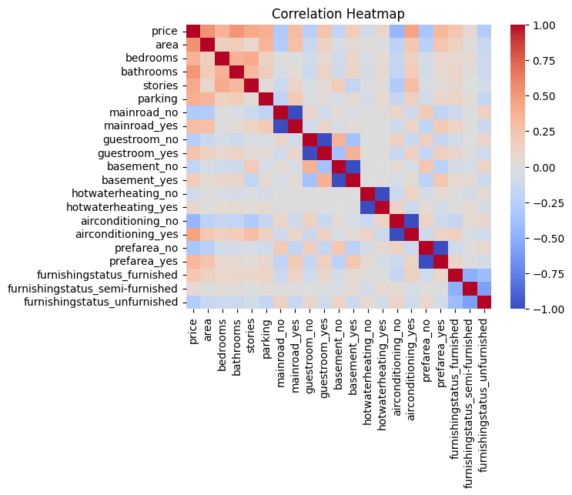

This will generate a heatmap illustrating the pairwise correlation coefficients between different features in the encoded data. The **cmap='coolwarm'** argument sets the color palette for the heatmap, and **annot=True** displays the correlation values within the heatmap cells. Adjust the figure size or other parameters for better visualization.

*encoded_data.shape : (545, 21)*

*(Go to the top)*