4.Algorithm to reverse an array

https://www.geeksforgeeks.org/write-a-program-to-reverse-an-array-or-string/

Solution By me:

**package** com.infogain.hackerrank;

**public** **class** ArrayReversal {

**public** **static** **void** main(String[] args) {

**int** a1[]={3,5,2,9};

**int** a2[]=**new** **int**[a1.length];

**for**(**int** i=a1.length-1,j=0;i>=0;i--,j++){

a2[j]=a1[i];

}

**for**(**int** y:a2){

System.***out***.println(y);

}

}

}

GEEKS FOR GEEKS

**Write a program to reverse an array or string**

Given an array (or string), the task is to reverse the array/string.

**Examples :**

Input : arr[] = {1, 2, 3}

Output : arr[] = {3, 2, 1}

Input : arr[] = {4, 5, 1, 2}

Output : arr[] = {2, 1, 5, 4}

1) Initialize start and end indexes as start = 0, end = n-1  
2) In a loop, swap arr[start] with arr[end] and change start and end as follows :  
start = start +1, end = end – 1

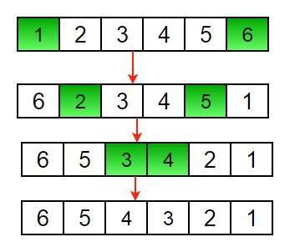

Another example to reverse a string:

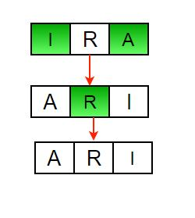

Below is the implementation of the above approach :

// Iterative java program to reverse an

// array

public class GFG {

   /* Function to reverse arr[] from

    start to end*/

    static void rvereseArray(int arr[],

                    int start, int end)

    {

        int temp;

        while (start < end)

        {

            temp = arr[start];

            arr[start] = arr[end];

            arr[end] = temp;

            start++;

            end--;

        }

    }

    /* Utility that prints out an

    array on a line */

    static void printArray(int arr[],

                            int size)

    {

        for (int i = 0; i < size; i++)

             System.out.print(arr[i] + " ");

         System.out.println();

    }

    // Driver code

    public static void main(String args[]) {

        int arr[] = {1, 2, 3, 4, 5, 6};

        printArray(arr, 6);

        rvereseArray(arr, 0, 5);

        System.out.print("Reversed array is \n");

        printArray(arr, 6);

    }

}

// This code is contributed by Sam007

**Output :**

1 2 3 4 5 6

Reversed array is

6 5 4 3 2 1

**Time Complexity :** O(n)

**Recursive Way :**

1) Initialize start and end indexes as start = 0, end = n-1  
2) Swap arr[start] with arr[end]  
3) Recursively call reverse for rest of the array.

Below is the implementation of the above approach :

*filter_none*

*edit*

*play_arrow*

*brightness_4*

|  |
| --- |
| // Recursive Java Program to reverse an array  import java.io.*;    class ReverseArray {        /* Function to reverse arr[] from start to end*/      static void rvereseArray(int arr[], int start, int end)      {          int temp;          if (start >= end)              return;          temp = arr[start];          arr[start] = arr[end];          arr[end] = temp;          rvereseArray(arr, start+1, end-1);      }        /* Utility that prints out an array on a line */      static void printArray(int arr[], int size)      {          for (int i=0; i < size; i++)              System.out.print(arr[i] + " ");          System.out.println("");      }        /*Driver function to check for above functions*/      public static void main (String[] args) {          int arr[] = {1, 2, 3, 4, 5, 6};          printArray(arr, 6);          rvereseArray(arr, 0, 5);          System.out.println("Reversed array is ");          printArray(arr, 6);      }  }  /*This article is contributed by Devesh Agrawal*/ |

**Output :**

1 2 3 4 5 6

Reversed array is

6 5 4 3 2 1

**Time Complexity :** O(n)