Salary Increment Request — Supporting Evidence
Name | Kuberan
Role during the work | Digital Marketing — Technical Team
Current role | Development Team
Work period | July–August 2026
System delivered | DM Dashboard — internal Digital Marketing operations platform
Repository | github.com/websitetecteam-arch/dm-dashboard
Live URL | dm-dashboard.vintageinterior.co.uk
Status | Live in production; used every working day by the full Digital Marketing team (~14 people)
Document date | 7 September 2026

1. Executive summary
During July and August 2026, while assigned to the Digital Marketing technical team, I single-handedly designed, built, and deployed the DM Dashboard — a complete internal web application that replaced the department's old static HTML pages.
The work was full-stack software engineering: a React front end, a Python (FastAPI) back end, two PostgreSQL databases, live integrations with the Shopify Admin API, Google Analytics 4 and Google Search Console, and production deployment on the company server.
The central deliverable was the live sales data system. For more than two years the company had been unable to produce accurate, current sales figures broken down by individual person and by sales channel. Every earlier attempt had failed. I solved it independently, using my own design built on the Shopify Admin API. That system is now the company's source of truth for measuring individual employee performance and calculating bonuses.
This work was delivered on a Digital Marketing technical-team salary. My move to the Development team has since been formalised. On that basis I am requesting a salary increment that reflects the developer role I am now in and the value of the work delivered.

2. What I built

2.1 Full dashboard rebuild
Layer | Technology | Delivered
Front end | React + Vite | Replaced the entire old static HTML dashboard
Back end | Python (FastAPI) | New API layer connecting every data source
Database | PostgreSQL x2 | App database (users, access, saved reports, sync history) + read-only link to the shared business database
Integrations | Shopify Admin API (UK, DE, FR stores), Google Analytics 4, Google Search Console | Live feeds so reports always reflect current figures
Hosting | Company server (Nginx + systemd) | Deployed and running in production

2.2 Platform features
- Login and security (password hashing, session tokens)
- User management and per-person access permissions
- Individual dashboards — each staff member sees only the reports for their role
- Admin overview — management can view every team member's data and "view as" any user
- Scheduled background jobs that refresh the heavier reports automatically so pages load fast
- Connection-pool management and automatic retry handling for reliability under load

2.3 Team reporting modules
Area | Staff covered | Approx. pages
Google Ads | UK, Germany, France, Italy markets (Sajeepan, Thivajini, Thasitha, Mahima, Jefri) | 25+
SEO | Germany (Sukirtha) | 6
Operations | UK / all markets (Kamsi, Sonya, Dilaksi, Theekshy) | 20+
Feed & Listings | All markets (Hetheesha) | 5
Plus admin-level reports: sales attribution, employee performance and refunds analysis.

2.4 Live sales data system — the core contribution
The problem, unsolved for 2+ years:
Sales figures were compiled manually — slow, frequently out of date, incomplete, and impossible to break down reliably by person. Previous attempts to fix this did not succeed.
What I delivered, independently:
- All sales channels pulled together and updated live in one place, via the Shopify Admin API
- Sales attributed to each individual staff member — UK and Germany operations, 2025 and 2026
- Every employee can log in and see their own sales performance directly, at any time
- Closed months stored permanently; the current month refreshes automatically, keeping the history accurate
- Sync controls, sync history and monitoring so the data flow can be managed and audited

3. What the company gets

3.1 Time saving
Task | Before | Now
Compiling all-channel sales figures | Manual pull and consolidation every reporting period | Automatic — no manual work
Breaking sales down by individual person | Manual, error-prone, often not done | Built in, instant
Each staff member checking their own sales | Had to ask a manager / wait for a report | Self-service, any time
Preparing data for performance reviews | Manual collation from several sources | Already in the dashboard
Team reports (Ads, SEO, Operations, Feed) | Static pages, manual updates | Live, refreshed automatically
A significant amount of recurring manual reporting and data chasing across managers and staff has been removed entirely. This is time that now goes back into selling and optimisation work.

3.2 Cost saving
- No external developer hire. A system of this scope — React, Python, PostgreSQL, multiple API integrations, deployment and maintenance — would normally require hiring a full-stack developer, at a cost well above my current salary. The company received the system without that cost.
- No third-party dashboard / BI subscription. The live sales and reporting capability was built in-house instead of paying for an external analytics product.
- Less management time spent on reporting, which is a direct cost saving at senior salary levels.
- Any increment for this work would be far below the cost of the alternatives above.

3.3 Performance measurement and bonus calculation
- The dashboard is now the agreed source of truth for how much each person has sold.
- Performance reviews can be based on consistent, live data rather than manually assembled figures that were open to dispute.
- Bonus calculations now run directly off the system's per-person, per-channel sales numbers — faster to produce and fair to everyone because the same method applies to all staff.
- Historical months are locked once closed, so past bonus periods stay auditable.

3.4 Other ongoing benefits
- Transparency for staff — everyone can see their own numbers, which supports motivation and self-management.
- A maintainable, documented codebase — other developers can now extend the system using the technical documentation I wrote, instead of starting from fragile undocumented pages.
- Reliability — retry handling and connection management keep the system stable under the load of the whole team using it at once.
- A foundation to build on — new reports and tools can be added quickly on top of the platform (several already have been).

4. Supporting evidence
- 87 commits authored by me (kuberan <digitalmarketing69140951@gmail.com>), including the initial full-project commit (24 August 2026) and 86 further commits of features and fixes. 359 files created or changed. Verifiable in the repository with git log --author="kuberan".
- Technical documentation set written by me (docs/SYSTEM-KNOWLEDGE.md and supporting docs): architecture, every module, the full API surface, database schemas, the authentication model, and the conventions for extending the system. Other developers use this as their reference.
- Live system — deployed and in daily use by the full Digital Marketing team. Management can verify usage directly, including the per-person sales views and the figures used for reviews and bonuses.
- Screenshots of the running system are included in Section 6.

5. Request
For the reasons set out above, I am requesting a salary increment in recognition of this work, effective from the next payroll cycle.
The basis: I delivered full developer-level work while on a technical-team salary; my move to the Development team is now formalised; the system I built is business-critical and solved a problem the company had been unable to close for more than two years; and the value delivered — in time saved, cost avoided, and a reliable basis for performance and bonus decisions — is substantial and ongoing.
I would welcome the opportunity to discuss this, including the amount, in person.

6. System screenshots
Captured from the live system at dm-dashboard.vintageinterior.co.uk on 7 September 2026. Figures shown are live production data.
6.1 Admin home — quick navigation to every area of the system
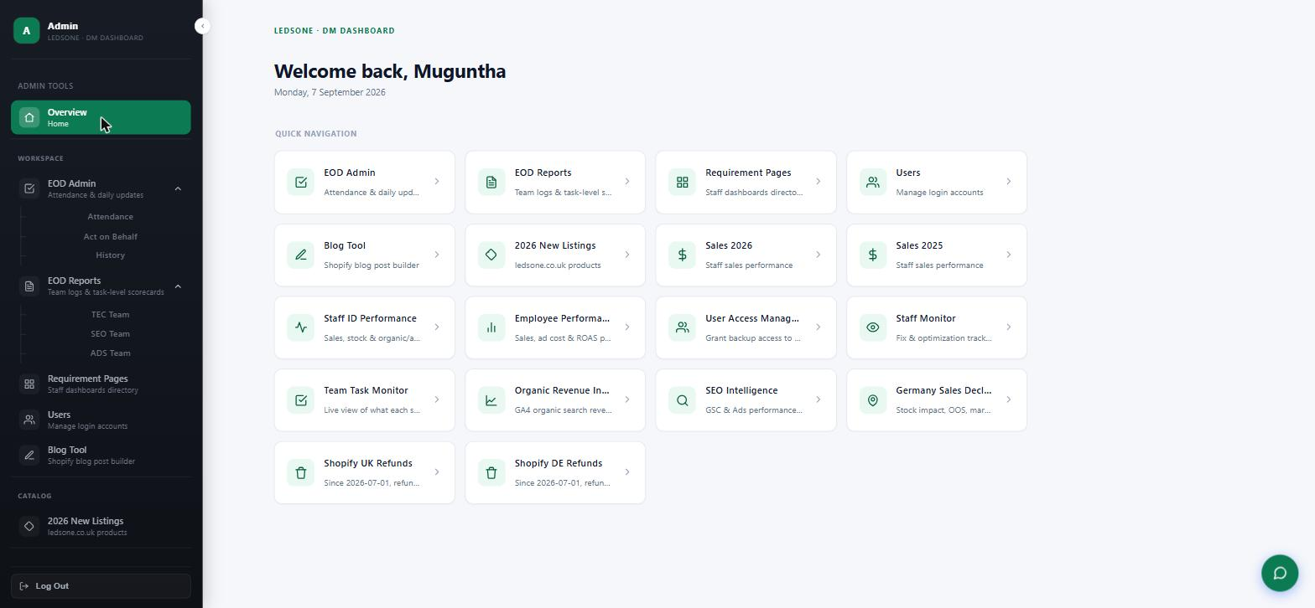
6.2 Live sales data system — Sales 2026, UK store, DM-Ad channel (live, per channel, order-level detail)
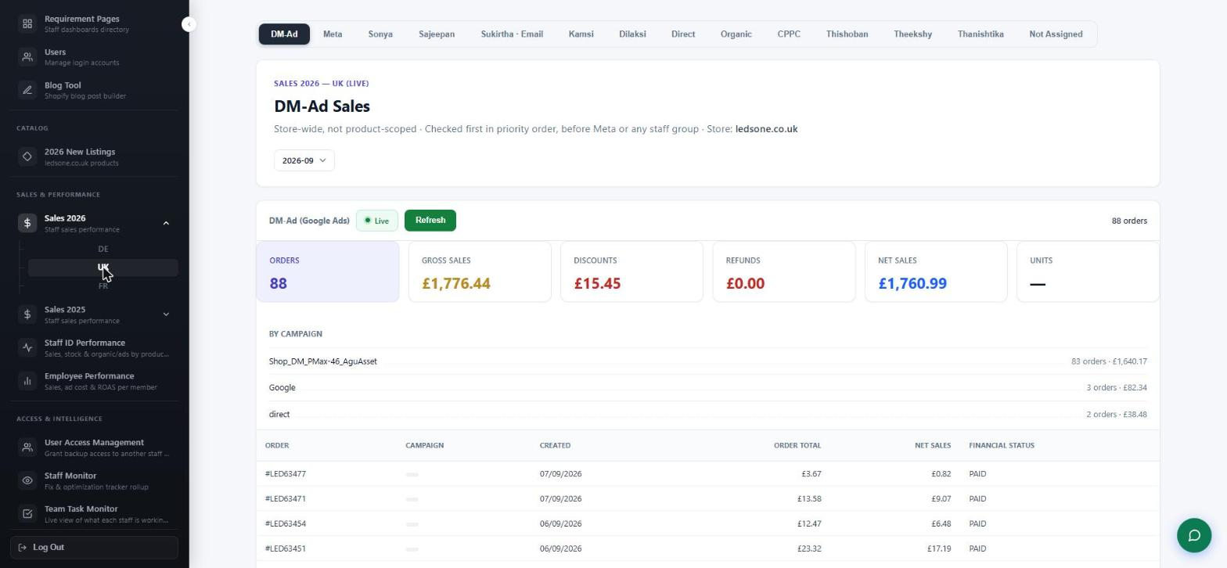
6.3 Live sales data system — Sales 2026 attributed to one staff member (Sonya): 221 orders, gross sales GBP 7,585.96, live
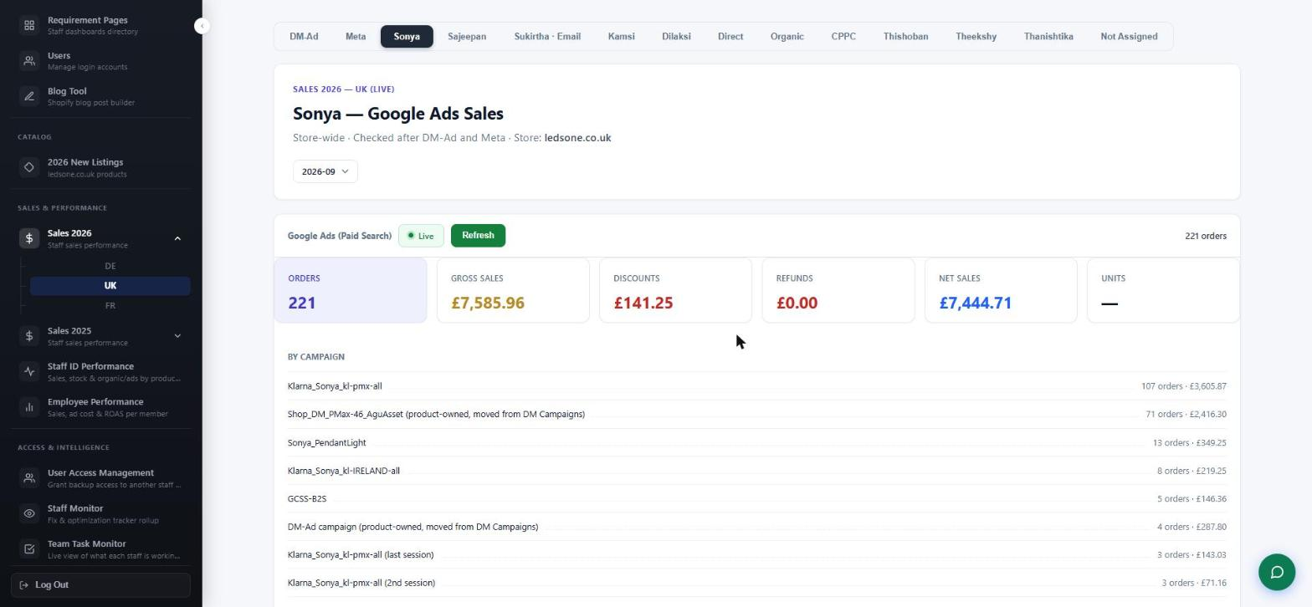
6.4 Sales 2025 — UK historical, same per-person breakdown for the prior year
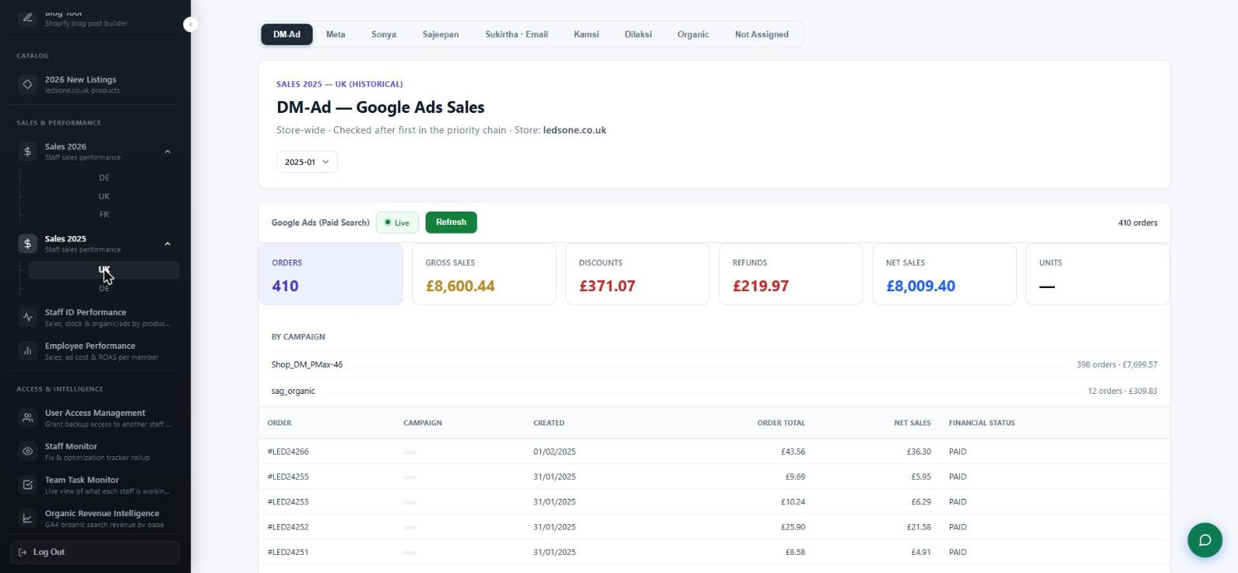
6.5 Employee Performance — per member, 2025 vs 2026: net sales, total cost, net profit, ROAS and year-on-year growth
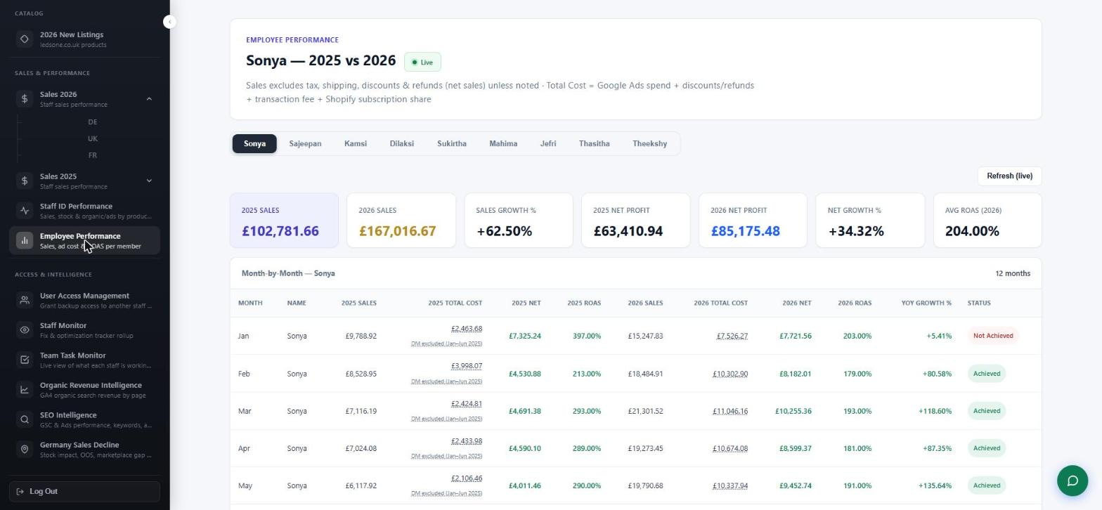
6.6 User Access Management — grant matrix controlling which staff can see which task pages and tools
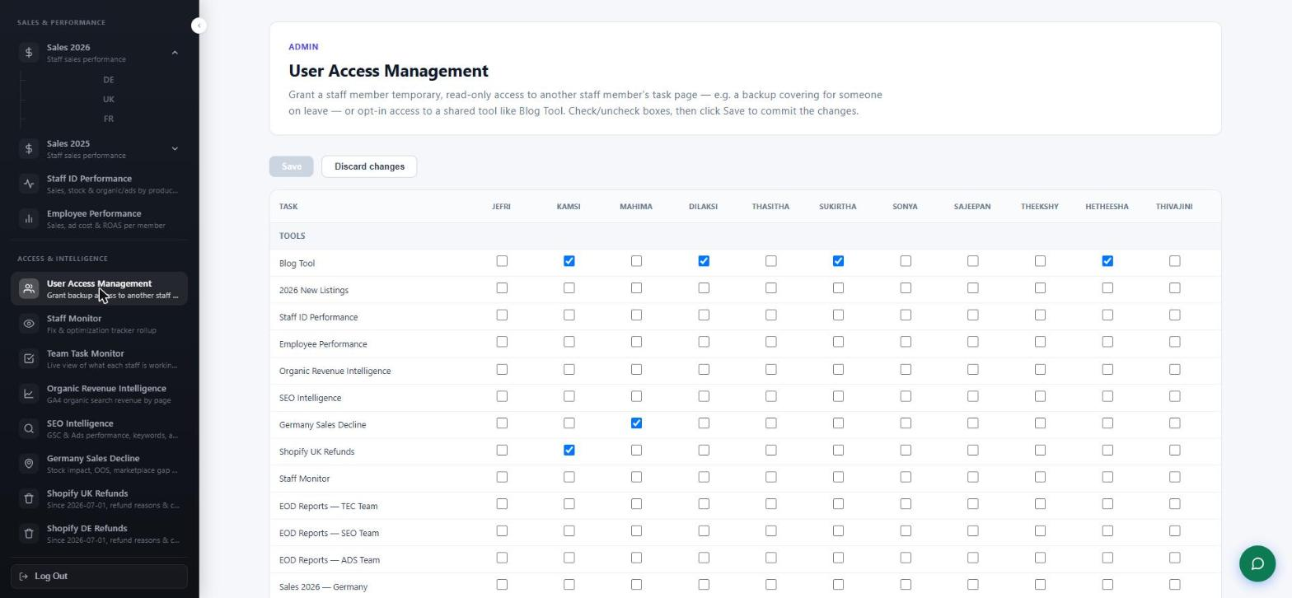
6.7 Users — every login account, role, staff key and last login
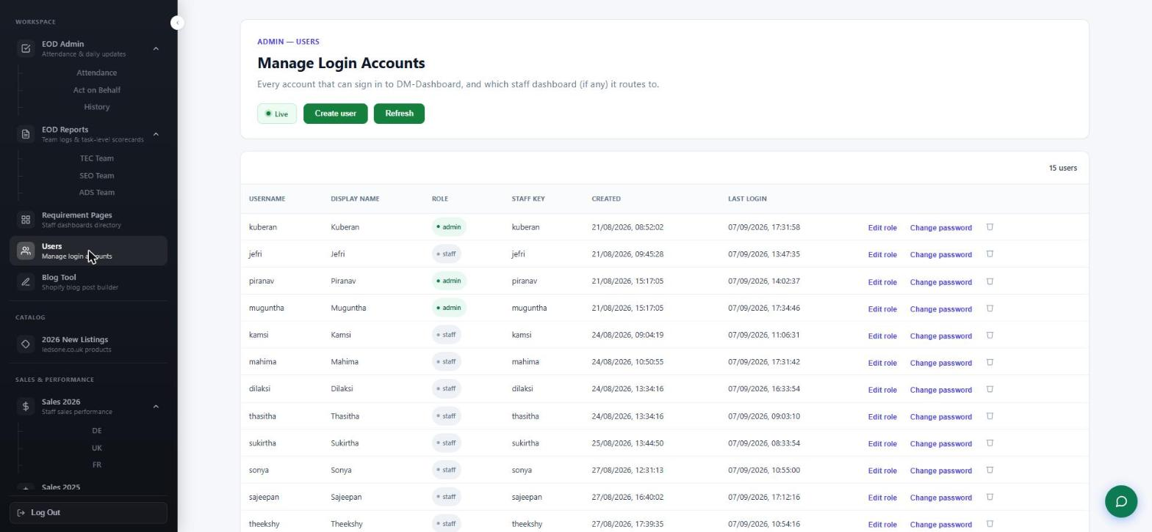
6.8 Requirement Pages — directory of every staff member's dashboard, with the number of requirement pages live for each
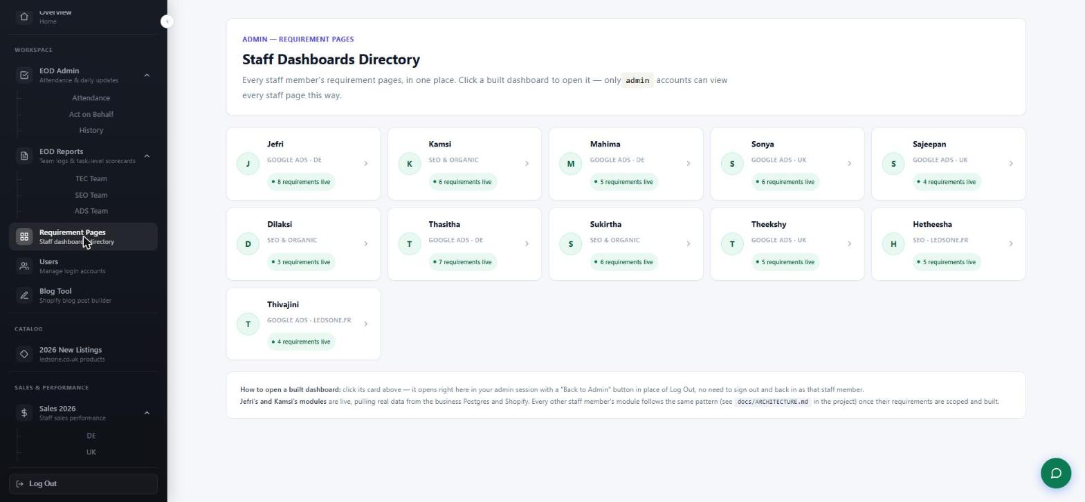
6.9 EOD Admin — attendance view showing who has submitted their end-of-day report for a given date
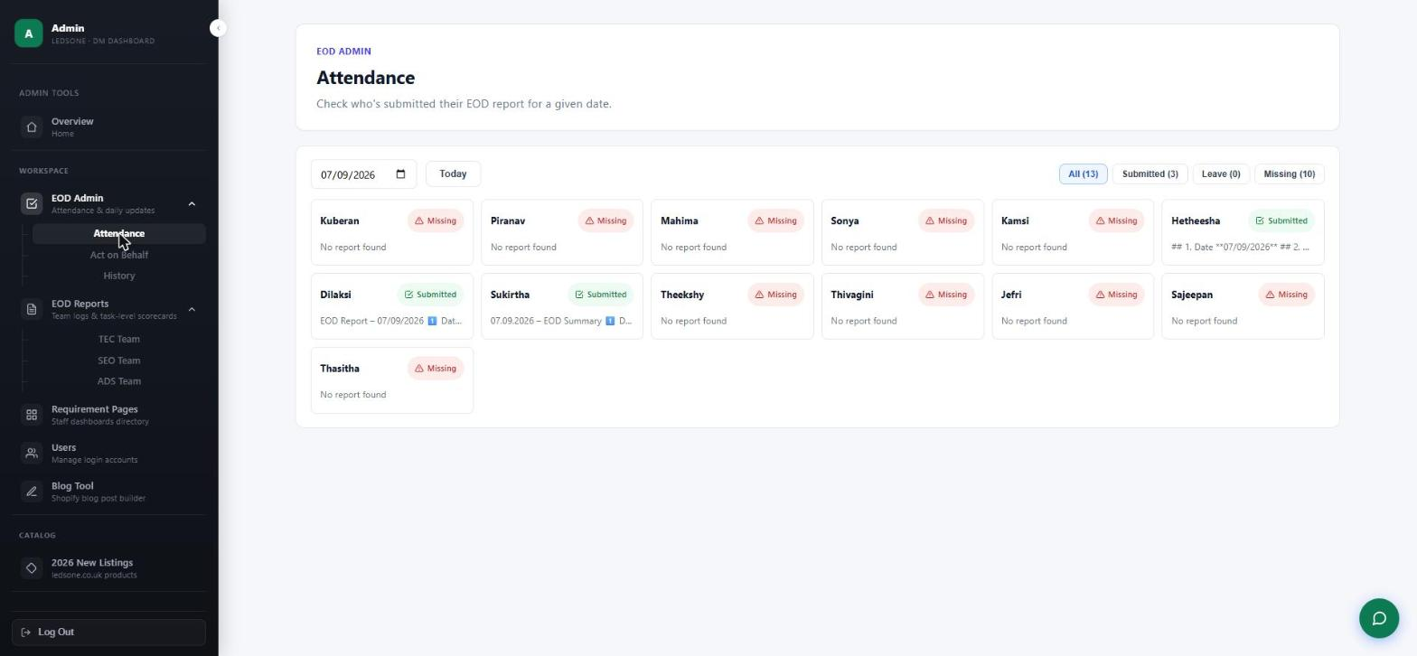
6.10 Shopify UK Refunds — live refund report from the Shopify Admin API with reason categories
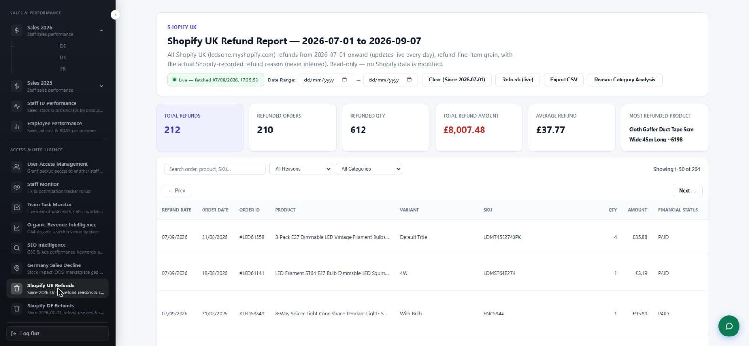
6.11 Shopify DE Refunds — the same report for the German store
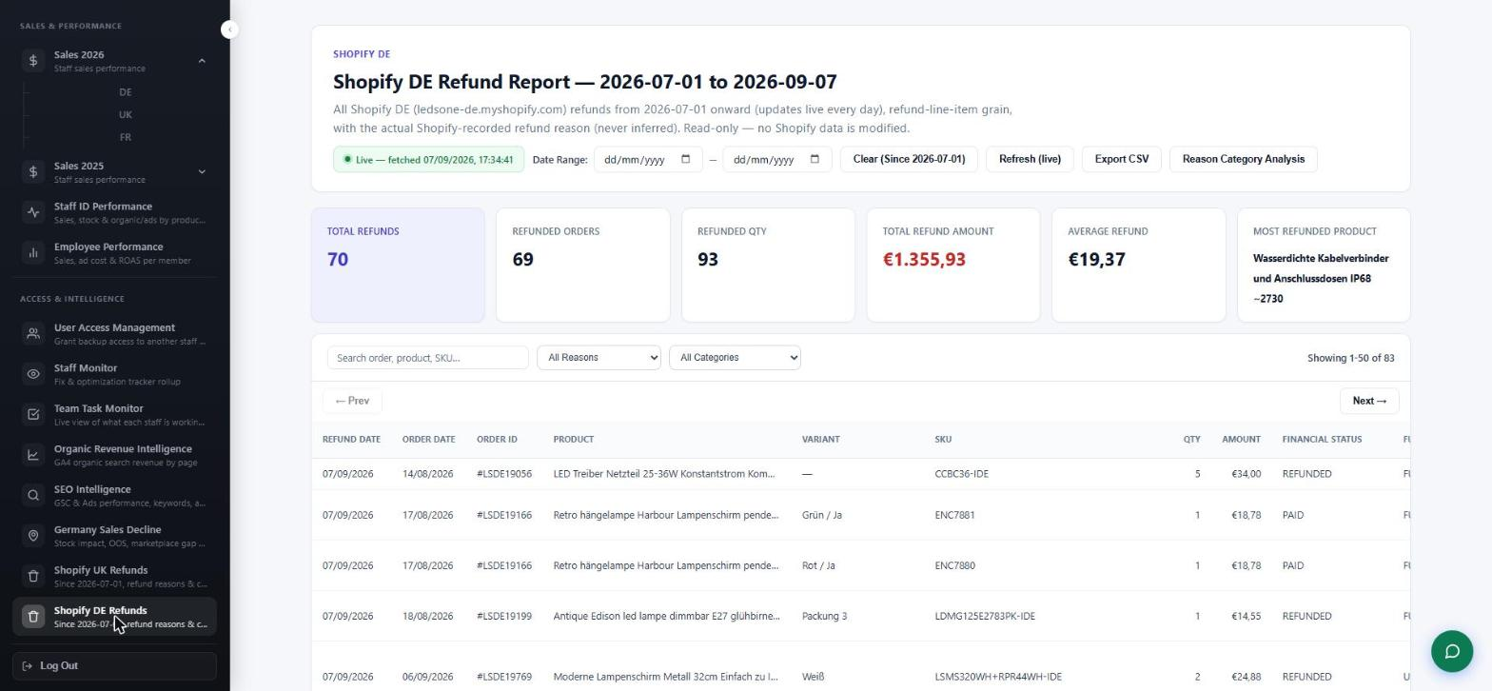
6.12 2026 New Listings — live Shopify product listing (price, title, status, inventory) pulled from the Shopify Admin GraphQL API
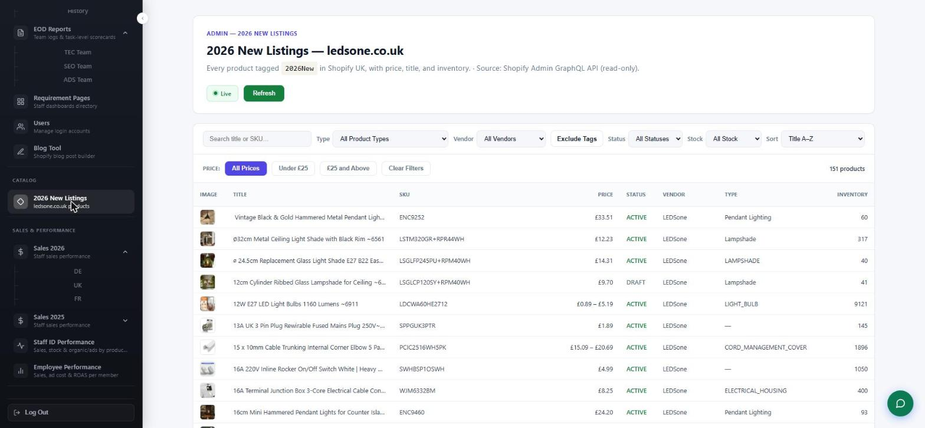
6.13 Blog Tool — Shopify blog post builder with live preview and HTML export
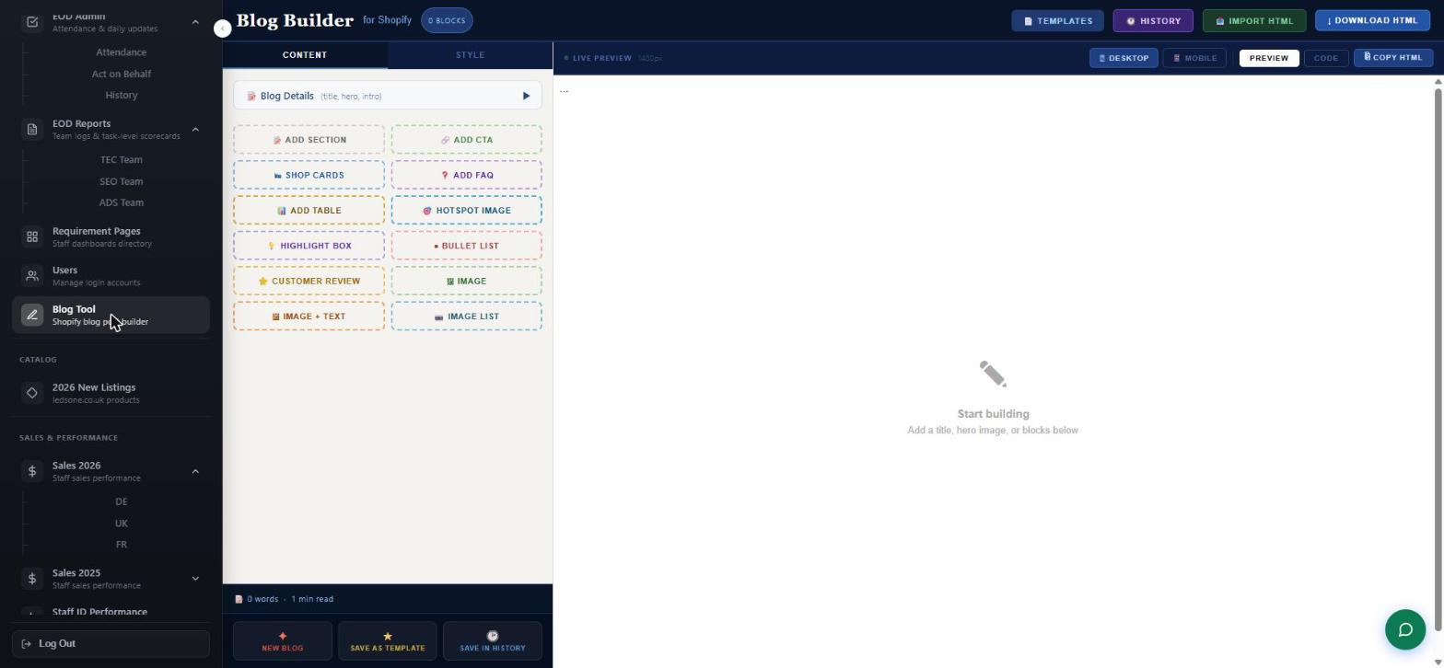
6.14 A staff dashboard (opened as Jefri) — personalised requirement menu and quick navigation
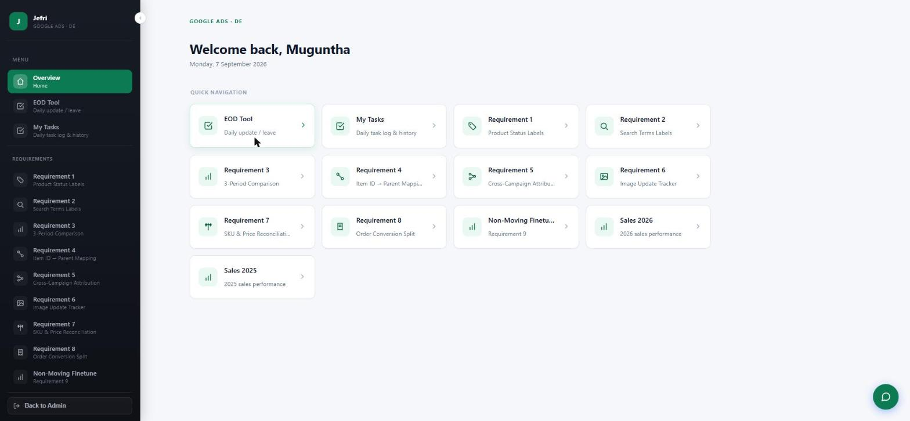
6.15 Jefri — Requirement 1: Product Status Labels, classifying 2,408 advertised products as Heroes / Villains / Zombies / Sidekicks from live Google Ads performance
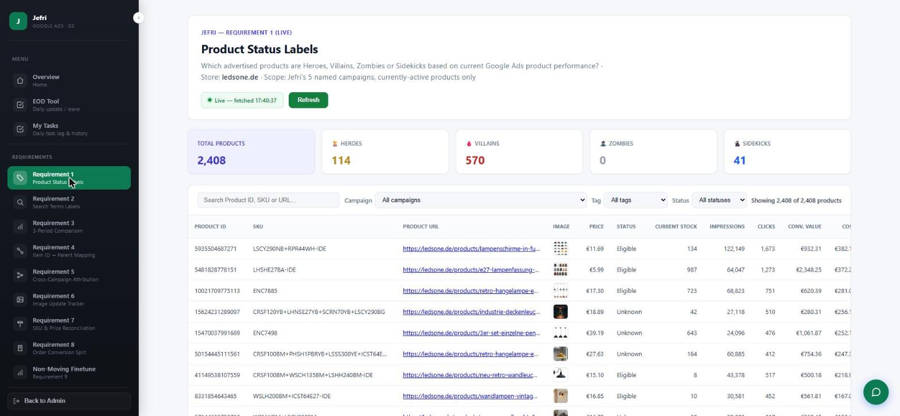
6.16 Jefri — Requirement 3: 3-Period Product Comparison across three fixed calendar-quarter windows, with performance tiering
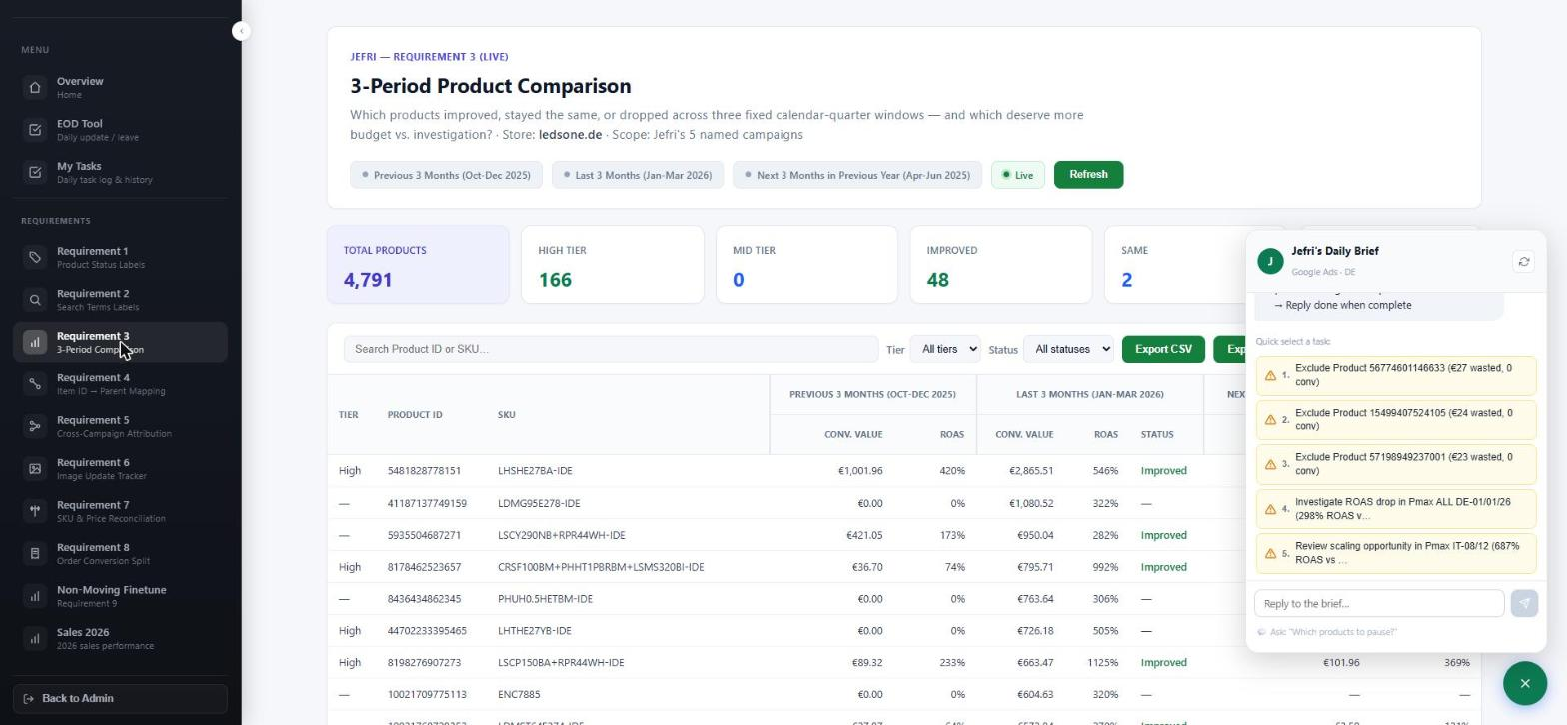
6.17 Jefri — Non-Moving Product Finetune workflow: 1,827 non-moving products from the Shopify catalogue, with a before / after tracking cycle
