CI/CD Setup — dm-dashboard (GitHub Actions → Contabo VPS)
Completed 2026-10-07

This document records the full setup of automatic deployment for dm-dashboard. Before this, deploying a change meant manually SSHing into the Contabo VPS and running /var/www/dashboard-dm/deploy.sh by hand after every merge to main. Now, GitHub Actions runs that exact same script automatically the moment something is merged into main -- nothing about the deploy itself changed, only who presses the button.

The live, always-current reference for how this works day to day lives in the codebase itself: docs/CI-CD-SETUP.md in the dm-dashboard repo. This document is the setup record/evidence trail, not the thing to keep updated going forward.

What was set up
1. A dedicated SSH key pair, generated just for GitHub Actions (not reusing any personal key).
2. The public half of that key added to the VPS's authorized_keys.
3. The private half, plus the VPS host/user/port, stored as 4 encrypted GitHub repository secrets -- never committed to the repo itself.
4. A GitHub Actions workflow (.github/workflows/deploy.yml) that triggers on every push to main and SSHes in to run the existing deploy.sh.
5. Verified end-to-end with a real run -- the commit that added the workflow itself triggered the first successful automated deploy, confirmed both in GitHub's UI and directly on the VPS via journalctl.

Security note
The private SSH key itself is intentionally not included anywhere in this document, the AIOS repository, or any other git-tracked location -- it lives only in GitHub's encrypted Secrets store and the VPS's own authorized_keys file.

Step 1 — Public key added to the VPS
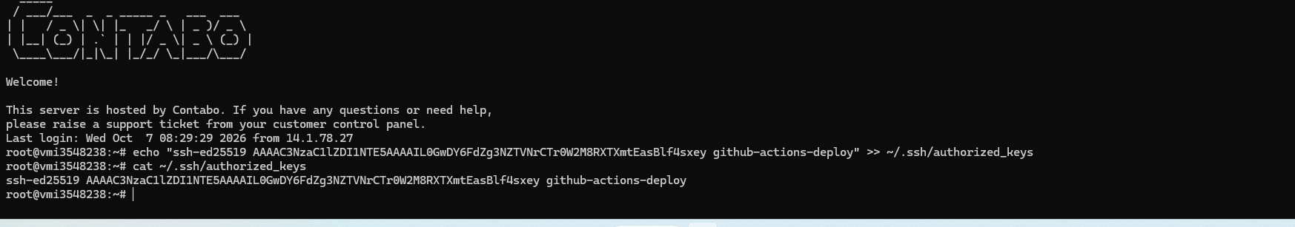
Connected to the Contabo VPS and appended the new public key to ~/.ssh/authorized_keys, then confirmed with cat — the new "github-actions-deploy" key is listed.

Step 2 — Repository secrets page
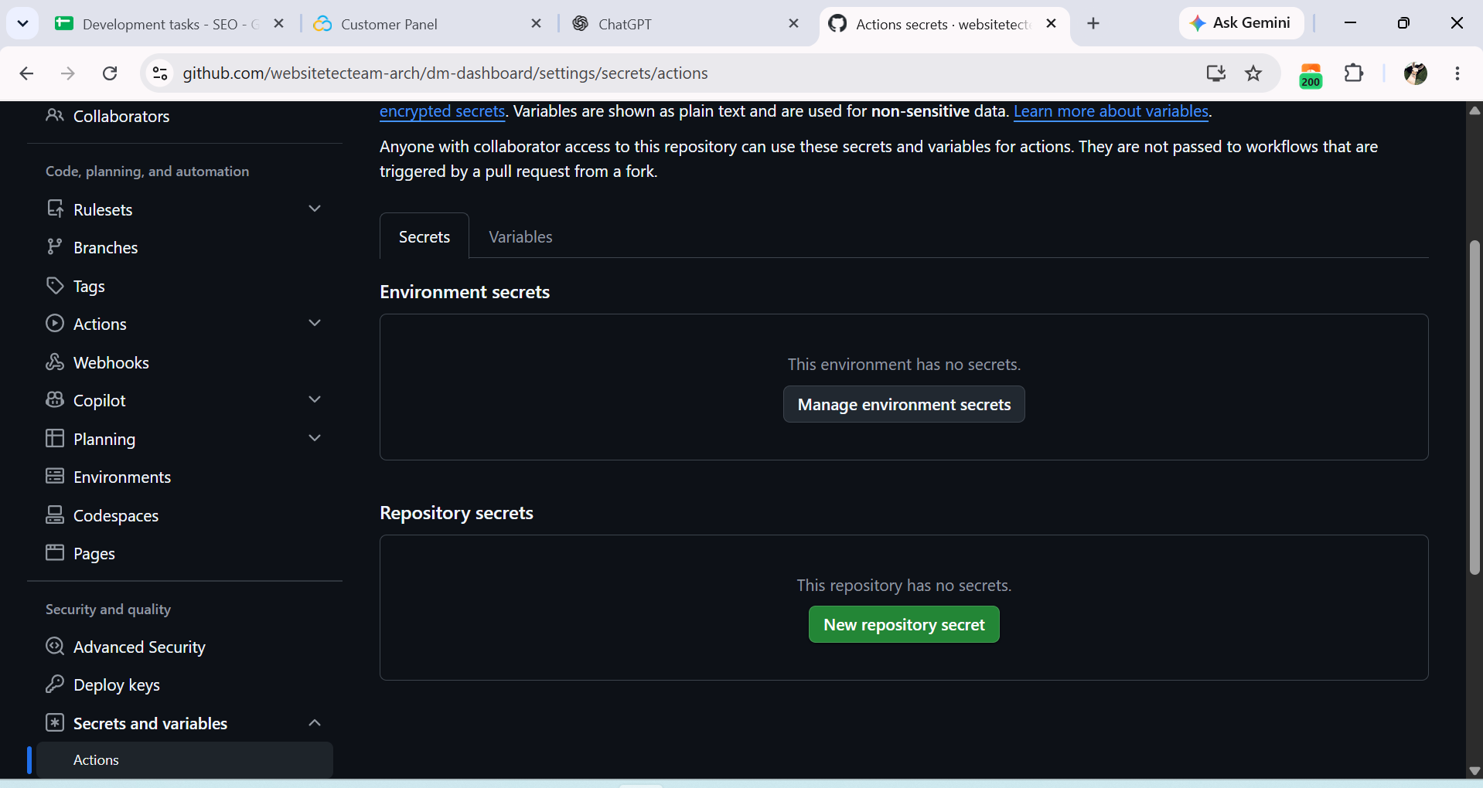
Settings > Secrets and variables > Actions, where the 4 deploy secrets were added.

Step 2 — All 4 secrets added
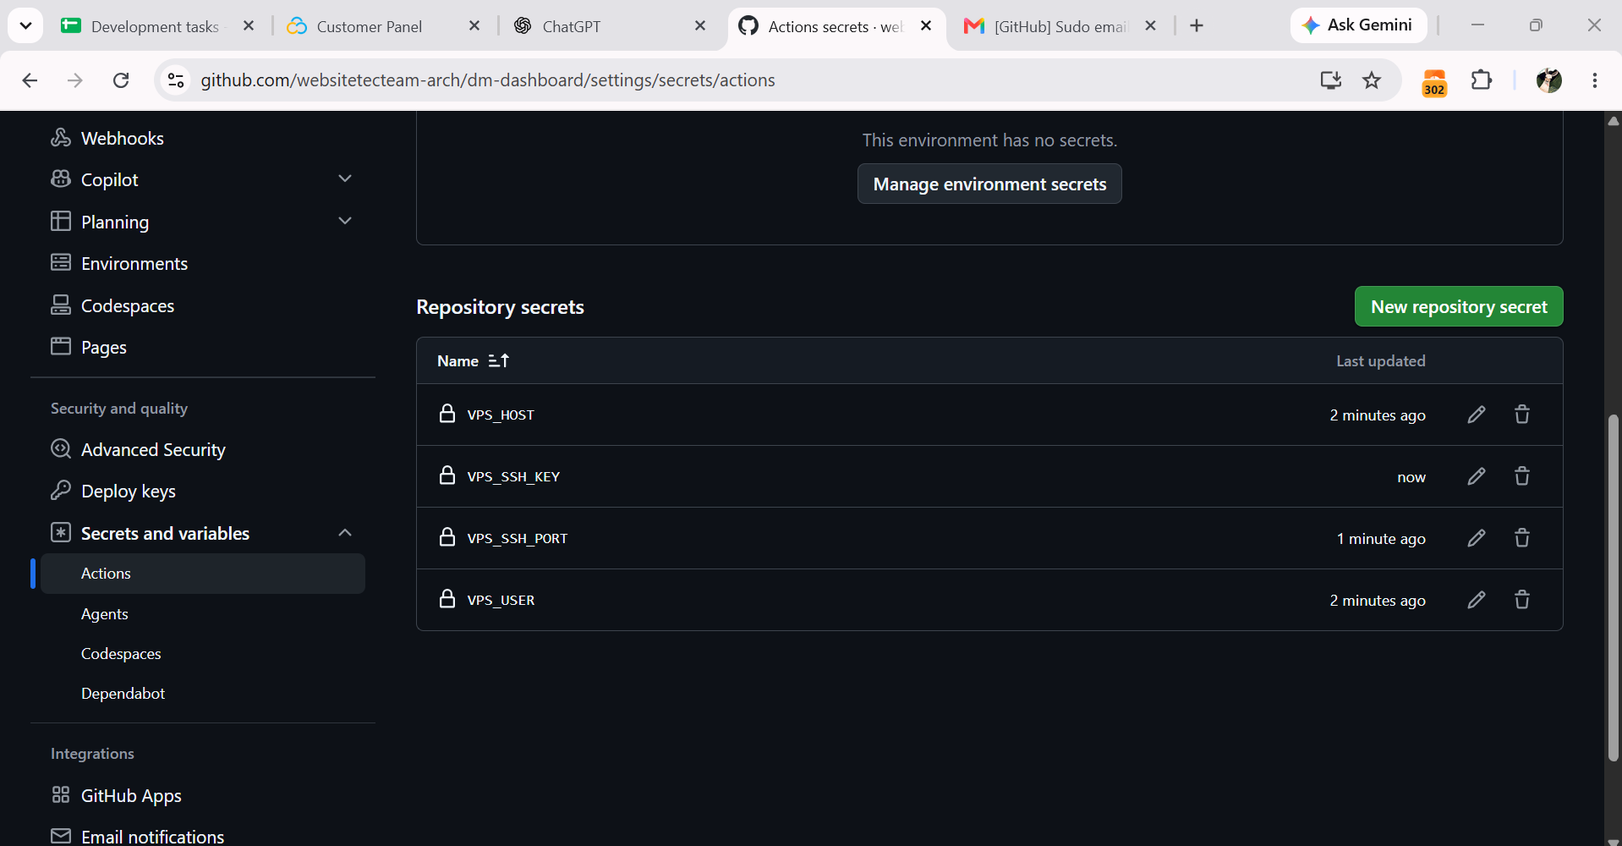
VPS_HOST, VPS_SSH_KEY, VPS_SSH_PORT, and VPS_USER all confirmed present in the repository secrets list.

Step 3 — Workflow YAML in the GitHub editor
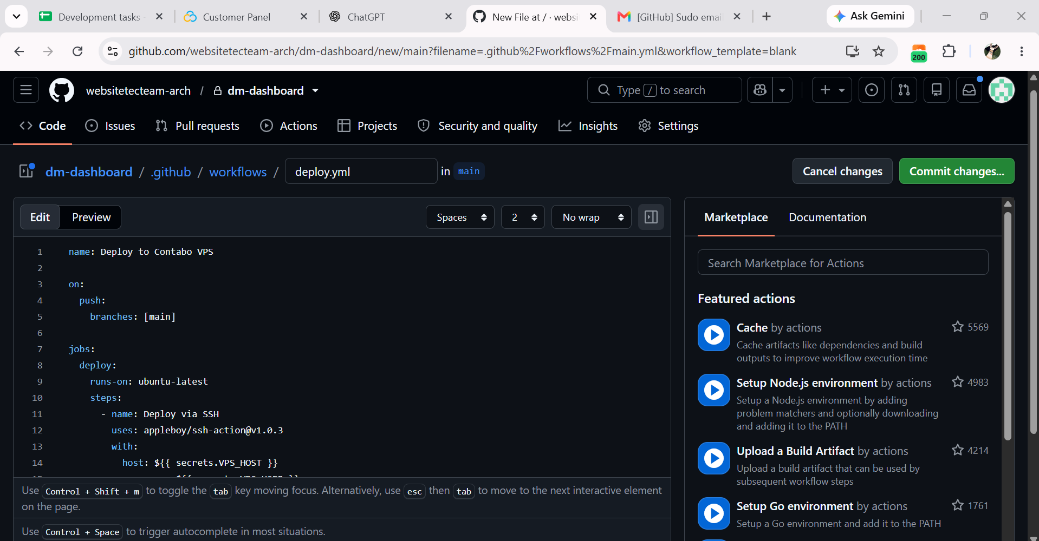
deploy.yml created directly in GitHub's web editor under .github/workflows/, triggered on push to main, running the existing deploy.sh over SSH via the appleboy/ssh-action.

Step 3 — Committing the workflow file
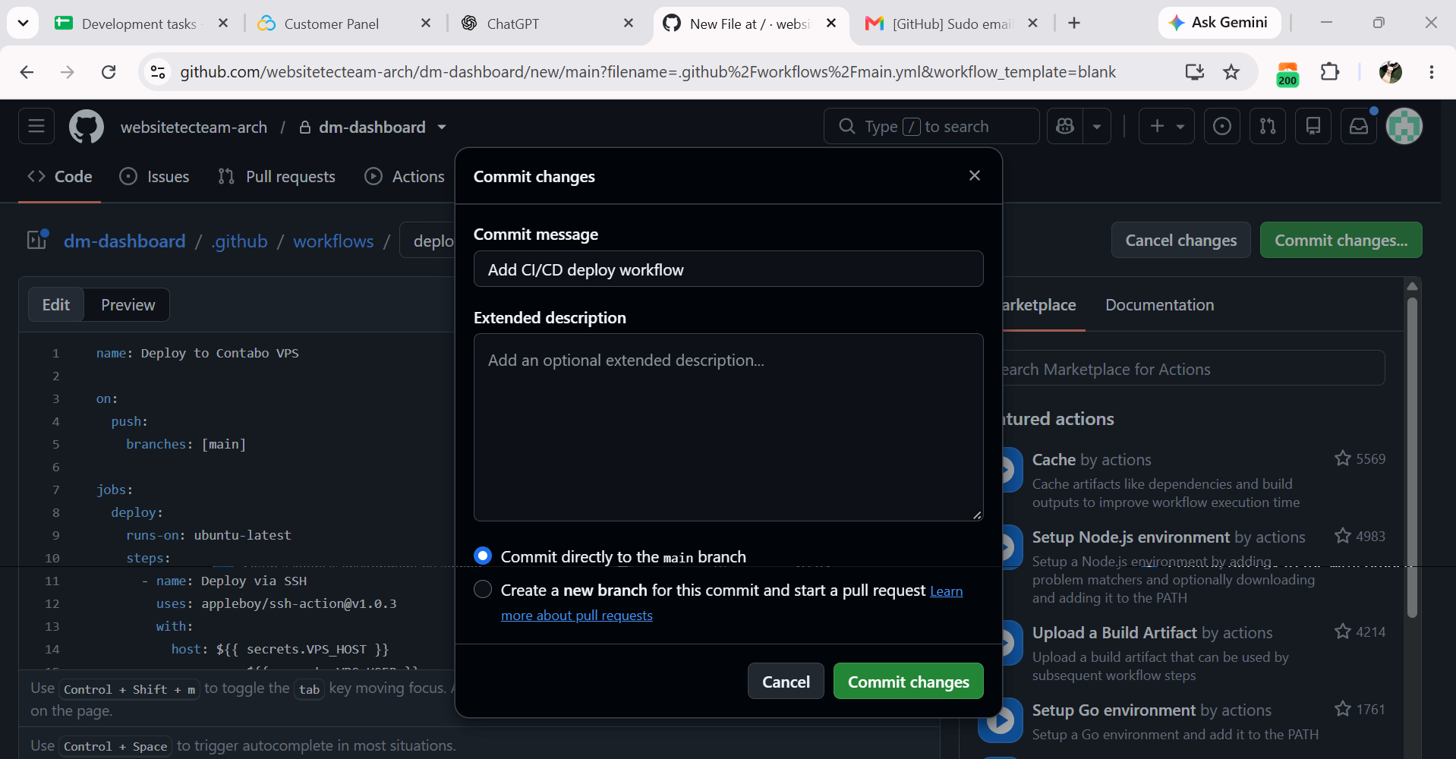
Commit dialog, committing deploy.yml directly to the main branch.

Step 3 — deploy.yml committed
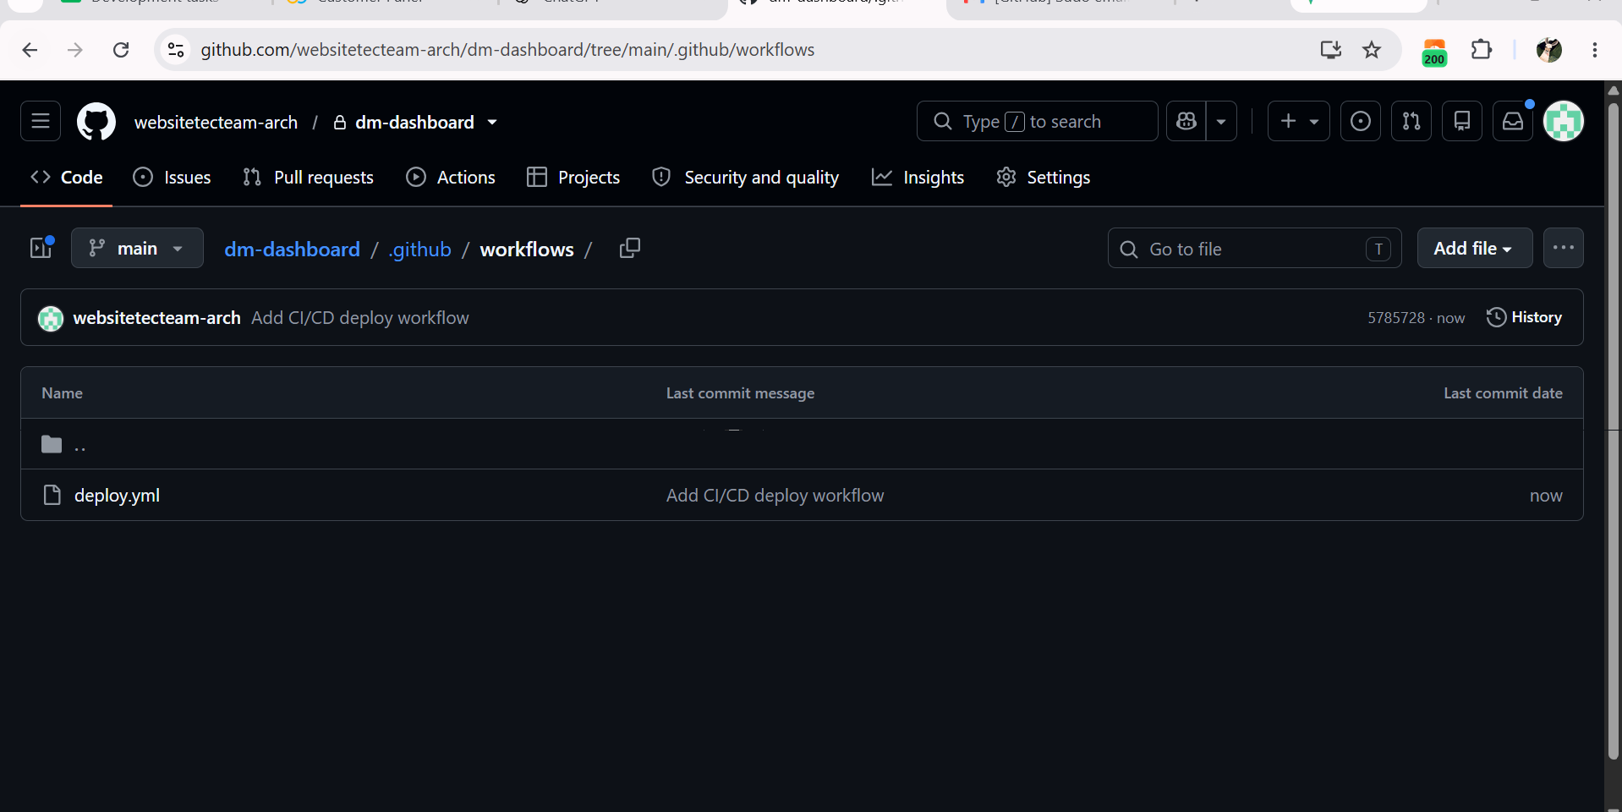
The file now exists in .github/workflows/ on main.

Step 4 — First automatic deploy run: SUCCESS
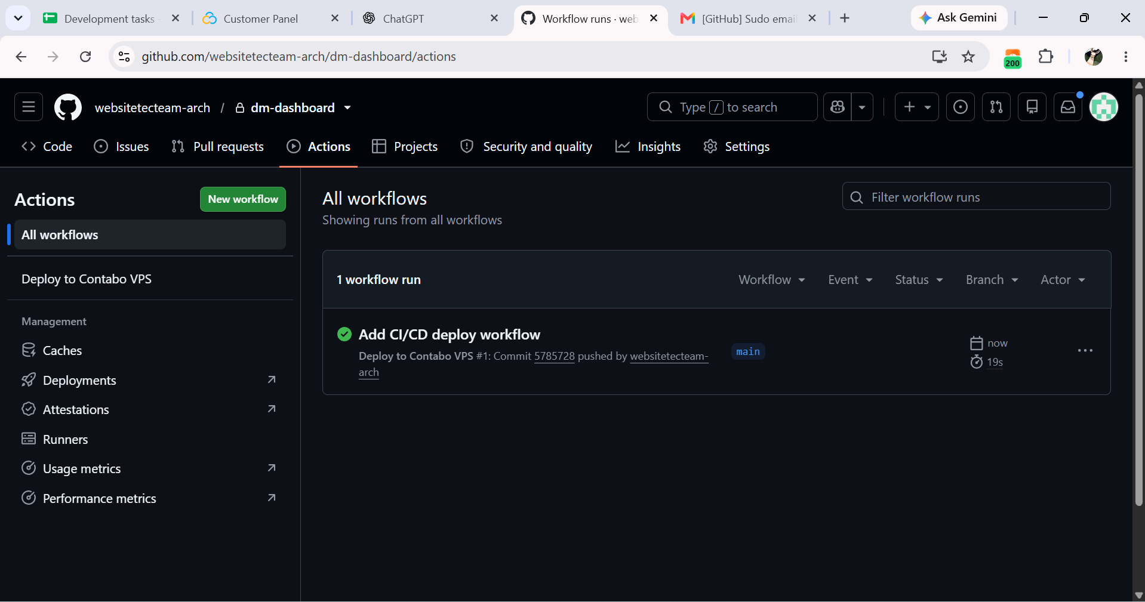
The commit that added the workflow was itself a push to main, so it immediately triggered the very first automated run — green check, completed in 19 seconds. CI/CD is live: every future merge to main now deploys automatically.

Step 5 — Confirmed on the VPS itself
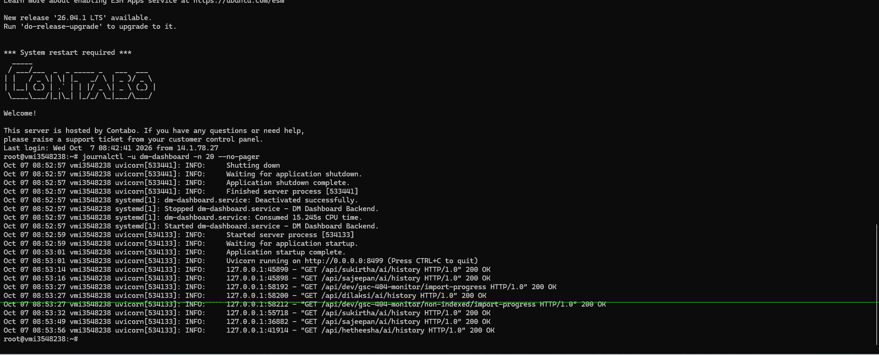
journalctl -u dm-dashboard -n 20 --no-pager on the server shows the real sequence: old process stopped, service restarted, new process started and serving live traffic seconds later. This confirms the automated run genuinely redeployed the backend, not just a green checkmark in GitHub's UI.

