GA-19 Progress Log
DC Voltage Pack — dcvoltage.co.uk
Date: 2026-10-05 • Owner: Kuberan • Source: LEDsone Organic Discovery doc (approved by Muguntha)

Part 1 — Product Title as the H1
STATUS: DONE

Root cause
Two separate bugs, both site-wide:
- templates/product.json, block text_GnyQiN — the main title rendered as <h3>, not <h1>, on every product except 1025 (which had a one-off manual fix applied earlier).
- sections/product-information.liquid, line 88 — the sticky add-to-cart bar duplicated the title a second time as <h3>, on every product including 1025.

Fix applied
- product.json: <h3>{{ closest.product.title }}</h3> → <h1>{{ closest.product.title }}</h1>
- product-information.liquid: sticky bar tag changed <h3> → <div> (styling is fully class-based, no visual change), with a comment documenting who/when/why.

Verified live
Confirmed via raw HTML (not just a visual check) on two different products: Product 1025 now shows exactly 1 real <h1> with the correct title and the duplicate <h3> is gone; Product ~1156, which previously had zero real H1 tags at all, now also shows exactly 1 correct <h1>.
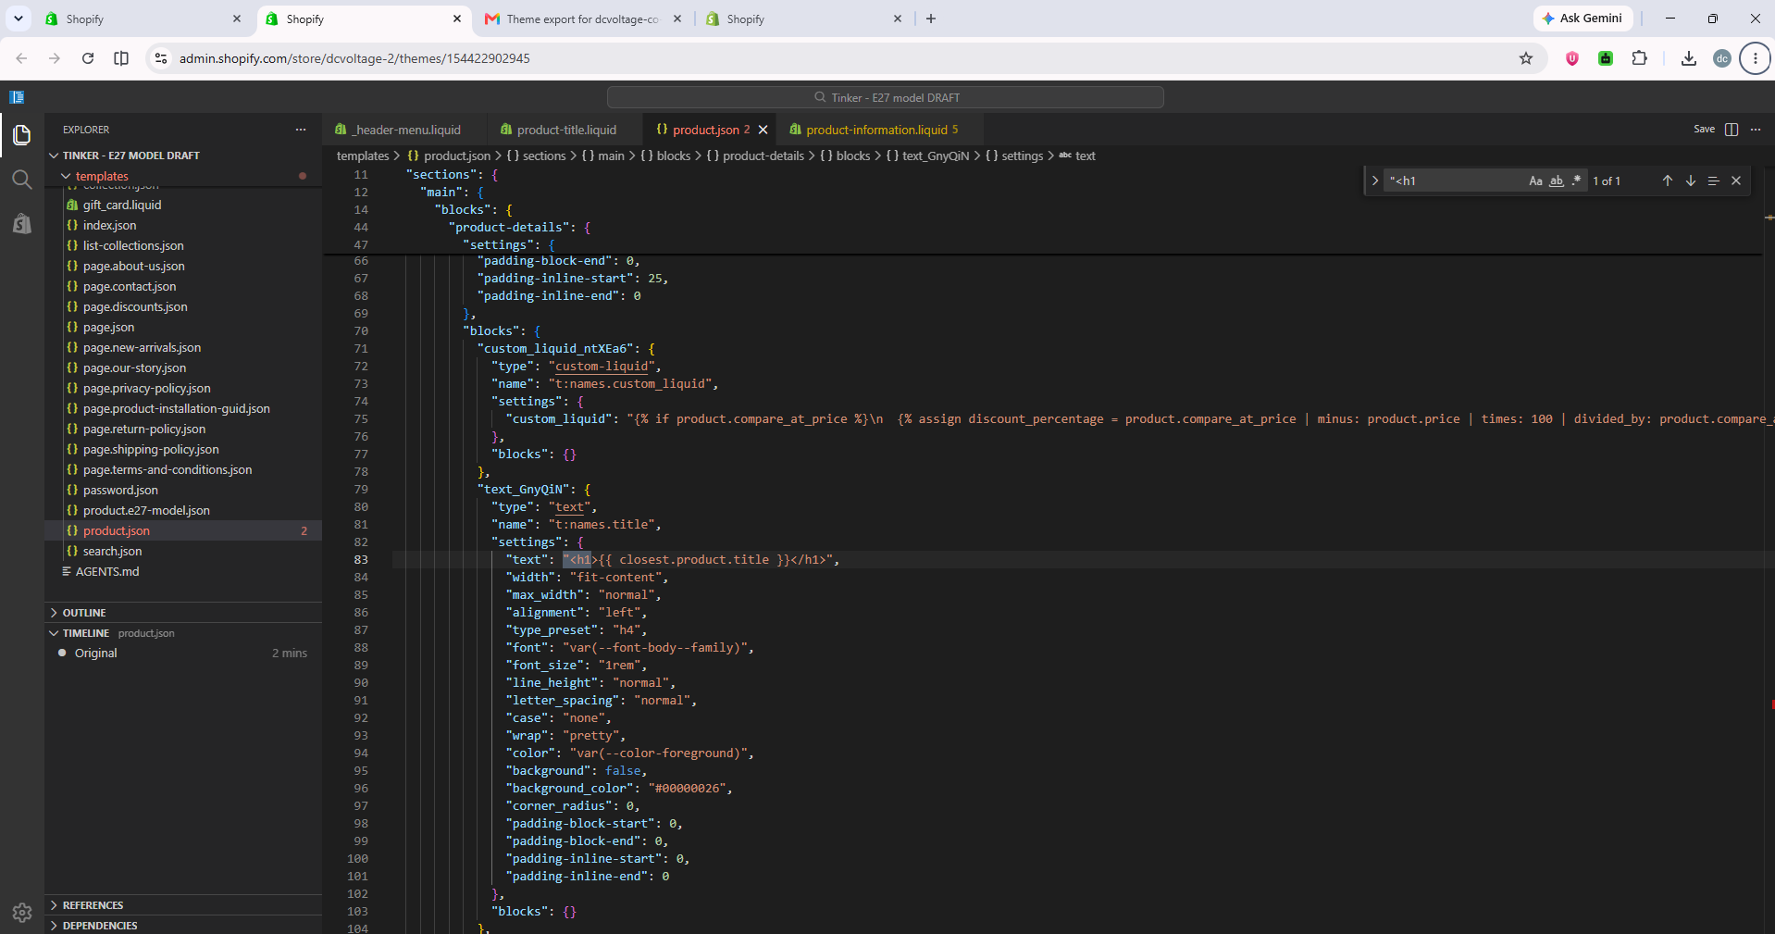
product.json — H1 change, confirmed live in Shopify's code editor
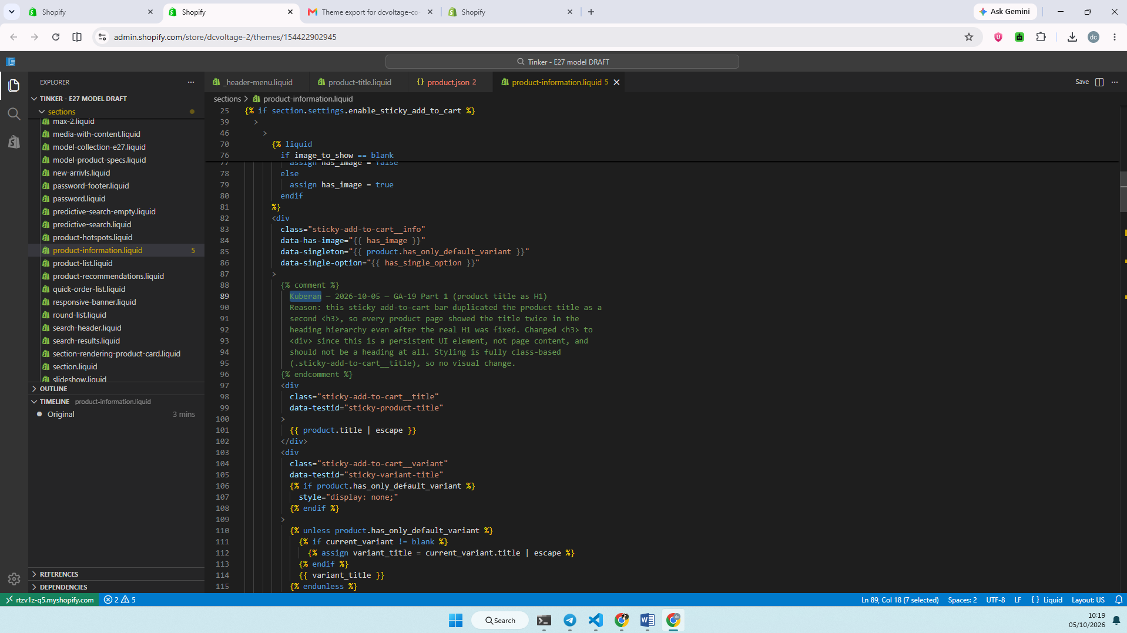
product-information.liquid — sticky bar fix + comment, confirmed live

Part 2 — Show Ratings
STATUS: DONE

Finding
Judge.me is already installed with 27 real, published reviews (confirmed directly in its dashboard, not fake or empty) — but the two blocks that display it on product pages were both switched off in product.json.

Fix applied
Removed “disabled: true” from both judge_me_reviews_preview_badge (compact stars + count) and judge_me_reviews_review_widget (full review list, already correctly set to real_data, not fake).

Verified live
Both jdgm-prev-badge and jdgm-widget markup now present on real product pages.
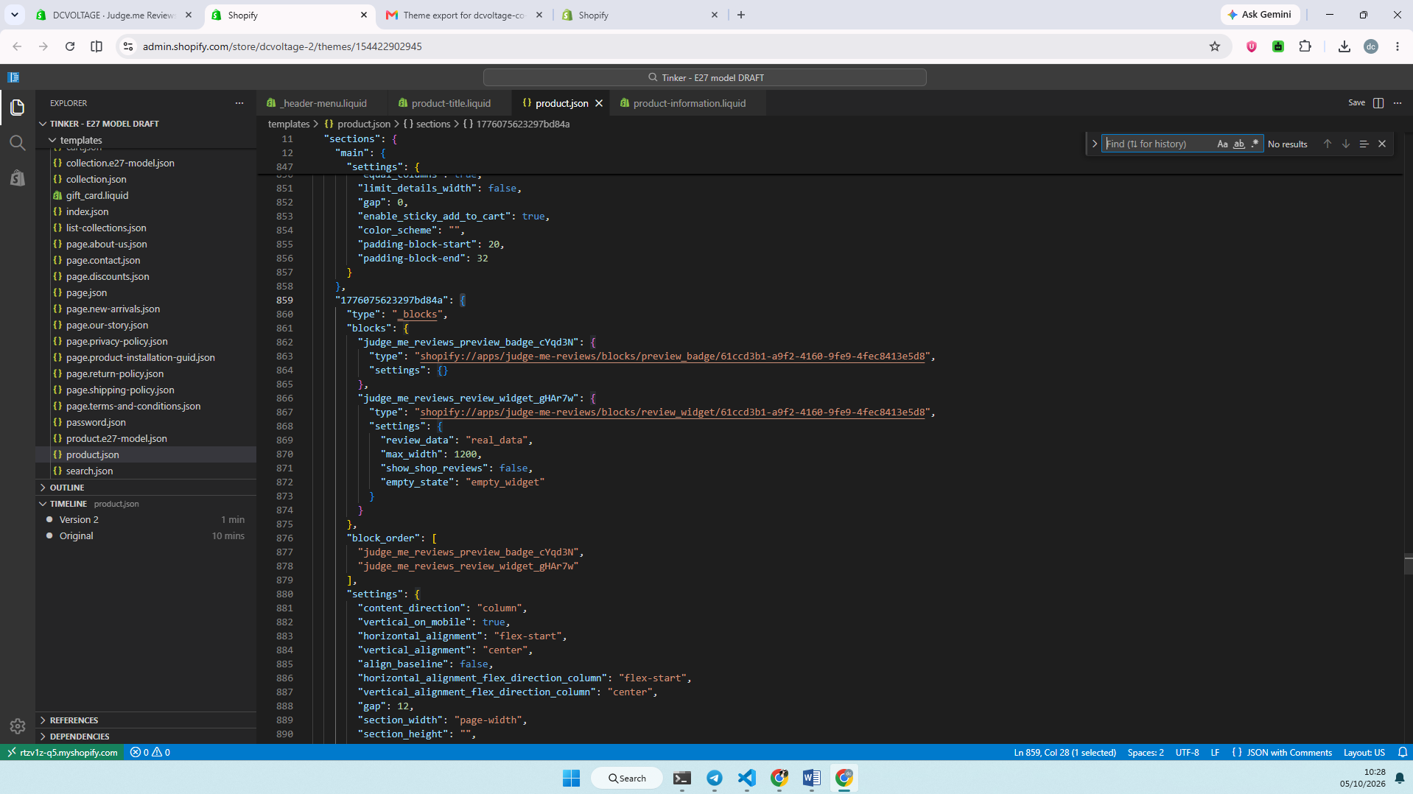
Judge.me blocks enabled, confirmed live in Shopify's code editor

Parts 3 & 4 — Alt Text / Compare-At Prices
STATUS: BLOCKED — waiting on Muguntha's approval
Both are store data, not theme code — per the standing rule in Kuberan_website_fixes_2026-09-29.docx, neither has been touched.

Live data pulled today
A new Shopify Admin API token was set up for dcvoltage specifically for this (token-generator-dc.js, store key “dcvoltage” registered in the backend). Numbers below are pulled live, not from the stale audit:
 | 2026-09-29 audit (stale) | Live today (2026-10-05)
Compare-at price issues | 41 variants | 57 variants (40 on ACTIVE products)
Missing alt text | 1,385 / 3,655 images | 1,356 / 4,196 images (134 products, 60 with zero alt text)

Report sent
Sent to Muguntha, cc Hethesha and Sajeepan (ads lead for DC Voltage — compare-at prices and imagery both feed ad campaigns), with the full live breakdown and two decisions needed from her:
- Compare-at prices: clear each one, or set a genuine prior price?
- Alt text: bulk pattern-based generation, or manual review per image?
Evidence: Store_Data_Issues_Report_Muguntha_2026-10-05_v2.docx (the report itself); email confirmation below.
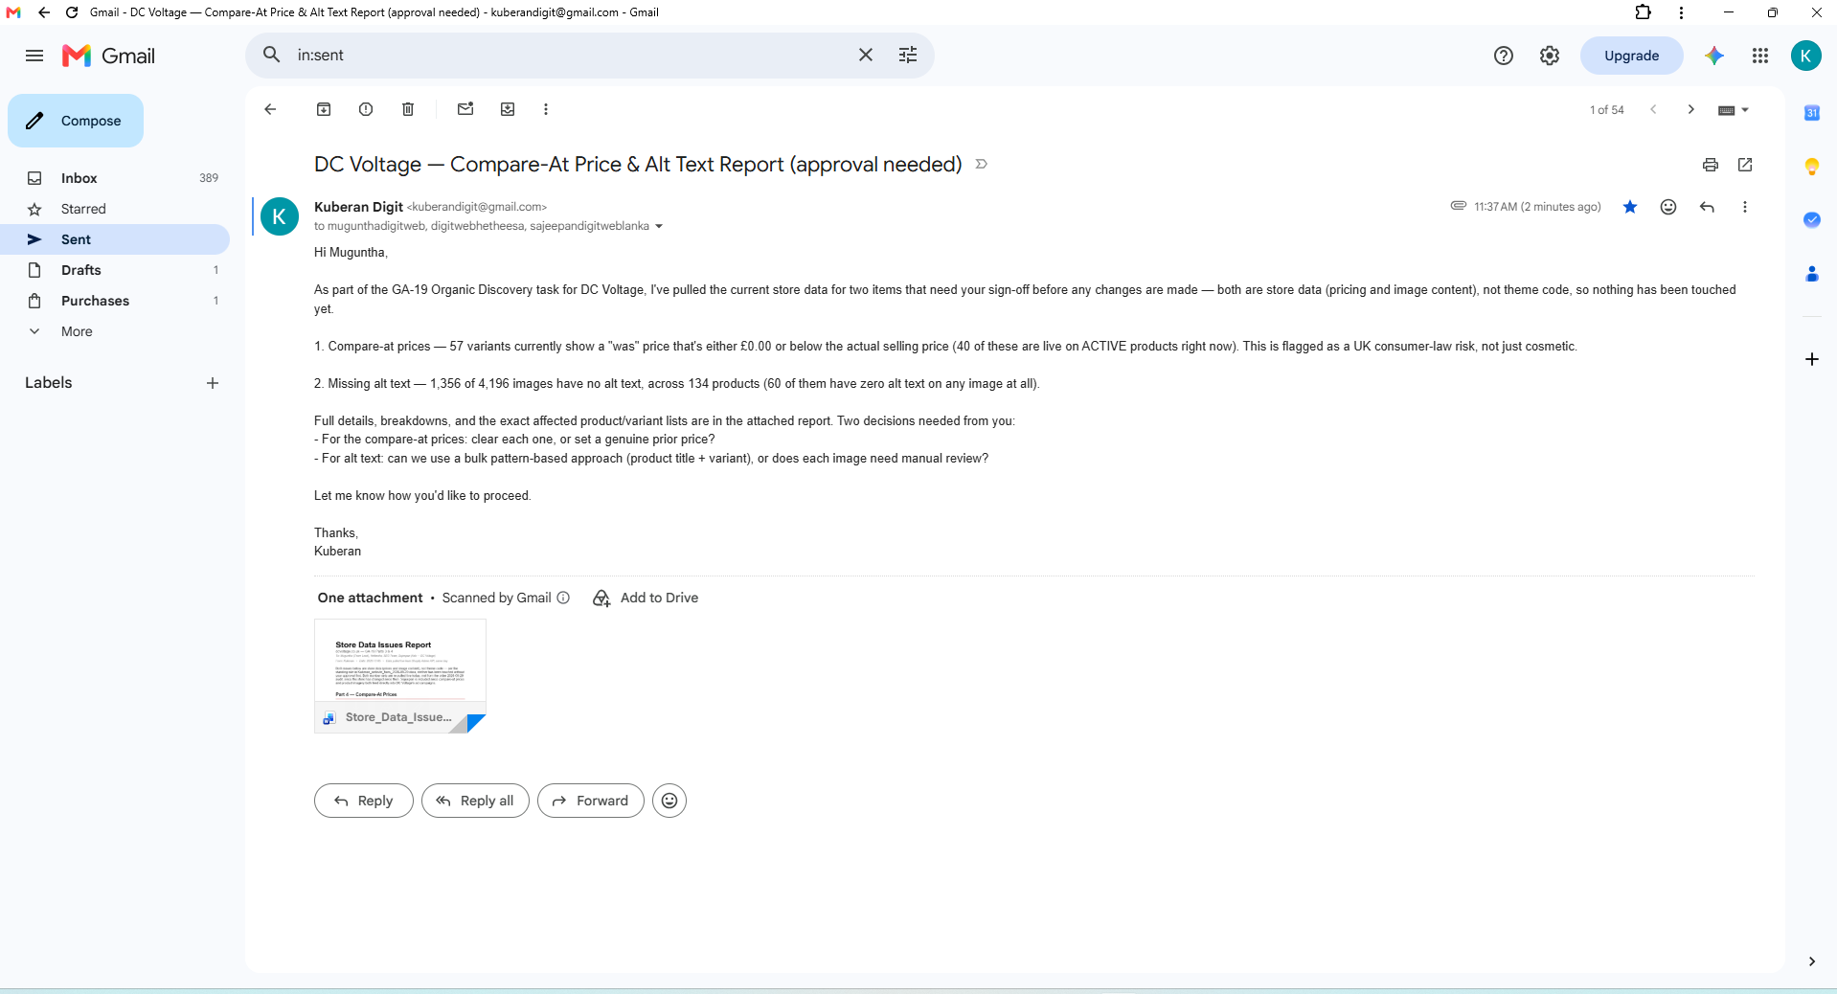
Report emailed to Muguntha, cc Hethesha and Sajeepan — sent confirmation

Part 5 — B22 and E14 Bulb Collections
STATUS: DONE (collections live) — content follow-up requested, see below

Verified product counts
Thorough sweep across titles, descriptions, tags, variant titles and SKUs — not just title matches:
- B22: 7 genuine bulb products found (6 ACTIVE, 1 DRAFT) — including one, “Dimmable Vintage Industrial LED Lighting Bulbs ~1097,” whose B22 variants only showed up via SKU, not its title.
- E14: only 1 genuine bulb product exists store-wide (“Dimmable E14 LED Filament Bulb | Vintage C35 Candle 4W ~1136”). Confirmed with Kuberan before creating a collection this small.

Collections created
Both manually-curated, matching E27 Bulbs' own pattern — no collection image, since E27 Bulbs doesn't have one either:
- B22 Bulbs — /collections/b22-bulbs-bayonet-cap-led-filament-bulbs-dcvoltage — 7 products added (including the 1 DRAFT one, which won't show live until that product itself is published)
- E14 Bulbs — /collections/e14-bulbs-small-edison-screw-candle-bulbs-dcvoltage — 1 product added

SEO title + meta description
Written in the same style/length as E27 Bulbs:
- B22 Bulbs: “B22 Bulbs – Bayonet Cap LED & Filament Bulbs | DCVOLTAGE” / “Bayonet-fit B22 bulbs: vintage filament ST64, G95 and T185, plus bright A60 and T75 LEDs. Choose by wattage, warm or cool white, and dimmable or not.”
- E14 Bulbs: “E14 Bulbs – Small Edison Screw Candle Bulbs | DCVOLTAGE” / “Small screw-fit E14 candle bulbs: vintage filament C35 style, 4W dimmable, warm white. More sizes added as our range grows.”

Verified live
Both collection URLs return 200 and show the correct title/products.
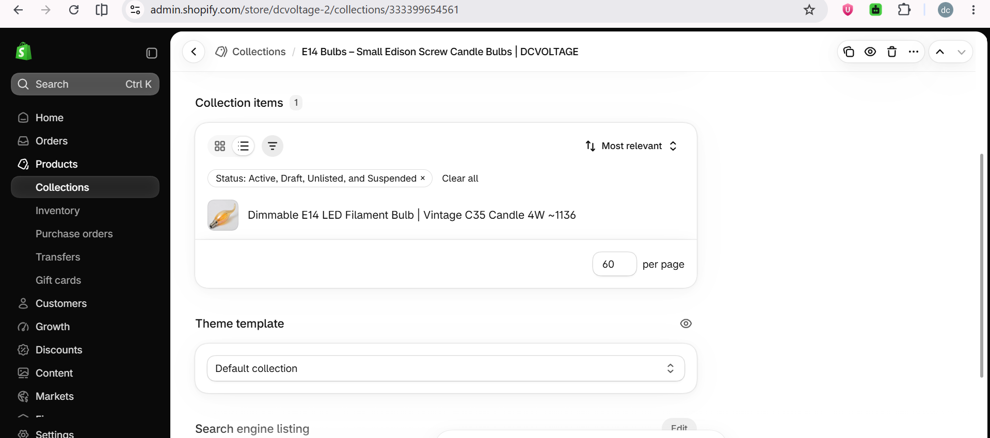
E14 Bulbs — collection item added
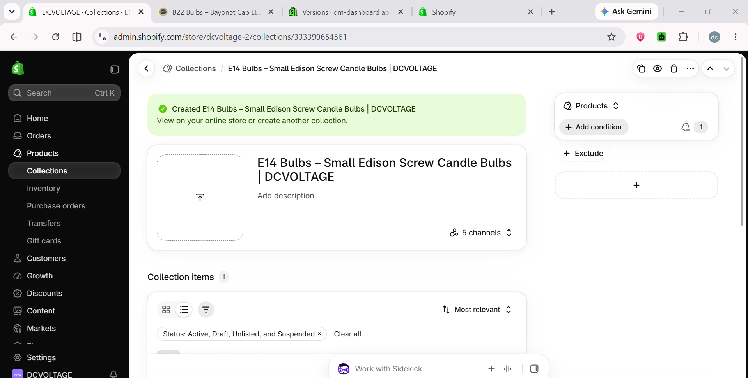
E14 Bulbs — collection created confirmation
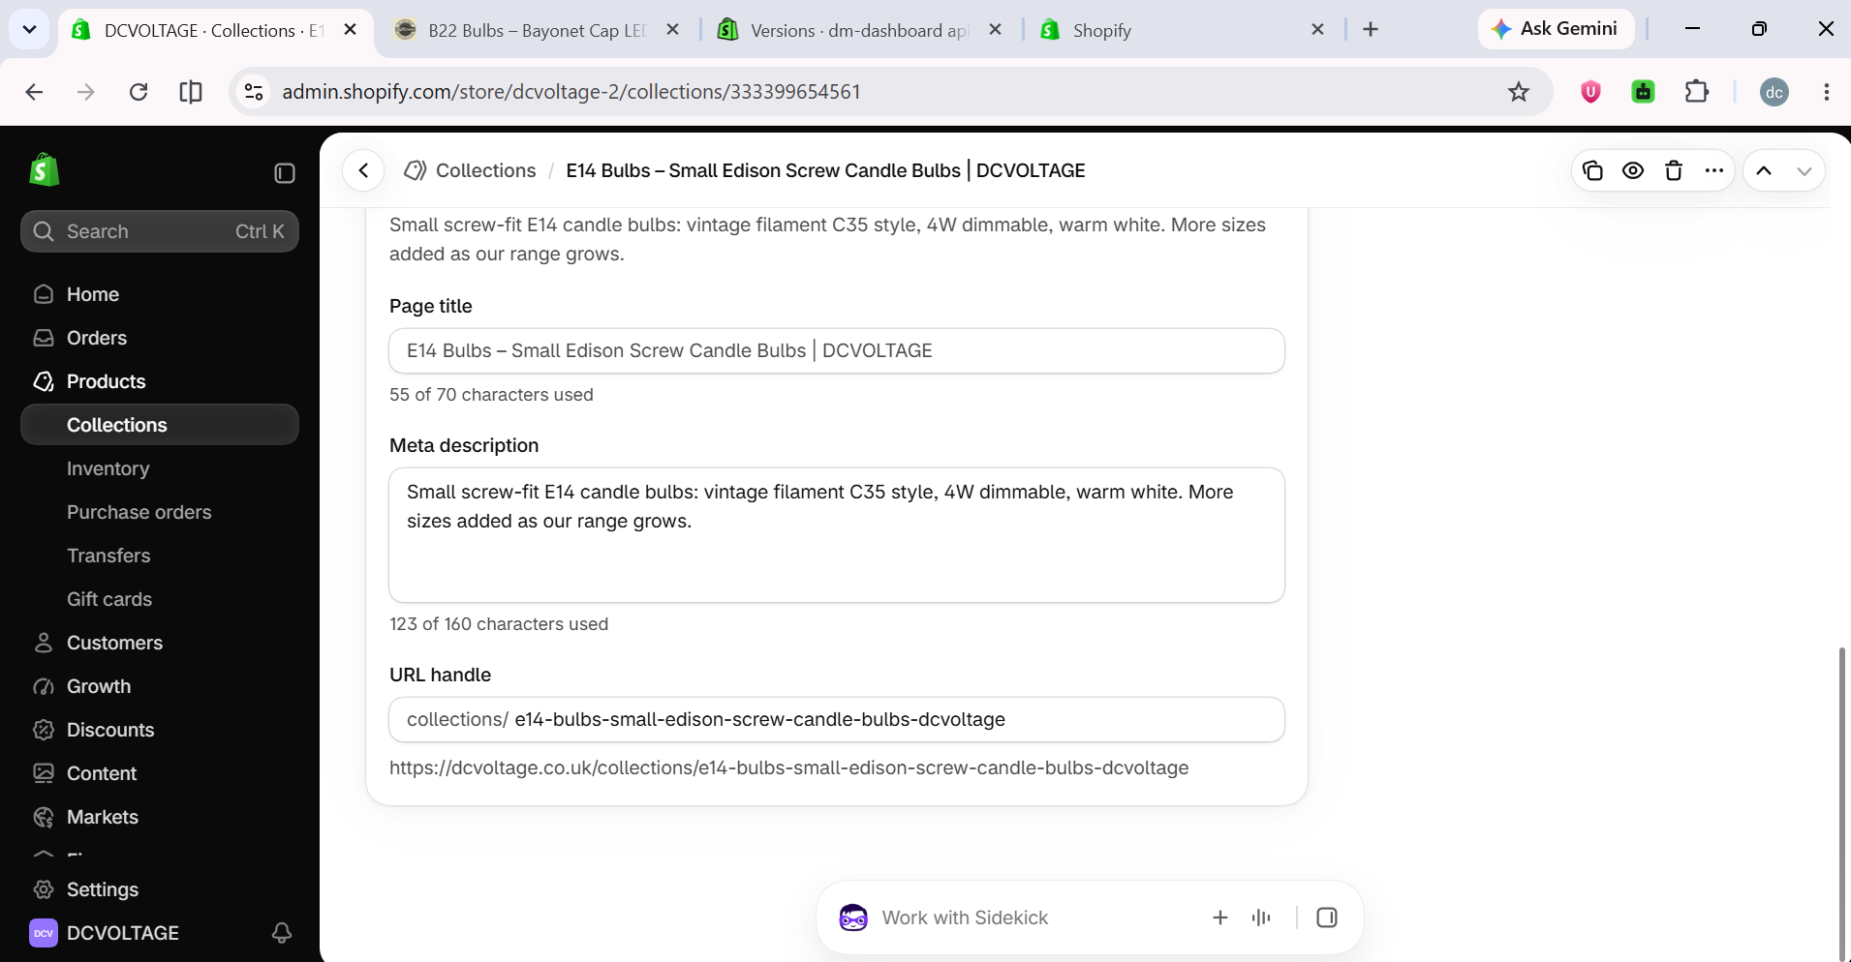
E14 Bulbs — SEO title and meta description
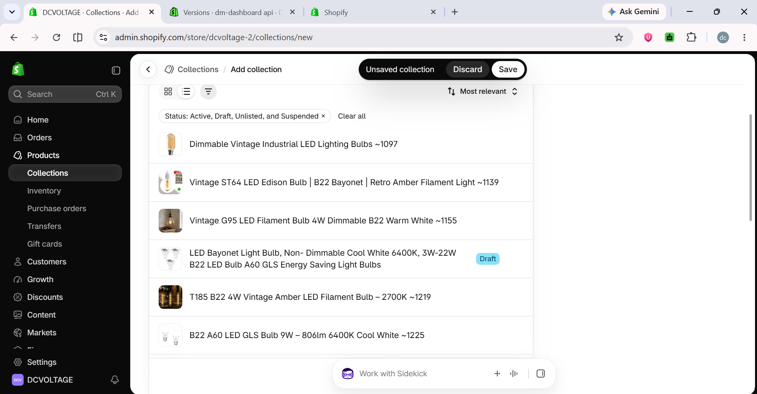
B22 Bulbs — 7 products added
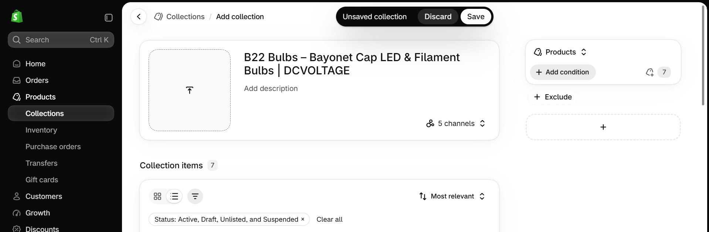
B22 Bulbs — title added
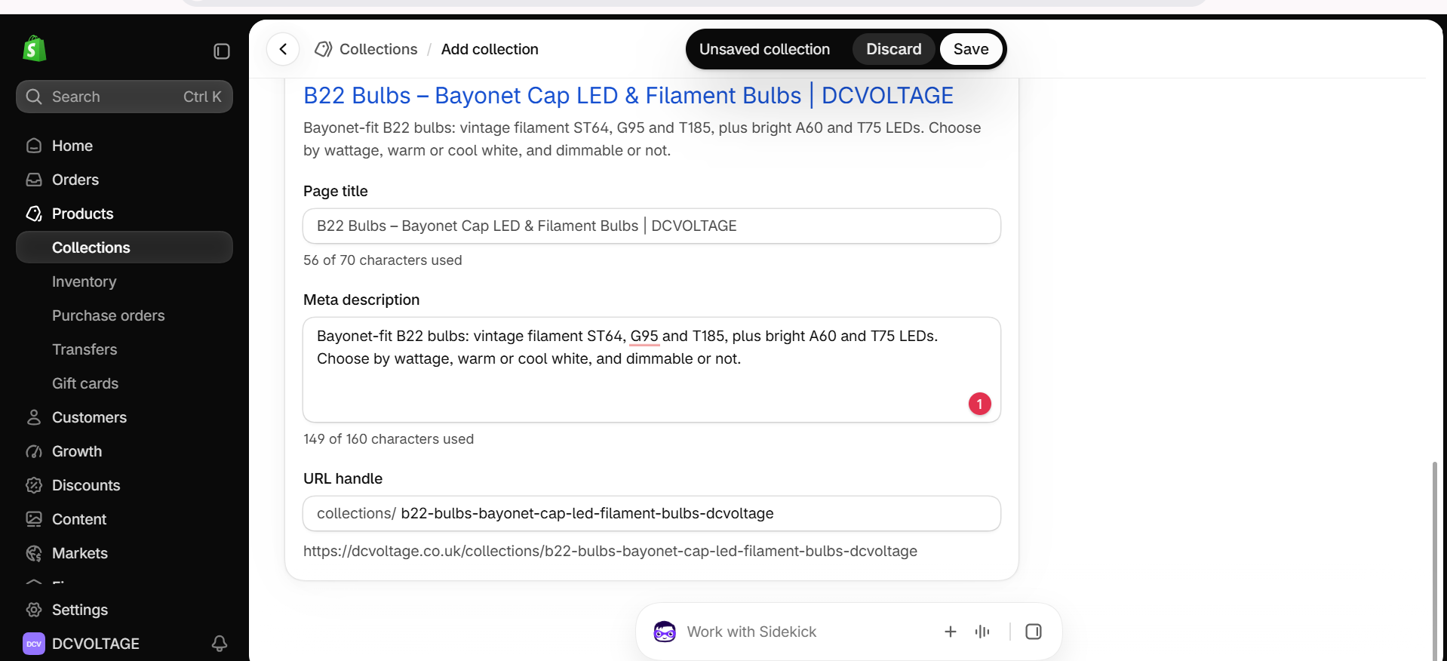
B22 Bulbs — meta description added

Done manually by Kuberan in Shopify Admin
- Created both collections (New collection → entered title)
- Added all matching products to each (7 for B22, 1 for E14)
- Entered Page title + meta description for both, using the wording drafted above
- Saved both collections live

Follow-up requested — bring B22 and E14 up to the same content level as E27
E27 Bulbs uses a special template (collection.e27-model.json), not the plain default one B22/E14 currently use. Full checklist of what it has, that B22/E14 need to match — every element from the header through to schema:
- Header / fitting-type nav list — a list of all three bulb-fitting pages shown together at the top (E27 SCREW BULBS / B22 BULBS / E14 BULBS), so each fitting type page cross-links to the other two. Right now this list exists on the E27 page but doesn't link out properly to the new B22/E14 pages yet — needs updating so all three reference each other correctly.
- Answer-first intro box — direct question + answer (e.g. “Which E27 bulb do I need?” style), category-specific wording for each.
- Quick links — short contextual links under the intro (E27's: “Not sure of your fitting?” / “Need a bayonet bulb?”) — B22/E14 need their own equivalents.
- Shape comparison table — E27 has 7 rows (“Which E27 shape for which job?”); B22/E14 need their own, built from their actual real shapes (e.g. B22 has ST64, G95, T185, A60, T75).
- FAQ section — E27 has 6 Q&As; B22/E14 need their own, genuinely relevant questions, not copied text.
- Breadcrumb — back to the parent category (“LED Light Bulbs”), same as E27.
- Structured data (schema.org) output — for Google rich results, same as E27.
Kuberan confirmed: all of the above — header nav through to schema — needs to be built for both B22 and E14, matching E27's structure exactly in format, with new, category-specific content for each (nothing copied verbatim from E27's own text). Next step for this task.
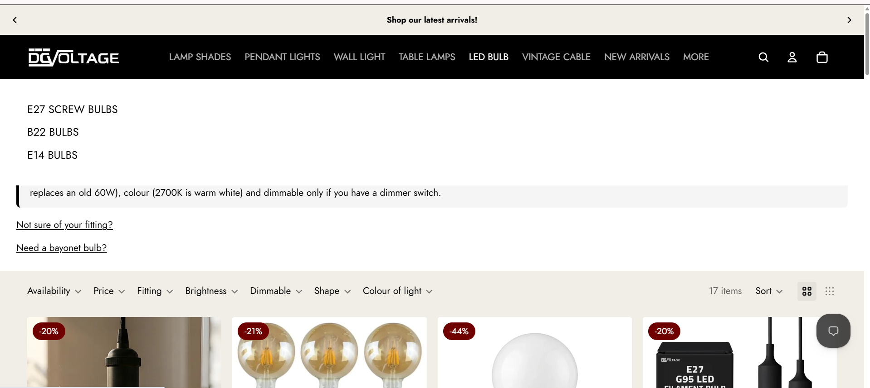
E27 page — header nav list, intro box, and quick links (the reference to match)

Part 6 — Answer-First Intro on Wall Light Collection
STATUS: IN PROGRESS
Wall Light already has a full content article in its description, but it opens with a descriptive line, not an answer-first one (“Lights on the wall, or sconces as they're often called, are a really neat way...”). Proposed a short answer-first intro to prepend above the existing article — awaiting final confirmation on wording before publishing.

Team update
Replied in the “website organic discovery” thread confirming GA-19 as the first task: Parts 1 & 2 done today, Parts 3 & 4 blocked pending Muguntha, Parts 5 & 6 in progress.

