DC Voltage E27 — Quick Fixes
Completion Report — Friday 2 October 2026 (due 18:00 SL)
Source: email from LED Sone <ledsoneuk@gmail.com>, 1 Oct 2026, 4:35 PM, attachment "Kuberan_E27_next_level_2026-10-01"
All 9 quick-fix items due today (C1, C3, C4, P1, P2, P5, G1, G2, G3) are complete. P5, P2 and P1 have already been approved by Thuwaraga. G1, G3 and C1 are confirmed live on the site. C3 is built on the duplicate theme ("Tinker - E27 model DRAFT") and awaiting Muguntha's sign-off to publish.

Summary
# | Item | What | Approver | Status
1 | P5 | Meta description, product 1025 | Thuwaraga | Done + Approved
2 | G2 | Meta description, E27 vs B22 vs GU10 guide | Muguntha | Done
3 | P2 | FAQ 1 link fix, product 1025 (B22 version) | Thuwaraga | Done + Approved
4 | C3 | FAQ 2 link + intro line breaks, collection page | Muguntha | Done (draft theme, awaiting publish approval)
5 | G1 | Fix 3 dead links in the guide | Muguntha | Done + Confirmed LIVE
6 | G3 | Remove duplicate H1 in guide body | Muguntha | Done + Confirmed LIVE
7 | C4 | Move sold-out products (1116, 1226) to end | Muguntha / Thuwaraga | Done
8 | C1 | Connect the collection (menu, LED Bulb page link, guide button) | Muguntha | Done + Confirmed LIVE
9 | P1 | Rewrite product 1025 description intro | Thuwaraga | Done + Approved

1-2. P5 & G2 — Meta Descriptions
P5: Meta description saved on product 1025 (Dimmable ST64 E27 LED Filament Bulb).
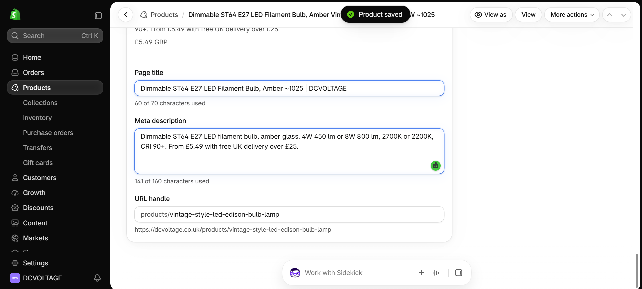
G2: Meta description saved on the E27 vs B22 vs GU10 guide article.
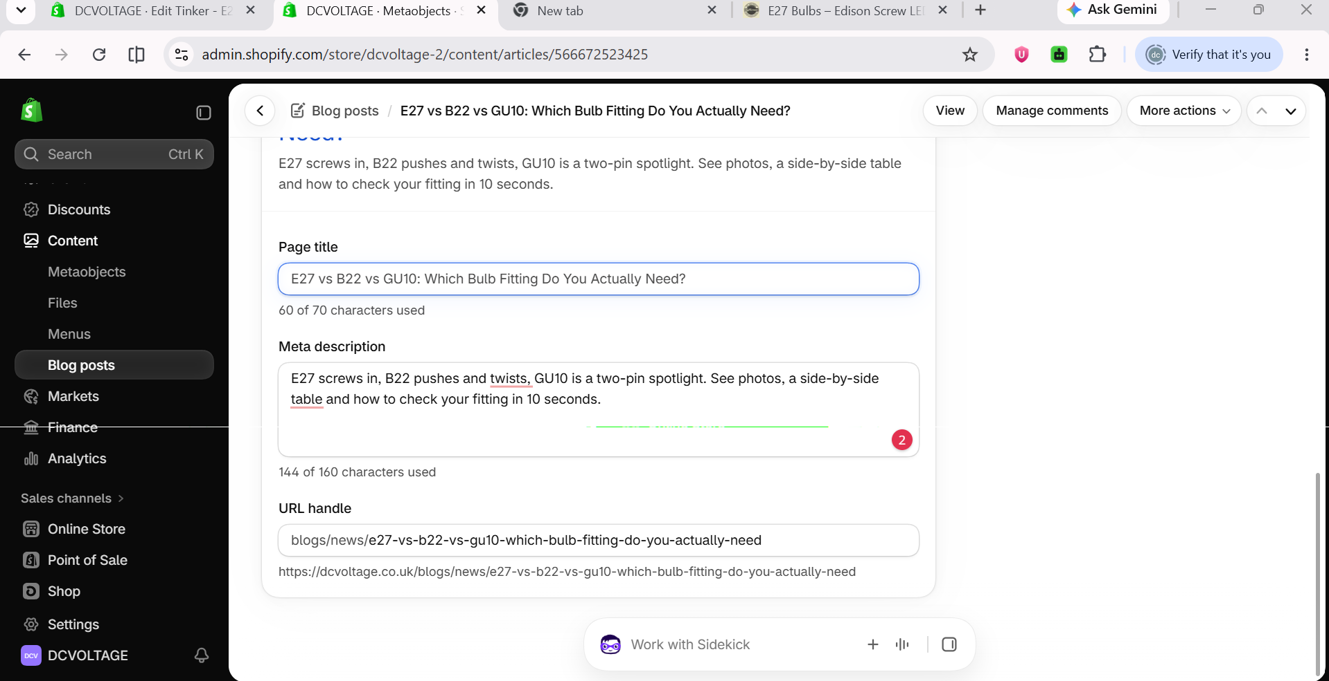

3. P2 — FAQ 1 Link Fix (Product 1025)
"B22 version of this bulb" is now a clean link to the B22 product, live on the site.
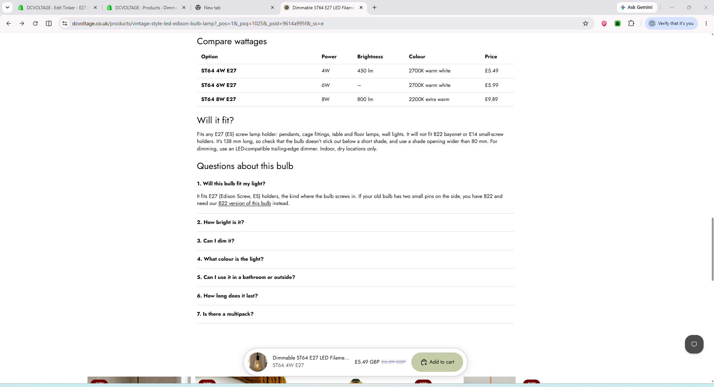

4. C3 — Collection Page Fixes
Part 1: FAQ 2's "E27 vs B22 guide" link fixed on the collection page.
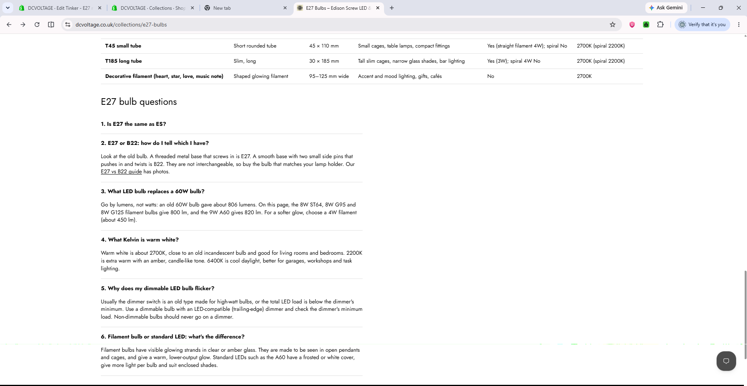
Part 2: Intro box line breaks removed, now one continuous paragraph (built on duplicate theme).
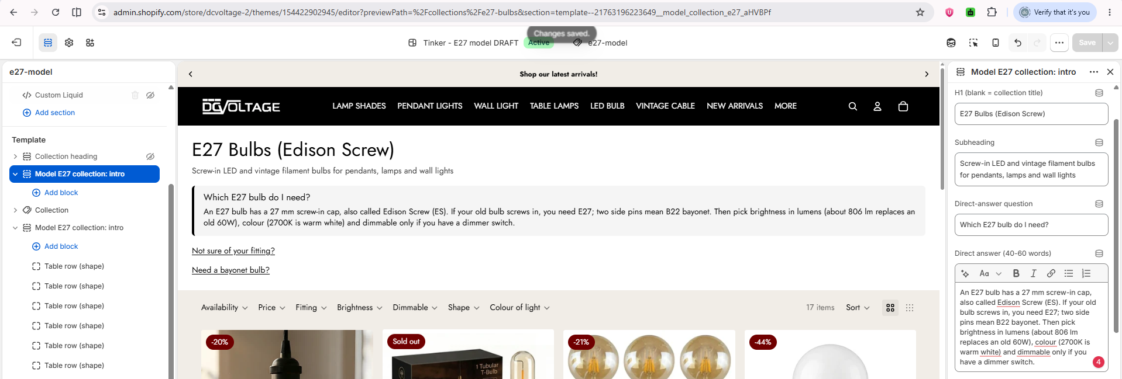

5. G1 — Guide Dead Links Fixed
"Shop E27 Bulbs", "Shop GU10 Bulbs" and the breadcrumb all point to valid collections. Confirmed live.
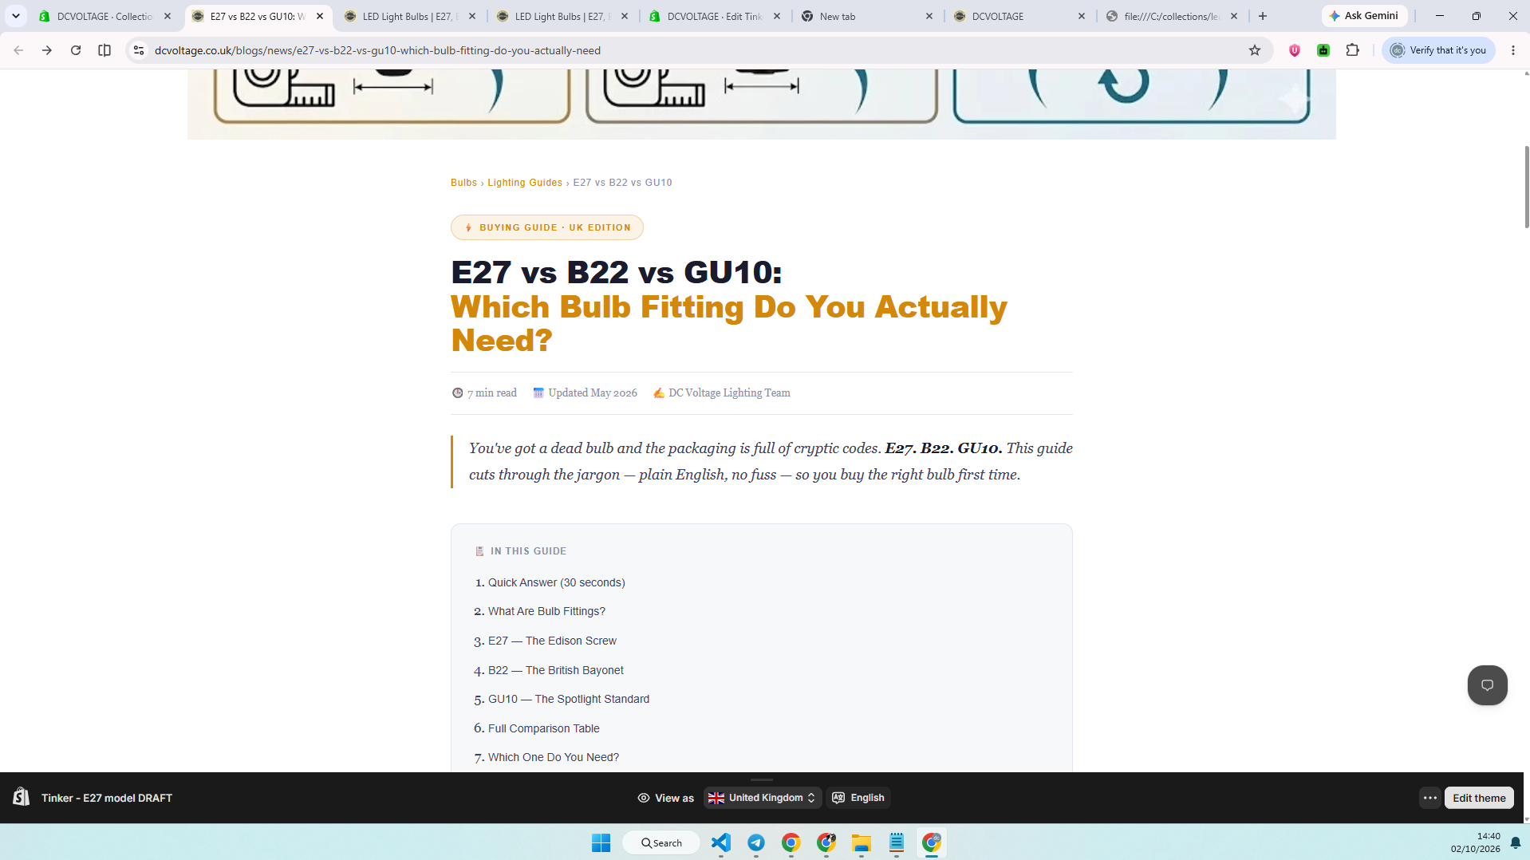

6. G3 — Duplicate H1 Removed
Verified via live page fetch: exactly one <h1> on the guide page; the oversized hero text is no longer a heading.

7. C4 — Sold-Out Products Reordered
Products ~1116 and ~1226 (both sold out) moved to positions 16-17 of 17 in the E27 Bulbs collection.
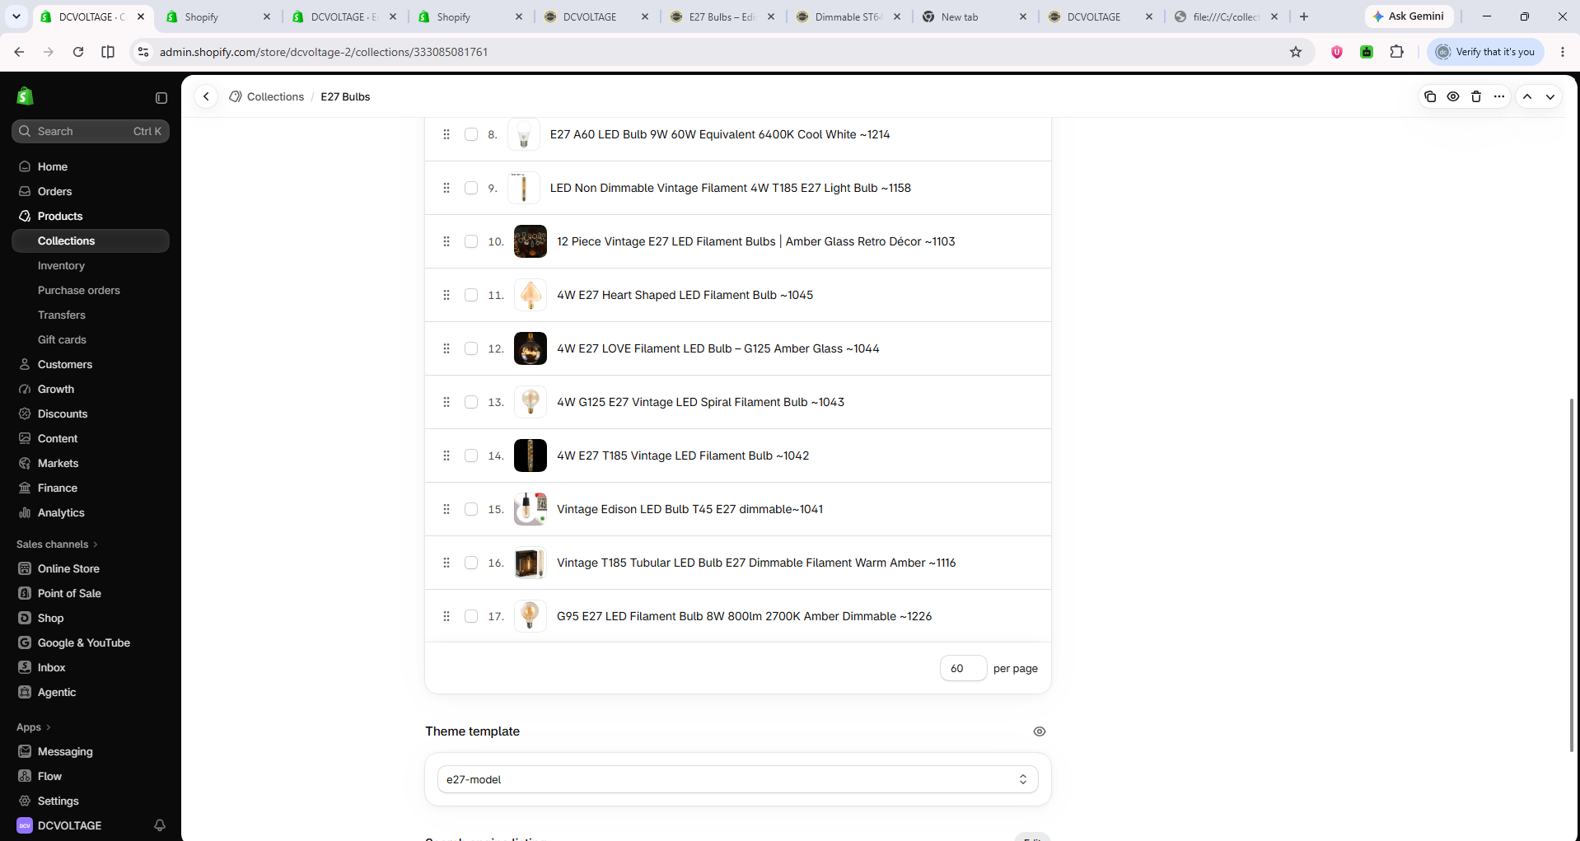

8. C1 — Connect the Collection
Menu: "E27 Screw Bulbs" nested correctly under "LED Bulb" before saving.
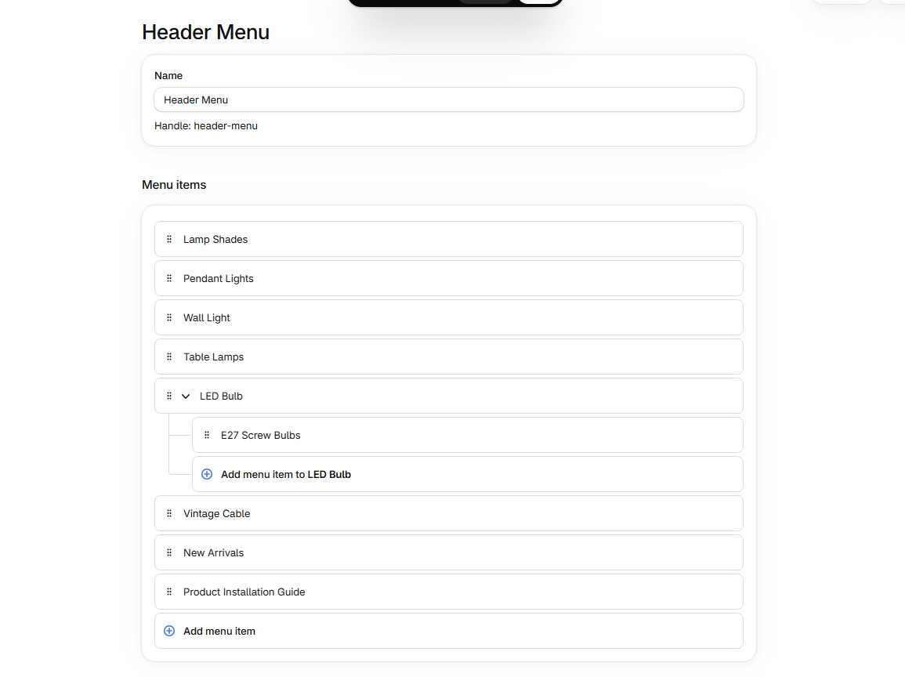
Confirmed live: main menu shows clean "LED BULB" with the nested dropdown, no stray top-level item.
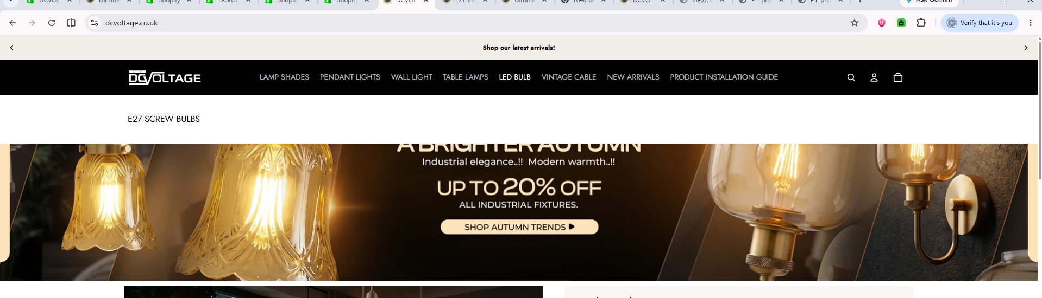
LED Bulb collection page: new "Shop E27 (Edison Screw) bulbs" link added and confirmed live.
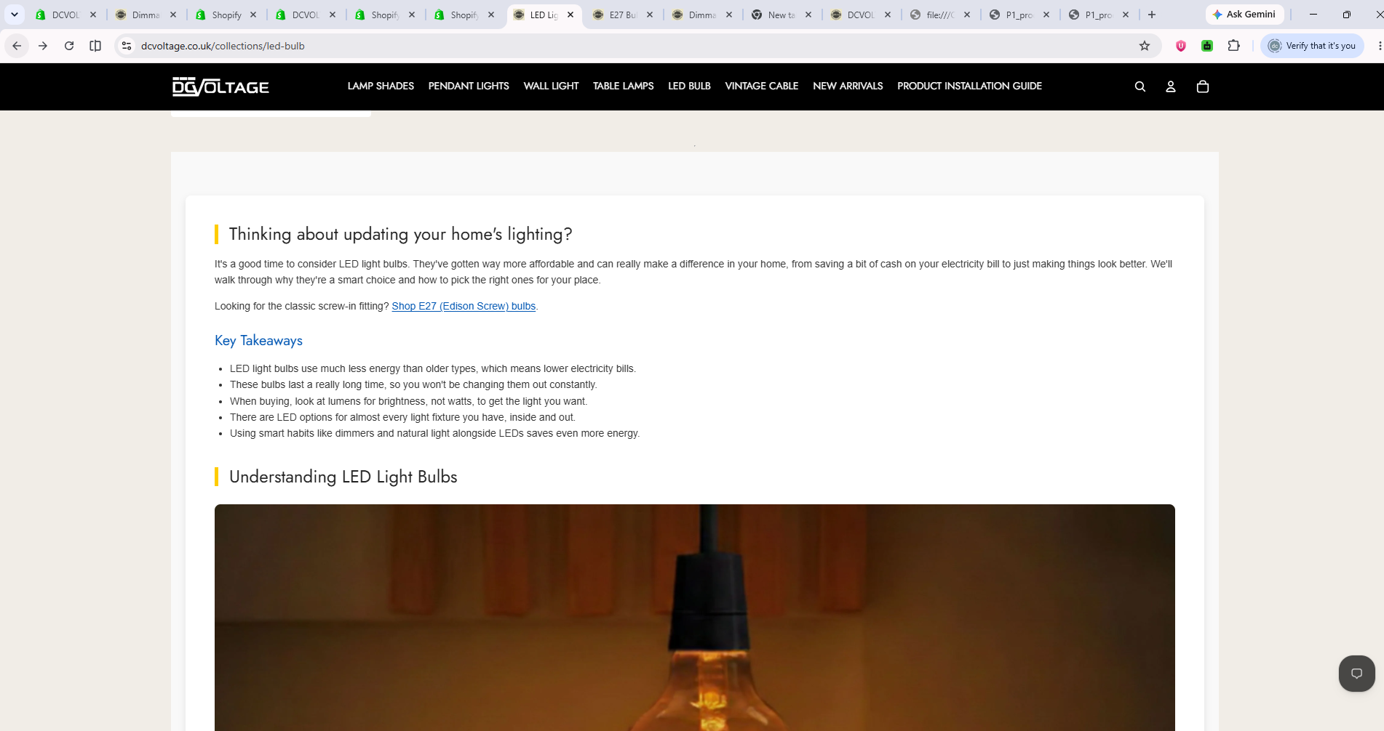

9. P1 — Product 1025 Description Rewritten
Old description (factual errors: wrong colour temperature, wrong shape, US spelling) replaced with the approved short intro. Thuwaraga approved.
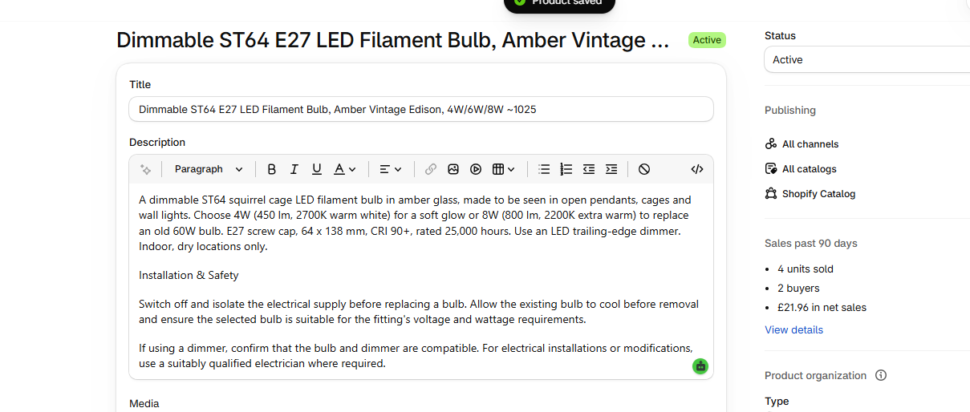

Outstanding
C3's collection-page fixes are built on the duplicate theme ("Tinker - E27 model DRAFT") and awaiting Muguntha's approval before publishing to the live theme.
Dates for the remaining tasks (C2, C5-C11, P3-P11, G4-G6) per the original schedule: Wednesday 7 October, Monday 12 October, with AI re-review of all three pages on Thursday 15 October.

