DC Voltage website fixes for Kuberan
29 Sep 2026

Briefing, implementation plan and full build pack
For: Kuberan (website team)
From: Muguntha (owner; approves every change)
Prepared with: LEDsone Organic Discovery (AI assistant)
Site: dcvoltage.co.uk only

Status: draft for implementation on a duplicate theme only. Nothing in this document has been changed on the live site. Nothing goes live without Muguntha's written OK.

Contents
Part A: Briefing 3
A1. What this is and who does what 3
A2. Working with the LLM in the loop 3
A3. How DC Voltage works: the organic growth loop 5
A4. The objective 6
A5. Why we're doing it: the evidence 6
A6. What happens if we don't implement 7
A7. What happens if we do: expected results 7
A8. How we implement: phased plan 7
A9. The rules 8
A10. How it will be monitored 8
A11. How AI is in the loop 9
A12. How a problem is reported 9
A13. One-page summary 10
A14. Glossary 10
Part B: Detailed instructions, copy, prices and code 11
1. Working rules and order (quick reference) 11
Rules 11
Order of work 11
2. DC Voltage audit findings 11
3. Model E27 collection and product page (DC Voltage) 15
3.1 Preview images (static mock-ups, not the live theme) 15
3.2 Install steps (for Kuberan) 24
3.3 Metafields 26
3.4 Collection page copy (E27 Bulbs) 28
3.5 Product page copy (ST64 best seller ~1025) 30
3.6 Keyword map 34
4. Proposed prices (for Muguntha's approval, not live) 36
4.1 Competitor evidence (UK, checked 29 Sep 2026) 37
4.2 NEEDS PRICE FROM MUGUNTHA (no Balance Price row, current price kept) 39
4.3 Flagged for Muguntha (not priced) 40
4.4 Separate flag: ledsone.co.uk 6W price 41
5. Open decisions for Muguntha 41
6. Related work on ledsone.co.uk 41
7. Checklist 41
Appendix A: sections/model-collection-e27.liquid 43
Appendix B: sections/model-product-specs.liquid 48
Appendix C: templates/collection.e27-model.json (reference) 54
Appendix D: templates/product.e27-model.json (reference) 59

Part A: Briefing
Kuberan, this briefing explains how DC Voltage grows, what you're building, why, in what order, how you'll know it has worked, and the rules. Read it before you open Part B, which has the step-by-step instructions, copy, prices and code. You shouldn't need anyone to explain anything verbally. If something here is unclear or doesn't match what you see in Shopify, write it down and send it to Muguntha; don't guess.

A1. What this is and who does what
DC Voltage (dcvoltage.co.uk) grows through an AI-driven organic growth loop: the AI assistant keeps finding where we're missing customers and drafts the fix; you validate and build it; Muguntha approves it; and the AI checks that it worked. This pack is the output of the first loop: an audit of what's holding the store back, a finished model for the E27 collection page and the ST64 ~1025 best-seller page (copy, code and preview), and proposed prices. You work on dcvoltage.co.uk only. There are three roles:
Who | Role | What that means in practice
Kuberan | Validates and implements | Works with the LLM in the loop (A2). His main job is to validate every LLM output against the evidence (SOT, approved prices, approved store facts, this pack) before using it. Then builds on a duplicate theme, sends screenshots, publishes only after Muguntha's OK, and fixes anything flagged.
Muguntha | Owner and approver | Owns DC Voltage and this project. Makes the business decisions (store facts, brand, prices), approves or rejects every finding, and approves every change before it goes live.
LEDsone Organic Discovery (the AI assistant, "the LLM") | Detects, drafts, verifies, measures | Runs the loop: finds shortfalls and missed opportunities, writes them up as findings with a proposed fix, drafts the copy, code and prices, checks your screenshots and previews, verifies pages after publishing and measures the result. It never publishes or changes anything on the store itself.

A2. Working with the LLM in the loop
You'll keep an LLM (the AI assistant) open while you work. It drafts, answers questions and re-checks your work, but it can be wrong: it can misread data, guess, or mix up products. Your main job is to validate what it gives you before you use any of it. Nothing the LLM writes goes on the site until you've checked it against the evidence and Muguntha has approved it.

What the LLM does during execution
- Drafts copy, theme code, metafield values, structured data and prices from SOT and Balance Price.
- Answers your questions about the task, the code or this pack.
- Re-checks your work: your screenshots, the preview link and the live page after publishing.

Your role: validator
You check every LLM output against the evidence before you use it: the SOT row, the approved price list (Part B section 4), the store facts Muguntha has approved, and this pack. If you can't find the evidence for something, it doesn't go on the page.

Working method for each task
1. Give the LLM the task plus its source data: the SOT row, the listing code (e.g. ~1025), the live URL and the relevant section of this pack. Never paste customer personal data.
2. Ask for the output with its sources: every fact, number and price must say where it came from.
3. Validate it with the checklist below. Correct anything that fails, or send it back to the LLM with the reason.
4. Implement it on the duplicate theme (never the live theme).
5. Send the screenshots and the preview link back to the LLM and ask it to verify them against the task.
6. Fix anything it or you find, then check again.
7. Send it to Muguntha for approval, with the screenshots, the preview link and your validation log entry.
8. After Muguntha's OK, publish, then ask the LLM to verify the live page. Record the result in the log.

Validation checklist
☐ Specs match SOT: fitting, watts, lumens, Kelvin, dimmable, size.
☐ Price follows the approved list and is never below the protected price.
☐ The listing code (~code) is kept in the title, the collection card and the Product JSON-LD name.
☐ No invented claims: warranty, CE/UKCA, energy class and similar only if confirmed.
☐ Store facts (delivery, returns, warranty, contact) match the one approved set.
☐ No text copied from ledsone.co.uk or from competitors.
☐ Structured data passes Google's Rich Results Test, and the currency is GBP.
☐ The page makes sense to a customer on mobile.
☐ Nothing is published without Muguntha's OK.

Red flags: stop and ask Muguntha
- The LLM gives numbers with no source.
- It contradicts SOT or this pack.
- It suggests publishing directly, or skipping the duplicate theme or approval.
- It fills gaps with guesses (e.g. a lumen value, warranty length or dimmer type that isn't in SOT).

Example prompts
Task | Prompt you can use
Metafields | "Here is the SOT row for ~1025 and the live URL. Fill the metafields from SOT only; mark anything missing as NEEDS CONFIRMATION and list your sources."
Copy check | "Here is my product description and the SOT row. List every claim in the text that isn't backed by the SOT row or the approved store facts."
Code review | "Here is the section file I installed and the preview link. Check it outputs one H1, GBP prices and valid Product JSON-LD with the ~code in the name. List any problems."
Price check | "Here is the approved price list (section 4) and a screenshot of the variant prices on the preview. Flag any price that differs from the list."
Live verify | "This page is now live: [URL]. Check it against the task's 'done when' and the validation checklist, and tell me what fails."

Validation log
Log every validation, one row per LLM output, in a shared sheet. Send the relevant rows to Muguntha with each approval request.
Date | Task | LLM output (what it gave) | Check result (pass/fail and why) | What was corrected | Screenshot
(example) | ~1025 metafields | Metafield values for the 3 variants | Fail: 6W lumens same as the 4W in SOT; needs supplier check | 6W lumens left blank (NEEDS SUPPLIER CONFIRMATION) | 1025-metafields.png

The first row is an illustration of how to fill it in, not a real result.

A3. How DC Voltage works: the organic growth loop
The AI assistant looks for shortfalls and missed opportunities by checking three things side by side:
What it checks | Where the data comes from | What it's looking for
1. What we have to sell | The product source of truth (SOT) and stock levels | Products that are in stock and could sell, but have no page, a weak page or wrong facts.
2. How competitors sell the same products | UK retailers' product and collection pages | Their prices, how their pages are built (collections by fitting, spec tables, FAQs), and how they get found.
3. What UK customers are searching for | Google Search Console, Google results and AI-assistant answers | Searches where customers want our products but land on someone else, or on a DC Voltage page that doesn't help them buy.

It then decides how to get DC Voltage products in front of those customers organically (no paid ads): a new or better page, clearer facts, correct structured data, or a price that fits the market. After that, every improvement goes round the same loop:
1. Detect: the AI assistant finds the gap (weekly scan plus event checks; see A12).
2. Draft: it writes up the finding and drafts the fix: copy, code, prices or data changes.
3. Approve: Muguntha approves or rejects the finding and its fix.
4. Validate and implement: Kuberan validates the draft (A2) and builds it on a duplicate theme, then sends screenshots.
5. Publish: after Muguntha's OK, Kuberan publishes.
6. Verify and measure: the AI assistant checks the live page and measures the result (A10).
7. Next loop: what it learned feeds the next finding.

The first loop in action: the E27 model pages
Loop step | What happened for E27
Stock (what we have) | DC Voltage stocks a range of E27 filament bulbs in SOT. The ST64 ~1025 is the best seller. 58 variants in the range were reviewed (section 4), including stock status.
Competitors (how they sell it) | On 29 Sep 2026 the AI assistant checked 42 like-for-like alternatives at UK retailers for the same bulbs, to see where our prices sit in the market (section 4.1).
Customer searches (what they want) | Our E27 vs B22 vs GU10 guide has 15,932 impressions at position 6.4, but it links to no E27 range. dcvoltage has no impressions for "e27 bulb". The ST64 page sits at position 55.5 for "st64 bulb".
Decision | Build an E27 collection that the guide links to, rebuild the best-seller page with correct facts, and price the range against the market without going below our protected price.
Draft | This pack: copy, theme code, metafields, previews (Part B section 3) and price proposals (section 4).
Implement → approve → verify | You build it (3.2), Muguntha approves, you publish, and the AI verifies and measures (A10).
Next loop | B22 and E14 pages built on the same pattern, plus the store-wide fixes in section 2.

What this pack asks you to build, in order
Phase | What | Where the detail is
1a | Build the model E27 bulb collection and the rebuilt ST64 ~1025 best-seller product page on a duplicate theme. | Part B, section 3
1b | Store-wide fixes from the audit (H1 on product pages, misleading "was" prices, structured data, data clean-up). | Part B, section 2

DC Voltage shares products and the product source of truth (SOT) with ledsone.co.uk, so keep DC Voltage copy unique: never copy text between the two stores.

A4. The objective
Get DC Voltage products in front of more UK customers who are already looking for them in Google and AI assistants (ChatGPT, Google AI Overviews, Perplexity, Microsoft Copilot), organically, and turn more of those visits into paid orders.
To get there, every page we touch must answer what the customer searched for, be easy to shop, and never confuse them about fitting (E27 screw vs B22 bayonet vs E14), wattage and brightness, price or delivery. When a page is clear and consistent for a customer, it's also clear for Google and AI assistants, and that's what gets us shown and quoted. Each loop should leave the store measurably better than the last.

A5. Why we're doing it: the evidence
All numbers below come from our own data (Google Search Console, orders and GA4 in our database) or from the audits in this pack. "L90" means the last 90 days (Search Console 23 Jun–20 Sep 2026).

dcvoltage.co.uk
What we found | Evidence
Google shows us a lot, but few people click | 80,366 impressions but only 543 clicks in L90, and 76 orders (£2,533.69) in the last 90 days.
Our best page leads nowhere | The E27 vs B22 vs GU10 guide has 15,932 impressions at average position 6.4 (63 clicks), but it links to no matching product or collection page.
Shop pages rank too low to be seen | Product and collection pages sit around positions 38–47. The only bulb collection ("LED bulb") had 1,428 impressions and 1 click, at position 39.5.
No fitting collection | There is no E27, B22 or E14 collection, so people searching by fitting land on a guide or a mixed page.
The best seller's description is wrong | The ST64 ~1025 page says "B22 & E27" but only sells E27, and makes claims (A+, 3-year warranty, CE/RoHS, 14.8 cm) that our SOT can't back up.
Store facts contradict each other | Free delivery over £25 on one page and £30 on another; different dispatch times and return rules; two addresses and two phone numbers; Warranty, FAQ and Delivery pages return 404.
No review or collection markup | Collections carry only a minimal Organization block (no collection, list or breadcrumb data), and there's no rating markup; the review widget shows 0.00.

AI assistants already send real orders in our business: on ledsone.co.uk, which shares our product data, GA4 shows ChatGPT brought 2,402 sessions, 195 purchases and about £4,933 in revenue in 90 days (24 Jun–21 Sep 2026). dcvoltage GA4 isn't connected yet, so the same figure for DC Voltage is UNKNOWN.

How Google and AI assistants choose which shop to show or quote
In plain terms, they favour pages that:
- Answer the question clearly: what it is, will it fit, how bright, will it dim, what it costs, when it arrives. A short direct answer near the top helps.
- State facts consistently: the same price, delivery promise and spec everywhere on the site. Contradictions make them trust us less, or quote the wrong one.
- Carry structured data (JSON-LD): machine-readable labels for product, price, availability, reviews, breadcrumbs and FAQs.
- Are crawlable: plain links between pages (guide → collection → product), no blocked pagination, one clear H1 per page.
- Show trust signals: a real company name and number, one address, genuine reviews, clear returns and warranty.

A6. What happens if we don't implement
- The traffic keeps going to the guide and leaks away. The E27 vs B22 guide keeps earning impressions, but with no link to an E27 range, readers who want to buy go elsewhere.
- Shop pages stay invisible. At positions around 38–47, product and collection pages get almost no clicks, and dcvoltage stays at its current order level.
- AI answers keep quoting wrong or conflicting facts about dcvoltage: the wrong delivery threshold, returns rule or price. AI assistants already drive real orders in our business (A5), so this is a real cost.
- Customers buy the wrong fitting and return it. A description that says "B22 & E27" on an E27-only bulb invites exactly that. Our business has already had a refund with the reason "incorrect bulb (B22) received".
- AI shopping answers keep seeing conflicting prices for the same item: 682 of 854 variants that share a SKU with ledsone.co.uk are priced differently on the two stores.
- Misleading "was" prices stay live (41 variants on dcvoltage show a compare-at price below the selling price or at £0.00), which is a UK consumer-law risk.

A7. What happens if we do: expected results
The targets below are directional. Every number is an estimate, to be confirmed by monitoring. No one can guarantee rankings; what we can do is remove the problems that are holding the pages back and measure honestly.
Area | Baseline (from our data) | Directional target (estimate, to be confirmed by monitoring) | Checked at
E27 collection and ST64 page indexed | E27 collection doesn't exist yet | Both URLs indexed within 2 weeks of publishing (URL Inspection shows "URL is on Google") | Day 1, 7, 14
Structured data valid | No collection/FAQ/breadcrumb markup | Rich Results Test passes for both pages on day 1 | Day 1
Guide → E27 collection | Guide: 15,932 impressions, 63 clicks, CTR about 0.4%, no link to a range | Clicks from the guide to the E27 pages appear in GA4 within the first month (needs GA4 connected); guide CTR moving towards 1% | Day 28, then weekly
Target queries (from the keyword map) | ST64 page: "st64 bulb" position 55.5, "st64 edison bulb" 40.2; "e27 amber light bulb" 44.6; dcvoltage has no impressions for "e27 bulb" | ST64 queries moving into the top 20, and the E27 collection gaining impressions for "e27 bulb" family queries, within about 90 days | Day 28, then weekly
Orders from organic and AI referrals | 76 orders (£2,533.69) in 90 days, store-wide | Measurable growth over that baseline in the first full 90 days after launch | Day 90 (first fair read)
Wrong-fitting returns | Wrong-fitting return count for dcvoltage: UNKNOWN (return reasons are free text) | No wrong-fitting returns on the E27 range after launch | Monthly

A8. How we implement: phased plan
Effort figures are rough estimates for one developer. Every phase follows the same loop: LLM draft → Kuberan validates (A2) → build on duplicate theme → LLM checks the preview → screenshots to Muguntha → Muguntha's OK → publish → LLM verifies live.

Decisions Muguntha must make (these unlock some steps)
Decision | What it unlocks | Can Kuberan start before it's made?
Store facts: free-delivery threshold, dispatch/delivery days, returns, warranty, one address and phone | Delivery line on the product page, shipping/returns schema, policy pages, Merchant Center | Yes: leave those fields blank; build everything else
Brand name in markup (per store) and legal name | Brand in Product schema, Organization schema, footer | Yes: leave "Brand name in schema" blank
Supplier specs (e.g. ST64 6W lumens, equivalents, energy class, warranty, CE/UKCA) | Showing those fields on pages | Yes: unconfirmed fields stay hidden
Pricing: the proposals and flags in Part B section 4 | Any price or compare-at change | Yes: build with current prices; change prices only when Muguntha approves
GA4 access for dcvoltage | Measuring organic and AI-referral orders on dcvoltage | Kuberan connects it once Muguntha grants access

The plan
Step | Task | Owner | Rough effort
1 | Duplicate the dcvoltage live theme (Tinker) | Kuberan | 10 min
2 | Install the two model sections, build the two templates, fix the product H1, create metafield definitions and fill the best seller's values (Part B, 3.2 steps 1–8) | Kuberan | 1–2 days
3 | Preview on phone and desktop; send 4 screenshots and 2 preview links to Muguntha | Kuberan | 1 hour
4 | Check the screenshots and preview against the model; validate structured data; report to Muguntha | AI assistant | Same day
5 | Approve, or ask for changes | Muguntha | –
6 | Create the E27 Bulbs collection, add filters, assign templates, publish (Part B, 3.2 steps 12–14) | Kuberan (after Muguntha's OK) | Half a day
7 | Rich Results Test, URL Inspection and request indexing; day-1 live check | Kuberan + AI assistant | 1 hour
8 | dcvoltage store-wide fixes (Part B section 2), in priority order, each via the same loop | Kuberan; Muguntha approves | 3–5 days spread over weeks
9 | Connect GA4 to dcvoltage | Kuberan (Muguntha grants access) | 1–2 hours

A9. The rules
1. Never publish without Muguntha's written OK. That includes publishing a theme, assigning a template, creating a collection, adding store-wide filters and editing policies.
2. Never change prices or compare-at prices without Muguntha's approval. The proposals in Part B section 4 are for Muguntha to decide on.
3. Listing codes stay in titles (e.g. "… 4W/6W/8W ~1025"). Customers quote them, so don't remove them from titles, collection cards or the Product JSON-LD name.
4. Prices are never below the protected price. Every proposal in this pack respects it. If you ever see a price that looks too low, report it; don't fix it yourself.
5. No guessing specs. Use the SOT values given in this pack. Anything marked NEEDS SUPPLIER CONFIRMATION stays hidden until the supplier confirms it.
6. Keep copy unique between the two stores. Don't copy dcvoltage text to ledsone or the other way round.
7. Work on a duplicate theme only, and send screenshots of every change to Muguntha.
8. Validate every LLM output before you use it (checklist in A2). If it has no source, contradicts SOT or guesses, stop and ask Muguntha.
9. No customer personal data in pages, screenshots or messages.
10. If a published change breaks a live page, switch back to the previous template or theme straight away and tell Muguntha.

A10. How it will be monitored
What is measured | Tool | Why
Impressions, clicks and average position for the target queries and pages (keyword map, Part B 3.6) | Google Search Console | Shows whether Google shows and chooses our pages
Whether the new URLs are indexed, and how Google sees them | Search Console URL Inspection | No index, no traffic
Structured data validity | Google Rich Results Test | Needed for FAQ, breadcrumb, product and review features
Organic and AI-referral sessions and purchases (ChatGPT, Perplexity, Copilot, Gemini) | GA4 | Shows whether visits turn into orders. dcvoltage GA4 isn't connected yet, so connecting it is a task (plan step 9).
Returns and refunds for wrong fitting | Shopify returns data | Shows whether clearer pages stop wrong orders
What AI answers say about our products and prices | Spot checks of AI answers | Catches wrong prices or facts being quoted

When: a day-1 check straight after publishing, then day 7, day 28, and weekly after that.
Who: the AI assistant runs the checks and reports to Muguntha. Kuberan fixes anything that's flagged, following the usual loop (duplicate theme, screenshots, Muguntha's OK).

A11. How AI is in the loop
The AI assistant runs the growth loop described in A3. At each stage:
Stage | What the AI assistant does
Detect | Compares what we have in stock (SOT and stock levels) with how UK competitors sell the same products (prices, page structure, how they're found) and with what UK customers search for in Google and AI assistants. Finds shortfalls (wrong facts, broken markup, pages that rank but don't sell) and missed opportunities (in-stock products with no page for a search customers make).
Decide and draft | Chooses the organic fix most likely to win those customers, then drafts it: copy from SOT, theme code, metafields, structured data and price proposals from Balance Price and a UK market check. Ranks findings by expected return.
During the build | Reviews Kuberan's screenshots against the draft, checks the duplicate-theme preview (one H1, links, mobile layout) and validates the structured data.
Verify and measure | Verifies the live pages, runs the day-1, day-7, day-28 and weekly checks (A10), and measures clicks, orders and returns against the baseline.
Next loop | Uses what it measured to pick the next finding. For example, after E27 comes B22 and E14 on the same pattern.

Humans approve everything and the AI never publishes. It has no permission to change the store; it only reads, drafts, checks, measures and reports.

A12. How a problem is reported
Every problem or opportunity follows the same path, from detection to close:
1. Detect. The AI assistant finds the issue in its weekly scan, or in an event check triggered by something changing: a product coming into or going out of stock, a new product in SOT, a competitor price or page change, a page dropping out of Google's index, a structured-data error, or a wrong-fitting return.
2. Write it up as a finding. Each finding states: what is wrong or missing; the evidence (data, screenshot or URL snippet); which product or page; the missed orders or opportunity (e.g. impressions without clicks, in-stock products with no page), or UNKNOWN if it can't be measured yet; the proposed fix; and a priority based on expected return.
3. Send it to Muguntha. Muguntha approves or rejects it. Rejected findings are closed with the reason noted.
4. Task to Kuberan. An approved finding goes to Kuberan as a task with a clear "done when" (for example: "Rich Results Test passes and the guide links to /collections/e27-bulbs").
5. Validate, build and screenshots. Kuberan validates the LLM's draft against the checklist (A2), builds it on a duplicate theme and sends screenshots and the preview link. After Muguntha's OK, Kuberan publishes.
6. Verify and close. The AI assistant checks the live page. If "done when" is met, the finding is closed and its result is tracked in monitoring. If not, it's re-raised to Muguntha with what's still wrong.
Part B section 2 lists the findings from this first loop in exactly this format.

A13. One-page summary
Task | Site | Owner | Depends on | Done when
Duplicate theme | dcvoltage | Kuberan | – | Copy theme exists, named "Tinker - E27 model DRAFT"
Model sections + templates + H1 | dcvoltage | Kuberan | Duplicate theme | Preview links work; one H1 per page
Metafields for the best seller | dcvoltage | Kuberan | Definitions created | Values filled; unconfirmed fields empty
Screenshots to Muguntha | dcvoltage | Kuberan | Templates built | 4 screenshots + 2 links sent
Preview check | dcvoltage | AI assistant | Screenshots | Report sent to Muguntha
Store facts, brand, specs, prices | dcvoltage | Muguntha | – | Decisions written down
Publish E27 collection + ST64 page | dcvoltage | Kuberan | Muguntha's OK | Live, templates assigned, date recorded
Rich Results + indexing request | dcvoltage | Kuberan + AI | Published | Test passed; indexing requested
Store-wide fixes (section 2) | dcvoltage | Kuberan | Muguntha's OK per item | Each item live and verified
Connect GA4 | dcvoltage | Kuberan | Muguntha grants access | Data flowing in GA4
Monitoring (day 1, 7, 28, weekly) | dcvoltage | AI assistant | Pages live | Reports sent to Muguntha

A14. Glossary
Term | Plain meaning
SOT (source of truth) | Our master product-spec data (fitting, watts, lumens, colour, size and so on). Page copy must match it.
LLM | Large language model: the AI assistant you work with while building (e.g. for drafting copy, code or metafield values). Its output must be validated before use (A2).
JSON-LD / structured data | A hidden block of machine-readable code on a page that tells Google and AI assistants what the page is: a product with this price, a list of FAQs, a breadcrumb trail.
Metafield | An extra custom field on a Shopify product or variant (e.g. lumens, colour temperature) that templates can display and filters can use.
Canonical | A tag saying which URL is the main version of a page, so Google doesn't treat copies as duplicates.
Duplicate theme | A copy of the live Shopify theme that customers don't see. All work is built and previewed there first.
Balance Price / Thrive | Our internal pricing guide. It sets a minimum each sale must earn after all costs, in levels from a protective lowest level up to "Thrive", the level we aim for. It is not a price cap. The protected price is the level we never go below.
Listing code | The short code at the end of a product title (e.g. ~1025). Customers quote it when they contact us, so it stays in titles.
AI Overviews | The AI-written summary Google shows above the normal results for some searches. It quotes and links to the pages it trusts.
H1 | The main heading of a page. Each page should have exactly one.
Rich Results Test | Google's free tool that checks whether a page's structured data is valid.
URL Inspection | The Search Console tool that shows whether Google has indexed a URL and lets you request indexing.

Part B: Detailed instructions, copy, prices and code
The sections below are referenced from the briefing as "Part B, section N". Follow the rules in A9 throughout.

1. Working rules and order (quick reference)
This is the short version of the briefing (A8 and A9) to keep next to you while you work.

Rules
1. Work on a duplicate theme only. Online Store > Themes > live theme > ⋯ > Duplicate. Never edit the live theme directly.
2. Send screenshots to Muguntha (desktop and mobile) and the preview link for every change before anything is published.
3. Wait for Muguntha's written OK before publishing. That includes publishing a theme, assigning a template, creating a collection, adding store-wide filters, or editing policies.
4. Keep the ~listing codes in product titles (e.g. "… 4W/6W/8W ~1025"). Don't strip them from titles, collection cards or the Product JSON-LD name.
5. Never change prices or compare-at prices without Muguntha's approval. The prices in section 4 are proposals for Muguntha to decide on. They are not instructions.
6. No customer personal data goes into pages, screenshots or tickets.
7. If Shopify shows an error you don't expect, stop and send the error text to Muguntha. Don't improvise a workaround on the live store.

Order of work
1. Phase 1a, dcvoltage: build the model E27 collection and ST64 ~1025 product page on the duplicate theme, including the product H1 fix (section 3).
2. Screenshots to Muguntha, then publish only what Muguntha approves, then verify.
3. Phase 1b, dcvoltage: store-wide fixes from section 2, in priority order, and connect GA4.

2. DC Voltage audit findings
Source: /workspace/dcvoltage/audit-2026-09-29/findings.csv (read-only audit, 29 Sep 2026). Priority: P1 = do first, P2 = next, P3 = when convenient. Effort: S = under half a day, M = 1–3 days, L = more. The ~listing codes stay in product titles (customers quote them), so there is no title-code task here.
ID | Pri | Area | Issue | Evidence (URL and snippet) | Fix | Effort
D01 | P1 | Catalogue / collections | There is no E27 bulb collection. The only bulb collection (/collections/led-bulb) mixes E27, B22 and E14, holds 16 of 27 bulb listings and ranks around position 40. | https://dcvoltage.co.uk/collections.json: 27 collections, none for E27/B22/filament. /collections/led-bulb/products.json: 16 products. 11 bulb listings are not in it, e.g. G95 E27 dimmable ~1140, G125 E27 8W ~1024, T185 E27 non-dimmable ~1158, T75 B22 ~1228. GSC L90 (23 Jun-20 Sep 2026): led-bulb 1,428 impressions, 1 click, average position 39.5. | Create an E27 bulbs collection (the model page in ../model-e27-2026-09-29). Put every bulb listing into led-bulb, or make led-bulb a parent that links to E27, B22 and E14 pages. | S
D02 | P1 | Structured data / on-page | Product pages have no H1. The product title is an H3, which appears twice. | https://dcvoltage.co.uk/products/vintage-style-led-edison-bulb-lamp raw HTML: no <h1>. The headings are h3 'ST64 E27 LED Filament Bulb – Vintage Edison Style ~1025' (x2). The E14 C35 page and dimmable-vintage-industrial page show the same pattern. | In the Tinker theme editor (product template > Title text block), set the heading level back to H1. It's one setting on the duplicate theme. | S
D04 | P1 | Content accuracy | The best-selling bulb's description says 'B22 & E27' and 'Select the correct B22 or E27 version', but the listing only sells E27. It also claims 'Energy Rating A+', '3-year warranty', 'CE/RoHS' and '14.8cm height'. | https://dcvoltage.co.uk/products/vintage-style-led-edison-bulb-lamp description (also in JSON-LD). All 3 variants are E27 SKUs (LDMST64E274/6/8). SOT (MAIN-PG components_sot) gives length 138 mm, energy_class [VERIFY], warranty_months [VERIFY], ce/ukca [VERIFY]. | Replace it with the SOT-based copy in ../model-e27-2026-09-29/product_copy.md. Remove the claims SOT can't back up until the supplier confirms them. | S
D05 | P1 | Trust / policies | Delivery, returns and contact facts contradict each other across pages. | https://dcvoltage.co.uk/pages/terms-and-conditions: 'free delivery for orders above £25', '3–5 working days'. https://dcvoltage.co.uk/collections/free-shipping title: 'Free Shipping — Orders Over £30'. https://dcvoltage.co.uk/pages/shipping-policy: dispatch '2-4 working days' + '2–5 working days'. Returns: '30 days from the date of purchase' vs 'more than 30 days after delivery' (refund policy). Address: Unit 3 Marshbrook Cl, CV2 2NW (pages) vs 107 St Martins Road, CV3 6ES (Shopify shipping/refund policies). Two phone numbers. | Muguntha sets one set of facts: free-delivery threshold, dispatch and delivery days, returns window and start point, warranty, one address and one phone number. Then edit the Shopify policies and the pages, and configure Merchant Center shipping and returns. | S
D06 | P1 | Company identity | The business name appears in several forms, and none of them matches the registered company exactly. | Companies House 14399736: 'DCVOLTAGE LTD' (Unit 3 Marshbrook Close, Coventry CV2 2NW, SIC 47599). The site says 'DC VOLTAGE UK Ltd'; site_name/Organization schema say 'DCVOLTAGE'; product schema brand says 'DC Voltage'; the vendor field has 4 spellings (Dcvoltage 105, DC Voltage 78, dcvoltage 25, dcvoltage-2 3). The home meta description says 'high-quality DC power solutions'. No company number is shown. The About page also lists a gmail address. | Muguntha picks the display brand. Show 'DCVOLTAGE LTD, company no. 14399736' in the footer and on the contact page. Normalise the vendor to one value (bulk edit). Expand the Organization schema (legalName, address, telephone, sameAs). | S
D07 | P1 | Overlap / duplicate catalogue | 184 of 211 dcvoltage products (87%) share SKUs with ledsone.co.uk listings. The best seller's SKUs appear on 7 ledsone listings. Same-SKU prices differ between the stores on 682 of 854 shared variants. | appendix_overlap_with_ledsone.csv. Matched by SKU against the ledsone catalogue (5,048 products, fetched 29 Sep 2026 04:39). Example: LDMST64E276 is £8.69 on dcvoltage and £2.99 on ledsone; LDMST64E274 is £5.49 vs £3.79. | Keep DC Voltage copy unique (never copied from ledsone.co.uk). Prices on shared SKUs are Muguntha's decision (section 4). No action for Kuberan beyond that. | L
D08 | P2 | Duplicate content | Most descriptions are rewritten rather than copied: 152 of 184 matched products share under 20% of 8-word phrases with the ledsone listing. But 10 are near-copies (80% or more) and 9 more share 50-80%. | appendix_overlap_with_ledsone.csv (column desc_8gram_share). Near-copies include vintage-hammered-pendant-light-26cm-e27 (1.00), vintage-crystal-cage-table-lamp-e27-bedside-desk-lamp-1175 (1.00), round-rocker-switch… (1.00), vintage-industrial-chandelier-light-fixtures-1040 (1.00). | Rewrite the 19 high-overlap descriptions from SOT facts, in dcvoltage's own voice. | M
D09 | P1 | AI findability / content | dcvoltage's strongest organic asset is its E27 vs B22 vs GU10 guide: 15,932 impressions and 63 clicks L90, average position 6.4, and it ranks for about 60 'e27 vs b22' variants. But it earns almost no clicks and doesn't link buyers to an E27 bulb range. | GSC L90 https://dcvoltage.co.uk/blogs/news/e27-vs-b22-vs-gu10-which-bulb-fitting-do-you-actually-need. 'e27 vs b22' 1,290 impressions, pos 8.7, 1 click; 'b22 vs e27' 1,081, pos 7.7, 0 clicks. WebSearch (29 Sep): the guide is cited in the synthesis for 'e27 vs b22 difference uk'. The page has 2 H1s, and its meta description starts 'Bulbs › Lighting Guides ›'. | Add a short direct answer at the top (40-60 words), fix the 2nd H1 and the meta description, add FAQPage schema, and link to the new E27 and B22 collections. Linking the guide to the collection is the main return on this work. | S
D10 | P2 | Structured data | Collection pages output only a minimal Organization block. There is no CollectionPage, ItemList or BreadcrumbList, and no FAQ markup anywhere. | https://dcvoltage.co.uk/collections/led-bulb and /collections/ceiling-pendant-lights: the only JSON-LD is Organization (name, logo, url). | Use the model collection section (JSON-LD with real shop currency via Liquid). Roll it out to the other category collections after testing. | M
D11 | P2 | Structured data / reviews | Judge.me is installed, but the best seller shows a rating of 0.00 and there is no AggregateRating in the Product schema. There are no shipping or returns properties in the offers. | https://dcvoltage.co.uk/products/vintage-style-led-edison-bulb-lamp: Judge.me CSS/JS present, data-average-rating='0.00'. Product JSON-LD (ProductGroup) has brand, sku, GBP, InStock, but no aggregateRating, hasMerchantReturnPolicy or shippingDetails. | Import or request reviews in Judge.me. The model product section adds aggregateRating only when a review metafield exists. Set up shipping and returns in Merchant Center rather than hard-coding them. | M
D12 | P2 | Pricing display | 41 variants on 14 products have a compare-at ('was') price below the selling price or at £0.00. Pack variants reuse the single-bulb compare-at price. | https://dcvoltage.co.uk/products.json. E.g. LDMST64E278 £9.89 'was' £9.59; T75 B22 ~1228 £7.20 'was' £2.63; heart bulb ~1045 5-pack £28.39 'was' £10.89; connector strip 'was' £0.00. | Bulk-clear every compare-at price that is at or below the selling price. Don't change selling prices. | S
D13 | P2 | Variant/option naming | Options have 36 different names for about 8 concepts: color/Colour/Color; Pack/PACK/pack/Pack Size/Number of Pack; 10 spellings of 'Request/Required a Bulb?'. 40 products use a 'Title' option. The best seller's option is called 'Type' with values like 'ST64 4W E27', listed in the order 4W, 8W, 6W. | https://dcvoltage.co.uk/products.json options field. | Standardise on Colour, Pack size, Wattage, Include bulb?, Size, Finish. The best seller becomes 'Wattage: 4W / 6W / 8W' in that order. | M
D14 | P2 | Product types and tags | 37 product types with near-duplicates (Pendant lighting / Pendant Light / Pendent Light; LED Light Bulb / LIGHT_BULB / LED Bulb / Bulb / E27_Base_Bulb; Lamp shade / LAMPSHADE / Lamp shades / Lampshade). 401 tags, 262 of them used once, plus 13 case/spelling duplicates and marketplace residue ('Amazon 2025', 'LMS'). | https://dcvoltage.co.uk/products.json product_type and tags. | Map to about 12 product types, e.g. LED Bulb, Pendant Light, Wall Light, Lamp Shade, Lamp Holder, Cable, LED Driver. Prune the single-use tags. Use tag rules for collections. | M
D15 | P2 | Collections | Near-duplicate and catch-all collections: ceiling-pendant-lights vs living-dining-room (98% the same products); industrial-flush-ceiling-lights = semi-flush-mount-lights (100%); power-converters = transformers (100%). 'New Arrivals' contains every product (211 of 211, and 230 by count including hidden ones). 11 promo/season collections (Summer Sale, Bank Holiday, Mid-Summer…) are indexable. 46 products sit only in non-category collections (new/sale/home). | https://dcvoltage.co.uk/collections/<handle>/products.json, Jaccard overlap. collections.json products_count. Promo collections are listed in sitemap_collections_1.xml (27 URLs). | Merge the duplicates, choosing one handle and 301-redirecting the other. Make New Arrivals the last 60 days only. Noindex or retire the seasonal collections. Give every product one category collection. | M
D16 | P2 | Technical / page weight | The HTML is heavy: collection pages are 0.9-1.2 MB of raw HTML and product pages about 450 KB, of which about 200 KB is inside <head>. The home page is 420 KB. | curl 29 Sep 2026 (box, US egress): https://dcvoltage.co.uk/collections/led-bulb 917,731 bytes; /collections/ceiling-pendant-lights 1,220,286; /collections/all 1,220,613; product 457,692. TTFB 0.04-0.86 s. | Audit the apps injecting CSS/JS into the head (Judge.me, others). Cap products per page at 24. Check CWV in GSC. | M
D17 | P3 | Robots / sitemap / crawl | This is fine and worth keeping. robots.txt is Shopify's current default (with agent and UCP notes), with no block on ?page= and no AI bots blocked. The sitemap covers 211/211 products, 27 collections, 10 pages and 24 blog URLs. Collections link plain ?page=2/3/4 URLs. Canonicals are self-referencing. GBP is served (Shopify.currency GBP, country GB) even to the box's US IP. | https://dcvoltage.co.uk/robots.txt, https://dcvoltage.co.uk/sitemap.xml, https://dcvoltage.co.uk/collections/ceiling-pendant-lights (links ?page=2..4), Shopify.currency {active: GBP}. | No action needed. Keep the promo collections out of the sitemap by retiring them (D15). | S
D18 | P3 | llms.txt / agents | /llms.txt and /agents.md are the generic Shopify agent text (UCP endpoints plus a Shop-app promotion). There is nothing about what the store sells or its policies. | https://dcvoltage.co.uk/llms.txt (4.5 KB), https://dcvoltage.co.uk/agents.md. | Lower priority. When the trust facts are fixed (D05), consider a short store summary if Shopify allows editing. | S
D19 | P2 | Trust pages | The Warranty, FAQ and Delivery pages don't exist (404), yet products promise a '3-year warranty'. The About page lists 'available on Amazon UK' and a gmail address alongside the business email. | https://dcvoltage.co.uk/pages/warranty 404, /pages/faq 404, /pages/delivery 404. Product description: '3-year warranty'. SOT warranty_months = [VERIFY]. | Muguntha confirms the warranty (SOT has it as [VERIFY]). Add one Warranty & Returns page and link it from the footer and product pages. | S
D20 | P2 | SOT data quality (affects both stores) | SOT contradictions found while building the model page: ST64 6W (LDMST64E276) has 450 lm, the same as the 4W; G95 8W 800 lm is labelled '40 Watts' equivalent while G125 8W 800 lm is '60 Watts'; LDSG95E274 lifespan is 3,000 h vs 25,000 h for the siblings; wattage_equiv_w is [VERIFY] for all ST64 SKUs. | MAIN-PG public.components_sot_* (source_tab bulb), read 29 Sep 2026. | The product/SOT owner confirms these with the supplier and updates SOT. The model page marks them NEEDS SUPPLIER CONFIRMATION. | S
D21 | P2 | Images | All 3,660 product images have empty alt text in products.json. Some product galleries reuse Amazon image filenames (e.g. 61C-8Wn0s0L._AC_SL1254.jpg). The best seller's 6W variant shows a generic image. | https://dcvoltage.co.uk/products.json images[].alt = null for 3,660/3,660. The best-seller gallery includes 71Fh88VkfUL.jpg and 81h0U9y62XL.jpg. | Add alt text such as 'ST64 E27 amber filament bulb, 4W, lit' to the top 30 products. Confirm that the images are owned. | M
D22 | P2 | Out of stock | 242 of 1,217 variants (19.9%) are out of stock, and 31 of 211 products are fully out of stock but still live, including G95 E27 8W ~1226 and T185 E27 dimmable ~1116 in the bulb range. | https://dcvoltage.co.uk/products.json variants[].available. | If a product is out of stock for more than 30 days: hide it from collections, keep the URL live with an 'alternatives' block, or redirect it to the closest match. | S
D23 | P3 | Handles vs titles | Handles contradict titles: '6-pack-bayonet-light-bulb-…-e27-led' is a single E27 bulb (not bayonet, and packs are options); 'pack-6-led-e27-a60…12w' starts at 1 bulb; 'vintage-style-led-bulb-e27-1' is a heart bulb. | https://dcvoltage.co.uk/products/6-pack-bayonet-light-bulb-60w-equivalent-cool-white-6400k-9w-806lm-e27-led | When a listing is next edited, change the handle and let Shopify create the 301 redirect. Don't do this on pages that have GSC clicks without checking first. | S
D24 | P3 | Measurement | dcvoltage has no GA4/AI-referral data in MAIN-PG. The only GA4 property there is ledsone's. Orders for dcvoltage exist (ss_name 'dcvoltage-2': 133 completed orders from 13 Jan to 21 Sep 2026; 76 in L90, total order value £2,533.69). | MAIN-PG google_search_console.ga4_ai_referral_revenue has only property 408110563. public.order_transaction ss_name='dcvoltage-2'. | Connect dcvoltage's GA4 property to the same export. Track organic sessions and orders monthly for the E27 collection and the best seller. | S
D25 | P2 | Titles / fitting | Some bulb titles don't state the fitting, and variant names are opaque. 'Dimmable Vintage Industrial LED Lighting Bulbs ~1097' is B22-only (every SKU is LDM…B22…) but the title doesn't say B22, and it sits in the bulb collection next to E27 bulbs. '~1102' sells 8 different bulbs as 'Style 3…Style 11', and 'Style 11' is a non-spiral G95 8W dimmable bulb (out of stock). | https://dcvoltage.co.uk/products/dimmable-vintage-industrial-led-lighting-bulbs (GSC L90: 1,151 impressions, 0 clicks, position 46.8, for 'vintage light bulbs'). https://dcvoltage.co.uk/products/vintage-style-led-bulb-e27-2 option 'color': Style 3-11. | Put the fitting in the title ('… B22 Bayonet'). Rename the Style options to shape + wattage (e.g. 'G125 music-note 4W'), using SOT names. | S
D26 | P2 | Pack/quantity check | The '12 Piece' E27 filament set ~1103 offers 'Pack 1 (12 Pieces)' at £31.91 and 'Pack 2 (24 Pieces)' at £32.71. Double the quantity for 2.5% more suggests that either the pack contents or the option label are wrong. The option is also named 'color'. | https://dcvoltage.co.uk/products/vintage-e27-led-spiral-filament-bulbs-amber-glass-retro-decor, SKUs ENC9246 / ENC8556. | The listing owner checks what ENC9246 and ENC8556 contain and fixes the label. This audit doesn't propose a price change. | S
D27 | P2 | Content accuracy / claims | '100W equivalent' is claimed for a 12W A60 bulb that SOT rates at 1,160 lm. The usual UK/EU reference for a 100W GLS is about 1,521 lm, and 1,160 lm is nearer a 75W bulb (about 1,055 lm). The 9W A60 (820 lm per SOT) at '60W equivalent' is consistent. | https://dcvoltage.co.uk/products/pack-6-led-e27-a60-light-bulb-12w-100w-equivalent-non-dimmable title '12W 100W Equivalent'. SOT LDCWA60HE2712 lumens_lm 1160 lm, wattage_equiv_w [VERIFY]. | Change it to '1,160 lm (brighter than a 60W bulb)' until the supplier confirms the equivalence. Update SOT wattage_equiv_w. | S

Items in that table that are store data rather than theme work (compare-at prices, tags, product types, vendor names, descriptions, alt text) still need Muguntha's OK before anyone bulk-edits them. Prices are never changed without Muguntha.

3. Model E27 collection and product page (DC Voltage)
Goal: one new E27 bulb collection page (/collections/e27-bulbs) and a rebuilt best-seller product page (/products/vintage-style-led-edison-bulb-lamp). These serve as the pattern for the B22 and E14 pages later. The package is in /workspace/dcvoltage/model-e27-2026-09-29.

3.1 Preview images (static mock-ups, not the live theme)
The previews are built from real product names, images and copy. Prices marked "proposed" are draft shelf prices for Muguntha's approval, not live. Every other price shown is the current live price. The layout is illustrative; the real page uses the Tinker theme.
Collection page, desktop:
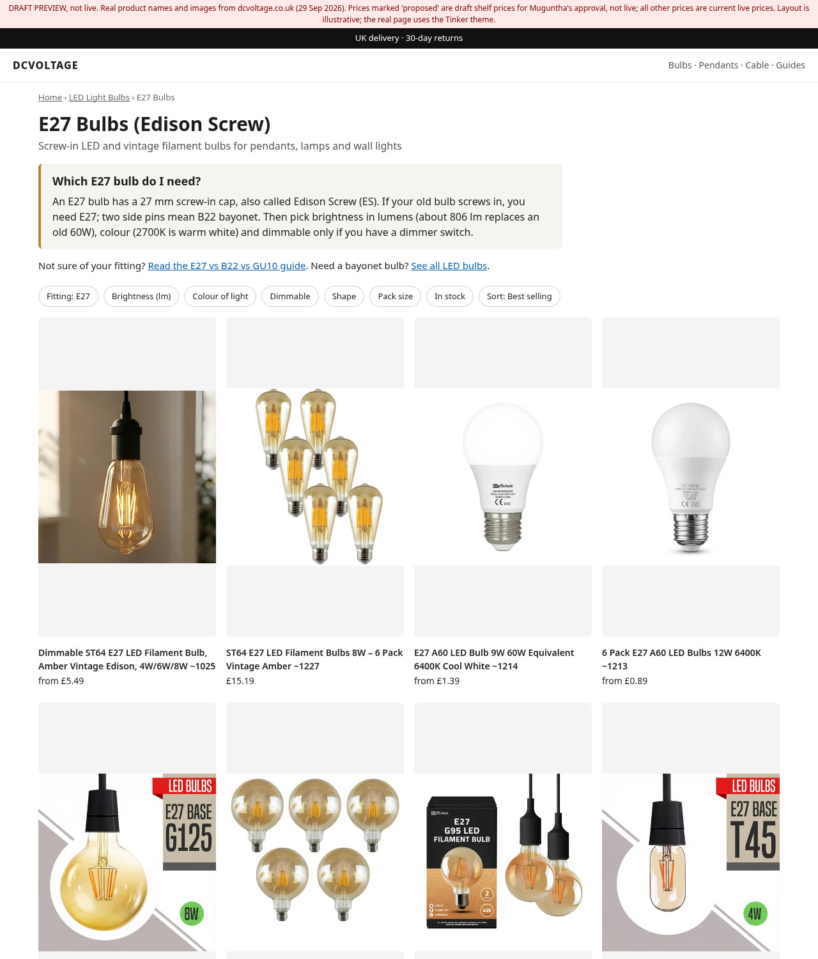
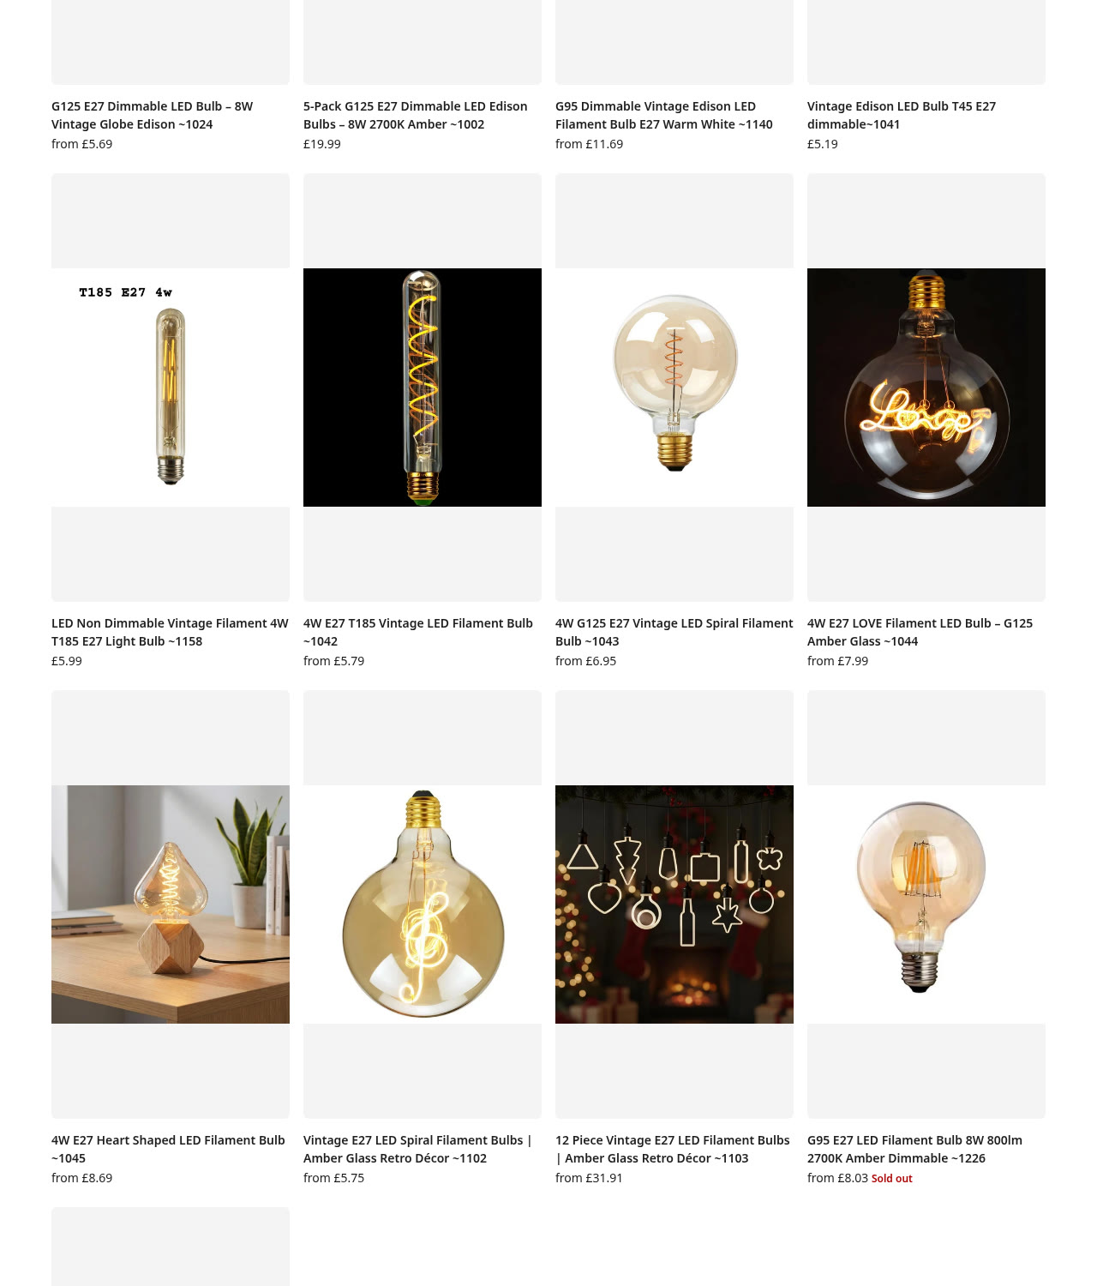
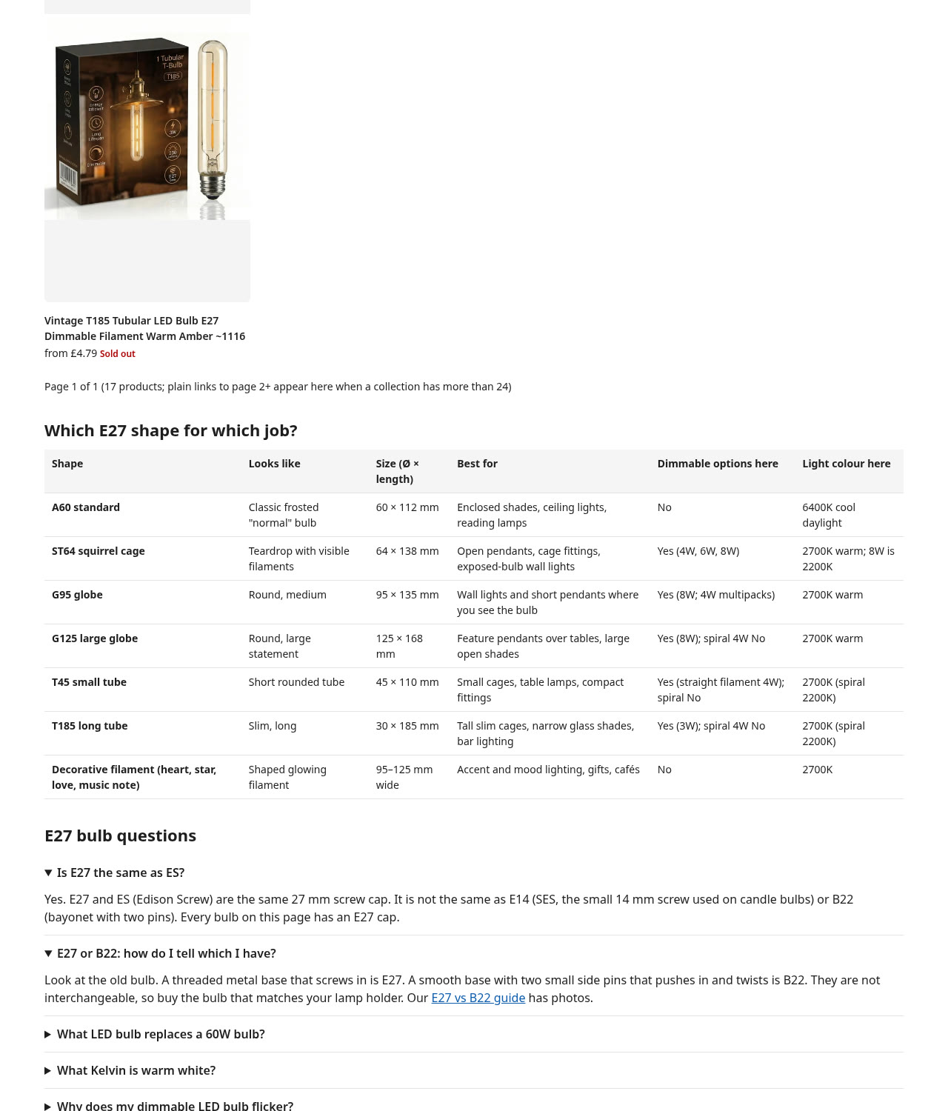
Product page, desktop:
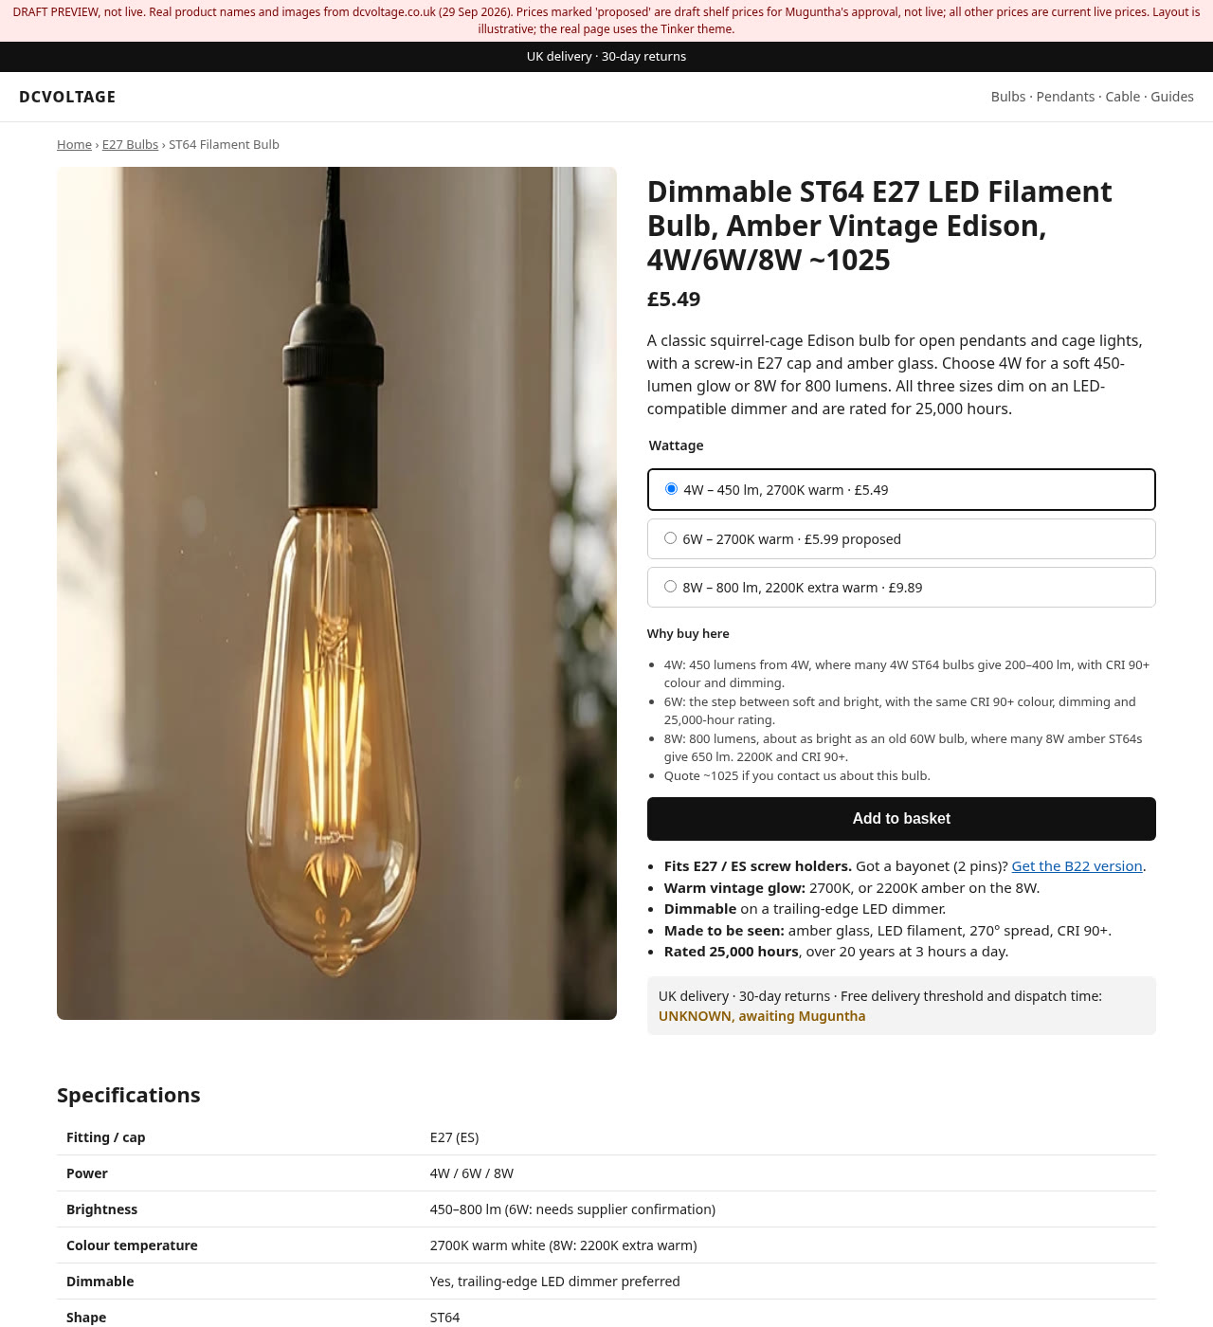
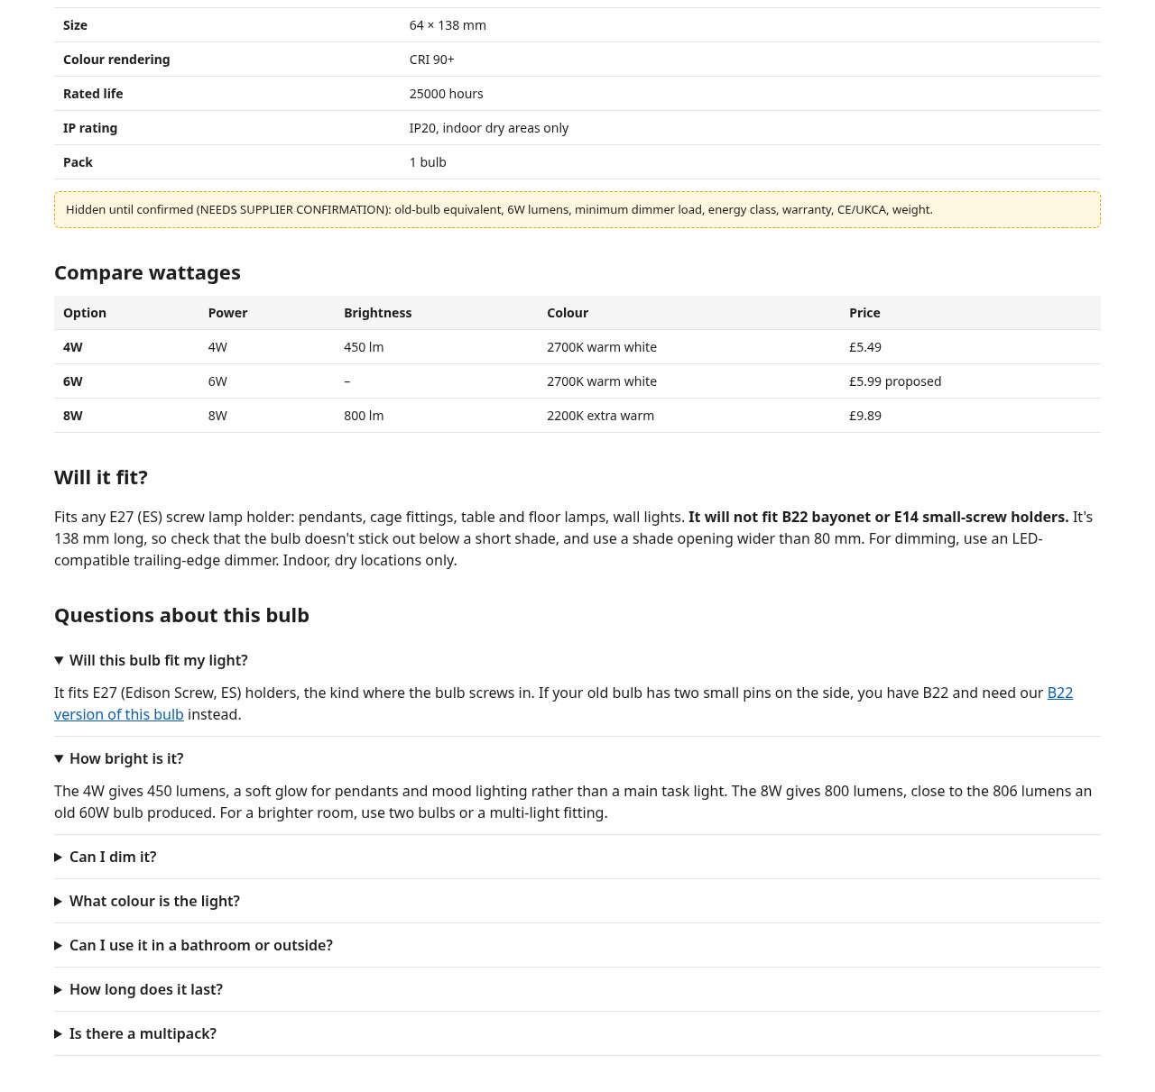
Collection page, mobile (read left to right):
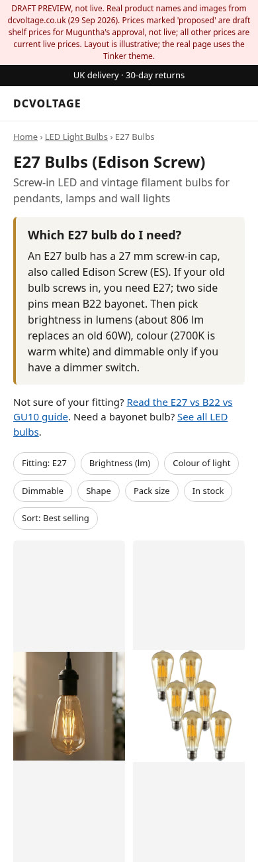 | 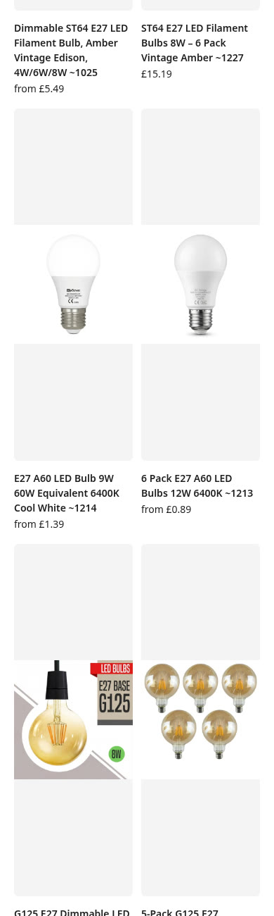 | 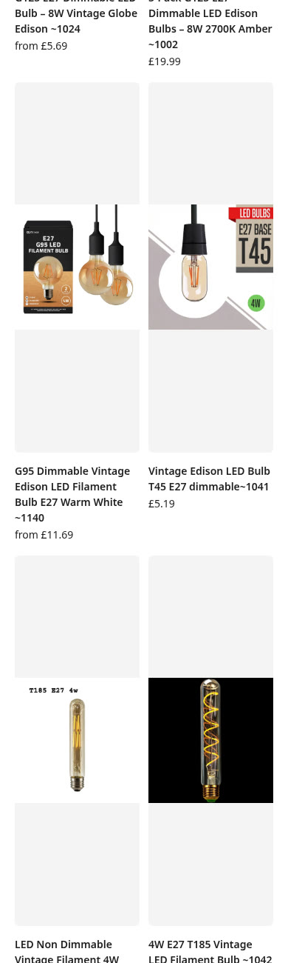

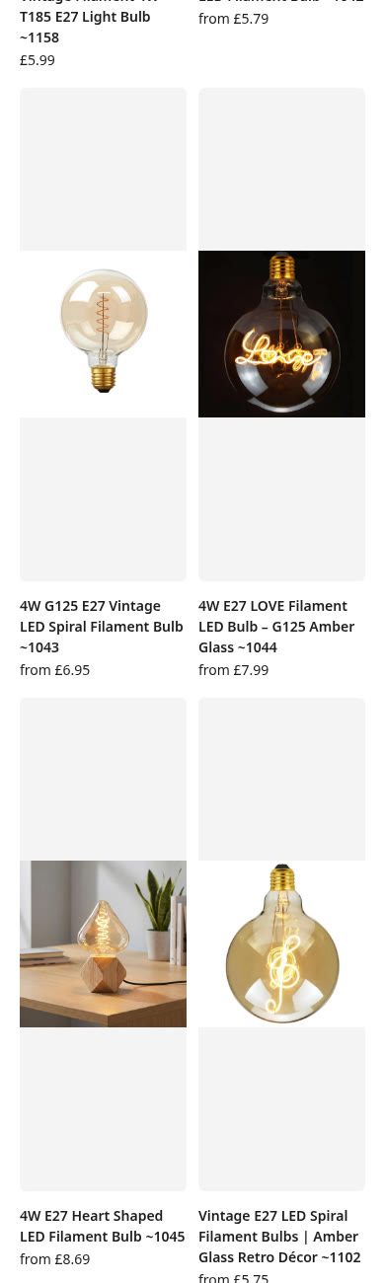 | 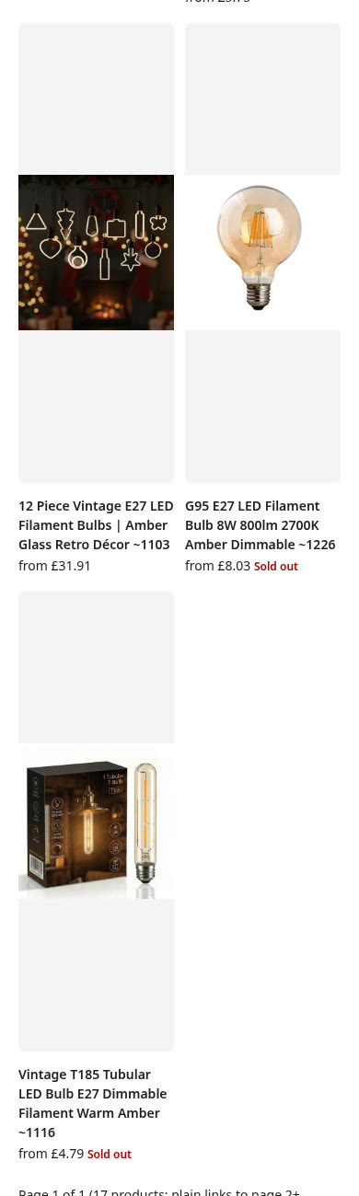 | 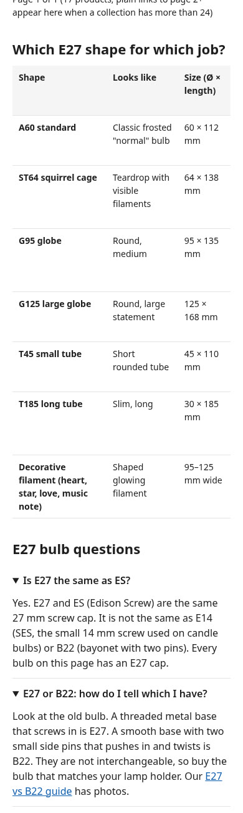

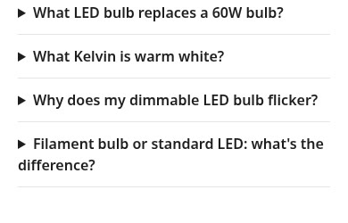

Product page, mobile (read left to right):
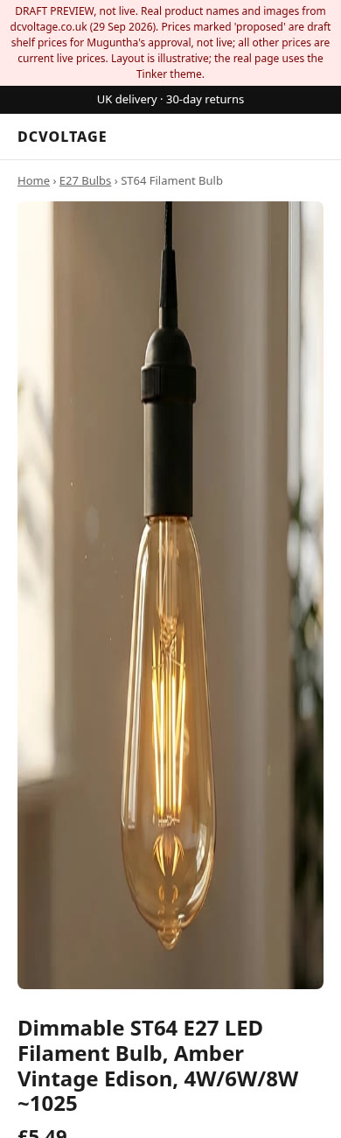 | 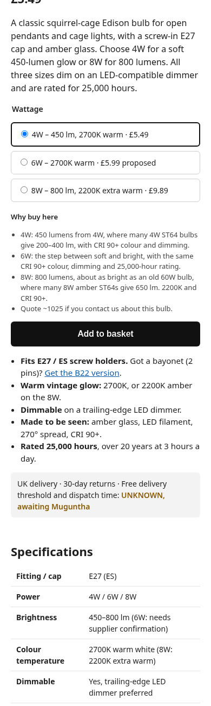 | 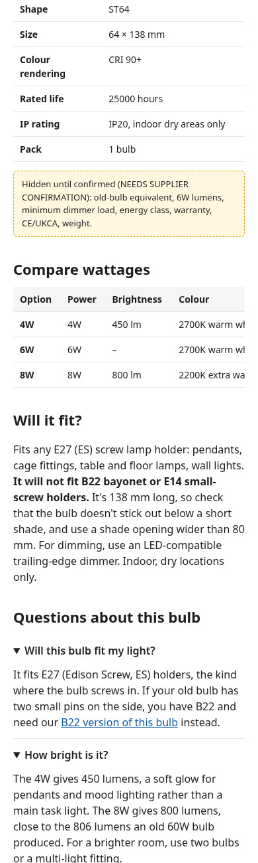

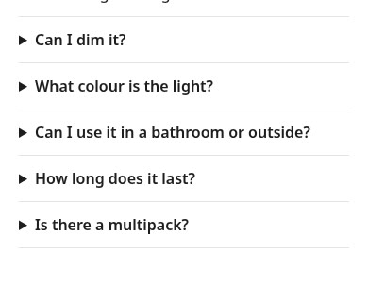

3.2 Install steps (for Kuberan)
Owner and approver: Muguntha. Nothing goes live until Muguntha says OK in writing. Files to install: sections/model-collection-e27.liquid (Appendix A), sections/model-product-specs.liquid (Appendix B), and the reference templates collection.e27-model.json (Appendix C) and product.e27-model.json (Appendix D). The copy is in 3.4 and 3.5, and the metafields are in 3.3.
1. In Shopify admin go to Online Store > Themes. On the live theme (Tinker) click the three dots > Duplicate. Rename the copy "Tinker - E27 model DRAFT". Do all the work below on this copy only. Never edit the live theme.
2. On the copy click the three dots > Edit code. In the Sections folder click "Add a new section", name it model-collection-e27, delete the starter code, paste the full contents of model-collection-e27.liquid and save. Do the same for model-product-specs. If Shopify shows an error on save, stop and send the error text to Muguntha. Don't try to fix it.
3. Still on the copy, open the theme editor (Customize). Top menu > Collections > Create template. Name: e27-model. Based on: Default collection.
4. In the new collection template:
- a. Remove (or hide) the section above the product grid that shows the collection title and description, so the page doesn't have two H1 headings.
- b. Add section "Model E27 collection" ABOVE the product grid. Set "Part of page" to Intro. Fill H1, subheading, question, direct answer and quick links from the collection copy (3.4).
- c. Add section "Model E27 collection" again BELOW the product grid. Set "Part of page" to Details. Add 7 "Table row (shape)" blocks and 6 "FAQ" blocks and copy the texts from the collection copy (3.4). Breadcrumb parent: LED Light Bulbs, /collections/led-bulb.
- d. Check that "Products per page" in our Details section matches the product grid setting (default 24).
- e. Save.
- (Only if steps 3 and 4 are not possible in the editor: upload theme/templates/collection.e27-model.json on the copy. It was built from the standard Horizon template and may not match Tinker exactly.)
5. Top menu > Products > Create template. Name: e27-model. Based on: Default product.
- a. In the product information section, click the product title text block and make it a Heading 1. The text should be <h1>{{ closest.product.title }}</h1>. The live site currently shows the product title as H3, and a product page should have exactly one H1.
- b. Add section "Model product specs" directly under the product information section.
- c. Paste the compatibility note and add the 7 FAQ blocks from the product copy (3.5).
- d. Leave "Delivery and returns line" EMPTY for now. The free-delivery amount and dispatch time must be decided by Muguntha first (the site currently shows two different versions).
- e. JSON-LD mode: leave on "FAQ + breadcrumbs only". Breadcrumb collection: pick E27 Bulbs once it exists; until then leave blank. Brand name: leave blank until Muguntha decides. Return window: leave 0.
- f. Save.
6. Optional, only if Muguntha asks for "Full" product schema: on the COPY theme open sections/product-information.liquid, find the line that starts with <script type="application/ld+json"> and contains structured_data, put {% unless template.suffix == 'e27-model' %} on the line above it and {% endunless %} on the line below it, then save. After that, and only then, switch JSON-LD mode to "Full" in step 5e. Otherwise the page would carry two product schemas.
7. Metafields: Settings > Custom data > Products > Add definition. Create the definitions listed in the metafields list (3.3) (namespace specs, and custom.listing_code). Then Variants > add specs.watts, specs.lumens, specs.kelvin. Customers can't see definitions; they only show up through the new templates. Leave anything marked NEEDS SUPPLIER CONFIRMATION empty.
8. Fill the metafield values for the best seller (/products/vintage-style-led-edison-bulb-lamp) exactly as listed in the metafields list (3.3), product level and variant level. Don't change prices, compare-at prices, title, description or options yet; those changes wait for Muguntha's OK (see the product copy (3.5) and section 4). When the new title is approved, keep the listing code at the end ("... 4W/6W/8W ~1025"): customers quote it.
9. Do NOT assign the new templates to any product or collection yet. In Shopify, template assignment applies to the live store, whichever theme you're working on. Preview instead:
Collection: https://dcvoltage.co.uk/collections/led-bulb?view=e27-model&preview_theme_id=THEME_ID

Product: https://dcvoltage.co.uk/products/vintage-style-led-edison-bulb-lamp?view=e27-model&preview_theme_id=THEME_ID

Replace THEME_ID with the number in the address bar when you open the copy theme's editor.

10. Check on phone and desktop: one H1 on each page, the FAQ opens and closes, the table scrolls sideways on a phone, and the product grid, filters and add to basket still work.
11. Take 4 screenshots (collection desktop, collection mobile, product desktop, product mobile) and send them with the two preview links to Muguntha. Compare them with the preview images in section 3.1.
12. Creating the new "E27 Bulbs" collection (handle e27-bulbs) is a live change that customers will see. Only do it after Muguntha says OK. Then add the 17 E27 bulb listings from the collection copy (3.4), fill SEO title and meta description from the collection copy (3.4), and set this collection as the Breadcrumb collection in step 5e.
13. Search and Discovery filters (Fitting, Brightness, Colour of light, Dimmable, Shape, Pack size, Availability) are store-wide and also only after Muguntha's OK. Keep "Old-bulb equivalent" hidden until the supplier confirms values.
14. After Muguntha approves the screenshots: assign template e27-model to the E27 Bulbs collection and to the best-seller product, then publish the copy theme (or copy the two sections and templates into the live theme). Write down the date and time.
15. After it is live: test both URLs in Google's Rich Results Test (search.google.com/test/rich-results) and send Muguntha the result. Then, in Google Search Console, use URL Inspection > Request indexing for both URLs.
16. If anything looks wrong after going live: set the product and collection back to the Default template (and re-publish the previous theme if you published the copy). Nothing else needs undoing.
Validation already done locally: Liquid tag balance, section schema JSON, template cross-check, a mock Liquid render of every JSON-LD mode, and a JSON-LD parse of the previews (all passed). Still to do on the duplicate theme: Shopify theme check, a real render, and Google's Rich Results Test.
JSON-LD note: the Product name is the page title including the listing code, sku is the real SKU, and the listing code goes in productID. productID holds the store's listing code; mpn is reserved for a manufacturer part number, which we don't have. The section reads the code from the metafield custom.listing_code, or from the text after "~" in the title when the metafield is blank.

3.3 Metafields
Where: Shopify admin → Settings → Custom data → Products (and → Variants). Creating definitions doesn't change anything customers see until a template or filter uses them. Values come from MAIN-PG SOT (public.components_sot_*, source_tab bulb), read 29 Sep 2026. Enter NOTHING for a NEEDS SUPPLIER CONFIRMATION item: a blank metafield is hidden on the page and left out of the JSON-LD.

Product metafields (namespace `specs`)
Key | Name shown in admin | Type | Used for | Storefront filter?
specs.fitting | Fitting / cap | Single line text (choices: E27 (ES), B22 (BC), E14 (SES), GU10, G9) | spec table, JSON-LD additionalProperty, filter | Yes
specs.watts | Power | Single line text, e.g. "4W / 6W / 8W" | spec table | No
specs.watt_equivalent | Old-bulb equivalent | Single line text (choices: 25W, 40W, 60W, 75W, 100W) | spec table, filter (hidden until ≥80% filled) | Later
specs.lumens | Brightness | Single line text for the product ("450–800 lm"). For filtering use specs.lumens_max (Integer) | spec table, filter | Yes (lumens_max)
specs.lumens_max | Brightest option (lm) | Integer | Brightness range filter | Yes
specs.kelvin | Colour temperature | Single line text (choices: 2200K extra warm, 2700K warm white, 3000K warm white, 4000K cool white, 6400K daylight) | spec table, filter | Yes
specs.dimmable | Dimmable | True or false | spec table, filter | Yes
specs.dimmer_note | Dimmer note | Single line text | spec table ("trailing-edge dimmer preferred") | No
specs.shape | Shape | Single line text (choices: A60, ST64, G95, G125, T45, T185, Decorative) | spec table, filter | Yes
specs.dimensions_mm | Size | Single line text, e.g. "64 × 138 mm" | spec table | No
specs.cri | Colour rendering | Single line text, e.g. "CRI 90+" | spec table | No
specs.lifespan_hours | Rated life (hours) | Integer | spec table, JSON-LD | No
specs.ip_rating | IP rating | Single line text, e.g. "IP20, indoor dry areas only" | spec table | No
specs.pack_size | Pack | Single line text, e.g. "1 bulb" | spec table | No (use the "Pack size" option)
custom.listing_code | Listing code | Single line text | Optional. Feeds JSON-LD productID and staff search. The code also stays in the title (customers quote it) | No

Note on specs.dimmable: create it as True/false, and leave it blank when unknown. The section prints "No" only when the value is explicitly false.

Variant metafields (namespace `specs`, optional, for the "Compare wattages" table)
Key | Type | Example
specs.watts | Single line text | "4W"
specs.lumens | Single line text | "450 lm"
specs.kelvin | Single line text | "2700K warm white"

Values for the best seller: `/products/vintage-style-led-edison-bulb-lamp`
Product level:
Key | Value (SOT)
specs.fitting | E27 (ES)
specs.watts | 4W / 6W / 8W
specs.watt_equivalent | leave blank: NEEDS SUPPLIER CONFIRMATION (SOT [VERIFY])
specs.lumens | 450 lm (4W) · 800 lm (8W) · 6W NEEDS SUPPLIER CONFIRMATION → enter "450–800 lm"
specs.lumens_max | 800
specs.kelvin | 2700K warm white (8W: 2200K extra warm)
specs.dimmable | true
specs.dimmer_note | trailing-edge LED dimmer preferred
specs.shape | ST64
specs.dimensions_mm | 64 × 138 mm
specs.cri | CRI 90+
specs.lifespan_hours | 25000
specs.ip_rating | IP20, indoor dry areas only
specs.pack_size | 1 bulb
custom.listing_code | 1025

Variant level:
Variant (SKU) | specs.watts | specs.lumens | specs.kelvin
LDMST64E274 | 4W | 450 lm | 2700K warm white
LDMST64E276 | 6W | (blank: NEEDS SUPPLIER CONFIRMATION; SOT shows 450 lm, the same as 4W) | 2700K warm white
LDMST64E278 | 8W | 800 lm | 2200K extra warm

Not stored anywhere until confirmed (NEEDS SUPPLIER CONFIRMATION): old-bulb equivalent (all 3), 6W lumens, minimum dimmer load, energy class, warranty, CE/UKCA marking, weight, model number. Barcode/GTIN: UNKNOWN (fill the variant barcode field only with the real EAN/UPC). Brand shown in schema: Muguntha decision (SOT brand "LEDsone" vs shop name "DCVOLTAGE"/"DC Voltage").

Other E27 listings (SOT values, for the filters)
Shape / SKU group | lumens_max | kelvin | dimmable | dimensions_mm | Flags
A60 9W | 820 | 6400K daylight | false | 60 × 112 mm
A60 12W | 1160 | 6400K daylight | false |  | the listing claims "100W equivalent": NEEDS SUPPLIER CONFIRMATION, and 1,160 lm is below the ~1,521 lm of an old 100W
G95 8W | 800 | 2700K | true | 95 × 135 mm | SOT equivalent "40 Watts" vs G125 8W "60 Watts" for the same 800 lm: NEEDS SUPPLIER CONFIRMATION
G95 4W (LDMG95E274) | 450 | 2700K | true | 95 × 135 mm
G125 8W | 800 | 2700K | true | 125 × 168 mm | see G95 note
T45 4W (LDMT45E274) | 450 | 2700K | true | 45 × 110 mm | SOT equivalent "40 Watts"
T45 / T185 4W spiral (LDST45E274, LDST185E274) | 450 | 2200K | false | 45 × 110 / 30 × 185 mm | equivalent [VERIFY]
T185 3W | 230 | 2700K | true | 30 × 185 mm
Spiral / shaped decorative | 450 | 2700K (spiral T/G: 2200K) | false |  | LDSG95E274 lifespan 3,000 h in SOT (an outlier): NEEDS SUPPLIER CONFIRMATION
Pack SKUs (5-pack, 6-pack, sets) | n/a | n/a | n/a | n/a | not in SOT; take values from the single-bulb SKU they contain

3.4 Collection page copy (E27 Bulbs)
Status: draft only. Nothing has been changed on the site. British English. Written from scratch for dcvoltage and not copied from ledsone.co.uk. Target queries and their data are in keyword_map.md.

Page setup
- Collection to create (after Muguntha's OK): "E27 Bulbs", handle e27-bulbs, automated rule. Suggested rule: product type = "LED Bulb" AND tag = "E27" (the types and tags need cleaning first; see audit D14). Until then, use a manual collection containing the 17 E27 bulb listings below.
- Theme template: collection.e27-model (files in theme/).
- SEO title (57 characters): E27 Bulbs – Edison Screw LED & Filament Bulbs | DCVOLTAGE
- Meta description (152 characters): Screw-in E27 (ES) bulbs: vintage filament ST64, G95, G125 and T45 plus bright A60 LEDs. Choose by lumens, warm or cool white, and dimmable or not.
- H1: E27 Bulbs (Edison Screw)
- Subheading (under the H1, one line): Screw-in LED and vintage filament bulbs for pendants, lamps and wall lights

Direct-answer intro (55 words, shown above the product grid)
Which E27 bulb do I need?
An E27 bulb has a 27 mm screw-in cap, also called Edison Screw (ES). If your old bulb screws in, you need E27; two side pins mean B22 bayonet. Then pick brightness in lumens (about 806 lm replaces an old 60W), colour (2700K is warm white) and dimmable only if you have a dimmer switch.
Quick links under the intro (plain text links, crawlable):
- Not sure of your fitting? → E27 vs B22 vs GU10 guide (/blogs/news/e27-vs-b22-vs-gu10-which-bulb-fitting-do-you-actually-need)
- Need a bayonet bulb? → B22 bulbs (the B22 collection doesn't exist yet; until it does, link to /collections/led-bulb)

Filter plan (Shopify Search & Discovery app → Filters)
The filters use product metafields (namespace specs, see metafields.md) and one standardised option name. The labels below are exactly what customers see.
Filter label | Source | Values shown | Notes
Fitting | metafield specs.fitting | E27 (ES) · B22 (BC) · E14 (SES) | Always "E27" on this page, but add it anyway so the same filter works on the B22, E14 and all-bulbs pages.
Brightness | metafield specs.lumens (number) | Search & Discovery groups numbers as a range. Add helper text: "about 450 lm = soft glow, about 800 lm = old 60W, 1,000 lm+ = bright room light" | SOT holds lumens for every E27 bulb SKU.
Old-bulb equivalent | metafield specs.watt_equivalent | 40W · 60W · 75W · 100W | Fill only when confirmed. SOT has [VERIFY] for the ST64, T185 spiral and A60 SKUs, and the G95 8W vs G125 8W values contradict each other. Hide this filter until at least 80% of products have a confirmed value.
Colour of light | metafield specs.kelvin | 2200K extra warm · 2700K warm white · 6400K cool daylight | Values from SOT.
Dimmable | metafield specs.dimmable | Yes · No | From SOT: the M-series filaments (ST64, G95, G125 8W, T45, T185 3W/4W dimmable) = Yes; A60 and the decorative spiral/shaped bulbs = No.
Shape | metafield specs.shape | A60 standard · ST64 squirrel cage · G95 globe · G125 large globe · T45 small tube · T185 long tube · Decorative (heart, star, love, music note)
Pack size | variant option "Pack size" (rename 'Pack', 'Number of Pack', 'PACK', 'color: Pack 1…' to this one name) | 1 · 2 · 3 · 5 · 6 · 12 | Search & Discovery filters by option name, so the name has to be identical across listings.
Availability | built-in | In stock | Default to showing in-stock items first.

Sort default: Best selling.

Comparison table: which shape for which job (sizes from SOT, diameter × length)
Shape | Looks like | Size | Best for | Dimmable options here | Light colour here
A60 standard | Classic frosted "normal" bulb | 60 × 112 mm | Enclosed shades, ceiling lights, reading lamps (bright, everyday light) | No | 6400K cool daylight
ST64 squirrel cage | Teardrop with visible filaments | 64 × 138 mm | Open pendants, cage fittings, exposed-bulb wall lights | Yes (4W, 6W, 8W) | 2700K warm; 8W is 2200K
G95 globe | Round, medium | 95 × 135 mm | Wall lights and short pendants where you see the bulb | Yes (8W; 4W multipacks) | 2700K warm
G125 large globe | Round, large statement | 125 × 168 mm | Feature pendants over tables, large open shades | Yes (8W); spiral 4W No | 2700K warm
T45 small tube | Short rounded tube | 45 × 110 mm | Small cages, table lamps, compact fittings | Yes (straight filament 4W); spiral No | 2700K (spiral 2200K)
T185 long tube | Slim, long | 30 × 185 mm | Tall slim cages, narrow glass shades, bar lighting | Yes (3W); spiral 4W No | 2700K (spiral 2200K)
Decorative filament (heart, star, love, music note) | Shaped glowing filament | 95–125 mm wide | Accent and mood lighting, gifts, cafés | No | 2700K

FAQs (accordion, with FAQPage schema)
1. Is E27 the same as ES?
Yes. E27 and ES (Edison Screw) are the same 27 mm screw cap. It is not the same as E14 (SES, the small 14 mm screw used on candle bulbs) or B22 (bayonet with two pins). Every bulb on this page has an E27 cap.
2. E27 or B22: how do I tell which I have?
Look at the old bulb. A threaded metal base that screws in is E27. A smooth base with two small side pins that pushes in and twists is B22. They are not interchangeable, so buy the bulb that matches your lamp holder. Our E27 vs B22 guide has photos.
3. What LED bulb replaces a 60W bulb?
Go by lumens, not watts: an old 60W bulb gave about 806 lumens. On this page, the 8W ST64, 8W G95 and 8W G125 filament bulbs give 800 lm, and the 9W A60 gives 820 lm. For a softer glow, choose a 4W filament (about 450 lm).
4. What Kelvin is warm white?
Warm white is about 2700K, close to an old incandescent bulb and good for living rooms and bedrooms. 2200K is extra warm with an amber, candle-like tone. 6400K is cool daylight, better for garages, workshops and task lighting.
5. Why does my dimmable LED bulb flicker?
Usually the dimmer switch is an old type made for high-watt bulbs, or the total LED load is below the dimmer's minimum. Use a dimmable bulb with an LED-compatible (trailing-edge) dimmer and check the dimmer's minimum load. Non-dimmable bulbs should never go on a dimmer.
6. Filament bulb or standard LED: what's the difference?
Filament bulbs have visible glowing strands in clear or amber glass. They are made to be seen in open pendants and cages, and give a warm, lower-output glow. Standard LEDs such as the A60 have a frosted or white cover, give more light per bulb and suit enclosed shades.

Products on this page (17 E27 bulb listings on dcvoltage, 29 Sep 2026)
In stock (15): ST64 filament (best seller) ~1025 · ST64 8W 6-pack ~1227 · A60 9W 6400K ~1214 · A60 12W 6400K ~1213 · G125 8W dimmable ~1024 · G125 8W 5-pack ~1002 · G95 dimmable 2/3-pack ~1140 · T45 dimmable ~1041 · T185 4W non-dimmable ~1158 · T185 4W spiral ~1042 · G125 4W spiral ~1043 · LOVE G125 ~1044 · Heart ~1045 · Spiral mixed styles ~1102 · 12-piece set ~1103.
Out of stock (2): G95 8W dimmable ~1226 · T185 dimmable ~1116.
Fixes to make before launch (see audit): the '100W equivalent' claim on ~1213 (D27); the 12/24-piece labelling on ~1103 (D26); the 'Style 3–11' option names on ~1102 (D25); the 'bayonet' handle on ~1214 (D23).

3.5 Product page copy (ST64 best seller ~1025)
Product: /products/vintage-style-led-edison-bulb-lamp, Shopify product 8388218781857, currently titled "ST64 E27 LED Filament Bulb – Vintage Edison Style ~1025".
Why this product (real order data, MAIN-PG `public.order_transaction`, SHOPIFY, ss_name `dcvoltage-2`, status Completed):
- It is dcvoltage's best-selling standalone E27 bulb: 7 orders / 16 units between 13 Jan and 21 Sep 2026 (LDMST64E274: 4 orders, 8 units; LDMST64E278: 3 orders, 8 units). L90 (26 Jun–23 Sep): 3 orders / 6 units.
- The next E27 bulbs are the T185 dimmable ~1116 and the G125 5-pack ~1002, with 2 orders each. Every other E27 bulb listing has 1 order or none.
- One more order used LDMST64E274 as a component of a wall-light bundle (WLTPFTBM+LDMST64E274). It isn't counted above.
- Context, not the basis of the choice: on ledsone.co.uk the same 3 SKUs had 258 completed orders / 737 units in L90. dcvoltage volumes are small (76 completed orders in total across the store in L90), so treat the "best seller" label as indicative.
Source of truth for specs: MAIN-PG public.components_sot_* (source_tab bulb), read 29 Sep 2026. Anything SOT marks [VERIFY], or where SOT looks inconsistent, is shown as NEEDS SUPPLIER CONFIRMATION. Current prices are today's live dcvoltage prices (products.json). Proposed shelf prices come from section 4 (Balance Price Thrive + channel costs + VAT, then a UK market check in section 4). They are for Muguntha's approval and not live.

Title, SEO and URL
- Product title (H1): Dimmable ST64 E27 LED Filament Bulb, Amber Vintage Edison, 4W/6W/8W ~1025
- Listing code "~1025" stays in the title on purpose. Customers quote it when they phone, email or reorder, so it stays at the end of the title, in the collection card and in the Product JSON-LD name. It's also stored in the optional metafield custom.listing_code (value 1025), which the model section outputs as productID in the JSON-LD. productID holds the store's listing code; mpn is reserved for a manufacturer part number, which we don't have. The SKUs (LDMST64E274 / 6 / 8) stay as they are and remain the JSON-LD sku.
- SEO title (61 characters): Dimmable ST64 E27 LED Filament Bulb, Amber ~1025 | DCVOLTAGE. The code is kept so a customer searching for it finds the page; the rest reads as customer language.
- Meta description (150 characters): Dimmable ST64 E27 screw-in LED filament bulb in amber glass. 4W (450 lm), 6W or 8W (800 lm), 25,000-hour life, CRI 90+. Made for open pendants.
- URL: keep the current handle (it has GSC impressions). Don't change it.

Option names (replace "Type: ST64 4W E27 / ST64 8W E27 / ST64 6W E27")
Option name: Wattage. Values, in this order:
Value shown to customer | SKU | Price now (live) → proposed (for Muguntha's approval, not live) | Compare-at now → proposed
4W – 450 lm, 2700K warm | LDMST64E274 | £5.49 → keep £5.49 (already above Thrive and inside the market range) | £6.89 → keep only if it's a genuine former price; otherwise clear
6W – 2700K warm | LDMST64E276 | £8.69 → £5.99 (market-aligned cut; still above Thrive) | £10.89 → clear (not a genuine former price at the new level)
8W – 800 lm, 2200K extra warm | LDMST64E278 | £9.89 → keep £9.89 (already above Thrive and inside the market range) | £9.59 → clear (a "was" price below the selling price is misleading)

(6W lumens are left out of the option label until the supplier confirms them; see the spec table.)
Why the 6W changes: at £8.69 it's dearer than every like-for-like rival found (MyGreenLighting £5.95, Luxor £6.95, Lights.co.uk £7.01). £5.99 sits with the market and stays above the Thrive level. ledsone.co.uk's £2.99 for the same SKU is treated as a ledsone pricing issue and flagged separately for Muguntha. Evidence is in section 4.

"Why buy here" lines (one per variant, shown under the option picker; honest, spec-based)
- 4W: 450 lumens from 4W, where many 4W ST64 bulbs give 200–400 lm, with CRI 90+ colour and dimming. Quote ~1025 if you contact us about this bulb.
- 6W: The step between soft and bright, with the same CRI 90+ colour, dimming and 25,000-hour rating as the 4W and 8W. Quote ~1025 if you contact us about this bulb.
- 8W: 800 lumens, about as bright as an old 60W bulb, where many 8W amber ST64s give 650 lm. 2200K extra-warm and CRI 90+.
Not claimed, because it can't be backed up today: reviews (Judge.me shows 0.00 on dcvoltage), dispatch speed (the store's pages contradict each other), the free-delivery threshold (£25 vs £30 on different pages) and "cheapest" price claims (competitor prices change).

Short intro (first lines of the description, 45 words)
A classic squirrel-cage Edison bulb for open pendants and cage lights, with a screw-in E27 cap and amber glass. Choose 4W for a soft 450-lumen glow or 8W for 800 lumens. All three sizes dim on an LED-compatible dimmer and are rated for 25,000 hours.

Key benefits (bullets)
- Fits E27 / ES screw holders. Check your old bulb screws in. There is a separate B22 bayonet version (/products/vintage-style-led-edison-bulb-lamp-b22).
- Warm vintage glow. 2700K warm white (4W, 6W), or 2200K extra-warm amber (8W).
- Dimmable. Works best with a trailing-edge LED dimmer.
- Made to be seen. Amber glass, visible LED filament, 270° light spread, colour rendering CRI 90+.
- Long life. Rated 25,000 hours, over 20 years at 3 hours a day.
- Low running cost. 4W, 6W or 8W of power.

Spec table (SOT unless marked)
Spec | 4W (LDMST64E274) | 6W (LDMST64E276) | 8W (LDMST64E278)
Fitting / cap | E27 Edison Screw (ES), 27 mm | same | same
Power | 4 W | 6 W | 8 W
Old-bulb equivalent | NEEDS SUPPLIER CONFIRMATION (SOT [VERIFY]) | NEEDS SUPPLIER CONFIRMATION | NEEDS SUPPLIER CONFIRMATION
Brightness | 450 lm | NEEDS SUPPLIER CONFIRMATION (SOT says 450 lm, the same as the 4W, which looks wrong) | 800 lm
Colour temperature | 2700K warm white | 2700K warm white | 2200K extra warm
Dimmable | Yes, trailing-edge dimmer preferred | Yes | Yes
Minimum dimmer load | NEEDS SUPPLIER CONFIRMATION | same | same
Shape | ST64 (squirrel cage / teardrop) | same | same
Size (diameter × length) | 64 × 138 mm (the listing currently says 14.8 cm; SOT says 138 mm) | same | same
Glass / filament | Amber glass, LED filament | same | same
Light spread | 270° | 270° | 270°
Colour rendering | CRI 90+ | CRI 90+ | CRI 90+
Voltage | 220–240V AC, 50 Hz | same | same
Rated life | 25,000 hours | 25,000 hours | 25,000 hours
IP rating / where to use | IP20, indoor dry areas only (SOT: not for bathrooms or outdoors) | same | same
Recommended shade opening | Over 80 mm (SOT compat_shade_diameter_mm) | same | same
Pack | 1 bulb | 1 bulb | 1 bulb (a 6-pack 8W is sold separately: ST64 8W 6-pack ~1227, £15.19)
Energy class | NEEDS SUPPLIER CONFIRMATION (the listing's "A+" is from the pre-2021 scale; remove it) | same | same
Warranty | NEEDS SUPPLIER CONFIRMATION (the listing says 3 years; SOT [VERIFY]) | same | same
CE / UKCA marking | NEEDS SUPPLIER CONFIRMATION (the listing says CE/RoHS; SOT [VERIFY]) | same | same
Weight | NEEDS SUPPLIER CONFIRMATION | same | same
Barcode / GTIN | UNKNOWN (not public; the section outputs it automatically if the variant barcode is filled) | same | same
Brand | Muguntha decision: SOT brand = "LEDsone"; dcvoltage shows "DC Voltage" (vendor has 4 spellings). The JSON-LD uses the shop name unless overridden.

Compatibility note (shown under the spec table)
Fits any E27 (ES) screw lamp holder: pendants, cage fittings, table and floor lamps, wall lights. It will not fit B22 bayonet or E14 small-screw holders. It's 138 mm long, so check that the bulb doesn't stick out below a short shade, and use a shade opening wider than 80 mm. For dimming, use an LED-compatible trailing-edge dimmer. Indoor, dry locations only.

Delivery and returns (one line, the same everywhere)
UK delivery · 30-day returns · Free delivery over £[UNKNOWN: £25 or £30] · Dispatched within [UNKNOWN] working days
UNKNOWN, needs Muguntha's decision: the site currently says free delivery over £25 (Terms) and over £30 (Free Shipping collection); dispatch 2–4 working days + delivery 2–5 working days (Shipping policy) and delivery 3–5 working days (Terms). Returns are "30 days from the date of purchase" on one page and "30 days after delivery" on another. Use one set of facts on every page, then update Merchant Center.

FAQs (accordion + FAQPage schema)
1. Will this bulb fit my light?
It fits E27 (Edison Screw, ES) holders, the kind where the bulb screws in. If your old bulb has two small pins on the side, you have B22 and need our B22 version of this bulb instead.
2. How bright is it?
The 4W gives 450 lumens, a soft glow for pendants and mood lighting rather than a main task light. The 8W gives 800 lumens, close to the 806 lumens an old 60W bulb produced. For a brighter room, use two bulbs or a multi-light fitting.
3. Can I dim it?
Yes, all three wattages are dimmable. Use an LED-compatible trailing-edge dimmer. If the bulb flickers at low levels, the total LED load may be below your dimmer's minimum; check the dimmer's label.
4. What colour is the light?
Warm white. The 4W and 6W are 2700K, similar to a traditional bulb. The 8W is 2200K, an extra-warm amber tone. The amber glass adds to the vintage look.
5. Can I use it in a bathroom or outside?
No. It's rated IP20, which means indoor, dry areas only.
6. How long does it last?
It's rated for 25,000 hours, which is over 20 years at three hours a day.
7. Is there a multipack?
Yes, the 8W comes in a 6-pack (sold as a separate listing). For other pack sizes, contact us.

Remove from the current description
- "B22 & E27", "B22 and E27 base options", "Select the correct B22 or E27 version": this listing is E27 only.
- "Energy Rating A+", "3-year warranty", "CE / RoHS certified": until the supplier confirms them.
- "14.8cm height": replace with 138 mm (SOT).

3.6 Keyword map
Sources used
- GSC-DCV: MAIN-PG google_search_console.gsc_web_query / gsc_web_query_page, site https://dcvoltage.co.uk/, 23 Jun–20 Sep 2026 (L90). These are real dcvoltage impressions.
- GSC-LED: the same tables for sc-domain:ledsone.co.uk, L90. This is a demand proxy only: it shows what UK searchers type for the same products on ledsone.co.uk (which shares our products), not dcvoltage performance.
- WS: WebSearch samples, 29 Sep 2026. These are AI-retrieval index summaries, not Google SERPs, and are used for People-Also-Ask / AI-answer style questions and for which sites get cited.
- Monthly search volume: UNKNOWN for every query. No keyword-volume tool was available, so impressions are the only demand measure.
- Position = impression-weighted average position. "–" = no impressions for that site.

Page 1: E27 bulb collection (new, suggested URL `/collections/e27-bulbs`)
Intent: "I need a screw-in (E27) bulb and want help choosing." The page owns the transactional and "which one" queries. The existing E27 vs B22 guide keeps the pure comparison queries and links here.
Target query | Role on page | GSC-DCV impr / clicks / pos | GSC-LED impr / clicks / pos (proxy) | Source
e27 bulb / e27 bulbs | Title, H1 | – / – / – | 8,988 / 10 / 11.9; 1,786 / 3 / 17.3 | GSC-LED
e27 light bulb(s) | Title, meta | – | 2,640 / 2 / 11.1; 709 / 1 / 16.7 | GSC-LED
e27 screw bulb / edison screw bulb | H1 subline, intro | – | 2,318 / 1 / 9.2; 1,757 / 1 / 11.5 | GSC-LED
e27 edison screw bulb | Intro | – | 2,036 / 3 / 9.7 | GSC-LED
e27 led bulb(s) | Intro, filter label | – | 1,830 / 2 / 23.1; 455 / 1 / 23.2 | GSC-LED
led screw in bulbs | Intro wording ("screw-in") | – | 1,213 / 0 / 8.5 | GSC-LED
e27 warm white bulb / e27 bulb warm white | Filter (colour temperature), FAQ | – | 1,150 / 0 / 14.6; 622 / 1 / 8.8 | GSC-LED
e27 vintage bulb / vintage light bulbs e27 | Shape table, filter | 55 / 0 / 32.4; 28 / 0 / 25.5 | 1,158 / 3 / 11.1; 407 / 6 / 7.9 | both
e27 filament bulb / e27 decorative bulb | Comparison table | – | 594 / 2 / 9.8; 719 / 0 / 14.5 | GSC-LED
e27 amber light bulb | Filter (glass) | 79 / 0 / 44.6 | – | GSC-DCV
e27 energy saving light bulbs | Intro ("LED") | 30 / 0 / 35.6 | – | GSC-DCV
what is an e27 bulb / what is e27 bulb | Direct-answer intro | – | 1,153 / 12 / 4.1; 1,389 / 7 / 3.9 | GSC-LED
what does e27 mean on a light bulb | Intro sentence | – | 357 / 3 / 3.7 | GSC-LED
is es the same as e27 / is e27 the same as es | FAQ | – | 212 / 0 / 6.8; 110 / 0 / 5.1 | GSC-LED
are all e27 bulbs the same | FAQ (shapes differ, cap is the same) | – | 66 / 3 / 2.1 | GSC-LED
is e27 screw or bayonet | FAQ (E27 vs B22) | – | 96 / 1 / 3.1 | GSC-LED
e27 vs b22 (+ about 60 variants) | FAQ + link to guide | ~5,000 combined on the guide, pos 5–9, ~5 clicks (e.g. "e27 vs b22" 1,290 / 1 / 8.7; "b22 vs e27" 1,081 / 0 / 7.7) | – | GSC-DCV
what LED replaces a 60W bulb / 60w equivalent e27 | FAQ | – / UNKNOWN | UNKNOWN | WS (answers cite 806 lm)
how many lumens for bedroom / living room | FAQ, brightness filter help | – | 84 / 1 / 5.4; 87 / 1 / 3.8 | GSC-LED
is 470 lumens bright | Brightness filter help | – | 171 / 0 / 8.8 | GSC-LED
why do dimmable LEDs flicker (dimmer) | FAQ | – / UNKNOWN | UNKNOWN | WS (Samotech, Heathfield cited)
filament vs standard LED bulb | FAQ / table | UNKNOWN | UNKNOWN | WS / AI-answer style

Page 2: best seller, ST64 E27 dimmable filament bulb (`/products/vintage-style-led-edison-bulb-lamp`)
Intent: "I want this specific vintage squirrel-cage bulb." The page should rank for ST64 plus fitting plus style queries and answer the "how bright / will it dim / will it fit my shade" questions.
Target query | Role on page | GSC-DCV (this URL) impr / clicks / pos | GSC-LED impr / clicks / pos (proxy) | Source
st64 bulb | Title, H1 | 63 / 0 / 55.5 | 119 / 0 / 26.3 | both
st64 edison bulb | Title | 61 / 0 / 40.2 | 62 / 0 / 18.0 | both
st64 led bulb / led filament st64 | Spec table, intro | 11 / 0 / 58.5 | 93 / 0 / 27.6 | both
e27 vintage bulb / vintage light bulb(s) e27 | Title, intro | 55 / 0 / 32.4; 28 / 0 / 25.5; 12 / 0 / 24.3 | see Page 1 | GSC-DCV
vintage filament light bulbs | Intro | 21 / 0 / 39.6 | UNKNOWN | GSC-DCV
edison vintage light bulb | Intro | 13 / 0 / 31.0 | – | GSC-DCV
dimmable edison bulb(s) / edison bulb dimmable | Benefits, FAQ | (on the B22 listing ~1097: 11 / 0 / 45.1; 83 / 0 / 48.9) | UNKNOWN | GSC-DCV
is 470 lumens bright | FAQ ("How bright is it?") | – | 171 / 0 / 8.8 | GSC-LED
what dimmer for LED filament bulbs | FAQ | UNKNOWN | UNKNOWN | WS (answers: trailing-edge, minimum load)
best e27 vintage filament bulb uk dimmable | Title, benefits | UNKNOWN | UNKNOWN | WS: answers cited Philips Hue, Dulora, FASUTY (Amazon), Industville. Neither dcvoltage nor ledsone was cited.
ST64 E27 4W amber | Variant names | UNKNOWN | UNKNOWN | WS: ledsone.co.uk ST64 4W listing was cited; dcvoltage was not

Queries that belong to ledsone.co.uk or to other dcvoltage pages (don't target here)
- "e27 lamp holder", "e27 ceiling rose", "e27 socket", "e27 pendant light fitting" (fittings intent; GSC-LED 3,292 / 2,980 / 1,692 / 747 impressions). Link out from the FAQ only.
- The pure "e27 vs b22" comparison stays on the dcvoltage guide (it already ranks at position 5–9). The collection links to it, and the guide links back to the collection.

Gaps and UNKNOWNs
- Search volumes: UNKNOWN. GA4 landing-page or AI-referral data for dcvoltage: UNKNOWN (not in MAIN-PG).
- Google People-Also-Ask boxes could not be fetched directly (Google SERPs are blocked from the box). PAA-style questions above come from GSC question queries and WebSearch answer summaries.

4. Proposed prices (for Muguntha's approval, not live)
Kuberan: don't change any price. This section is so you know what may change after Muguntha decides, and so the preview labels make sense. Shelf prices include VAT.
How the proposals were set: Thrive (from Balance Price, plus Shopify channel costs and VAT) is the aim, not a cap.
- If the current price already clears Thrive and sits inside the like-for-like market range, it is kept ("above Thrive, kept").
- If the current price is above every credible like-for-like rival, it is cut to a market-aligned price that is still at or above Thrive.
- If the current price is below Thrive and Thrive is uncompetitive, Healthy is used; if Healthy is also uncompetitive, the variant is flagged for Muguntha and not priced. Survive and Floor are never used.
Result: one price changes (ST64 6W ~1025, £8.69 → £5.99). Six variants keep their current price, three are flagged for Muguntha, and 48 need a price from Muguntha.
Listing | Variant (SKU) | Current | Proposed | Change | Tier | Verdict | Why
~1025 | ST64 4W E27 (LDMST64E274) | £5.49 | £5.49 | keep | above Thrive, kept | competitive | Current £5.49 already clears the Thrive shelf (£3.29) and sits inside the like-for-like market range £3.79–£10.00. Thrive is the aim, not a cap, so the current price is kept. Advantages: 450 lm (Amazon SCNNC 400 lm), CRI 90+, dimmable, 25,000 h; customers can quote ~1025.
~1025 | ST64 8W E27 (LDMST64E278) | £9.89 | £9.89 | keep | above Thrive, kept | competitive | Current £9.89 already clears the Thrive shelf (£5.99) and sits inside the like-for-like market range £7.95–£9.89. Thrive is the aim, not a cap, so the current price is kept. Advantages: 800 lm vs 650 lm on most 8W rivals, 2200K, CRI 90+, dimmable. Pack alternatives are cheaper per bulb (LEDSone Amazon 3-pack about £4.30/bulb, Harper Living 5-pack £6.40/bulb); dcvoltage's own 6-pack ~1227 covers that need.
~1025 | ST64 6W E27 (LDMST64E276) | £8.69 | £5.99 | cut | above Thrive, market-aligned cut | competitive | Current £8.69 is above every credible like-for-like rival (like-for-like market range £5.95–£7.01). Cut to a market-aligned £5.99, which is still at or above the Thrive shelf (£5.49). Advantages: CRI 90+, dimmable; 6W lumens unconfirmed so no brightness claim; same product as ledsone. Rivals: MyGreenLighting £5.95, Luxor £6.95, Lights.co.uk £7.01. Excluded from the benchmark at Muguntha's direction (29 Sep): ledsone's £2.99 for the same SKU (treated as a ledsone pricing issue; see other_flags) and Bell Aztex £16.38 (premium branded CRI 90 bulb).
~1214 | 1 Pack (LDCWA60HE279) | £1.39 | £1.39 | keep | HEALTHY (current kept) | competitive | Thrive shelf £1.89 is uncompetitive vs cheapest credible like-for-like single: ledsone.co.uk £1.39, and no advantage justifies the gap (none beyond price (commodity daylight bulb)). Healthy shelf £1.39 is competitive and equals the current price, so the current price is kept.
~1024 | 1 Pack (LDMG125E278) | £5.69 | FLAG FOR MUGUNTHA | flag | none (flagged) | uncompetitive | Thrive shelf £13.09 and Healthy shelf £9.59 are both uncompetitive vs cheapest credible like-for-like single: ledsone.co.uk £6.89. Advantages: 800 lm, CRI 90+ (same as the DC VOLTAGE Amazon listing, so no advantage over it). Not priced; current price kept for Muguntha's decision. The cheapest like-for-like is our own group: ledsone and the DC VOLTAGE Amazon listing (£8.19). Harper Living sells at £12.00.
~1226 | 1 Pack (LDMG95E278) | £9.89 | £9.89 | keep | above Thrive, kept | competitive | Current £9.89 already clears the Thrive shelf (£8.09) and sits inside the like-for-like market range £6.10–£10.00. Thrive is the aim, not a cap, so the current price is kept. Advantages: 800 lm, dimmable; CRI not confirmed in SOT for G95. Out of stock: review when back in stock. Ledsone sells the same SKU at £8.69.
~1041 | Default Title (LDMT45E274) | £5.19 | £5.19 | keep | above Thrive, kept | competitive | Current £5.19 already clears the Thrive shelf (£3.19) and sits inside the like-for-like market range £2.99–£13.80. Thrive is the aim, not a cap, so the current price is kept. Advantages: 450 lm vs 200-240 lm on the single-bulb rivals, dimmable.
~1042 | 1 Pack (LDST185E274) | £5.79 | FLAG FOR MUGUNTHA | flag | none (flagged) | uncompetitive | Thrive shelf £8.39 and Healthy shelf £6.09 are both uncompetitive vs cheapest credible like-for-like single: ledsone.co.uk £4.39. Advantages: none: ours is non-dimmable and similar-priced rivals include dimmable ones. Not priced; current price kept for Muguntha's decision. Ours is non-dimmable; dimmable T185s sell from about £4.92 (eBay) to £8.79 (Lampwise).
~1102 | Style 9 (LDST185E274) | £5.75 | FLAG FOR MUGUNTHA | flag | none (flagged) | uncompetitive | Thrive shelf £8.39 and Healthy shelf £6.09 are both uncompetitive vs cheapest credible like-for-like single: ledsone.co.uk £4.39. Advantages: none: ours is non-dimmable and similar-priced rivals include dimmable ones. Not priced; current price kept for Muguntha's decision. Ours is non-dimmable; dimmable T185s sell from about £4.92 (eBay) to £8.79 (Lampwise).
~1102 | Style 11 (LDMG95E278) | £9.89 | £9.89 | keep | above Thrive, kept | competitive | Current £9.89 already clears the Thrive shelf (£8.09) and sits inside the like-for-like market range £6.10–£10.00. Thrive is the aim, not a cap, so the current price is kept. Advantages: 800 lm, dimmable; CRI not confirmed in SOT for G95. Out of stock: review when back in stock. Ledsone sells the same SKU at £8.69.

"Why buy here" lines for the ~1025 variants (honest, spec-based) are in the product copy (3.5). Nothing is claimed about reviews, dispatch speed, free-delivery thresholds or being cheapest.

4.1 Competitor evidence (UK, checked 29 Sep 2026)
From search-index snippets and page fetches on 29 Sep 2026, not re-verified at checkout. Postage shows as UNKNOWN where the retailer's delivery charge wasn't visible. "Cheapest credible" is the cheapest like-for-like single bulb from a credible UK seller.
Our SKU | Retailer | Product | Pack | Item £ | Postage £ | Delivered £ | Like-for-like | Cheapest credible | URL
LDMST64E274 | ledsone.co.uk | Same SKU LDMST64E274, ST64 4W dimmable filament | 1 | 3.79 | 2.69 | 6.48 | yes | YES | https://ledsone.co.uk/products/4w-st64-e27-4w-dimmable-vintage-led-retro-classic-filament-bulbs
LDMST64E274 | simplelighting.co.uk | Energizer ST64 5W gold/amber filament, dimmable | 1 | 4.39 | UNKNOWN | UNKNOWN (postage not known) | yes |  | https://www.simplelighting.co.uk/products/energizer-st64-led-filament-lamp-e27-screw-amber-2200k-dimmable
LDMST64E274 | Amazon UK | SCNNC ST64 4W 2700K dimmable, 3-pack | 3 | 11.99 | UNKNOWN | UNKNOWN (postage not known) | no (pack/spec differs) |  | https://www.amazon.co.uk/SCNNC-Filament-Incandescent-Decorative-Restaurant/dp/B0B6B54CY2
LDMST64E274 | speckpumpsuk.com | BELL 01469 ST64 4W amber dimmable | 1 | 5.44 | UNKNOWN | UNKNOWN (postage not known) | yes |  | (search result; URL not captured)
LDMST64E274 | Industville | Industville LED Pear Edison ST64 5W amber, dimmable | 1 | 10.00 | UNKNOWN | UNKNOWN (postage not known) | yes |  | https://www.industville.co.uk/products/led-pear-edison-bulb-e27-st64
LDMST64E274 | eBay UK | Amber ST64 LED Bulb 4W/6W/8W E27/B22 dimmable (multi-variant listing) | 1 | 5.49 | 0.00 | 5.49 | no (pack/spec differs) |  | https://www.ebay.co.uk/p/876798531 (related-items panel)
LDMST64E276 | ledsone.co.uk | Same SKU LDMST64E276, ST64 6W dimmable filament | 1 | 2.99 | 2.69 | 5.68 | yes |  | https://ledsone.co.uk/products/4w-retro-e27-base-filament-led-edison-bulb-dimmable-decorative-5610
LDMST64E276 | MyGreenLighting | LyvEco 4684 6W golden filament ST64, dimmable | 1 | 5.95 | UNKNOWN | UNKNOWN (postage not known) | yes | YES | https://www.mygreenlighting.co.uk/replacement-bulbs/st64-bulbs/lyveco-4684--6w-golden-filament-led-st64-dimmable-2200k-e27-600lm-55w.html
LDMST64E276 | Luxor Lighting | ST64 E27 6W Amber Glow filament pear, dimmable | 1 | 6.95 | UNKNOWN | UNKNOWN (postage not known) | yes |  | https://www.luxorlighting.co.uk/shop/decoractive/st64-e27-6w-amber-glow-led-filament-pear-dimmable/
LDMST64E276 | Lights.co.uk | Orion Rustic LED ST64 6W amber 2200K dimmable | 1 | 7.01 | UNKNOWN | UNKNOWN (postage not known) | yes |  | https://www.lights.co.uk/p/rustic-led-bulb-e27-st64-6w-amber-2-200k-dimmable-7255832.html
LDMST64E276 | Heathfield LED / The LED Specialist | Bell Aztex 6W CRI90 ST64 amber 2200K dimmable (60216) | 1 | 16.38 | UNKNOWN | UNKNOWN (postage not known) | yes |  | https://www.heathfieldled.co.uk/bell-lighting-6w-es-aztex-led-cri90-filament1/
LDMST64E276 | eBay UK | Amber ST64 LED Bulb 4W/6W/8W E27/B22 dimmable (multi-variant listing) | 1 | 5.49 | 0.00 | 5.49 | no (pack/spec differs) |  | https://www.ebay.co.uk/p/876798531 (related-items panel)
LDMST64E278 | ledsone.co.uk | Same SKU LDMST64E278, ST64 8W dimmable filament | 1 | 9.89 | 2.69 | 12.58 | yes |  | https://ledsone.co.uk/products/4w-retro-e27-base-filament-led-edison-bulb-dimmable-decorative-5610
LDMST64E278 | Home Industrial Lighting | ST64 E27 8W Edison dimmable, vintage amber | 1 | 7.99 | 2.95 | 10.94 | yes |  | https://homeindustriallighting.co.uk/products/e27-st64-vintage-led-dimmable-bulbs-8w-edison-light-bulb
LDMST64E278 | The Famous Little Lamp Shop | LED 8W E27 ST64 valve filament bulb, amber | 1 | 9.00 | UNKNOWN | UNKNOWN (postage not known) | yes |  | https://www.thefamouslittlelampshop.com/led-8w-e27-st64-valve-filament-bulb-amber
LDMST64E278 | Superior Lighting | E27 8W LED filament ST64 tinted 2200K dimmable | 1 | 7.95 | 7.99 | 15.94 | yes | YES | https://superiorlighting.co.uk/products/e27-8w-led-filament-st64-bulb-tinted-2200k-warm-white-dimmable
LDMST64E278 | B&Q (Harper Living, marketplace) | Harper Living 8W ST64 E27 amber dimmable, pack of 5 | 5 | 32.00 | UNKNOWN | UNKNOWN (postage not known) | no (pack/spec differs) |  | https://www.diy.com/departments/harper-living-8-watts-st64-e27-led-bulb-amber-warm-white-dimmable-pack-of-5/5060449873462_BQ.prd
LDMST64E278 | Amazon UK (LEDSone, via Bigshopper) | LEDSone ST64 8W 2200K dimmable, 3-pack | 3 | 12.89 | UNKNOWN | UNKNOWN (postage not known) | no (pack/spec differs) |  | (Bigshopper comparison result; Amazon URL not captured)
LDMST64E278 | Screwfix | Philips WiZ Amber ST64 7W smart (only ST64 amber type found) | 1 | 14.98 | UNKNOWN | UNKNOWN (postage not known) | no (pack/spec differs) |  | https://www.screwfix.com (search 'ST64 filament')
LDCWA60HE279 | ledsone.co.uk | Same SKU LDCWA60HE279, A60 9W 6400K | 1 | 1.39 | 2.69 | 4.08 | yes | YES | https://ledsone.co.uk/products/9w-60w-eqv-806lm-b22-led-bulb-a60-gls
LDCWA60HE279 | A-Cas Electrical | V-TAC 9W E27 A60 frosted 6400K, 806 lm | 1 | 1.66 | UNKNOWN | UNKNOWN (postage not known) | yes |  | https://acaselectrical.co.uk/products/v-tac-9-watt-e27-led-bulb-frosted-in-cool-white
LDCWA60HE279 | Poundstretcher | Hyundai 9W E27 A60 cool daylight | 1 | 1.99 | UNKNOWN | UNKNOWN (postage not known) | yes |  | https://poundstretcher.co.uk/products/hyundai-energy-saving-led-lightbulb-single-9w-e27-a60-cool-daylight
LDCWA60HE279 | Sonica LED (trade) | V-TAC VT-2099 9W E27 A60 6400K | 1 | 2.39 | UNKNOWN | UNKNOWN (postage not known) | yes |  | https://sonicaled.co.uk/product/e27-led-bulb/
LDMG125E278 | ledsone.co.uk | Same SKU LDMG125E278, G125 8W dimmable | 1 | 6.89 | 2.69 | 9.58 | yes | YES | https://ledsone.co.uk/products/globe-filament-dimmable-led-bulb
LDMG125E278 | Amazon UK (DC VOLTAGE brand) | DC VOLTAGE G125 8W dimmable, 2700K amber, 806 lm, CRI>90 | 1 | 8.19 | UNKNOWN | UNKNOWN (postage not known) | yes |  | https://www.amazon.co.uk/DC-VOLTAGE-Edison-Dimmable-Filament/dp/B0CNQ1Q3BJ
LDMG125E278 | Harper Living (also Debenhams, B&Q marketplace) | Harper Living G125 8W amber, 2200K, dimmable, single | 1 | 12.00 | UNKNOWN | UNKNOWN (postage not known) | yes |  | https://www.harperliving.com/products/harper-living-g125-e27-8w-amber-glass-warm-white-dimmable-led-bulb-single-bulb
LDMG125E278 | The Famous Little Lamp Shop | G125 8W LED filament globe amber | 1 | 14.00 | UNKNOWN | UNKNOWN (postage not known) | yes |  | (search result; URL not captured)
LDMG95E278 | ledsone.co.uk | Same SKU LDMG95E278, G95 8W dimmable | 1 | 8.69 | 2.69 | 11.38 | yes |  | https://ledsone.co.uk/products/globe-filament-dimmable-led-bulb
LDMG95E278 | GWS-LED | G95 vintage dimmable E27 8W filament globe (amber, 2700K) | 1 | 6.10 | UNKNOWN | UNKNOWN (postage not known) | yes | YES | https://www.gws-led.co.uk/products/vintage-style-dimmable-g95-e27-8w-led-filament-globe-light-bulb
LDMG95E278 | Superior Lighting | E27 8W LED filament G95 tinted 2200K dimmable | 1 | 8.95 | 7.99 | 16.94 | yes |  | https://superiorlighting.co.uk/products/bravo-e27-8w-led-filament-g95-medium-globe-tinted-2700k-dimmable
LDMG95E278 | The Famous Little Lamp Shop | G95 8W LED E27 filament globe amber | 1 | 10.00 | UNKNOWN | UNKNOWN (postage not known) | yes |  | https://www.thefamouslittlelampshop.com/g95-8w-led-e27-filament-globe-amber-bulb
LDMT45E274 | ledsone.co.uk | Same SKU LDMT45E274, T45 4W dimmable | 1 | 2.99 | 2.69 | 5.68 | yes | YES | https://ledsone.co.uk/products/4w-t45-b22-led-dimmable-vintage-filament-light-bulb-5614
LDMT45E274 | Amazon UK | TEKLED T45 4W dimmable 2400K amber, pack of 4 | 4 | 14.34 | UNKNOWN | UNKNOWN (postage not known) | no (pack/spec differs) |  | https://www.amazon.co.uk/TEKLED%C2%AE-Filament-Vintage-DIMMABLE-Equivalent/dp/B09WB19R2C
LDMT45E274 | Amazon UK | William & Watson T45 4W dimmable amber 2200K | 1 | 11.95 | UNKNOWN | UNKNOWN (postage not known) | yes |  | https://www.amazon.co.uk/William-Watson-LED-Bulb-Amber/dp/B07Q1GHQXW
LDMT45E274 | Lighting Styles | 4W dimmable E27 T45 tubular amber 110mm | 1 | 13.80 | UNKNOWN | UNKNOWN (postage not known) | yes |  | https://www.lightingstyles.co.uk/e27-4w-dimmable-led-spiral-filment-amber-lamp-110mm
LDMT45E274 | speckpumpsuk.com | T45 4W dimmable (reseller) | 1 | 2.16 | UNKNOWN | UNKNOWN (postage not known) | yes |  | (search result; URL not captured)
LDST185E274 | ledsone.co.uk | Same SKU LDST185E274, T185 4W non-dimmable | 1 | 4.39 | 2.69 | 7.08 | yes | YES | https://ledsone.co.uk/products/4w-t185-e27-led-non-dimmable-vintage-filament-light-bulb
LDST185E274 | Electricalsone | T185 E27 vintage tubular 4W amber | 1 | 4.99 | UNKNOWN | UNKNOWN (postage not known) | yes |  | https://electricalsone.co.uk/products/t185-e27-4w-antique-style-edison-vintage-led-light-bulbs
LDST185E274 | Home Industrial Lighting | T185 E27 4W Edison non-dimmable, vintage amber | 1 | 7.99 | 2.95 | 10.94 | yes |  | https://homeindustriallighting.co.uk/products/led-e27-t185-4w-non-dimmable-filament-glass-retro-warm-white-1045
LDST185E274 | Amazon UK (LEDSone) | LEDSone T185 4W non-dimmable 2700K amber, pack of 2 | 2 | 5.98 | UNKNOWN | UNKNOWN (postage not known) | no (pack/spec differs) |  | https://www.amazon.co.uk/LEDSone-Vintage-Filament-Dimmable-Equivalent/dp/B0CV5FGN5Z
LDST185E274 | eBay UK | Vintage LED T185 4W decorative dimmable E27 | 1 | 4.92 | UNKNOWN | UNKNOWN (postage not known) | yes |  | https://www.ebay.co.uk/itm/315192085660
LDST185E274 | Lampwise | Vintage LED tubular 185x30 4W E27 amber 2200K dimmable | 1 | 8.79 | UNKNOWN | UNKNOWN (postage not known) | yes |  | https://www.lampwise.co.uk/vintage-led-tubular-185x30mm-4w-es-e27-amber-tint-extra-warm-white-2200k-dimmable.html
LDMST64E274/6/8 | Toolstation | no like-for-like found |  |  |  |  | n/a |  | https://www.toolstation.com/lighting/led/c703?shape=ST64
LDMST64E274/6/8 | B&Q | no like-for-like found |  |  |  |  | n/a |  | https://www.diy.com/departments/calex-gold-flex-e27-4w-200lm-360-amber-st64-extra-warm-white-led-dimmable-filament-light-bulb/8712879156413_BQ.prd
LDMST64E274/6/8 | Dusk (dusklighting.co.uk) | no like-for-like found |  |  |  |  | n/a
LDMST64E274/6/8 | Lamps & Lights | no like-for-like found |  |  |  |  | n/a

4.2 NEEDS PRICE FROM MUGUNTHA (no Balance Price row, current price kept)
These variants have no Balance Price row, so no shelf price can be worked out. Pack prices are not derived from single-bulb prices. They keep their current price until Muguntha sets one.
Listing | Variant | SKU | Current price | In stock
~1227 | Default Title | LDMST64E2786PK | £15.19 | yes
~1214 | 2 Pack | LDCWA60HE2792PK | £2.99 | yes
~1214 | 3 Pack | LDCWA60HE2793PK | £3.59 | yes
~1214 | 6 Pack | LDCWA60HE2796PK | £5.84 | yes
~1213 | 1 Pack | LDCWA60HE2712 | £0.89 | yes
~1213 | 2 Pack | LDCWA60HE27122PK | £1.65 | yes
~1213 | 3 Pack | LDCWA60HE27123PK | £2.29 | yes
~1213 | 6 Pack | LDCWA60HE27126PK | £6.74 | yes
~1024 | 3 Pack | LDMG125E2783PK | £14.69 | yes
~1024 | 5 Pack | LDMG125E2785PK | £20.71 | yes
~1002 | Default Title | LDMG125E2785PK | £19.99 | yes
~1140 | 2 Pack | LDMG95E2742PK | £11.69 | yes
~1140 | 3 Pack | LDMG95E2743PK | £13.79 | yes
~1226 | 2 Pack | LDMG95E2782PK | £8.03 | no
~1226 | 3 Pack | LDMG95E2783PK | £13.50 | no
~1226 | 5 Pack | LDMG95E2785PK | £24.49 | no
~1226 | 6 Pack | LDMG95E2786PK | £28.09 | no
~1158 | Default Title | LDMT185E274 | £5.99 | yes
~1042 | 2 Pack | LDST185E2742PK | £10.99 | yes
~1042 | 3 Pack | LDST185E2743PK | £15.49 | yes
~1042 | 5 Pack | LDST185E2745PK | £24.49 | yes
~1042 | 10 Pack | LDST185E274APK | £44.99 | yes
~1116 | T185 3W - Pack 1 | LDMT185E273 | £4.79 | no
~1116 | T185 3W - Pack 2 | LDMT185E2732PK | £9.59 | no
~1116 | T185 3W - Pack 3 | LDMT185E2733PK | £11.99 | no
~1116 | T185 3W - Pack 5 | LDMT185E2735PK | £14.39 | no
~1116 | T185 3W - Pack 6 | LDMT185E2736PK | £16.79 | no
~1043 | 1 Pack | LDSG125E274 | £6.95 | yes
~1043 | 2 Pack | LDSG125E2742PK | £12.03 | yes
~1044 | 1 Pack | LDSG125LOE274 | £7.99 | yes
~1044 | 2 Pack | LDSG125LOE2742PK | £14.31 | yes
~1044 | 3 Pack | LDSG125LOE2743PK | £18.31 | yes
~1044 | 5 Pack | LDSG125LOE2745PK | £28.71 | yes
~1044 | 6 Pack | LDSG125LOE2746PK | £28.99 | yes
~1044 | 10 Pack | LDSG125LOE274APK | £32.79 | yes
~1045 | 1 Pack | LDSHEAE274 | £8.69 | yes
~1045 | 2 Pack | LDSHEAE2742PK | £13.03 | yes
~1045 | 3 Pack | LDSHEAE2743PK | £18.31 | yes
~1045 | 5 Pack | LDSHEAE2745PK | £28.39 | yes
~1045 | 6 Pack | LDSHEAE2746PK | £31.03 | yes
~1102 | Style 3 | LDSG125MUE274 | £6.79 | yes
~1102 | Style 4 | LDSG95DIE274 | £11.11 | yes
~1102 | Style 5 | LDSG95E274 | £10.31 | yes
~1102 | Style 7 | LDSST64E274 | £10.31 | yes
~1102 | Style 8 | LDSSTRE274 | £9.51 | yes
~1102 | Style 10 | LDST45E274 | £8.15 | yes
~1103 | Pack 1 (12 Pieces) | ENC9246 | £31.91 | yes
~1103 | Pack 2 (24 Pieces) | ENC8556 | £32.71 | yes

4.3 Flagged for Muguntha (not priced)
- ~1024 1 Pack (LDMG125E278): current £5.69 (kept until Muguntha decides). Thrive shelf £13.09 and Healthy shelf £9.59 are both uncompetitive vs cheapest credible like-for-like single: ledsone.co.uk £6.89. Advantages: 800 lm, CRI 90+ (same as the DC VOLTAGE Amazon listing, so no advantage over it). Not priced; current price kept for Muguntha's decision. The cheapest like-for-like is our own group: ledsone and the DC VOLTAGE Amazon listing (£8.19). Harper Living sells at £12.00.
- ~1042 1 Pack (LDST185E274): current £5.79 (kept until Muguntha decides). Thrive shelf £8.39 and Healthy shelf £6.09 are both uncompetitive vs cheapest credible like-for-like single: ledsone.co.uk £4.39. Advantages: none: ours is non-dimmable and similar-priced rivals include dimmable ones. Not priced; current price kept for Muguntha's decision. Ours is non-dimmable; dimmable T185s sell from about £4.92 (eBay) to £8.79 (Lampwise).
- ~1102 Style 9 (LDST185E274): current £5.75 (kept until Muguntha decides). Thrive shelf £8.39 and Healthy shelf £6.09 are both uncompetitive vs cheapest credible like-for-like single: ledsone.co.uk £4.39. Advantages: none: ours is non-dimmable and similar-priced rivals include dimmable ones. Not priced; current price kept for Muguntha's decision. Ours is non-dimmable; dimmable T185s sell from about £4.92 (eBay) to £8.79 (Lampwise).

4.4 Separate flag: ledsone.co.uk 6W price
ledsone.co.uk sells LDMST64E276 (ST64 6W) at £2.99. That's below its own 4W (£3.79) and below the Healthy-based shelf price, so it may be below the protected price. Muguntha should check it. Kuberan: no action unless Muguntha asks.

5. Open decisions for Muguntha
Kuberan: leave these fields blank or unchanged until Muguntha decides.
- Store facts: one free-delivery threshold (DC Voltage shows £25 and £30), dispatch and delivery days, next-day price, return window and who pays return postage, warranty length (the Warranty pages are 404), one address, one phone number and one email. When these are set, the delivery line on the model product page and the shipping/returns schema can be switched on.
- Company identity and brand name in markup: DC Voltage shows "DC VOLTAGE UK Ltd", "DCVOLTAGE" and "DC Voltage", but the registered company is DCVOLTAGE LTD, no. 14399736. Muguntha picks the display brand and legal name. Until then, the model section's "Brand name in schema" setting stays blank.
- Supplier specs to confirm before they appear on pages: ST64 6W lumens (SOT shows the same as the 4W), old-bulb equivalents, minimum dimmer load, energy class, warranty, CE/UKCA marking, the "100W equivalent" claim on the A60 12W, G95 vs G125 equivalents at the same 800 lm, and the spiral bulb's 3,000 h lifespan.
- Pricing: approve or change the proposals in section 4 (only the ST64 6W moves, £8.69 → £5.99), decide the 3 flagged variants (G125 ~1024; T185 spiral ~1042 and ~1102) and the 48 NEEDS PRICE FROM MUGUNTHA variants (Muguntha will also check ledsone's £2.99 price for the same 6W SKU; no action for Kuberan).

6. Related work on ledsone.co.uk
DC Voltage shares products and the product source of truth (SOT) with ledsone.co.uk. Keep copy unique: never copy text between the two stores. Work on ledsone.co.uk is handled separately and isn't part of your tasks.

7. Checklist
Tick each item when it's done. Items marked (Muguntha) need Muguntha's written OK first.

Setup
☐ Duplicate the DC Voltage live theme (Tinker) and name the copy "Tinker - E27 model DRAFT"

DC Voltage
☐ D02: product title block set to H1 on the copy (one H1 per page)
☐ Model sections added: model-collection-e27, model-product-specs (saved without errors)
☐ Collection template e27-model built (intro above the grid, details below it, 7 shape rows, 6 FAQs)
☐ Product template e27-model built (H1 title, specs section, compatibility note, 7 FAQs, JSON-LD mode "FAQ + breadcrumbs only")
☐ Metafield definitions created (specs.*, custom.listing_code) and best-seller values filled; NEEDS SUPPLIER CONFIRMATION fields left empty
☐ Preview links checked on desktop and phone (one H1, FAQ opens, table scrolls, grid/filters/add to basket work)
☐ 4 screenshots and 2 preview links sent to Muguntha
☐ (Muguntha) E27 Bulbs collection created with the 17 listings, SEO title and meta
☐ (Muguntha) Search & Discovery filters added
☐ (Muguntha) Templates assigned and copy theme published; date and time recorded
☐ Rich Results Test passed for both URLs and result sent to Muguntha; indexing requested in GSC
☐ (Muguntha) New product title applied, keeping ~1025 at the end
☐ (Muguntha) Prices and compare-at prices changed only as Muguntha approves (section 4: only the ST64 6W is proposed to change)
☐ (Muguntha) Other audit fixes from section 2 scheduled
☐ GA4 connected to dcvoltage (after Muguntha grants access)

Appendix A: sections/model-collection-e27.liquid
Paste the whole block as-is. Monospace text; the source file is on the shared box in /workspace/dcvoltage/model-e27-2026-09-29/theme/.
{% comment %}
Model E27 collection section (DRAFT, dcvoltage.co.uk, 29 Sep 2026)
------------------------------------------------------------------
Purpose: adds, to one collection template only (collection.e27-model):
- "intro" layout: H1, one-line subheading, a 40-60 word direct answer, quick links
- "details" layout: shape comparison table, FAQ accordion, plain crawlable pagination links,
and JSON-LD (CollectionPage + ItemList + BreadcrumbList + FAQPage)
Use it twice in the template: once ABOVE the theme's product grid (layout = intro) and once
BELOW it (layout = details). The theme's own "main-collection" grid, filters and cards are untouched.

Safe by design:
- Self-contained: no snippets, no theme JS, CSS is scoped to .mce27-{{ section.id }}.
- Only renders on collection templates ("enabled_on"), so it cannot break other templates.
- Prices in JSON-LD come from Liquid (cart currency, falling back to shop currency). Nothing is hard-coded.
- The template must NOT also contain the theme's default heading section, or the page gets two H1s.
{% endcomment %}

{%- liquid
assign layout = section.settings.layout
assign per_page = section.settings.products_per_page
assign heading = section.settings.heading | default: collection.title
assign currency_code = cart.currency.iso_code | default: shop.currency
-%}

<div class="mce27 mce27-{{ section.id }} page-width" data-layout="{{ layout }}">
{%- if layout == 'intro' -%}
{%- comment -%} ---------- INTRO (above the grid) ---------- {%- endcomment -%}
<header class="mce27__header">
<h1 class="mce27__h1">{{ heading | escape }}</h1>
{%- if section.settings.subheading != blank -%}
<p class="mce27__sub">{{ section.settings.subheading | escape }}</p>
{%- endif -%}
</header>

{%- if section.settings.answer != blank -%}
<section class="mce27__answer" aria-labelledby="mce27-q-{{ section.id }}">
<h2 id="mce27-q-{{ section.id }}" class="mce27__q">{{ section.settings.question | escape }}</h2>
<div class="mce27__a">{{ section.settings.answer }}</div>
</section>
{%- endif -%}

{%- if section.settings.quick_links != blank -%}
<div class="mce27__links">{{ section.settings.quick_links }}</div>
{%- endif -%}
{%- else -%}
{%- comment -%} ---------- DETAILS (below the grid) ---------- {%- endcomment -%}

{%- comment -%} Plain page links so crawlers can reach page 2+ even when the grid uses infinite scroll. {%- endcomment -%}
{%- comment -%} One paginate block covers the page links and the JSON-LD (same page of products). {%- endcomment -%}
{%- paginate collection.products by per_page -%}
{%- if section.settings.show_pagination_links and paginate.pages > 1 -%}
<nav class="mce27__pages" aria-label="{{ heading | escape }}: pages">
<span class="mce27__pages-label">Pages:</span>
{%- for part in paginate.parts -%}
{%- if part.is_link -%}
<a href="{{ part.url }}">{{ part.title }}</a>
{%- elsif part.title contains 'hellip' -%}
<span aria-hidden="true">{{ part.title }}</span>
{%- else -%}
<span aria-current="page">{{ part.title }}</span>
{%- endif -%}
{%- endfor -%}
</nav>
{%- endif -%}

{%- assign rows = section.blocks | where: 'type', 'shape_row' -%}
{%- if rows.size > 0 -%}
<section class="mce27__table-wrap" aria-labelledby="mce27-t-{{ section.id }}">
<h2 id="mce27-t-{{ section.id }}">{{ section.settings.table_heading | escape }}</h2>
<div class="mce27__scroll" role="region" aria-labelledby="mce27-t-{{ section.id }}" tabindex="0">
<table class="mce27__table">
<thead>
<tr>
<th scope="col">Shape</th>
<th scope="col">Looks like</th>
<th scope="col">Size</th>
<th scope="col">Best for</th>
<th scope="col">Dimmable here</th>
<th scope="col">Light colour here</th>
</tr>
</thead>
<tbody>
{%- for block in rows -%}
<tr {{ block.shopify_attributes }}>
<th scope="row">{{ block.settings.shape | escape }}</th>
<td>{{ block.settings.looks_like | escape }}</td>
<td>{{ block.settings.size | escape }}</td>
<td>{{ block.settings.best_for | escape }}</td>
<td>{{ block.settings.dimmable | escape }}</td>
<td>{{ block.settings.colour | escape }}</td>
</tr>
{%- endfor -%}
</tbody>
</table>
</div>
</section>
{%- endif -%}

{%- assign faqs = section.blocks | where: 'type', 'faq' -%}
{%- if faqs.size > 0 -%}
<section class="mce27__faq" aria-labelledby="mce27-f-{{ section.id }}">
<h2 id="mce27-f-{{ section.id }}">{{ section.settings.faq_heading | escape }}</h2>
{%- for block in faqs -%}
<details class="mce27__item" {{ block.shopify_attributes }}>
<summary>{{ block.settings.question | escape }}</summary>
<div class="mce27__item-a">{{ block.settings.answer }}</div>
</details>
{%- endfor -%}
</section>
{%- endif -%}

{%- if section.settings.output_schema -%}
{%- comment -%}
JSON-LD. Every string goes through the | json filter, which adds quotes and escaping.
ItemList covers the products on the CURRENT page only, positioned by the page offset.
{%- endcomment -%}
{%- assign offset = paginate.current_offset -%}
{%- capture item_list -%}
{%- for product in collection.products -%}
{
"@type": "ListItem",
"position": {{ offset | plus: forloop.index }},
"item": {
"@type": "Product",
"name": {{ product.title | json }},
"url": {{ shop.url | append: product.url | json }}
{%- if product.featured_image -%},
"image": {{ product.featured_image | image_url: width: 800 | prepend: 'https:' | json }}
{%- endif -%},
"offers": {
"@type": "AggregateOffer",
"lowPrice": {{ product.price_min | divided_by: 100.0 | round: 2 | json }},
"highPrice": {{ product.price_max | divided_by: 100.0 | round: 2 | json }},
"offerCount": {{ product.variants.size }},
"priceCurrency": {{ currency_code | json }},
"availability": {% if product.available %}"https://schema.org/InStock"{% else %}"https://schema.org/OutOfStock"{% endif %}
}
}
}{% unless forloop.last %},{% endunless %}
{%- endfor -%}
{%- endcapture -%}
{%- assign page_url = shop.url | append: collection.url -%}
{%- if paginate.current_page > 1 -%}
{%- assign page_url = page_url | append: '?page=' | append: paginate.current_page -%}
{%- endif -%}
<script type="application/ld+json">
{
"@context": "https://schema.org",
"@type": "CollectionPage",
"@id": {{ page_url | append: '#collection' | json }},
"url": {{ page_url | json }},
"name": {{ heading | json }},
"description": {{ section.settings.schema_description | default: collection.description | strip_html | strip | truncate: 300 | json }},
"inLanguage": {{ request.locale.iso_code | json }},
"isPartOf": { "@type": "WebSite", "name": {{ shop.name | json }}, "url": {{ shop.url | json }} },
"breadcrumb": {
"@type": "BreadcrumbList",
"itemListElement": [
{ "@type": "ListItem", "position": 1, "name": "Home", "item": {{ shop.url | json }} },
{%- if section.settings.parent_label != blank and section.settings.parent_url != blank -%}
{ "@type": "ListItem", "position": 2, "name": {{ section.settings.parent_label | json }}, "item": {{ shop.url | append: section.settings.parent_url | json }} },
{ "@type": "ListItem", "position": 3, "name": {{ heading | json }}, "item": {{ shop.url | append: collection.url | json }} }
{%- else -%}
{ "@type": "ListItem", "position": 2, "name": {{ heading | json }}, "item": {{ shop.url | append: collection.url | json }} }
{%- endif -%}
]
},
"mainEntity": {
"@type": "ItemList",
"numberOfItems": {{ collection.products_count }},
"itemListElement": [{{ item_list }}]
}
}
</script>

{%- if faqs.size > 0 -%}
<script type="application/ld+json">
{
"@context": "https://schema.org",
"@type": "FAQPage",
"mainEntity": [
{%- for block in faqs -%}
{
"@type": "Question",
"name": {{ block.settings.question | json }},
"acceptedAnswer": { "@type": "Answer", "text": {{ block.settings.answer | strip_html | strip | json }} }
}{% unless forloop.last %},{% endunless %}
{%- endfor -%}
]
}
</script>
{%- endif -%}
{%- endif -%}
{%- endpaginate -%}
{%- endif -%}
</div>

{% style %}
.mce27-{{ section.id }} { padding-block: {{ section.settings.padding_top }}px {{ section.settings.padding_bottom }}px; }
.mce27-{{ section.id }} .mce27__h1 { margin: 0 0 .25em; }
.mce27-{{ section.id }} .mce27__sub { margin: 0 0 1rem; opacity: .8; }
.mce27-{{ section.id }} .mce27__answer { border-left: 4px solid currentColor; padding: .75rem 1rem; margin: 0 0 1rem; background: rgba(127,127,127,.08); border-radius: 6px; max-width: 72ch; }
.mce27-{{ section.id }} .mce27__q { font-size: 1.1em; margin: 0 0 .35rem; }
.mce27-{{ section.id }} .mce27__a p { margin: 0; }
.mce27-{{ section.id }} .mce27__links a { text-decoration: underline; }
.mce27-{{ section.id }} .mce27__pages { display: flex; flex-wrap: wrap; gap: .5rem; align-items: center; margin: 1rem 0 2rem; }
.mce27-{{ section.id }} .mce27__pages a, .mce27-{{ section.id }} .mce27__pages span[aria-current] { padding: .25rem .6rem; border: 1px solid rgba(127,127,127,.4); border-radius: 4px; }
.mce27-{{ section.id }} .mce27__pages span[aria-current] { font-weight: 700; }
.mce27-{{ section.id }} .mce27__scroll { overflow-x: auto; }
.mce27-{{ section.id }} .mce27__table { width: 100%; border-collapse: collapse; min-width: 640px; font-size: .95em; }
.mce27-{{ section.id }} .mce27__table th, .mce27-{{ section.id }} .mce27__table td { text-align: left; padding: .6rem .7rem; border-bottom: 1px solid rgba(127,127,127,.25); vertical-align: top; }
.mce27-{{ section.id }} .mce27__table thead th { font-size: .85em; text-transform: uppercase; letter-spacing: .03em; }
.mce27-{{ section.id }} .mce27__faq { margin-top: 2rem; max-width: 80ch; }
.mce27-{{ section.id }} .mce27__item { border-bottom: 1px solid rgba(127,127,127,.25); }
.mce27-{{ section.id }} .mce27__item summary { cursor: pointer; padding: .9rem 0; font-weight: 600; list-style-position: outside; }
.mce27-{{ section.id }} .mce27__item-a { padding: 0 0 1rem; }
{% endstyle %}

{% schema %}
{
"name": "Model E27 collection",
"tag": "section",
"class": "section-model-e27",
"enabled_on": { "templates": ["collection"] },
"settings": [
{
"type": "select", "id": "layout", "label": "Part of page",
"options": [
{ "value": "intro", "label": "Intro (place ABOVE the product grid)" },
{ "value": "details", "label": "Details: table, FAQ, schema (place BELOW the grid)" }
],
"default": "intro"
},
{ "type": "header", "content": "Intro" },
{ "type": "text", "id": "heading", "label": "H1 (blank = collection title)" },
{ "type": "text", "id": "subheading", "label": "Subheading" },
{ "type": "text", "id": "question", "label": "Direct-answer question", "default": "Which E27 bulb do I need?" },
{ "type": "richtext", "id": "answer", "label": "Direct answer (40-60 words)" },
{ "type": "richtext", "id": "quick_links", "label": "Quick links" },
{ "type": "header", "content": "Details" },
{ "type": "text", "id": "table_heading", "label": "Table heading", "default": "Which shape for which job?" },
{ "type": "text", "id": "faq_heading", "label": "FAQ heading", "default": "E27 bulb questions" },
{
"type": "range", "id": "products_per_page", "label": "Products per page (must match the product grid)",
"min": 8, "max": 48, "step": 4, "default": 24
},
{ "type": "checkbox", "id": "show_pagination_links", "label": "Show plain page links (helps crawlers)", "default": true },
{ "type": "header", "content": "Structured data" },
{ "type": "checkbox", "id": "output_schema", "label": "Output JSON-LD (use on the Details part only)", "default": true },
{ "type": "textarea", "id": "schema_description", "label": "Schema description (blank = collection description)" },
{ "type": "text", "id": "parent_label", "label": "Breadcrumb parent label (optional)", "info": "e.g. LED Light Bulbs" },
{ "type": "text", "id": "parent_url", "label": "Breadcrumb parent URL path (optional)", "info": "e.g. /collections/led-bulb" },
{ "type": "header", "content": "Spacing" },
{ "type": "range", "id": "padding_top", "label": "Top padding", "min": 0, "max": 80, "step": 4, "unit": "px", "default": 24 },
{ "type": "range", "id": "padding_bottom", "label": "Bottom padding", "min": 0, "max": 80, "step": 4, "unit": "px", "default": 24 }
],
"blocks": [
{
"type": "faq", "name": "FAQ",
"settings": [
{ "type": "text", "id": "question", "label": "Question" },
{ "type": "richtext", "id": "answer", "label": "Answer" }
]
},
{
"type": "shape_row", "name": "Table row (shape)",
"settings": [
{ "type": "text", "id": "shape", "label": "Shape" },
{ "type": "text", "id": "looks_like", "label": "Looks like" },
{ "type": "text", "id": "size", "label": "Size" },
{ "type": "text", "id": "best_for", "label": "Best for" },
{ "type": "text", "id": "dimmable", "label": "Dimmable here" },
{ "type": "text", "id": "colour", "label": "Light colour here" }
]
}
],
"presets": [
{ "name": "Model E27 collection: intro", "settings": { "layout": "intro" } },
{ "name": "Model E27 collection: details", "settings": { "layout": "details" } }
]
}
{% endschema %}

Appendix B: sections/model-product-specs.liquid
Paste the whole block as-is. Monospace text; the source file is on the shared box in /workspace/dcvoltage/model-e27-2026-09-29/theme/.
{% comment %}
Model product specs section (DRAFT, dcvoltage.co.uk, 29 Sep 2026)
----------------------------------------------------------------
Goes BELOW the theme's product-information section on templates/product.e27-model.json only.
Renders:
1. Spec table from product metafields (namespace "specs"), with a fallback to manual "Spec row" blocks
2. Optional per-wattage table from VARIANT metafields (specs.watts / specs.lumens / specs.kelvin)
3. Compatibility note + one delivery/returns line
4. FAQ accordion (native <details>, so the answers are in the raw HTML)
5. JSON-LD:
schema_mode = "full" -> Product with one Offer per variant + FAQPage + BreadcrumbList
schema_mode = "supplement" -> FAQPage + BreadcrumbList only (keeps the theme's own ProductGroup)
schema_mode = "off" -> nothing
Use "full" only after the theme's own product JSON-LD is switched off FOR THIS TEMPLATE
(see install step 6); otherwise the page has two Product entities.

Rules followed:
- Currency is cart.currency (the price the shopper sees), falling back to shop.currency. Never hard-coded.
- gtin is output only when the variant barcode is 8, 12, 13 or 14 digits.
- aggregateRating only when the standard review metafields exist (reviews.rating + reviews.rating_count > 0),
which Judge.me and other review apps can write. No rating = no rating markup.
- Brand = the "Brand override" setting if filled, otherwise the shop name.
- Returns policy markup only if the "Return window (days)" setting is filled in after Muguntha confirms the policy.
{% endcomment %}

{%- liquid
assign specs = product.metafields.specs
assign currency_code = cart.currency.iso_code | default: shop.currency
assign brand_name = section.settings.brand_override | default: shop.name

comment
Listing code (e.g. ~1025) stays in the title because customers quote it.
For JSON-LD it goes into productID (the store's own identifier). It is not used as mpn,
which is reserved for a manufacturer part number. Metafield custom.listing_code wins;
otherwise the text after the last "~" in the title is used.
endcomment
assign listing_code = product.metafields.custom.listing_code.value | default: ''
if listing_code == blank and product.title contains '~'
assign listing_code = product.title | split: '~' | last | strip
endif

comment
Build "label|value" pairs from product metafields. Blank metafields are skipped.
endcomment
assign rows_html = ''
-%}

{%- capture rows_html -%}
{%- if specs.fitting != blank -%}<tr><th scope="row">Fitting / cap</th><td>{{ specs.fitting.value | escape }}</td></tr>{%- endif -%}
{%- if specs.watts != blank -%}<tr><th scope="row">Power</th><td>{{ specs.watts.value | escape }}</td></tr>{%- endif -%}
{%- if specs.watt_equivalent != blank -%}<tr><th scope="row">Old-bulb equivalent</th><td>{{ specs.watt_equivalent.value | escape }}</td></tr>{%- endif -%}
{%- if specs.lumens != blank -%}<tr><th scope="row">Brightness</th><td>{{ specs.lumens.value | escape }}</td></tr>{%- endif -%}
{%- if specs.kelvin != blank -%}<tr><th scope="row">Colour temperature</th><td>{{ specs.kelvin.value | escape }}</td></tr>{%- endif -%}
{%- if specs.dimmable.value == true -%}
<tr><th scope="row">Dimmable</th><td>Yes{% if specs.dimmer_note != blank %}, {{ specs.dimmer_note.value | escape }}{% endif %}</td></tr>
{%- elsif specs.dimmable.value == false and specs.dimmable.type != blank -%}
<tr><th scope="row">Dimmable</th><td>No</td></tr>
{%- endif -%}
{%- if specs.shape != blank -%}<tr><th scope="row">Shape</th><td>{{ specs.shape.value | escape }}</td></tr>{%- endif -%}
{%- if specs.dimensions_mm != blank -%}<tr><th scope="row">Size</th><td>{{ specs.dimensions_mm.value | escape }}</td></tr>{%- endif -%}
{%- if specs.cri != blank -%}<tr><th scope="row">Colour rendering</th><td>{{ specs.cri.value | escape }}</td></tr>{%- endif -%}
{%- if specs.lifespan_hours != blank -%}<tr><th scope="row">Rated life</th><td>{{ specs.lifespan_hours.value | escape }} hours</td></tr>{%- endif -%}
{%- if specs.ip_rating != blank -%}<tr><th scope="row">IP rating</th><td>{{ specs.ip_rating.value | escape }}</td></tr>{%- endif -%}
{%- if specs.pack_size != blank -%}<tr><th scope="row">Pack</th><td>{{ specs.pack_size.value | escape }}</td></tr>{%- endif -%}
{%- endcapture -%}

{%- assign rows_html = rows_html | strip -%}
{%- assign manual_rows = section.blocks | where: 'type', 'spec_row' -%}
{%- assign faqs = section.blocks | where: 'type', 'faq' -%}

{%- comment -%} Does any variant carry its own specs? Then show the per-wattage comparison. {%- endcomment -%}
{%- assign has_variant_specs = false -%}
{%- for v in product.variants -%}
{%- if v.metafields.specs.watts != blank or v.metafields.specs.lumens != blank -%}
{%- assign has_variant_specs = true -%}
{%- break -%}
{%- endif -%}
{%- endfor -%}

<div class="mps mps-{{ section.id }} page-width">
{%- if rows_html != blank or manual_rows.size > 0 -%}
<section class="mps__specs" aria-labelledby="mps-s-{{ section.id }}">
<h2 id="mps-s-{{ section.id }}">{{ section.settings.specs_heading | escape }}</h2>
<table class="mps__table">
<tbody>
{%- if rows_html != blank -%}
{{ rows_html }}
{%- else -%}
{%- comment -%} Fallback: manual rows typed into the theme editor {%- endcomment -%}
{%- for block in manual_rows -%}
<tr {{ block.shopify_attributes }}><th scope="row">{{ block.settings.label | escape }}</th><td>{{ block.settings.value | escape }}</td></tr>
{%- endfor -%}
{%- endif -%}
</tbody>
</table>
</section>
{%- endif -%}

{%- if has_variant_specs -%}
<section class="mps__variants" aria-labelledby="mps-v-{{ section.id }}">
<h2 id="mps-v-{{ section.id }}">{{ section.settings.variants_heading | escape }}</h2>
<div class="mps__scroll" role="region" aria-labelledby="mps-v-{{ section.id }}" tabindex="0">
<table class="mps__table mps__table--grid">
<thead><tr><th scope="col">Option</th><th scope="col">Power</th><th scope="col">Brightness</th><th scope="col">Colour</th><th scope="col">Price</th></tr></thead>
<tbody>
{%- for v in product.variants -%}
<tr>
<th scope="row">{{ v.title | escape }}</th>
<td>{{ v.metafields.specs.watts.value | default: '–' | escape }}</td>
<td>{{ v.metafields.specs.lumens.value | default: '–' | escape }}</td>
<td>{{ v.metafields.specs.kelvin.value | default: '–' | escape }}</td>
<td>{{ v.price | money }}{% unless v.available %} <small>(out of stock)</small>{% endunless %}</td>
</tr>
{%- endfor -%}
</tbody>
</table>
</div>
</section>
{%- endif -%}

{%- if section.settings.compatibility != blank -%}
<section class="mps__compat">
<h2>{{ section.settings.compat_heading | escape }}</h2>
{{ section.settings.compatibility }}
</section>
{%- endif -%}

{%- if section.settings.delivery_line != blank -%}
<p class="mps__delivery">{{ section.settings.delivery_line | escape }}</p>
{%- endif -%}

{%- if faqs.size > 0 -%}
<section class="mps__faq" aria-labelledby="mps-f-{{ section.id }}">
<h2 id="mps-f-{{ section.id }}">{{ section.settings.faq_heading | escape }}</h2>
{%- for block in faqs -%}
<details class="mps__item" {{ block.shopify_attributes }}>
<summary>{{ block.settings.question | escape }}</summary>
<div class="mps__item-a">{{ block.settings.answer }}</div>
</details>
{%- endfor -%}
</section>
{%- endif -%}
</div>

{%- comment -%} ======================= JSON-LD ======================= {%- endcomment -%}
{%- assign product_url = shop.url | append: product.url -%}

{%- if section.settings.schema_mode == 'full' -%}
{%- liquid
assign rating = product.metafields.reviews.rating.value
assign rating_count = product.metafields.reviews.rating_count.value | default: 0
-%}
<script type="application/ld+json">
{
"@context": "https://schema.org",
"@type": "Product",
"@id": {{ product_url | append: '#product' | json }},
"name": {{ product.title | json }},
"url": {{ product_url | json }},
"description": {{ product.description | strip_html | strip | truncate: 4900 | json }},
"image": [
{%- for image in product.images limit: 6 -%}
{{ image | image_url: width: 1200 | prepend: 'https:' | json }}{% unless forloop.last %},{% endunless %}
{%- endfor -%}
],
"brand": { "@type": "Brand", "name": {{ brand_name | json }} },
{%- if product.selected_or_first_available_variant.sku != blank -%}
"sku": {{ product.selected_or_first_available_variant.sku | json }},
{%- endif -%}
{%- if listing_code != blank -%}
"productID": {{ listing_code | json }},
{%- endif -%}
{%- if specs.shape != blank or specs.fitting != blank or specs.kelvin != blank or specs.lumens != blank -%}
"additionalProperty": [
{%- assign sep = '' -%}
{%- if specs.fitting != blank -%}{{ sep }}{ "@type": "PropertyValue", "name": "Fitting", "value": {{ specs.fitting.value | json }} }{%- assign sep = ',' -%}{%- endif -%}
{%- if specs.shape != blank -%}{{ sep }}{ "@type": "PropertyValue", "name": "Shape", "value": {{ specs.shape.value | json }} }{%- assign sep = ',' -%}{%- endif -%}
{%- if specs.lumens != blank -%}{{ sep }}{ "@type": "PropertyValue", "name": "Brightness", "value": {{ specs.lumens.value | json }} }{%- assign sep = ',' -%}{%- endif -%}
{%- if specs.kelvin != blank -%}{{ sep }}{ "@type": "PropertyValue", "name": "Colour temperature", "value": {{ specs.kelvin.value | json }} }{%- assign sep = ',' -%}{%- endif -%}
{%- if specs.lifespan_hours != blank -%}{{ sep }}{ "@type": "PropertyValue", "name": "Rated life (hours)", "value": {{ specs.lifespan_hours.value | json }} }{%- assign sep = ',' -%}{%- endif -%}
{%- if specs.dimmable.type != blank -%}{{ sep }}{ "@type": "PropertyValue", "name": "Dimmable", "value": {% if specs.dimmable.value == true %}"Yes"{% else %}"No"{% endif %} }{%- endif -%}
],
{%- endif -%}
{%- if rating != blank and rating_count > 0 -%}
"aggregateRating": {
"@type": "AggregateRating",
"ratingValue": {{ rating.rating | json }},
"bestRating": {{ rating.scale_max | json }},
"worstRating": {{ rating.scale_min | json }},
"ratingCount": {{ rating_count | json }}
},
{%- endif -%}
"offers": [
{%- for v in product.variants -%}
{%- liquid
assign bc = v.barcode | strip
assign bc_nondigits = bc | remove: '0' | remove: '1' | remove: '2' | remove: '3' | remove: '4' | remove: '5' | remove: '6' | remove: '7' | remove: '8' | remove: '9'
assign bc_ok = false
if bc != blank and bc_nondigits == ''
if bc.size == 8 or bc.size == 12 or bc.size == 13 or bc.size == 14
assign bc_ok = true
endif
endif
-%}
{
"@type": "Offer",
"name": {{ v.title | json }},
"url": {{ product_url | append: '?variant=' | append: v.id | json }},
{%- if v.sku != blank -%}"sku": {{ v.sku | json }},{%- endif -%}
{%- if bc_ok -%}"gtin": {{ bc | json }},{%- endif -%}
"price": {{ v.price | divided_by: 100.0 | round: 2 | json }},
"priceCurrency": {{ currency_code | json }},
"itemCondition": "https://schema.org/NewCondition",
"availability": {% if v.available %}"https://schema.org/InStock"{% else %}"https://schema.org/OutOfStock"{% endif %},
{%- if section.settings.return_days > 0 -%}
"hasMerchantReturnPolicy": {
"@type": "MerchantReturnPolicy",
"applicableCountry": "GB",
"returnPolicyCategory": "https://schema.org/MerchantReturnFiniteReturnWindow",
"merchantReturnDays": {{ section.settings.return_days }}
},
{%- endif -%}
"seller": { "@type": "Organization", "name": {{ shop.name | json }} }
}{% unless forloop.last %},{% endunless %}
{%- endfor -%}
]
}
</script>
{%- endif -%}

{%- if section.settings.schema_mode != 'off' -%}
{%- assign crumb = section.settings.breadcrumb_collection -%}
<script type="application/ld+json">
{
"@context": "https://schema.org",
"@type": "BreadcrumbList",
"itemListElement": [
{ "@type": "ListItem", "position": 1, "name": "Home", "item": {{ shop.url | json }} },
{%- if crumb and crumb.title != blank -%}
{ "@type": "ListItem", "position": 2, "name": {{ crumb.title | json }}, "item": {{ shop.url | append: crumb.url | json }} },
{ "@type": "ListItem", "position": 3, "name": {{ product.title | json }}, "item": {{ product_url | json }} }
{%- else -%}
{ "@type": "ListItem", "position": 2, "name": {{ product.title | json }}, "item": {{ product_url | json }} }
{%- endif -%}
]
}
</script>
{%- if faqs.size > 0 -%}
<script type="application/ld+json">
{
"@context": "https://schema.org",
"@type": "FAQPage",
"mainEntity": [
{%- for block in faqs -%}
{
"@type": "Question",
"name": {{ block.settings.question | json }},
"acceptedAnswer": { "@type": "Answer", "text": {{ block.settings.answer | strip_html | strip | json }} }
}{% unless forloop.last %},{% endunless %}
{%- endfor -%}
]
}
</script>
{%- endif -%}
{%- endif -%}

{% style %}
.mps-{{ section.id }} { padding-block: {{ section.settings.padding_top }}px {{ section.settings.padding_bottom }}px; max-width: 900px; }
.mps-{{ section.id }} h2 { margin: 1.5rem 0 .6rem; }
.mps-{{ section.id }} .mps__scroll { overflow-x: auto; }
.mps-{{ section.id }} .mps__table { width: 100%; border-collapse: collapse; }
.mps-{{ section.id }} .mps__table th, .mps-{{ section.id }} .mps__table td { text-align: left; padding: .55rem .7rem; border-bottom: 1px solid rgba(127,127,127,.25); vertical-align: top; }
.mps-{{ section.id }} .mps__table tbody th { width: 38%; font-weight: 600; }
.mps-{{ section.id }} .mps__table--grid { min-width: 520px; }
.mps-{{ section.id }} .mps__delivery { margin: 1.25rem 0; padding: .75rem 1rem; border-radius: 6px; background: rgba(127,127,127,.08); }
.mps-{{ section.id }} .mps__item { border-bottom: 1px solid rgba(127,127,127,.25); }
.mps-{{ section.id }} .mps__item summary { cursor: pointer; padding: .9rem 0; font-weight: 600; }
.mps-{{ section.id }} .mps__item-a { padding: 0 0 1rem; }
{% endstyle %}

{% schema %}
{
"name": "Model product specs",
"tag": "section",
"class": "section-model-product-specs",
"enabled_on": { "templates": ["product"] },
"settings": [
{ "type": "text", "id": "specs_heading", "label": "Spec table heading", "default": "Specifications" },
{ "type": "text", "id": "variants_heading", "label": "Per-option table heading", "default": "Compare wattages" },
{ "type": "text", "id": "compat_heading", "label": "Compatibility heading", "default": "Will it fit?" },
{ "type": "richtext", "id": "compatibility", "label": "Compatibility note" },
{ "type": "text", "id": "delivery_line", "label": "Delivery and returns line (one line, same on every page)" },
{ "type": "text", "id": "faq_heading", "label": "FAQ heading", "default": "Questions about this bulb" },
{ "type": "header", "content": "Structured data" },
{
"type": "select", "id": "schema_mode", "label": "JSON-LD mode",
"options": [
{ "value": "full", "label": "Full Product + FAQ + breadcrumbs (theme product schema must be off for this template)" },
{ "value": "supplement", "label": "FAQ + breadcrumbs only (keep the theme's product schema)" },
{ "value": "off", "label": "Off" }
],
"default": "supplement"
},
{ "type": "text", "id": "brand_override", "label": "Brand name in schema (blank = shop name)" },
{ "type": "collection", "id": "breadcrumb_collection", "label": "Breadcrumb collection (e.g. E27 Bulbs)" },
{
"type": "number", "id": "return_days", "label": "Return window in days (leave 0 until Muguntha confirms the policy)",
"default": 0
},
{ "type": "header", "content": "Spacing" },
{ "type": "range", "id": "padding_top", "label": "Top padding", "min": 0, "max": 80, "step": 4, "unit": "px", "default": 16 },
{ "type": "range", "id": "padding_bottom", "label": "Bottom padding", "min": 0, "max": 80, "step": 4, "unit": "px", "default": 32 }
],
"blocks": [
{
"type": "faq", "name": "FAQ",
"settings": [
{ "type": "text", "id": "question", "label": "Question" },
{ "type": "richtext", "id": "answer", "label": "Answer" }
]
},
{
"type": "spec_row", "name": "Spec row (fallback)",
"settings": [
{ "type": "text", "id": "label", "label": "Label" },
{ "type": "text", "id": "value", "label": "Value" }
]
}
],
"presets": [ { "name": "Model product specs" } ]
}
{% endschema %}

Appendix C: templates/collection.e27-model.json (reference)
Paste the whole block as-is. Monospace text; the source file is on the shared box in /workspace/dcvoltage/model-e27-2026-09-29/theme/.
/*
* DRAFT template for dcvoltage.co.uk: collection.e27-model (29 Sep 2026). Not installed anywhere.
* Built from Shopify Horizon's default templates/collection.json (Tinker is a Horizon-family theme).
* PREFERRED INSTALL: in the theme editor on a DUPLICATE theme, go to Collections > Create template >
* name "e27-model", based on Default collection. Then delete the heading/description section and add
* "Model E27 collection" twice: intro ABOVE the product grid and details BELOW it. Copy the texts from
* collection_copy.md. Only upload this file directly if the Tinker main-collection blocks match Horizon.
* The "main" section below is copied unchanged from Horizon (theme grid, filters, product cards).
*/
{
"sections": {
"e27_intro": {
"type": "model-collection-e27",
"settings": {
"layout": "intro",
"heading": "E27 Bulbs (Edison Screw)",
"subheading": "Screw-in LED and vintage filament bulbs for pendants, lamps and wall lights",
"question": "Which E27 bulb do I need?",
"answer": "<p>An E27 bulb has a 27 mm screw-in cap, also called Edison Screw (ES). If your old bulb screws in, you need E27; two side pins mean B22 bayonet. Then pick brightness in lumens (about 806 lm replaces an old 60W), colour (2700K is warm white) and dimmable only if you have a dimmer switch.</p>",
"quick_links": "<p>Not sure of your fitting? <a href=\"/blogs/news/e27-vs-b22-vs-gu10-which-bulb-fitting-do-you-actually-need\" title=\"E27 vs B22 vs GU10 guide\">Read the E27 vs B22 vs GU10 guide</a>. Need a bayonet bulb? <a href=\"/collections/led-bulb\" title=\"LED bulbs\">See all LED bulbs</a>.</p>",
"padding_top": 24,
"padding_bottom": 8
},
"blocks": {},
"block_order": []
},
"main": {
"type": "main-collection",
"blocks": {
"filters": {
"type": "filters",
"static": true,
"settings": {
"enable_filtering": true,
"filter_style": "horizontal",
"filter_width": "centered",
"text_label_case": "default",
"show_swatch_label": false,
"show_filter_label": false,
"enable_sorting": true,
"enable_grid_density": true,
"padding-block-start": 8,
"padding-block-end": 8,
"padding-inline-start": 0,
"padding-inline-end": 0,
"facets_margin_bottom": 8,
"facets_margin_right": 20
},
"blocks": {}
},
"product-card": {
"type": "_product-card",
"static": true,
"settings": {
"product_card_gap": 4,
"border": "none",
"border_width": 1,
"border_opacity": 100,
"border_radius": 0,
"padding-block-start": 0,
"padding-block-end": 0,
"padding-inline-start": 0,
"padding-inline-end": 0
},
"blocks": {
"card-gallery": {
"type": "_product-card-gallery",
"settings": {
"image_ratio": "adapt",
"border": "none",
"border_width": 1,
"border_opacity": 100,
"border_radius": 0,
"padding-block-start": 0,
"padding-block-end": 0,
"padding-inline-start": 0,
"padding-inline-end": 0
},
"blocks": {}
},
"product_title_4nY4eT": {
"type": "product-title",
"name": "t:names.product_title",
"settings": {
"width": "100%",
"max_width": "normal",
"alignment": "left",
"type_preset": "paragraph",
"font": "var(--font-body--family)",
"font_size": "1rem",
"line_height": "normal",
"letter_spacing": "normal",
"case": "none",
"wrap": "pretty",
"background": false,
"background_color": "#00000026",
"corner_radius": 0,
"padding-block-start": 4,
"padding-block-end": 0,
"padding-inline-start": 0,
"padding-inline-end": 0
},
"blocks": {}
},
"price_EzJzMm": {
"type": "price",
"settings": {
"show_sale_price_first": true,
"show_installments": false,
"show_tax_info": false,
"type_preset": "h6",
"width": "100%",
"alignment": "left",
"font": "var(--font-body--family)",
"font_size": "1rem",
"line_height": "normal",
"letter_spacing": "normal",
"case": "none",
"padding-block-start": 0,
"padding-block-end": 0,
"padding-inline-start": 0,
"padding-inline-end": 0
},
"blocks": {}
},
"swatches": {
"type": "swatches",
"name": "t:names.swatches",
"settings": {
"product_swatches_alignment": "flex-start",
"product_swatches_padding_top": 4,
"product_swatches_padding_bottom": 0,
"product_swatches_padding_left": 0,
"product_swatches_padding_right": 0
}
}
},
"block_order": [
"card-gallery",
"product_title_4nY4eT",
"price_EzJzMm",
"swatches"
]
}
},
"settings": {
"layout_type": "grid",
"product_card_size": "medium",
"mobile_product_card_size": "small",
"product_grid_width": "centered",
"full_width_on_mobile": true,
"columns_gap_horizontal": 16,
"columns_gap_vertical": 24,
"padding-inline-start": 0,
"padding-inline-end": 0,
"padding-block-start": 0,
"padding-block-end": 32
}
},
"e27_details": {
"type": "model-collection-e27",
"settings": {
"layout": "details",
"table_heading": "Which E27 shape for which job?",
"faq_heading": "E27 bulb questions",
"products_per_page": 24,
"show_pagination_links": true,
"output_schema": true,
"schema_description": "Screw-in E27 (Edison Screw) LED and vintage filament bulbs: A60, ST64, G95, G125, T45 and T185 shapes, warm or cool white, dimmable and non-dimmable.",
"parent_label": "LED Light Bulbs",
"parent_url": "/collections/led-bulb",
"padding_top": 24,
"padding_bottom": 32
},
"blocks": {
"shape_1": {
"type": "shape_row",
"settings": {
"shape": "A60 standard",
"looks_like": "Classic frosted \"normal\" bulb",
"size": "60 × 112 mm",
"best_for": "Enclosed shades, ceiling lights, reading lamps",
"dimmable": "No",
"colour": "6400K cool daylight"
}
},
"shape_2": {
"type": "shape_row",
"settings": {
"shape": "ST64 squirrel cage",
"looks_like": "Teardrop with visible filaments",
"size": "64 × 138 mm",
"best_for": "Open pendants, cage fittings, exposed-bulb wall lights",
"dimmable": "Yes (4W, 6W, 8W)",
"colour": "2700K warm; 8W is 2200K"
}
},
"shape_3": {
"type": "shape_row",
"settings": {
"shape": "G95 globe",
"looks_like": "Round, medium",
"size": "95 × 135 mm",
"best_for": "Wall lights and short pendants where you see the bulb",
"dimmable": "Yes (8W; 4W multipacks)",
"colour": "2700K warm"
}
},
"shape_4": {
"type": "shape_row",
"settings": {
"shape": "G125 large globe",
"looks_like": "Round, large statement",
"size": "125 × 168 mm",
"best_for": "Feature pendants over tables, large open shades",
"dimmable": "Yes (8W); spiral 4W No",
"colour": "2700K warm"
}
},
"shape_5": {
"type": "shape_row",
"settings": {
"shape": "T45 small tube",
"looks_like": "Short rounded tube",
"size": "45 × 110 mm",
"best_for": "Small cages, table lamps, compact fittings",
"dimmable": "Yes (straight filament 4W); spiral No",
"colour": "2700K (spiral 2200K)"
}
},
"shape_6": {
"type": "shape_row",
"settings": {
"shape": "T185 long tube",
"looks_like": "Slim, long",
"size": "30 × 185 mm",
"best_for": "Tall slim cages, narrow glass shades, bar lighting",
"dimmable": "Yes (3W); spiral 4W No",
"colour": "2700K (spiral 2200K)"
}
},
"shape_7": {
"type": "shape_row",
"settings": {
"shape": "Decorative filament (heart, star, love, music note)",
"looks_like": "Shaped glowing filament",
"size": "95–125 mm wide",
"best_for": "Accent and mood lighting, gifts, cafés",
"dimmable": "No",
"colour": "2700K"
}
},
"faq_1": {
"type": "faq",
"settings": {
"question": "Is E27 the same as ES?",
"answer": "<p>Yes. E27 and ES (Edison Screw) are the same 27 mm screw cap. It is not the same as E14 (SES, the small 14 mm screw used on candle bulbs) or B22 (bayonet with two pins). Every bulb on this page has an E27 cap.</p>"
}
},
"faq_2": {
"type": "faq",
"settings": {
"question": "E27 or B22: how do I tell which I have?",
"answer": "<p>Look at the old bulb. A threaded metal base that screws in is E27. A smooth base with two small side pins that pushes in and twists is B22. They are not interchangeable, so buy the bulb that matches your lamp holder. Our <a href=\"/blogs/news/e27-vs-b22-vs-gu10-which-bulb-fitting-do-you-actually-need\" title=\"E27 vs B22 guide\">E27 vs B22 guide</a> has photos.</p>"
}
},
"faq_3": {
"type": "faq",
"settings": {
"question": "What LED bulb replaces a 60W bulb?",
"answer": "<p>Go by lumens, not watts: an old 60W bulb gave about 806 lumens. On this page, the 8W ST64, 8W G95 and 8W G125 filament bulbs give 800 lm, and the 9W A60 gives 820 lm. For a softer glow, choose a 4W filament (about 450 lm).</p>"
}
},
"faq_4": {
"type": "faq",
"settings": {
"question": "What Kelvin is warm white?",
"answer": "<p>Warm white is about 2700K, close to an old incandescent bulb and good for living rooms and bedrooms. 2200K is extra warm with an amber, candle-like tone. 6400K is cool daylight, better for garages, workshops and task lighting.</p>"
}
},
"faq_5": {
"type": "faq",
"settings": {
"question": "Why does my dimmable LED bulb flicker?",
"answer": "<p>Usually the dimmer switch is an old type made for high-watt bulbs, or the total LED load is below the dimmer's minimum. Use a dimmable bulb with an LED-compatible (trailing-edge) dimmer and check the dimmer's minimum load. Non-dimmable bulbs should never go on a dimmer.</p>"
}
},
"faq_6": {
"type": "faq",
"settings": {
"question": "Filament bulb or standard LED: what's the difference?",
"answer": "<p>Filament bulbs have visible glowing strands in clear or amber glass. They are made to be seen in open pendants and cages, and give a warm, lower-output glow. Standard LEDs such as the A60 have a frosted or white cover, give more light per bulb and suit enclosed shades.</p>"
}
}
},
"block_order": [
"shape_1",
"shape_2",
"shape_3",
"shape_4",
"shape_5",
"shape_6",
"shape_7",
"faq_1",
"faq_2",
"faq_3",
"faq_4",
"faq_5",
"faq_6"
]
}
},
"order": [
"e27_intro",
"main",
"e27_details"
]
}

Appendix D: templates/product.e27-model.json (reference)
Paste the whole block as-is. Monospace text; the source file is on the shared box in /workspace/dcvoltage/model-e27-2026-09-29/theme/.
/*
* DRAFT template for dcvoltage.co.uk: product.e27-model (29 Sep 2026). Not installed anywhere.
* Built from Shopify Horizon's default templates/product.json (Tinker is a Horizon-family theme).
* PREFERRED INSTALL: theme editor on a DUPLICATE theme > Products > Create template > "e27-model",
* based on Default product. Then (1) make sure the product title text block is <h1>{{ closest.product.title }}</h1>
* (the live site currently renders the title as an H3), and (2) add the "Model product specs" section
* directly under the product information section. Copy the texts from product_copy.md.
* "delivery_line" is left blank on purpose: the free-delivery threshold and dispatch time are UNKNOWN
* until Muguntha picks one set of facts. schema_mode "supplement" avoids a duplicate Product entity. Switch to
* "full" only after the theme's own product JSON-LD is wrapped for this template (install step 6).
*/
{
"sections": {
"main": {
"type": "product-information",
"blocks": {
"media-gallery": {
"type": "_product-media-gallery",
"static": true,
"settings": {
"media_presentation": "grid",
"media_columns": "two",
"image_gap": 4,
"large_first_image": false,
"icons_style": "arrow",
"slideshow_controls_style": "counter",
"slideshow_mobile_controls_style": "dots",
"thumbnail_position": "right",
"thumbnail_width": 44,
"aspect_ratio": "adapt",
"constrain_to_viewport": true,
"media_fit": "contain",
"media_radius": 0,
"extend_media": false,
"zoom": true,
"video_loop": false,
"hide_variants": true,
"padding-block-start": 0,
"padding-block-end": 0,
"padding-inline-start": 0,
"padding-inline-end": 0
},
"blocks": {}
},
"product-details": {
"type": "_product-details",
"static": true,
"settings": {
"width": "fill",
"custom_width": 100,
"width_mobile": "fill",
"custom_width_mobile": 100,
"height": "fit",
"details_position": "flex-start",
"gap": 28,
"sticky_details_desktop": true,
"background_media": "none",
"video_position": "cover",
"background_image_position": "cover",
"border": "none",
"border_width": 1,
"border_opacity": 100,
"border_radius": 0,
"padding-block-start": 24,
"padding-block-end": 24,
"padding-inline-start": 0,
"padding-inline-end": 0
},
"blocks": {
"group_icgrde": {
"type": "group",
"name": "t:names.header",
"settings": {
"content_direction": "column",
"vertical_on_mobile": true,
"horizontal_alignment": "flex-start",
"vertical_alignment": "center",
"align_baseline": false,
"horizontal_alignment_flex_direction_column": "flex-start",
"vertical_alignment_flex_direction_column": "center",
"gap": 12,
"width": "fill",
"custom_width": 100,
"width_mobile": "fill",
"custom_width_mobile": 100,
"height": "fit",
"custom_height": 100,
"background_media": "none",
"video_position": "cover",
"background_image_position": "cover",
"toggle_overlay": false,
"overlay_color": "#00000026",
"overlay_style": "solid",
"gradient_direction": "to top",
"border": "none",
"border_width": 1,
"border_opacity": 100,
"border_radius": 0,
"link": "",
"open_in_new_tab": false,
"placeholder": "",
"padding-block-start": 0,
"padding-block-end": 0,
"padding-inline-start": 0,
"padding-inline-end": 0
},
"blocks": {
"text_xpVMaM": {
"type": "text",
"name": "t:names.title",
"settings": {
"text": "<h1>{{ closest.product.title }}</h1>",
"width": "fit-content",
"max_width": "normal",
"alignment": "left",
"type_preset": "h3",
"font": "var(--font-body--family)",
"font_size": "1rem",
"line_height": "normal",
"letter_spacing": "normal",
"case": "none",
"wrap": "pretty",
"background": false,
"background_color": "#00000026",
"corner_radius": 0,
"padding-block-start": 0,
"padding-block-end": 0,
"padding-inline-start": 0,
"padding-inline-end": 0
},
"blocks": {}
},
"price_tVjtKg": {
"type": "price",
"settings": {
"show_sale_price_first": true,
"show_installments": true,
"show_tax_info": true,
"type_preset": "paragraph",
"width": "100%",
"alignment": "left",
"font": "var(--font-body--family)",
"font_size": "1rem",
"line_height": "normal",
"letter_spacing": "normal",
"case": "none",
"padding-block-start": 4,
"padding-block-end": 0,
"padding-inline-start": 0,
"padding-inline-end": 0
},
"blocks": {}
}
},
"block_order": [
"text_xpVMaM",
"price_tVjtKg"
]
},
"divider_VJhene": {
"type": "_divider",
"name": "t:names.divider",
"settings": {
"thickness": 1,
"corner_radius": "square",
"divider_color": "{{ settings.color_palette.color3 }}",
"width_percent": 100,
"padding-block-start": 0,
"padding-block-end": 0
},
"blocks": {}
},
"variant_picker_R3rGDr": {
"type": "variant-picker",
"settings": {
"variant_style": "buttons",
"show_swatches": false,
"alignment": "left",
"padding-block-start": 0,
"padding-block-end": 0,
"padding-inline-start": 0,
"padding-inline-end": 0
},
"blocks": {}
},
"buy_buttons_eYQEYi": {
"type": "buy-buttons",
"settings": {
"stacking": true,
"show_pickup_availability": false,
"gift_card_form": true,
"padding-block-start": 0,
"padding-block-end": 0,
"padding-inline-start": 0,
"padding-inline-end": 0
},
"blocks": {
"quantity": {
"type": "quantity",
"static": true,
"settings": {},
"blocks": {}
},
"add-to-cart": {
"type": "add-to-cart",
"static": true,
"settings": {
"style_class": "button"
},
"blocks": {}
},
"accelerated-checkout": {
"type": "accelerated-checkout",
"static": true,
"settings": {},
"blocks": {}
}
},
"block_order": []
},
"text_aEtTtq": {
"type": "text",
"name": "t:names.product_description",
"settings": {
"text": "{{ closest.product.description }}",
"width": "100%",
"max_width": "normal",
"alignment": "left",
"type_preset": "rte",
"font": "var(--font-body--family)",
"font_size": "",
"line_height": "normal",
"letter_spacing": "normal",
"case": "none",
"wrap": "pretty",
"background": false,
"background_color": "#00000026",
"corner_radius": 0,
"padding-block-start": 0,
"padding-block-end": 0,
"padding-inline-start": 0,
"padding-inline-end": 0
},
"blocks": {}
}
},
"block_order": [
"group_icgrde",
"divider_VJhene",
"variant_picker_R3rGDr",
"buy_buttons_eYQEYi",
"text_aEtTtq"
]
},
"disclosures": {
"type": "disclosures",
"settings": {
"padding-block-start": 0,
"padding-block-end": 0
},
"blocks": {}
}
},
"block_order": [
"disclosures"
],
"settings": {
"content_width": "content-center-aligned",
"desktop_media_position": "left",
"equal_columns": false,
"limit_details_width": false,
"gap": 48,
"padding-block-start": 0,
"padding-block-end": 0
}
},
"e27_specs": {
"type": "model-product-specs",
"settings": {
"specs_heading": "Specifications",
"variants_heading": "Compare wattages",
"compat_heading": "Will it fit?",
"compatibility": "<p>Fits any E27 (ES) screw lamp holder: pendants, cage fittings, table and floor lamps, wall lights. <strong>It will not fit B22 bayonet or E14 small-screw holders.</strong> It's 138 mm long, so check that the bulb doesn't stick out below a short shade, and use a shade opening wider than 80 mm. For dimming, use an LED-compatible trailing-edge dimmer. Indoor, dry locations only.</p>",
"delivery_line": "",
"faq_heading": "Questions about this bulb",
"schema_mode": "supplement",
"brand_override": "",
"return_days": 0,
"padding_top": 16,
"padding_bottom": 32
},
"blocks": {
"faq_1": {
"type": "faq",
"settings": {
"question": "Will this bulb fit my light?",
"answer": "<p>It fits E27 (Edison Screw, ES) holders, the kind where the bulb screws in. If your old bulb has two small pins on the side, you have B22 and need our <a href=\"/products/vintage-style-led-edison-bulb-lamp-b22\" title=\"ST64 B22 version\">B22 version of this bulb</a> instead.</p>"
}
},
"faq_2": {
"type": "faq",
"settings": {
"question": "How bright is it?",
"answer": "<p>The 4W gives 450 lumens, a soft glow for pendants and mood lighting rather than a main task light. The 8W gives 800 lumens, close to the 806 lumens an old 60W bulb produced. For a brighter room, use two bulbs or a multi-light fitting.</p>"
}
},
"faq_3": {
"type": "faq",
"settings": {
"question": "Can I dim it?",
"answer": "<p>Yes, all three wattages are dimmable. Use an LED-compatible trailing-edge dimmer. If the bulb flickers at low levels, the total LED load may be below your dimmer's minimum; check the dimmer's label.</p>"
}
},
"faq_4": {
"type": "faq",
"settings": {
"question": "What colour is the light?",
"answer": "<p>Warm white. The 4W and 6W are 2700K, similar to a traditional bulb. The 8W is 2200K, an extra-warm amber tone. The amber glass adds to the vintage look.</p>"
}
},
"faq_5": {
"type": "faq",
"settings": {
"question": "Can I use it in a bathroom or outside?",
"answer": "<p>No. It's rated IP20, which means indoor, dry areas only.</p>"
}
},
"faq_6": {
"type": "faq",
"settings": {
"question": "How long does it last?",
"answer": "<p>It's rated for 25,000 hours, which is over 20 years at three hours a day.</p>"
}
},
"faq_7": {
"type": "faq",
"settings": {
"question": "Is there a multipack?",
"answer": "<p>Yes, the 8W comes in a 6-pack (sold as a separate listing). For other pack sizes, contact us.</p>"
}
}
},
"block_order": [
"faq_1",
"faq_2",
"faq_3",
"faq_4",
"faq_5",
"faq_6",
"faq_7"
]
},
"product_recommendations_qggXJq": {
"type": "product-recommendations",
"blocks": {
"text_cbcgyb": {
"type": "text",
"name": "t:names.header",
"settings": {
"text": "<h2>You may also like </h2>",
"width": "fit-content",
"max_width": "normal",
"alignment": "left",
"type_preset": "h4",
"font": "var(--font-body--family)",
"font_size": "",
"line_height": "normal",
"letter_spacing": "normal",
"case": "none",
"wrap": "pretty",
"background": false,
"background_color": "#00000026",
"corner_radius": 0,
"padding-block-start": 0,
"padding-block-end": 0,
"padding-inline-start": 0,
"padding-inline-end": 0
},
"blocks": {}
},
"static-product-card": {
"type": "_product-card",
"name": "t:names.product_card",
"static": true,
"settings": {
"product_card_gap": 8,
"border": "none",
"border_width": 1,
"border_opacity": 100,
"border_radius": 0,
"padding-block-start": 0,
"padding-block-end": 8,
"padding-inline-start": 0,
"padding-inline-end": 0
},
"blocks": {
"product_card_gallery_DNizbJ": {
"type": "_product-card-gallery",
"name": "t:names.product_card_media",
"settings": {
"image_ratio": "adapt",
"border": "none",
"border_width": 1,
"border_opacity": 100,
"border_radius": 0,
"padding-block-start": 0,
"padding-block-end": 0,
"padding-inline-start": 0,
"padding-inline-end": 0
},
"blocks": {}
},
"product_title_M7MJkb": {
"type": "product-title",
"name": "t:names.product_title",
"settings": {
"width": "100%",
"max_width": "normal",
"alignment": "left",
"type_preset": "paragraph",
"font": "var(--font-body--family)",
"font_size": "1rem",
"line_height": "normal",
"letter_spacing": "normal",
"case": "none",
"wrap": "pretty",
"background": false,
"background_color": "#00000026",
"corner_radius": 0,
"padding-block-start": 4,
"padding-block-end": 0,
"padding-inline-start": 0,
"padding-inline-end": 0
},
"blocks": {}
},
"price_gLWgA6": {
"type": "price",
"settings": {
"show_sale_price_first": true,
"show_installments": false,
"show_tax_info": false,
"type_preset": "h6",
"width": "100%",
"alignment": "left",
"font": "var(--font-body--family)",
"font_size": "1rem",
"line_height": "normal",
"letter_spacing": "normal",
"case": "none",
"padding-block-start": 0,
"padding-block-end": 0,
"padding-inline-start": 0,
"padding-inline-end": 0
},
"blocks": {}
}
},
"block_order": [
"product_card_gallery_DNizbJ",
"product_title_M7MJkb",
"price_gLWgA6"
]
}
},
"block_order": [
"text_cbcgyb"
],
"name": "t:names.product_recommendations",
"settings": {
"product": "{{ closest.product }}",
"recommendation_type": "related",
"layout_type": "grid",
"carousel_on_mobile": false,
"max_products": 4,
"columns": 4,
"mobile_columns": "2",
"columns_gap": 12,
"rows_gap": 24,
"icons_style": "arrow",
"icons_shape": "none",
"section_width": "page-width",
"gap": 28,
"padding-block-start": 48,
"padding-block-end": 48
}
}
},
"order": [
"main",
"e27_specs",
"product_recommendations_qggXJq"
]
}

