DC Voltage — E27 Model Build
Collection & Product Page — Phase 1a Implementation Log
Site: dcvoltage.co.uk
Source document: Kuberan_website_fixes_2026-09-29.docx (LLM-drafted, sent by Anna/MD on behalf of Muguntha, 29 Sep 2026)
Role: Kuberan — Validator. Every LLM-drafted value checked against the document's SOT/evidence before use, built on a duplicate theme only, published only after Muguntha's written OK.
Status: COMPLETE. Live and verified; title, price and description updates applied with Muguntha's confirmation.

1. What This Task Is
The source document asked for a "model" build: one new E27 bulb collection page (/collections/e27-bulbs, not yet created) and a rebuilt version of the best-seller product page (/products/vintage-style-led-edison-bulb-lamp, ST64 ~1025), both built on a duplicate theme only, to serve as the pattern for future B22/E14 pages. This is "Phase 1a" of the document's phased plan (Part A8).

2. Implementation Log — In Order
Every step below was carried out in the Shopify admin in the order shown, each screenshot captured at the point of implementation.

Step 1 — Duplicate the Live Theme
Duplicated "Tinker 0.1" (live theme) and renamed the copy "Tinker - E27 model DRAFT". All subsequent work was done only on this copy.
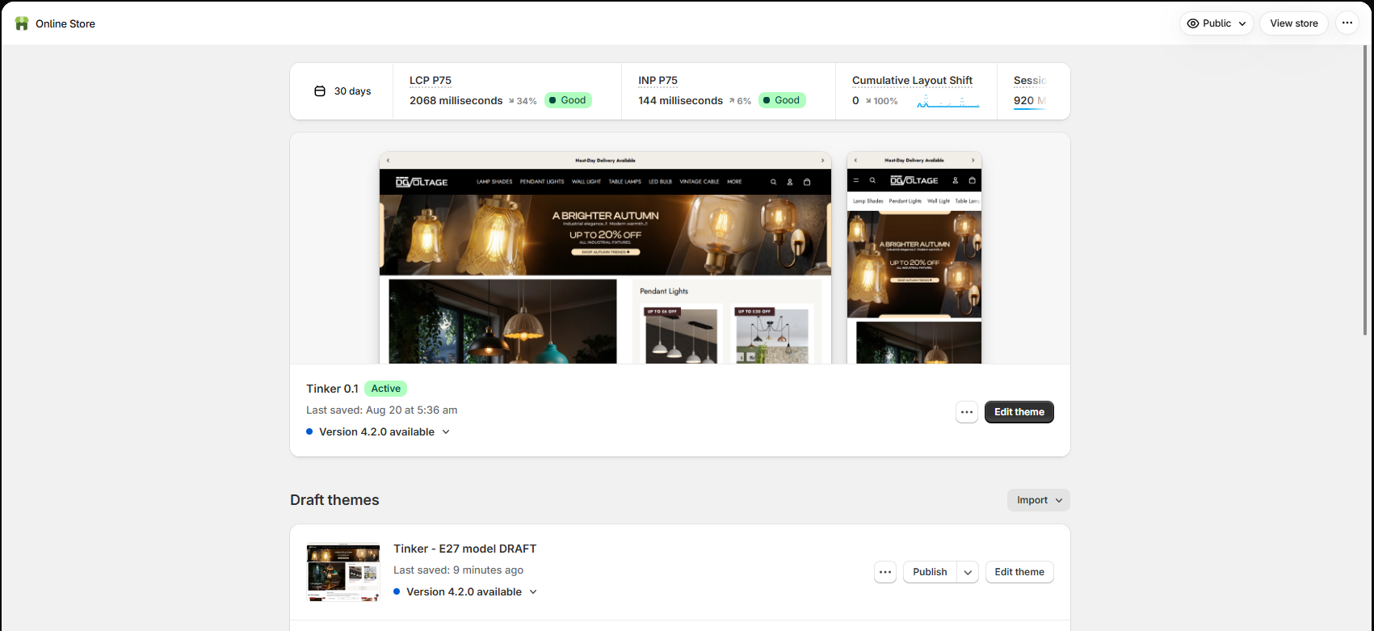
Figure 1. Draft theme "Tinker - E27 model DRAFT" created alongside the live "Tinker 0.1" theme.

Step 2 — Add the Two New Theme Sections
Added model-collection-e27.liquid and model-product-specs.liquid via Edit code. One real Shopify validation error was hit on first save (a schema_mode option label exceeded the 50-character limit), fixed by shortening the option labels.
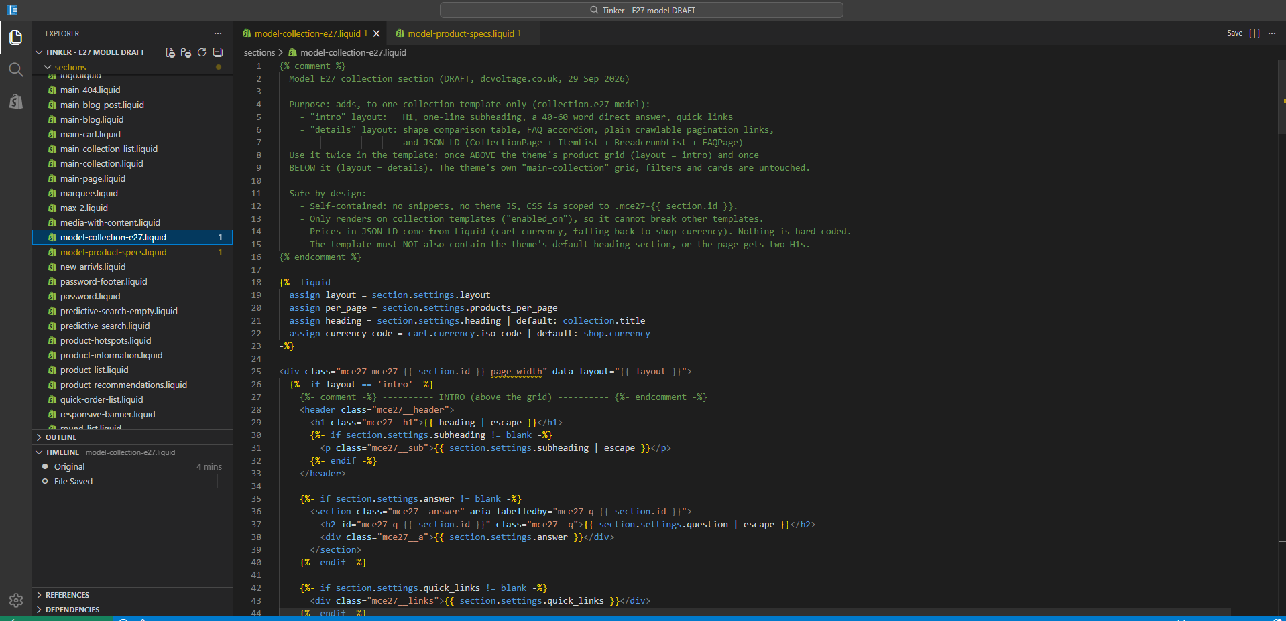
Figure 2. model-collection-e27.liquid saved without errors.
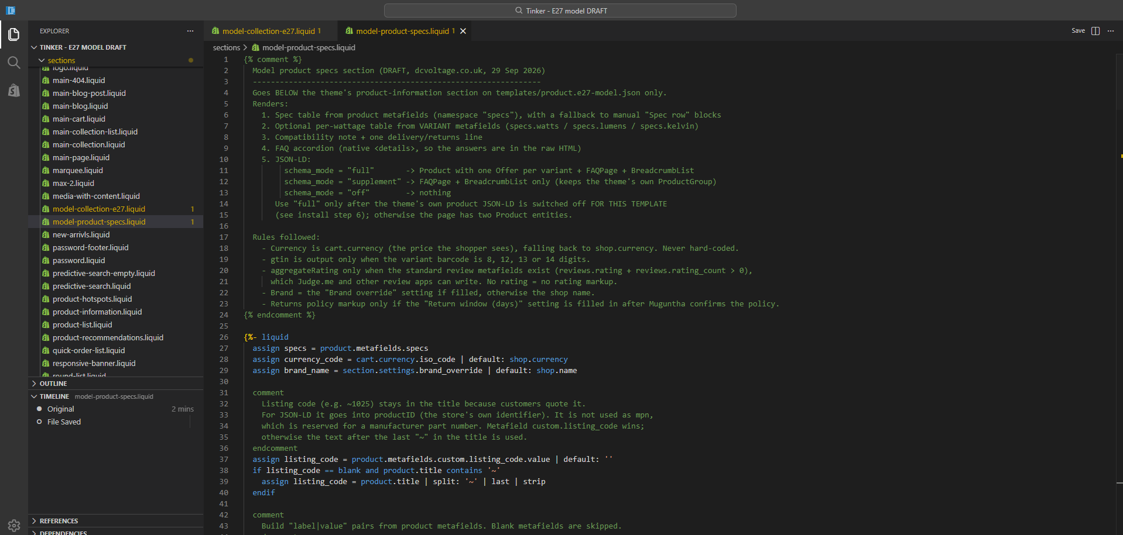
Figure 3. model-product-specs.liquid saved without errors, after fixing the option-label-length error.

Step 3 — Create the Collection Template
Created template e27-model, based on Default collection.
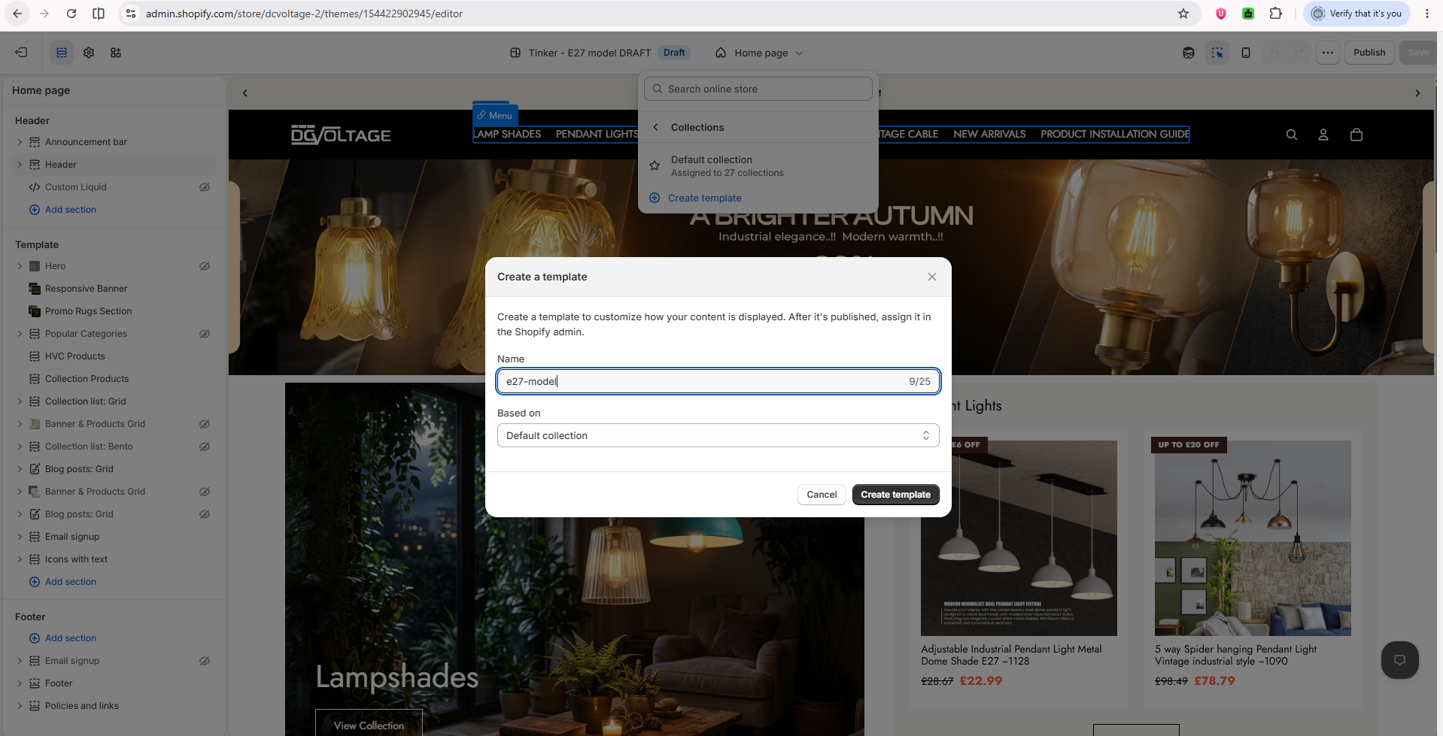
Figure 4. "Create a template" dialog — name e27-model, based on Default collection.
Figure 5. e27-model collection template created and open in the theme editor.

Step 4 — Build the Collection Template: Intro + Details
Filled the Intro section (H1, subheading, 55-word direct answer, quick links) and the Details section (table heading, FAQ heading, 7 shape rows, 6 FAQs, breadcrumb settings). A layout issue (content rendering flush-left) and a quick-links issue (raw URLs instead of hyperlinked text) were found and fixed during this step.
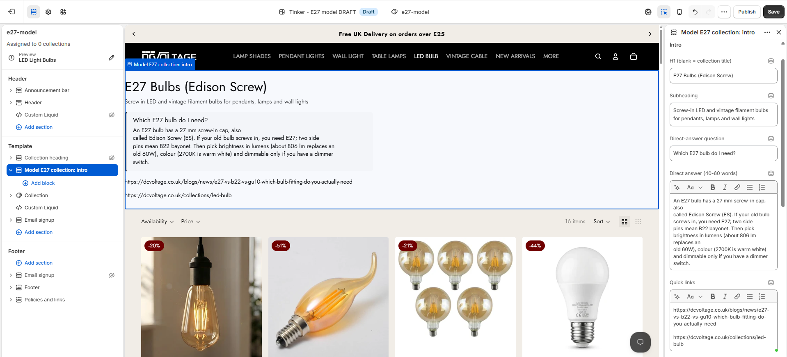
Figure 6. Intro section filled — H1 "E27 Bulbs (Edison Screw)", subheading, direct-answer box, quick links.
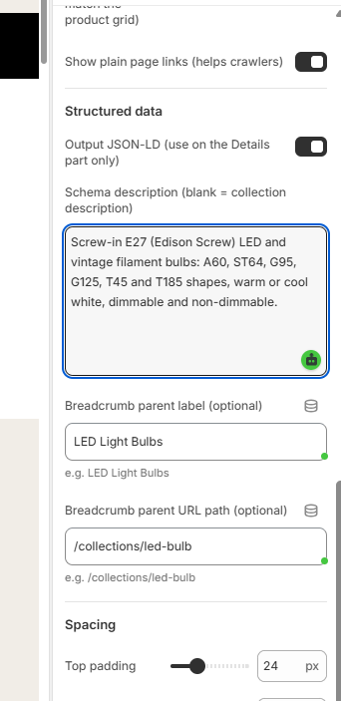
Figure 7. Details section settings — table heading and FAQ heading fields.

Step 5 — Build the Product Template: H1 Fix + Specs Section
Created template e27-model for products, based on Default product. Fixed the product title block to render as a real H1 (previously H3 — the core bug this build exists to fix). Added the "Model product specs" section with a compatibility note and 7 product FAQs.
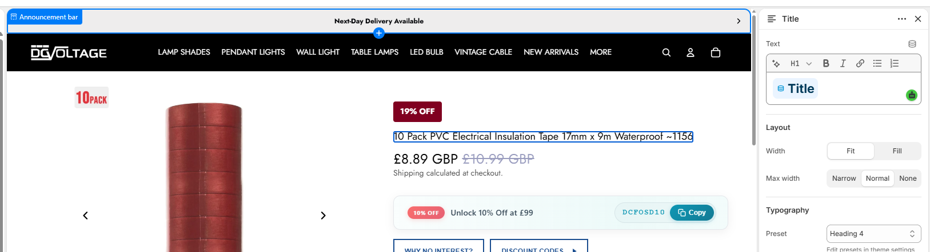
Figure 8. Product title block set to H1 tag in the theme editor.
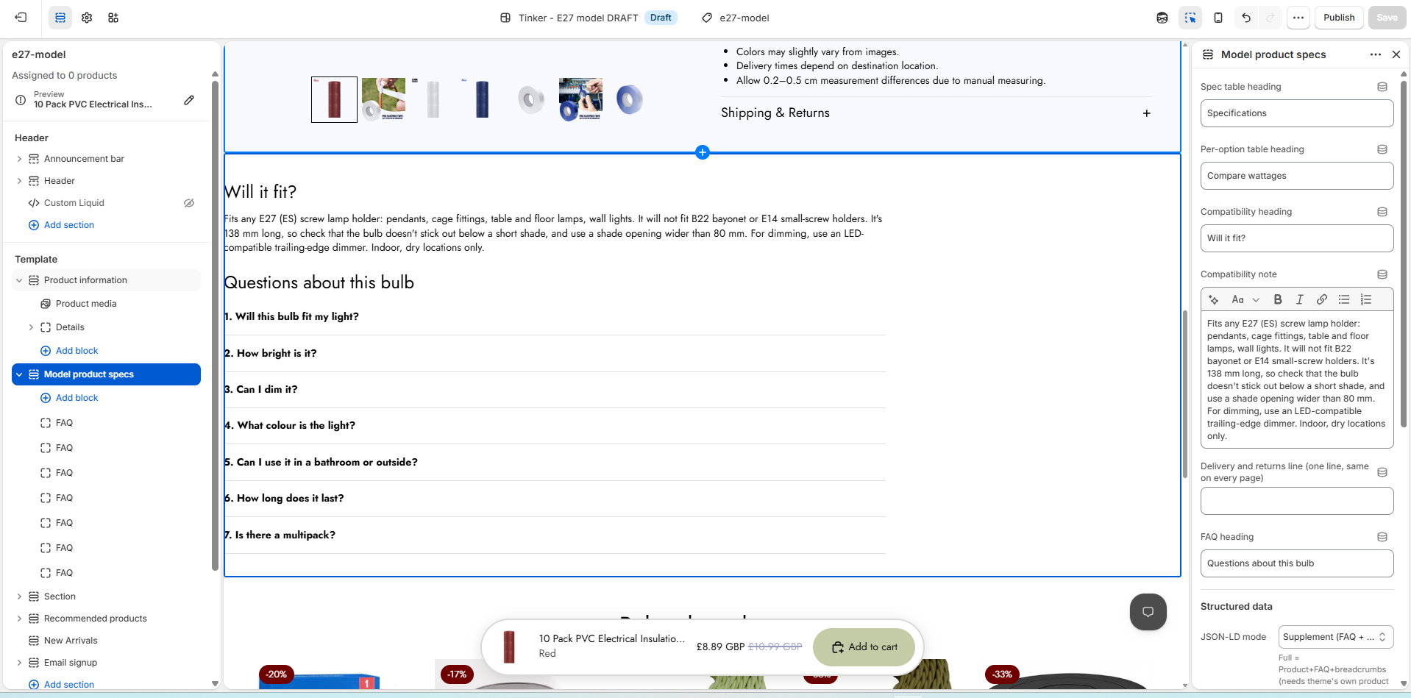
Figure 9. Model product specs section — spec table heading, compatibility note, FAQ heading, JSON-LD mode set to Supplement, 7 FAQs listed.

Step 6 — Create the Product-Level Metafield Definitions
Created 14 product-level metafield definitions (namespace specs.* plus custom.listing_code) — 13 as Single line text, 1 (specs.dimmable) as True/false.
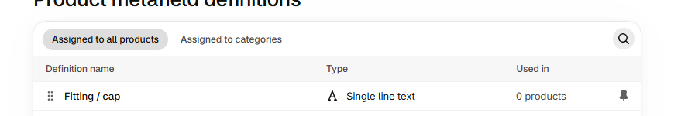
Figure 10. First metafield definition created — "Fitting / cap" (specs.fitting).
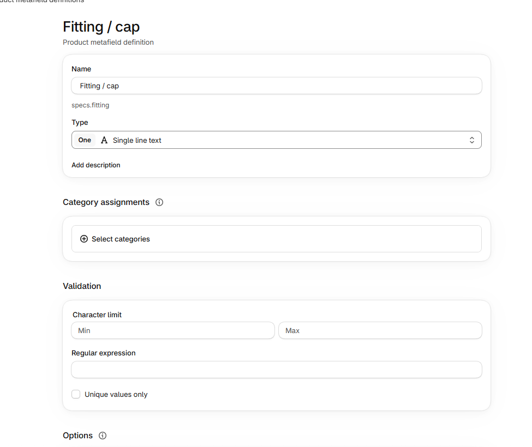
Figure 11. Metafield definition detail view for "Fitting / cap".
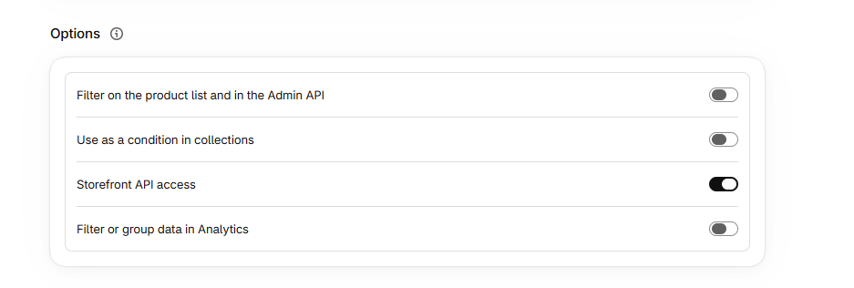
Figure 12. Metafield Options panel (Storefront API access, filters, analytics grouping).
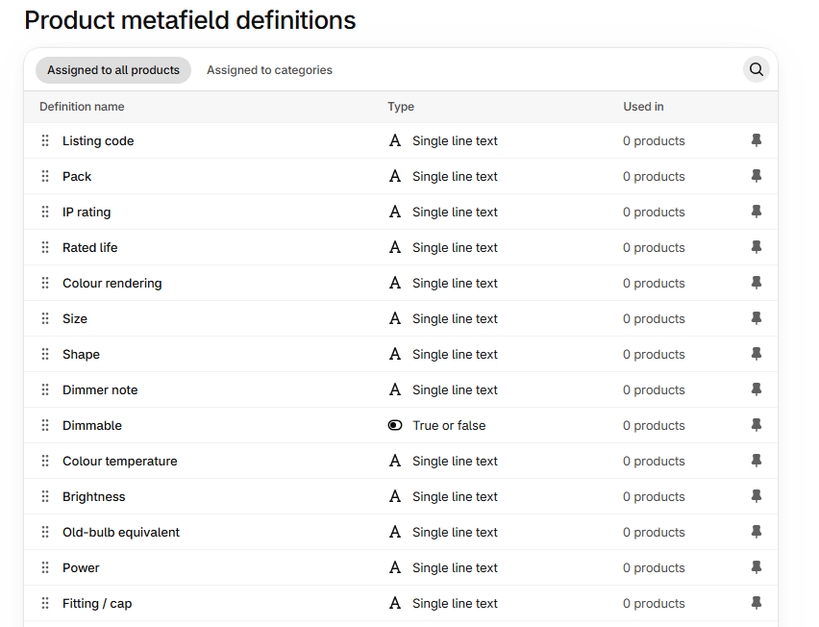
Figure 13. Full list of all 13 product-level metafield definitions, including "Dimmable" correctly typed as True or false.

Step 7 — Create the Variant-Level Metafield Definitions
Created 3 variant-level metafield definitions (specs.watts, specs.lumens, specs.kelvin) for the "Compare wattages" table.
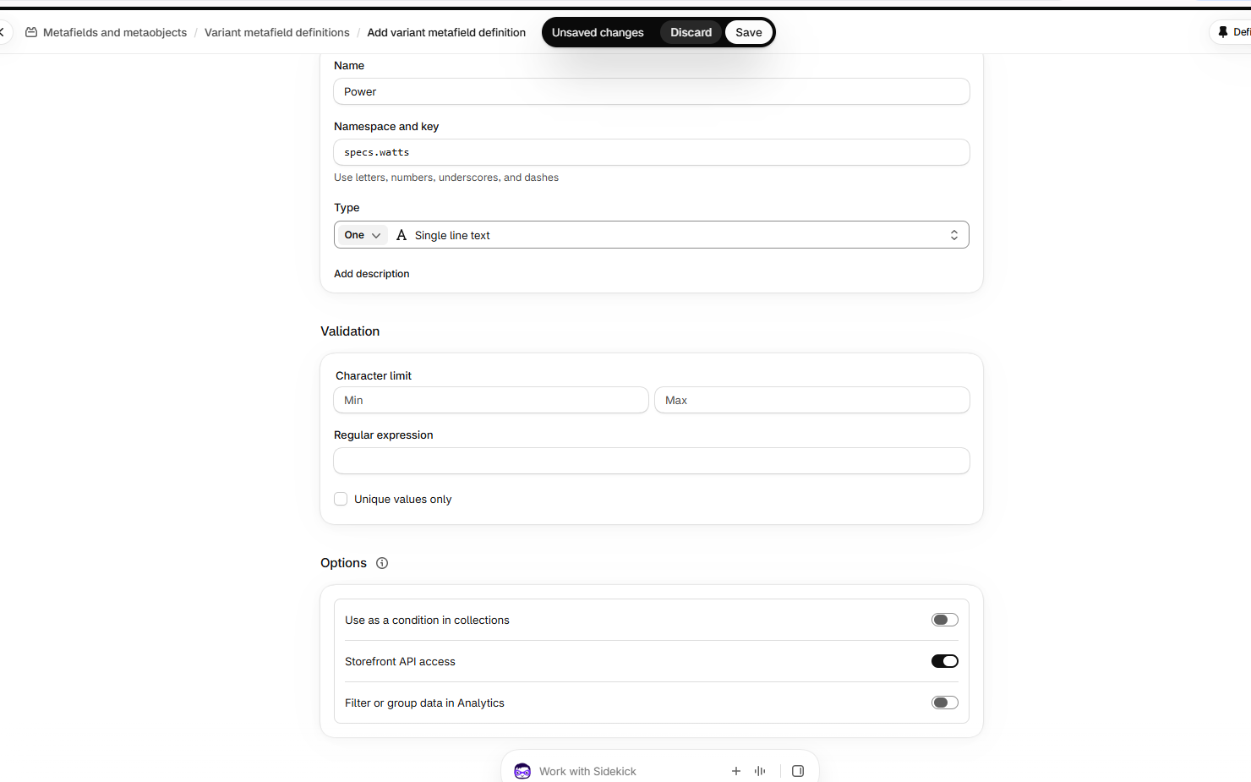
Figure 14. Variant metafield definition — "Power" (specs.watts), Single line text.
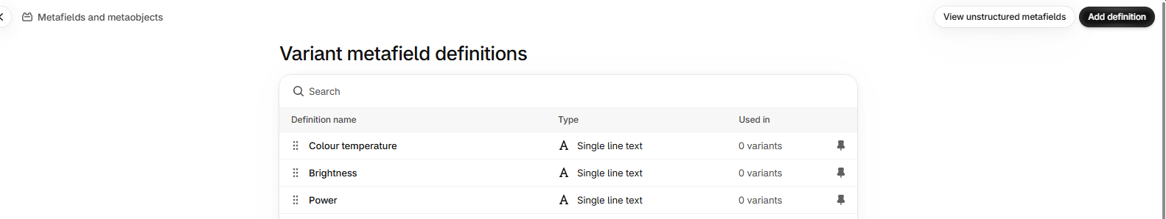
Figure 15. All 3 variant metafield definitions created: Colour temperature, Brightness, Power.

Step 8 — Fill in Real SOT Values for the ST64 ~1025 Product
Entered the real SOT values into the product-level metafields for the ST64 ~1025 best-seller. Two real data-entry errors were caught and corrected: the Listing code was mistakenly entered as 1035 instead of 1025 (fixed after being flagged three times), and the Size/Pack values were initially swapped (Size held "1 bulb", Pack was empty) — corrected to Size = 64 x 138 mm, Pack = 1 bulb.
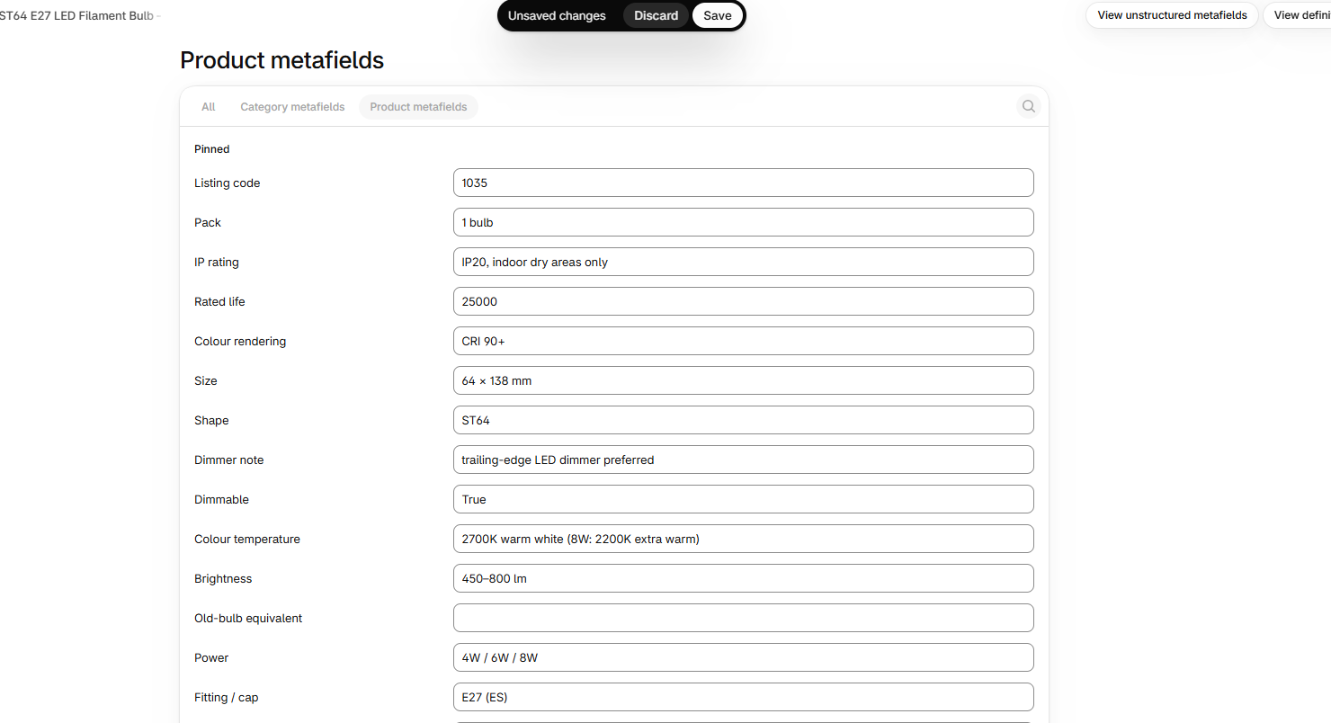
Figure 16. Product metafields being filled in — Listing code still showing the incorrect "1035" at this point.
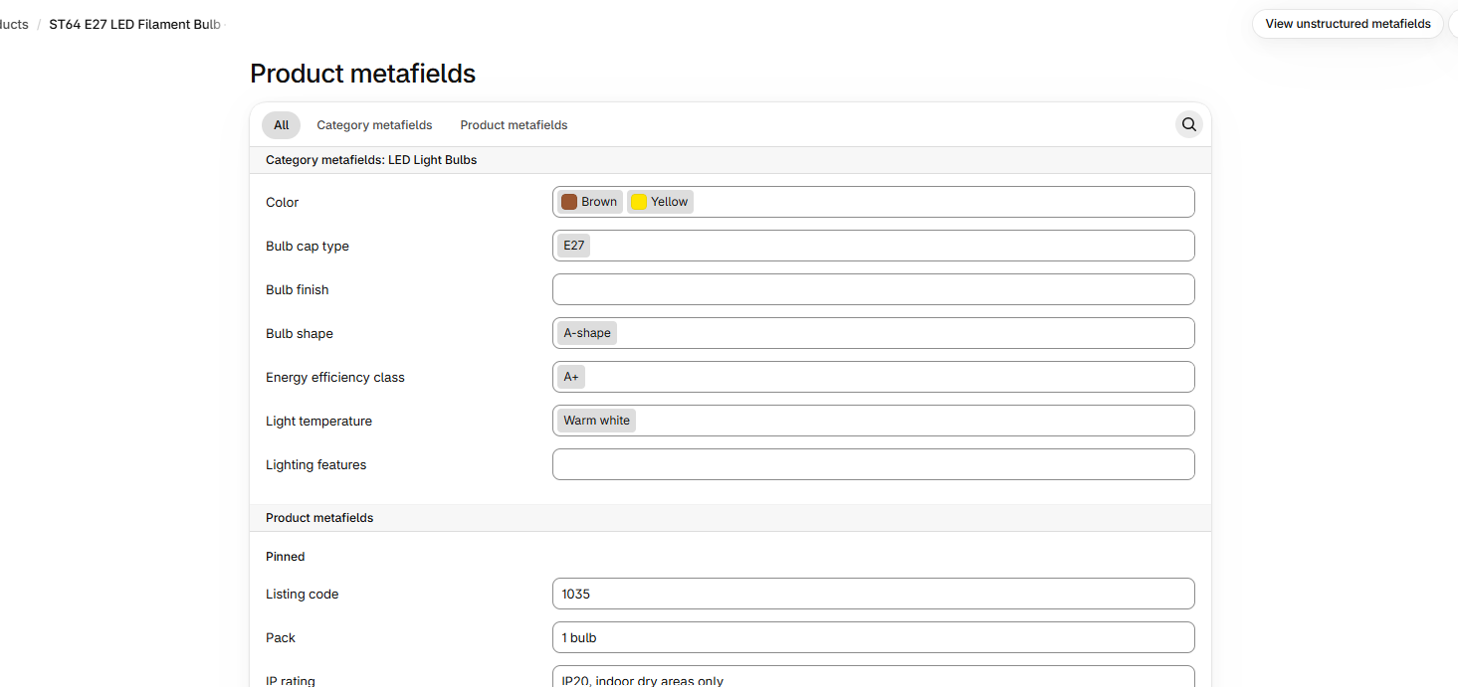
Figure 17. Live category metafield "Bulb cap type" corrected from E27+B22 to E27 only — matches a real bug class the source document flags as having already caused a customer return.
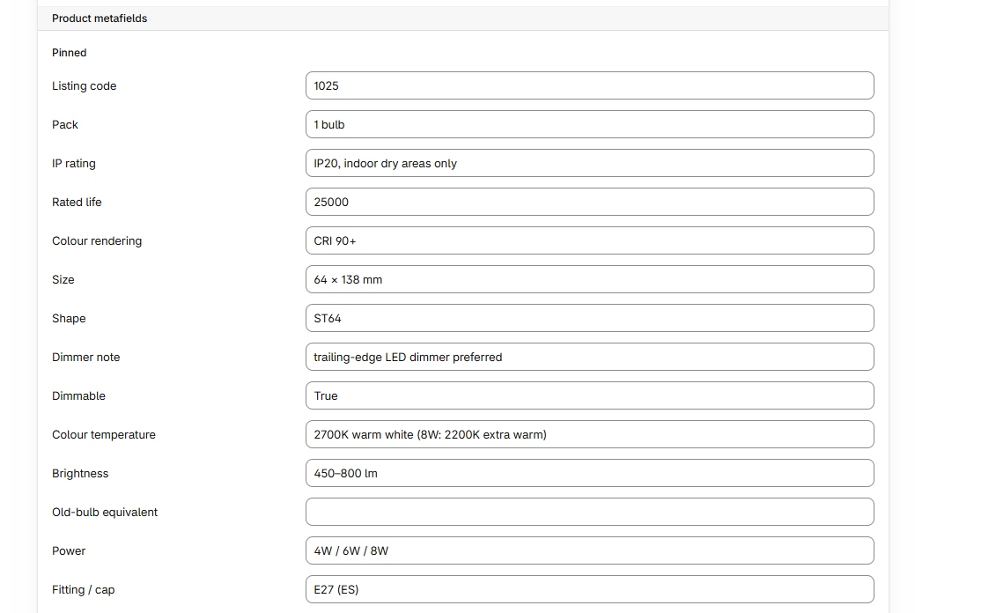
Figure 18. All 14 product-level metafields confirmed correct, including Listing code finally corrected to 1025.
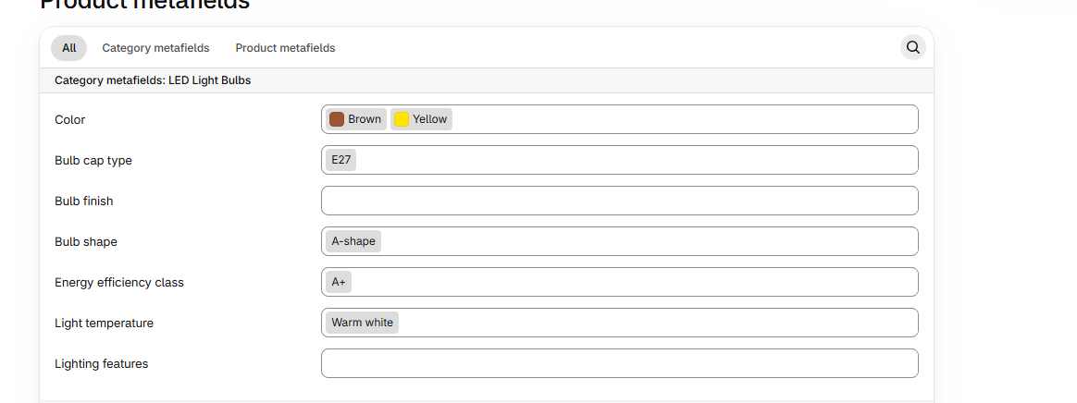
Figure 19. Confirmation view — Bulb cap type shows only E27; Listing code still showing 1035 at this point in the sequence, corrected shortly after.

Step 9 — Fill in Variant-Level Values (4W / 6W / 8W)
Entered specs.watts / specs.lumens / specs.kelvin for each of the 3 variants (SKUs LDMST64E274, LDMST64E276, LDMST64E278). The 6W variant's brightness value was correctly left blank per the source document (SOT shows the same value as 4W, flagged as unreliable — NEEDS SUPPLIER CONFIRMATION).
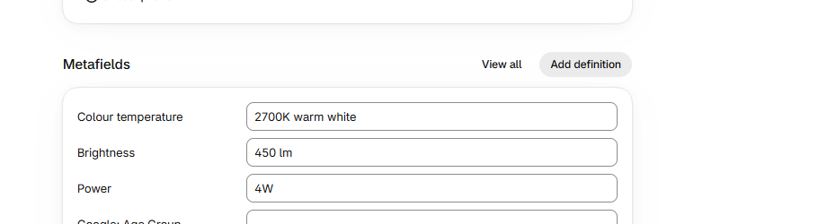
Figure 20. 4W variant (LDMST64E274): Colour temperature 2700K warm white, Brightness 450 lm, Power 4W.
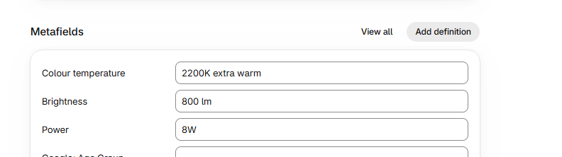
Figure 21. 8W variant (LDMST64E278): Colour temperature 2200K extra warm, Brightness 800 lm, Power 8W.
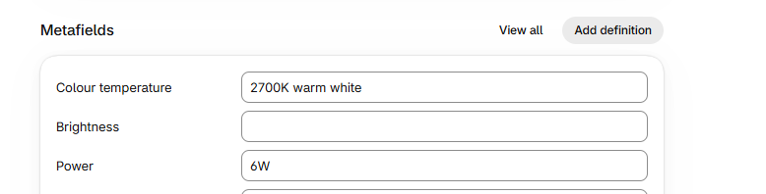
Figure 22. 6W variant (LDMST64E276): Colour temperature 2700K warm white, Brightness left blank (NEEDS SUPPLIER CONFIRMATION), Power 6W.

Step 10 — Final Validation of the Rendered Pages
Checked both the product page and the collection page on the live preview (?view=e27-model&preview_theme_id=...). A layout bug affecting both pages (content rendering flush-left with no side margins) was fixed by adding explicit centering CSS, matched to the theme's real 1440px content width confirmed via live devtools inspection. A data bug in the shape table (row 1 duplicating the "ST64 squirrel cage" label instead of reading "A60 standard") was also caught and fixed.
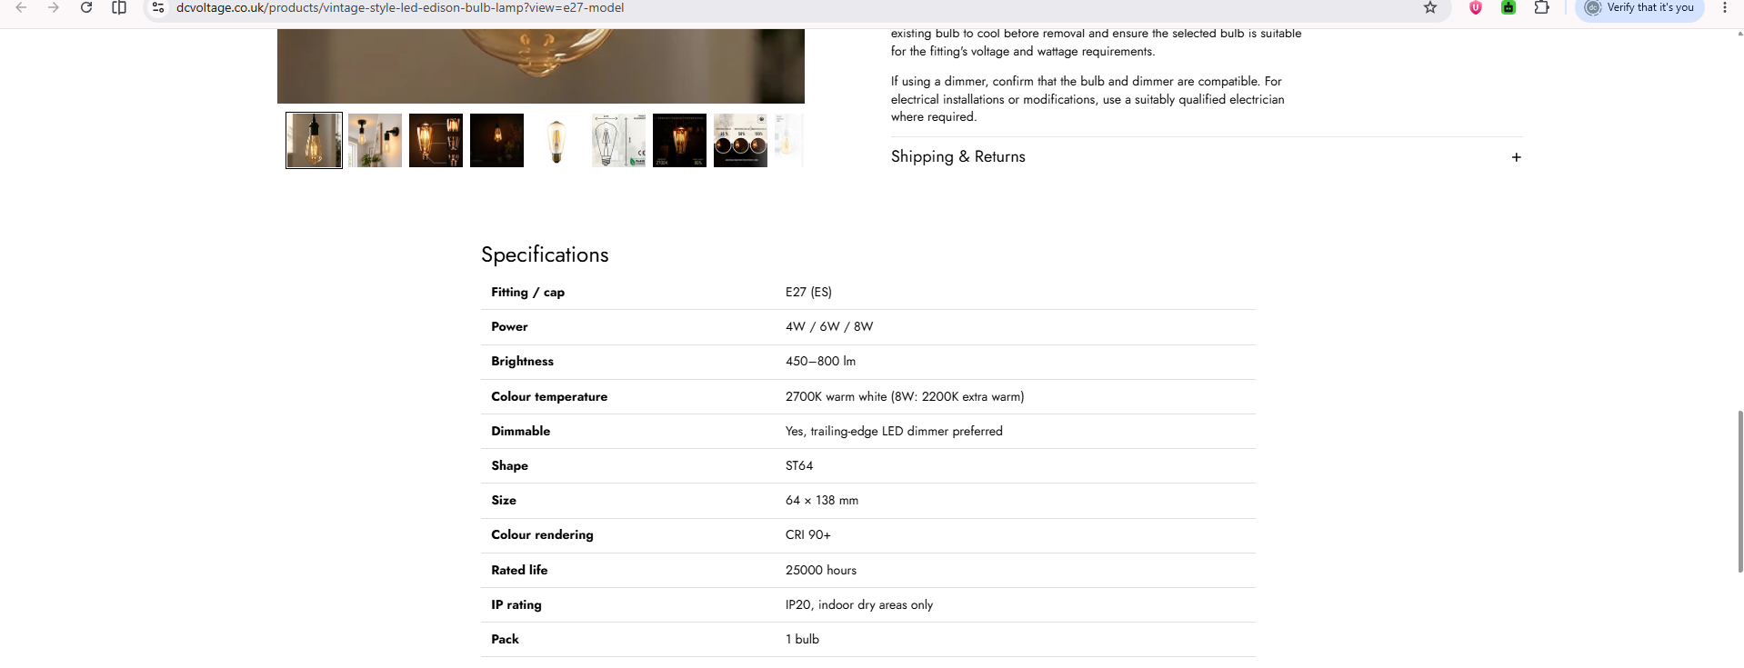
Figure 23. Product page preview — Specifications table and Compare wattages table rendering correctly with real SOT data, properly centred.
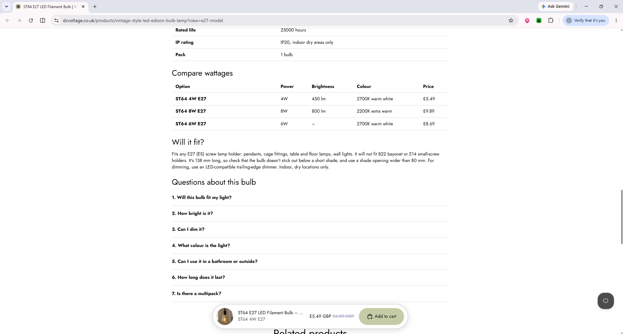
Figure 24. Product page preview — Compare wattages table, "Will it fit?" compatibility note, and all 7 product FAQs.
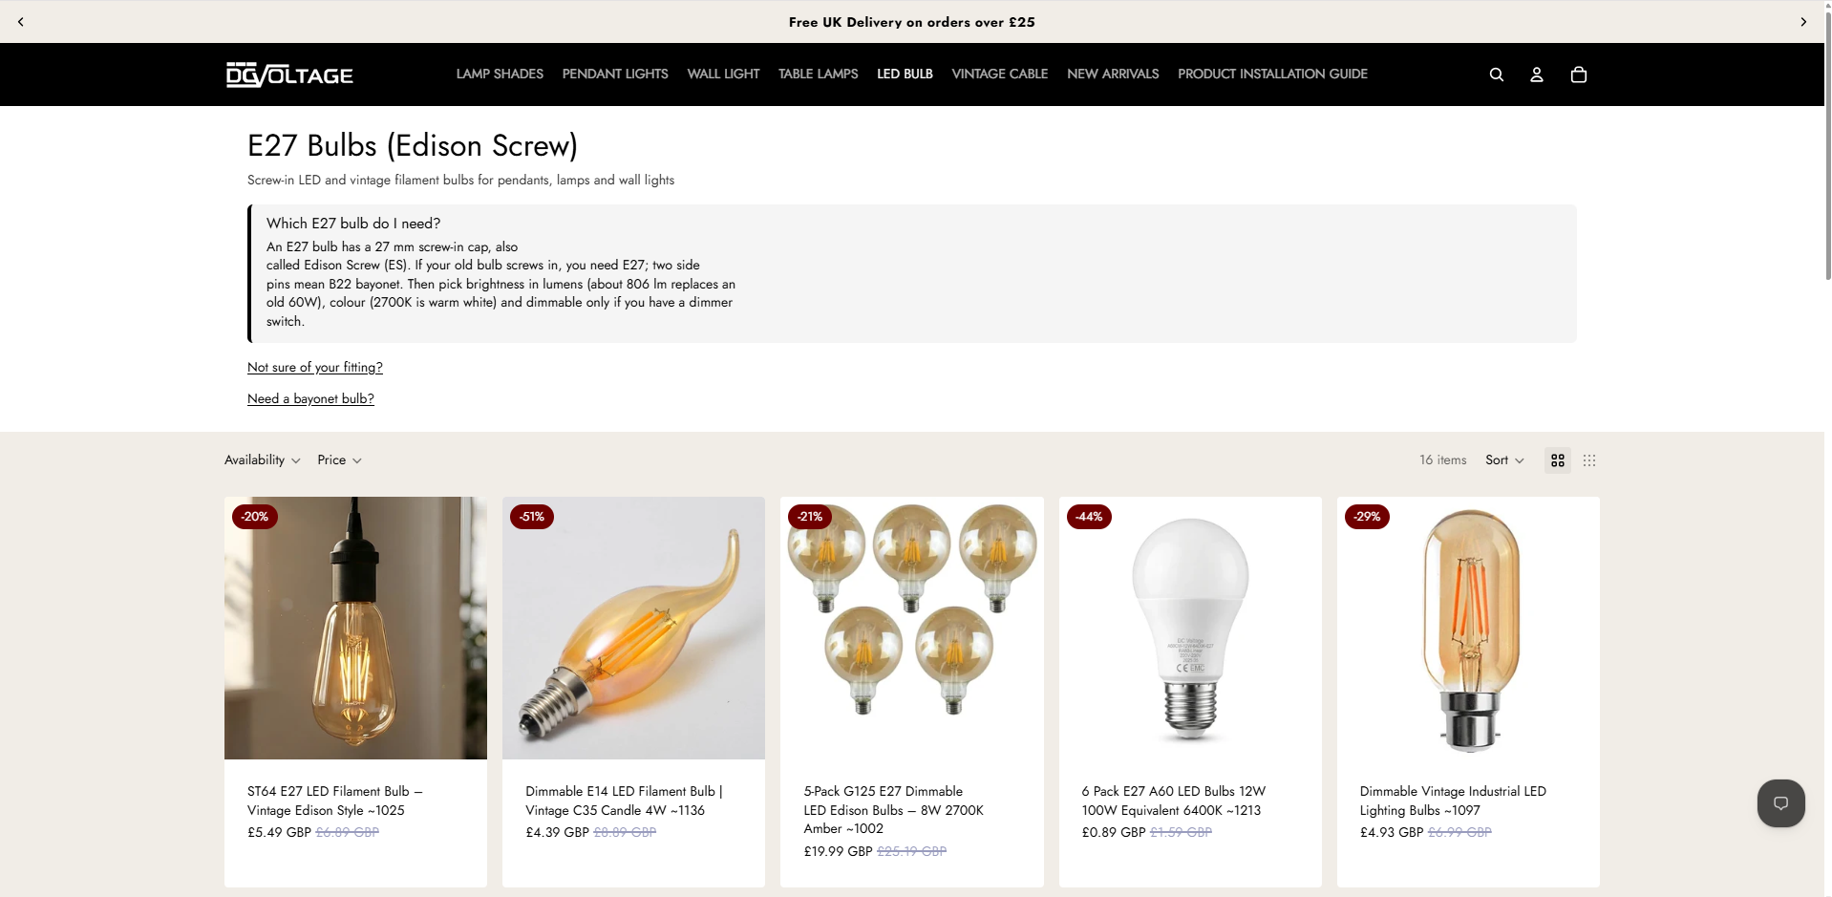
Figure 25. Collection page preview — Intro section (H1, subheading, direct answer, hyperlinked quick links) and start of the product grid.
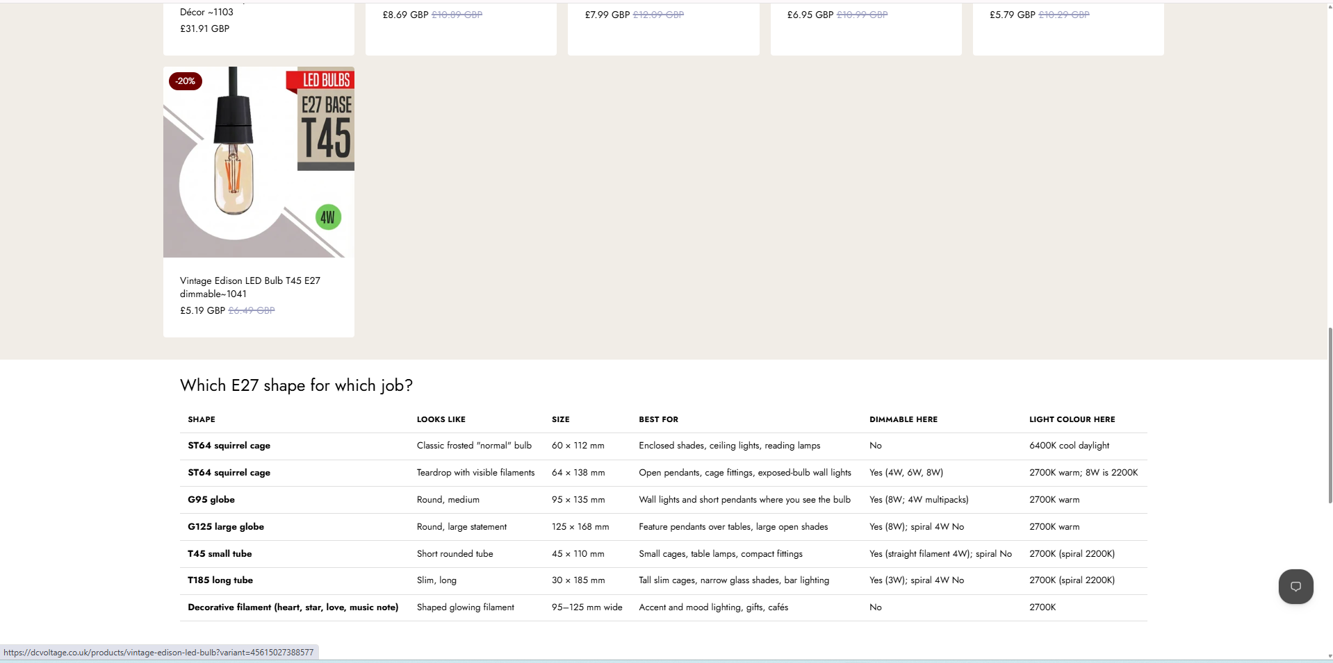
Figure 26. Collection page preview — shape comparison table, showing the row-1 duplicate-label bug prior to the fix.
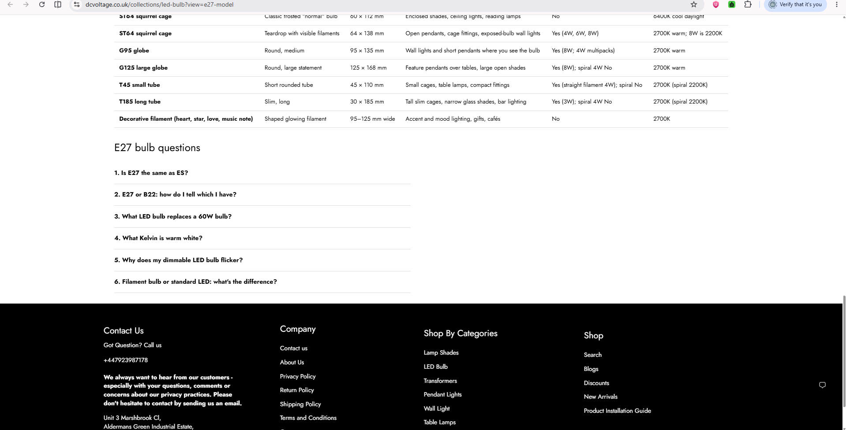
Figure 27. Collection page preview — shape table, 6 collection FAQs, and site footer.
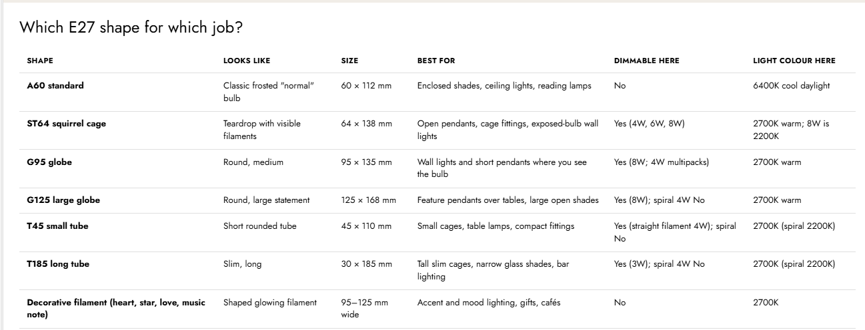
Figure 28. Shape table after the fix — all 7 rows correct: A60 standard, ST64 squirrel cage, G95 globe, G125 large globe, T45 small tube, T185 long tube, Decorative filament.

Step 11 — Send Preview Links and Screenshots to Muguntha
Sent both preview links (product and collection) plus desktop and mobile screenshots to Muguntha via Teams, per the source document's approval process.

3. Going Live (Post-Approval) — In Order
Muguntha reviewed and approved the build. The steps below cover creating the live collection, adding filters, assigning templates and publishing — all carried out after his written approval, per rule A9 of the source document.

Step 12 — Create the Live "E27 Bulbs" Collection
A first attempt at this collection was built incorrectly by a teammate: named "E27 Base Bulb", set up as an automated collection matching Tag includes "E27 NEW" (16 items), which does not match the source document's instruction to use a manual collection with the 17 named listings. This was caught during validation, discarded, and rebuilt correctly: renamed "E27 Bulbs", converted to a manual collection, and the 17 listed products added individually by their listing codes. SEO title, meta description and the e27-bulbs handle were then filled in exactly as specified in section 3.4.
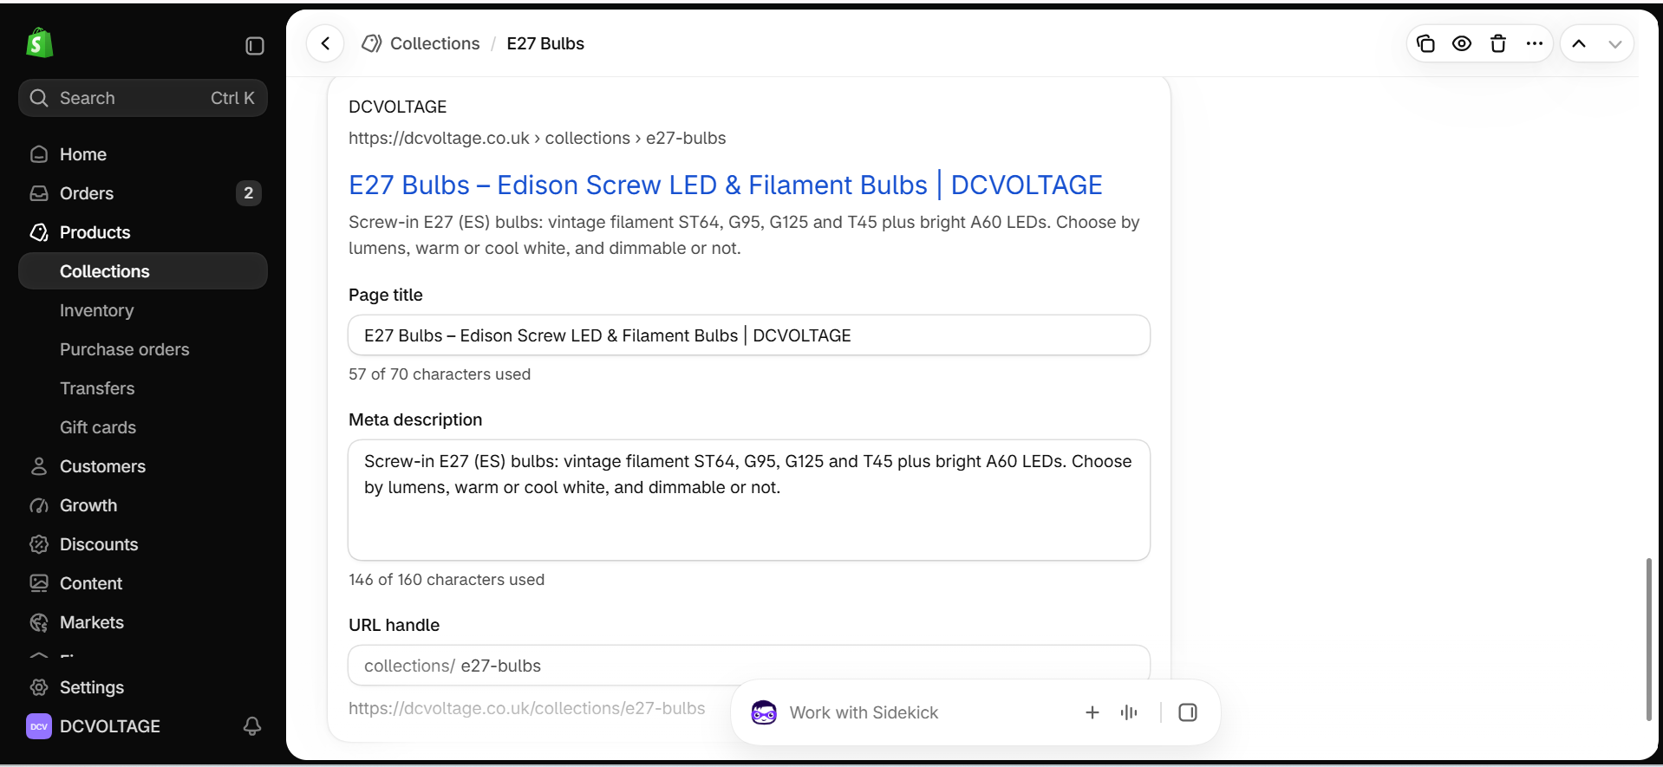
Figure 29. Corrected "E27 Bulbs" collection — handle e27-bulbs, SEO title and meta description matching the source document exactly.
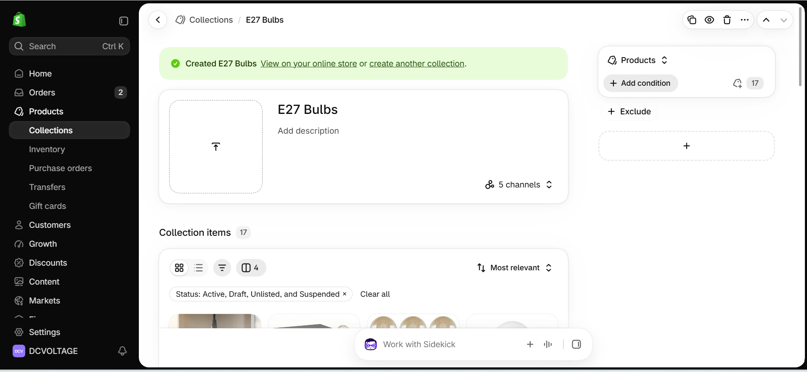
Figure 30. Collection created as a manual collection with the full 17 items, confirmed by the "17" badge next to Products.

Step 13 — Add Search & Discovery Filters
Added filters per the source document's filter plan (section 3.4): Fitting, Brightness, Colour of light (relabelled from the metafield's internal name "Colour temperature"), Dimmable and Shape. Two filters specified in a later phase were added by mistake and then removed during validation: "Old-bulb equivalent" (source data is blank on every product, marked NEEDS SUPPLIER CONFIRMATION in SOT) and "Pack Size" (the underlying variant option name is inconsistent across the store — values pulled in ("1 pcs", "10 Pcs", "20 Pcs") did not match the E27 range at all, confirming the option-name cleanup the source document flags as a prerequisite has not been done yet).
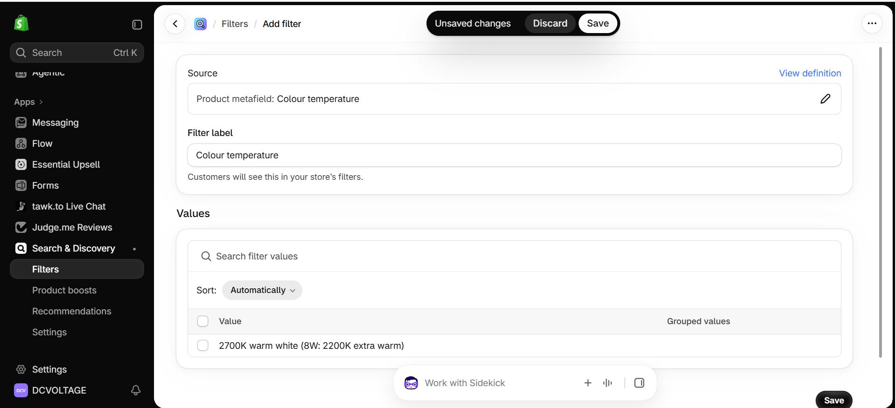
Figure 31. Colour temperature filter (specs.kelvin) with real product values populated, before being relabelled.
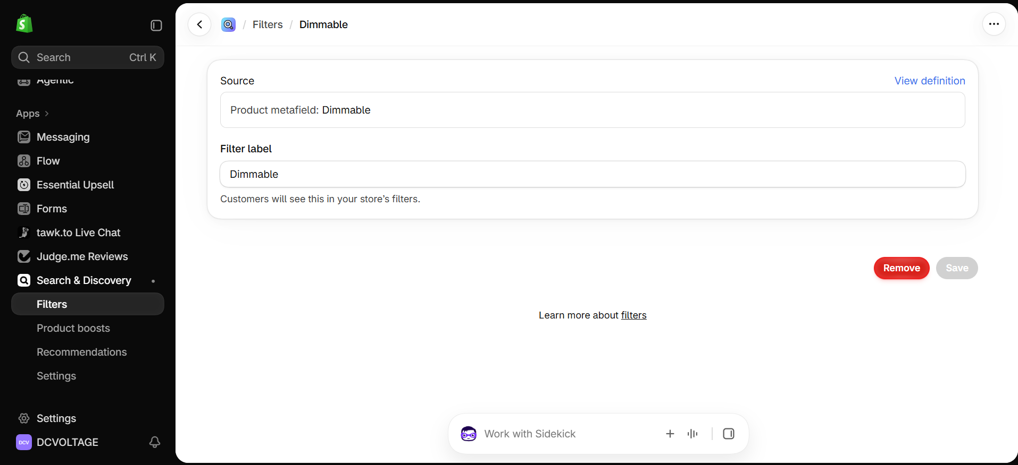
Figure 32. Dimmable filter (specs.dimmable) configured.
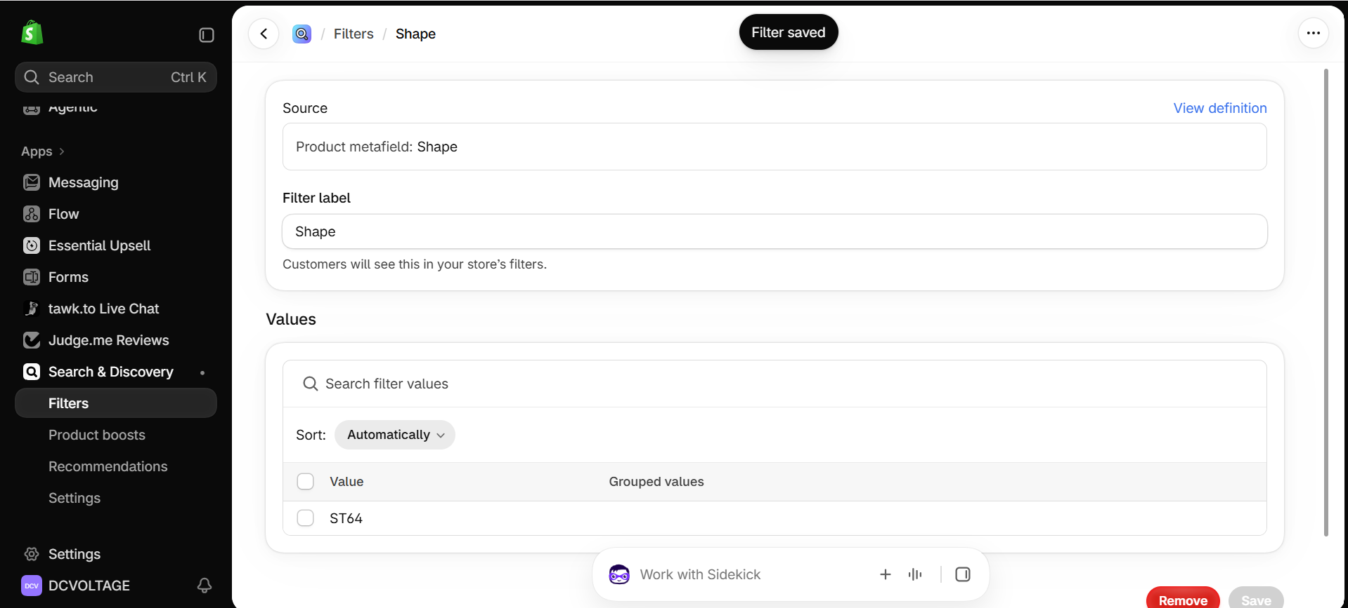
Figure 33. Shape filter (specs.shape) saved.
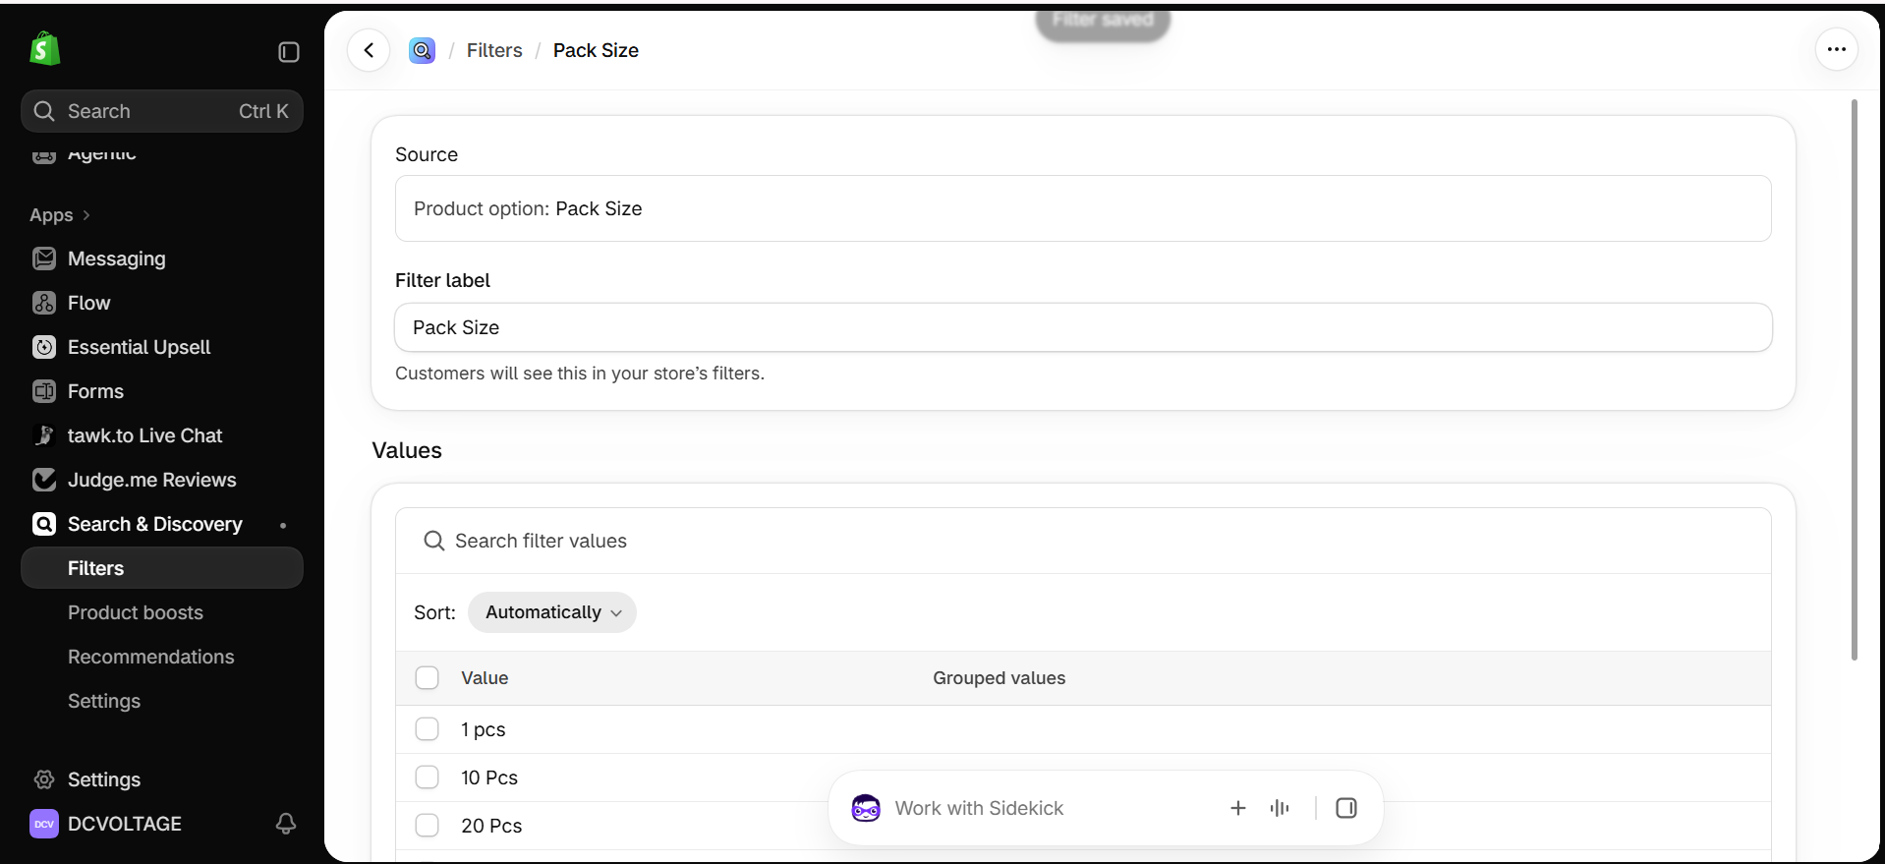
Figure 34. Pack Size filter showing mismatched values ("1 pcs", "10 Pcs", "20 Pcs") — later removed as incorrect.
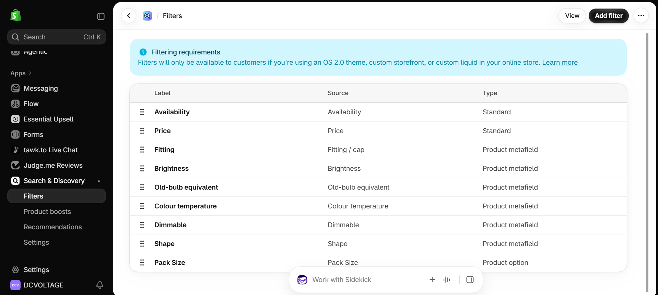
Figure 35. Filter list before correction — Old-bulb equivalent and Pack Size still present, Colour temperature not yet relabelled.
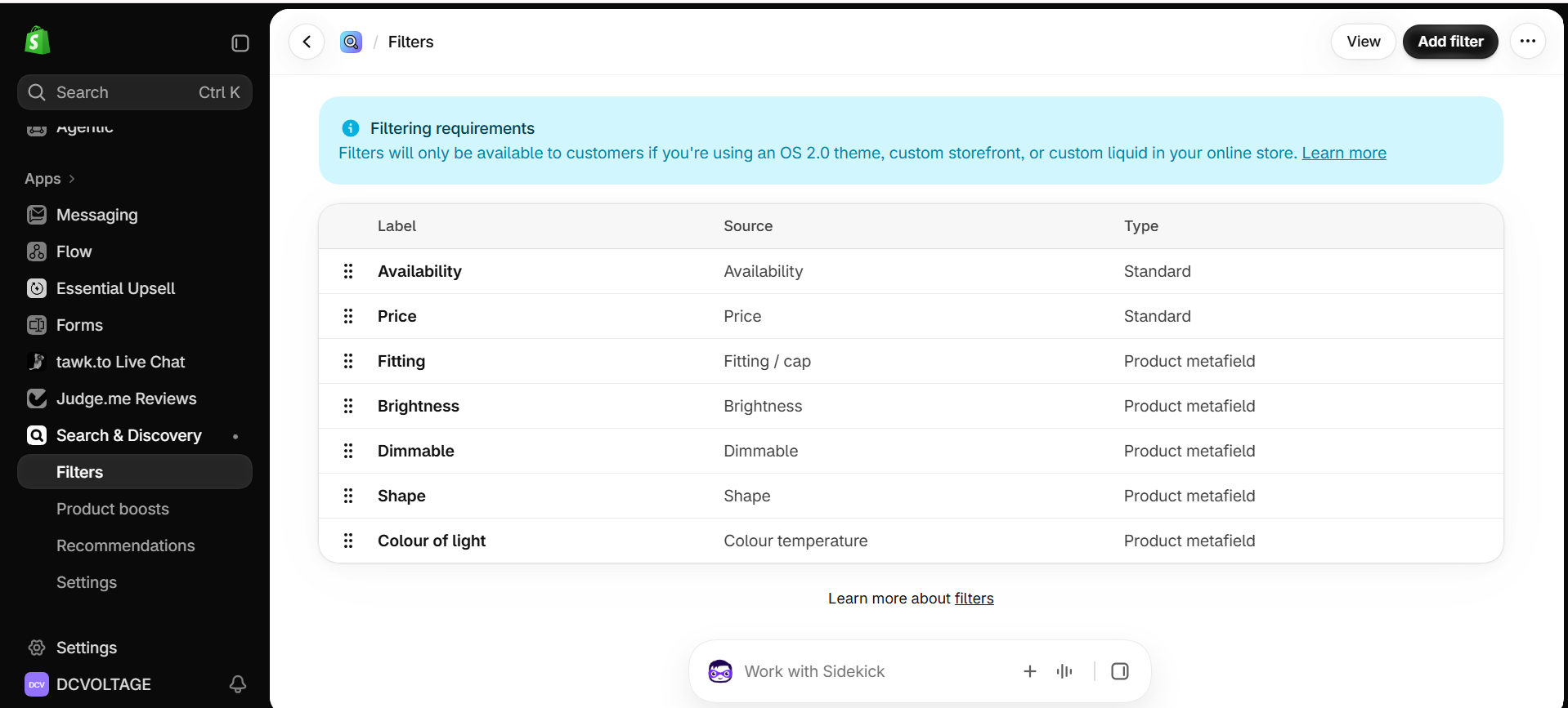
Figure 36. Final corrected filter list: Availability, Price, Fitting, Brightness, Dimmable, Shape, and Colour of light — matching the source document exactly.

Step 14 — Assign Templates and Publish
Assigned the e27-model theme template to both the ST64 ~1025 product and the new E27 Bulbs collection, then published the "Tinker - E27 model DRAFT" theme, making it the live theme for dcvoltage.co.uk. Template assignment was done after publishing, since the e27-model template only became selectable in the admin once it existed on the live theme.
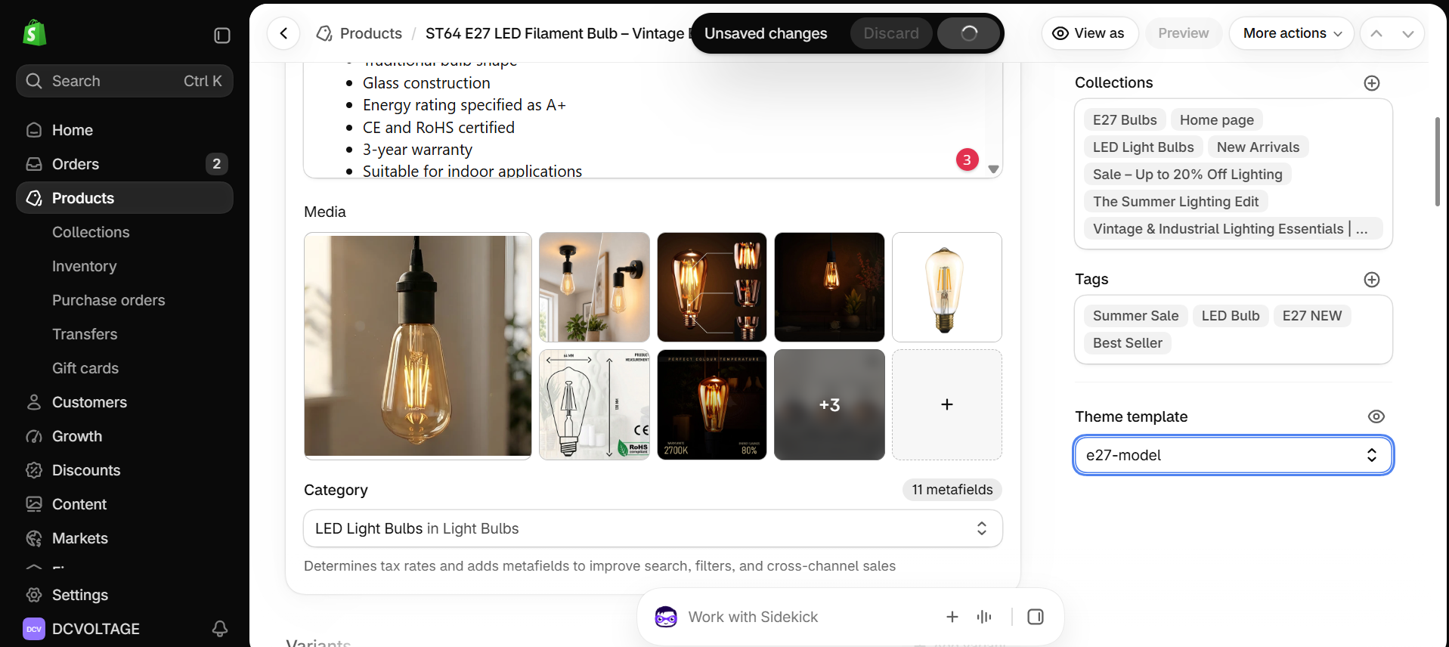
Figure 37. ST64 ~1025 product — Theme template set to e27-model.
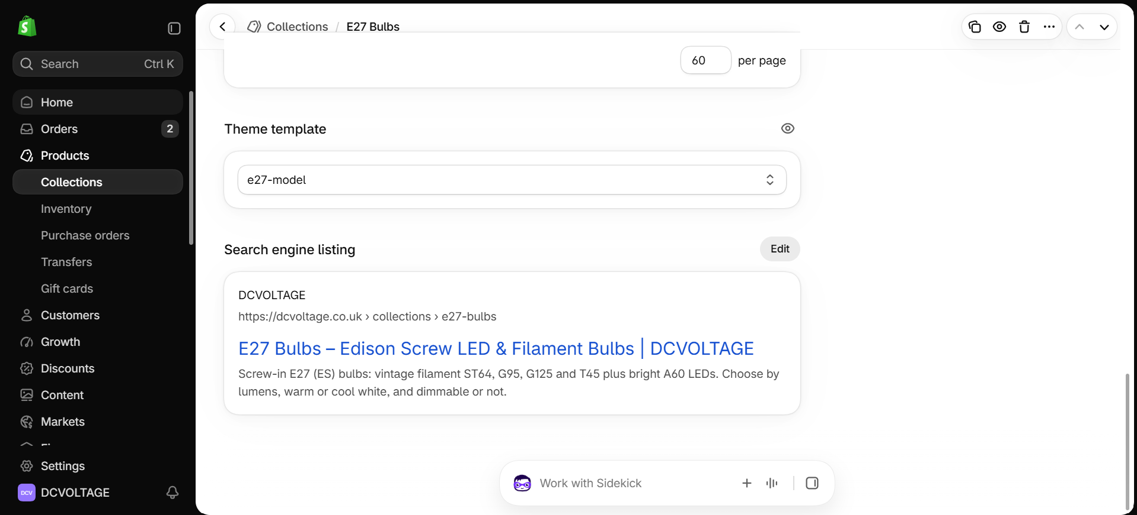
Figure 38. E27 Bulbs collection — Theme template set to e27-model, SEO listing confirmed.
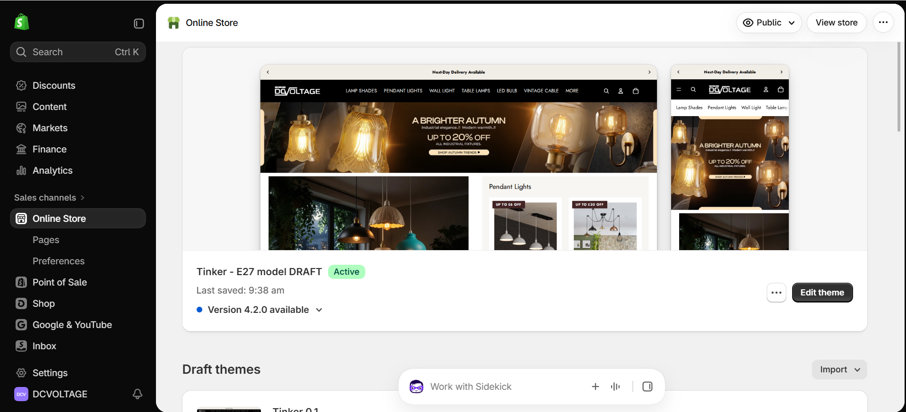
Figure 39. "Tinker - E27 model DRAFT" now shows as the Active theme; the previous live theme moved to Draft themes.

Live URLs
- Collection: https://dcvoltage.co.uk/collections/e27-bulbs
- Product: https://dcvoltage.co.uk/products/vintage-style-led-edison-bulb-lamp

Step 15 — Verify Structured Data and Request Indexing
Ran both live URLs through Google's Rich Results Test: the collection page returned 18 valid items (17 Product snippets, 1 Breadcrumbs), the product page returned 5 valid items (1 Product snippet, 3 Merchant listings, 1 Breadcrumbs) — both passed, with only non-critical issues noted on Product snippets (not blocking eligibility). Then used Google Search Console's URL Inspection tool to request indexing for both URLs — the collection page was not yet indexed and was added to the priority crawl queue; the product page was already indexed (from its prior content) and indexing was re-requested to pick up the new content.
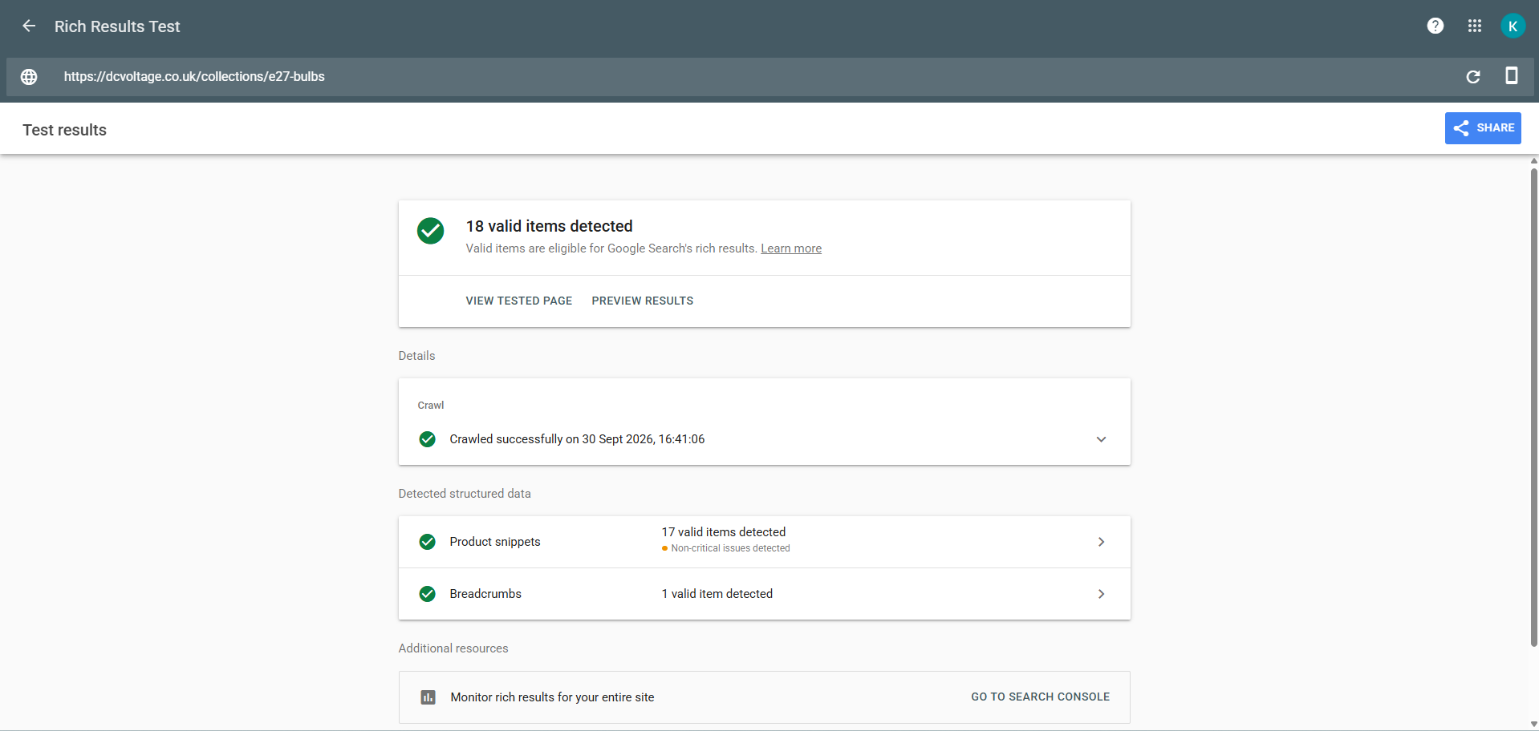
Figure 40. Rich Results Test — collection page: 18 valid items detected, Product snippets and Breadcrumbs both valid.
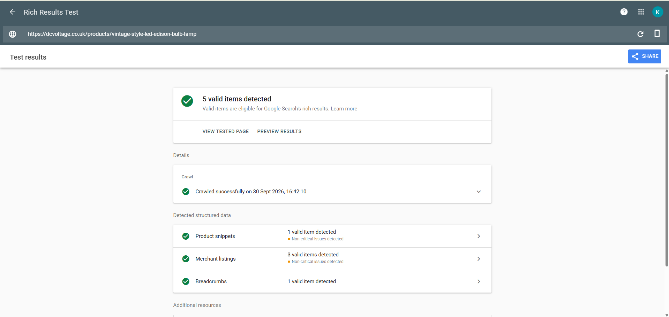
Figure 41. Rich Results Test — product page: 5 valid items detected, Product snippets, Merchant listings and Breadcrumbs all valid.
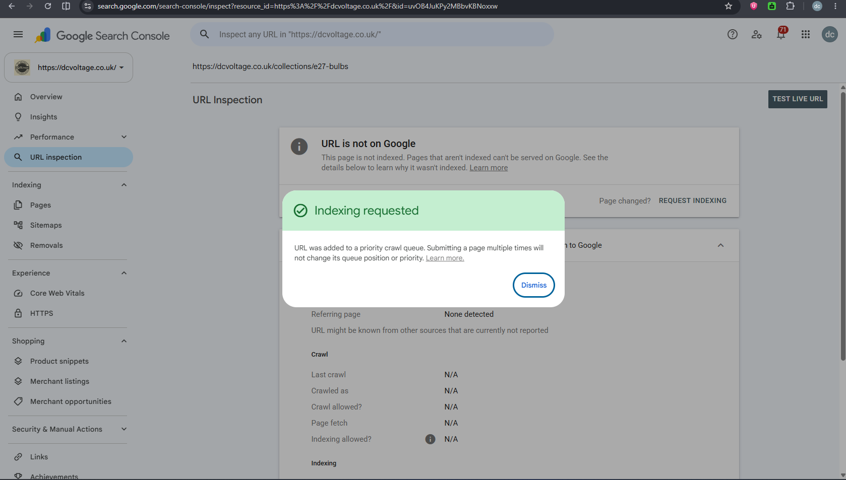
Figure 42. Google Search Console — indexing requested for the collection URL, added to the priority crawl queue.
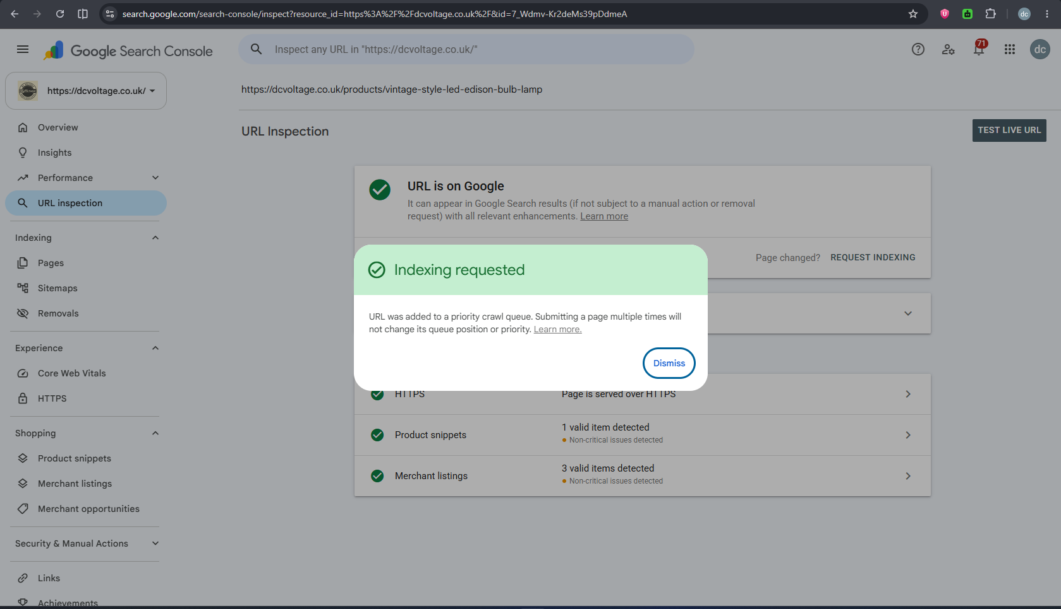
Figure 43. Google Search Console — indexing requested for the product URL (already indexed; re-requested to pick up the new content).

Step 16 — Post-Approval Product Data Updates
With Muguntha's explicit confirmation, three further changes were made directly to the live ST64 ~1025 product (data-field edits, not theme/template changes, so no preview step applied): the new product title was applied per section 3.5, keeping the ~1025 listing code at the end; the ST64 6W variant price was changed from GBP 8.69 to GBP 5.99, the one price change proposed in section 4 (the existing GBP 9.89 compare-at price was left as-is, since it sits above the new selling price and is not a misleading "was" price); and, caught during final validation, the product Description field was found to still carry the unconfirmed claims D04 explicitly flags ("Energy rating specified as A+", "CE and RoHS certified", "3-year warranty") plus an incorrect dimension ("14.8cm height" vs SOT's real 138 mm). These were removed and corrected, closing D04 for this product; everything else in the description was left unchanged.
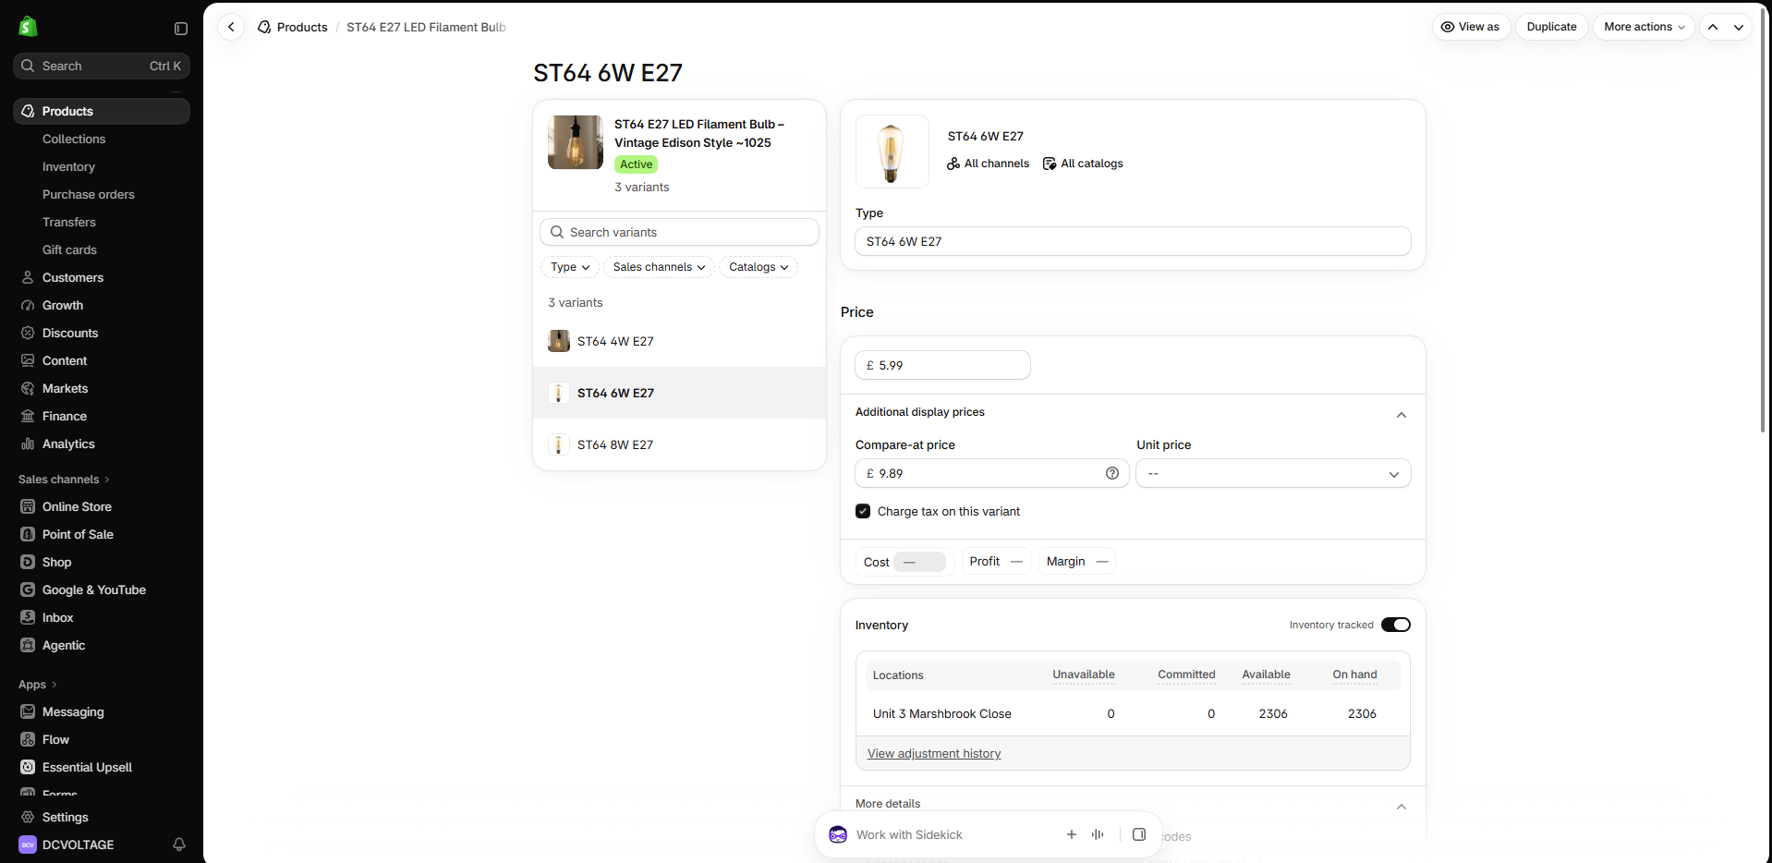
Figure 44. ST64 6W variant price updated to £5.99; compare-at price (£9.89) left unchanged as it is not misleading.
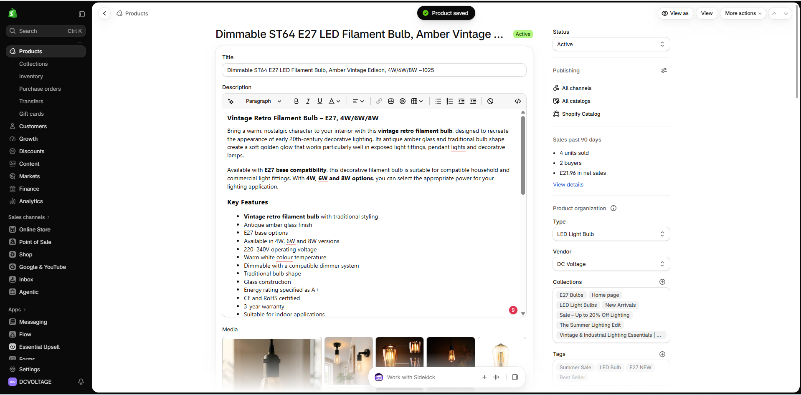
Figure 45. Product title updated to "Dimmable ST64 E27 LED Filament Bulb, Amber Vintage Edison, 4W/6W/8W ~1025".
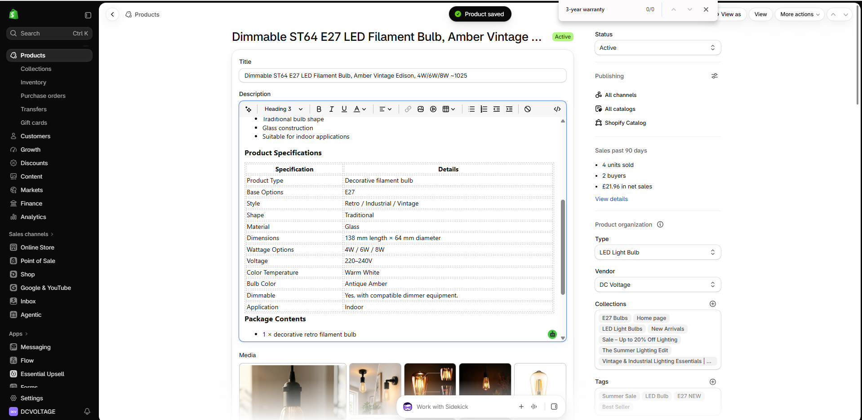
Figure 46. Description corrected — unconfirmed claims (Energy Rating A+, CE/RoHS, 3-year warranty) and the wrong dimension removed; everything else preserved unchanged. Search shows zero remaining matches for the removed text, confirming the edit is complete.

3a. Post-Approval Follow-Up — R19 Fixes (1 Oct 2026)
Mani (listing corrections channel) re-checked the live build on 1 Oct 2026 and confirmed PASS on the build, approval and price items above, but flagged 2 further open items, with a deadline of 17:00 Sri Lanka time the same day: the ST64 ~1025 product's SEO title still showed old wording, and the "E27 vs B22 vs GU10" guide blog post had a duplicate H1, no link to the new /collections/e27-bulbs, and no FAQ schema despite having a real FAQ section.

Step 17 — Fix ST64 ~1025 SEO Title
Updated the ST64 ~1025 product's Search engine listing page title to "Dimmable ST64 E27 LED Filament Bulb, Amber ~1025 | DCVOLTAGE", matching Mani's requested wording exactly.
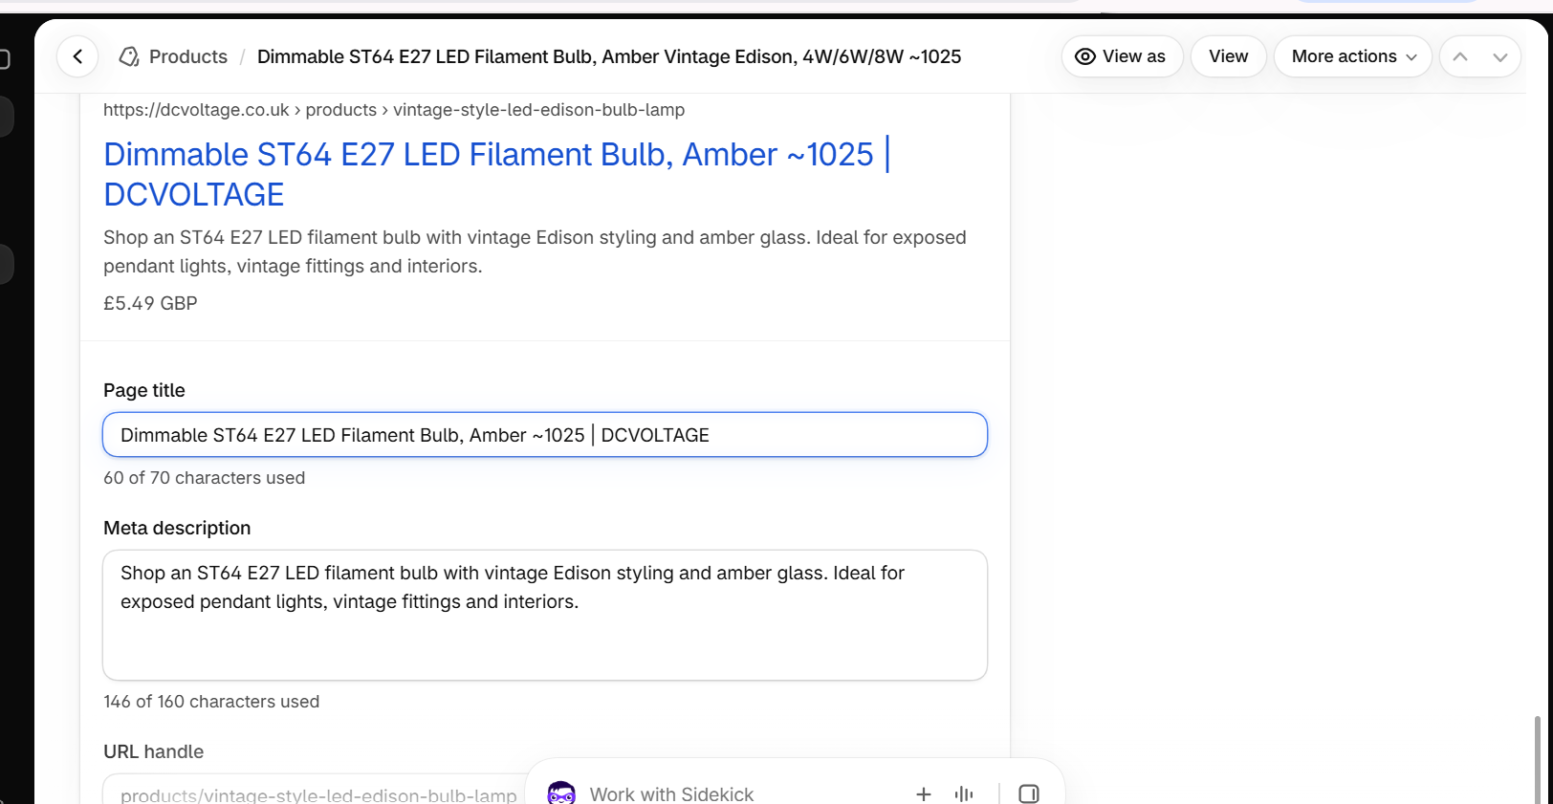
Figure 47. ST64 ~1025 product — Search engine listing showing the updated page title, saved.

Step 18 — Fix the "E27 vs B22 vs GU10" Guide Blog Post
Applied exactly 3 scoped fixes to the blog post body, with no other content, wording or structure changed: (1) the content block's own <h1> (duplicating the theme's own blog-post title H1) was changed to <h2> with matching styling preserved, closing the "2 H1s" issue; (2) the "Shop E27 Bulbs" CTA button's href was changed from the single product page to https://dcvoltage.co.uk/collections/e27-bulbs; (3) a FAQPage JSON-LD schema was added, built from the 6 FAQ Q&As already visible in the post. A meta description was also added via the post's separate Search engine listing field: "E27, B22 and GU10 explained: how to tell your bulb fitting apart, with photos, so you order the right replacement first time."
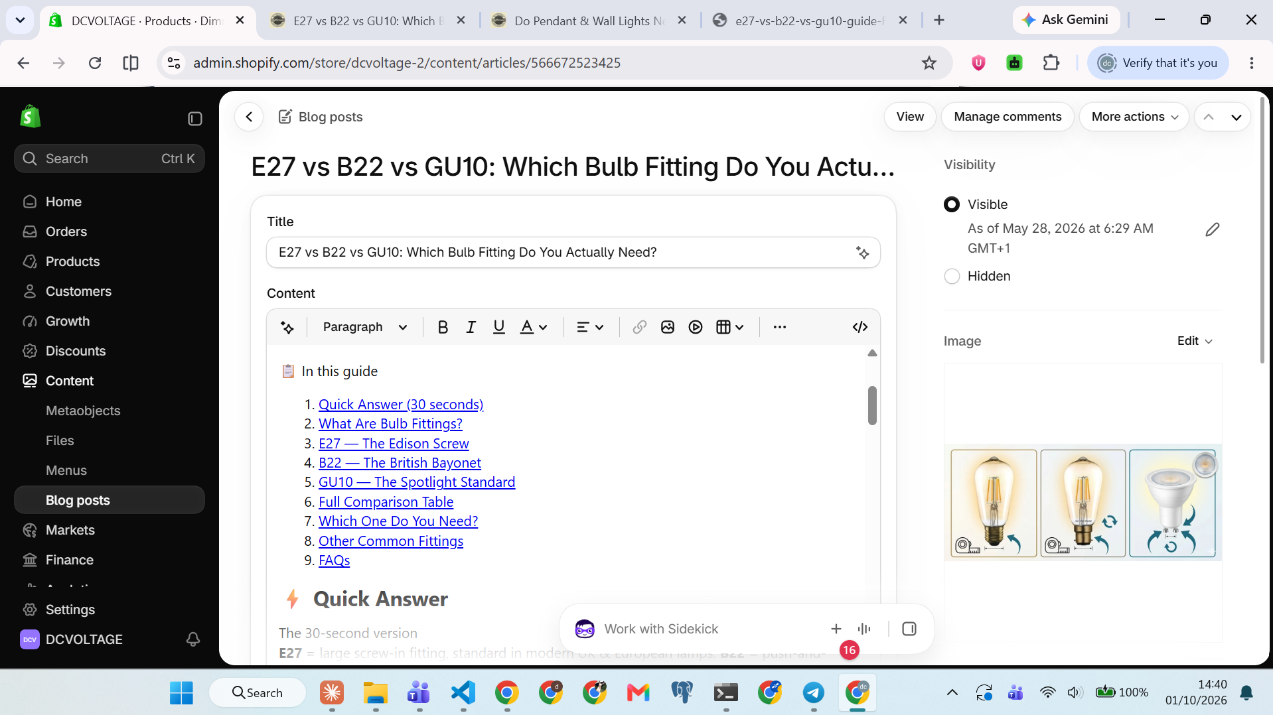
Figure 48. Shopify blog post editor — the </> "Show HTML" icon used to switch to raw HTML source view before pasting the fix.
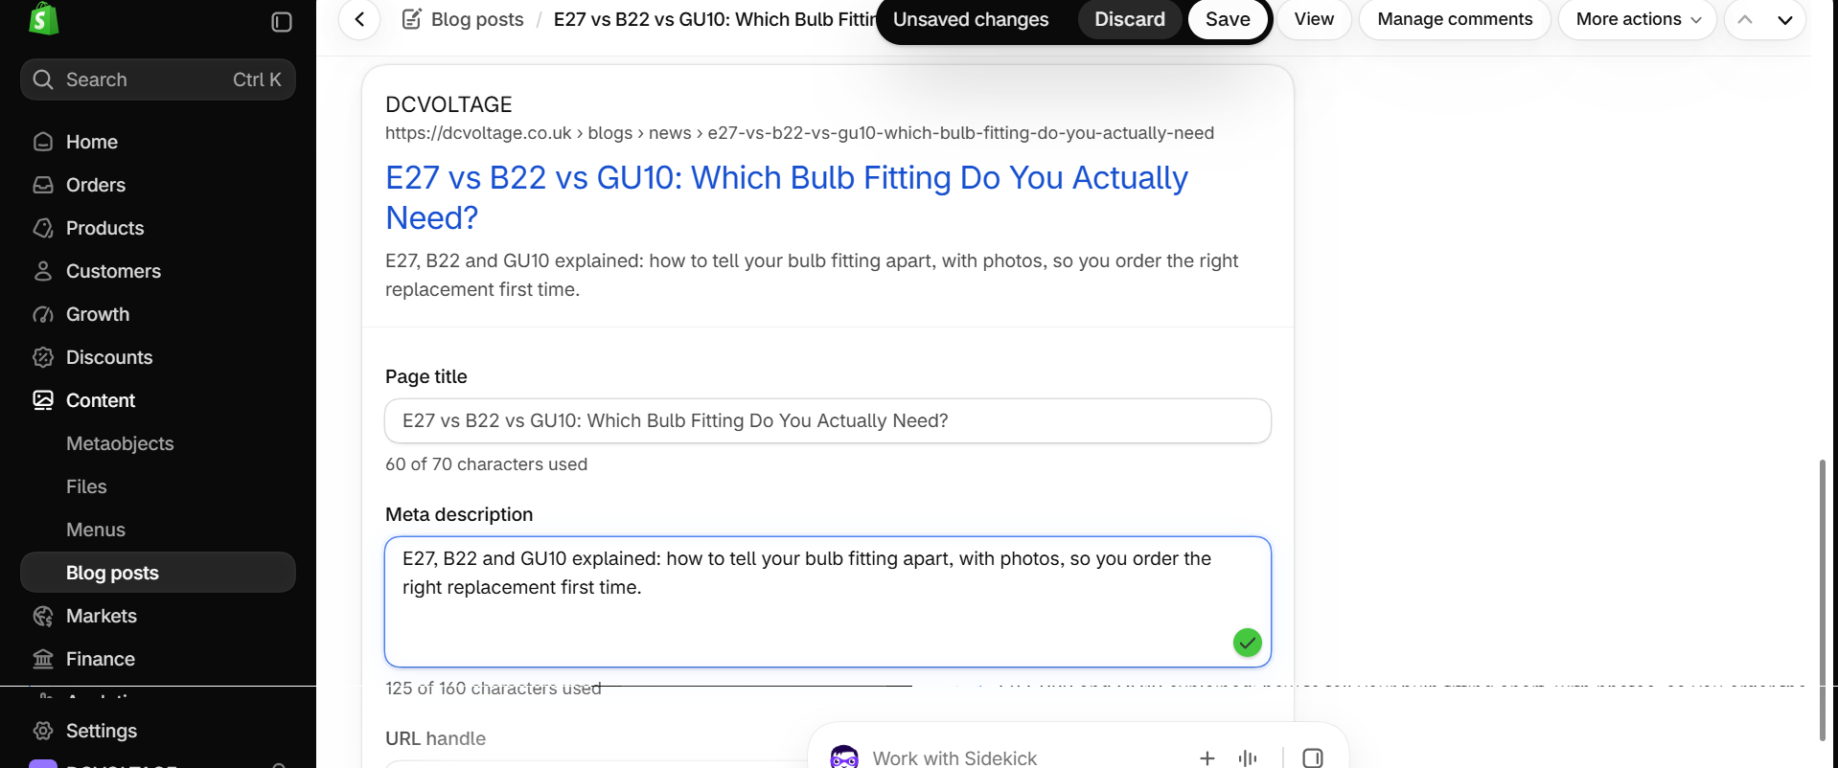
Figure 49. Blog post — Search engine listing showing the new meta description saved.

Step 19 — Real Bug Found Mid-Fix: Shopify Strips <style> Tags
The first pasted fix used a <style> block for all layout CSS. After saving, the live page rendered as plain unstyled text with an oversized uncropped hero image and unstyled FAQ buttons - confirmed by re-opening the saved HTML in Shopify's code view and finding the <style> block genuinely absent from what came back, meaning Shopify's blog content editor strips <style> tags on save even via the HTML source view. Root cause confirmed, then fixed: the entire stylesheet was rebuilt as inline style="" attributes on every element, using CSS custom properties defined once on the outer wrapper <div> and referenced via var() on every child element, since inline style attributes are never stripped. Re-pasted and confirmed live: fonts, fitting cards, comparison table, FAQ layout and the dark CTA box all render correctly. Known, accepted tradeoff: hover effects and mobile responsive grid-stacking do not survive an inline-only conversion (would need the CSS moved into the theme's own stylesheet instead) - flagged to Kuberan, not built.
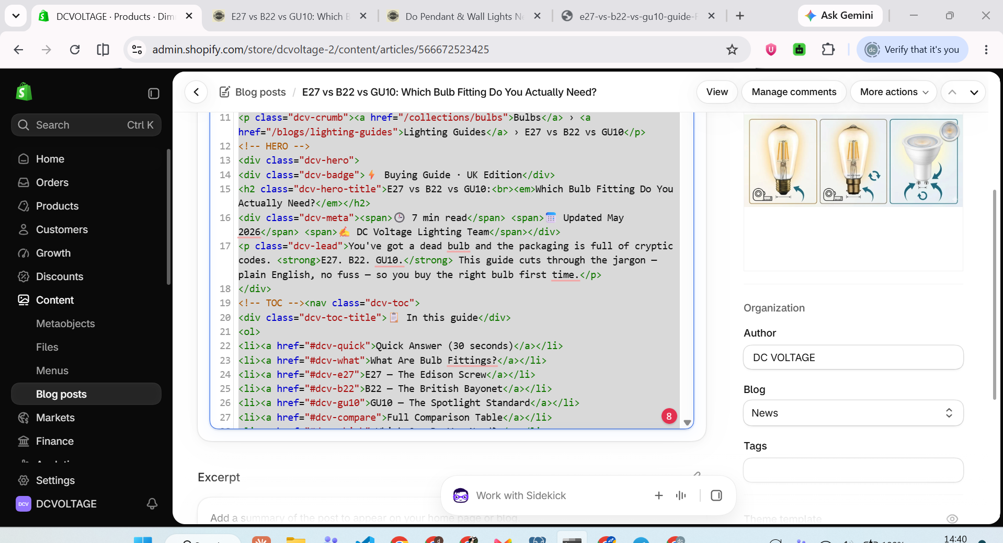
Figure 50. Blog post HTML source view showing the saved content with no <style> block present, confirming Shopify strips it on save.
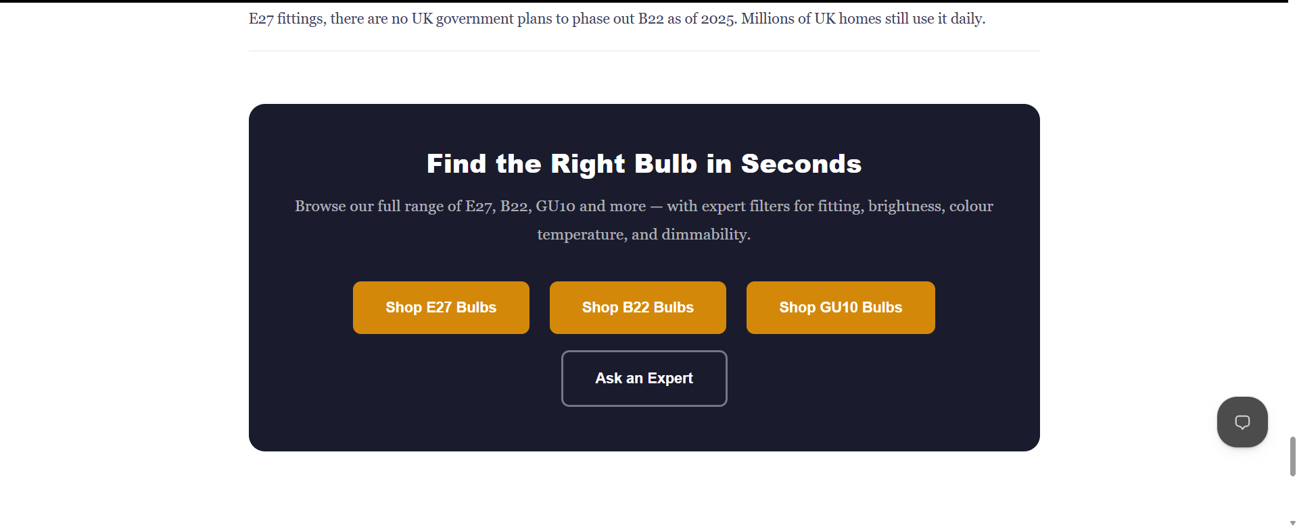
Figure 51. Live blog post after the inline-CSS rebuild - "Find the Right Bulb in Seconds" CTA box and Shop E27/B22/GU10 buttons rendering fully styled.

Known Pre-Existing Issue, Left As-Is
The "Shop GU10 Bulbs" CTA button links to /collections/gu10-bulbs, which 404s. This link was already present in the original blog content before any of today's fixes and is out of scope for the R19 request; Kuberan's explicit instruction was to leave it. The real GU10 collection handle was not looked up as part of this task.

4. Real Bugs Found and Fixed During Build (Validator Catches)
Issue | Where | Fix
Shopify schema error: option label >50 chars | model-product-specs.liquid | Shortened option labels, moved detail into "info"
Quick links pasted as raw URLs, not hyperlinked text | Collection Intro section | Re-entered as proper link text via the rich-text link tool
Content flush-left, no side margins | Both new sections | Added max-width:1440px; margin-inline:auto (verified against live theme's real computed width)
Answer box capped at 72 characters wide | Collection Intro | Changed max-width: 72ch to 100%
Listing code typo: entered 1035 instead of 1025 | Product metafields | Corrected to 1025 (caught 3 times before it stuck)
Size and Pack values swapped | Product metafields | Corrected: Size to 64 x 138 mm, Pack to 1 bulb
Shape table row 1 mislabeled "ST64 squirrel cage" while holding A60 data | Collection Details - shape table | Corrected row 1 Shape field to "A60 standard" - fixed twice before it persisted, reconfirmed before sending to Muguntha
Live product "Bulb cap type" category metafield showed both E27 and B22 on an E27-only product | Product's built-in category metafields | Corrected to E27 only - matches the exact bug class the doc cites as having already caused a real customer return
Live product "Bulb shape" category metafield shows "A-shape" (should reflect ST64) | Product's built-in category metafields | NOT yet fixed - flagged, not blocking, logged as an open item
Product description (source doc finding D04) still carried unconfirmed claims after the title/price update - caught during final validation, not part of the original build | Product's Description field | Removed Energy Rating A+, CE/RoHS certified and 3-year warranty claims; corrected dimension from 14.8cm to the real SOT value 138mm. Confirmed via in-page search showing 0 remaining matches.

5. Current Status
The build is live and fully verified: the E27 Bulbs collection and the rebuilt ST64 ~1025 product page are published on dcvoltage.co.uk, using the e27-model templates on the now-live "Tinker - E27 model DRAFT" theme. Both URLs pass Google's Rich Results Test and indexing has been requested for both in Google Search Console. With Muguntha's confirmation, the product title and the ST64 6W price have been applied, and the product description has been corrected to remove unconfirmed claims (closing source-document finding D04 for this product). As of 1 Oct 2026, Mani's R19 follow-up re-check items are also closed: the ST64 ~1025 SEO title is updated, and the "E27 vs B22 vs GU10" guide blog post has the duplicate H1 removed, the e27-bulbs collection link added, FAQ schema added, and a meta description set - confirmed rendering correctly live after fixing a real Shopify <style>-stripping bug found along the way. Remaining, outside today's scope: prioritisation of the other 26 audit findings (D02-D27, excluding D01 and D04 which are addressed), the pre-existing GU10 collection 404 on the blog's CTA button (left as-is per Kuberan's instruction), and GA4 connection, which remains Muguntha's to schedule/grant.

6. Checklist (Source Document, Part B Section 7)
Reproduced from the source document. Items marked (Muguntha) required his written OK before being actioned.

Setup
☑ Duplicate the DC Voltage live theme (Tinker) and name the copy "Tinker - E27 model DRAFT"

DC Voltage
☑ D02: product title block set to H1 on the copy (one H1 per page)
☑ Model sections added: model-collection-e27, model-product-specs (saved without errors)
☑ Collection template e27-model built (intro above the grid, details below it, 7 shape rows, 6 FAQs)
☑ Product template e27-model built (H1 title, specs section, compatibility note, 7 FAQs, JSON-LD mode "FAQ + breadcrumbs only")
☑ Metafield definitions created (specs.*, custom.listing_code) and best-seller values filled; NEEDS SUPPLIER CONFIRMATION fields left empty
☑ Preview links checked on desktop and phone (one H1, FAQ opens, table scrolls, grid/filters/add to basket work)
☑ 4 screenshots and 2 preview links sent to Muguntha
☑ (Muguntha) E27 Bulbs collection created with the 17 listings, SEO title and meta
☑ (Muguntha) Search & Discovery filters added
☑ (Muguntha) Templates assigned and copy theme published; date and time recorded
☑ Rich Results Test passed for both URLs and result sent to Muguntha; indexing requested in GSC
☑ (Muguntha) New product title applied, keeping ~1025 at the end
☑ (Muguntha) Prices and compare-at prices changed only as Muguntha approves (section 4: only the ST64 6W is proposed to change)
☐ (Muguntha) Other audit fixes from section 2 scheduled
☐ GA4 connected to dcvoltage (after Muguntha grants access)

R19 Follow-Up (1 Oct 2026)
☑ ST64 ~1025 SEO title updated to match Mani's requested wording
☑ Blog post duplicate H1 fixed
☑ Blog post E27 collection link added
☑ Blog post FAQ schema added
☑ Blog post meta description added
☑ Blog post confirmed rendering correctly live (inline-CSS fix for Shopify's <style>-stripping bug)
☐ GU10 collection 404 on blog CTA button (pre-existing, left as-is per Kuberan)

7. Reference
All screenshots (embedded above, in implementation order) and the two section .liquid files are saved at: Desktop \ kuberan web \ dcvoltage-e27-model \

