LEDSone.de - GA4 Enhanced Conversions for Web Implementation Report
Prepared for: Sonya
Prepared by: Kuberan / Website Technical Team
Website: https://ledsone.de/
Platform: Shopify
Implementation area: Google Analytics 4 and Google Tag configuration
Status: Implementation completed - Google diagnostics verification pending

1. Objective
To configure GA4 Enhanced Conversions for Web on ledsone.de by enabling user-provided data collection at the GA4 property level and enabling user-provided data capabilities on the associated Google tag, so that eligible first-party customer identifiers can be used, in hashed form, to improve conversion measurement accuracy.

2. Scope
This report covers only Task 1: GA4 Enhanced Conversions for Web for the ledsone.de property (LEDSONE_DE_2024). Enhanced Conversions for Leads and Campaign Data Import are out of scope and are not addressed in this document.

3. Before-State Evidence

Screenshot 1 - GA4 property and web stream - before state
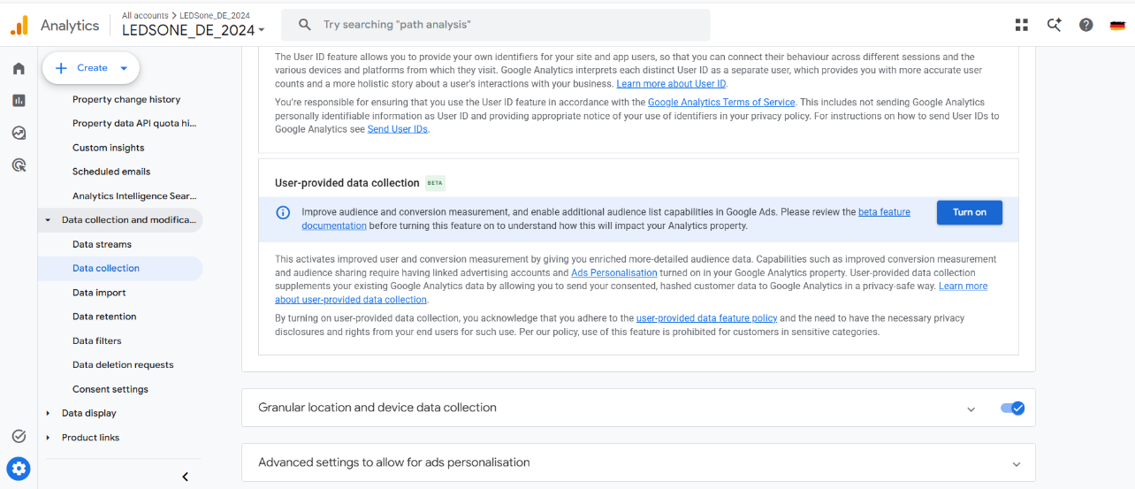
Screen:
GA4 Admin, Data collection and modification, Data collection page, property LEDSONE_DE_2024.
Action completed:
No configuration action was taken in this screenshot; it was captured to record the starting state before implementation.
Reason:
This confirms the correct GA4 property for ledsone.de was opened, and establishes the baseline state of the User-provided data collection feature prior to any changes.
Result:
The User-provided data collection panel (BETA) displays a Turn on button, confirming the feature was not active at the start of this task.
Evidence status:
Confirmed by screenshot

4. Implementation Steps

Screenshot 2 - Policy review and activation dialog
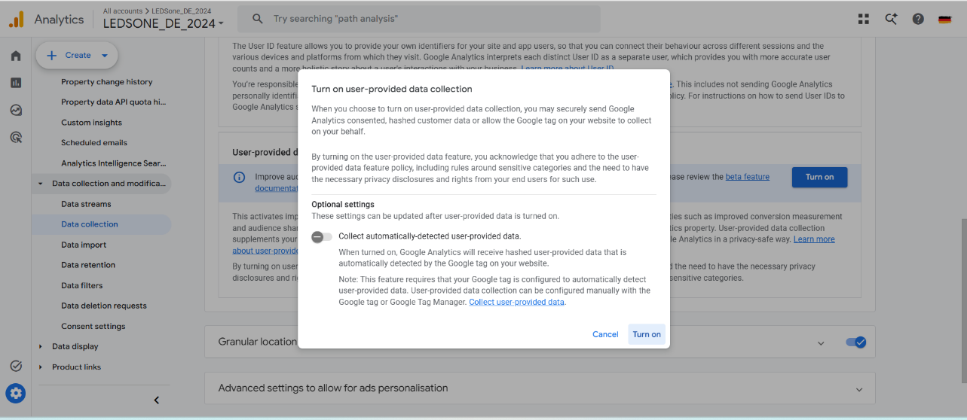
Screen:
GA4 Data collection page - Turn on user-provided data collection dialog.
Before state:
User-provided data collection was disabled (Turn on button shown, as per Screenshot 1).
Action completed:
The Turn on button was selected, opening the confirmation dialog. The dialog text confirming adherence to the user-provided data feature policy was reviewed, along with the optional Collect automatically-detected user-provided data setting shown in the dialog.
Reason:
Google requires explicit acknowledgement of the user-provided data feature policy before the feature can be activated for a property.
Result:
The dialog confirms the policy terms and optional settings were presented for review prior to activation.
Evidence status:
Confirmed by screenshot

Screenshot 3 - User-provided data collection enabled
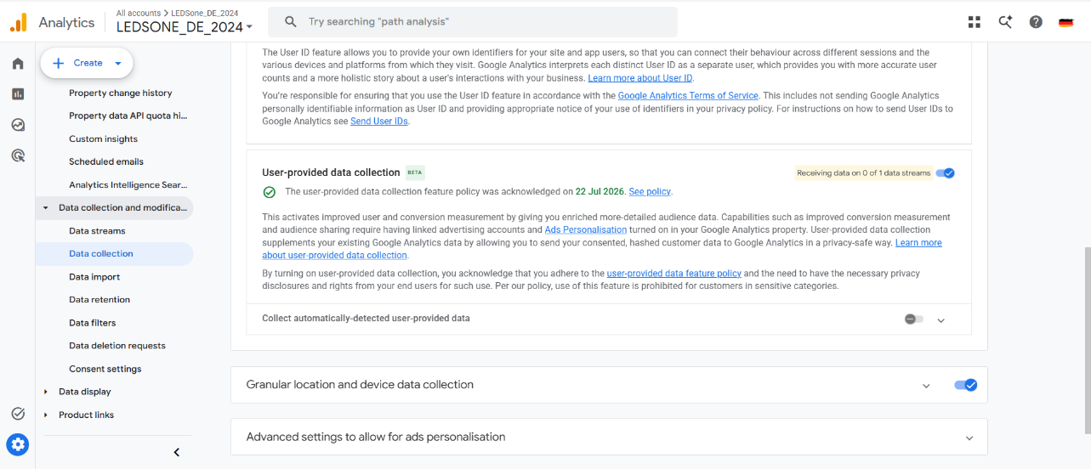
Screen:
GA4 Data collection page, User-provided data collection panel, after activation.
Before state:
Previously disabled, as shown in Screenshot 1.
Action completed:
User-provided data collection was switched on for the LEDSONE_DE_2024 property. The panel now records that the user-provided data feature policy was acknowledged on 22 Jul 2026.
Reason:
Enabling this setting at the property level is a prerequisite for GA4 to accept hashed, user-provided data from the associated Google tag.
Result:
The feature toggle is shown as active, with the status indicator Receiving data on 0 of 1 data streams. This is expected immediately after activation, as data volume depends on subsequent site traffic and Google processing time.
Evidence status:
Confirmed by screenshot; live data flow pending Google processing

Screenshot 4 - Automatic detection enabled at property level
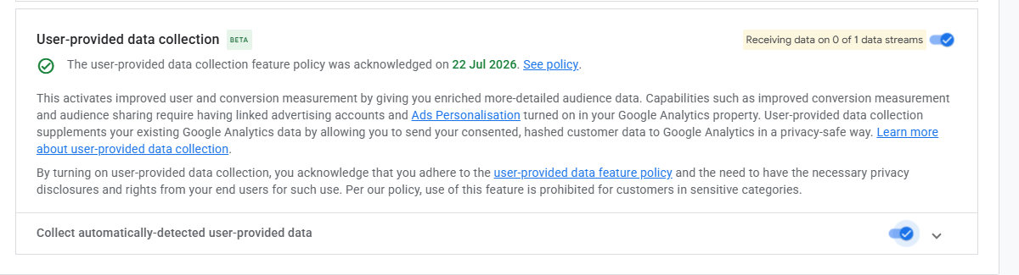
Screen:
GA4 Data collection page, User-provided data collection panel (close-up view).
Action completed:
The Collect automatically-detected user-provided data toggle was switched on within the User-provided data collection panel.
Reason:
This setting allows GA4 to receive hashed data that is automatically detected by the Google tag on the website, rather than requiring a manually coded data layer.
Result:
The toggle is confirmed as enabled alongside the acknowledged policy date.
Evidence status:
Confirmed by screenshot

Screenshot 5 - Google tag configuration - capabilities enabled
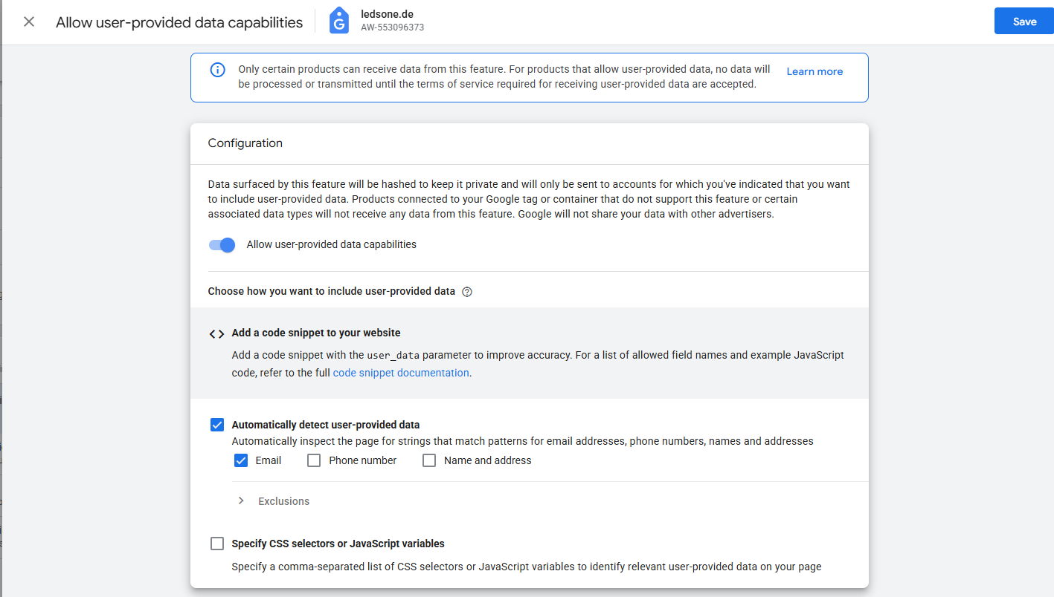
Screen:
Google Tag settings for ledsone.de (Tag ID AW-553096373), reached via Data Streams, Web Stream, Configure tag settings, Allow user-provided data capabilities.
Before state:
Automatic detection was configured with only the Email field enabled at this stage.
Action completed:
The Allow user-provided data capabilities toggle was switched on for the Google tag linked to the ledsone.de web stream, and Automatically detect user-provided data was selected as the collection method, with the Email field enabled.
Reason:
This was required so that the Google tag associated with the GA4 web stream is permitted to process eligible user-provided information, and automatic detection was chosen because ledsone.de is a Shopify-based site, allowing Google to identify supported fields without a custom code snippet.
Result:
Allow user-provided data capabilities is shown as enabled, with Automatically detect user-provided data selected and Email checked.
Evidence status:
Confirmed by screenshot

Screenshot 6 - Automatic detection - all supported fields enabled
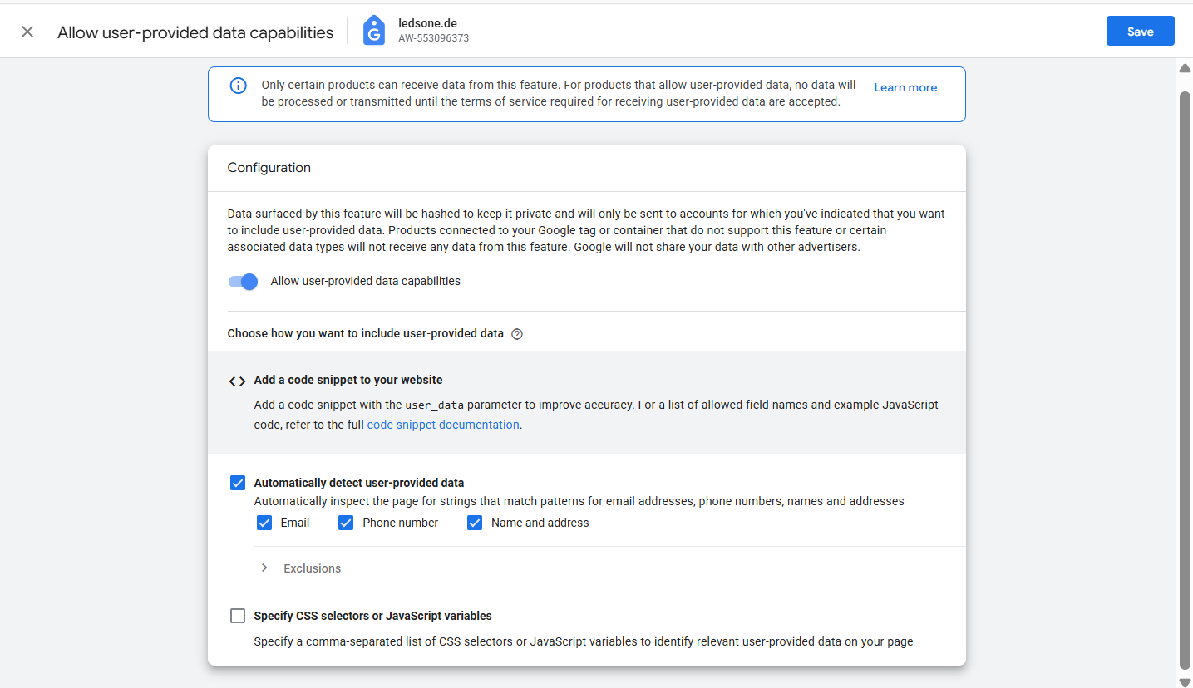
Screen:
Google Tag settings for ledsone.de, same panel as Screenshot 5.
Before state:
Only Email was enabled, as shown in Screenshot 5.
Action completed:
Phone number and Name and address were additionally enabled alongside Email under Automatically detect user-provided data. The Specify CSS selectors or JavaScript variables option was left unchecked.
Reason:
Email, phone number, and name and address are supported identifiers that improve conversion matching accuracy. No customer data was manually entered; these are field-type toggles that instruct Google to automatically identify matching patterns already present on the site's checkout and account pages.
Result:
Email, Phone number, and Name and address are all shown as checked under automatic detection, confirming the manual CSS selector method was not used.
Evidence status:
Confirmed by screenshot

Saving the configuration
Reason:
After the fields above were enabled, the configuration was saved using the Save control on the Google tag settings panel (visible at the top of Screenshots 5 and 6), applying the settings to the Google tag and the linked ledsone.de GA4 web stream.
Evidence status: Confirmed by screenshot (Save control visible in panel header).

5. Configuration Decisions
Automatic detection was used in preference to a manually coded snippet or CSS selector list, because ledsone.de is built on Shopify and Google Tag can reliably identify supported fields (email, phone number, name and address) on standard Shopify checkout and account pages without custom development work. This keeps the implementation low-maintenance and avoids the need for ongoing code changes if Shopify updates its page markup.

6. Validation Evidence

Screenshot 7 - Tag Assistant connection check
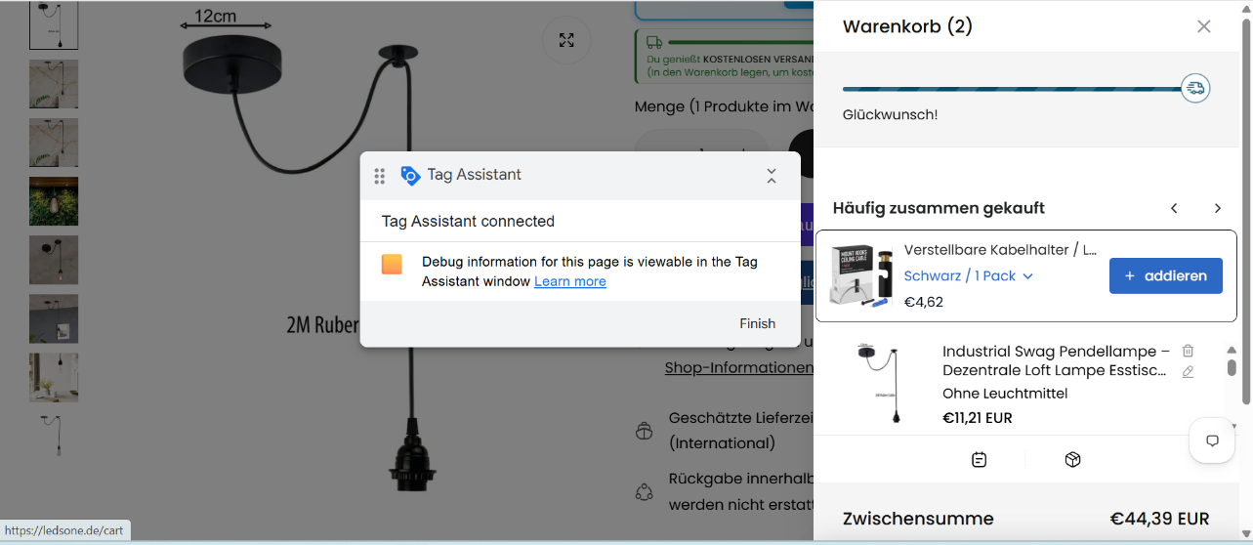
Screen:
Google Tag Assistant Companion window overlaid on the ledsone.de cart page (https://ledsone.de/cart).
Action completed:
Tag Assistant was connected to the live ledsone.de site to check that the website's tag environment was correctly detected following the configuration changes.
Reason:
This step verifies that the Google tag environment on ledsone.de is present and reachable by Google's diagnostic tooling, which is a precondition for Enhanced Conversions data to be processed.
Result:
Tag Assistant reports Tag Assistant connected and confirms that debug information for the page is available in the Tag Assistant window.
Evidence status:
Confirmed by screenshot; confirms tag environment detection only, not enhanced-conversion match data

Screenshot 8 - CSS selector field - clarification
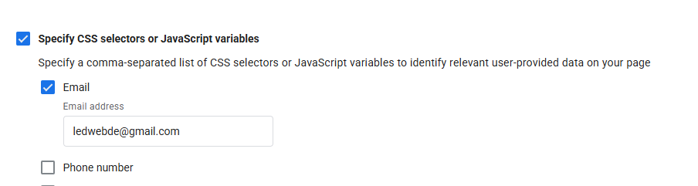
Screen:
Google Tag settings for ledsone.de, Specify CSS selectors or JavaScript variables section.
Action completed:
No action was taken to implement this method. This screenshot is included for transparency and to clarify its content, since the Email address field visible here can be misread as customer data being entered manually.
Reason:
For the record: this field is designed to accept a CSS selector or JavaScript variable name that identifies where user data appears on the page, not an actual email address. The value shown in the field was populated by the browser's own autofill function when the page was viewed, and does not represent a saved implementation setting or customer data. The manual selector method was not required and was not used for ledsone.de, because Automatic detection (Screenshots 5 and 6) was the method configured and saved for this property.
Result:
The Specify CSS selectors or JavaScript variables option is not part of the saved configuration for ledsone.de. No email address, customer identifier, or credential was entered as part of this implementation.
Evidence status:
Partially confirmed - included for clarification only, not a saved setting

7. Final Status
The GA4 Enhanced Conversions for Web configuration for ledsone.de has been completed. This includes: activating User-provided data collection at the GA4 property level, acknowledging the required Google policy, enabling automatic detection at the property level, and enabling and saving Allow user-provided data capabilities with automatic detection of email, phone number, and name and address on the Google tag linked to the ledsone.de web stream. Tag Assistant confirmed that the website's tag environment is correctly detected.
Google may require a period of time to process the new configuration before matched conversion improvements or user-provided data diagnostics become visible in GA4 or Google Ads. No enhanced-conversion match data or improved-diagnostics results have been claimed in this report, as no screenshot yet evidences this.

8. Pending Verification
Google diagnostics verification (i.e., confirmation within GA4 or Google Ads that user-provided data is being matched and improving conversion measurement) is pending, as no screenshot in this evidence set shows this diagnostic output. This should be checked again after Google has had sufficient processing time and the site has received further traffic.

9. Conclusion
The configuration steps required to enable GA4 Enhanced Conversions for Web on ledsone.de have been completed and are evidenced by the screenshots above. The implementation used Google's automatic detection method, appropriate for the site's Shopify platform, and no manual code changes or CSS selector configuration were required. The remaining step is to confirm, after a processing period, that Google diagnostics show user-provided data being received and matched.

Final Summary Table
Configuration Item | Status | Evidence | Notes
Correct GA4 property and web stream | Completed | Screenshot 1 | LEDSONE_DE_2024 property confirmed
User-provided data policy accepted | Completed | Screenshots 2, 3 | Acknowledged 22 Jul 2026
User-provided data collection enabled | Completed | Screenshots 3, 4 | Property-level toggle on
User-provided data capabilities enabled | Completed | Screenshots 5, 6 | Google tag for ledsone.de (AW-553096373)
Automatic detection enabled | Completed | Screenshots 5, 6 | Selected over manual snippet
Email enabled | Completed | Screenshots 5, 6 | Checked under automatic detection
Phone number enabled | Completed | Screenshot 6 | Checked under automatic detection
Name and address enabled | Completed | Screenshot 6 | Checked under automatic detection
Manual CSS/JavaScript selector method not used | Not required | Screenshot 8 | Field shown for clarification only; not saved
Settings saved | Completed | Screenshots 5, 6 | Save control used on tag settings panel
Tag Assistant connected | Completed | Screenshot 7 | Connected on ledsone.de/cart
Google tags detected | Completed | Screenshot 7 | Tag environment detection confirmed
Google diagnostics verification | Pending verification | None yet | No screenshot evidences match diagnostics

