GA-19 Review Fixes
DC Voltage — response to Muguntha's live-site review
Date: 2026-10-05 • Owner: Kuberan • Source: Muguntha's review in the “website organic discovery” thread

Summary
Muguntha reviewed GA-19 live and flagged 6 items across Parts 1, 2, 5 and 6. Parts 1 and 2 were already passing. The remaining 4 real gaps — 2 on the B22/E14 collections, 2 on Wall Light — are now all fixed and verified live, confirmed by direct page fetch, not just the admin editor view.
Item Muguntha flagged | Status
Part 1 (title as H1) | Already passing — no action needed
Part 2 (ratings) | Already passing — no action needed
B22: H1 shows full SEO title incl. “| DCVOLTAGE” | Fixed
E14: still shows default title “E14 Bulbs – DCVOLTAGE” | Fixed
B22: shows 6 products publicly, not 7 | Checked — expected (1 of 7 is Draft status)
Wall Light: answer sits below the grid, not at the top | Fixed
Wall Light: page has two H1s | Fixed

Fix 1 — B22 Bulbs: SEO title
STATUS: FIXED
The SEO “Page title” field looked filled in but was actually an unsaved placeholder preview — the real saved value was empty, so the browser tab fell back to Shopify's auto-generated default. Re-typed and saved the field properly.
Verified live: the real <title> tag now shows “B22 Bulbs – Bayonet Cap LED & Filament Bulbs | DCVOLTAGE”, and the on-page H1 is confirmed clean (“B22 Bulbs” only, no SEO text).
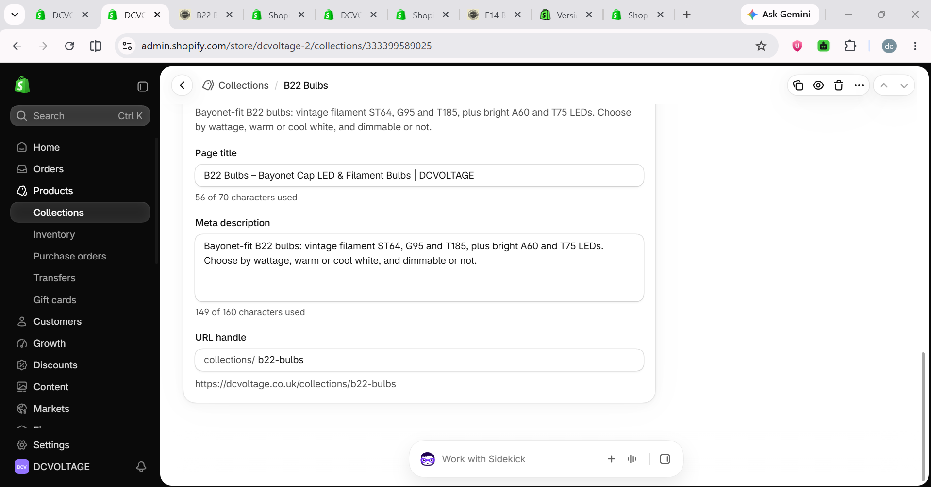
B22 Bulbs — SEO title re-saved
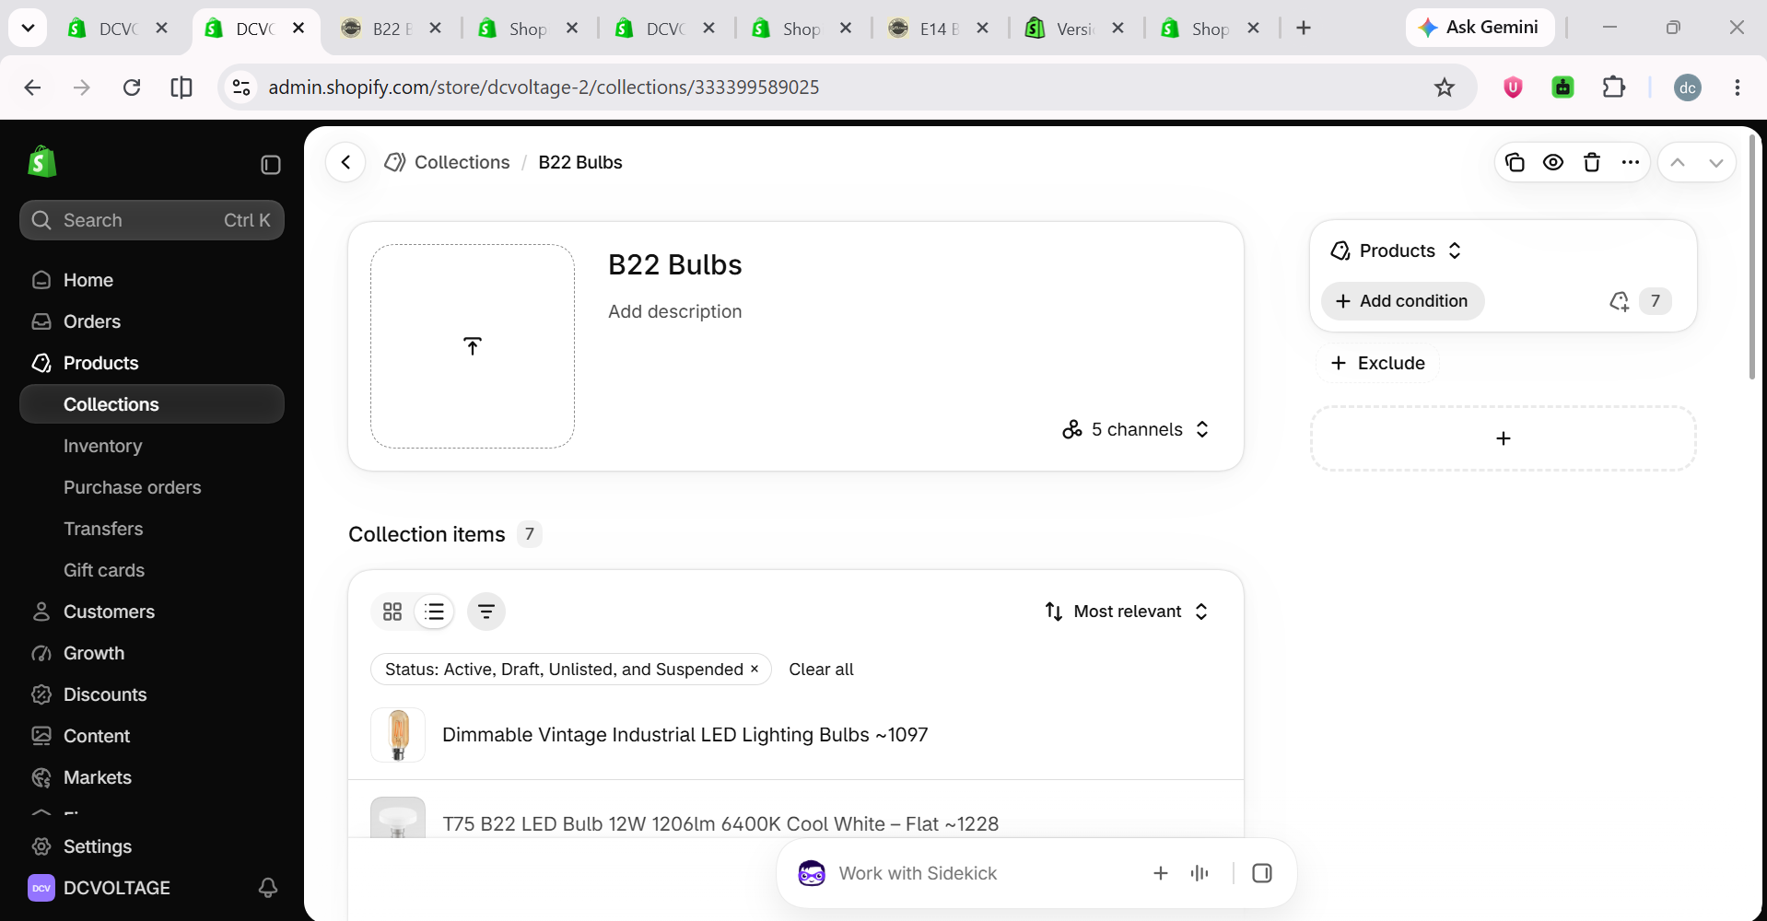
B22 Bulbs — main Title field confirmed clean, all 7 products listed

Fix 2 — E14 Bulbs: SEO title
STATUS: FIXED
Same root cause as B22 — the custom SEO title was never actually saved. Re-typed and saved it.
Verified live: the real <title> tag now shows “E14 Bulbs – Small Edison Screw Candle Bulbs | DCVOLTAGE”.
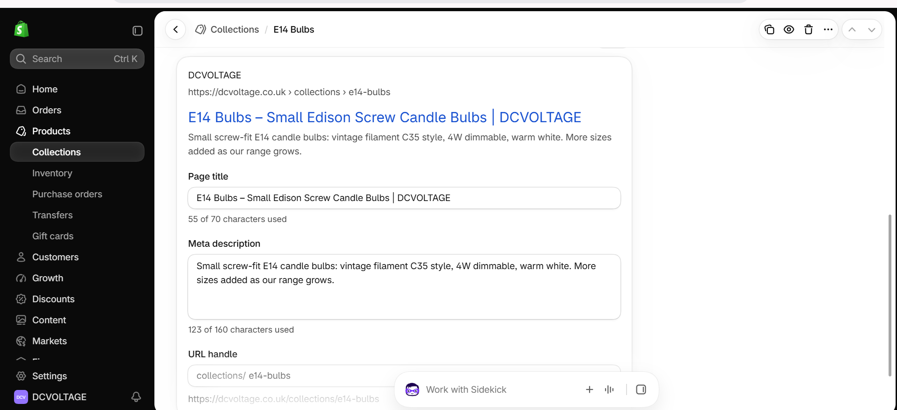
E14 Bulbs — SEO title re-saved, confirmed live

Fix 3 — Wall Light: one H1 only
STATUS: FIXED
The page had two real H1 tags — the collection's own auto-generated title (“Wall Light”) and the long article's own heading (“Lights on the Wall: A Guide to Sconces and Style”). Changed the article's heading tag to styled text (visually identical, no longer a real heading), keeping the page's own title as the single true H1.
Verified live: exactly 1 <h1> tag found (“Wall Light”).

Fix 4 — Wall Light: answer-first intro before the grid
STATUS: FIXED
Root cause: the block that prints the collection description sat after the product grid in the shared page template, pushing the intro (and the whole long article) below all the products instead of above them.
First attempt moved the whole shared block above the grid — caught that this affected every collection site-wide, not just Wall Light, and reverted it the same session.
Correct fix: built a dedicated template for Wall Light only, reusing the same reusable section already proven on the E27 Bulbs page (not hardcoded content — editable in the theme customizer). The short answer-first question/answer now renders directly under the “Wall Light” heading, before the grid; the long article stays in its original position, unaffected.
Verified live, using the page's real section markers (not just text position): the intro section's wrapper sits before the product grid's wrapper. Styled with the same orange-accent box used elsewhere on the site, plus a subheading matching E27's own style.
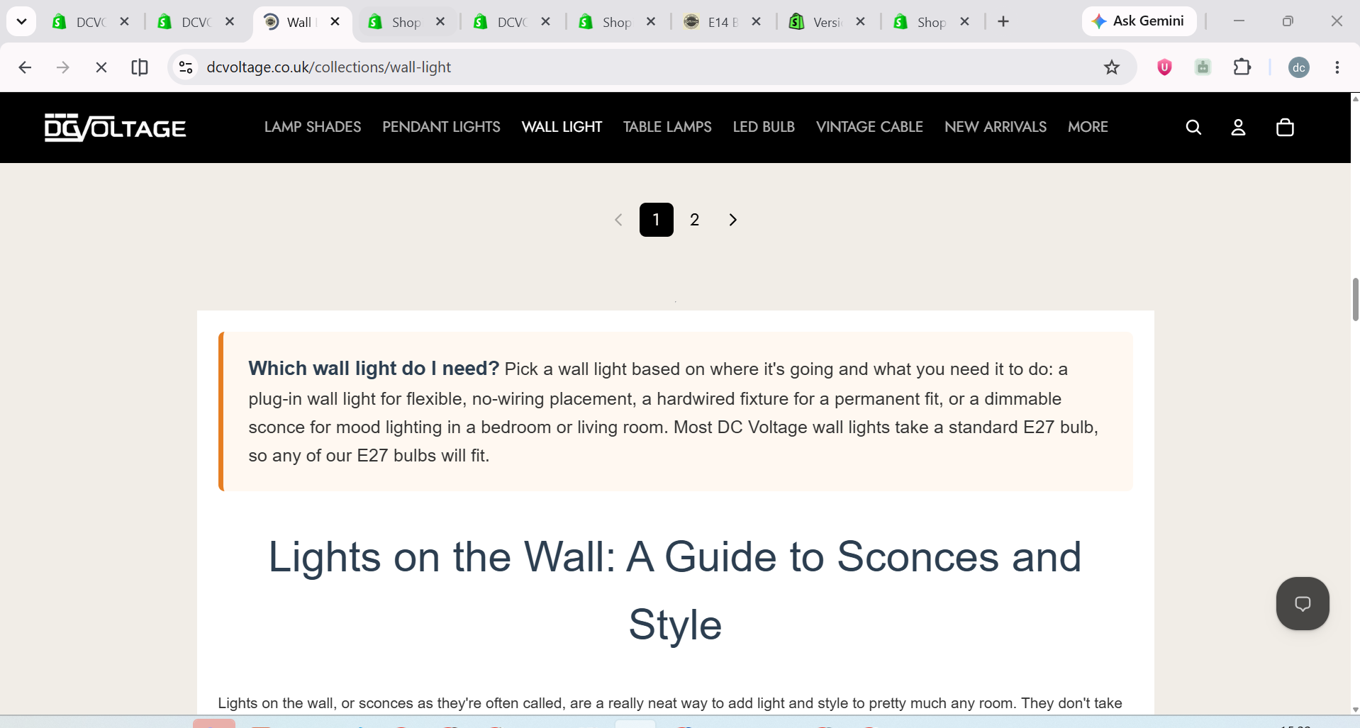
Wall Light — styled answer-first box, confirmed live
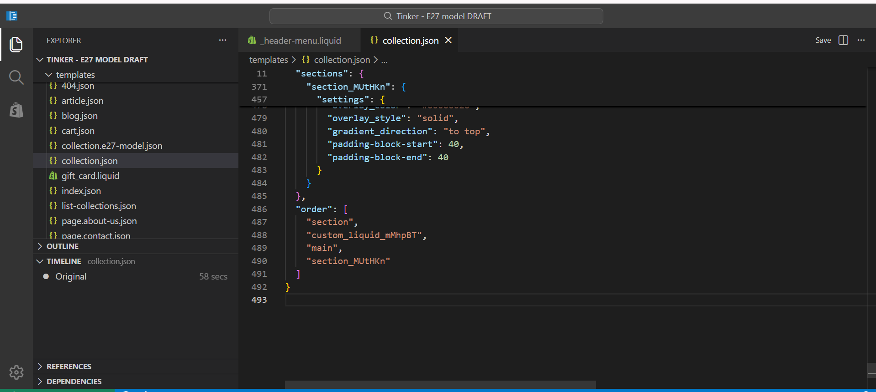
Theme code — confirmed live in Shopify's editor
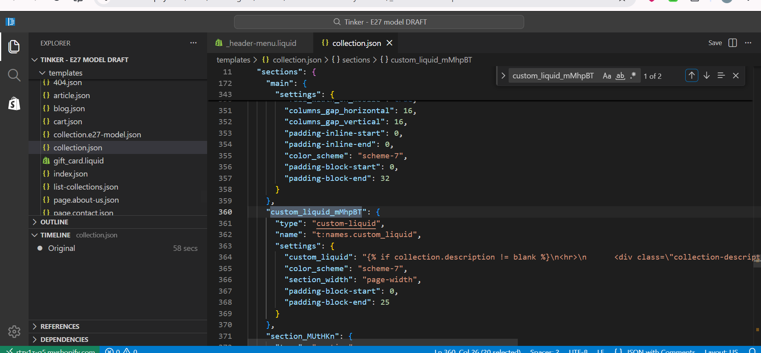
Theme code — the block controlling description position, confirmed live
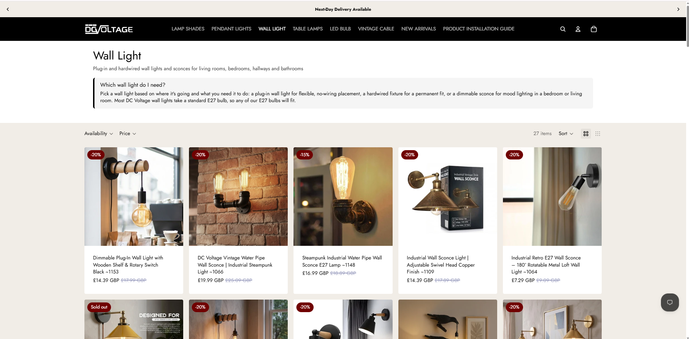
Wall Light — final result: one H1, subheading, answer-first box, then the grid

Verification method
Every fix above was confirmed by fetching the real, live public page directly (not the Shopify admin preview or theme editor), checking the actual HTML served to a visitor — H1 tag counts, the real <title> tag, and exact section render order using Shopify's own section ID markers. This rules out “looks right in the editor but isn't actually live” as a failure mode.

