* Accessing Kubernetes Deployment to the outside world.

in previous PDF’s we have learnt about what is pod, replica set and deployment.

And after successfully deployed the application, we checked the status of pod and deployments are running perfectly in Kubernetes cluster. but is it enough.

How can we expos our application to outside world so that users can access it?

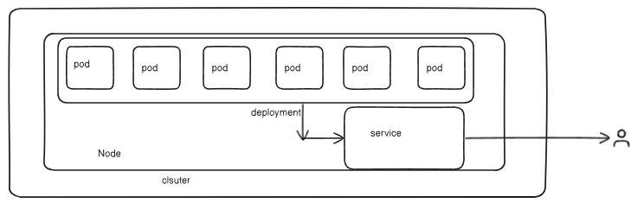

In above image we can see that inside the cluster our application pods are running and suppose each pod has port number 80