Practical Exercises 4
Name, Surname 1: Jakub Hejhal
Name, Surname 2:

Degree (Ing. del Software/Ing. Informática/Ing. Computadores): Erasmus
Group (A/B/C): B

PC Label in the lab (e.g. 012): own laptop

Trace 1 (p4e1-7.pcapng):
Exercise 1. Use the “Analize -> Follow -> TCP stream” option of the Wireshark to see the information interchange between the client and the server. Show a screenshot with this information.

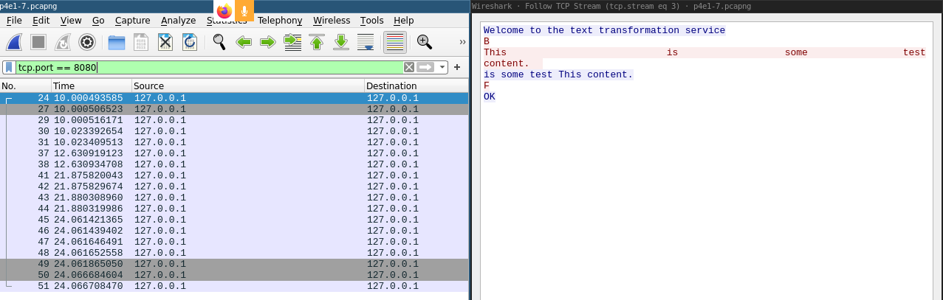

Exercise 2. Does the client send the messages (letter and text) in the same TCP segment? Why?

No, it does not, because I explicitly flush the socket after writing the command letter, such that especially in case of “F”, the command is sent immediately to the server and doesn’t wait around in the buffer.

.

Exercise 3. What is the port used by the client? What is the one of the server? What are the fields of the TCP header where they are stored?
Client uses port 55394, which is chosen by the operating system and we have no control over it, it’s more or less random. Server binds to port 8080. It’s stored in the Source/Destination Port TCP header field.

Exercise 4. What is the initial sequence number used by the client? What is the initial sequence number used by the server?

Client seq_n: 1754341604
Server seq_n: 2757352421

Although Wireshark is nice enough to substract this initial sequence number from every segment in ongoing TCP connection and shows us the relative sequence number.
Exercise 5. Take screenshots of the TCP segments responsible of the following activities.
a) Connection initialization
b) Data sending
c) Finish a connection.

a) 3-way handshake

b) Data sending (with corresponding ACKs)
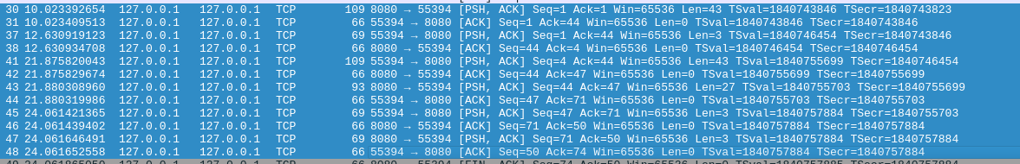

c) Closing the connection
Exercise 6. How many sequence numbers are in each communication end (client and server) consumed during the initialization and closing of the connection?

One sequence number is consumed for initializing and one for closing the simplex connection, so 4 sequence numbers are consumed by the full-duplex init and close process.

Exercise 7. Observe the size of the sliding window that is transmitted in the segments that travel in both directions (client and server). Does the sliding window size change? What are its values in the client and in the server?

Only first 2 packets have a sliding window size different from the rest of the communication – 65495 and 65483 for the client and server respectively. In the rest of the communication, the sliding window=65536.

Trace 2 (p4e8.pcapng):
Exercise 8. Does the client receive any response after trying to connect to the server? If the answer is positive then, what are the special characteristics of this response?

If there is no service running at port 8080 to which the client is trying to connect to, the kernel responds with TCP RST, by which it tells the clients to kill the connection instantly.
Trace 3 (p4e9-10.pcapng):
Exercise 9. Did the 3 client manage to connect? If one has not been able to connect, does it receive a notification about full queue?
Yes, all 3 clients manage to connect, which is not what I would expect. I create the server socket with backlog=1, as instructed, which is according to Oracle documentation - “requested maximum length of the queue of incoming connections”

As I understand it, the following should happen:
- First client connects successfully and server starts handling it’s request.
- Second client tries to create the Socket to server, and is successful as well, because there is no-one in the waiting queue, but trying to read data from socket blocks, because server hasn’t yet accepted the connection and hasn’t sent anything.
- Third client tries to create the Socket to server, but is unsuccessul, because the waiting queue is full.

But that is not what happens. Looking at the communication in wireshark, we can see that all three connections are created – we can see 3-way handshake for every client, even though server hasn’t yet accepted the second and third client connection and even though the third client shouldn’t connect at all.
When I try to connect 4-th client, another interesting thing happens. The creation of a Socket blocks on the client side, so it looks like backlog=1 actually means backlog=2, or I don’t know.

Exercise 10. Do the waiting clients (those queued ones) have the connection initialised? Or the connection initialization is performed after the clients are pulled from the queue (in the accept method)?

As I said, all 3-way handshakes happen and all connections are initialized even though they are not pulled from the queue by the accept method.

The code UML:
