Practical Exercises 2
Surname: Hejhal
Name: Jakub

Degree (Ing. del Software/Ing. Informática/Ing. Computadores): Erasmus
Group (A/B/C): B

PC Label in the lab (e.g. 012): personal laptop

Exercise 1: Observe the IP headers of the different datagrams. What is the protocol of the field “protocol” (from the IP header) of the ICMP, FTP and HTTP? Fill the following table with this information. What is the meaning of this field?

Protocol | Protocol field | Value (HEX) | Frame number
ICMP | ICMP | 01 | 107680
HTTP | TCP | 06 | 90600
FTP | TCP | 06 | 94941

The IPv4 protocol field tells us the name of the encapsulated protocol
Exercise 2. Select an ICMP request (message echo request) and fill in the table with the IP destination address and the MAC destination address (i.e., the Ethernet header). Complete the same information for a FTP request (i.e., the info field contains “request”). Why are the addresses the same for one protocol and different for the other one?

 | ICMP | FTP
IP Destination address (IP header) | 150.214.54.249 | 150.214.40.67
MAC Destination Address (Ethernet header) | 02:10:18:37:91:9c | 02:10:18:37:91:9c
Frame number | 107680 | 94957

Ethernet frames go through the same WiFi router at my home, so the WiFi router MAC is the same in both cases. The IP address is different because accoding to DNS, informatica.cv.uma.es and ftp.uma.es have different IPs.

Exercise 3. What are the type and code of the ICMP messages (request/reply)? Focus on ICMP requests for the rest of the questions. What filter can you put to see only the fragments of a concrete IP datagram? Indicate in the following table the value of each flag of the fragment, its identification and offset (write these values for each packet size). Note: put the information of each fragment in a separate row, so add new rows when necessary.

Size | Fragments | Identifiers | Flags | Fragment Offsets
1200 | 1 | 4846 | Reserved bit: 0, Don't fragment: 1, More fragments: 0 | 0
3100 | 3 | 4927 | Reserved bit: 0, Don't fragment: 0, More fragments: 1  Reserved bit: 0, Don't fragment: 0, More fragments: 1  Reserved bit: 0, Don't fragment: 0, More fragments: 0 | 0,1480,2960

ICMP request type: 8
ICMP reply type: 0
ICMP request code: 0
ICMP reply code: 0

If I want to see only fragments of a IP datagram with id=4927, I will put in a filter ip.id == 4927

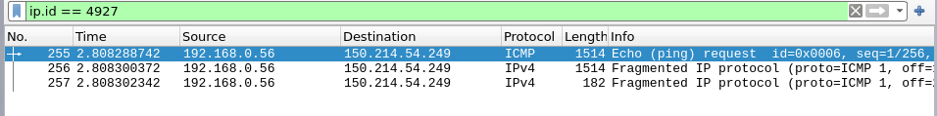

Exercise 4. Calculate the maximum amount of user data that you can transmit in the network of the laboratory. Being MAX the maximum amount of user data that you have calculated, execute the ping command two times with the D flag set to 1 (-f option), one with a packet of length MAX and another with a packet of length MAX+1 (option -l). What is the value of MAX? Why? Does the second ping appear in the packet trace? Save the traffic capture as p2e4.png and take screenshots to show how the first ping succeed and the second one fail.

My WiFi card interface has MTU=1500
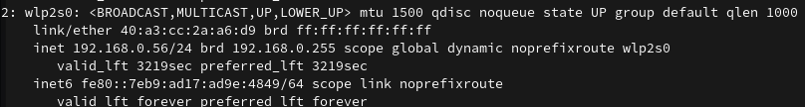

MAX = 1472 B, because together with 8 byte ICMP header + 20 byte IP header, 1472 + 8 + 20 = 1500

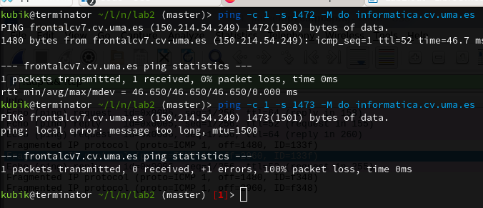

Second pind fails and doesn’t appear in the packet trace, because the packet size exeeds MTU.

Btw, why should I save the traffic capture as PNG image (p2e4.png) ?

Exercise 5. Make successive pings to informatica.cv.uma.es starting with a TTL value of 1 and stopping as soon as a reply from the server arrives. Observe in Wireshark the message exchange that takes place during the execution of the pings. What type of ICMP message arrives? What type and code values does this ICMP message have? What is the additional information encapsulated in this ICMP message?

When ping fails, ICMP Time-to-live exceeded message is received.
Type: 11
Code: 0

After that, the packet contains the original IPv4 packet before just before exeeding the TTL (without the data field)
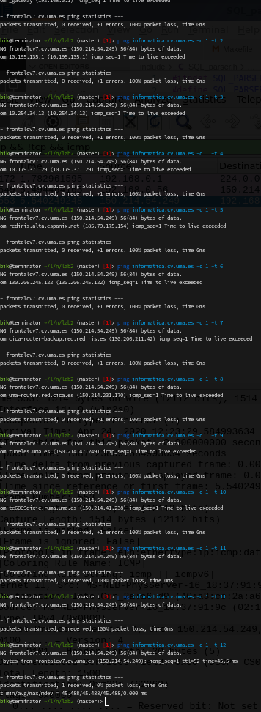

Exercise 6. What protocol does the traceroute use? List the protocols of each network layer. What are the protocols involved in the reply? What is the strategy used by tracert to find out the IP address of each of the hops?

What protocol does the traceroute use?
Tricky question. Linux traceroute implements various methods. Linux manpage says:

List Of Available Methods
In general, a particular traceroute method may have to be chosen by -M name, but most of the methods have their simple cmdline switches (you can see them after the method name, if present).

default
The traditional, ancient method of tracerouting. Used by default.
Probe packets are udp datagrams with so-called "unlikely" destination ports. The "unlikely" port of the first probe is 33434, then for each next probe it is incremented by one. Since the ports are expected to be unused, the destination host normally returns "icmp unreach port" as a final response. (Nobody knows what happens when some application listens for such ports, though).
This method is allowed for unprivileged users.
icmp -I
Most usual method for now, which uses icmp echo packets for probes.
If you can ping(8) the destination host, icmp tracerouting is applicable as well.
tcp -T
Well-known modern method, intended to bypass firewalls.
Uses the constant destination port (default is 80, http).
If some filters are present in the network path, then most probably any "unlikely" udp ports (as for default method) or even icmp echoes (as for icmp) are filtered, and whole tracerouting will just stop at such a firewall. To bypass a network filter, we have to use only allowed protocol/port combinations. If we trace for some, say, mailserver, then more likely -T -p 25 can reach it, even when -I can not.
This method uses well-known "half-open technique", which prevents applications on the destination host from seeing our probes at all. Normally, a tcp syn is sent. For non-listened ports we receive tcp reset, and all is done. For active listening ports we receive tcp syn+ack, but answer by tcp reset (instead of expected tcp ack), this way the remote tcp session is dropped even without the application ever taking notice.
There is a couple of options for tcp method:
syn,ack,fin,rst,psh,urg,ece,cwr
Sets specified tcp flags for probe packet, in any combination.
flags=num
Sets the flags field in the tcp header exactly to num.
ecn
Send syn packet with tcp flags ECE and CWR (for Explicit Congestion Notification, rfc3168)
sack,timestamps,window_scaling
Use the corresponding tcp header option in the outgoing probe packet.
sysctl
Use current sysctl (/proc/sys/net/*) setting for the tcp header options above and ecn. Always set by default, if nothing else specified.
mss=num
Use value of num for maxseg tcp header option (when syn).
Default options is syn,sysctl.
tcpconn
An initial implementation of tcp method, simple using connect(2) call, which does full tcp session opening. Not recommended for normal use, because a destination application is always affected (and can be confused).
udp -U
Use udp datagram with constant destination port (default 53, dns).
Intended to bypass firewall as well.
Note, that unlike in tcp method, the correspond application on the destination host always receive our probes (with random data), and most can easily be confused by them. Most cases it will not respond to our packets though, so we will never see the final hop in the trace. (Fortunately, it seems that at least dns servers replies with something angry).
This method is allowed for unprivileged users.
udplite -UL
Use udplite datagram for probes (with constant destination port, default 53).
This method is allowed for unprivileged users.
Options:
coverage=num
Set udplite send coverage to num.
raw -P proto
Send raw packet of protocol proto.
No protocol-specific headers are used, just IP header only.
Implies -N 1.
Options:
protocol=proto
Use IP protocol proto (default 253).

So the answer is: it really depends on which tracing method we choose. But by detault it uses UDP to some random ports (33000-ish in my case) with increasing TTL, and checks, whether it recieves ICMP TTL exceeded, so something similar to what we did in the previous exercise manually. So in my case the protocol stack is:
Query: WiFi Radio→ Ethernet II → IPv4 → UDP
Response: WiFi Radio→ Ethernet II → IPv4 → ICMP

The IPv4 header in the response contains the IP of the hop on the route.

