Elliot Giese

Hamad Khawja

CS 355 - Systems Programming

Part 2 - System Design

On it’s own, the Raspberry Pi can not read incoming analog data on GPIO pins. Since this irrigation system utilizes analog soil moisture sensors, an analog-to-digital converter is required. An MCP3008 chip is used to convert up to eight analog inputs into digital inputs for the Pi to read, and can either run on the Pi’s SPI hardware bus, or implemented on SPI via software. The diagram below depicts only two analog sensors connected to the chip, for the sake of space; however, up to eight can be used with this MCP3008 chip. Both the chip and the soil moisture sensors take 3.3V of power from the RPi 3V3 pin.

The soil sensors will periodically (~every 15 minutes) gather data values between 0 - 600 (with 0 constituting dry soil, and 600 wet) from each connected plant to send to the Pi. Based on programming logic enforced in a C-based program, the Pi will make a decision during these intervals to water the plant(s) or not. If the moisture value of a plant falls below a defined constant threshold (based on the type of plant input to the program on runtime), the Pi will turn on a water pump and particular solenoid valve associated with the dry plant.

Solenoid valves require 12VDC to activate, and are closed when power is off, and open when supplied power. The pump utilizes 120VAC, and is automatically on when plugged in (there is no on-off switch). By default, it’s flow rate is 80 gal/hr, but this can be adjusted manually with a dial on the side. Both solenoid valves and the pump will be connected to a 4-channel 5VDC relay, which in turn is connected to the Pi.

A 4-channel relay operates on 5VDC, which will be taken from the 5VDC pin on the Pi. Three GPIO pins, and GND will connect from the Pi to the relay. When the Pi sends a signal to turn on the pump over the GPIO line, 5VDC will activate the pump and valve relays. Relays allow low-power (5VDC) circuits to switch on higher-power (12VDC - 220VAC) circuits - in this case, the relay will activate the pump and one or both of the pump circuits. The pump will distribute water to one or both plants in short intervals until the next sensor reading returns a moisture value that has returned above the threshold. Flyback diodes may need to be included on the Pi side of the relay, as well as the pump and valve sides to prevent current from re-entering the devices in the wrong direction, damaging it.

Finally, a water float switch will be connected to the 3V3 pin of the Pi as well as a GPIO pin, which will monitor the water level of the basin that the pump is drawing water from. When the basin level falls below a certain value, the float switch will trip, sending a signal to the Pi. Upon receiving the signal, the Pi will send a Tweet to the user, informing them that the water levels are low, and should be refilled.

Collecting data from and interacting with GPIO pins in C will require including an open source library called wiringPi. Data interaction will be done via ThingSpeak, where the user can view daily summaries of water usage, power consumption, moisture levels, and watering times.

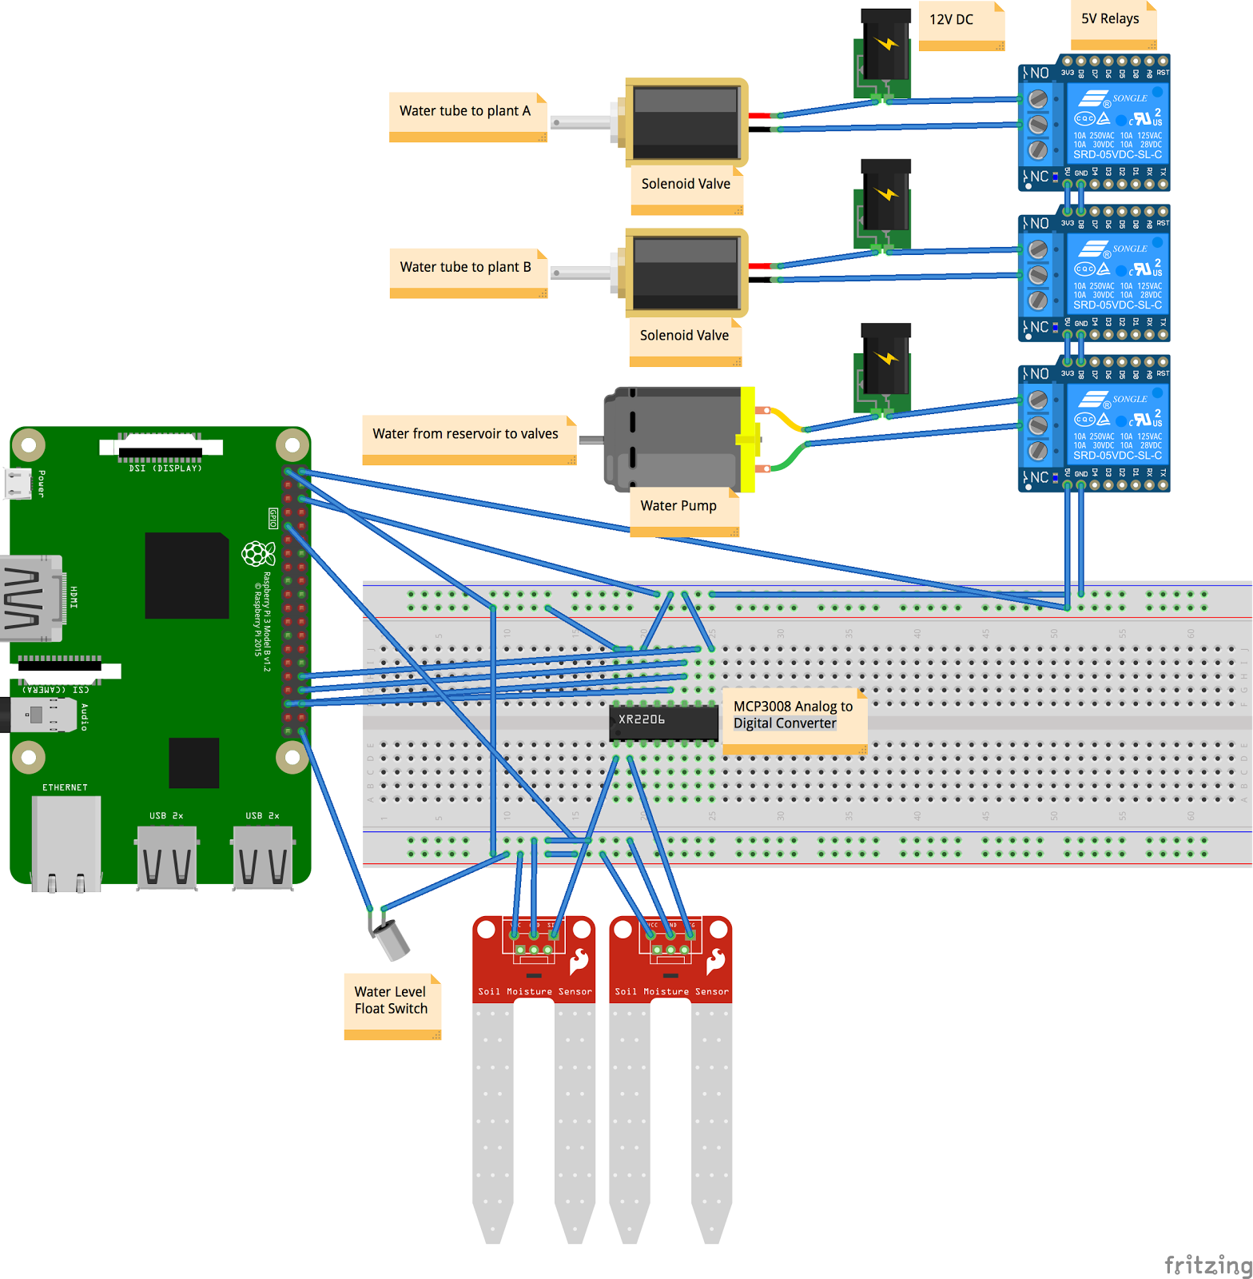

Wiring diagram of the circuit. Soil moisture sensors will be inserted into individual potted plants. Float switch will be in the reservoir of water. ½” clear vinyl tubing connects the pump to a T-joint, which in turn connects both of the solenoid valves. Valves use ½” male x ½” barbed connectors to attach vinyl tube, which then goes to plant. Each plant has one valve and one sensor associated.

**BASIC FLOWCHART:**

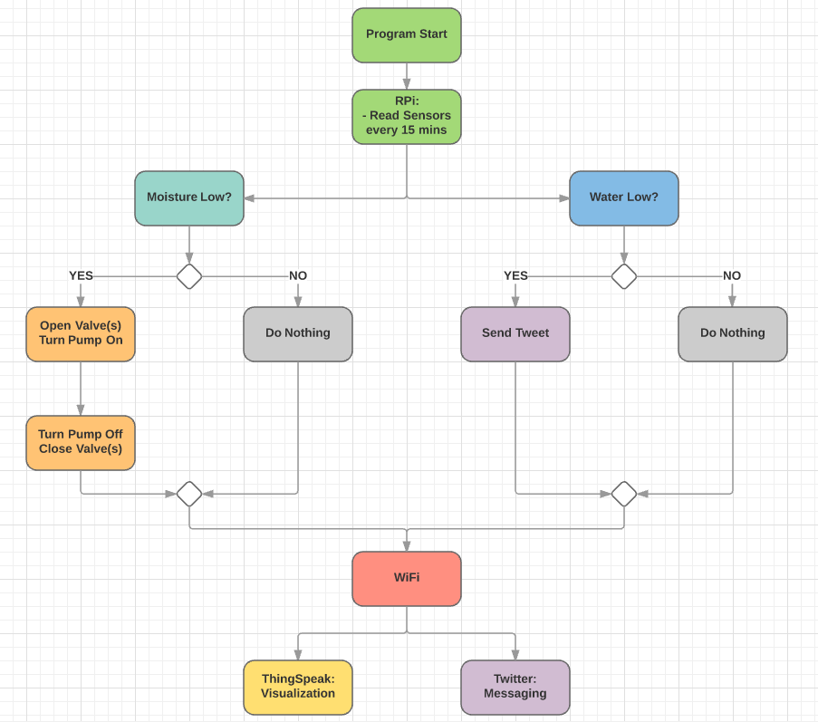

**DATA FLOW:**

