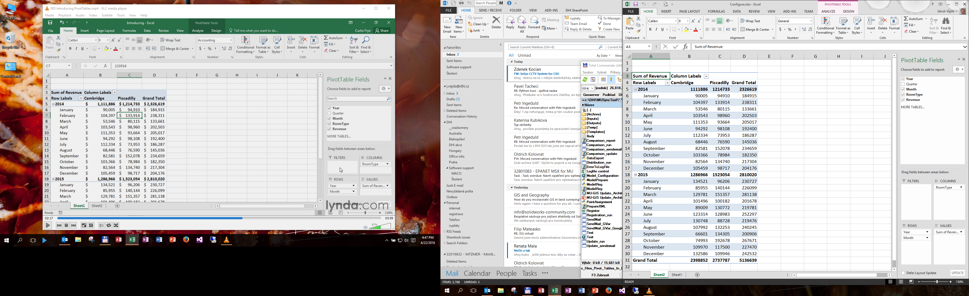

Rows

Limit the data displayed within pivot table without changing table structure

Rows

Columns

Columns

List of available fields in data source   
(to be added to report)

Field areas

DataPrep.xlsx

CreatePivot.xlsx

Recommended.xlsx

Pivoting.xlsx

Configure.xlsx

External.xlsx 🡪 with OutsideSource.xlsx

Consolidation.xlsx

Managing.xlsx

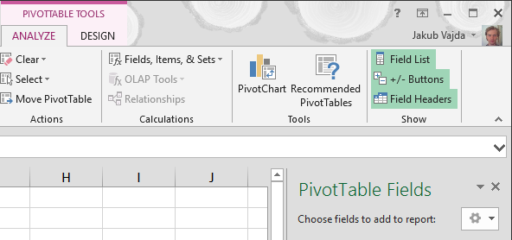

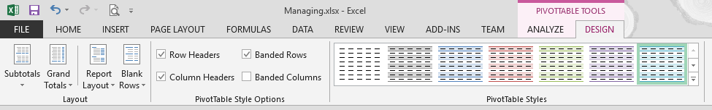

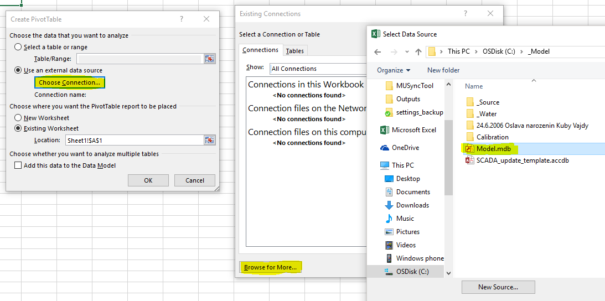

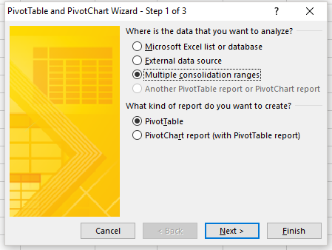 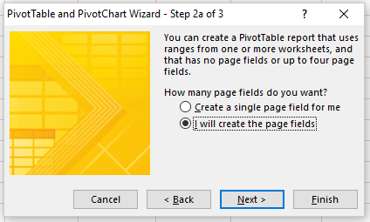 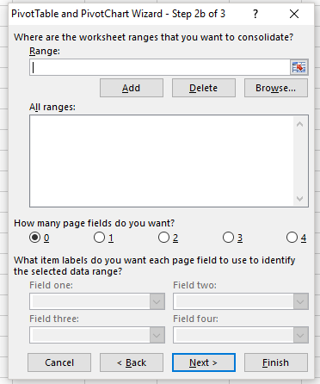 Consolidation Through Wizard: ALT, D, P