**CMPE 443 PRINCIPLES OF EMBEDDED SYSTEMS DESIGN**

**LAB #002 “Debug, Memory and Optimization”**

1. **Debug**

In this prelab, create a project as the PRELAB1 configuration (empty project) and change the main.c file with the file that is available on moodle. You can debug the problem via . There are some debug related buttons, you can use . Add breakpoints near the *“wait_counter = wait_counter + 1;”* lines.

* When you run the code, what happens on the board? __________

1. **Memory Addresses and Registers**

While debugging, you can access the memory of the board and can make some changes. In order to look at the variable value on the memory, you need to know the memory address of the variable. Build the project and look at the *{ProjectName}.map* file.

* Find the “wait_millisecond” variable at map file and paste screenshot (only that part): __________

Also you can see the address of the variables at the IDE. *Show View - Expression View*.

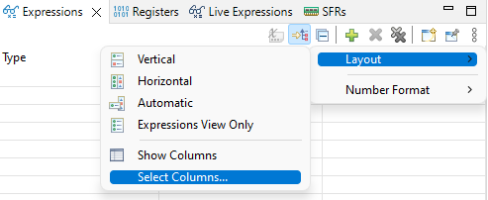

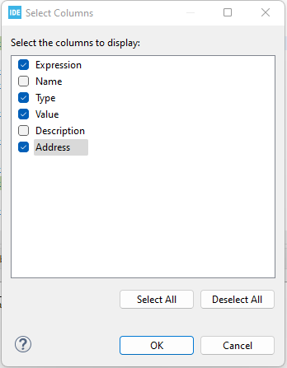

Add the “wait_millisecond” variable to *Expression*.

* What is the address of the “wait_millisecond” variable: __________

Not all the expressions are stored in the memory. *Show View - Registers*:

* Which register stored the wait_millisecond*333 value: __________

1. **Memory**

You can change the variable values on the memory during debugging. *Show View - Memory*, Add Memory Monitor and write the address of the variable.

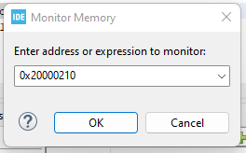

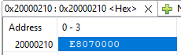

* Variable type is uint32 and if you see E8010000 in the memory, what is the value of the variable: __________
* Change the “wait_millisecond” value on the memory with E8070000, what changes on the board? __________

1. **Compiler Optimization**

When you build your code, on the console (text data bss dec hex) will be written.

* What are these values for your projects? __________

Open the properties of the project and change the Optimization to -Ofast.

* What are these (text data bss dec hex) values for this new setting? __________
* Run your optimized code on the board, what changes on the board? __________
* Change *int index;* with *volatile int index;* what changes on the board? __________

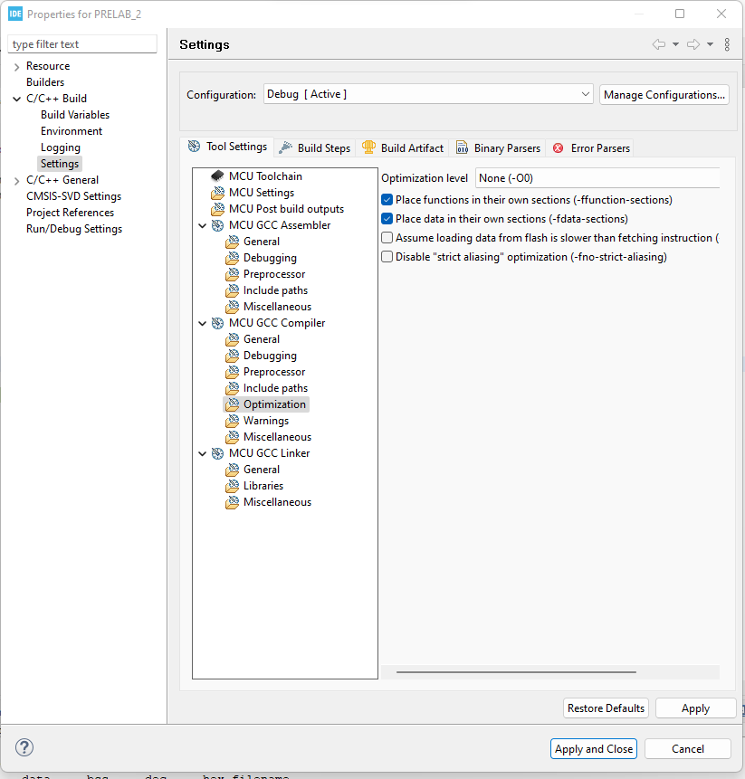

1. **Submission**

You will submit one zip file which contains this document and your project (all the files with the last configuration)

The naming of the zip file should be:

PRELAB<exp num>_<StudentID>.zip

1. **Related Videos and Links**

For *text data bss dec hex* meaning:

<https://mirzafahad.github.io/2021-05-08-text-data-bss/>

For debugging:

<https://www.youtube.com/watch?v=BVC7KaUNCS8>

Volatile Keyword:

<https://www.youtube.com/watch?v=W3pFxSBkeJ8>