INFERENCES

When implementing linear regression instructions, prediction of y. (as shown below) So, error is quite excessive.

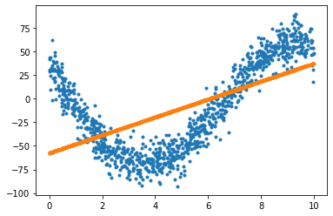

When implementing polynomial regression instructions error will be decrease.And by increasing complexity to 4, predicted y will be approach the real data.But from 4 to 7 change won’t be too much.

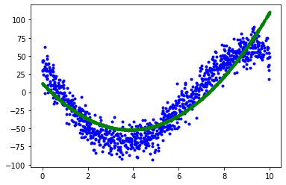

If degree is 2.

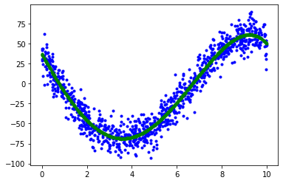

If degree is 7.

|  |  |
| --- | --- |
| Degree | Rsquare |
| 1 | 0.35 |
| 2 | 0.81 |
| 3 | 0.92 |
| 4 | 0.93 |
| 5 | 0.93 |
| *6* | 0.93 |
| *7* | 0.93 |

** If Rsquare is 1 this point out that model is best model for us.

We see that as complexity increases, model approaches best model.

After each estimation, arrays of weights . (as shown below)

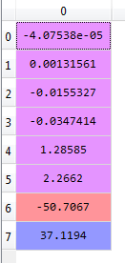 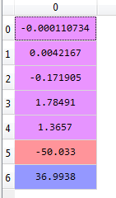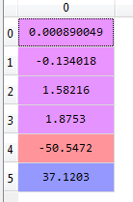

Degree is 7. Degree is 6. Degree is 5.

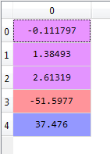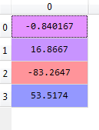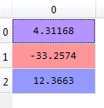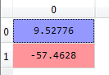

Degree is 4. Degree is 3. Degree is 2. Degree is 1.