LOGICAL REGRESSION (BY USING GRADIENT DESCENT)

DISCUSSIONS

I selected learning rate as 1 but iteration took so much time to train the algorithm.I restricted the iteration with a high value.As a result training the algorithm was so bad.Like this way;

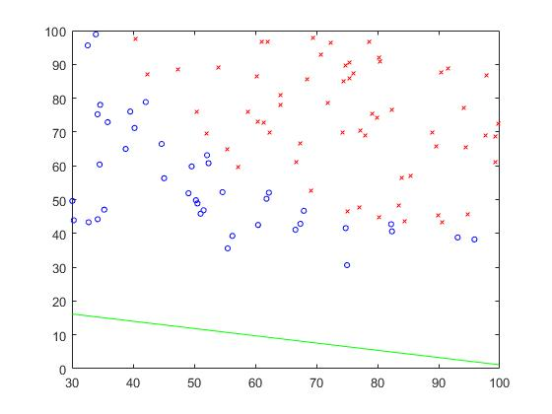

After so many trials I selected training algoritm as 16.And at that time classification border seperated classes from each other. That is, Class 1 and Class -1. Unfortunately there is error.Prediction is not excellent.



H(theta_x)=theta_1+theta_2*x1+theta_3*x2 🡪 this equation is a model for logistic regression.And after iterations , theta values was found as;

theta_1 = 94.1628

theta_2 = -78.8055

theta_3 = -75.8782

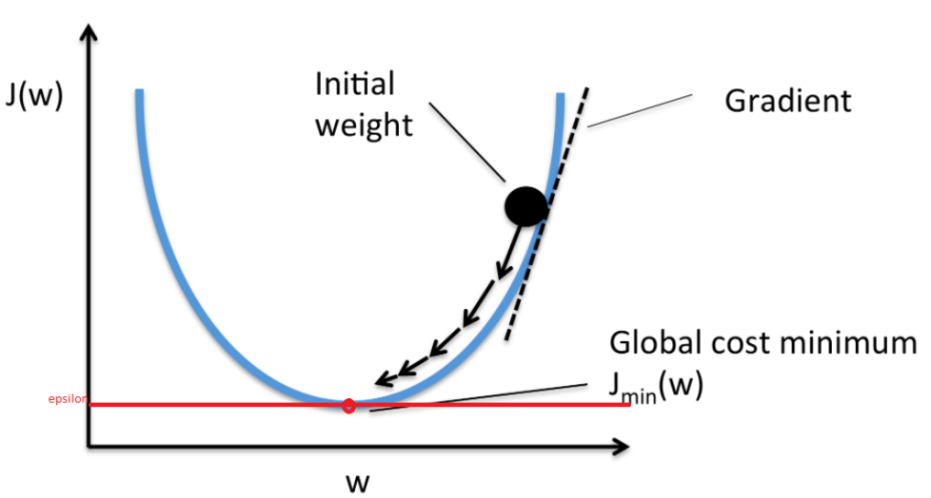

When cost function (j or error) intersect with epsilon value.Error will be minimized.

(w=theta)