1. Signup.

First of all user/customer needs to signup, after that he’ll be able to make requests and receive responses.

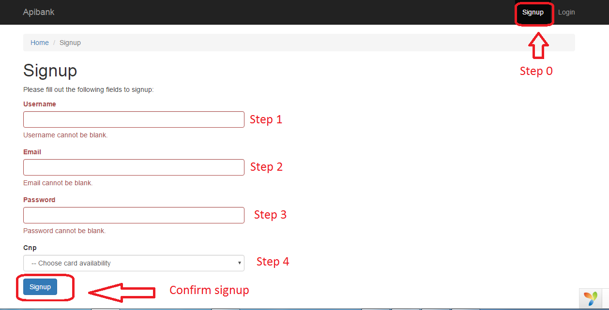To be able to send / receive IPA requests a user needs to register on http://localhost/apibank/frontend/web/ (Picture 1)

Picture 1

1. Move to backend side (Picture 2).

Picture 2

1. 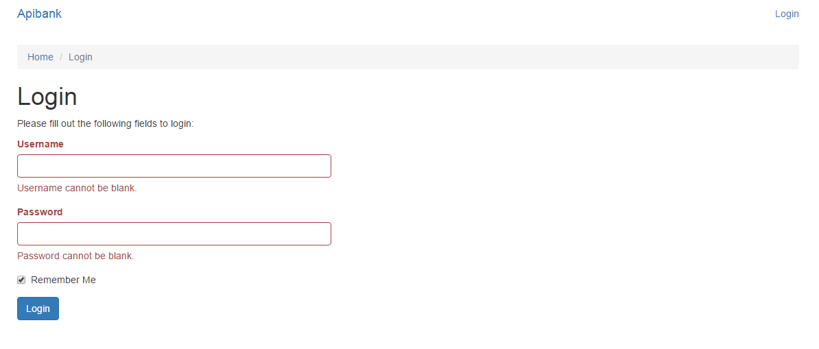Login on backend side (Picture 3).

Picture 3

1. API requests (I use Postman application):

* 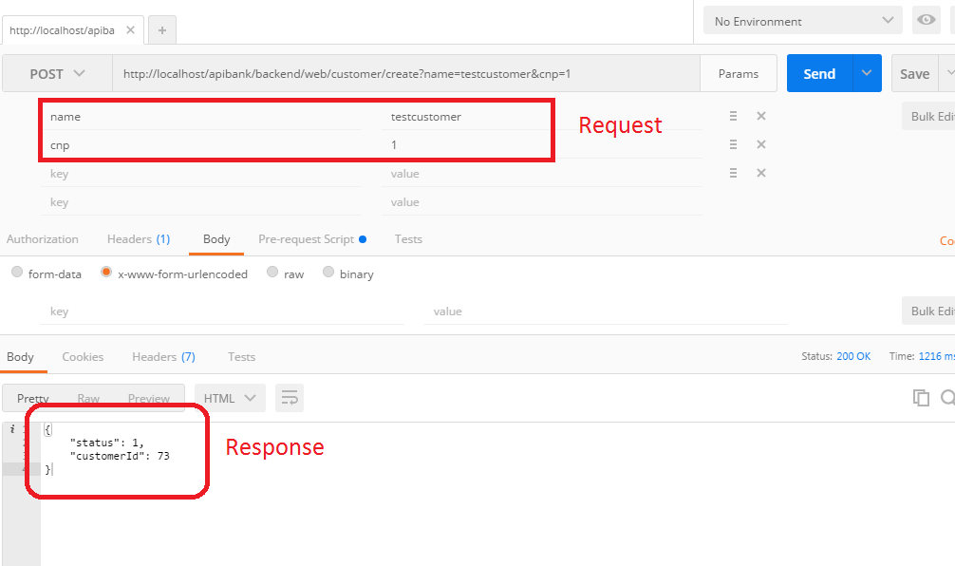Adding a customer <http://localhost/apibank/backend/web/customer/create>, method POST. (Picture 4).

Picture 4.

* Getting a transaction <http://localhost/apibank/backend/web/transaction/view?customerId=2&transactionId=2>,

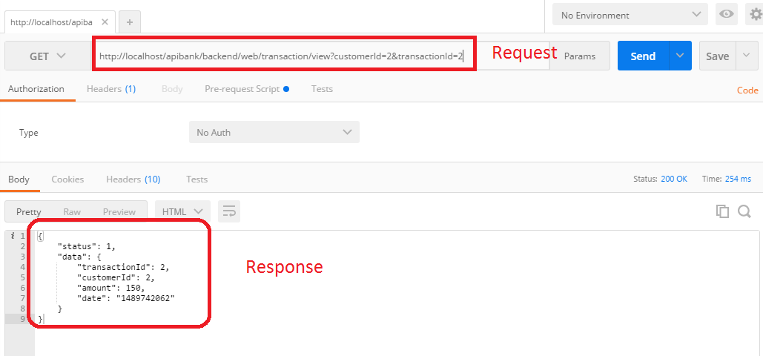method GET (picture 5).

Picture 5.

* 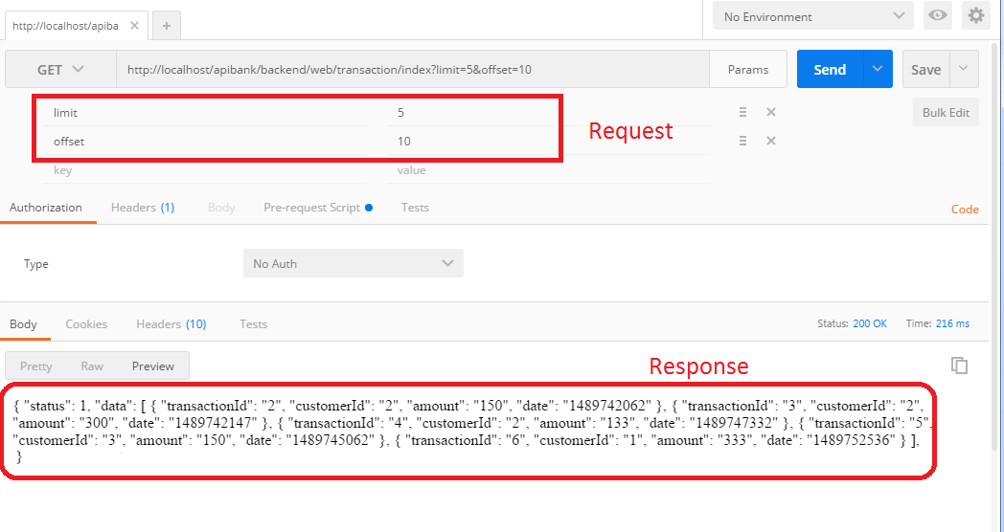Getting transaction be filters <http://localhost/apibank/backend/web/transaction/index>, methid GET (Picture 6).

Picture 6.

* 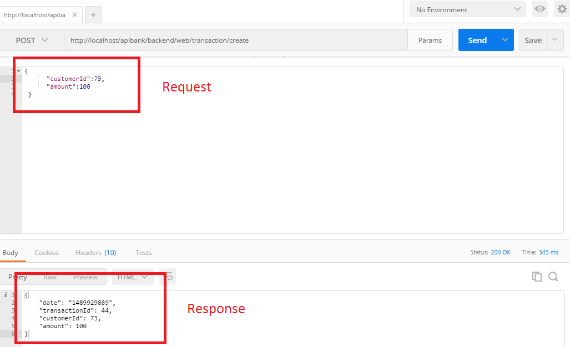Adding a transaction <http://localhost/apibank/backend/web/transaction/create>, method POST (Picture 7).

Picture 7.

* 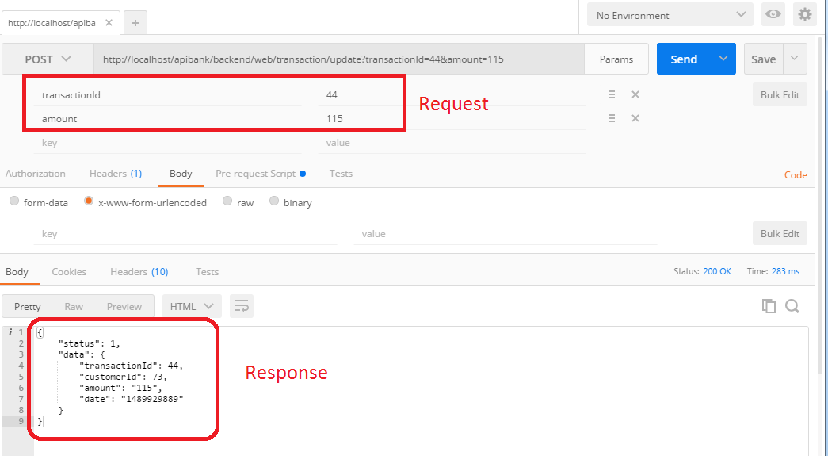Updating a transaction <http://localhost/apibank/backend/web/transaction/update>, method POST (Picture 8).

Picture 8.

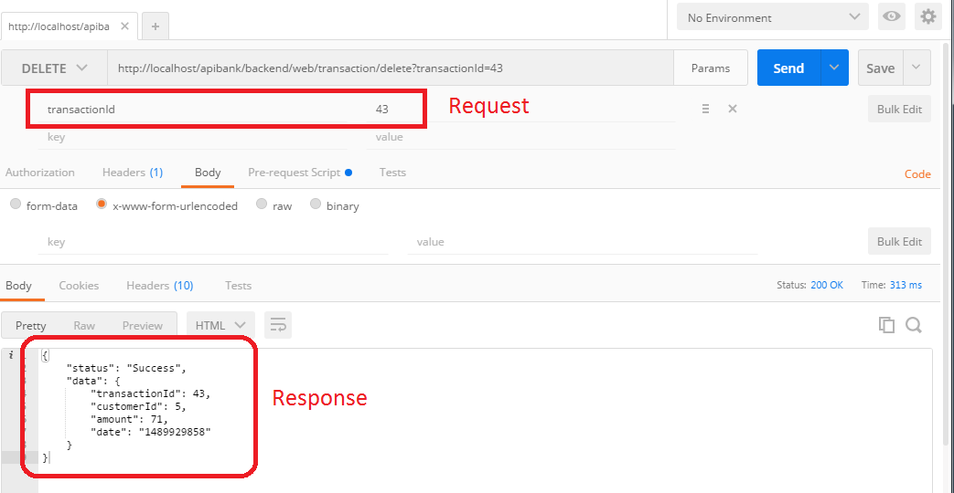Deleting a transaction <http://localhost/apibank/backend/web/transaction/delete>, method DELETE (Picture 9).

Picture 9.

1. 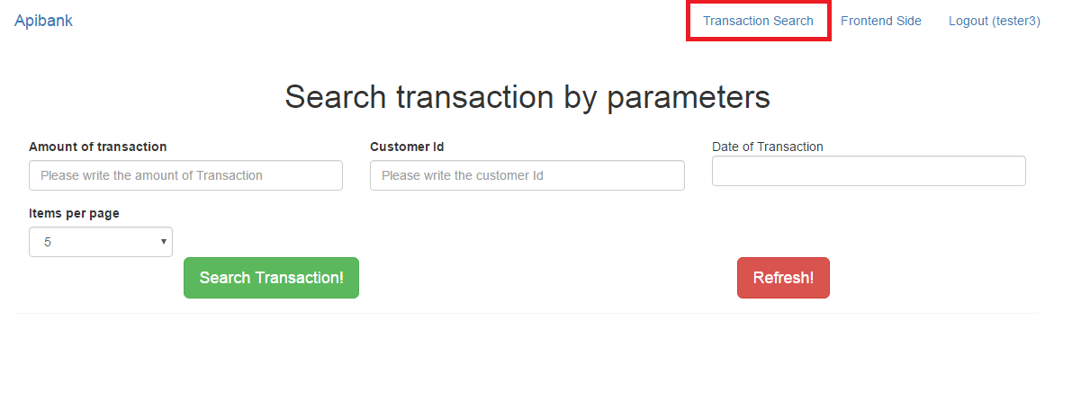Page where we can see transactions and filter them (amount, date, customerId, items per page) <http://localhost/apibank/backend/web/transaction/search>, (Picture 10).

Picture 10.