Site where task are deployed: <http://deku.esy.es/frontend/web/>,

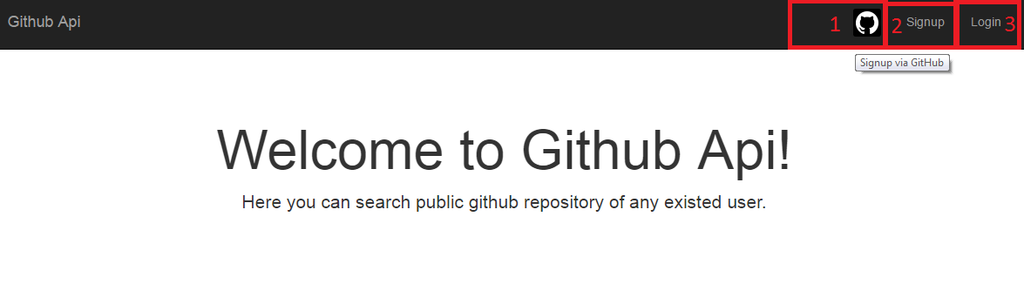

Picture 1

1. User sign in to the GitHub – user can sign via Github account (Picture 1 sign 1) or sign in application (Picture 1 sign 2) or login if he signed before (Picture 1 sign 3)

2) Show the list of user's repositories – After sing up or sign in user can search the list of any public Github account repository (Picture 2)

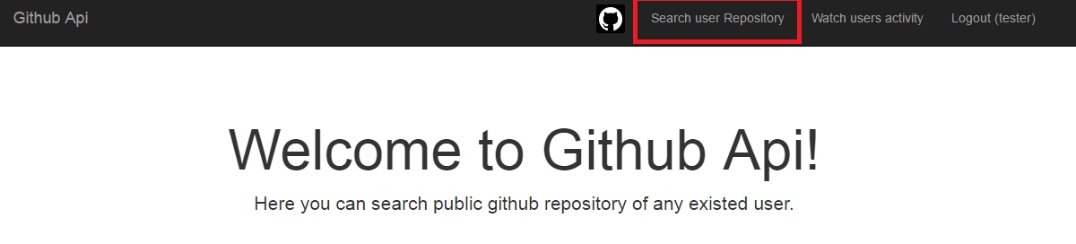

Picture 2

3) Show issues of the chosen project(repository)

4) Show tooltip on the mouse over event for the chosen repository – Issues 3 and 4 described on picture 3

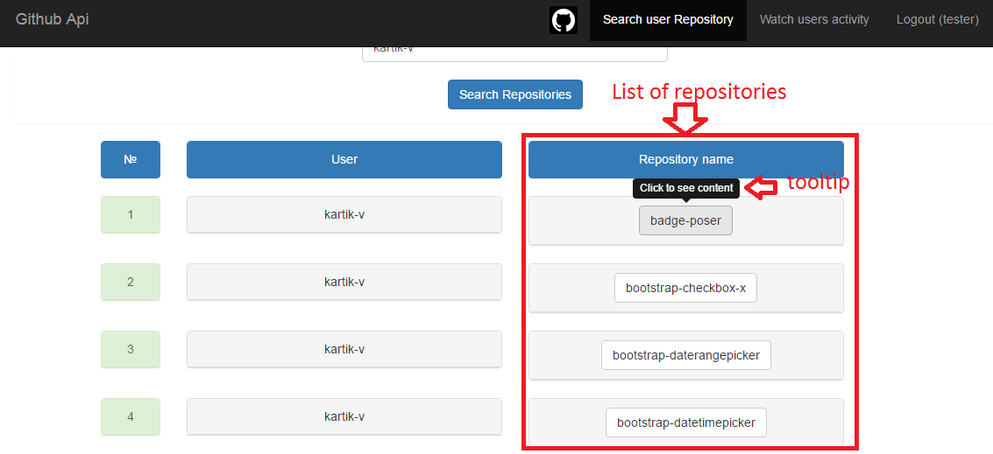

Picture 3

5) Create database and save all user activity into it. – all user activity saves to mysql table user_activity picture 4

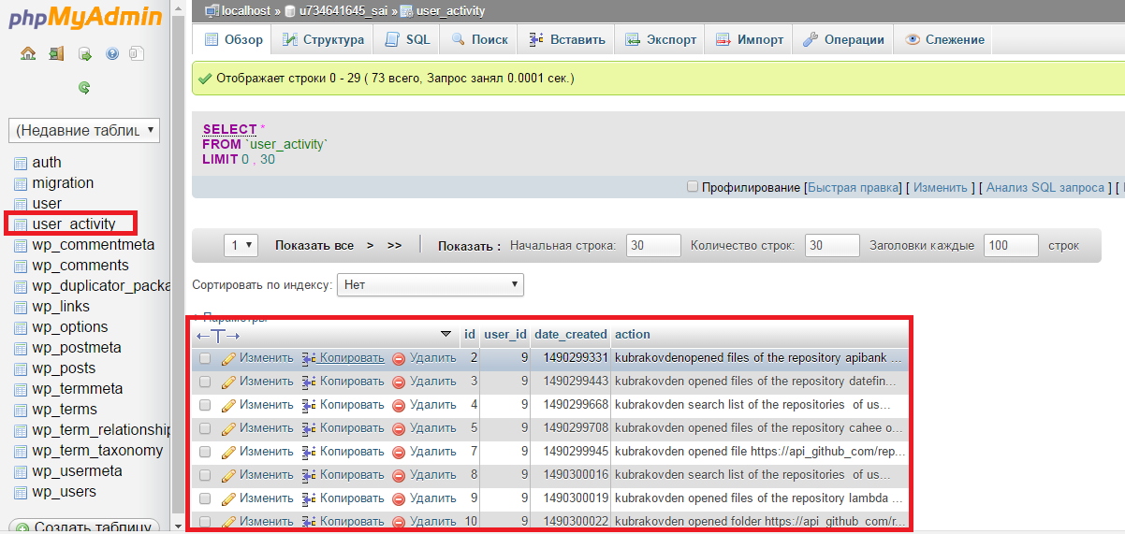

Picture 4

6) Create standalone web page where all user activity will be showing. - standalone web page with all user activity described on picture 5

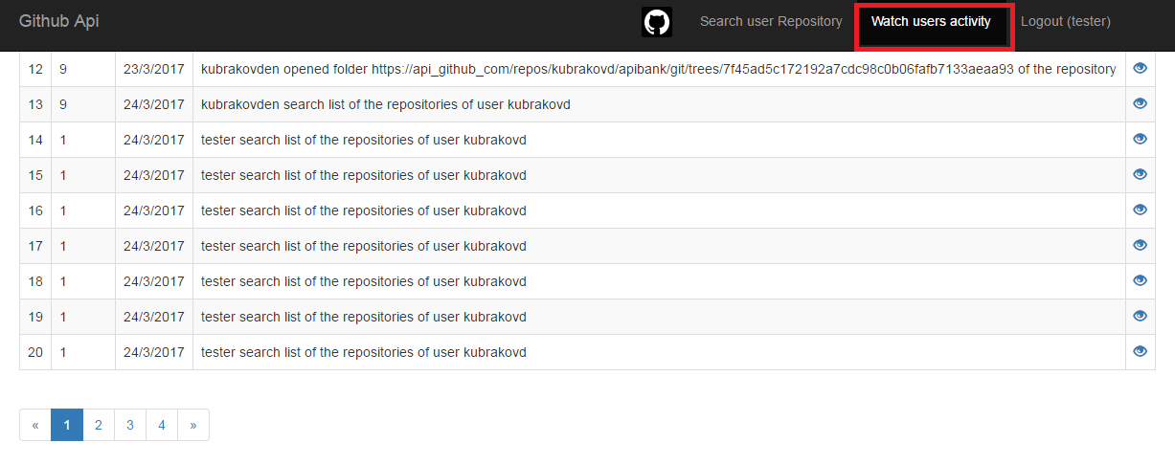

Picture 5

Please use any of these technologies:

Frontend:

AngularJS, HTML5, CSS3, Bootstrap, Javascript, JQuery (or any other Javascript frameworks).

Backend:

node.js or PHP

It should be well commented code in English, and the interface also has to be in English