**GTmetrix Performance Test Report**  
  
Project Name: Website Performance Testing  
Tested By: Kubra Memon  
Tool Used: GTmetrix  
Test Date: 2025-06-08  
  
Website URL: https://parghor.com/  
  
GTmetrix Results:  
  
Performance Score: 76%  
Structure Score: 98%  
Largest Contentful Paint (LCP): 5.2 seconds  
Total Blocking Time (TBT): 0 ms  
Cumulative Layout Shift (CLS): 0  
  
Summary:  
  
- The website structure is excellent with a 98% score.  
- LCP is improved to 5.2s but can still be optimized further.  
- TBT is 0 ms, showing no blocking issues.  
- CLS is 0, indicating layout stability.  
  
Recommendations:  
  
1. Further optimize large images and use next-gen formats (e.g., WebP).  
2. Minify any remaining CSS/JS files.  
3. Use lazy loading for below-the-fold content.  
4. Implement a CDN for faster global load times.  
  
Conclusion:  
  
The website shows strong performance, excellent structure, and stable layout. Improving LCP further will enhance user experience and overall page speed.  
  
Attachments:  
  
- GTmetrix Screenshot  
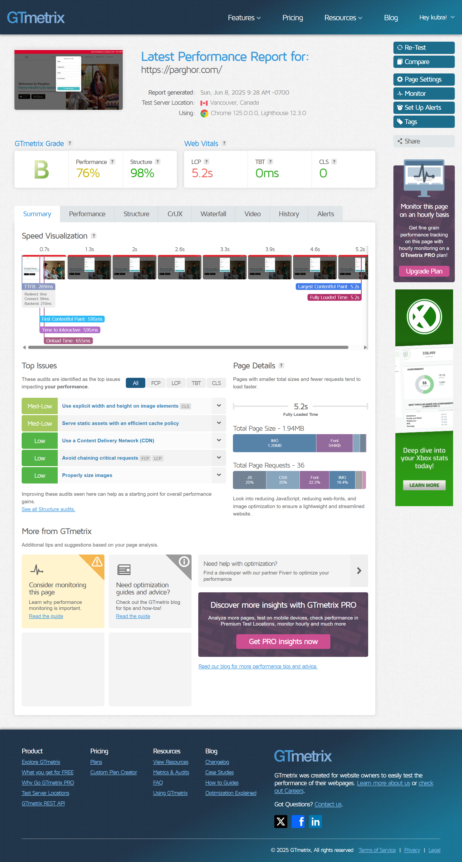

Prepared by: Kubra Memon