Project Report

Title: Development of Genomic Markers for Environmental Resilience in Mussels

Reporting Period: June, 2021

(A) Project Summary

Our project seeks to support the sustainable expansion of the shellfish aquaculture industry by investigating the downstream impact of ocean acidification (OA) and ocean warming (OW) on the survival and successful cultivation of marine bivalves. Our research *objective* is to describe the response of commercially relevant species of marine mussels to current and near-future OA and OW, utilizing cutting-edge molecular technologies to identify genetic markers that confer resilience to environmental change. In collaboration with our industry partner, Penn Cove Shellfish LLC, the measure of success for this proposal will be the identification of genetic markers that, when used as selection criteria for mussel broodstock, will produce adults with robust attachment to aquaculture lines under near-future OA and OW. By defining these gene-environment interactions, our results stand to support commercial growers in the development of selective breeding programs to ensure the efficient, sustainable, and profitable production of mussels within the United States.

(B) Summary of Progress and Results

During the June 2021 reporting period, a majority of our effort has been allocated to building and testing the saltwater mesocosm system that is needed to complete the environmental exposures outlined in the project proposal. This effort necessitated the purchase of tubing, plumbing supplies, carbon dioxide and nitrogen gas cylinders, and other supplies to construct two environmental chambers capable of maintaining seawater pH, temperature, and dissolved oxygen setpoints (see picture below). The next steps will be to adapt microprocessor-based controllers currently available in the Carrington laboratory to work with this system and to test the range of control with live animals.

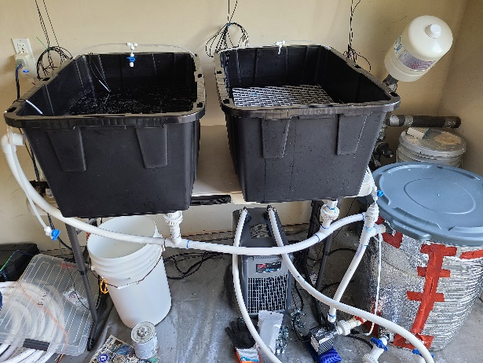

(C) Challenges

No challenges have yet been encountered.