**CAR PARKING SLOT MANAGEMENT SYSTEM**

### **A Project Work**

### *Submitted in the partial fulfillment for the award of the degree of*

### **BACHELOR OF ENGINEERING**

### **IN**

### **ARTIFICIAL INTELLIGENCE AND**

### **MACHINE LEARNING**

### **Submitted by:**

### **Arnav R Patnaik**

### **20BCS6658**

### **Sai Rahul**

### **20BCS6670**

### **Under the Supervision of:**

**MRS.AKWINDER KAUR**

### **SUPERVISORS NAME**

**MR. DINESH VIJ**

# **DEPARTMENT OF COMPUTER SCIENCE AND ENGINEERING APEX INSTITUE OF TECHNOLOGY**

### **CHANDIGARH UNIVERSITY, GHARUAN, MOHALI - 140413,**

**PUNJAB**

#### **MONTH & YEAR**

**26 JULY, 2021**

**DECLARATION**

I, **Arnav R Patnaik and Sai Rahul**, students of **‘Bachelor of Engineering in Artificial Intelligence and Machine Learning**, **session: 2020-2024**, Department of Computer Science and Engineering, Apex Institute of Technology, Chandigarh University, Punjab, hereby declare that the work presented in this Project Work entitled ‘**Car Parking Slot Management System’** is the outcome of our bona fide work and is correct to the best of our knowledge and this work has been undertaken taking care of Engineering Ethics. It contains no material previously published or written by another person nor material which has been accepted for the award of any other degree or diploma of the university or other institute of higher learning, except where due acknowledgment has been made in the text.

### [20AIML3-B]

### (**Arnav R Patnaik**)

### Candidate UID: **20BCS6658**

### (**Sai** **Rahul**)

### Candidate UID: **20BCS6670**

#### **Date:26 July 2021**

**Place: Chandigarh University, Mohali, Punjab**

**ii**

**ABSTRACT**

**[1][2]** Over the years, we have seen that the population has exponentially increased. Due to which there has been a huge spike in the purchase of vehicles. A survey based on the preference of transport in pre and post covid period was conducted by RESEARCH AND MARKETS in which they interviewed more than 350 2-wheeler and 4-wheeler owners from various age groups. Some key findings of the survey showed that there has been a significant shift from public transport to personal transport as 56% of respondents were apprehensive about hygiene and lack of social distancing. So, more space will be required to park a vehicle. In apartments, societies, and shopping areas, we have seen that finding a suitable parking area has become a severe issue. This paper proposes a compiler-based program that will serve the purpose of booking and handling parking slots easier. This program will help the admin to maintain a record of the parked vehicles, customer details and further to check which slots are empty, CCTV's will be installed so we will be able to monitor the parking area. This program is user-friendly and keeps the data secured. This can help in the proper management and parking of vehicles. Editing and updating the records becomes easy and efficient.

Keywords: survey, transport, compiler-based, CCTV’s

**ACKNOWLEDGEMENT**

I would like to thank my supervisor, Mr. Dinesh Vij sir, for his guidance and advice through each stage of making this project. I would also like to thank Mrs. Akwinder Kaur ma’am for giving me and my teammate Mr. Sai Rahul this opportunity to work on an Industrial project in which we can show our true potential, creativity, and hard work. I would also like to thank my family and friends, who have been a constant support and have always motivated me to work hard and bring out the best in me.

**LIST OF FIGURES**

|  |  |  |
| --- | --- | --- |
| ***Figure*** | ***title*** | ***page*** |
| 1 | Project timeline | 6 |
| 2.2.1 | Login portal of car parking slot management system | 10 |
| 2.2.2 | car parking slot management system dashboard | 1 |
| 2.3.1 | CCTV camera’s and monitor setup in the apartments | 11 |
| 5.1 | Methodology Table | 13 |

**TIMELINE/GANTT CHART**

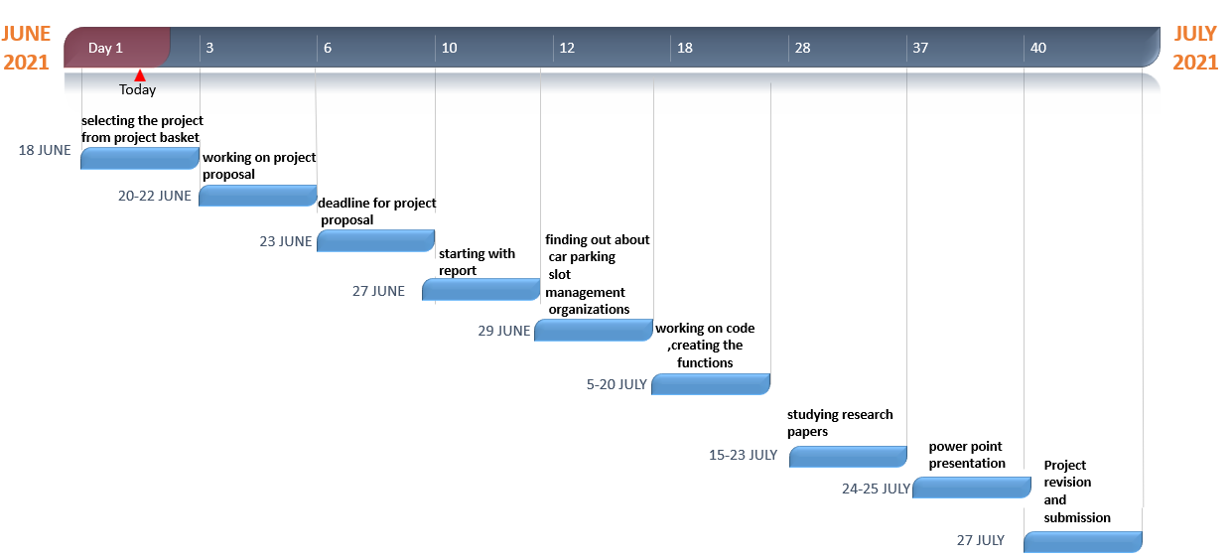

**Fig-1 Project timeline**

# Table of Contents

|  |  |  |
| --- | --- | --- |
| **SR.NO** |  | **PAGE NUMBER** |
| 0 | Title page  Declaration of student  Abstract  Acknowledgment  List of figures  Timeline / Gantt Chart | 1  2  3  4  5  6 |
| 1 | **INTRODUCTION\***   * 1. Problem Definition   2. Project Overview/Specifications*   3. Hardware Specification   1.3.1 PC  1.3.2 CCTV  1.4 Software Specification  1.4.1 Visual Studio Code/ Code::Blocks  1.4.2 Notepad Text Editor  1.4.3 Ip Webcam Application | 8  9 |
| 2 | **LITERATURE SURVEY**   * 1. Existing System   2. Proposed System   3. Feasibility Study* | 10 |
| 3 | **PROBLEM FORMULATION** | 12 |
| 4 | **OBJECTIVES** | 13 |
| 5 | **METHODOLOGY** | 13 |
| 6 | **CONCLUSIONS AND DISCUSSION** | 14 |
| 7 | **REFERENCES** | 14 |

**INTRODUCTION\***

* 1. **PROBLEM DEFINITION**

Residential areas always face a problem as there is always an increased population of cars and there are not enough parking spaces within the societies and residential areas. So we see a lot of people parking outside the apartments in an uneven manner which also causes a problem for the general public. Moreover, more fuel is consumed while finding the available parking space, which results in more CO2 emissions.

It is not possible to reduce the number of cars on the road or practically possible to reframe the existing parking areas in these residential areas. But we can digitalize the parking spaces by maintaining a record of vacant and occupied spaces, which will make it easy for the people. Using CCTV’s and our compiler-based software, we can provide both parking operators and the drivers a real-time map of the available spaces.

* 1. **PROJECT OVERVIEW/ SPECIFICATIONS**
* The car parking slot management system is based on C++.
* It stores the customer’s name, phone number, car number, hours of stay and the amount to be charged.
* It has a secured login system that requires the user id and password.
* The user id and password are encrypted to provide better security from the operator’s end.
* The total number of vehicles that are being parked can be recorded.
* Parking expenses of the customer’s vehicles record are maintained.
* The records of the customers can be deleted.
* The ticket can be printed to give to the customer or just for maintaining the records.
  1. **HARDWARE SPECIFICATION**
     1. **PC**

A pc is a personal computer which is a multi-purpose computer whose size, capabilities, and price make it feasible for individual use. They are intended to be operated directly by an end-user, rather than by a computer expert or technician. Software for personal computers is typically developed and distributed independently. Our compiler-based program will be installed on the pc for the operator/admin to use it.

* + 1. **CCTV**

**[4][5][6]** Closed-circuit television also know as video surveillance, is the use of video cameras to transmit a signal to a specific place, on a limited set of monitors. CCTV cameras require constant monitoring by the operator or the employee. In the market today, there are two types of parking lot security cameras. One is the CCTV analog system, which is a traditional camera used in CCTV systems. It sends video over cable to VCRs or DVRs. The other type is the IP camera. This one works by sending footage to a Network Video Recorder that uses a Power over Ethernet system. The power for the camera runs through the data cable, hence requiring fewer cables to install and run. Footages from the parking lot can be accessed over the internet using the smartphone or can be displayed on the monitor. This allows the user to view what’s happening remotely.

* 1. **SOFTWARE SPECIFICATION**

**1.4.1Visual Studio Code/ Code::Blocks**

Visual Studio Code is a code editor with support for development operations like debugging, task running, etc. It focuses on providing the tools a developer needs for building a code and leaves the more complex workflows to the featured IDEs, such as Visual Studio IDE. It works on macOS, Linux, and Windows. It is free for private or commercial use.

Code::Blocks is a free open-source, cross-platform IDE. It uses a plugin architecture, its capabilities and features are defined by the provided plugins. Currently, Code::Blocks is oriented towards C/C++.

**1.4.2 Atom Text editor**

Atom is a text and source code editor which works across all operating systems. It speeds up find-and-replace operations by an order of magnitude, improves loading performance for large, single-line files It’s a desktop application built with HTML, Javascript, CSS, and Node.js integration.

**1.4.3 Ip Webcam Application**

IP Webcam is a network camera application that allows users to monitor happenings around them with multiple viewing options. View your camera on any platform with a VLC player or web browser. Stream video inside WiFi network without internet access. Optional video and cloud broadcasting is supported for instant global access.

**LITERATURE SURVEY**

**2.1 EXISTING SYSTEM**

|  |  |  |  |
| --- | --- | --- | --- |
| **Year and citation** | 2019  (PARKOFFICE)  Dublin | 2018  (VERSIONX)  India | 2009  (BOOKINGNINJAS)  USA, Florida |
| **Purpose of study** | optimizing car park occupancy, managing parking availability, generating employee parking revenue and reducing carbon footprint | digitize the end-to-end management of parking spaces and all parking processes related to visitors, vehicles, & payments. | It focuses on helping individuals manage their parking procedures |
| **Intermediate representation** | * Smartphone application * RFID * website | * Smartphone application * RFID * website | * Smartphone application * RFID * website |
| **Granularity Level** | 3 | 3 | 3 |
| **Match detection technique** | * IOT * RFID | * IOT * FASTag * RFID * Biometric | * IOT * RFID |
| **Types of clone** | 0 | 0 | 0 |
| **Type of vulnerabilities** | * system looks simple, but architecture is complex * high cost of maintenance * cant be used in bigger parking slots | * high cost of maintenance * initial setup will be costly * use of manpower | * high cost of maintenance * initial setup will be costly |
| **Data set** | [The employee parking management software for smart | ParkOffice.io](https://parkoffice.io/) | [Parking Management System | Smart Parking System | VersionX](https://www.versionx.in/parking-management-system) | [Parking Management System & Parking Software | Booking Ninjas](https://www.bookingninjas.com/parking-management-system) |
| **Evaluation parameters** | * fairness * complexity * cost | * fairness * complexity * cost | * fairness * complexity * cost |

**[7]** For the past 50 years, expensive pieces of hardware were used to control payment and access in the parking slot management system. Motorists tend to have access managed by large barriers, to enter they need to pull a ticket. Before departure, they need to pay at a pay station for the length of their stay. A local staff member will often be on-site in case of any difficulties. The hardware will have backend reporting to report on occupancy and revenue generation. Nowadays consumers are looking for smoother parking experiences.

There have been many organizations that have been working on car parking slot management with having the prime focus on shifting from the traditional or manual way of a person noting down the data in a book to digitalizing it through a computer.

**[8]** A “smart” car parking system is based on technologies such as mobile, cloud, IoT, etc. It has been created to tackle the dysfunctional system that comes with the traditional parking style. Without working on space and solely with the software, the parking capacity of companies can improve tremendously too. The system requires minimal hardware for efficient functioning. Features can be quickly and easily added or tailored to specific needs. The parking management system is of different types, and companies have to choose based on the building’s structure and the need of the general populace who will make use of the parking management system.

It eliminates manual monitoring and tracking of vehicles. It digitizes end-to-end parking processes including multi-tenant, multi-level parking. We can customize & reserve parking space as per customer’s demand, pay-&-park, etc. Allocate slots as per two-wheeler and four-wheeler vehicles to utilize all the available spaces. The customers can view it on your phone along with reports. QR code-based passes are instantly auto-generated for a visitor. Parking passes generated can be on a pay-&-park or a monthly payment basis. It is FASTag enabled. It displays empty slot info such as floor and bay on LED screens in the parking bay. Instant penalty tickets are issued, if any person or vehicle is found guilty of any time or rule violation. Live countdown of occupied versus unoccupied slots, filled versus unfilled slots, etc. can be displayed on a LED screen and the phone. Guards are made more accountable since the system cannot be tampered with. Built-in statistical tools help you use the data captured for further decision-making. It gives real-time car parking information such as vehicle & slot counts, available slots display, reserved parking, pay-and-park options, easy payments, reports, and a host of other features.

**[9]** Majorly, it is electronically operated which makes its efficiency a lot higher than that of the average human. It doesn’t require a lot of human effort; instead, the user relies on their smartphones to help with necessary information. It improves efficiency, saves time, saves energy, and makes the collation of reports very easy when compared to the manual or hardware-only type of system. The things which delay at gates or in parking spaces simply do not exist in the case of the modern type of parking management system which makes use of the software. No longer do visitors or users have to fight, block, or hit one another when the software is in place. With ease, everyone can get information about the right place to park, and the available space is utilized maximally. The stress of having to queue for payment before parking or entering is removed as each gets to pay easily on their own. Other than helping with the parking protocols, the intelligent parking management system also helps with map management as it directs and guides users. You don’t have to worry about having to go through the stress of finding a parking space when you can easily make use of your Smartphone’s software for mapping. Entry & exit can be linked directly to smartphones or license plates. Real-time reporting is available for car park owners giving them access to insights instantly. Many car parks are slowly migrating from hardware focus to software focus. Although you’ll still often see hybrid parking management systems between both models.

**2.2 PROPOSED SYSTEM**

The proposed system of car parking slot management system is compiler-based. The exact location of a parking slot in a particular area will be monitored through CCTV cameras. The parking slots will be continuously monitored and the data will be updated through the program.

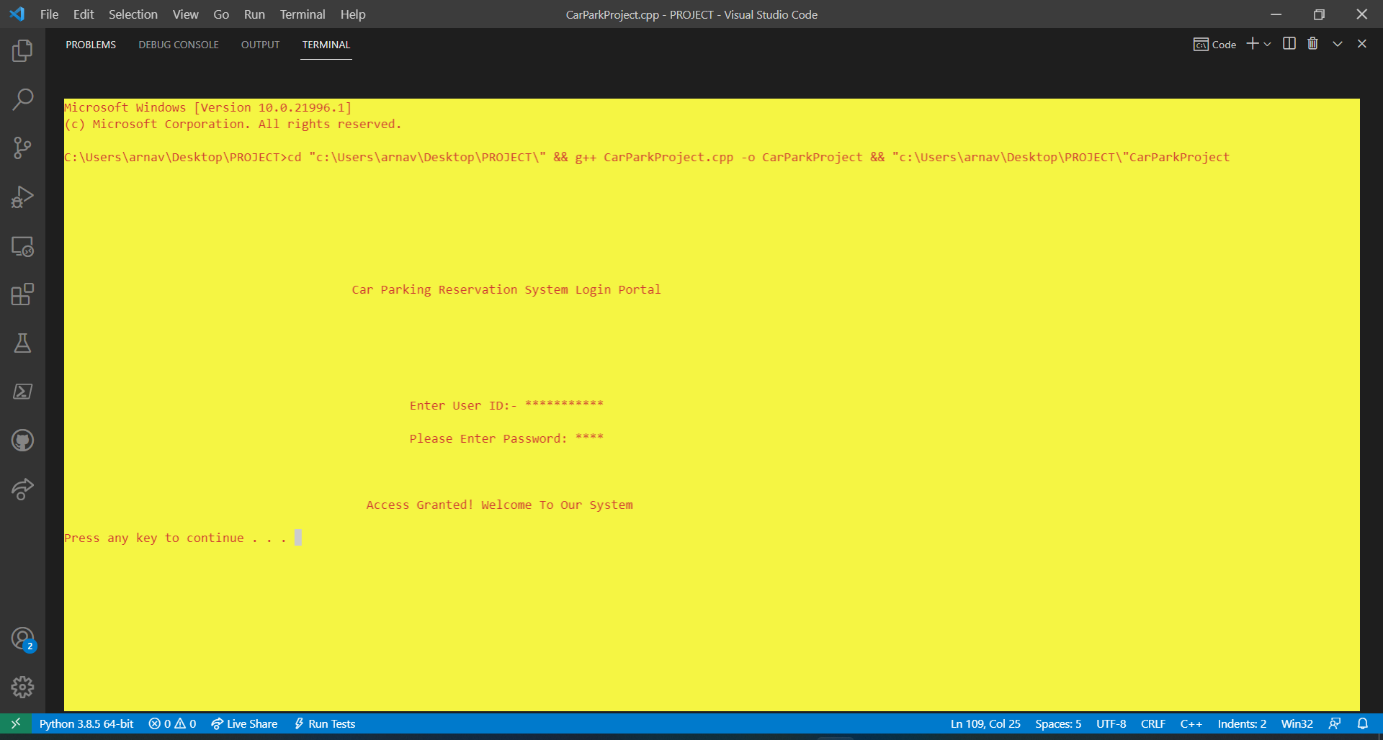

**Fig-2.2.1- Login portal of car parking slot management system**

Using different functions with the knowledge of file handling, the program will provide the user to book a slot for a customer in which the customer’s name, phone number, car number, hours of stay, and time slot of parking is stored in a text file after the data is entered. The user can keep a check on the total number of vehicles that have arrived and a slot has been allotted to the following. The parking charges can be calculated (GST added) and stored as well according to different individuals. The user can delete a record of a customer if the data is not required anymore. Further, a ticket can be printed to give to the customer if needed.

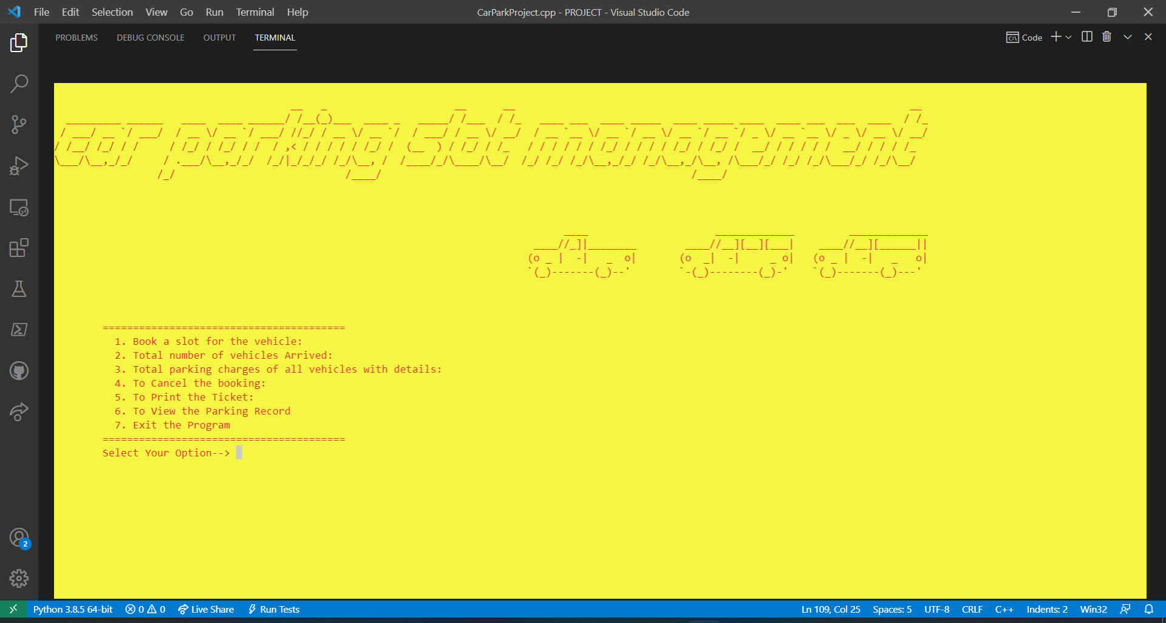

**Fig-2.2.2- car parking slot management system dashboard**

**2.3 FEASIBILITY STUDY**

The major issue of parking comes into the picture in the case in case of cars which occupy a big area. We have introduced such a system which will make the car parking system efficient and resolve the issue of handling the vacant and occupied parking slots. Our system is dependent on both software and hardware. At first, CCTV will be installed in the lane or area where we will be using our program to keep a record of the parking slots. With the CCTV footage, we can keep a check of which slot is empty and which slot has been occupied. A pc and monitor has to be installed in a lobby of an apartment, small residential, or commercial spaces, where our program can be used in storing the data and allotting the slots to the vehicles to avoid the chaos

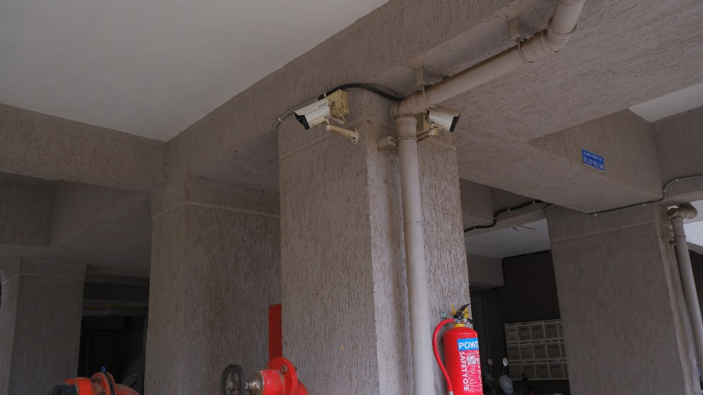 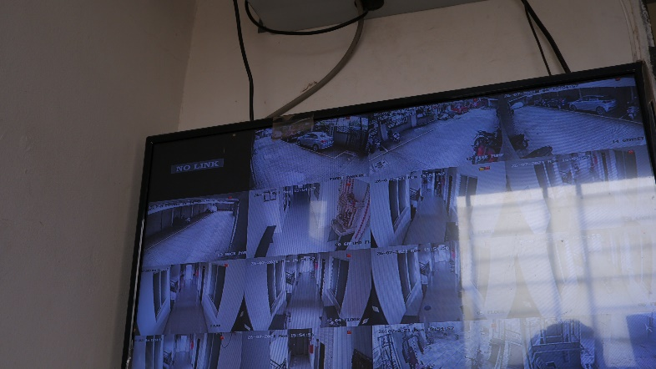

**Fig-2.3.1- CCTV camera’s and monitor setup in the apartments**

Limitations🡪

* Excel or pdf reports cannot be generated.
* The system works in offline mode, hence modification of data for a vehicle's parking duration fees in online mode will not be possible.
* Initial set up of the system in real life can be expensive as one has to invest in a pc, CCTV camera’s, etc.
* This system is not fully automated, so it will require manpower.

**PROBLEM FORMULATION**

* The major problem arising in this research project is that how to manage the problem of car parking in small residential areas, apartments, commercials, and the streets.
* It is important to resolve this issue as it creates chaos amongst the drivers who are not able to get a slot or parking area to park their vehicle.
* This issue gets severe when a person owns a car or 4-wheeler as it requires a bigger area.
* There is a need to keep all the cars organized and secure in their parking slots which can only be done by this program as it stores all the information as records real-time into the memory.
* To resolve this issue we came up with a system in which the operator can assign the slots to the vehicles and a system of proper car management can be initiated.
* Our program is compiler-based in which the operator will be able to add the details of the customer, their vehicle, and the parking charges as well.
* This car parking management system also has a secure login portal which makes it more secure and accessible to the user/admin/management.

**OBJECTIVES**

The main objective of this Car Parking Slot Management System which is based on C++ is to:

* manage the details of the customer like vehicle number, phone number, stay hours of their parked vehicle, Parking slots.
* Focus on the administrative end.
* reduce the manual work for managing the customer and their vehicle details
* Create a reliable system, which provides accuracy, keeps the system secured, and is cost-effective.

**METHODOLOGY**

The methods and functionalities work in the following way in our car parking slot management system:

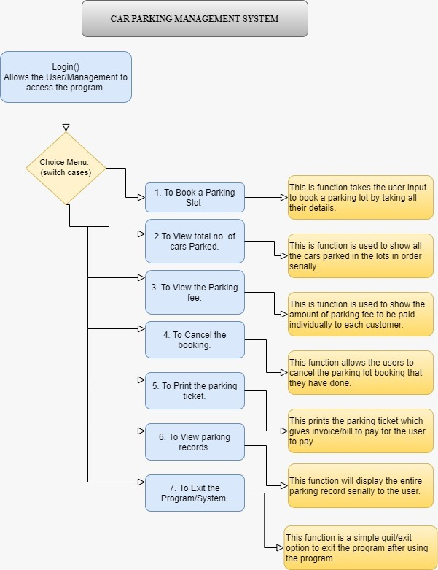

**Fig-5.1-Methodology Table**

**CONCLUSIONS AND DISCUSSION**

This project work aims at providing an efficient car parking management system based on compiler programs and CCTV cameras. CCTV cameras are used to keep a check on the slots and with the help of the program, we can store and keep a record for the same.

The prime focus of this study was to introduce a system in which car parking can be managed efficiently without causing any hassle to the driver as well as the general public. **[11]** An efficient parking detection system will reduce the load on the driver, who spends time finding a vacant space to park his vehicle which is also called a traditional binary search(TBS). This system is partially automated as it requires the involvement of manpower. In the future, the goal is to make the program fully automated and more user-friendly and also develop it into an app that will be feasible for everyone.

**REFERENCES**

**[1] Research and markets- India Vehicle Purchase Preferences Report 2021**

**[2] McKinsey & Company- Marketing & Sales report**

**[3] UBC SMART PARKING SYSTEM**

**[4] WIKIPEDIA-The free encyclopedia**

**[5] MOBILEVIDEOGUARD.COM**

**[6] Black box- analogue and ip cameras**

**[7] PARKOFFICE**

**[8] VERSIONX**

**[9] BOOKINGNINJAS**

**[10] Design and Implementation of Smart Car Parking System, Modelling and Simulation -P B Natarajan, Samit Kumar Ghosh, pg.4-7**

**[11] A Comparative review on Car Parking Technologies- R. Ranjini, D. Manivannan, pg.1-5**