A THESIS REPORT

On

City Crisis Management Simulation

M.Tech 2nd year

Guide Name: Dr. Abhijit Biswas



The ICFAI University, Tripura

DEPARTMENT OF COMPUTER SCIENCE AND ENGINEERING

ICFAI Technical School Faculty of Science and Technology

Course Code: CSE620P.

Course Title: Thesis Report II

2025-2026

Submitted by :-

Student name : Kalyan Bijoy Jamatia ID: 24IUT0600002


The ICFAI University, Tripura

(Approved by UGC under section 2(f) of UGC Act, 1956) Kamalghat, Mohanpur, West Tripura – 799 210, Ph: 0381- 2865752/62

Fax: 2865-754 E-mail: registrar@iutripura.edu.in

CERTIFICATE

This is to certify that the project titled “City Crisis Management Simulation” is the bonafide work carried out by Kalyan Bijoy Jamatia student of M.Tech of Department of Computer Science and Engineering, The ICFAI University, Tripura during the Thesis Report II 2025-2026, in fulfillment of the requirements for the award of the degree and that the project has not formed the basis for the award previously of any other degree, diploma, fellowship or any other similar title.

….……………………… …………………………………

Dr. Abhijit Biswas Dr. Saptarshi Chakraborty

Coordinator CSE & CA HOD, CSE

….………………………

Dr. Prasanta Kumar Sinha

Principal, ITS



The ICFAI University, Tripura

DEPARTMENT OF COMPUTER SCIENCE AND ENGINEERING

Declaration of Student

I hereby declare that the project entitled “City Crisis Management Simulation” submitted for the Thesis Report II CSE620P, is my original work and the project has not formed the basis for the award of any other degree, diploma, fellowship or any other similar titles.

Date:20/03/2026 Signature of the Student

ACKNOWLEDGEMENT

I would like to express my special thanks of gratitude to my guide Sir Dr.Abhijit Biswas for guidance and support in completing of my project. I would thank God for being able to complete the project “City Crisis Management Simulation”, with success.

A special thanks to our Hon’ble VC Sir, Registrar, Dean Sir, Principal Sir for providing me with such opportunities and helping us gain knowledge.

Finally, I extend my sincere thanks to one and all of ICFAI family for the completion of the project.

Student Name
Kalyan Bijoy Jamatia

LIST OF FIGURES

Figure 1:Flowchart of the Proposed System..……………………………...18

Figure 2: Result………………………………………………………………..20

ABSTRACT

Managing a city during a crisis is a complex task due to the interdependence of multiple factors such as economy, public satisfaction, infrastructure, and taxation. Changes in one parameter can significantly influence others, making decision-making challenging for administrators. This project presents a decision-based city crisis management simulation designed to demonstrate how strategic policy choices impact overall urban stability and economic performance.
The system allows the user to assume the role of a city administrator and make decisions related to taxation and infrastructure over a fixed number of 10 rounds. These decisions directly affect key parameters including Happiness, Budget, Tax Rate, and Infrastructure. Based on these parameters, two primary indicators—Stability and Economy—are calculated using weighted formulas to evaluate the condition of the city.
The simulation incorporates both early failure conditions and multiple possible outcomes such as failure, survival, partial recovery, and economic success. This enhances the realism of the system by reflecting dynamic consequences of user decisions. The implementation was initially developed using a Python console-based model and later extended into a web-based interactive system using HTML, CSS, and JavaScript for improved user experience.
This project serves as a conceptual prototype rather than a real-world urban planning tool. It uses a rule-based and heuristic approach instead of real-world data models, making it simple, understandable, and suitable for demonstrating decision-making processes. The system can be further enhanced by incorporating additional parameters, advanced algorithms, and richer graphical interfaces.
Overall, the project highlights how simulation can be used as an effective tool to study decision-making and system behavior in a controlled and simplified environment.

TABLE OF CONTENTS: Page No.

- INTRODUCTION………………………………………………………………………….….9

1.2. Problem Definition……………………………………………………………….…10

1.3. Problem overview…………………………………………………………………..10
1.4.Objective………………………………………………………………………..…….11

1.5. Hardware and Software specification……………………………….…….………11

1.6. Scope and Relevance…………………………………………….……….……11-12

- LITERATURE SURVEY………………………………………………………….…………..13

  - Overview of Simulation Based Research…..…………………….……………….13

  - Decision Making in Simulation system…………………………….……………...13

  - Simulation in Decision Support System………...………………………………...14

  - Rule-Based and Heuristic Models.……………….………………………………..14

  - Gap in existing work and motivation for this project.………………...…………..15

- METHODOLOGY……………………………………………………………………….…….16

  - System architecture…………………………………………………………….….16

  - Work-flow of the proposed system……………………………………….…..16-17

  - Tools and technologies used…………………………………………………..…17

  - Algorithmic steps…………………………………………………………………..17

  - Flowchart of the system…………………………………………………………..18

  - Implementation summary…………………………………………………….…..19

- RESULTS AND OUTPUT…..…………………………………………………...…….…..20

  - Terminal Output………………………………………………………..……….…20

  - Explanation of Results...…………………………………………………….……20

- CONCLUSION AND FUTURE WORK…..………………………………………….…...21

- REFERENCE…………………………………………………………………….…………22

INTRODUCTION
In modern urban environments, managing crisis situations such as economic instability, public dissatisfaction, and infrastructure challenges has become increasingly complex. Cities function as interconnected systems where economic performance, public sentiment, governance policies, and infrastructure development are tightly coupled. Even small changes in one factor can produce cascading effects across the entire system, making decision-making a challenging and dynamic process. City administrators are therefore required to continuously evaluate multiple variables and make strategic decisions that influence both short-term outcomes and long-term sustainability.
Simulation-based systems provide an effective approach for understanding such complexity. These systems create simplified and controlled environments where users can experiment with different strategies and observe their consequences without real-world risks. By modeling cause-and-effect relationships between parameters, simulation enables the analysis of how decisions influence overall system behaviour over time. This makes simulation an important tool in studying complex systems, especially in domains such as urban planning, economics, and decision support.
From a computational perspective, such environments can be modeled as discrete-time dynamic systems, where the state of the system evolves over multiple iterations based on user-driven inputs. In these systems, parameters are interdependent and are updated using predefined rules or mathematical relationships. Rule-based and heuristic approaches are commonly used in such models to represent complex real-world behaviour in a simplified and interpret-able manner.
This project presents a City Crisis Management Simulation designed as a decision-based system. The user assumes the role of a city administrator and makes policy decisions related to taxation and infrastructure over a fixed number of 10 rounds, representing a structured decision-making time frame. These decisions directly influence key parameters such as Happiness, Budget, Tax Rate, and Infrastructure, which together define the state of the system.
The condition of the city is evaluated using two primary indicators: Stability and Economy. These indicators are computed using weighted relationships between system parameters, reflecting the influence of governance decisions on overall performance. The use of weighted equations allows the model to simulate the relative importance of different factors, providing a balanced representation of system behaviour. The simulation also incorporates early failure conditions and multiple outcome states, including failure, survival, partial recovery, and economic success, thereby enhancing the realism of the system.
The project was initially developed as a console-based prototype using Python and later extended into a web-based interactive application using HTML, CSS, and JavaScript. This transition improves usability, enhances visualization, and provides a more engaging user experience through structured decision panels and real-time feedback mechanisms.
Unlike complex data-driven urban simulation models, this system adopts a heuristic and rule-based modeling approach to maintain simplicity, interpret-ability, and ease of implementation. The objective is not to replicate real-world systems with full accuracy, but to demonstrate how decision-making influences system behaviour in a controlled environment.
The aim of this project is to provide a conceptual and interactive model for understanding decision-making in crisis situations. It highlights the importance of balancing multiple interconnected factors to achieve stability and economic recovery, while also demonstrating how simulation can be used as an effective tool for analyzing dynamic systems.

Problem Definition:

Managing a city during a crisis is a complex task due to the interaction of multiple socio-economic and infrastructural factors. Key parameters such as economic stability, public satisfaction, taxation policies, and infrastructure development are highly interdependent, meaning that changes in one parameter can significantly influence others. This interconnected nature makes decision-making challenging, particularly when administrators must balance short-term outcomes with long-term sustainability.
In real-world scenarios, city administrators are required to continuously evaluate multiple variables and make policy decisions under uncertain and dynamic conditions. Improper decision-making can lead to several adverse outcomes, including imbalance between economic growth and public satisfaction, inefficient allocation of financial resources, degradation of infrastructure, and overall decline in system stability. As the number of influencing parameters increases, maintaining equilibrium among them becomes increasingly difficult.
Traditional approaches to understanding such systems often rely on complex real-world data or advanced analytical models, which may not always be accessible or easily interpretable for conceptual analysis. Additionally, real-world experimentation in urban governance is not feasible due to associated risks and consequences. Therefore, there is a need for a simplified and controlled environment that can demonstrate how policy decisions influence system behavior.
This project addresses the problem by developing a rule-based simulation system that models the interaction between key urban parameters. The system enables users to analyze how different decision strategies affect the overall condition of the city through iterative updates of system variables. The primary focus is not to replicate real-world complexity in full detail, but to provide a conceptual framework that clearly illustrates the cause-and-effect relationships between decision-making and system performance.

1.2 Project Overview:
This project presents a city crisis management simulation developed as a decision support system for modeling the interaction between key urban parameters. The objective of the system is not to replicate real-world complexity in full detail, but to provide a simplified and controlled environment where users can analyze how policy decisions influence system behavior.
In the simulation, the user assumes the role of a city administrator and makes decisions related to taxation and infrastructure over a fixed number of discrete time steps (10 rounds), which act as a structured decision-making time-frame. Each decision directly impacts core system parameters such as Happiness, Budget, Tax Rate, and Infrastructure. These parameters are interdependent, and changes in one variable can influence the others, reflecting the dynamic nature of urban systems.
The system follows a rule-based and heuristic approach, where parameter updates are governed by predefined logical conditions rather than data-driven or machine learning models. This ensures that the system remains interpret-able while still capturing essential cause-and-effect relationships between decisions and outcomes.
The overall condition of the city is evaluated using two primary indicators: Stability and Economy. These indicators are computed using weighted relationships between the system parameters, allowing the model to represent how multiple factors collectively influence urban performance. Through iterative updates over multiple rounds, the simulation demonstrates how different decision strategies can lead to varying outcomes, including failure, recovery, or stable growth.
1.3 Objective:
The main objectives of this project are:
- To design and implement a simulation-based decision support system that models urban crisis management as a multiparameter, discrete-time dynamic system operating under constrained conditions.
- To formalize the interaction between key urban variables—Happiness, Budget, Tax Rate, and Infrastructure—by representing their relationships through rule-based transitions and weighted computational models.
- To analyze the interdependency and feedback mechanisms between system parameters, where changes in one variable propagate through the system and influence overall state evolution across successive decision cycles.
- To develop a heuristic, rule-based modeling framework that approximates real-world governance dynamics using deterministic update rules, conditional logic, and constraint-based parameter adjustments.
- To quantitatively evaluate system performance using derived indicators such as Stability and Economy, computed through weighted aggregation functions and penalty-based adjustments to capture trade-offs in decision-making.
- To simulate iterative policy decision processes over fixed time steps, enabling analysis of short-term and cumulative effects of user-driven actions on system behaviour.
- To provide an interactive and interpretable decision support interface that facilitates understanding of cause-and-effect relationships in crisis management scenarios through real-time feedback and parameter visualization.
1.4 Hardware Specifications:
The development and execution of the proposed city crisis management simulation system were carried out using a standard personal computing environment. Since the system is designed as a lightweight simulation model rather than a computationally intensive data-driven system, high-end hardware resources were not required.
The implementation primarily focuses on logical computation, parameter updates, and user interaction, which can be efficiently handled by general-purpose computing systems. The hardware configuration used for development is summarized as follows:
- Processor: Intel/AMD multi-core processor suitable for general-purpose computation.
- System Memory: Minimum 4 GB RAM for smooth execution of simulation logic and interface rendering.
- Storage: Standard storage for project files and application resources.
- Display: Standard monitor for user interaction and visualization of system parameters.
The system does not require specialized hardware such as GPUs, as it does not involve computationally intensive operations like deep learning or large-scale data processing. This ensures that the simulation remains accessible and can be executed on commonly available computing systems.
1.5 Software Specifications:
The proposed simulation system was developed using a combination of programming tools and web technologies to support both the initial prototype and the final interactive implementation. The system development process involved designing simulation logic, implementing decision-based parameter updates, and creating a user interface for interaction and visualization.
The initial prototype of the system was implemented in Python, which was used to develop and test the core simulation logic due to its simplicity and flexibility in handling rule-based computations. Basic Python libraries such as random and time were utilized to support simulation behavior and execution flow.
For the final implementation, the system was extended into a web-based application using standard frontend technologies. The web-based version provides improved usability, structured interaction panels, and real-time feedback for user decisions.
The primary software tools and technologies used in this project include:
- Programming Language: Python(for initial prototype development)
- Development Environment: Visual Studio Code or equivalent IDE
- Operating System: Windows or Linux based platforms
- Front-end Technologies: HTML, JavaScript and CSS for building the interactive user interface.
- Libraries: Basic Python libraries(random, time) for simulation logic implementation.

The combination of these tools enabled the development of a complete simulation system that integrates decision-making logic with an interactive interface. Unlike data-driven or machine learning-based systems, the proposed model relies on a rule-based and heuristic approach, ensuring simplicity, interpret-ability, and ease of deployment across standard computing environments.

1.6 Scope and Relevance:

Scope:
The scope of this project is centered on the development of a simulation-based decision support system that models urban crisis management using a rule-based and heuristic approach. The system is intentionally designed as a simplified and controlled representation of real-world urban dynamics, focusing on conceptual understanding rather than full-scale realism.
The model does not incorporate real-world datasets, advanced predictive algorithms, or data-driven learning techniques. Instead, it emphasizes interpretability and clarity by representing system behaviour through predefined rules and logical relationships between parameters.
The scope of the project includes:
- Designing and implementing a decision-based simulation model that operates over discrete time steps to represent iterative policy decision cycles.
- Defining and managing key system parameters, including Happiness, Budget, Tax Rate, and Infrastructure, which collectively represent the state of the city.
- Developing rule-based mechanisms and conditional logic to update system parameters dynamically based on user decisions and predefined constraints.
- Modeling the interaction and interdependency between parameters to simulate cause-and-effect relationships within the system.
- Evaluating system performance using derived indicators such as Stability and Economy, enabling analysis of decision outcomes across multiple simulation rounds.
Relevance:
The relevance of this project lies in its ability to demonstrate complex decision-making processes in a simplified and interpretable manner. By abstracting real-world urban systems into a controlled simulation environment, the model provides a practical framework for understanding how multiple parameters interact and influence overall system performance.
This project contributes to the conceptual study of decision support systems and simulation-based analysis in the following ways:
- It provides a structured environment for analyzing decision-making strategies under constrained and dynamic conditions.
- It highlights the interdependency between multiple system parameters and illustrates how local decisions can produce global effects on system behaviour.
- It offers an accessible approach to studying system dynamics using rule-based modeling, making it suitable for educational and conceptual applications.
- It establishes a foundational framework that can be extended into more advanced systems incorporating additional parameters, data-driven techniques, or predictive modeling approaches.

- LITERATURE SURVEY

  - Overview of Simulation Based Research
Simulation-based research focuses on studying complex systems by creating simplified models. These models help in understanding how different variables interact without dealing with real-world risks. Simulations are widely used in areas such as urban planning, economics, and decision-making systems.
In many studies, simulation models are used to analyze how decisions affect system behaviour over time. Simple rule-based and heuristic approaches are commonly used to represent real-world situations in a controlled environment. These methods allow users to test different strategies and observe their outcomes easily.
With the availability of programming tools like Python, developing simulation-based systems has become more accessible. This has led to the increased use of small-scale simulation models in academic projects to demonstrate decision-making and system interaction.

  - Decision Making in Simulation Systems

Decision making plays an important role in simulation models and system behaviour. In such systems, user choices directly affect the outcome, making it possible to study how different strategies perform under various conditions.
In many simulation-based studies, simple rule-based decisions are used to represent real-world scenarios. These decisions may not be perfectly realistic, but they help in understanding cause-and-effect relationships between variables. The behaviour of the system changes based on the decisions taken, which allows users to observe different outcomes over time.
This makes decision-based simulations useful for studying how actions influence system performance in a controlled environment.

  - Simulation in Decision Support Systems

Simulation models are widely used in decision support systems to analyze and predict outcomes. These systems are applied in areas such as urban planning, economic analysis, and resource management.
Many academic projects use simplified simulations to demonstrate how systems behave under different conditions. Instead of building complex real-world models, small-scale simulations are developed to focus on specific concepts such as decision-making and parameter interaction.
These simulations help users understand how different variables influence system performance and provide a practical way to study decision-based scenarios.Modern web-based technologies have further enhanced simulation systems by providing interactive interfaces and real-time feedback for users.

  - Rule-Based and Heuristic Models

Rule-based and heuristic models are commonly used in simple simulation systems. These models rely on predefined rules and logical conditions to determine how the system behaves.
Instead of using complex algorithms, heuristic approaches use approximate methods to represent real-world behaviour. This makes them easier to implement and understand, especially in small-scale projects.
Such models are useful for demonstrating how decisions affect system outcomes without requiring advanced mathematical or computational techniques.

  - Gap in existing work and motivation for this project
Most existing studies on simulation and decision-making systems are either too complex or too theoretical. Many models focus on detailed real-world applications, making them difficult to understand for beginners. Some studies also involve advanced algorithms and mathematical analysis, which may not be suitable for simple demonstration purposes.
There are limited examples of simple, beginner-friendly simulation models that clearly show how decisions affect system behaviour.
This project aims to address this gap by developing a simple and interactive city crisis management simulation that demonstrates how user decisions influence key parameters and overall system performance in a controlled environment.

- Methodology:

This chapter explains the overall approach used to design and implement the city crisis management simulation. The methodology is kept simple and systematic so that the working of the system is easy to understand while demonstrating how decision-making affects system behaviour.

  - System Architecture

The system follows a simple rule-based simulation architecture, where:
- The user provides input decisions.
- The system processes decisions using predefined rules.
- The output is generated based on updated parameters.
The architecture consists of:
- User Interface (Console Input for Initial Prototype)
- User Interface(Web-based Interface)
- Decision Processing Module
- Parameter Update System
- Calculation Module (Stability and Economy)
- Output Display System
This allows the system to simulate how decisions impact the overall condition of the city. In the updated system, the user interface is implemented using web technologies, providing interactive panels for decision-making and real-time feedback.

  - Work-flow of the Proposed System:

The work-flow involves the following steps:
- Start the Program
The simulation begins and initializes all parameters.
- Display Current Status
The system shows current values of happiness, infrastructure, budget, and tax.
- Tax Decision
The user selects a tax policy(increase, decrease, or maintain).
- Update Parameters
The system updates happiness, budget, and tax based on the selected decision.
- Infrastructure Decision
The user chooses whether to invest in infrastructure.
- Update Parameters
Infrastructure, happiness, and budget are updated accordingly.
- Calculate Main Parameters
Stability and economy are calculated using predefined formulas.
- Check Conditions
The system checks for early loss or continuation.
- Repeat Process
The steps continue for a fixed number of 10 rounds.
- Final Result Display
The system shows the final outcome based on stability and economy.

  - Tools and Technologies Used:

Python 3.x (Initial Prototype)
HTML, CSS, JavaScript (Web-based Implementation)

- Python was used to develop the initial console-based simulation model due to its simplicity and ease of implementing logic-based systems.

- The system was later extended into a web-based application using HTML, CSS, and JavaScript to provide a graphical user interface, improve interactivity, and enhance user experience.

  - Algorithmic Steps

The algorithm of the system is as follows:
- Initialize parameters (happiness, infrastructure, budget, tax).
- Start loop for fixed number of rounds.
- Display current status.
- Take user input for tax decision
- Update parameters based on decision.
- Take user input for infrastructure decision.
- Update parameters accordingly.
- Calculate stability and economy.
- Check early loss condition.
- Repeat until all rounds are completed.
- Display final result.

  - Flowchart of the system

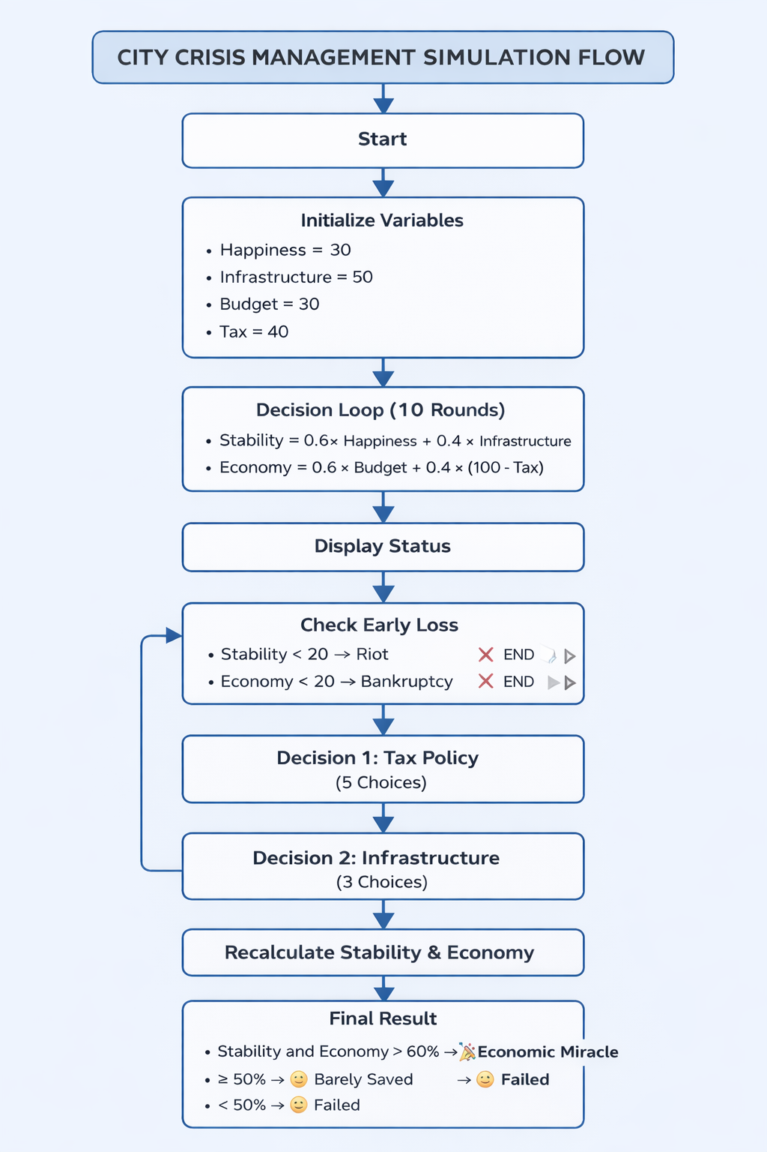

Figure 1: Flowchart of the proposed system

3.6 Implementation Summary

The methodology focuses on:
- Using a simple rule-based simulation model.
- Demonstrating decision-making through user interaction.
- Showing how parameters affect system behaviour.
- Providing a basic and easy-to-understand decision support system.
The web-based implementation enhances the usability of the system by providing visual feedback, structured decision panels, and a more engaging user experience compared to the console-based prototype.

- Results and Output

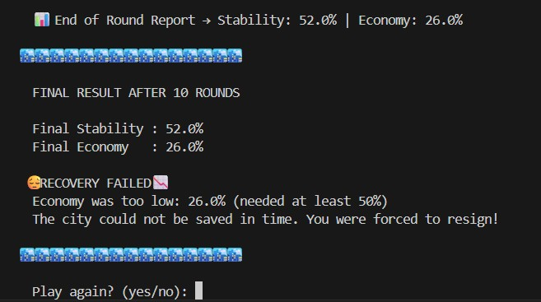
Figure 2: Result

  - Terminal Output
The output shows the final condition of the city after all rounds. The values of stability and economy are calculated based on the changes in key parameters.

  - Explanation of Results
The result shows that the city failed to recover. While stability reached a moderate level, the economy remained low. This indicates that unbalanced decisions can negatively affect the overall system, leading to failure.

- Conclusion and Future Work

  - Conclusion:

The project successfully demonstrates a simple city crisis management simulation based on decision-making. The system shows how different policy choices affect key parameters such as happiness, infrastructure, budget, and tax.
Although the model is basic, it clearly illustrates how unbalanced decisions can lead to failure, while proper decision-making can improve overall system performance. The project provides a simple and understandable way to study the relationship between decisions and outcomes in a controlled environment.

  - Future Work:

Although the current model is simple, it can be improved in several ways:

    - Early Victory Condition:
An early success condition can be added where the simulation ends if both stability and economy reach 60% or above before the final round.

    - Graphical Interface:

The system can be upgraded from a console-based program to a graphical interface for better user interaction.

References

- Python Software Foundation. Python 3.x Documentation.
- Random Module — Python Standard Library.
- Basic literature on Simulation Systems and Decision-Making Models.
- Online Tutorials and Resources on Python Programming and Simulation Development.

