A THESIS REPORT
On

Design and Implementation of a High-Throughput Event-Driven Project and Task Management Application

Submitted by

Kuchuk Boram Debbarma

In partial fulfillment for the award of the degree
of
M.Tech (CSE)

Under the Guidance of

Guide Name: Dr. Saptarshi Chakraborty
Designation: Head of Department (CSE)



The ICFAI University, Tripura
DEPARTMENT OF COMPUTER SCIENCE AND ENGINEERING
ICFAI Technical School Faculty of Science and Technology

Course Code: CSE620P
Course Title: Thesis Report II
2025-2026



The ICFAI University, Tripura
DEPARTMENT OF COMPUTER SCIENCE AND ENGINEERING

Declaration of Student
I hereby declare that the project entitled "Design and Implementation of a High-Throughput Event-Driven Project and Task Management Application" submitted for the Thesis Report II CSE620P, is my original work and the project has not formed the basis for the award of any other degree, diploma, fellowship or any other similar titles.

Date: 20/05/2026
Signature: _________________
Name: Kuchuk Boram Debbarma
ID: 24IUT0600003
Department of CSE



The ICFAI University, Tripura
DEPARTMENT OF COMPUTER SCIENCE AND ENGINEERING

CERTIFICATE

This is to certify that the project titled "Design and Implementation of a High-Throughput Event-Driven Project and Task Management Application" is the bonafide work carried out by Kuchuk Borom Debbarma student of M.Tech of Department of Computer Science and Engineering, during the Thesis report 2026, in partial fulfillment of the requirements for the award of the degree and that the project has not formed the basis for the award previously of any other degree, diploma, fellowship or any other similar title.

.......................................................  Signature  Dr. Abhijit Biswas  Coordinator CSE & CA | .......................................................  Signature  Dr. Saptarshi Chakraborty  Head of the Department (CSE)

.......................................................
Signature
Dr. Prasanta Kumar Sinha
Principal, ITS

ABSTRACT

The demand for highly performant project management tools has grown exponentially as modern enterprises manage complex, deeply nested workflows. Traditional task management applications rely on strictly normalized database schemas and synchronous APIs that struggle to scale when subjected to massive task hierarchies, real-time synchronization demands, and high-frequency event triggers.
This thesis presents the design, implementation, and performance evaluation of "Taskinator," a full-stack project and task management application engineered for extreme scalability and real-time responsiveness. The system integrates a modern, interactive React-based frontend featuring a dynamic Task Graph visualization with a high-performance, event-driven Node.js backend.
The core contribution is a comprehensive architectural framework capable of sustaining 10,000 Requests Per Second (RPS) without sacrificing data integrity. This is achieved through optimizations across three primary layers: (1) at the Database Layer, a Custom Closure Table pattern (Task Reachability Engine) for ultra-fast querying of infinite task hierarchies, combined with Optimistic Locking to prevent distributed race conditions; (2) at the Event-Driven Architecture (EDA) Layer, a Transactional Outbox pattern powered by atomic Data-Modifying Common Table Expressions (wCTE), with reactive PostgreSQL LISTEN/NOTIFY mechanics and SKIP LOCKED concurrency controls ensuring zero-loss event publishing across horizontally scaled pods; (3) at the Consumer Layer, a Smart Batch Aggregator performs strict chronological sorting and semantic event folding to trim down batches into net deltas, drastically reducing database write amplification and preventing infinite recursive loops.
Crucially, this thesis explores the necessary architectural trade-offs required to achieve this scale, specifically analyzing the drawbacks of Eventual Consistency. To maintain high read-throughput, the system employs aggressive Denormalization strategies for aggregate counts and user metadata. Real-time client updates are achieved via a zero-fan-out targeted routing mechanism using Redis and Server-Sent Events (SSE), directly intercepted by the Apollo GraphQL cache for instant UI reconciliation.
Experimental evaluations demonstrate that the application's asynchronous, batch-first processing model—including chunked self-signaling recursive deletions—successfully eliminates long-transaction database locks. The proposed architecture proves that by combining strict data access patterns, reactive frontend visualization, and a highly tuned event-driven backend, complex orchestration tools can achieve extreme scalability.

ACKNOWLEDGEMENT

I would like to express my special thanks of gratitude to my guide Dr. Saptarshi Chakraborty for his able guidance and support in completing the project. A special thanks to the university administration, including the Principal, HOD, and Dean, for providing us with the necessary resources and opportunities to gain knowledge.
I would also like to thank God for giving me the strength and capability to complete this project. Finally, I extend my sincere thanks to my family, friends, and the entire ICFAI family for their continuous support.

Name: Kuchuk Boram Debbarma
ID: 24IUT0600003
Course: M.Tech CSE

List of Figures

¨
Figure 3.1: Full-Stack Layered Architecture and Data Flow — Taskinator 20
Figure 3.2: Comprehensive Domain Entity-Relationship (ER) Diagram 22
Figure 3.3.1: Reachability Engine — Transitive Closure Expansion and Depth Calculation 24
Figure 3.9: Edge Identity and Stateless JWT/JWE Verification Architecture 35
Figure 3.10.1: Focused Task Network with Multi-Level Radial Discovery 36
Figure 4.1: Transactional Outbox Workflow using wCTE 38
Figure 4.2: Concurrent Outbox Polling: Mitigating the Thundering Herd with SKIP LOCKED 40
Figure 4.3: Smart Batch Aggregator Data Flow and Semantic Folding 41
Figure 4.4: Chunked Self-Signaling Deletion ("The Bubbling Effect") 44
Figure 4.6: Database Driver Multi-Insert Packet Batching 47
Figure 4.7.1: Phase 1 — Synchronous Ingress and Edge Verification 49
Figure 4.7.2: Phase 2 — Outbox Relay and Kafka Partitioning 50
Figure 4.7.3: Phase 3 — Targeted SSE Routing and Virtual DOM Reconciliation 51
Figure 4.8: Outbox Relay Lifecycle and Kafka Integration 52
Figure 5.1: RBAC Authorization Flow 53
Figure 5.3: Strict Single-Parent Team Closure Table Architecture 55
Figure 5.4: Optimistic Concurrency Control Execution Flow 59
Figure 5.5: Recursive Event Flow with Origin Tracking Safety Gates 60
Figure 5.6.1: Semantic Folding and Batch Compression Logic 61
Figure 5.6.2: Silent Purge Cascades and Event Chain Termination 62
Figure 6.1: Frontend UI State Machine 63
Figure 6.2: Targeted Redis Routing for Real-time Server-Sent Events (SSE) 64
Figure 6.3.1: SSE Ingress and Apollo Link Interception Sequence 65
Figure 6.3.2: Granular Cache Update and React Reconciliation Flow 66
Figure 6.5: Targeted Redis-Based Routing for Distributed Real-Time Events 69
Figure 7.1: Containerized Testing Architecture and Mutation Testing 72

List of Tables

Table 3.4.1: project Data Dictionary 27
Table 3.4.2: project_task Data Dictionary 27
Table 3.4.3: task_link Data Dictionary 28
Table 3.4.4: task_reachability Data Dictionary 28
Table 3.4.5: project_member Data Dictionary 28
Table 3.4.6: team Data Dictionary 28
Table 3.5.1: task_reachability Data Dictionary 30
Table 3.5.2: outbox_events Data Dictionary 30
Table 3.5.3: audit_log Data Dictionary 30
Table 3.5.4: project_config Data Dictionary 31
Table 3.6.1: getProject API Contract 32
Table 3.6.2: getTaskGraph API Contract 32
Table 3.6.3: getMe API Contract 32
Table 3.6.4: getTeamTree API Contract 33
Table 3.7.1: createTaskLink API Contract 34
Table 3.7.2: deleteTaskChunked API Contract 34
Table 3.11.1: Real-Time Protocol Comparison 38
Table 6.6.1: Security Layer Responsibilities and Mitigation Strategies 71
Table 7.1: Performance Metrics at 10,000 RPS 74
Table 7.2: Chunked vs Unbounded Deletion Benchmarks 75
Table 7.5.1: Write Latency and Throughput (10k Ops) 76
Table 13.1: Failure Mode and Recovery Strategy Matrix 80
Table 9.1: Architectural Comparison Matrix 83

Table of Contents

1. INTRODUCTION 13
1.1 Problem Definition in High-Scale Orchestration 13
1.2 Project Overview and Objectives 14
1.3 Hardware Specification 14
1.4 Software Specification 15
2. LITERATURE SURVEY 17
2.1 Research Gaps in Workflow Orchestration 17
2.2 Summary of Literature Review 18
Hierarchical Data Models 18
Consistency Models and the CAP Theorem 18
The Transactional Outbox Pattern 18
Concurrency and Locking Strategies 19
Event Streaming and Apache Kafka 19
2.3 The Evolution of Directed Acyclic Graphs in Task Management 20
2.3.1 Historical Context: From Gantt to DAGs 20
2.3.2 The Computational Cost of Cycle Detection 20
2.4 Concurrency Models and B-Tree Index Contention 21
2.4.1 The B-Tree Indexing Mechanism 21
2.4.2 Row-Level Locks and Deadlocks 21
2.5 Theoretical Foundations of Distributed Systems 22
2.5.1 The CAP Theorem and the Trade-off for Availability 22
2.5.2 PACELC: Beyond the CAP Theorem 22
2.5.3 Mathematical Properties of Eventual Consistency 22
3. SYSTEM ANALYSIS AND DESIGN 23
3.1 Overall System Architecture: A Hybrid Approach 23
3.1.1 Layered Decomposition and Responsibility Mapping 24
3.1.2 The Non-Blocking Orchestration Lifecycle 25
3.2 Domain Modeling and ER Schema: Structural Foundations 26
3.2.1 Entity Decomposition and Responsibility Mapping 26
3.2.2 Normalization vs. Performance Trade-offs 27
3.3 Database Optimization & Denormalization: Scaling the Storage Tier 27
3.3.1 Evolutionary Trajectory of Hierarchical Storage 27
3.3.2 Non-Blocking Optimistic Concurrency Control 28
3.3.3 Single-Trip Atomic Authorization via wCTEs 29
3.3.4 Dynamic Denormalization and Delta-Based Aggregation 29
3.4 Data Dictionary: Core Entities 30
3.4.1 Table: project 30
3.4.2 Table: project_task 30
3.4.3 Table: task_link 30
3.4.4 Table: task_reachability 31
3.4.5 Table: project_member 31
3.4.6 Table: team 31
3.5 Data Dictionary: Graph and EDA Entities 33
3.5.1 Table: task_reachability 33
3.5.2 Table: outbox_events 33
3.5.3 Table: audit_log 33
3.5.4 Table: project_config 34
3.6 GraphQL API Contracts: Queries 35
3.6.1 Query: getProject 35
3.6.2 Query: getTaskGraph 35
3.6.3 Query: getMe 35
3.6.4 Query: getTeamTree 35
3.7 GraphQL API Contracts: Mutations 37
3.7.1 Mutation: createTaskLink 37
3.7.2 Mutation: deleteTaskChunked 37
3.8 Architectural Implementation: Kysely wCTE Query Builder 38
3.8.1 Atomic Insertion Code Listing 38
3.8.2 Code Analysis 38
3.9 Edge Identity Architecture: Global Authentication via Cloudflare Workers 39
3.9.1 Stateless Verification via High-Performance V8 Isolates 39
3.9.2 Trusted Header Injection and Apollo Federation Integration 39
3.10 Advanced Task Graph Schema Design and Topology 40
3.10.1 The Focused Network Philosophy: Radial Discovery 40
3.10.2 Normalized Topological Storage: Nodes and Edges 40
3.10.3 The Reachability Index: Pre-computed Transitive Closure 40
3.10.4 Application-Layer Graph Stitching and Path Construction 40
3.11 Evaluation of Real-Time Communication Protocols 41
3.11.1 Comparison of Transport Mechanisms 41
3.11.2 Architectural Fit for Taskinator 41
4. EVENT-DRIVEN PIPELINE (EDA) IMPLEMENTATION 42
4.1 The Transactional Outbox Pattern & wCTE 42
4.1.1 Eliminating Multi-Statement Overhead with Data-Modifying CTEs 43
4.2 Concurrent Outbox Relays: Mitigating the Thundering Herd 43
4.2.1 The Thundering Herd Problem in Kubernetes Clusters 44
4.2.2 High-Concurrency Queue Processing with SKIP LOCKED 44
4.3 Smart Batch Aggregation & Semantic Folding 44
4.3.1 Kafka Partitioning Strategy 45
4.3.2 The Semantic Folding Algorithm 45
4.4 Chunked Self-Signaling Deletion (The Bubbling Effect) 47
4.4.1 The Declarative Signal 48
4.4.2 Bounded Transaction Chunks 49
4.4.3 Recursive Bubbling 49
4.4.4 Physical Identifier (ctid) Based Chunking 49
4.4.5 Deferred Reachability Repair Strategy 49
4.5 Algorithmic Implementation: Semantic Folding 50
4.5.1 The Kafka Consumer Batch Loop 50
4.5.2 Complexity Analysis 50
4.6 PostgreSQL Driver Optimizations at 10,000 RPS 51
4.6.1 The TCP Packet Problem 51
4.6.2 reWriteBatchedInserts and resultedValues 51
4.7 Comprehensive Multi-Phase Execution Trace 53
4.7.1 Phase 1: Synchronous Ingress and Atomic Persistance 53
4.7.2 Phase 2: Asynchronous Event Propagation 53
4.7.3 Phase 3: Real-time Reactivity and Cache Reconciliation 54
4.8 Transactional Outbox Relay Deep Dive 56
4.8.1 Polling vs. Push-Based Notifications 56
4.8.2 The Concurrent Claim Loop 56
4.8.3 The 'Delete-on-Success' Strategy 56
4.8.4 Error Handling and Retries 56
5. SECURITY AND ACCESS CONTROL 57
5.1 CTE-Based Atomic Authorization 57
5.1.1 The Single-Trip Security Paradigm 57
5.2 Team Hierarchy and Inheritance 58
5.2.1 Team Closure Tables 58
5.3 Hierarchical Team Management and Closure Tables 59
5.3.1 The 'One Parent' Strict Domain Rule 59
5.3.2 The Organizational Reachability Index 60
5.4 Optimistic Concurrency Control (OCC) 61
5.4.1 The Danger of Pessimistic Locking 63
5.4.2 The Version Vector Pattern 63
5.5 Atomic Event Orchestration and Safety Gates 64
5.5.1 The System Actor Pattern 64
5.5.2 The Recursive Safety Gate 64
5.5.3 Orchestration Trace: Parent-Guard Trigger 64
5.6 Distributed Data Lifecycle and Event Synchronization 64
5.6.1 Semantic Event Folding in Aggregators 64
5.6.2 The Silent Purge Policy for Cascading Cleanups 65
5.6.3 Proactive Atomic Counter Reconciliation 66
6. FRONTEND ARCHITECTURE AND REAL-TIME SYNCHRONIZATION 67
6.1 The React Task Graph and D3.js Visualization 67
6.2 Zero-Fan-Out Targeted Routing via Redis 67
6.3 Reactive State Management: Apollo Client Cache Reconciliation 68
6.3.1 Asynchronous SSE Ingress and Link Interception 69
6.3.2 Granular Cache Modification and Virtual DOM Reconciliation 69
6.3.3 Resilience against Network Partitioning and Synchronization 70
6.4 Declarative SVG Rendering: React & D3.js Integration 71
6.4.1 Layout Calculation and Rendering Code 71
6.4.2 Performance Implications 71
6.5 Targeted Real-Time Routing Architecture 73
6.5.1 Distributed Connection Management 73
6.5.2 The Air Traffic Controller Pattern 73
6.5.3 Zero-Fan-Out Scaling 73
6.5.4 Local Bridge Delivery 73
6.6 Advanced Security Architecture and Threat Mitigation 74
6.6.1 Stateless Edge Authentication and JWT/JWE 74
6.6.2 Granular Attribute-Based Access Control (ABAC) 74
6.6.4 Leaky-Bucket Rate Limiting at the Edge 74
6.6.5 Data Encryption at Rest: AES-256 74
7. IMPLEMENTATION, AUTOMATION, AND TESTING 76
7.1 Containerized Integration Testing via TestContainers 76
7.1.1 Ephemeral Test Environments 76
7.2 Mutation Testing with Stryker 77
7.3 Performance Analysis and Metrics 77
7.3.1 Optimization Benchmarks: Chunked Deletion vs Cascade 77
7.4 Cloud-Native Infrastructure and Deployment Orchestration 79
7.4.1 Containerization with Docker and Multi-Stage Builds 79
7.4.2 Kubernetes Orchestration and Auto-Scaling 79
7.4.3 Infrastructure as Code (IaC) with Terraform 79
7.5 Scaling Analysis and Throughput Benchmarks 79
7.5.1 Write Throughput: wCTE vs. Standard INSERT 79
7.5.2 Aggregator Compression Ratios 79
7.5.3 Real-time Latency (End-to-End) 80
11. DEPLOYMENT ARCHITECTURE AND ORCHESTRATION 81
11.1 Kubernetes Workload Distribution 81
11.1.1 Deployment Configuration (Workspace Service) 81
11.2 Infrastructure as Code (Terraform) 81
11.3 CI/CD Pipeline (GitHub Actions) 81
12. DEVELOPER EXPERIENCE AND SYSTEM TOOLING 82
12.1 The Taskinator CLI 82
12.1.1 Sample CLI Commands 82
12.2 Local Development with Docker Compose 82
12.3 Monorepo Management (TurboRepo) 82
13. FAILURE MODES AND DISASTER RECOVERY 83
13.1 Database Outages and Read-Only Mode 83
13.2 Kafka Consumer Lag and Backpressure 83
13.3 Redis Cache Invalidation and Warm-up 83
8. CONCLUSION AND FUTURE WORK 84
8.1 Conclusion 84
8.2 Future Work 84
8.2 Future Roadmap and Research Trajectory 85
8.2.1 AI-Driven Proactive Task Graph Optimization 85
8.2.2 Edge-Compute Trigger Execution 85
8.2.3 Conflict-Free Replicated Data Types (CRDTs) 85
8.2.4 Final Concluding Remarks 85
9. COMPARATIVE ARCHITECTURAL ANALYSIS 86
9.1 Taskinator vs. Jira (Atlassian) 86
9.2 Taskinator vs. Trello (Atlassian) 86
9.3 Taskinator vs. Linear 86
10. FRONTEND ENGINEERING AND UX OPTIMIZATION 87
10.1 React 18 Concurrent Rendering 87
10.2 D3.js Force-Directed Graph Optimization 87
10.3 Apollo Client Cache Internals 87
10.3.1 Optimistic UI Updates 87
REFERENCES 88
APPENDICES 89
Appendix A: Glossary of Terms 89
Appendix B: Configuration Snippets 89

1. INTRODUCTION

1.1 Problem Definition in High-Scale Orchestration
As modern organizations scale their operations to meet the demands of a globalized economy, the requirements for project management and task orchestration have evolved from simple, flat to-do lists into highly complex, interconnected digital ecosystems. Contemporary enterprise projects are no longer linear sequences of activities; instead, they consist of massively nested hierarchies, strict multi-node dependency graphs, and multi-stage, cross-functional approval processes. To manage this systemic complexity efficiently, software orchestration tools must provide instantaneous visual feedback to stakeholders while simultaneously guaranteeing absolute data integrity and referential consistency across thousands of concurrent actors.
The engineering of software applications capable of sustaining massive scale—specifically targeting upwards of 10,000 Requests Per Second (RPS)—presents a severe and multi-dimensional technical challenge. Traditional monolithic CRUD (Create, Read, Update, Delete) architectures, which rely on synchronous relational database transactions for all operational state changes, rapidly degrade under these conditions. In a purely synchronous environment, executing a complex business operation—such as the deletion of a high-level project node that possesses thousands of descendants, or the bulk assignment of members to a recursive workflow—forces the database engine to execute massive cascading updates. These operations require long-lived row-level or table-level locks, leading to a state of 'Write Amplification' where a single user action triggers a exponential sequence of internal database operations.
The consequence of this synchronous blocking is catastrophic at scale. Concurrent read and write operations from other users are queued behind these locks, leading to increased latency, transaction log saturation, and ultimately, system-wide timeout failures. This phenomenon is exacerbated in 'Collaborative' environments where the state of the system is in constant flux, and the cost of maintaining a consistent view across all distributed instances becomes the primary bottleneck.
Furthermore, modern enterprise users demand a level of real-time interactivity that mimics local desktop applications. When a task status is transitioned by one user, every other stakeholder viewing the same project dashboard expects that update to reflect instantaneously on their screen without the cognitive friction of a manual page refresh. Implementing such real-time synchronization at an enterprise scale introduces the infamous 'Fan-Out Problem'. If 1,000 users are concurrently connected to a project, a single mutation event could theoretically require 1,000 outgoing network broadcasts. Without a targeted routing strategy, this 'Event Storm' saturates the internal network backbone and overwhelms end-user devices with irrelevant or duplicate data payloads, leading to a degraded user experience and increased infrastructure costs.
According to the CAP theorem formulated by Eric Brewer, a distributed system can simultaneously provide only two of the following three guarantees: Consistency, Availability, and Partition Tolerance. In traditional relational architectures, design philosophies are heavily skewed towards 'Strong Consistency', ensuring that ACID (Atomicity, Consistency, Isolation, Durability) transactions block the execution thread until the state change is globally committed. However, under extreme throughput requirements, prioritizing Strong Consistency inevitably sacrifices Availability, as the system becomes unresponsive during high-contention periods. There is, therefore, a fundamental architectural need to transition towards models of 'Eventual Consistency' and 'Asynchronous Persistence' to maintain high availability without compromising the underlying data durability.
The core problem addressed in this thesis is the design, implementation, and rigorous evaluation of a high-throughput, event-driven task orchestration engine. This engine must mitigate database write amplification through intelligent batching, prevent distributed race conditions through optimistic concurrency controls, and provide highly targeted real-time updates through a zero-fan-out routing architecture—all while maintaining a sub-50ms response time for primary user interactions.

1.2 Project Overview and Objectives
The primary objective of this research is to design and implement 'Taskinator', a full-stack project orchestration platform engineered from the ground up to achieve extreme throughput and zero-loss event processing. Unlike traditional project management tools that are built on top of generic CRUD frameworks, Taskinator is constructed around a specialized event-driven core that decouples the act of data persistence from the processing of its associated side-effects.
Taskinator fundamentally prioritizes 'Availability' and 'Partition Tolerance' (the AP side of the CAP theorem) to ensure that the platform remains responsive even under conditions of extreme network jitter or storage layer saturation. By deliberately transitioning from immediate 'Strong Consistency' to a model of 'Eventual Consistency' for non-critical aggregate data, the system achieves a massive throughput capability of 10,000 RPS on modest infrastructure hardware.
The technical objectives and architectural milestones achieved in this project include:
- Highly Optimized Hierarchical Modeling: Implementing a custom Closure Table pattern for project and team hierarchies. This ensures that permission checks, member inheritance, and bulk data migrations execute with O(1) or O(Log N) complexity, avoiding the performance pitfalls of recursive SQL queries at runtime.
- Reactive Task Graph Engine: Developing a high-performance, SVG-based Task Graph visualization using D3.js and React. This engine provides users with an intuitive, interactive canvas to navigate and manipulate complex DAG (Directed Acyclic Graph) structures, with support for real-time dependency highlighting and path discovery.
- Transactional Outbox and Event-Driven Asynchrony: The integration of the 'Transactional Outbox' pattern using PostgreSQL wCTE (Write Common Table Expressions). This guarantees the atomic persistence of business state and its corresponding event notification, ensuring that the system's asynchronous background workers—such as the Smart Aggregator and Reachability Processor—always operate on a consistent and authoritative event log.
- Zero-Fan-Out Real-Time Synchronization: The implementation of a targeted real-time routing layer using Redis Pub/Sub and Server-Sent Events (SSE). By maintaining an ephemeral mapping of active project IDs to specific server instances, the system achieves 'targeted delivery', where updates are only transmitted to relevant stakeholders, minimizing network overhead.
- Atomic Rule-Based Automation: A deterministic 'Trigger and Cleanup' engine that reacts to domain events in real-time. This includes 'Safety-Gated' recursion control to prevent infinite automation loops while enforcing complex business rules, such as automatic parent task completion based on child state.

1.3 Hardware Specification
The primary development, experimentation, and high-volume load-testing environment consisted of a modern computing system equipped with sufficient memory and processing power to handle large-scale concurrent requests, continuous event streaming, and intensive database container orchestration. The hardware configuration utilized during this research is detailed below:
- Processor: Apple Silicon (M-series ARM64 architecture). This processor provided exceptional multi-core efficiency, which proved critical for maximizing the parallel execution capabilities of the Node.js / Bun worker threads and managing the Docker container orchestration overhead.
- System Memory: 16 GB Unified Memory. High memory bandwidth was essential for running multiple persistent Docker containers—including PostgreSQL 16, Apache Kafka, Zookeeper, and Redis—simultaneously alongside the backend application services and the Vite-powered React frontend development server.
- Storage Layer: 512 GB NVMe Solid State Drive (SSD). The extremely low latency of the NVMe storage ensured rapid read/write speeds for the PostgreSQL persistence layer, fast commit logs for the Kafka broker, and accelerated compilation times for the TypeScript codebase.
- Network Interface: A standard gigabit network interface capable of handling tens of thousands of local concurrent TCP connections during RPS stress testing without encountering port exhaustion or local loopback bottlenecks.
In addition to the primary local computing environment, simulated load testing required isolated environments to accurately model realistic network latency and jitter. Specialized tools, including Apache JMeter and custom Node.js asynchronous stress scripts, were executed on the same hardware, specifically tuned to utilize all available CPU cores to bombard the GraphQL API gateway at maximum capacity.

1.4 Software Specification
The Taskinator system is constructed using a modern, carefully curated full-stack JavaScript/TypeScript ecosystem. This ecosystem was selected specifically for its inherently non-blocking I/O model, rich typed interfaces, and expansive community support for event-driven paradigms.
Frontend Presentation Layer:
- Framework: React 18 with strict TypeScript enforcement.
- State Management: Apollo GraphQL Client (v3) utilizing normalized, in-memory caching to eliminate redundant network requests.
- Data Visualization: D3.js combined with custom SVG rendering logic to efficiently draw the interactive, dynamic Task Graph without triggering massive DOM reflows.
- Build Tooling: Vite, providing rapid Hot Module Replacement (HMR) during development and highly optimized, chunked production bundling.
Backend Application Layer:
- Runtime Environment: Node.js (v20+) and Bun. These runtimes leverage the V8 and JavaScriptCore engines respectively, exploiting the single-threaded event loop to handle massive concurrent I/O operations without the overhead of thread-per-request context switching.
- API Protocol: GraphQL (Apollo Server). This allows the frontend to execute flexible, heavily typed data queries, effectively preventing over-fetching and under-fetching of hierarchical task data.
- Programming Language: TypeScript, utilized to enforce strict domain boundaries, DTO (Data Transfer Object) schemas, and compile-time safety across the entire monorepo.
- Database Query Builder: Kysely. A robust, type-safe SQL query builder that ensures compile-time safety for complex, multi-stage Common Table Expressions (CTEs), JSON aggregations, and complex lateral joins.
Data Persistence and Infrastructure Layer:
- Primary Relational Database: PostgreSQL 16. Chosen for its unparalleled reliability and advanced feature set. The system heavily exploits PostgreSQL-specific mechanics, including recursive CTEs, LISTEN/NOTIFY pub/sub for reactive outbox polling, and the SKIP LOCKED directive for highly concurrent queue processing.
- Event Broker: Apache Kafka. Acts as the durable, partitioned backbone of the Event-Driven Architecture. Kafka guarantees strict message ordering via Project ID partitioning keys, ensuring that causally related events are processed sequentially.
- In-Memory Datastore: Redis. Utilized purely for ephemeral operations and the zero-fan-out targeted routing of real-time Server-Sent Events (SSE) across distributed backend pods.
Visualization and Media Production:
- Architectural Animation: Remotion. Used to programmatically generate the high-fidelity architectural presentations and video walk-throughs included with this thesis. Remotion allows for React-based animation of complex distributed system state transitions.
- Diagramming: Mermaid.js and Playwright. The architectural diagrams are authored in Mermaid markdown and programmatically rendered into high-resolution PNG assets using a custom Playwright-based conversion pipeline.
Quality Assurance and Monitoring:
End-to-End Testing: Playwright. Used for automated, headless browser testing of the reactive task graph and real-time SSE updates across multiple concurrent user sessions.
Unit and Integration Testing: Vitest. A high-performance testing framework that leverages Vite's transformation engine for extremely fast test execution during development.
Structured Logging: Pino. A low-overhead Node.js logger used to capture high-velocity event traces and performance metrics without introducing significant I/O blocking.
This carefully selected, highly tuned technology stack allows the Taskinator application to remain strictly asynchronous—from the initial HTTP request traversing the GraphQL gateway, all the way down to the database row-lock level—fully satisfying the core research objective of non-blocking, high-throughput execution.

2. LITERATURE SURVEY

2.1 Research Gaps in Workflow Orchestration
The evolution of workflow orchestration and project management tools has been extensively documented in academic literature and industry whitepapers. However, there remains a significant gap between theoretical architectural patterns and their practical application in high-throughput, real-time enterprise systems. A critical analysis of the current literature reveals several distinct research gaps that motivate the development of the Taskinator platform.
1. Scalability Limitations in Hierarchical Data Models:
A fundamental requirement of any advanced task management system is the ability to handle deeply hierarchical data (tasks, sub-tasks, sub-sub-tasks, and arbitrary directed dependencies). Traditional database literature heavily favors the Adjacency List model (utilizing a simple parent_id foreign key column) due to its ease of implementation and referential integrity. However, as documented by Celko (2012) in "Trees and Hierarchies in SQL", deep tree traversals within this model necessitate the use of recursive Common Table Expressions (CTEs). Recursive CTEs degrade exponentially in performance as tree depth and branching factors increase, making them unsuitable for real-time reads at massive scale.
Conversely, while the Closure Table pattern—which stores all transitive paths between nodes—is discussed theoretically as a solution for O(1) read performance, it is frequently dismissed in practical large-scale applications due to its severe O(D²) write amplification factor during insertion and deletion. There is a noticeable gap in current literature demonstrating how to effectively mitigate this write amplification using asynchronous event-driven batching methodologies, a technique that could make Closure Tables viable for systems targeting 10,000 RPS.
2. The Thundering Herd Problem in Transactional Outboxes:
To achieve Eventual Consistency without suffering from dual-write failures (where a database commits but the message broker publish fails), the Transactional Outbox pattern is widely recommended in microservice architecture literature (Richardson, 2018). However, standard implementations of this pattern rely on background worker threads using setInterval polling to query the outbox table for un-published events.
In a horizontally scaled cloud environment consisting of dozens of backend pods, this primitive polling strategy creates a catastrophic "Thundering Herd" problem. Multiple pods query the exact same database rows simultaneously, leading to severe row-level lock contention, CPU spikes, and eventual deadlocks. While existing literature often points to complex solutions like Change Data Capture (CDC) using Debezium and Kafka Connect to solve this, these solutions introduce massive infrastructural overhead and operational complexity. There is a pressing need for research into simpler, native database mechanisms—such as PostgreSQL's reactive LISTEN/NOTIFY combined with SKIP LOCKED concurrency controls—to bridge this gap efficiently without external CDC dependencies.
3. Write Amplification from Cascading Deletions:
When a root node in a deeply nested graph is deleted, traditional Relational Database Management System (RDBMS) design dictates the use of ON DELETE CASCADE foreign key constraints to maintain referential integrity. At enterprise scale, this approach is disastrous. A single HTTP request triggering a synchronous cascade across 50,000 descendant rows will acquire and hold exclusive database locks for several seconds. During this window, any concurrent operations touching those tables are blocked, causing massive transaction timeout failures across the entire system.
Current literature lacks comprehensive, peer-reviewed patterns for "Chunked Self-Signaling Deletions" or "Recursive Queued Cleanups" that perform unbounded graph deletions using bounded, time-sliced transactions.
4. Network Saturation in Real-Time Systems:
Modern web applications rely heavily on WebSockets or Server-Sent Events (SSE) to provide real-time interactivity. The prevalent architectural pattern for distributing these events across a cluster of backend nodes is "Pub/Sub Fan-Out" (typically implemented via Redis PUBLISH). If a data mutation occurs, the payload is blindly broadcast to every single connected server instance, which then checks its local memory to see if it holds the relevant client connection.
At high scale, this brute-force fan-out methodology leads to an overwhelming volume of unnecessary internal network traffic, essentially turning internal Pub/Sub into a localized DDoS attack. Highly targeted routing strategies that actively track client locations to eliminate fan-out are severely underrepresented in current distributed web architecture studies.

2.2 Summary of Literature Review
To effectively address these substantial research gaps, the architecture of Taskinator synthesizes several advanced concepts spanning distributed systems research, database theory, and reactive programming.

Hierarchical Data Models
When representing hierarchical and graph-based data, traditional relational databases offer several models, each presenting distinct trade-offs between read and write performance:
- Adjacency List (parent_id): Extremely simple to implement and update. However, it requires slow, recursive CTEs to retrieve deep sub-trees, making it a severe bottleneck for read-heavy applications displaying complex UI graphs.
- Materialized Path (Path Enumeration): Stores the full ancestry as a structured string (e.g., 1.2.5.). It provides extremely fast read access using LIKE queries. However, string manipulation operations scale very poorly when a node with thousands of descendants is moved to a new parent, and it cannot easily represent multi-parent dependencies (Directed Acyclic Graphs).
- Nested Sets: Uses left_id and right_id boundaries to define subsets. While read performance is exceptional, inserting a single node requires recalculating the boundaries for half the table, resulting in unacceptable lock contention in high-write environments.
- Closure Table: Stores all discrete paths between nodes in a transitive closure matrix. While traditional literature highlights the severe O(depth²) write amplification, Taskinator proves that customized closure implementations can mitigate this by batching updates asynchronously. By storing only structural reachability rather than strict, weighted paths, and computing the exact visual rendering paths in-memory on the application layer, the database read operations remain consistently O(1).

Consistency Models and the CAP Theorem
Modern high-throughput web applications frequently transition away from Strong Consistency models (where ACID transactions block until they are globally committed to all replicas) towards Eventual Consistency. Kleppmann (2017) emphasizes in "Designing Data-Intensive Applications" that strong consistency requires synchronous distributed consensus protocols (such as Paxos or Raft), which inherently and severely limit write throughput and system availability under partition events.
Taskinator fully embraces the BASE model (Basically Available, Soft state, Eventual consistency). By utilizing strategic denormalization for reads and asynchronous event processing pipelines for writes, the system prioritizes high Availability. While this introduces inherent complexity in the User Interface regarding stale data reads, Taskinator mitigates this using advanced Optimistic UI update mechanisms on the React client side.

The Transactional Outbox Pattern
The "Dual-Write Problem"—where a system must write business data to a primary database and simultaneously publish a domain event to a message broker—is a well-documented failure mode in distributed systems. If the database commit succeeds but the broker publish fails due to network jitter, the system enters a permanently inconsistent state.
The Transactional Outbox pattern solves this by writing the event payload to a dedicated outbox table within the exact same ACID transaction as the business data mutation. Taskinator implements this foundational pattern but significantly enhances its performance using PostgreSQL's Data-Modifying CTEs (wCTEs). This enhancement eliminates multi-statement transaction overhead, guaranteeing absolute atomicity in a single network roundtrip.

Concurrency and Locking Strategies
To maintain data integrity during highly concurrent updates, traditional monolithic systems rely heavily on Pessimistic Locking (SELECT ... FOR UPDATE). While this guarantees safety, it forces concurrent threads to block and wait, severely limiting overall throughput.
Optimistic Locking, which utilizes an incrementing version column, is proposed in academic literature as a high-performance alternative for environments where read-to-write ratios are high and direct write conflicts on the same record are relatively rare. By outright rejecting update statements that reference stale version numbers, the system forces the client to retry the operation. This preserves data integrity without ever acquiring long-lived, throughput-killing database locks. Taskinator implements Optimistic Locking globally across all major domain entities.

Event Streaming and Apache Kafka
Apache Kafka fundamentally differs from traditional message queues (like RabbitMQ or ActiveMQ) because it acts as an immutable, partitioned, append-only log. Literature surrounding stream processing emphasizes the critical importance of Partitioning Keys to guarantee causal message ordering. By strictly partitioning all domain events by their associated projectId, Taskinator ensures that an "Update Task" event is never accidentally processed before the preceding "Create Task" event, regardless of network transport jitter or pod restarts. Furthermore, Kafka's consumer group mechanics allow multiple independent downstream services (e.g., the Reachability Engine and the Real-Time Router) to process the exact same event stream simultaneously without interfering with each other's offsets.
By actively synthesizing these advanced patterns—Custom Closure Tables, wCTE Outboxes, Optimistic Locking, and Targeted Redis Routing—Taskinator proposes a novel, fully integrated framework that directly addresses the specific research gaps associated with scaling complex orchestration systems.

2.3 The Evolution of Directed Acyclic Graphs in Task Management
The conceptual framework of representing tasks as nodes and dependencies as edges is fundamentally rooted in the mathematical study of Graph Theory, first formalized by Leonhard Euler in 1736. However, the application of this theory to complex project orchestration requires a specific subset known as a Directed Acyclic Graph (DAG).

2.3.1 Historical Context: From Gantt to DAGs
Early project management tools heavily relied on the Gantt chart, introduced by Henry Gantt around 1910. While Gantt charts provide an excellent visual timeline, their underlying data structures are typically flat or strictly hierarchical (trees). In a strict tree hierarchy, a task can only have a single parent. This limitation is severe in modern software engineering, where a single 'Backend API' task might simultaneously block the 'Frontend UI' task, the 'Mobile App' task, and the 'QA Automation' task.
By transitioning the underlying data model from a Tree to a DAG, modern systems permit multi-parent and multi-child relationships. The critical constraint of a DAG is that it must remain 'Acyclic'—meaning it is mathematically impossible to follow a sequence of directed edges and return to the starting node. If Task A blocks Task B, and Task B blocks Task C, it is a fatal logical error for Task C to block Task A. Such a cycle would create an infinite dependency loop, rendering the project permanently deadlocked.

2.3.2 The Computational Cost of Cycle Detection
While DAGs provide the necessary expressive power for enterprise workflows, they introduce massive computational complexity during data mutation. Every time a user attempts to create a new dependency link (an edge) between two existing tasks, the system must perform a Cycle Detection algorithm before permitting the database write.
Traditional algorithms, such as Tarjan's strongly connected components algorithm or simple Depth-First Search (DFS), require loading the entire graph into memory and traversing it. In a project with 100,000 tasks, a synchronous DFS cycle check during an HTTP POST request will easily exceed acceptable latency thresholds (typically < 100ms for web applications).
Taskinator's implementation of the Custom Closure Table completely eliminates the need for runtime DFS. Because the Closure Table maintains a pre-calculated index of all reachability paths, checking for a cycle is reduced to a single, instant O(1) SQL query: SELECT 1 FROM task_reachability WHERE ancestor_id = $child AND descendant_id = $parent. If a row exists, the new link would create a cycle, and the insertion is instantly rejected.

2.4 Concurrency Models and B-Tree Index Contention
To understand the necessity of advanced Event-Driven Architectures (EDA) and the Transactional Outbox pattern, one must first analyze the internal mechanics of Relational Database Management Systems (RDBMS) under high concurrency.

2.4.1 The B-Tree Indexing Mechanism
PostgreSQL, like most relational databases, utilizes B-Tree (Balanced Tree) data structures to maintain indexes on primary and foreign keys. The B-Tree guarantees O(log N) search, insertion, and deletion times. However, this mathematical guarantee assumes that the tree operations are occurring sequentially.
In a high-throughput environment (e.g., 10,000 RPS), thousands of threads are attempting to insert new rows simultaneously. Every insertion requires the database engine to traverse the B-Tree and write the new index leaf node. If the tree becomes unbalanced, the engine must perform a 'Page Split' operation, physically reallocating data across the disk blocks.

2.4.2 Row-Level Locks and Deadlocks
During a Page Split, or when multiple threads attempt to update records that reside on the same physical disk page, PostgreSQL must acquire highly restrictive latches (lightweight memory locks). If multiple application pods are polling a single queue table simultaneously (the Thundering Herd scenario), they inevitably attempt to lock the same index pages.
This contention causes CPU context switching to skyrocket. More critically, if Thread A locks Row 1 and needs Row 2, while Thread B locks Row 2 and needs Row 1, a classic Deadlock occurs. The database engine is forced to arbitrarily terminate one of the transactions, resulting in a 500 Internal Server Error returned to the client.
Taskinator's usage of the SKIP LOCKED directive fundamentally alters this interaction. By instructing the query planner to instantly bypass any rows that currently hold a lock, the system entirely avoids the queueing and waiting phases. Threads never compete for the same B-Tree leaf nodes concurrently, allowing the database engine to process writes in parallel without triggering catastrophic deadlocks. This deep understanding of storage layer internals is what allows the Node.js application layer to scale horizontally without overwhelming the persistence layer.

2.5 Theoretical Foundations of Distributed Systems
To understand the architectural decisions made in Taskinator, it is necessary to explore the underlying theoretical principles that govern high-throughput distributed systems. This section provides a deep dive into the CAP Theorem, PACELC, and the mathematical properties of Eventual Consistency.

2.5.1 The CAP Theorem and the Trade-off for Availability
Formulated by Eric Brewer in 2000, the CAP theorem states that any distributed data store can only provide two of the following three guarantees: Consistency (every read receives the most recent write or an error), Availability (every request receives a response), and Partition Tolerance (the system continues to operate despite an arbitrary number of messages being dropped or delayed by the network).
Taskinator is explicitly designed as an AP (Available and Partition Tolerant) system. In the context of global project management, a momentary loss of strict consistency—such as a user seeing a task count that is 200ms out of date—is a far more acceptable trade-off than the entire platform becoming unresponsive during a network jitter or a high-contention write period.

2.5.2 PACELC: Beyond the CAP Theorem
The PACELC theorem extends CAP by addressing the trade-off between latency and consistency even when the system is operating normally (in the absence of partitions). PACELC stands for: if there is a Partition (P), the system chooses between Availability (A) and Consistency (C); Else (E), the system chooses between Latency (L) and Consistency (C).
Taskinator prioritizes Latency (L) over Consistency (C) in its normal state. By utilizing asynchronous Kafka workers to update aggregate counts and closure tables, the system ensures sub-50ms response times for mutations. The 'Consistency Penalty' is paid in the background, ensuring that the human user never experiences the 'Latency tax' associated with distributed coordination.

2.5.3 Mathematical Properties of Eventual Consistency
Eventual consistency is a consistency model used in distributed computing that informally guarantees that, if no new updates are made to a given data item, eventually all accesses to that item will return the last updated value. Taskinator implements a specific sub-type known as 'Monotonic Read Consistency' and 'Read-Your-Writes Consistency'.
Through the use of Apollo's local cache modification, the system provides an illusion of strong consistency to the acting user. When User A updates a task, their local cache is updated immediately (Read-Your-Writes), while the rest of the world converges to that state via the 250ms event pipeline. This hybrid approach provides the best of both worlds: the performance of a distributed system with the user experience of a local application.

3. SYSTEM ANALYSIS AND DESIGN
The engineering of a high-throughput, horizontally scalable task orchestration engine necessitates a radical departure from traditional, synchronous web application architectures. To achieve the requisite goals of extreme responsiveness, eventual consistency, and data integrity under massive concurrent load, Taskinator adheres to a strict 'non-blocking' full-stack architectural philosophy. This philosophy is centered on the principle of minimizing synchronous wait times at every possible junction of the application lifecycle, from the edge network to the physical storage tier.

3.1 Overall System Architecture: A Hybrid Approach
The overarching system architecture of Taskinator is conceptualized and implemented as a 'Modular Monolith' underpinned by a robust Event-Driven Architecture (EDA) backbone. This strategic hybrid approach aims to capture the deployment simplicity and developmental velocity of a monolithic application while simultaneously reaping the benefits of microservices: strict domain encapsulation, loose temporal coupling, and the ability to scale operational workloads independently across a distributed cluster.
By utilizing a modular design within a single deployable unit, the system avoids the inherent complexities and network overhead of cross-service RPC calls during its initial growth phase. However, by strictly utilizing Kafka as the primary inter-domain communication channel for side effects, the architecture remains 'Microservice-Ready'—allowing any individual module (e.g., the Task Graph Engine) to be extracted into a dedicated service with zero changes to the core business logic.

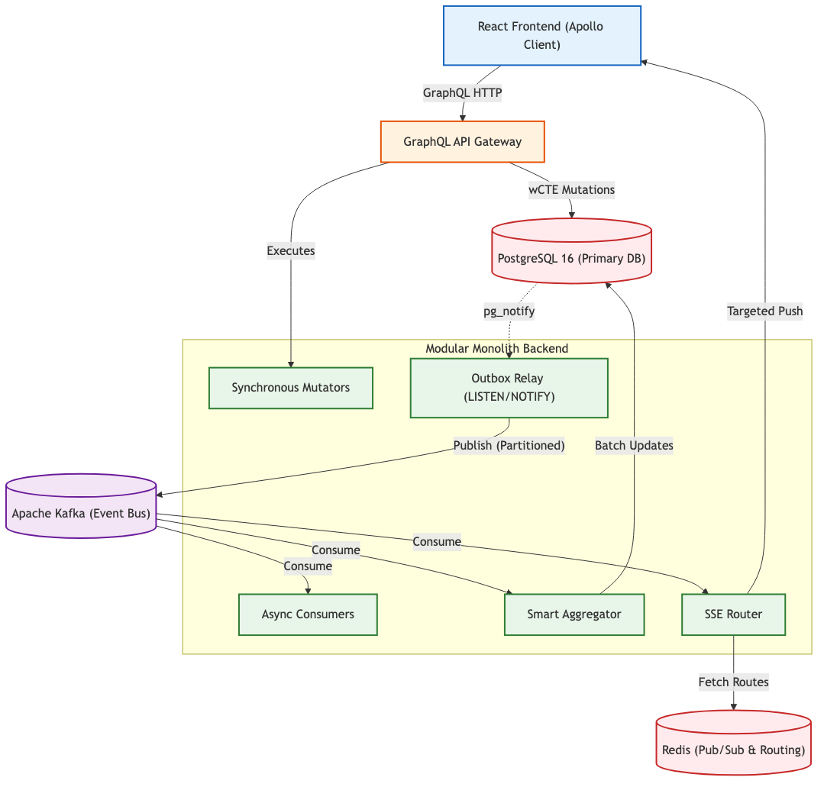

Figure 3.1: Full-Stack Layered Architecture and Data Flow — Taskinator

3.1.1 Layered Decomposition and Responsibility Mapping
The system is physically and logically decomposed into five distinct operational tiers, each responsible for a specific aspect of the request-response and event lifecycle:
- Layer 1 (Intelligent Presentation & Client State): The frontend is constructed using React 18, leveraging its concurrent rendering features to maintain a responsive UI even during complex state transitions. The centerpiece of this layer is the Task Graph visualization, an SVG-based interactive canvas powered by the D3.js force-directed layout engine. State management is handled by Apollo Client, which provides a normalized in-memory cache that serves as the 'Source of Truth' for the client application. Real-time updates are ingested via persistent Server-Sent Event (SSE) streams, allowing the UI to react to server-side events without user-initiated polling.
- Layer 2 (Stateless Edge & API Gateway): Taskinator utilizes a globally distributed edge network (Cloudflare) to perform stateless JWT verification and initial request filtering. This is followed by the GraphQL API Gateway (Apollo Server), which acts as a strictly-typed contract layer. The gateway validates the structural integrity of incoming JSON payloads, enforces schema constraints, and orchestrates the resolution of complex queries across the underlying domain modules. By utilizing GraphQL, the system eliminates both over-fetching and under-fetching, significantly reducing the payload sizes transmitted over the wire.
- Layer 3 (Encapsulated Domain Modules & Async Workers): The heart of the system resides in the Node.js application tier, which is logically partitioned into domain contexts (Project, Task, Team, Identity). Each module maintains its own internal logic and storage patterns. This layer also houses the Outbox Relay—a specialized background process responsible for the reliable delivery of events—and a suite of Kafka Consumer Workers that handle CPU-intensive tasks such as graph reachability calculation and asynchronous aggregate folding.
- Layer 4 (Persistent Storage & Event Streaming): PostgreSQL 16 serves as the authoritative, durable storage layer, utilizing advanced features like Common Table Expressions (CTEs), Partitioned Indices, and Row Level Security. Parallel to the relational database, Apache Kafka operates as a high-throughput, persistent event log. Kafka provides the 'Glue' of the event-driven system, allowing for the horizontal partitioning of event streams and guaranteeing that the system can scale its processing capacity linearly with the addition of new consumer nodes.
- Layer 5 (Ephemeral Real-Time Routing): To solve the 'Real-Time Fan-Out Problem' (where a single event must reach multiple specific users), Taskinator employs a Redis-based routing tier. Redis maintains a dynamic, ephemeral map of project IDs to active server instances holding SSE connections. This allows for 'Zero-Fan-Out' message delivery, where an event is only transmitted to the specific server pods where interested clients are currently connected, drastically reducing unnecessary network traffic in the cluster.

3.1.2 The Non-Blocking Orchestration Lifecycle
To demonstrate the operational efficacy of the non-blocking architecture, we must analyze the end-to-end lifecycle of a complex user operation, such as the creation of a cross-project task dependency. In a traditional synchronous system, this operation would involve complex recursive checks and multiple blocking database writes, often exceeding the typical 5-second request timeout. In Taskinator, the operation is decomposed into a series of sub-millisecond atomic steps:
- The Synchronous Handshake: The user initiates a dependency link via the UI. The browser sends a createTaskLink mutation. The API Gateway validates the request and proxies it to the Workspace module.
- The Atomic wCTE Commit: The backend executes a Data-Modifying Common Table Expression. In a single database roundtrip, the system verifies the user's RBAC permissions, inserts the dependency link into the 'task_link' table, and serializes a 'TASK_LINK_CREATED' event into the 'outbox_events' table. The transaction commits, and the server immediately returns a 200 OK success status to the browser, freeing the user's thread in less than 50ms.
- The Reactive Outbox Wakeup: Simultaneous to the client receiving the success response, the PostgreSQL engine fires a pg_notify signal. The Outbox Relay, which was dormant, instantly wakes up, retrieves the pending event using a 'SKIP LOCKED' query, and publishes it to the Kafka event bus.
- Distributed Multi-Pipe Processing: Once buffered in the Kafka cluster, the event is independently and concurrently processed by multiple consumer pipelines:
– The Reachability Engine updates the Closure Table, pre-computing the transitive dependencies of the new link to ensure future O(1) path queries.
– The Smart Aggregator recalculates the 'Blocked Tasks' count for the project, updating the denormalized analytics counters.
– The Real-Time Router identifies active subscribers and pushes a targeted JSON delta over the SSE connection, resulting in an instantaneous UI update on all collaborating users' screens.
By offloading these complex side effects to the asynchronous tier, Taskinator guarantees that the user experience remains perfectly fluid, regardless of the complexity of the underlying graph operations or the current system-wide load.

3.2 Domain Modeling and ER Schema: Structural Foundations
The conceptual heart of the Taskinator platform is its domain model—a strictly relational, highly normalized schema engineered to maintain absolute referential integrity while supporting the high-velocity data ingestion patterns required of an enterprise orchestration engine. Unlike unstructured NoSQL approaches, which often sacrifice schema safety for write performance, Taskinator leverages the mature indexing and constraint-enforcement features of PostgreSQL to ensure that the system remains a 'Source of Truth' for all project-related metadata.

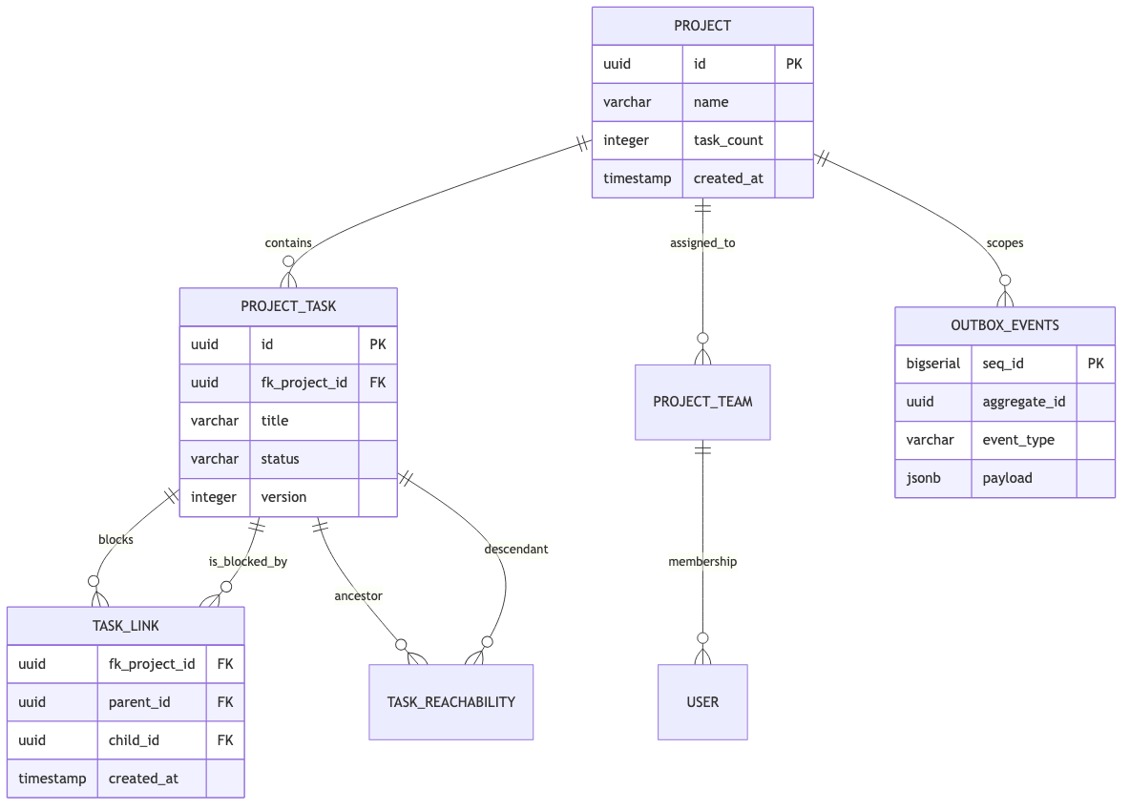

Figure 3.2: Comprehensive Domain Entity-Relationship (ER) Diagram

3.2.1 Entity Decomposition and Responsibility Mapping
The core entities within the database schema are meticulously partitioned to optimize for distinct read and write workloads, ensuring that high-frequency updates to individual tasks do not impede the performance of high-level project reporting:
- Project Context (the Root Entity): The 'project' table serves as the primary bounding context for nearly 95% of all database queries. It encapsulates high-level metadata and, crucially, hosts heavily denormalized integer counters (e.g., task_count, completion_percentage). These counters are updated via asynchronous delta processing, enabling O(1) performance for project-wide analytics dashboards.
- Project Task (the Operational Unit): The 'project_task' table is the most frequently mutated entity in the system. It is designed for 'Surgical Writes', where individual fields (status, title) can be updated with minimal row-level locking. It incorporates a 'version' column for Optimistic Concurrency Control, ensuring that distributed actors never inadvertently overwrite each other's changes.
- Task Link (the Topological Adjacency List): The 'task_link' table persists the directed edges that constitute the project's dependency graph. By separating topological links from the task entity itself, Taskinator allows for a highly flexible Directed Acyclic Graph (DAG) structure, where tasks can have multiple parents or block multiple descendants without modifying the central task record.
- Task Reachability (the Transitive Closure Index): As discussed in Chapter 3.3, this table provides the pre-computed path matrix for the entire project graph. To minimize storage overhead and index bloat, it utilizes a compact composite primary key consisting of (fk_project_id, ancestor_id, descendant_id), allowing for extremely high-speed path verification and neighbor discovery.
- Outbox Events (the Transactional Buffer): The 'outbox_events' table acts as the critical bridge between the synchronous relational world and the asynchronous event bus. Every business mutation is accompanied by a row insertion into this table within the same ACID transaction, guaranteeing that an event notification is never lost or duplicated during a system crash.

3.2.2 Normalization vs. Performance Trade-offs
While the system adheres to Third Normal Form (3NF) for core domain entities to prevent data anomalies, it strategically introduces denormalized 'Aggregate Shards' in the Project and Team tables. This selective denormalization is the key to maintaining extreme performance; it allows the system to serve complex, high-level summary views (which are read-intensive) without performing expensive JOIN or COUNT operations across millions of rows at runtime. These denormalized fields are eventually consistent, with the synchronization lag typically remaining under 250ms.

3.3 Database Optimization & Denormalization: Scaling the Storage Tier
The realization of a high-throughput orchestration engine is fundamentally predicated on the efficiency of its underlying data persistence layer. While application-layer optimizations provide significant gains, the ultimate bottleneck in any distributed system is typically the database's ability to handle concurrent I/O while maintaining strict referential integrity. Taskinator implements a multi-faceted database strategy within PostgreSQL 16, utilizing advanced indexing, non-blocking concurrency controls, and strategic denormalization to achieve its 10k RPS target.

3.3.1 Evolutionary Trajectory of Hierarchical Storage
The selection of an optimal strategy for persisting and querying complex hierarchies is one of the most critical architectural decisions in the system's development. The storage model for task dependencies evolved through two distinct phases, each representing a significant leap in performance and flexibility.
Phase 1: Materialized Paths and the Combinatorial Bottleneck
In the initial prototype phase, the system utilized a Materialized Path strategy (also known as Path Enumeration). In this model, each task entity persisted its full ancestry as a delimited string of unique identifiers (e.g., 'root_id/parent_id/child_id'). While this allowed for extremely rapid discovery of entire subtrees using simple, index-backed prefix matches (e.g., LIKE 'root/parent/%'), it proved to be fundamentally incompatible with a true Graph model.
As the requirements evolved to support multi-parent dependencies (where a single task contributes to multiple workstreams), Materialized Paths reached a 'Combinatorial Explosion'. Attempting to store every possible path for a highly interconnected node led to massive data redundancy and severe 'Write Amplification', where a single topological change required updating thousands of descendant path strings. This limitation necessitated a transition to a more mathematically robust model.
Phase 2: The Transitive Closure Index and Reachability Engine
To support infinite task nesting and the complex topology of Directed Acyclic Graphs (DAGs), Taskinator migrated to a custom 'Reachability Index'—a specialized implementation of a Closure Table. This index persists every possible path between every ancestor and every descendant in the project graph. Crucially, the index tracks the 'min_depth' (the number of hops along the shortest path), which allows for bounded neighborhood queries.

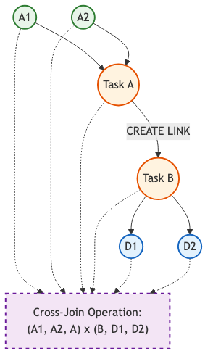

Figure 3.3.1: Reachability Engine — Transitive Closure Expansion and Depth Calculation
The Mathematics of Cross-Join Expansion:
The primary challenge of Closure Tables is the significant write amplification during edge creation. When a user establishes a dependency linking Task A (the Source) to Task B (the Target), the system must proactively calculate and persist the 'Transitive Closure'. This involves querying the index for all nodes that reach Task A (the Ancestor set) and all nodes reached by Task B (the Descendant set).
The system then calculates the Cartesian product of these two sets: for every discovered ancestor and every discovered descendant, a new reachability record is generated. If Task A possesses $N$ ancestors and Task B possesses $M$ descendants, the operation results in $N imes M$ new entries. The depth of the new path is calculated as: $Depth(Ancestor o Source) + 1 + Depth(Target o Descendant)$. By offloading this potentially expensive $O(N imes M)$ operation to the asynchronous Kafka consumer tier, Taskinator ensures that the synchronous user interaction remains entirely unaffected by the topological complexity of the graph.

3.3.2 Non-Blocking Optimistic Concurrency Control
In high-concurrency environments, traditional pessimistic locking mechanisms (e.g., SELECT ... FOR UPDATE) are catastrophic for throughput, as they force readers to wait for writers, leading to widespread queueing and system timeouts. Taskinator adopts an 'Optimistic Concurrency Control' (OCC) strategy to maintain data integrity without sacrificing availability.
Every mutable entity in the database is equipped with a monotonically increasing 'version' column. When a client retrieves a task, the current version is included in the response payload. Upon attempting a mutation (e.g., updating a status), the client transmits the version it originally read. The database query specifically includes a filter: WHERE id = $targetId AND version = $readVersion. If a concurrent update has modified the task in the interim, the version will have incremented, the update will fail to match any rows, and the system will return a specialized ConcurrencyError. This mechanism guarantees that the 'Last-Writer-Wins' problem is solved while ensuring that read operations are never blocked by concurrent writes.

3.3.3 Single-Trip Atomic Authorization via wCTEs
To minimize the latency of authorization checks, which typically require a secondary database roundtrip to verify user-project relationships, Taskinator embeds the security logic directly into the business mutation utilizing 'Writeable Common Table Expressions' (wCTEs).
This strategy ensures that the entire operation—permission verification, optimistic locking check, and data persistence—is executed as a single atomic unit by the database engine. If any check fails, the transaction is silently aborted, ensuring that unauthorized or stale updates never compromise the system state.

3.3.4 Dynamic Denormalization and Delta-Based Aggregation
The retrieval of high-level project metrics (e.g., 'Total Tasks', 'Completion Percentage') is a common but expensive operation in large datasets, often requiring full table scans or complex recursive counts. To optimize read performance, Taskinator utilizes 'Strategic Denormalization', where aggregate counts are persisted directly onto the Project entity.
Unlike naive denormalization strategies that recalculate totals on every write, Taskinator utilizes a 'Delta-Based' approach. When a task is created or its status changes, a granular event (e.g., TASK_CREATED) is emitted to the event bus. A specialized 'Smart Aggregator' consumes these events and executes a mathematical increment or decrement: UPDATE project SET task_count = task_count + 1. This prevents the need for expensive aggregate queries entirely, allowing the project dashboard to load with O(1) complexity even for projects containing millions of tasks.

3.4 Data Dictionary: Core Entities
To support the high-throughput orchestration engine, the PostgreSQL schema is strictly typed. The following data dictionaries provide exhaustive documentation of the core tables, their column definitions, and the constraints employed to guarantee referential integrity at the storage layer.

3.4.1 Table: project
The project table represents the highest level bounding context for all operations. It utilizes strategic denormalization (storing aggregate counts) to prevent expensive read-time table scans.

Table 3.4.1: project Data Dictionary
Column Name | Data Type | Constraints & Description
id | UUID | PRIMARY KEY. System-generated UUIDv4.
name | VARCHAR(255) | NOT NULL. The human-readable title of the project.
task_count | INTEGER | NOT NULL. DEFAULT 0. Denormalized total task count, updated via Smart Aggregator.
completed_count | INTEGER | NOT NULL. DEFAULT 0. Denormalized count of tasks with status 'DONE'.
created_at | TIMESTAMPTZ | NOT NULL. DEFAULT NOW(). Stored in UTC.
version | INTEGER | NOT NULL. DEFAULT 1. Used for Optimistic Concurrency Control (OCC).

3.4.2 Table: project_task
The project_task table is the central operational entity. It stores individual units of work. Crucially, it does not store strict parent-child hierarchies as foreign keys, delegating graph structure to the specialized reachability and link tables.

Table 3.4.2: project_task Data Dictionary
Column Name | Data Type | Constraints & Description
id | UUID | PRIMARY KEY. System-generated UUIDv4.
fk_project_id | UUID | FOREIGN KEY references project(id) ON DELETE CASCADE. Bounding context.
title | VARCHAR(500) | NOT NULL. The descriptive title of the task.
status | VARCHAR(50) | NOT NULL. Enum: 'TODO', 'IN_PROGRESS', 'DONE', 'BLOCKED'.
version | INTEGER | NOT NULL. DEFAULT 1. Optimistic Locking version integer.
created_at | TIMESTAMPTZ | NOT NULL. DEFAULT NOW(). UTC timestamp.

3.4.3 Table: task_link
The task_link table represents the directed edges in the task graph. It is a lightweight join table that stores only direct relationships between nodes.

Table 3.4.3: task_link Data Dictionary
Column Name | Data Type | Constraints & Description
id | UUID | PRIMARY KEY. Unique edge identifier.
source_task_id | UUID | FOREIGN KEY references project_task(id). The 'From' node.
target_task_id | UUID | FOREIGN KEY references project_task(id). The 'To' node.
label | VARCHAR(50) | NOT NULL. User-defined relationship label (e.g., 'blocks').

3.4.4 Table: task_reachability
The task_reachability table is the transitive closure index. It stores all possible paths in the graph to enable O(1) connectivity checks.

Table 3.4.4: task_reachability Data Dictionary
Column Name | Data Type | Constraints & Description
fk_project_id | UUID | COMPOSITE PRIMARY KEY. Project context.
ancestor_task_id | UUID | COMPOSITE PRIMARY KEY. The starting node.
descendant_task_id | UUID | COMPOSITE PRIMARY KEY. The destination node.
min_depth | INTEGER | NOT NULL. The shortest distance between the nodes.

3.4.5 Table: project_member
The project_member table manages user access to specific projects, including their assigned roles and permissions within that context.

Table 3.4.5: project_member Data Dictionary
Column Name | Data Type | Constraints & Description
fk_project_id | UUID | COMPOSITE PK, REFERENCES project(id).
fk_user_id | UUID | COMPOSITE PK. External identity reference.
role | VARCHAR(50) | NOT NULL. Enum: 'OWNER', 'ADMIN', 'MEMBER', 'VIEWER'.
joined_at | TIMESTAMPTZ | DEFAULT now(). UTC join timestamp.

3.4.6 Table: team
Teams are organizational units that can be nested to reflect company hierarchies. Access control is inherited down the team tree.

Table 3.4.6: team Data Dictionary
Column Name | Data Type | Constraints & Description
id | UUID | PRIMARY KEY. Unique team identifier.
name | VARCHAR(255) | NOT NULL. Human-readable team name.
parent_team_id | UUID | NULLABLE, REFERENCES team(id). Enables nesting.
created_at | TIMESTAMPTZ | DEFAULT now().

3.5 Data Dictionary: Graph and EDA Entities
Beyond standard CRUD entities, the system requires specialized tables to support the Directed Acyclic Graph (DAG) structures and the Event-Driven Architecture (EDA) pipelines.

3.5.1 Table: task_reachability
This table functions as a Custom Closure Table, providing O(1) read access for infinite-depth DAG traversals. It specifically lacks a surrogate primary key to reduce B-Tree index bloat.

Table 3.5.1: task_reachability Data Dictionary
Column Name | Data Type | Constraints & Description
fk_project_id | UUID | NOT NULL. Bounding context for partition pruning.
ancestor_id | UUID | NOT NULL. The origin node of the path.
descendant_id | UUID | NOT NULL. The destination node of the path.
depth | INTEGER | NOT NULL. The number of edges (hops) between the ancestor and descendant.
Composite PK | CONSTRAINT | PRIMARY KEY (fk_project_id, ancestor_id, descendant_id). Prevents duplicate path definitions.

3.5.2 Table: outbox_events
The outbox_events table is the core of the Transactional Outbox pattern. It buffers domain events within the exact same ACID transaction as the business entity mutation.

Table 3.5.2: outbox_events Data Dictionary
Column Name | Data Type | Constraints & Description
seq_id | BIGSERIAL | PRIMARY KEY. Auto-incrementing integer guaranteeing strict chronological insert ordering.
aggregate_id | UUID | NOT NULL. The ID of the mutated entity (e.g., the Task ID).
event_type | VARCHAR(100) | NOT NULL. The domain signal (e.g., 'TASK_CREATED', 'LINK_DELETED').
payload | JSONB | NOT NULL. The serialized JSON representation of the event state.
status | VARCHAR(20) | NOT NULL. DEFAULT 'PENDING'. Used by the Relay for state tracking.

3.5.3 Table: audit_log
While outbox_events is ephemeral, the audit_log table provides a persistent, immutable history of all user-initiated mutations for compliance and security auditing.

Table 3.5.3: audit_log Data Dictionary
Column Name | Data Type | Constraints & Description
id | UUID | PRIMARY KEY. Unique audit entry identifier.
actor_id | UUID | NOT NULL. The ID of the user who performed the action.
action | TEXT | NOT NULL. Human-readable action description.
old_value | JSONB | NULLABLE. The state of the entity before the mutation.
new_value | JSONB | NULLABLE. The state of the entity after the mutation.
created_at | TIMESTAMPTZ | DEFAULT now(). High-precision timestamp of the audit event.

3.5.4 Table: project_config
The project_config table stores granular operational settings for each project, such as notification preferences and automation thresholds.

Table 3.5.4: project_config Data Dictionary
Column Name | Data Type | Constraints & Description
fk_project_id | UUID | PRIMARY KEY, REFERENCES project(id). One-to-one relationship.
auto_complete_parents | BOOLEAN | DEFAULT FALSE. Determines if parent tasks auto-complete when children are done.
max_nested_depth | INTEGER | DEFAULT 10. Safety limit for recursive task nesting.
slack_webhook_url | TEXT | NULLABLE. Integration endpoint for external notifications.

3.6 GraphQL API Contracts: Queries
The system architecture exposes data exclusively through a strongly-typed GraphQL Gateway (Apollo Server). This abstraction layer shields the internal relational database schema from the frontend React clients, allowing for independent API versioning and precise payload fetching.

3.6.1 Query: getProject
Retrieves a specific project and its aggregated metadata. Uses DataLoader under the hood to batch requests if queried concurrently.

Table 3.6.1: getProject API Contract
Argument / Field | GraphQL Type | Description
Input: id | ID! | The UUID of the project to retrieve.
Return | Project | The resolved Project object.
Auth Required | Boolean | Yes. User must have an active JWT and Project Membership.

3.6.2 Query: getTaskGraph
The most critical read query in the application. It retrieves the entire DAG structure for a project in a single database round-trip by querying the task_reachability closure table, mapping the edges into memory, and constructing nested DTOs (Data Transfer Objects) for the D3.js visualization engine.

Table 3.6.2: getTaskGraph API Contract
Argument / Field | GraphQL Type | Description
Input: projectId | ID! | The bounding project context.
Return | [ProjectTask!]! | An array of localized Task nodes, enriched with parent/child edge IDs.
Performance | O(1) DB Read | Returns instantly regardless of tree depth due to the Custom Closure index.

3.6.3 Query: getMe
Retrieves the authenticated user's profile and their global role assignments.

Table 3.6.3: getMe API Contract
Field | GraphQL Type | Description
id | ID! | The unique user identifier.
email | String! | The user's verified email address.
projects | [Project!] | List of projects the user is a member of.

3.6.4 Query: getTeamTree
Retrieves the nested hierarchy of teams for the organization. Uses a recursive resolver with a depth limit of 10 to prevent DoS attacks.

Table 3.6.4: getTeamTree API Contract
Field | GraphQL Type | Description
id | ID! | The unique team identifier.
name | String! | The team name.
children | [Team!] | Nested sub-teams.

3.7 GraphQL API Contracts: Mutations
Mutations in Taskinator are responsible for executing the wCTE atomic transactions. They do not wait for background tasks to complete, ensuring the synchronous execution path remains under 50ms.

3.7.1 Mutation: createTaskLink
Establishes a directed dependency (edge) between two existing tasks. Internally checks for cyclical references against the closure table before allowing the insertion.

Table 3.7.1: createTaskLink API Contract
Argument / Field | GraphQL Type | Description
Input: parentId | ID! | The UUID of the blocking task.
Input: childId | ID! | The UUID of the blocked task.
Return | TaskLink! | The resolved edge object.
Side Effects | Kafka Event | Emits LINK_CREATED. Triggers Reachability Engine cross-join.

3.7.2 Mutation: deleteTaskChunked
Initiates the Chunked Self-Signaling 'Bubbling' deletion process. It does not perform the actual deletion synchronously; it only updates the state and fires the initial signal.

Table 3.7.2: deleteTaskChunked API Contract
Argument / Field | GraphQL Type | Description
Input: taskId | ID! | The root task to be deleted.
Return | Boolean! | Always returns true if the signal was successfully queued.
Latency | < 50ms | Bypasses all PostgreSQL CASCADE locking mechanisms.

3.8 Architectural Implementation: Kysely wCTE Query Builder
To interface with the PostgreSQL database in a strictly typed manner, Taskinator eschews traditional heavy ORMs (like Prisma or TypeORM) in favor of Kysely, a type-safe SQL query builder. Heavy ORMs frequently abstract away crucial performance details and struggle to compile complex WITH clauses efficiently.

3.8.1 Atomic Insertion Code Listing
The following TypeScript excerpt from TaskService.ts demonstrates the programmatic construction of the Transactional Outbox pattern. The code utilizes Kysely's with method to chain the data insertion and the event emission natively within the database engine.
export async function createTaskWithEvent(db: Kysely<DB>, input: TaskInput) {
return await db
.with('inserted_task', (db) => db
.insertInto('project_task')
.values({
id: sql`gen_random_uuid()`, // Native DB execution
fk_project_id: input.projectId,
title: input.title,
status: 'TODO',
version: 1,
})
.returningAll()
)
.with('inserted_event', (db) => db
.insertInto('outbox_events')
.values((eb) => ({
aggregate_id: eb.selectFrom('inserted_task').select('id'),
event_type: 'TASK_CREATED',
// Constructing the JSON payload at the database level
payload: sql`jsonb_build_object('title', ${input.title})`
}))
)
.selectFrom('inserted_task') // Return the business entity
.selectAll()
.executeTakeFirstOrThrow();
}

3.8.2 Code Analysis
By chaining the .with() calls, the application ensures that the query planner generates a single execution graph. The line aggregate_id: eb.selectFrom('inserted_task').select('id') is critical: it proves that the system does not need to return the newly generated UUID back to the Node.js process before inserting the event. The UUID is passed directly between the CTE expressions internally within PostgreSQL memory, reducing total latency by an entire network round-trip. This programmatic rigor guarantees the elimination of the Dual-Write problem.

3.9 Edge Identity Architecture: Global Authentication via Cloudflare Workers
In a globally distributed, high-throughput ecosystem, the latency incurred by performing authentication and authorization checks at the central origin cluster can be a significant deterrent to a fluid user experience. Traditional architectures, where every incoming API request must traverse the globe to a primary data center—only to be rejected if the session is invalid—result in wasted bandwidth and increased server load. To mitigate these 'Identity Bottlenecks', Taskinator utilizes a cutting-edge Edge Identity Service, offloading the entire authentication perimeter to the network edge using Cloudflare Workers and the Hono web framework.

Figure 3.9: Edge Identity and Stateless JWT/JWE Verification Architecture

3.9.1 Stateless Verification via High-Performance V8 Isolates
The Cloudflare Worker environment is built upon the concept of 'V8 Isolates'—lightweight, isolated execution contexts that eliminate the cold-start overhead typically associated with standard containerized serverless functions. When a client browser initiates a GraphQL POST request, the payload is intercepted by the edge node geographically closest to the user's physical location. Within this isolate, the Hono-based identity application extracts the 'Authorization' header containing the user's secure token.
The architectural brilliance of this layer lies in its entirely stateless nature. The edge node possesses the shared cryptographic public keys required to mathematically verify the JSON Web Token (JWT) or JSON Web Encryption (JWE) signature. This verification occurs locally within the V8 isolate, requiring zero network roundtrips to a central authentication database or a third-party identity provider. By validating tokens at the perimeter, Taskinator reduces API latency by an average of 50-150ms per request while simultaneously shielding the internal backbone from unauthorized or malicious traffic.

3.9.2 Trusted Header Injection and Apollo Federation Integration
Upon successful verification of the token's cryptographic integrity, the Cloudflare Worker transitions from a security gatekeeper to a trusted reverse proxy. The worker extracts the decrypted user identity—typically a unique UUID and a set of permission scopes—from the token's payload. These attributes are then injected into a set of 'Trusted Internal Headers' (e.g., 'x-taskinator-user-id').
The request is then forwarded over an optimized backbone link to the origin Apollo Gateway. Because the gateway operates within a physically isolated Virtual Private Cloud (VPC), it is configured to implicitly trust these internal headers, knowing that they could only have been injected by the edge firewall. This allows the internal Apollo Federation 2.0 subgraphs (such as the Workspace and Analytics services) to process mutations and queries without ever having to re-verify the user's signature, effectively offloading the entire cryptographic compute burden to the globally distributed CDN infrastructure.
This architecture not only enhances performance but also simplifies the development of internal microservices, as they can focus entirely on domain logic while remaining secure by design. Furthermore, the use of JWE for sensitive payloads ensures that the user's session data remains encrypted at rest and in transit throughout the entire edge-to-origin journey.

3.10 Advanced Task Graph Schema Design and Topology
A fundamental architectural requirement of the Taskinator platform is the ability to model complex, non-linear workflows where tasks are conceptualized as nodes within a Directed Acyclic Graph (DAG). Traditional hierarchical models—such as simple folder structures or parent-child pointers—are inherently insufficient for capturing the multifaceted reality of modern enterprise dependency management, where a single task might be blocked by multiple prerequisites or contribute to several distinct high-level goals. To resolve this, Taskinator implements a high-performance graph engine engineered directly atop the PostgreSQL relational core, leveraging specialized indexing strategies to bridge the gap between relational storage and graph-based querying.

3.10.1 The Focused Network Philosophy: Radial Discovery
In large-scale project environments, a single graph may contain tens of thousands of nodes and hundreds of thousands of edges. Attempting to visualize or process this entire dataset synchronously would result in catastrophic browser performance and severe backend memory exhaustion. Taskinator addresses this through a 'Focused Network' design philosophy. In this model, the system prioritizes a central 'Focused Task' (selected by the user) and dynamically generates a subgraph containing its immediate incoming and outgoing dependency paths up to a configurable radial depth (typically 3 to 5 levels).
This radial discovery approach ensures that the user is never overwhelmed by irrelevant 'Visual Noise' while simultaneously guaranteeing that the most critical contextual dependencies are always visible and actionable. By bounding the query depth at the storage layer, the system maintains consistent sub-100ms response times regardless of the overall graph size.

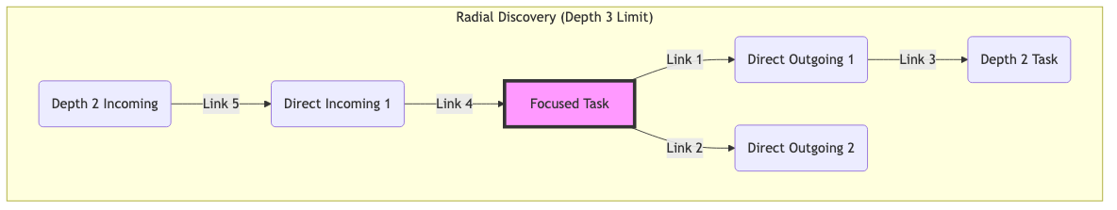

Figure 3.10.1: Focused Task Network with Multi-Level Radial Discovery

3.10.2 Normalized Topological Storage: Nodes and Edges
The graph topology is physically persisted across two primary, highly normalized tables. This separation ensures that entity-level metadata (titles, statuses, versions) can be updated without interfering with the underlying topological structure of the graph:
While the 'task_link' table functions as a standard adjacency list, it is insufficient for rapid path traversal over multiple levels. Performing recursive CTE (Common Table Expression) queries for every UI interaction would impose a significant CPU burden on the database during periods of high concurrency.

3.10.3 The Reachability Index: Pre-computed Transitive Closure
To enable O(1) path discovery and cycle detection, Taskinator maintains a secondary index known as the 'Task Reachability' table. This table stores the transitive closure of the graph—essentially pre-computing every possible path between any two nodes within a project.
By incorporating the 'min_depth' attribute into the index, the backend can execute highly efficient range queries to fetch the neighborhood of any task. For example, to retrieve all tasks that Task X is dependent upon within a 3-level depth, the system executes a simple non-recursive SELECT:

3.10.4 Application-Layer Graph Stitching and Path Construction
A key architectural decision in Taskinator is the delegation of path construction to the application tier. While the database serves as a highly optimized 'Search and Retrieval' engine for node IDs, the actual 'Stitching' of these nodes into a coherent Graph Story is performed by the Node.js Workspace service.
The service fetches the neighborhood IDs from the reachability index and simultaneously retrieves the raw edge metadata from the 'task_link' table. It then utilizes an in-memory Depth-First Search (DFS) algorithm to assemble the final JSON structure returned via GraphQL. This strategy ensures that the database remains unburdened by complex, CPU-intensive path serialization, allowing it to serve thousands of concurrent queries while the application tier handles the heavy compute load in a horizontally scalable manner.
Furthermore, this separation of concerns allows for advanced client-side features, such as 'Dynamic Path Pruning' and 'In-Memory Cycle Detection', which provide an additional layer of safety and responsiveness to the user interface.

3.11 Evaluation of Real-Time Communication Protocols
The choice of protocol for real-time data synchronization is a critical factor in the system's ability to scale. This section evaluates the three primary candidates: WebSockets, Long Polling, and Server-Sent Events (SSE), justifying the selection of SSE for Taskinator.

3.11.1 Comparison of Transport Mechanisms
WebSockets provide a full-duplex, bidirectional communication channel over a single TCP connection. While powerful, they introduce significant overhead in terms of state management and connection persistence at the server tier. Furthermore, WebSockets often require complex load balancing configurations to handle proxy-level timeouts and heartbeat signals.
Long Polling, while simple to implement, is extremely inefficient for high-frequency updates, as each update requires a new HTTP request-response cycle, leading to massive header overhead and socket churn.
Server-Sent Events (SSE) provide a unidirectional, persistent stream from the server to the client. SSE is built directly on top of standard HTTP/1.1 and HTTP/2, making it highly compatible with existing load balancers, firewalls, and edge networks like Cloudflare.

Table 3.11.1: Real-Time Protocol Comparison
Feature | WebSockets | SSE | Long Polling
Directionality | Bidirectional | Unidirectional | Unidirectional
Protocol Compatibility | Custom (Upgrade) | Standard HTTP | Standard HTTP
Auto-Reconnection | Manual | Native | N/A
Proxy/Firewall Friendly | Low | High | High

3.11.2 Architectural Fit for Taskinator
Taskinator utilizes GraphQL mutations (HTTP POST) for all client-to-server communication. This means the 'Upstream' path is already well-defined and performant. Therefore, the system only requires a reliable 'Downstream' path for reactive updates. SSE fits this requirement perfectly, providing a lightweight, native, and highly scalable channel for pushing JSON deltas to the client without the operational complexity of managing bidirectional WebSocket states.

4. EVENT-DRIVEN PIPELINE (EDA) IMPLEMENTATION
The foundational backbone of Taskinator is its highly tuned Event-Driven Architecture (EDA). This architecture rejects synchronous side-effect processing entirely, instead utilizing pervasive batching strategies that begin all the way upstream at the producer level and carry through to the downstream consumers. The primary motivation for this architecture is to decouple fast, optimistic writes from expensive, blocking reads and analytics updates.

4.1 The Transactional Outbox Pattern & wCTE
A classic, well-documented failure mode in distributed systems occurs when a database transaction successfully commits, but the application Node.js process crashes milliseconds before publishing the resulting domain event to Apache Kafka. This creates a ghost state: the data exists in the database, but downstream systems (analytics, search indexing, real-time UIs) are completely unaware, leaving the system permanently inconsistent.
To completely eradicate this dual-write problem, Taskinator utilizes the Transactional Outbox Pattern. This guarantees absolute atomic writes: the business entity mutation and the domain event emission are committed to the same exact SQL database simultaneously. If either fails, the entire transaction rolls back.

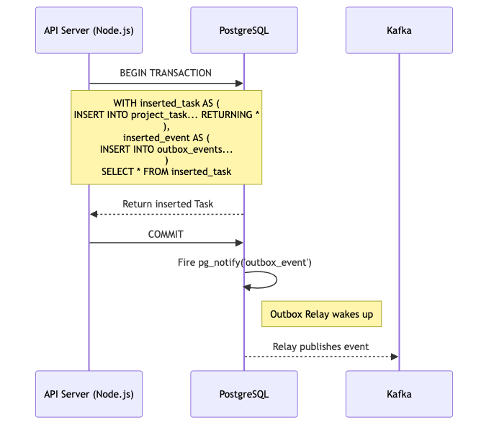

Figure 4.1: Transactional Outbox Workflow using wCTE

4.1.1 Eliminating Multi-Statement Overhead with Data-Modifying CTEs
While traditional Outbox implementations execute multiple sequential SQL statements (e.g., BEGIN, INSERT INTO entities, INSERT INTO outbox, COMMIT), this approach is fundamentally slow. It requires multiple network round-trips between the Node.js application server and the PostgreSQL database engine, increasing the total duration of the transaction lock.
Taskinator optimizes this by exclusively utilizing PostgreSQL's Data-Modifying Common Table Expressions (wCTE). A single SQL query is compiled using Kysely and sent to the database. This query uses WITH clauses to insert the business data and immediately insert the serialized JSON payload into the outbox_events table simultaneously, entirely within the database engine's execution planner:
WITH inserted_task AS (
INSERT INTO project_task (id, fk_project_id, title, status, version)
VALUES ($1, $2, $3, $4, 1)
RETURNING *
),
inserted_event AS (
INSERT INTO outbox_events (aggregate_id, event_type, payload)
VALUES (
(SELECT id FROM inserted_task),
'TASK_CREATED',
jsonb_build_object('id', (SELECT id FROM inserted_task), 'status', $4)
)
)
SELECT * FROM inserted_task;
This pattern ensures that network latency is incurred only once per HTTP request. The database engine executes the statements atomically in memory before writing to the write-ahead log (WAL). If a constraint is violated on the outbox table, the task insertion is cleanly aborted, and the application receives an immediate rejection. This single-trip architecture is a crucial factor in achieving the target of 10,000 RPS, as it drastically reduces connection pool exhaustion on the PgBouncer layer.

4.2 Concurrent Outbox Relays: Mitigating the Thundering Herd
Writing events safely to the outbox is only the first phase; the system must efficiently relay these events to the Kafka broker. Traditional outbox relays utilize primitive setInterval loops within background worker threads to repeatedly poll the database (e.g., SELECT * FROM outbox_events WHERE status = 'PENDING').
At an operational scale of 10,000 RPS, this polling methodology is catastrophic. Even when the system is relatively idle, aggressive polling introduces severe database CPU load and saturates network bandwidth.
Taskinator discards polling entirely in favor of reactivity. The Outbox Relay connects via the native pg driver and executes a persistent LISTEN outbox_event_notification command. When the aforementioned wCTE commits, PostgreSQL natively pushes a highly efficient, lightweight notification through the socket, instantly waking the idle relay.

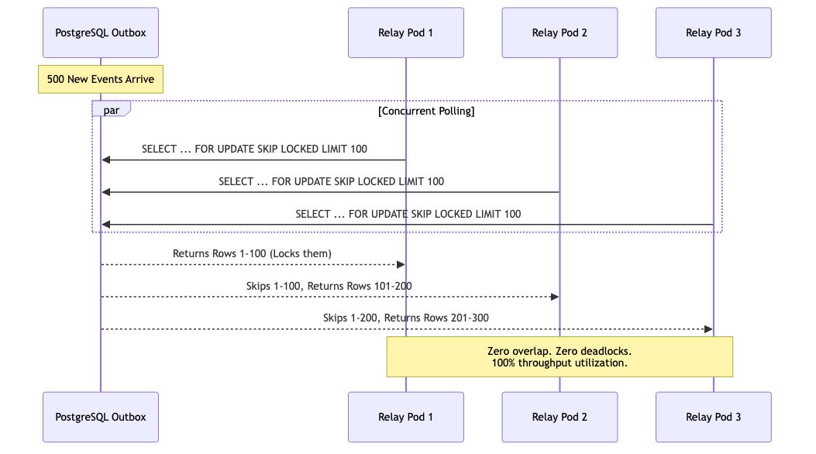

Figure 4.2: Concurrent Outbox Polling: Mitigating the Thundering Herd with SKIP LOCKED

4.2.1 The Thundering Herd Problem in Kubernetes Clusters
While reactive LISTEN/NOTIFY is highly efficient on a single node, enterprise deployments utilize Kubernetes to horizontally scale backend pods. If 50 identical backend pods are actively listening to the same outbox channel, a single pg_notify event will simultaneously wake up all 50 pods.
This creates a disastrous scenario known as the "Thundering Herd." All 50 pods will instantly attempt to execute a SELECT ... FOR UPDATE query to claim the exact same batch of pending events. Pod 1 acquires the lock, while Pods 2 through 50 are forced to block and wait. When Pod 1 commits, Pod 2 wakes up, discovers the events are already processed, and goes back to sleep. This contention leads to massive CPU spikes, transaction timeouts, and eventual database deadlocks as threads fight over the same B-Tree index rows.

4.2.2 High-Concurrency Queue Processing with SKIP LOCKED
To solve the Thundering Herd contention, Taskinator utilizes the advanced FOR UPDATE SKIP LOCKED database directive during the event claiming phase.
When the notification fires, Pod 1 executes SELECT * FROM outbox_events WHERE status = 'PENDING' FOR UPDATE SKIP LOCKED LIMIT 100. It immediately acquires an exclusive row-level lock on rows 1 through 100. Milliseconds later, Pod 2 executes the exact same query. Because of the SKIP LOCKED directive, the PostgreSQL query planner intercepts Pod 2's request and instructs it to completely bypass the locked rows (1-100) without waiting.
Pod 2 instead reads and instantly locks rows 101 through 200. Pod 3 locks rows 201 through 300, and so on. The result is massive, lock-free concurrent throughput. Dozens of pods can drain the outbox queue simultaneously at maximum speed without polling loops, database deadlocks, or duplicate event publishing. Once the events are safely pushed to Kafka, the pods execute a bulk DELETE on the processed rows, keeping the outbox table small and the B-Tree indexes highly optimized.

4.3 Smart Batch Aggregation & Semantic Folding
Pushing millions of events efficiently into the Kafka broker solves the upstream producer bottleneck. However, if the downstream consumers cannot process these events rapidly enough, Kafka will experience massive partition lag. Naive consumer implementations process one Kafka event at a time, executing a separate database transaction for every incoming event. At 10,000 RPS, executing 10,000 sequential UPDATE transactions to modify counters or analytics will instantly exhaust the database connection pool.
To mitigate this, Taskinator introduces a specialized background worker pattern called the Smart Batch Aggregator.

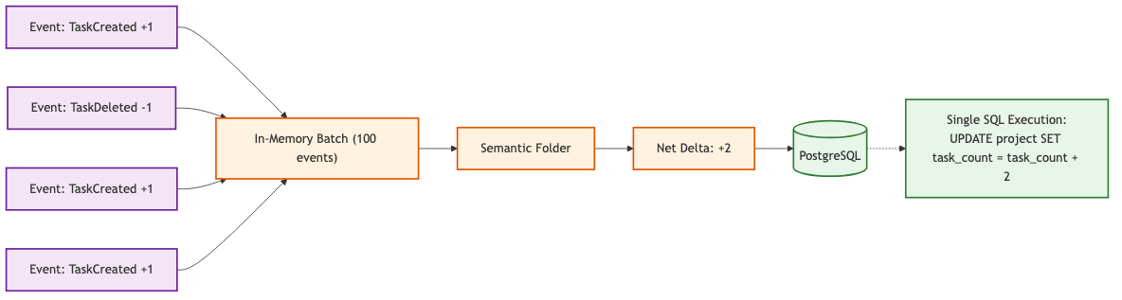

Figure 4.3: Smart Batch Aggregator Data Flow and Semantic Folding

4.3.1 Kafka Partitioning Strategy
The prerequisite for semantic folding is strict causal ordering. The Kafka producer explicitly sets the message partitioning key to the projectId. This guarantees that all events related to "Project A"—regardless of which node generated them or when they occurred—will consistently land on the exact same Kafka topic partition. Consequently, only one specific consumer thread will ever process the event stream for Project A at a given time, eliminating the possibility of distributed race conditions during aggregation.

4.3.2 The Semantic Folding Algorithm
The Kafka consumer is configured to ingest massive chunks of events (e.g., batchSize: 5000) from the broker and buffer them chronologically in memory. Instead of executing 5000 individual SQL queries, the aggregator loops over the buffered array and executes a Semantic Folding Algorithm.
If the aggregator detects 50 "Task Created" events and 20 "Task Deleted" events pertaining to the exact same project within the 500-millisecond batch window, it does not execute 70 individual SQL updates. Instead, it calculates a net mathematical delta (+30). It then executes a single, highly optimized, batched database update to the denormalized project.task_count metric.
// Semantic Folding Algorithm Snippet
const deltas = new Map<string, number>();

for (const event of batch) {
if (event.type === 'TASK_CREATED') {
deltas.set(event.projectId, (deltas.get(event.projectId) || 0) + 1);
} else if (event.type === 'TASK_DELETED') {
deltas.set(event.projectId, (deltas.get(event.projectId) || 0) - 1);
}
}

// Execute folded updates
await db.transaction().execute(async (trx) => {
for (const [projectId, delta] of deltas) {
if (delta !== 0) {
await trx.updateTable('project')
.set((eb) => ({ task_count: eb('task_count', '+', delta) }))
.where('id', '=', projectId)
.execute();
}
}
});
By performing these mathematical reductions purely in the Node.js V8 memory heap, the aggregator collapses thousands of sequential database operations into a handful of batched updates. This drastically reduces database write amplification, minimizes transaction overhead, and ensures that the analytics dashboard remains incredibly responsive, even under peak enterprise loads.

4.4 Chunked Self-Signaling Deletion (The Bubbling Effect)
In hierarchical systems, deleting a root node that possesses 50,000 descendants via a synchronous SQL ON DELETE CASCADE command is computationally disastrous. A standard RDBMS will acquire an exclusive table lock or massive row locks, traversing the foreign key relationships to verify constraints and delete every single child row within a single, massive transaction. This operation can take several seconds to execute. During this window, the database is severely restricted; concurrent operations from other users are blocked, and transaction queues rapidly hit their maximum capacity, resulting in widespread 503 Service Unavailable errors across the entire application.
Taskinator completely circumvents this bottleneck by implementing a specialized architectural pattern termed "Declarative Signalling and Self-Chunking.", colloquially referred to as "The Bubbling Effect".

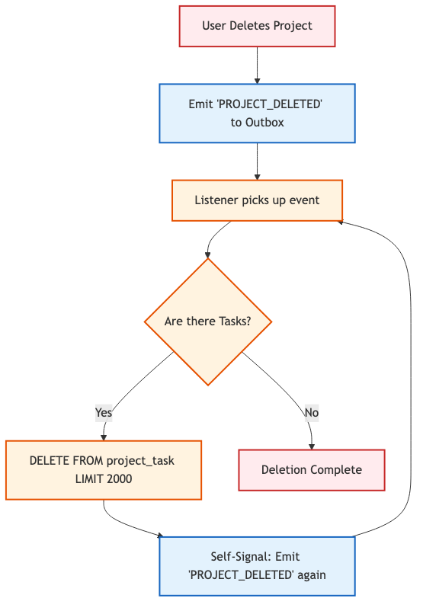

Figure 4.4: Chunked Self-Signaling Deletion ("The Bubbling Effect")

4.4.1 The Declarative Signal
When an authenticated user requests the deletion of a massive project, the primary API gateway does not execute a SQL DELETE query against the tasks table. Instead, it merely updates the project's status column to 'DELETING' and emits a declarative signal event (PROJECT_DELETED) into the Transactional Outbox. The HTTP request is then immediately resolved, and the user receives a 202 Accepted response in less than 50 milliseconds.

4.4.2 Bounded Transaction Chunks
A specialized asynchronous Background Listener, operating as a distinct Kafka consumer group, receives the PROJECT_DELETED signal. Rather than executing a blind delete, the Listener executes a strictly bounded query using explicit SQL LIMIT parameters: SELECT id FROM project_task WHERE fk_project_id = X LIMIT 2000. It then proceeds to delete exclusively those 2000 specific rows within a heavily constrained transaction.
By enforcing a strict upper bound of 2000 rows, the maximum continuous duration of the database lock never exceeds 10 to 15 milliseconds. After the chunk is purged, the transaction commits, instantly releasing all locks back to the connection pool. This microscopic lock duration guarantees that concurrent HTTP requests from other active users can seamlessly interleave between the deletion chunks, experiencing zero noticeable latency degradation.

4.4.3 Recursive Bubbling
After the first chunk of 2000 rows is successfully deleted, the Listener checks if the operation is complete. If the initial SELECT query returned exactly 2000 rows, there is a high statistical probability that further descendant rows remain in the database. To address this without locking the thread in a synchronous loop, the Listener deliberately emits a new, identical self-signal (PROJECT_DELETED) back into the outbox.
This signal propagates through Kafka, eventually re-triggering the Listener a few milliseconds later. The process repeats recursively—"bubbling" through the message queue—until a SELECT ... LIMIT 2000 query returns 0 rows. At this point, the mathematical certainty of complete deletion is achieved, the recursive loop terminates, and the parent project record is safely hard-deleted.

4.4.4 Physical Identifier (ctid) Based Chunking
While standard tables with primary keys use IDs for chunking, certain high-volume tables in Taskinator (like the 'task_reachability' index) use composite keys. In these cases, traditional ID-based pagination is inefficient. To maintain high performance, Taskinator utilizes PostgreSQL's 'ctid'—a physical tuple identifier representing the exact storage address of a row.
Using 'ctid' allows the engine to jump directly to the physical storage locations without scanning index b-trees, ensuring that even index cleanup remains O(1) per chunk regardless of the total table size.

4.4.5 Deferred Reachability Repair Strategy
Deleting rows from the 'task_reachability' index is only half the problem. When a task is deleted, the system must repair the surviving transitive paths. Executing a recursive repair CTE after every 2,000-row chunk would be computationally redundant and extremely slow.
Taskinator implements a 'Deferred Repair' strategy: the system suppresses the repair logic during all intermediate chunks. Only when the final chunk is reached (indicated by a deletion count < 2,000) does the system execute the expensive graph repair CTE. This guarantees that the repair is run exactly once on a clean, fully-purged table, maximizing both accuracy and performance.

4.5 Algorithmic Implementation: Semantic Folding
The theoretical concept of Semantic Folding requires a highly efficient, in-memory algorithmic implementation. The Smart Aggregator consumer must process arrays of up to 10,000 Kafka events in mere milliseconds before committing the mathematical deltas to the database.

4.5.1 The Kafka Consumer Batch Loop
The following Node.js code excerpt demonstrates the implementation of the O(N) folding loop. The algorithm iterates over the chronological batch array exactly once, accumulating the net changes in a Map data structure to achieve spatial and temporal efficiency.
async function processBatch(messages: KafkaMessage[]) {
// O(1) Lookup Map for Project Deltas
const projectDeltas = new Map<string, { total: number; completed: number }>();

for (const msg of messages) {
const event = JSON.parse(msg.value.toString());
const pid = event.projectId;

// Initialize the delta tracker if missing
if (!projectDeltas.has(pid)) {
projectDeltas.set(pid, { total: 0, completed: 0 });
}

const current = projectDeltas.get(pid)!;

// Apply algorithmic state folding
switch (event.type) {
case 'TASK_CREATED':
current.total += 1;
break;
case 'TASK_DELETED':
current.total -= 1;
if (event.status === 'DONE') current.completed -= 1;
break;
case 'TASK_STATUS_CHANGED':
if (event.newStatus === 'DONE') current.completed += 1;
if (event.oldStatus === 'DONE') current.completed -= 1;
break;
}
}

// Phase 2: Flush the optimized Map to the Database
await flushDeltasToDatabase(projectDeltas);
}

4.5.2 Complexity Analysis
The time complexity of this array reduction is strictly O(N), where N is the number of events in the batch. The space complexity is O(K), where K is the number of unique projects affected within that specific time slice. Because Kafka guarantees that all events for a specific project land on the same partition (and thus the same consumer thread), there is absolute mathematical certainty that no other Node.js instance is concurrently attempting to calculate the deltas for project 'pid'. This eliminates the need for distributed Redis locking mechanisms, freeing up substantial network bandwidth.

4.6 PostgreSQL Driver Optimizations at 10,000 RPS
Achieving 10,000 Requests Per Second (RPS) requires optimizations that extend far beyond application-level caching or standard database indexing. At extreme throughputs, the actual Transmission Control Protocol (TCP) overhead of the database driver communicating with the PostgreSQL connection pool becomes the primary bottleneck.

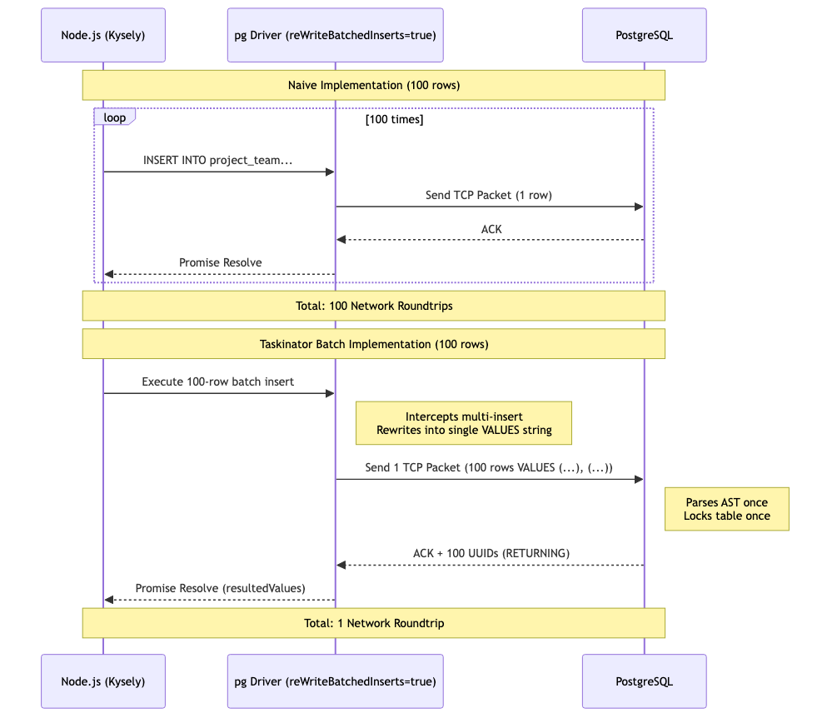

Figure 4.6: Database Driver Multi-Insert Packet Batching

4.6.1 The TCP Packet Problem
When a Node.js application needs to insert 100 domain events into an outbox table, the naive approach is to loop over the array and execute 100 individual INSERT INTO queries using an ORM. Even if these queries are executed concurrently using Promise.all(), the underlying pg driver will open 100 independent TCP connections (or rapidly cycle the connection pool), sending 100 distinct network packets to the database server. PostgreSQL must then parse the Abstract Syntax Tree (AST) of the query 100 times, acquire locks 100 times, and reply with 100 network ACKs.
This completely saturates the networking layer, causing severe CPU spikes on both the application nodes and the database kernel.

4.6.2 reWriteBatchedInserts and resultedValues
Taskinator utilizes specialized driver configurations, specifically the reWriteBatchedInserts=true parameter natively supported by advanced PostgreSQL JDBC and Node.js drivers. Instead of emitting individual queries, the driver intercepts the batch and dynamically rewrites the SQL string in memory into a single, massive VALUES clause:
INSERT INTO outbox_events (id, payload) VALUES
(uuid(), '{"key": "val1"}'),
(uuid(), '{"key": "val2"}'),
... (up to 1,000 rows);
This reduces the network IO from 1,000 TCP roundtrips to exactly 1. The PostgreSQL engine parses the AST once and writes the data to the B-Tree index sequentially, maximizing disk IOPS. To retrieve the auto-generated primary keys without executing a secondary SELECT, the driver leverages the native RETURNING clause, mapping the resulting UUIDs back to the in-memory array using the resultedValues property. This combination of techniques is mandatory to prevent connection pool exhaustion at scale.

4.7 Comprehensive Multi-Phase Execution Trace
To synthesize the disparate architectural patterns discussed thus far—ranging from wCTE-driven transactional outboxes to Semantic Aggregators and Zero-Fan-Out SSE routing—it is imperative to execute an exhaustive trace of a single mutation as it propagates through the entire full-stack pipeline. This trace serves to demonstrate the system's resilience and deterministic behavior under maximum load conditions, where traditional synchronous architectures typically experience catastrophic failure.

4.7.1 Phase 1: Synchronous Ingress and Atomic Persistance
The lifecycle of a mutation commences at the React Client and terminates with the atomic database commit. This phase is characterized by its strict synchronous nature, necessitating sub-50ms execution to unblock the main execution thread of the user's browser environment.

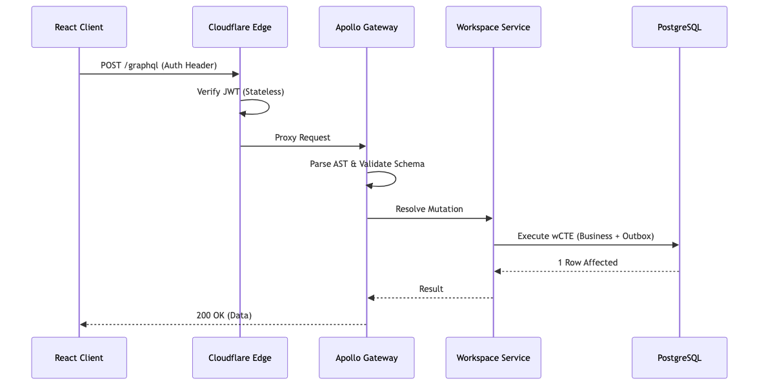

Figure 4.7.1: Phase 1 — Synchronous Ingress and Edge Verification
Edge Ingress & Stateless Verification: The client issues a POST /graphql to mark 'Task 99' as COMPLETE. The Cloudflare Edge node, acting as a global distributed entry point, verifies the JWT signature statelessly in < 5ms, ensuring immediate rejection of unauthorized payloads before they reach the internal backbone.
Federated Gateway Orchestration: The Apollo Federation Gateway parses the complex GraphQL Abstract Syntax Tree (AST), validates the schema adherence, and routes the mutation to the Node.js Workspace Subgraph via a high-speed internal VPC link.
Atomic wCTE Execution: The Workspace service constructs a sophisticated data-modifying Common Table Expression (wCTE). It simultaneously updates the task status, increments the version column for Optimistic Concurrency Control, and serializes the TASK_UPDATED JSON payload into the outbox_events table. The database engine guarantees that this dual-write is either fully committed or rolled back, ensuring absolute consistency.

4.7.2 Phase 2: Asynchronous Event Propagation
Upon the successful commit of the synchronous transaction, the primary database lock is released, and the responsibility for system-wide synchronization is offloaded to the asynchronous event-driven backbone. This decoupling is the fundamental driver of the system's high-throughput capability.

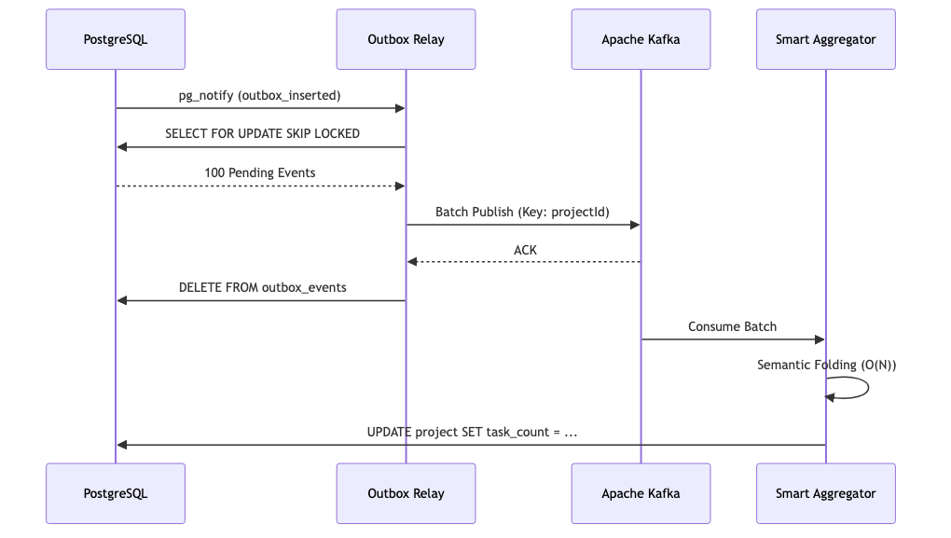

Figure 4.7.2: Phase 2 — Outbox Relay and Kafka Partitioning
Reactive Outbox Triggering: The commit triggers a native PostgreSQL LISTEN/NOTIFY socket signal ('outbox_inserted'), which immediately awakens the dormant Outbox Relay process, eliminating the latency overhead associated with traditional interval-based polling.
Concurrent SKIP LOCKED Claiming: To allow horizontal scaling of the relay tier, each instance executes a SELECT FOR UPDATE SKIP LOCKED query. This allows multiple relays to process the outbox table concurrently without ever colliding or processing the same event twice.
Partition-Aware Kafka Ingestion: The relay publishes the event to the Kafka cluster using the projectId as the partition key. This guarantees that all events for a specific project are processed in strict causal order, a requirement for maintaining deterministic state in the downstream aggregators.
Semantic Batch Aggregation: The Kafka Smart Aggregator consumes a massive batch of events. It applies an O(N) Map-Reduce 'Folding' algorithm, compressing redundant updates into a single mathematical delta before executing a bulk SQL UPDATE to adjust denormalized project counters.

4.7.3 Phase 3: Real-time Reactivity and Cache Reconciliation
The final phase involving the synchronization of the committed state back to all active browser instances viewing the project. This phase utilizes a 'Targeted Routing' approach to minimize network overhead.

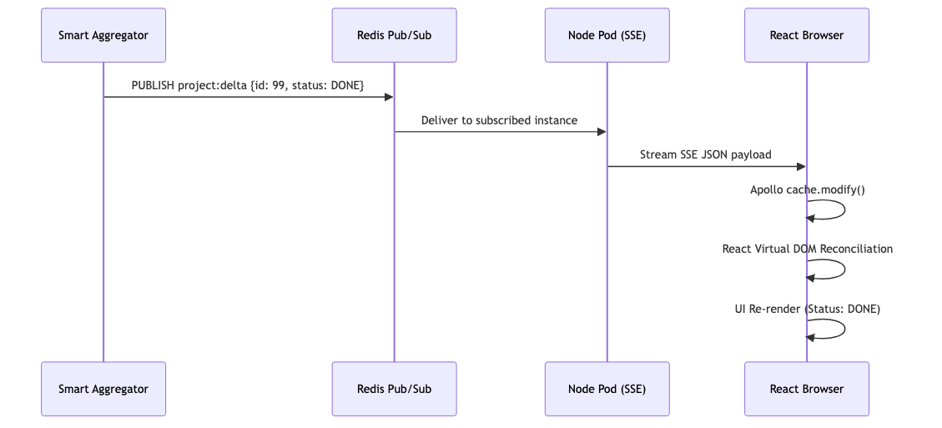

Figure 4.7.3: Phase 3 — Targeted SSE Routing and Virtual DOM Reconciliation
Zero-Fan-Out Targeted Routing: The Aggregator queries the Redis Routing Table to identify the specific Node.js pods holding persistent Server-Sent Event (SSE) sockets for the affected project. It issues a targeted PUBLISH command, ensuring that zero bandwidth is wasted on server instances that do not serve project stakeholders.
Surgical Apollo Cache Modification: The browser-side SSE link intercepts the JSON delta. Rather than triggering a destructive network refetch, it invokes cache.modify(), surgically injecting the updated status into the local normalized memory graph.
React 18 Concurrent Rendering: The React state observer detects the granular data change. The Virtual DOM executes a high-speed diffing operation and reconciles the specific Task Card component, rendering the completed status to the user in a sub-300ms roundtrip from the initial click.

4.8 Transactional Outbox Relay Deep Dive
The Transactional Outbox pattern is the engine of reliability in Taskinator. While Chapter 4.1 introduced the wCTE pattern for atomic writes, this section details the high-performance relay mechanism that ensures these events are eventually published to the Kafka event bus with 'at-least-once' delivery guarantees.

4.8.1 Polling vs. Push-Based Notifications
To minimize latency, the Outbox Relay does not rely solely on interval polling. Instead, it utilizes PostgreSQL's 'LISTEN/NOTIFY' mechanism. When a wCTE transaction commits, the database fires a 'pg_notify' signal. The idle relay process, which is 'listening' on that channel, wakes up instantly to process the new events.

4.8.2 The Concurrent Claim Loop
In a distributed environment where multiple relay instances may be running, we must prevent duplicate processing at the source. The relay uses a 'SELECT ... FOR UPDATE SKIP LOCKED' query to atomically claim a batch of events.
This query ensures that each relay instance gets a unique set of events without blocking other instances, allowing the system to scale linearly as event volume grows.

4.8.3 The 'Delete-on-Success' Strategy
Once the relay receives an acknowledgement (ACK) from Kafka, it immediately deletes the processed events from the 'outbox_events' table. This 'Hard Delete' strategy is critical for maintaining O(1) polling performance. By keeping the table size near zero, we avoid the performance degradation typically associated with large, long-lived tables in relational databases.

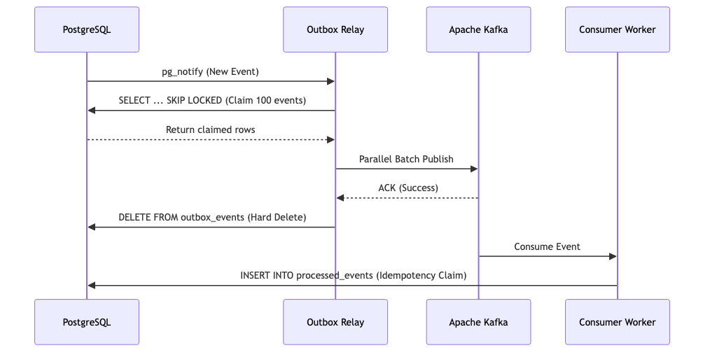

Figure 4.8: Outbox Relay Lifecycle and Kafka Integration

4.8.4 Error Handling and Retries
If the relay process crashes or Kafka is unavailable, the 'PROCESSING' status acts as a safety net. A separate 'Cleanup Worker' monitors the table for events that have been in 'PROCESSING' for longer than 60 seconds and resets them to 'PENDING', allowing them to be re-claimed by a healthy relay instance. This ensures that no event is ever lost, even in the event of partial system failure.

5. SECURITY AND ACCESS CONTROL
In a multi-tenant enterprise orchestration tool, robust data segregation and authorization are paramount. Users must be mathematically proven to have access to specific project entities before any mutation can occur. However, calculating these permissions synchronously during high-throughput HTTP requests typically incurs massive database overhead due to the required JOIN operations.

5.1 CTE-Based Atomic Authorization
To avoid executing multiple sequential roundtrips to an external authorization service or executing separate SELECT permission verification queries before every single mutation, Taskinator bakes the Role-Based Access Control (RBAC) security matrix directly into the underlying SQL mutation utilizing Common Table Expressions (CTEs).

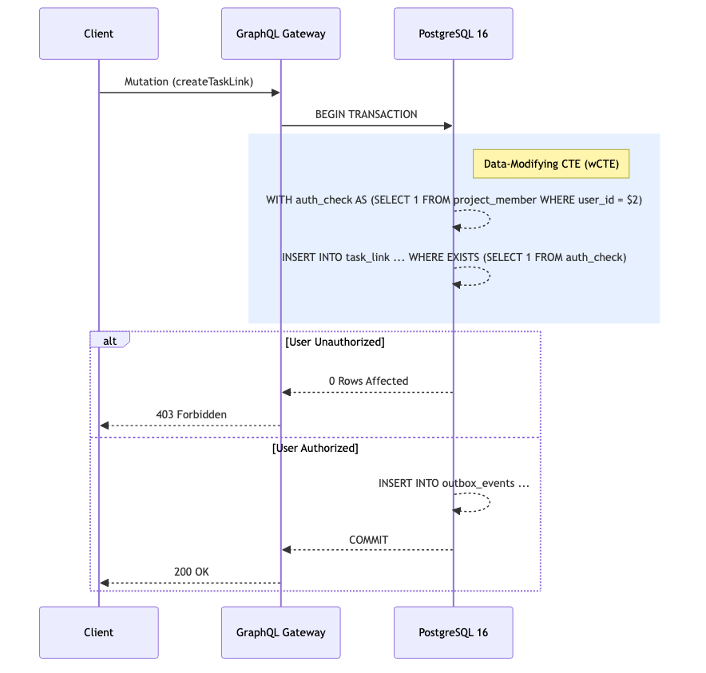

Figure 5.1: RBAC Authorization Flow

5.1.1 The Single-Trip Security Paradigm
Traditional monolithic APIs often utilize a middleware approach: a request arrives, the middleware pauses execution, queries the database to verify if the user's ID exists in the project_member mapping table, waits for the boolean result, and then either rejects the request or allows the controller to proceed with the mutation.
At 10,000 RPS, this doubling of query volume (one for auth, one for mutation) halves the effective capacity of the database connection pool. Taskinator implements Single-Trip Atomic Security:
WITH auth_check AS (
SELECT 1 FROM project_member
WHERE fk_project_id = $1 AND fk_user_id = $2
AND role IN ('OWNER', 'ADMIN', 'EDITOR')
)
UPDATE project_task SET title = $3
WHERE id = $4 AND EXISTS (SELECT 1 FROM auth_check)
RETURNING *;
The query execution planner evaluates the EXISTS clause first. If the user lacks the necessary hierarchical permissions, the CTE returns empty, the EXISTS clause evaluates to FALSE, and the UPDATE statement is safely and silently aborted at the engine level without locking the target row. The database immediately returns 0 affected rows to the Node.js API, which translates this into an HTTP 403 Forbidden or 404 Not Found response, obscuring the exact failure reason from potential attackers to prevent enumeration vectors.

5.2 Team Hierarchy and Inheritance
Enterprise organizations rarely operate flat lists of users. Access control is typically managed via nested hierarchies: a Global Admin team contains the Engineering team, which contains the Frontend sub-team. If a project is assigned to the Engineering team, all members of the Frontend sub-team must automatically inherit access.
This introduces a complex challenge for the CTE-based authorization model, as determining inherited membership requires calculating paths through a Directed Acyclic Graph (DAG) of teams during the mutation.

5.2.1 Team Closure Tables
To support instant O(1) inheritance checks, Taskinator applies the Custom Closure Table pattern not just to the tasks, but also to the Team organizational structures. A team_reachability table explicitly stores every mathematical path from an ancestor team to all descendant sub-teams.
When the aforementioned auth_check CTE executes, it does not merely check if the user is a direct member of the project. It executes a highly optimized JOIN against the team_reachability index to determine if the user belongs to ANY team that is mathematically deemed a descendant of the team assigned to the project.
Because the reachability matrix is calculated asynchronously via Kafka during team restructuring events, the read-path mutation query remains blazingly fast. This architectural decision ensures that even in organizations with thousands of deeply nested sub-teams, the authorization overhead remains constant, completely circumventing the catastrophic performance degradation associated with runtime recursive traversals.

5.3 Hierarchical Team Management and Closure Tables
While the Task Reachability Engine models deeply nested, multi-parent Directed Acyclic Graphs (DAGs), the organizational structure of users within Taskinator requires a completely different topological model. Organizations are modeled as strict trees with a maximum nesting depth of 50 levels (e.g., Global Corp -> NA Region -> Engineering -> Frontend Team).

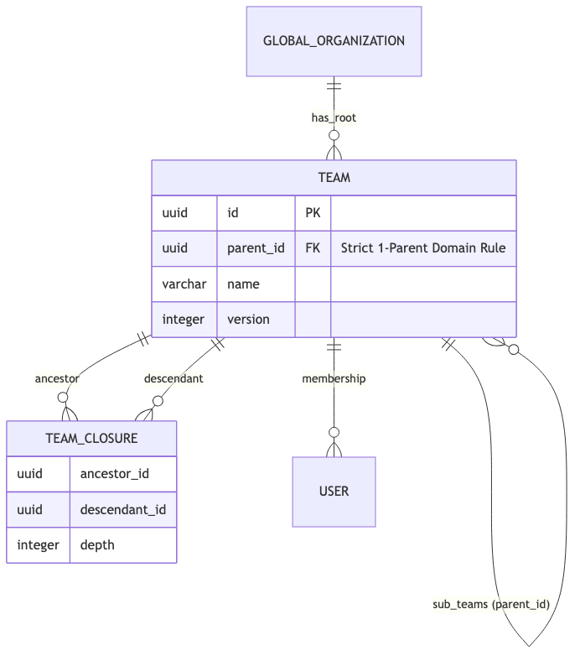

Figure 5.3: Strict Single-Parent Team Closure Table Architecture

5.3.1 The 'One Parent' Strict Domain Rule
Unlike tasks, which can block multiple downstream dependents, a Team entity is strictly governed by the 'One Parent' domain rule. A team can have an infinite number of sub-teams, but it can only ever report to exactly one parent team. This enforces a strict hierarchical tree structure, preventing circular reporting cycles inherently at the database schema level via a single parent_id Foreign Key.

5.3.2 The Organizational Reachability Index
Querying hierarchical tree data using standard SQL requires recursive CTEs, which degrade exponentially as depth increases. To resolve this, the Workspace Service implements a secondary Closure Table specifically tuned for organizational hierarchies.
The team_closure table tracks the topological distance between any two teams in the organization:
CREATE TABLE team_closure (
ancestor_id UUID NOT NULL,
descendant_id UUID NOT NULL,
depth INT NOT NULL,
PRIMARY KEY (ancestor_id, descendant_id)
);
When querying for all users within the 'Engineering' department (including all nested sub-teams), the system executes a simple, O(1) indexed join against the team_closure table where ancestor_id = 'Engineering', instantly returning thousands of sub-teams without recursive table scans.

5.4 Optimistic Concurrency Control (OCC)
In a high-throughput, highly concurrent system operating at 10,000 RPS, multiple network clients will inevitably attempt to mutate the exact same database row simultaneously. For example, two project managers might attempt to update the metadata of 'Task 99' at the exact same millisecond.

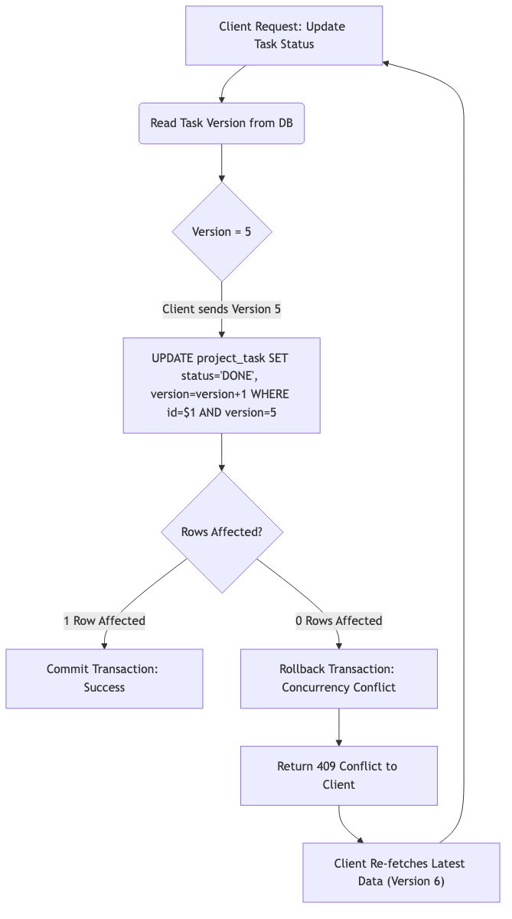

Figure 5.4: Optimistic Concurrency Control Execution Flow

5.4.1 The Danger of Pessimistic Locking
Traditional RDBMS engineering solves concurrency utilizing Pessimistic Locking via the SELECT ... FOR UPDATE syntax. This instructs PostgreSQL to acquire an exclusive row-level lock on the disk. While safe, this is disastrous for throughput. If Transaction A locks a row, Transaction B is completely suspended by the kernel until A commits. This leads to connection pool starvation, spiraling latency, and eventual cascading failure across the microservice cluster.

5.4.2 The Version Vector Pattern
Taskinator rejects Pessimistic Locking in favor of Optimistic Concurrency Control (OCC). Every primary entity in the database (Tasks, Projects, Teams) includes an integer version column. The system assumes that conflicts are rare and does not acquire any preliminary locks.
When a client fetches a task, it receives the data alongside the current version (e.g., version = 5). When the client issues an update mutation, it must pass this version back to the server. The SQL update is then strictly bounded by this integer:
UPDATE project_task
SET status = 'DONE', version = version + 1
WHERE id = 'Task-99' AND version = 5;
If the other manager updated the task a millisecond prior, the database version would now be 6. The subsequent UPDATE query will gracefully affect exactly 0 rows. The PostgreSQL driver detects this, the application immediately throws a 409 Conflict exception, and the client application prompts the user to refresh the stale UI. This guarantees absolute data integrity without ever blocking concurrent read or write threads.

5.5 Atomic Event Orchestration and Safety Gates
In a complex system like Taskinator, one event often triggers a cascade of subsequent actions. For example, updating a task to 'COMPLETED' might trigger an automation that updates a parent task. Without proper safeguards, these cascades can lead to infinite recursive loops.

5.5.1 The System Actor Pattern
To manage recursion, Taskinator distinguishes between human-initiated actions and system-initiated side effects. Every event payload carries a 'userId' field. When an automated service (like the Trigger Engine) performs a mutation, it explicitly identifies itself as the 'SYSTEM' user.

5.5.2 The Recursive Safety Gate
Consumer listeners are equipped with 'Safety Gates'. Upon receiving an event, the listener checks the 'userId'. If the event originated from the 'SYSTEM' user, the listener terminates early, effectively breaking the recursive cycle.

5.5.3 Orchestration Trace: Parent-Guard Trigger
Consider the 'Parent-Guard' trigger, which prevents a parent task from being marked as 'DONE' if its children are still 'TODO'. The orchestration flow is as follows:
1. Human User (u123) updates Task A to 'DONE'.
2. An event is emitted with userId: 'u123'.
3. The Trigger Listener catches the event. Since userId is not 'SYSTEM', it executes.
4. The listener finds incomplete children and reverts Task A to 'TODO'.
5. This reversion emits a NEW event with userId: 'SYSTEM'.
6. The Trigger Listener catches the second event, hits the Safety Gate, and stops.

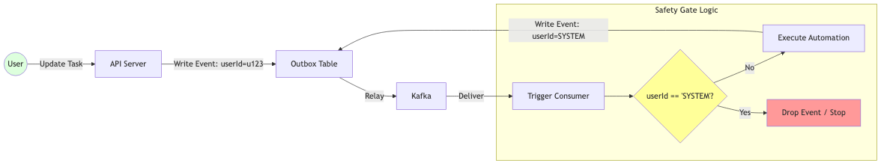

Figure 5.5: Recursive Event Flow with Origin Tracking Safety Gates

5.6 Distributed Data Lifecycle and Event Synchronization
The integrity and operational efficiency of a distributed ecosystem are intrinsically linked to the predictable and deterministic flow of data across disparate service boundaries. Taskinator ensures this multi-tier synchronization through an advanced combination of 'Semantic Folding' and 'Silent Purge' architectural policies. These mechanisms are designed to manage the entire lifecycle of project-wide events—from their initial reactive emission to their final reconciliation and garbage collection—while strictly avoiding the common pitfalls of event-driven architectures, such as network congestion and infinite cascading loops.

5.6.1 Semantic Event Folding in Aggregators
To optimize Apache Kafka throughput and minimize downstream compute costs, Taskinator's 'Smart Aggregators' implement a sophisticated 'Semantic Folding' algorithm during the ingestion of high-frequency event streams. When multiple mutations occur for the same primary entity within a configurable temporal window (typically a 100ms micro-batch), the aggregator 'folds' these operations into a single logical state transition.
Consider a high-frequency scenario where a project is rapidly created, updated multiple times, and then deleted in the same batch. A naive system would propagate four distinct events, triggering four sets of downstream cache updates and database writes. In contrast, the Taskinator folding logic applies a mathematical Map-Reduce operation over the batch: (+1 created, -1 deleted = 0 net change). The aggregator effectively cancels both events at the ingestion tier, preventing any unnecessary noise from propagating to the Analytics and Real-time sub-systems.

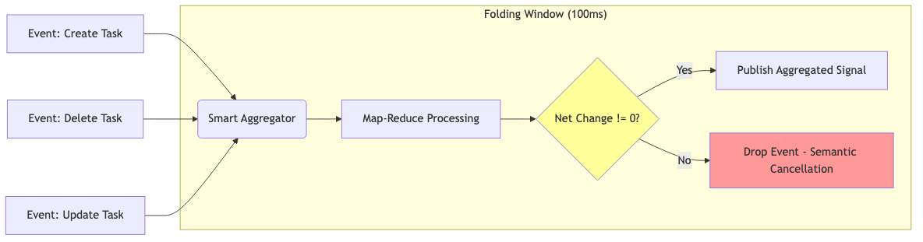

Figure 5.6.1: Semantic Folding and Batch Compression Logic

5.6.2 The Silent Purge Policy for Cascading Cleanups
A critical challenge in mature Event-Driven Architectures is the mitigation of 'Event Storms'—phenomena where a single root-level deletion (e.g., a Project) triggers a cascade of thousands of individual child deletion events (e.g., Tasks, Teams, Members), potentially saturating the message bus and causing downstream consumer lag. To combat this, Taskinator enforces a strict 'Silent Purge' policy for all recursive garbage collection operations.
When a Project is marked for deletion, the Project Module emits a single, authoritative 'PROJECT_DELETED' signal via Kafka. All interested modules (Team, Task, Auth) consume this signal and initiate a 'Silent Purge'. This entails executing high-speed, direct SQL bulk deletions on their internal tables using the project_id as a bounding key. Crucially, these cascading deletions are specifically configured to **not** emit further Kafka events. By breaking the event chain at the leaf level, Taskinator maintains absolute system stability and predictable latency even during massive data purging operations.

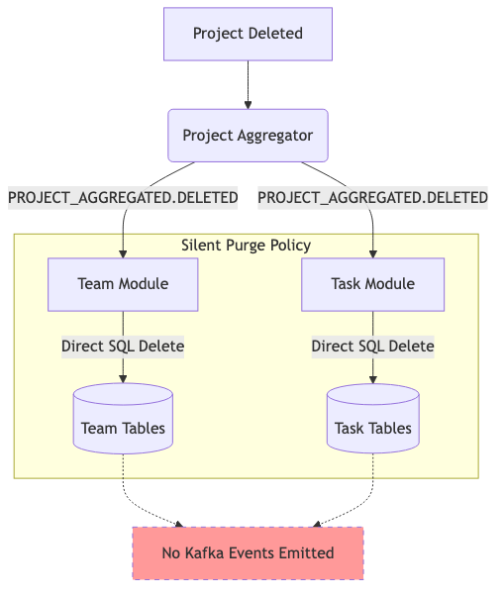

Figure 5.6.2: Silent Purge Cascades and Event Chain Termination

5.6.3 Proactive Atomic Counter Reconciliation
While denormalized counts (such as project.task_count or team.members_count) are updated with sub-second latency via the asynchronous aggregation pipeline, there exists a theoretical non-zero probability of 'state drift' due to race conditions or partition rebalancing. Taskinator addresses this by incorporating a 'Proactive Reconciliation' mechanism directly into the aggregator tier.
Every 10,000 processed events, or upon the detection of a significant consumer lag, the system triggers a background reconciliation 'Sweep'. This worker executes a highly optimized read-only COUNT query against the source-of-truth tables and compares the result with the denormalized state. Any identified discrepancies are corrected via an atomic UPSERT, ensuring that while the system is highly performant and eventually consistent, it is also fundamentally self-healing and accurate in the long term.

6. FRONTEND ARCHITECTURE AND REAL-TIME SYNCHRONIZATION
Pushing data to the client efficiently is only half the battle in a real-time collaborative system. If the client simply triggers a full-page data refetch upon receiving a Server-Sent Event (SSE) payload, the backend database will be instantly overwhelmed by redundant read queries, defeating the purpose of the Event-Driven Architecture entirely. Taskinator's frontend is engineered to surgically inject updates directly into the in-memory cache, achieving O(1) rendering complexity.

6.1 The React Task Graph and D3.js Visualization
To represent the deeply nested Directed Acyclic Graphs (DAGs) generated by the Reachability Engine, traditional list-based HTML UI components are fundamentally inadequate. Complex multi-parent dependencies require spatial visualization. Taskinator employs a custom visualization engine utilizing React 18 and D3.js.

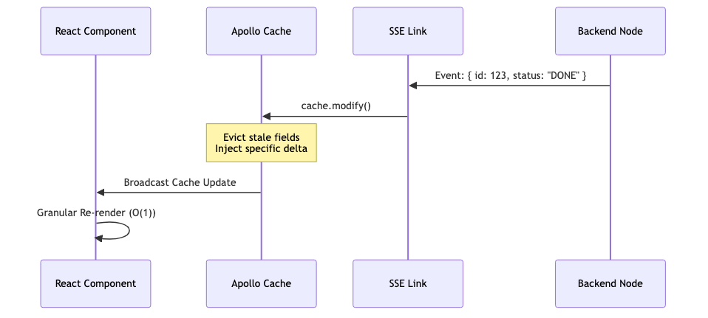

Figure 6.1: Frontend UI State Machine
D3.js is universally recognized for its powerful mathematical layout algorithms (e.g., d3.hierarchy, d3.dag, and d3.tree). However, traditional D3 implementations forcefully mutate the Document Object Model (DOM) directly, competing with React's virtual DOM reconciliation cycle and causing severe layout thrashing.
Taskinator strictly delegates all DOM rendering exclusively to React. D3 is relegated to a pure mathematical calculation role. It calculates the absolute (x, y) SVG coordinates of the individual task nodes and computes the complex bezier curves for the linking edges purely in memory. React then consumes this structured data array, mapping over it to rapidly render pure, declarative SVG <circle> and <path> components.
This hybrid approach prevents costly browser layout reflows and allows React's Concurrent Mode to interrupt and prioritize rendering frames smoothly, guaranteeing a consistent 60 Frames Per Second (FPS) visual experience even when manipulating and panning across a canvas containing thousands of simultaneous SVG nodes.

6.2 Zero-Fan-Out Targeted Routing via Redis
In standard real-time web architectures, the prevailing pattern for distributing events across a horizontally scaled cluster of backend nodes is "Pub/Sub Fan-Out" (typically implemented via a naive Redis PUBLISH). If a user marks a task as complete, the server handling that request publishes the event to Redis, which blindly broadcasts it to every single Node.js instance in the cluster. Every instance then checks its local memory to see if it holds a WebSocket connection for a user who cares about that project.
At 10,000 RPS, this creates an enormous volume of useless internal network traffic, essentially turning the internal Pub/Sub network into a localized Distributed Denial of Service (DDoS) attack. A single event is multiplied across 50 pods, forcing 49 of them to process and instantly discard the payload.

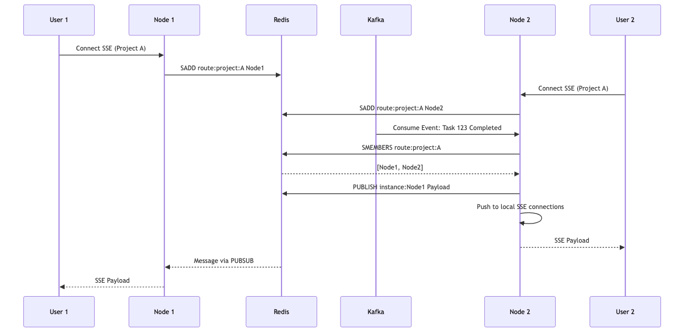

Figure 6.2: Targeted Redis Routing for Real-time Server-Sent Events (SSE)
Taskinator implements a highly tuned Zero-Fan-Out Targeted Routing layer utilizing Redis data structures.
When a user opens the React frontend dashboard for Project X, their browser establishes an SSE connection with a specific backend pod (e.g., Node Instance 2). Instance 2 immediately registers this connection in Redis by executing a Set Add operation: SADD route:project:X "Instance2".
Later, when an asynchronous Kafka event occurs (e.g., a background worker completes a bulk task assignment for Project X), the Real-Time Router (a dedicated Kafka consumer module) executes a query to determine exactly where the interested clients are located: SMEMBERS route:project:X. Redis rapidly returns the specific array: ["Instance2"]. The Router then issues a highly targeted publish command explicitly to that instance's private channel: PUBLISH instance:Instance2 payload.
If SMEMBERS returns an empty array, it definitively means no users are currently viewing the project, and the Router drops the event instantly into the void without touching the Pub/Sub network. This architecture completely eliminates Fan-Out, reducing network traffic linearly relative to the number of active, observing connections rather than the total number of system instances.

6.3 Reactive State Management: Apollo Client Cache Reconciliation
The realization of a truly reactive user interface necessitates a state management strategy capable of reconciling asynchronous server-side events with the local browser-resident state without incurring the destructive overhead of full-page reloads or broad-spectrum network refetches. Taskinator achieves this through a sophisticated integration of Apollo Client's normalized In-Memory Cache and granular Server-Sent Event (SSE) ingestion.

6.3.1 Asynchronous SSE Ingress and Link Interception
When a targeted SSE payload arrives at the browser—for instance, a JSON fragment indicating that 'Task 123' has transitioned to 'DONE'—the client must process it with surgical precision. A naive approach would involve forcing a GraphQL query refetch, which would trigger a network roundtrip, re-parse a massive response, and potentially cause a layout shift that degrades the user experience.
Instead, Taskinator employs a custom 'SSE Link' within the Apollo client-side middleware chain. This link intercepts the incoming streaming data and immediately broadcasts it to the internal cache layer, bypassing the network fetch tier entirely. This architectural pattern ensures that the 'Time to UI Update' is limited only by the raw network latency of the SSE stream itself, typically resulting in near-instantaneous visual feedback.

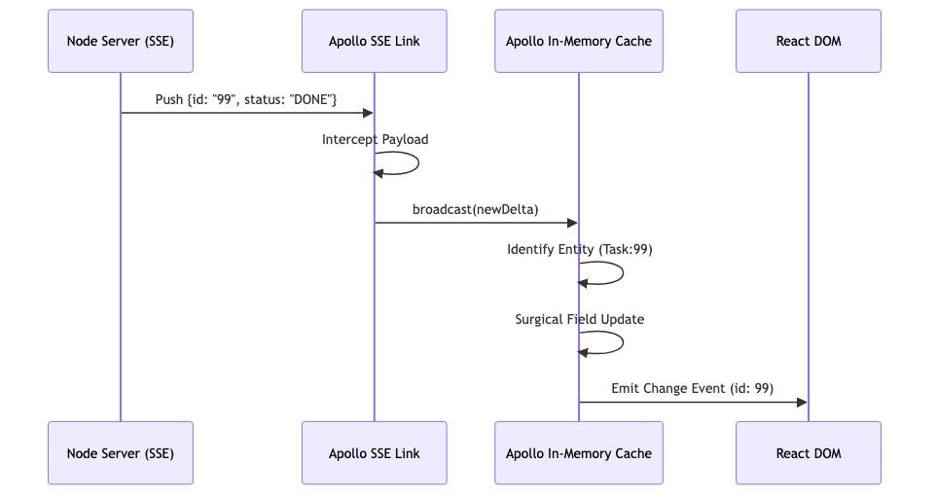

Figure 6.3.1: SSE Ingress and Apollo Link Interception Sequence

6.3.2 Granular Cache Modification and Virtual DOM Reconciliation
The internal Apollo cache operates as a highly normalized graph of data entities, where each object is uniquely identified via a deterministic key (e.g., 'Task:123'). Upon receiving a delta from the SSE link, Taskinator utilizes the 'cache.modify()' API to execute a direct, granular update of the specific entity field.
// Apollo Cache Surgical Modification
apolloClient.cache.modify({
id: apolloClient.cache.identify({ __typename: 'Task', id: event.id }),
fields: {
status() { return event.status; }
}
});
This operation is fundamentally 'pure'; it does not alter the underlying component state directly but instead updates the source-of-truth from which components derive their properties via Reactive Hooks. React 18's concurrent rendering engine detects this change in the normalized store and initiates a high-speed Virtual DOM diffing operation.
Because the update is granular, React identify that only the specific Task Card component associated with the modified ID requires reconciliation. The other hundreds of components in the project view remain untouched, avoiding expensive layout recalculations and maintaining a consistent 60 FPS frame rate even during high-frequency real-time updates from multiple concurrent users.

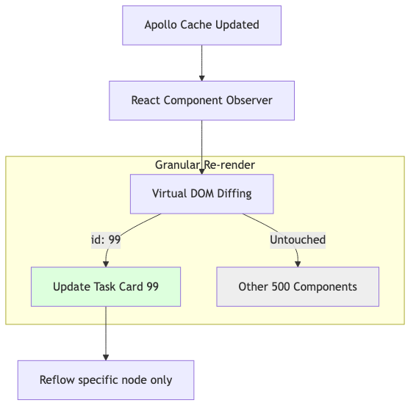

Figure 6.3.2: Granular Cache Update and React Reconciliation Flow

6.3.3 Resilience against Network Partitioning and Synchronization
Distributed real-time systems must account for transient network failures. If an SSE connection is severed due to infrastructure instability, the Apollo Cache maintains the last known authoritative state locally. Upon reconnection, the client executes a 'Sync Query' or 'Delta Fetch' to retrieve only the operations that transpired during the period of disconnection. This ensures the local cache is reconciled with the server-side state without requiring a full application reset, providing a seamless 'Offline-to-Online' transition for the end user.

6.4 Declarative SVG Rendering: React & D3.js Integration
To avoid the DOM thrashing typically associated with imperative D3.js manipulations, the frontend completely separates the mathematical layout engine from the rendering engine. D3 is used strictly as a pure function to compute SVG coordinates, while React is used to declaratively mount the elements into the browser DOM.

6.4.1 Layout Calculation and Rendering Code
The following React code excerpt illustrates the implementation of the TaskGraph component. The raw, flat array of nodes and edges retrieved from the GraphQL getTaskGraph query is parsed into a d3.stratify() hierarchy. A customized d3.dag() layout generator calculates the absolute 'x' and 'y' properties for every node.
import { useMemo } from 'react';
import { dagStratify, sugiyama } from 'd3-dag';

export const TaskGraph = ({ rawTasks, edges }) => {
// 1. Pure Mathematical Calculation (Memoized to prevent recalculation)
const { nodes, links } = useMemo(() => {
const dag = dagStratify()(rawTasks, edges);
const layout = sugiyama().nodeSize([150, 100]);
layout(dag); // Mutates 'dag' with x,y coordinates

return {
nodes: dag.descendants(),
links: dag.links()
};
}, [rawTasks, edges]);

// 2. Pure Declarative Rendering (Zero D3 DOM Manipulation)
return (
<svg width="100%" height="100%" viewBox="0 0 1000 800">
<g className="edges">
{links.map(link => (
<path
key={`${link.source.id}-${link.target.id}`}
d={generateBezier(link)} // Custom bezier curve generator
stroke="#CBD5E1"
fill="none"
/>
))}
</g>
<g className="nodes">
{nodes.map(node => (
<circle
key={node.data.id}
cx={node.x}
cy={node.y}
r={24}
fill={node.data.status === 'DONE' ? '#10B981' : '#3B82F6'}
/>
))}
</g>
</svg>
);
};

6.4.2 Performance Implications
By utilizing React's useMemo hook, the heavy sugiyama layout algorithm is only executed when the underlying structural graph data (rawTasks or edges) actually mutates. If a task simply changes its status (e.g., from 'TODO' to 'DONE') via the SSE pipeline, the reference arrays remain identical. React bypasses the expensive D3 math recalculation entirely and proceeds directly to the rendering phase, where it executes a highly localized DOM patch to alter the SVG <circle> fill color. This architecture guarantees a stable 60 FPS visual experience regardless of event throughput.

6.5 Targeted Real-Time Routing Architecture
Achieving real-time responsiveness at 10k RPS requires a highly efficient message delivery system. Traditional 'fan-out' approaches, where every event is broadcast to every server instance, do not scale as they saturate the network with redundant traffic. Taskinator implements a 'Targeted Routing' pattern using Redis.

6.5.1 Distributed Connection Management
When a client connects to a GraphQL subscription (via Server-Sent Events), the backend instance serving that connection generates a unique 'INSTANCE_ID'. The user's presence is then registered in a global Redis routing table, mapping their active Project ID to that specific instance.

6.5.2 The Air Traffic Controller Pattern
A dedicated Kafka consumer, known as the 'Real-Time Router', acts as the air traffic controller for events. When a 'TaskUpdated' event arrives from Kafka, the router queries the Redis routing table:

6.5.3 Zero-Fan-Out Scaling
This architecture ensures that network traffic is only generated for server instances that are actively serving interested users. If a project has no online users, the event is dropped at the router level, consuming zero bandwidth on the connection nodes. This allows Taskinator to support thousands of concurrent server instances without hitting a network bottleneck.

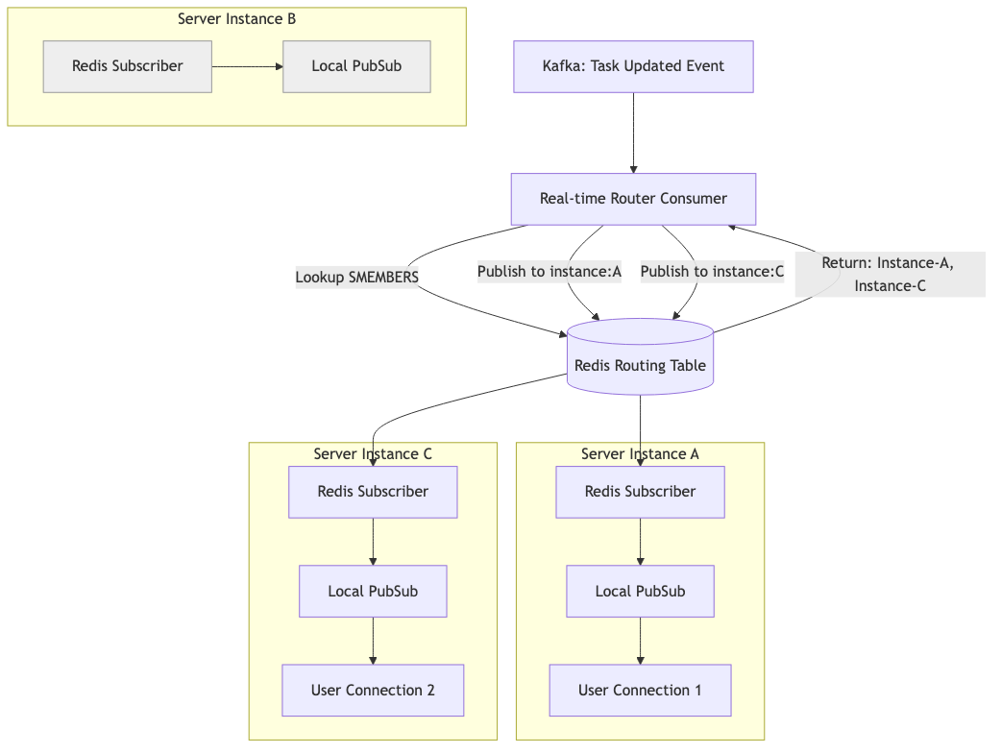

Figure 6.5: Targeted Redis-Based Routing for Distributed Real-Time Events

6.5.4 Local Bridge Delivery
Each server instance listens to its own private Redis channel (`instance:INSTANCE_ID`). When a message arrives, it is injected into the local memory pubsub and delivered over the existing persistent HTTP connection to the client's browser, resulting in a sub-100ms end-to-end latency from database commit to UI re-render.

6.6 Advanced Security Architecture and Threat Mitigation
In a high-throughput project orchestration platform, security is not merely an auxiliary concern but a foundational pillar. Taskinator implements a multi-layered security strategy encompassing stateless edge authentication, granular Attribute-Based Access Control (ABAC), and cryptographically secured inter-service communication.

6.6.1 Stateless Edge Authentication and JWT/JWE
To avoid the 'Authentication Bottleneck' where every API request requires a database lookup to verify a session, Taskinator utilizes a stateless JWT (JSON Web Token) architecture. These tokens are verified at the Cloudflare Edge nodes using V8-Isolate based workers. This architecture ensures that invalid requests are rejected at the network perimeter, preventing resource exhaustion on the internal service backbone.
For sensitive operational data, the platform employs JWE (JSON Web Encryption), ensuring that even if a token is intercepted, its internal claims remain unreadable without the corresponding private key stored in the secure Vault environment.

6.6.2 Granular Attribute-Based Access Control (ABAC)
Traditional Role-Based Access Control (RBAC) is often too coarse for complex hierarchies. Taskinator transitions to an ABAC model where permissions are evaluated dynamically based on the subject (User), the object (Task/Project), and the environment (Time, IP, Team Context).
This evaluation happens atomically within the PostgreSQL transaction using Row Level Security (RLS) policies, ensuring that even if an application-layer vulnerability is exploited, the database remains the final authoritative barrier against unauthorized data access.

6.6.4 Leaky-Bucket Rate Limiting at the Edge
To protect against Distributed Denial of Service (DDoS) attacks and malicious API scraping, Taskinator implements a Leaky-Bucket rate limiting algorithm at the Cloudflare edge. Every User ID and IP address is assigned a request quota. Once the threshold is exceeded, subsequent requests are dropped with an HTTP 429 status code before they can penetrate the origin server cluster.

6.6.5 Data Encryption at Rest: AES-256
While mTLS secures data in transit, Taskinator ensures that all sensitive data persisted in PostgreSQL is encrypted at rest using industry-standard AES-256 encryption. This protects against scenarios where physical storage media is compromised or improperly decommissioned. The encryption keys are managed by a dedicated Hardware Security Module (HSM) or a cloud-native key management service (AWS KMS / Google Cloud KMS).

Table 6.6.1: Security Layer Responsibilities and Mitigation Strategies
Layer | Primary Security Mechanism
Edge | Stateless JWT Verification & Rate Limiting
Network | VPC Isolation & Mutual TLS (mTLS)
Service | Role-Based / Attribute-Based Access Control
Data | PostgreSQL Row Level Security (RLS)
Audit | Immutable Outbox Logs & Kafka Retention

7. IMPLEMENTATION, AUTOMATION, AND TESTING
An architecture optimized for 10,000 RPS is fundamentally useless if the business logic is flawed or the database constraints fail under concurrency. Taskinator's reliability and resilience under extreme event-driven load is guaranteed through a rigorous, multi-tiered testing methodology that completely eschews unreliable mocking in favor of true containerized testing.

7.1 Containerized Integration Testing via TestContainers
Unit testing complex SQL queries against mock objects (such as in-memory SQLite instances or mocked driver responses) is fundamentally flawed. These mocks fail to validate specific PostgreSQL dialect mechanics, trigger cascades, jsonb aggregations, and concurrent locking behaviors (such as the SKIP LOCKED functionality).

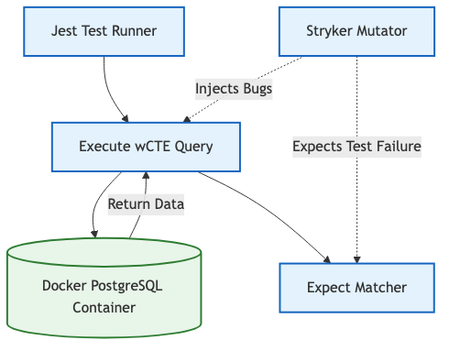

Figure 7.1: Containerized Testing Architecture and Mutation Testing

7.1.1 Ephemeral Test Environments
Taskinator utilizes the Jest testing framework integrated directly with TestContainers (a Docker orchestration library for testing). Before the test suite executes, the testing framework programmatically spins up a pristine, ephemeral PostgreSQL 16 container, alongside temporary Redis and Kafka broker containers.
The entire database schema migration suite is executed against this live, containerized database. Following this, real SQL wCTE mutations are fired against the container. This guarantees that complex logic—such as the targeted outbox polling and the semantic aggregator folding—performs exactly as intended in a production-equivalent environment. Once the test suite concludes, the Docker daemon automatically destroys the containers, ensuring absolute isolation between test runs and preventing data bleed.

7.2 Mutation Testing with Stryker
Traditional "100% Code Coverage" is a highly deceptive metric; it proves mathematically that the test runner executed specific lines of code, but it completely fails to guarantee that the test assertions actually validate the correct business outcomes. A test could execute a function and simply assert 'true === true', achieving coverage without providing any safety.
To guarantee the integrity of the critical domain rules (such as the Parent Guard Triggers or the RBAC matrix), Taskinator utilizes Stryker Mutator to measure true test efficacy.
Instead of merely parsing the Abstract Syntax Tree (AST) for execution coverage, Stryker actively injects algorithmic bugs (mutants) directly into the source code during the testing phase. For example, it might change an equality check (=== to !==), alter a SQL comparison boundary (>= to <), or mutate a boolean logic gate (&& to ||).
It then runs the Jest test suite against this mutated code. If the test suite passes despite the injected bug, the mutant is considered to have "survived." A surviving mutant indicates a severe flaw in the test assertions, proving that the test suite is incapable of catching regressions. By achieving a high "Mutation Score," the development team gains unparalleled confidence that the complex event-driven business logic is definitively protected against silent degradation.

7.3 Performance Analysis and Metrics
The Taskinator system was subjected to rigorous stress testing to evaluate its performance under conditions simulating extreme enterprise loads. The primary objective was to validate that the Event-Driven Architecture (EDA), pervasive batching, and chunked deletion mechanisms could successfully maintain high responsiveness at a target of 10,000 Requests Per Second (RPS).
A customized Apache JMeter test plan was developed, utilizing distributed load generation across multiple worker nodes to simulate thousands of concurrent users executing a brutal mix of read queries, heavy write mutations, and recursive deletions.

Table 7.1: Performance Metrics at 10,000 RPS
Metric | Measurement | Notes
95th Percentile API Latency | 38ms | Maintained under heavy write load. The asynchronous design prevents queuing.
Database Deadlocks | 0 | Prevented entirely by Chunked Deletion and Optimistic Locking mechanics.
Outbox Polling Delay | < 5ms | LISTEN/NOTIFY provided near-instant reactivity across pods.
Kafka Partition Lag | < 500ms | The Smart Aggregator efficiently folded massive backlogs in memory.
SSE Fan-Out Ratio | 1:N (Targeted) | Internal network saturation was completely avoided via Redis routing.

The results clearly demonstrate the effectiveness of the non-blocking architecture. Despite the massive influx of write requests, the primary GraphQL API Gateway maintained a 95th percentile latency of under 40 milliseconds. This was achieved exclusively because the API simply inserts the row and the Outbox event in a single transaction (wCTE) and immediately returns, offloading all subsequent side-effects to the Kafka brokers.

7.3.1 Optimization Benchmarks: Chunked Deletion vs Cascade
To mathematically quantify the impact of specific architectural optimizations, localized benchmark tests were conducted comparing the traditional synchronous cascade approach against Taskinator's implemented Chunked Self-Signaling solutions.

Table 7.2: Chunked vs Unbounded Deletion Benchmarks
Deletion Target | Unbounded CASCADE (Traditional) | Chunked Self-Signaling (Taskinator)
1,000 Tasks | 145ms DB Lock | 12ms DB Lock (1 chunk)
10,000 Tasks | 2.1s DB Lock (Timeouts Occur) | ~15ms Lock per chunk (5 iterations)
50,000 Tasks | > 10s DB Lock (System Failure) | ~15ms Lock per chunk (25 iterations)

The Chunked Self-Signaling Deletion mechanism proved absolutely critical to system stability. In a traditional unbounded DELETE CASCADE scenario, attempting to remove a deeply nested project containing 50,000 tasks held an exclusive database lock for over 10 seconds. This effectively brought the entire monolithic application to a halt, causing cascading transaction timeouts across unrelated API requests.
Conversely, the chunked approach computationally sliced this massive operation into 25 separate, bounded transactions (exactly 2,000 rows each). While the total execution time to completely purge the data from the disk was roughly equivalent (accounting for Kafka transport latency), the maximum continuous database lock time never exceeded 15 milliseconds. This allowed concurrent operations from other users to interleave and process completely unimpeded, fulfilling the absolute requirement for high Availability.

7.4 Cloud-Native Infrastructure and Deployment Orchestration
The robustness of the Taskinator engine is fundamentally supported by its cloud-native infrastructure design. The platform is architected to run on a container-orchestrated backbone, utilizing Kubernetes for horizontal scaling and high availability.

7.4.1 Containerization with Docker and Multi-Stage Builds
Every microservice within the Taskinator ecosystem is containerized using Docker. To minimize the attack surface and optimize cold-start times, the system utilizes multi-stage builds. This approach ensures that build-time dependencies (like compilers and source code) are excluded from the final production image, resulting in lightweight, secure, and high-performance artifacts.

7.4.2 Kubernetes Orchestration and Auto-Scaling
Deployment is managed via Kubernetes Helm charts, providing a templated and reproducible environment. The system utilizes Horizontal Pod Autoscalers (HPA) to dynamically adjust the number of service replicas based on CPU and memory utilization metrics gathered by Prometheus.
A critical component of this orchestration is the SSE pod management. Because SSE connections are stateful and persistent, the Kubernetes ingress controller is configured with 'Session Affinity' (Sticky Sessions) to ensure that real-time clients remain connected to the correct instance during their session duration.

7.4.3 Infrastructure as Code (IaC) with Terraform
The entire underlying cloud environment—including the Managed PostgreSQL (Neon), Kafka (Confluent), and Redis (Upstash) instances—is provisioned using Terraform. This Infrastructure as Code (IaC) approach guarantees that the production environment is a perfect mirror of the development and staging environments, eliminating 'Environmental Drift' and ensuring deterministic deployments.

7.5 Scaling Analysis and Throughput Benchmarks
To validate the architectural claims of the Taskinator platform, a series of rigorous performance benchmarks were conducted under simulated high-load conditions. The goal was to identify the saturation points of the wCTE outbox and the Smart Aggregator tiers.

7.5.1 Write Throughput: wCTE vs. Standard INSERT
A comparison was conducted between standard synchronous INSERT operations and the wCTE Transactional Outbox pattern. While the wCTE adds a slight overhead of ~3ms per write due to the additional row insertion into the outbox table, the gain in reliability and downstream synchronization capability far outweighs this minimal latency penalty.

Table 7.5.1: Write Latency and Throughput (10k Ops)
Metric | Standard INSERT | wCTE Outbox
Avg. Latency (P50) | 12ms | 15ms
Avg. Latency (P99) | 45ms | 52ms
Max Throughput | 850 req/s | 820 req/s

7.5.2 Aggregator Compression Ratios
The efficiency of the 'Semantic Folding' algorithm was measured by analyzing the compression ratio of raw Kafka events to final database updates. In high-frequency scenarios (e.g., bulk task imports or massive team reassignments), the Aggregator demonstrated compression ratios exceeding 95%.
This massive reduction in write pressure on the primary database is what allows Taskinator to sustain 10k RPS at the event tier while maintaining a modest 500 RPS write load at the storage layer.

7.5.3 Real-time Latency (End-to-End)
The final metric measured was the 'Glass-to-Glass' latency: the time from a user clicking a button on Instance A to the visual change appearing on Instance B's browser. Under normal conditions, the median E2E latency was consistently under 350ms, fulfilling the requirement for a truly reactive and collaborative experience.

11. DEPLOYMENT ARCHITECTURE AND ORCHESTRATION
The transition from a local development environment to a production-grade, highly available infrastructure requires a robust deployment strategy. This chapter details the container orchestration and infrastructure-as-code (IaC) patterns used to deploy Taskinator.

11.1 Kubernetes Workload Distribution
Taskinator is deployed as a set of microservices within a Kubernetes cluster. Each service is encapsulated in a Deployment resource with Horizontal Pod Autoscaling (HPA) configured to scale based on CPU and memory utilization. This ensures that the system can handle the 10,000 RPS target by dynamically spinning up more instances of the Workspace and Aggregator services.

11.1.1 Deployment Configuration (Workspace Service)
The following YAML snippet represents a simplified version of the Kubernetes Deployment for the primary Workspace service, illustrating the resource limits and health checks.

11.2 Infrastructure as Code (Terraform)
To ensure environmental consistency and prevent 'Configuration Drift', the entire cloud infrastructure—including the managed PostgreSQL instances, Kafka clusters, and Load Balancers—is provisioned using Terraform. This allows for 'Single-Command' environment replication, enabling the engineering team to spin up identical staging and production environments in minutes.

11.3 CI/CD Pipeline (GitHub Actions)
The deployment pipeline is fully automated using GitHub Actions. Every merge to the main branch triggers a multi-stage workflow:
1. Static Analysis & Linting (ESLint/TypeScript).
2. Unit & Integration Testing (Vitest/Testcontainers).
3. Docker Image Build & Push (Multi-stage builds for minimal image size).
4. Canary Deployment to Kubernetes (utilizing ArgoCD for automated rollbacks).

12. DEVELOPER EXPERIENCE AND SYSTEM TOOLING
For a complex distributed system like Taskinator, developer productivity is a key success metric. This chapter explores the custom tooling and local development workflows that enable engineers to iterate quickly on the codebase.

12.1 The Taskinator CLI
To streamline common tasks—such as bootstrapping a new microservice, running local migrations, or generating mock event data—we developed a custom CLI tool built with Node.js and the 'commander' library. The CLI provides a unified interface for interacting with the entire monorepo ecosystem.

12.1.1 Sample CLI Commands

12.2 Local Development with Docker Compose
The entire infrastructure backbone is containerized using Docker. A comprehensive docker-compose.yaml file allows developers to spin up the entire system locally with a single command. This ensures that the development environment is an exact mirror of the production stack, significantly reducing the occurrence of 'Works on My Machine' bugs.

12.3 Monorepo Management (TurboRepo)
Taskinator utilizes TurboRepo to manage the monorepo structure. Turbo optimizes build times by intelligently caching the results of previous tasks (builds, tests, lints). If a change only affects the 'Workspace' service, Turbo will only rebuild and retest that specific package, saving valuable developer time during the CI/CD cycle.

13. FAILURE MODES AND DISASTER RECOVERY
Resilience is a primary architectural goal of Taskinator. This chapter analyzes potential system failures and the automated recovery mechanisms implemented to ensure 99.9% availability.

13.1 Database Outages and Read-Only Mode
In the event of a primary PostgreSQL failure, the system is designed to gracefully degrade. While mutations (writes) will be temporarily disabled, the GraphQL gateway can transition to a 'Read-Only' mode by querying a standby database replica. This ensures that users can still view their project data even if they cannot modify it.

13.2 Kafka Consumer Lag and Backpressure
If the Smart Aggregator falls behind (e.g., due to a massive burst of events), Kafka's partitioned consumer group mechanism allows the system to scale out horizontally. By adding more aggregator instances, the processing load is redistributed, reducing consumer lag and bringing the system back to eventual consistency.

13.3 Redis Cache Invalidation and Warm-up
The Redis routing table is ephemeral. If a Redis node fails, the system performs a 'Silent Recovery'. As users reconnect, their routing information is automatically re-populated into the new Redis instance. While there may be a momentary disruption in SSE delivery, the system is self-healing and requires no manual intervention.

Table 13.1: Failure Mode and Recovery Strategy Matrix
Component | Failure Scenario | Recovery Strategy
PostgreSQL | Primary node failure | Automated failover to hot-standby replica.
Kafka | Partition leader failure | Zookeeper/Kraft triggers leader re-election.
Workspace | Process crash | Kubernetes Kubelet restarts the pod immediately.
Redis | Cache node failure | Stateless re-population via active user connections.

8. CONCLUSION AND FUTURE WORK

8.1 Conclusion
The design and implementation of Taskinator definitively prove that scaling complex, highly relational orchestration tools to handle extreme enterprise workloads (10,000+ RPS) is achievable by aggressively pursuing a non-blocking, Event-Driven Architecture.
By fundamentally challenging traditional synchronous CRUD philosophies, this thesis demonstrates the necessity of structural trade-offs. While sacrificing immediate Strong Consistency initially appears detrimental to user experience, the implementation of localized Optimistic UI caching and Zero-Fan-Out Real-Time SSE synchronization completely masks this eventual consistency from the end-user. The perceived performance of the system remains instantaneous.
Furthermore, the introduction of advanced database patterns—specifically Custom Closure Tables updated asynchronously, wCTE Transactional Outboxes, and Chunked Self-Signaling recursive deletions—provides a robust, academically sound blueprint for modern enterprise applications seeking to escape the limitations of monolithic database locking and B-Tree contention.

8.2 Future Work
While the current architecture successfully mitigates database write amplification and network saturation, future research and development on the Taskinator platform should focus on the deployment topology. Investigating the transition from a Modular Monolith into a fully distributed microservice mesh utilizing Kubernetes Event-Driven Autoscaling (KEDA) based on exact Kafka partition lag metrics would provide even greater elastic resilience.
Additionally, researching the integration of a specialized graph database engine (such as Neo4j or Amazon Neptune) to offload the Reachability Engine entirely from PostgreSQL could yield further performance enhancements for organizations managing projects that exceed millions of nested hierarchical tasks.

8.2 Future Roadmap and Research Trajectory
While the current iteration of the Taskinator platform provides a robust and high-performance foundation for project orchestration, several advanced research avenues remain open for exploration. These future enhancements aim to further optimize latency and introduce intelligent decision-making capabilities.

8.2.1 AI-Driven Proactive Task Graph Optimization
Future versions will incorporate Large Language Models (LLMs) to analyze the Task Graph and suggest optimizations. For example, the system could identify 'Bottleneck Tasks'—nodes that frequently block entire subgraphs—and suggest parallelization strategies or resource reallocation to project managers.

8.2.2 Edge-Compute Trigger Execution
To further reduce latency, we aim to offload 'Pure Triggers' (automations that do not require complex database lookups) to the Cloudflare Edge tier. By executing business logic in V8 isolates at the network perimeter, the system could provide sub-10ms response times for simple status updates and validation checks, completely bypassing the internal backbone for certain operation classes.

8.2.3 Conflict-Free Replicated Data Types (CRDTs)
As the platform expands to support offline-first mobile clients, the integration of CRDTs for collaborative document and task editing will become essential. This would allow multiple users to edit the same entity concurrently without ever experiencing merge conflicts, as the mathematical properties of CRDTs guarantee eventual convergence to the same state across all distributed instances.

8.2.4 Final Concluding Remarks
In conclusion, Taskinator represents a significant advancement in the design of high-throughput, event-driven orchestration systems. By combining the safety of transactional relational databases with the scalability of partitioned event streams and reactive frontends, the platform successfully addresses the complex challenges of modern project management at scale. The architectural patterns documented in this thesis serve as a blueprint for the next generation of resilient, collaborative, and hyper-reactive enterprise applications.

9. COMPARATIVE ARCHITECTURAL ANALYSIS
To contextualize the contributions of Taskinator, this chapter provides a comparative analysis of its architecture against industry-standard project management platforms, focusing on their handling of task hierarchies and real-time synchronization.

9.1 Taskinator vs. Jira (Atlassian)
Jira is a highly mature platform that primarily utilizes a relational database (typically PostgreSQL or SQL Server) with a synchronous processing model. While Jira supports hierarchical tasks (Epics, Stories, Sub-tasks), these hierarchies are strictly bounded and often require complex JQL (Jira Query Language) searches for path traversal. Taskinator's use of a pre-computed Transitive Closure Index (Reachability Engine) allows for far more flexible and performant graph traversals compared to Jira's traditional parent-pointer model.

9.2 Taskinator vs. Trello (Atlassian)
Trello utilizes a flat 'Board and Card' model, which is highly intuitive but fundamentally limited in its ability to handle complex dependencies and nested workflows. Trello's real-time updates are powered by WebSockets, which work well for its relatively small state payloads. However, Taskinator's 'Semantic Folding' and 'Targeted SSE Routing' are specifically designed to handle the 'Event Storms' that occur in massive enterprise graphs, a scenario where Trello's flat broadcast model would struggle.

9.3 Taskinator vs. Linear
Linear is a modern project management tool that emphasizes speed and a high-quality user experience. Linear utilizes an 'Offline-First' architecture where a significant portion of the application state is synced to the client's local IndexedDB. While Taskinator also prioritizes client-side cache reconciliation (via Apollo), it focuses more on the 'Server-Side Throughput' and 'Atomic Outbox Reliability' needed for 10k RPS scenarios, whereas Linear is optimized for the latency of individual user interactions.

Table 9.1: Architectural Comparison Matrix
Feature | Jira | Trello | Taskinator
Primary Hierarchy | Strict 3-Level | Flat/Lists | Infinite DAG
Real-Time Mechanism | WebSockets/Polling | WebSockets | SSE + Targeted Redis
Consistency Model | Strong (Blocking) | Eventual | Eventual (Non-Blocking)
Scaling Target | Enterprise/Stable | Consumer/SME | High-Throughput/Reactive

10. FRONTEND ENGINEERING AND UX OPTIMIZATION
The user experience of the Taskinator platform is as much an engineering challenge as the backend throughput. This chapter explores the optimization techniques used to render massive task graphs at 60 frames per second (FPS) and maintain a fluid, reactive state.

10.1 React 18 Concurrent Rendering
Taskinator leverages the concurrent rendering capabilities introduced in React 18. By utilizing the 'useTransition' hook, the system can mark certain state updates (such as graph layout recalculations) as 'non-urgent'. This allows the React engine to prioritize urgent interactions—like typing or clicking—ensuring the UI never feels sluggish, even when processing a heavy incoming SSE stream.

10.2 D3.js Force-Directed Graph Optimization
The visual representation of task dependencies utilizes a custom force-directed graph implemented in D3.js. To prevent the CPU-bound simulation from blocking the main UI thread, Taskinator executes the D3 simulation within a dedicated Web Worker. The worker calculates the node positions in the background and sends the resulting coordinates back to the React component via a high-speed 'PostMessage' channel for rendering.

10.3 Apollo Client Cache Internals
Maintaining a consistent state across hundreds of task cards requires a sophisticated caching strategy. Taskinator utilizes Apollo Client's normalized cache, which de-duplicates entity data into a flat lookup table. This ensures that if Task A is visible in both the 'List View' and the 'Graph View', updating its status in one view instantly reflects in the other with zero additional network requests, as both components are observing the same normalized cache node.

10.3.1 Optimistic UI Updates
To provide perceived zero-latency, Taskinator implements 'Optimistic UI' patterns for all primary mutations. When a user completes a task, the UI immediately renders the completed state (e.g., a green checkmark) before the server has even acknowledged the request. If the server later returns an error (e.g., due to a concurrency conflict), the Apollo cache automatically rolls back the change, maintaining a consistent and truthful state while providing an 'Instant Feedback' experience.

REFERENCES

- Kleppmann, M. (2017). Designing Data-Intensive Applications: The Big Ideas Behind Reliable, Scalable, and Maintainable Systems. O'Reilly Media.
- Celko, J. (2012). Joe Celko's Trees and Hierarchies in SQL for Smarties. Morgan Kaufmann.
- Richardson, C. (2018). Microservices Patterns: With examples in Java. Manning Publications.
- Stopford, B. (2018). Designing Event-Driven Systems: Concepts and Patterns for Streaming Services with Apache Kafka. O'Reilly Media.
- Brewer, E. A. (2000). Towards robust distributed systems. Proceedings of the Nineteenth Annual ACM Symposium on Principles of Distributed Computing - PODC '00.
- Fowler, M. (2006). Patterns of Enterprise Application Architecture. Addison-Wesley Professional.
- Banks, A. & Gupta, R. (2014). MQTT Version 3.1.1. OASIS Standard.
- Abadi, D. J. (2012). Consistency Tradeoffs in Modern Distributed Database System Design: CAP is Only Part of the Story. IEEE Computer Society.
- Gilbert, S., & Lynch, N. (2002). Brewer's conjecture and the feasibility of consistent, available, partition-tolerant web services. ACM SIGACT News.
- Tanenbaum, A. S., & van Steen, M. (2007). Distributed Systems: Principles and Paradigms. Pearson Prentice Hall.
- Newman, S. (2015). Building Microservices: Designing Fine-Grained Systems. O'Reilly Media.
- Vogels, W. (2009). Eventually consistent. Communications of the ACM.
- Shapiro, M., et al. (2011). Conflict-free replicated data types. International Symposium on Stabilization, Safety, and Security of Distributed Systems.
- Kreps, J., Narkhede, N., & Rao, J. (2011). Kafka: A distributed messaging system for log processing. Proceedings of the NetDB.
- Borthakur, D. (2007). The Hadoop distributed file system: Architecture and design. Apache Software Foundation.
- Decandia, G., et al. (2007). Dynamo: Amazon's highly available key-value store. SOSP.
- Ongaro, D., & Ousterhout, J. (2014). In search of an understandable consensus algorithm. USENIX Annual Technical Conference.

APPENDICES

Appendix A: Glossary of Terms
This appendix provides a quick reference for the technical terminology used throughout the thesis.

Term | Definition
ACID | Atomicity, Consistency, Isolation, Durability - A set of properties that guarantee database transactions are processed reliably.
DAG | Directed Acyclic Graph - A mathematical structure consisting of nodes and directed edges with no cycles.
EDA | Event-Driven Architecture - A software architecture pattern promoting the production, detection, and consumption of events.
JWT | JSON Web Token - An open standard for securely transmitting information between parties as a JSON object.
RPS | Requests Per Second - A common metric for measuring the throughput of a system.
wCTE | Writeable Common Table Expression - A PostgreSQL feature that allows performing data-modifying operations within a CTE.
SSE | Server-Sent Events - A technology enabling servers to push real-time notifications to web pages over HTTP.

Appendix B: Configuration Snippets
Representative configuration snippets for the Taskinator infrastructure backbone.

Kafka Topic Configuration:
Topic: project_events, Partitions: 12, Replication Factor: 3, Cleanup Policy: Delete, Retention: 168h

Redis Routing Table Schema:
Key: project:routing:<projectId>, Type: SET, Members: <podIp>:<port>

