# Graded homework 09 – Fibonacci matrix **Team-Berger-Nussbaum**

**1) Prove Matrix equality by induction on n**

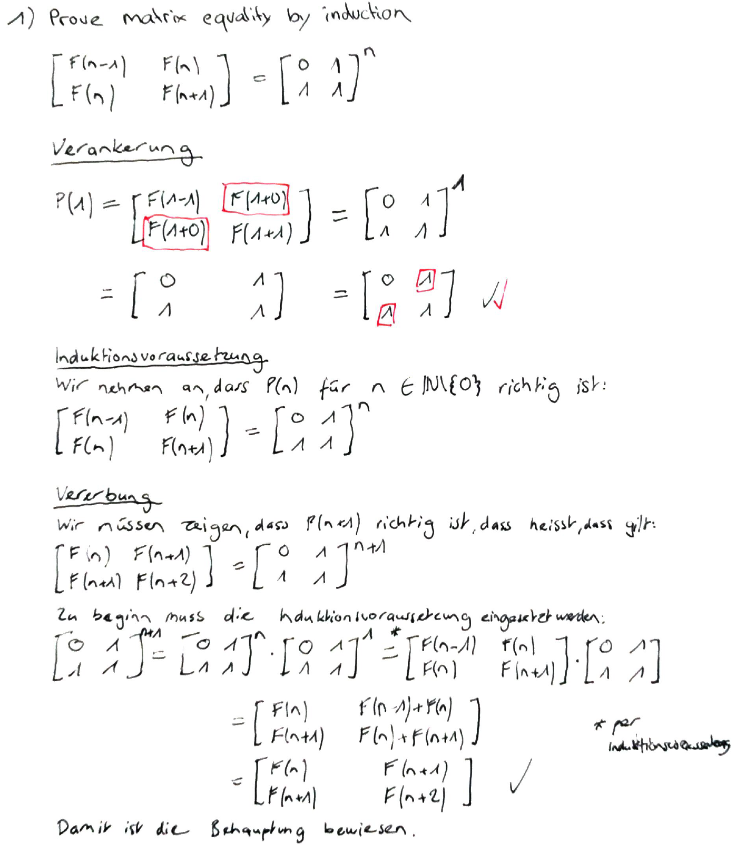

**2) Progam matrix-based calculation**

See in folder «code» OR  
<https://github.com/kucki10/BTI7062-Algorithms-and-DataStructures/tree/master/09-homework/Algorithms>

**3) Print functional graph**

Execute the application, or have a look at the following image (Sample)

**NOTE: There is only the linear reference line, because we just realized that the complexity is linear.**

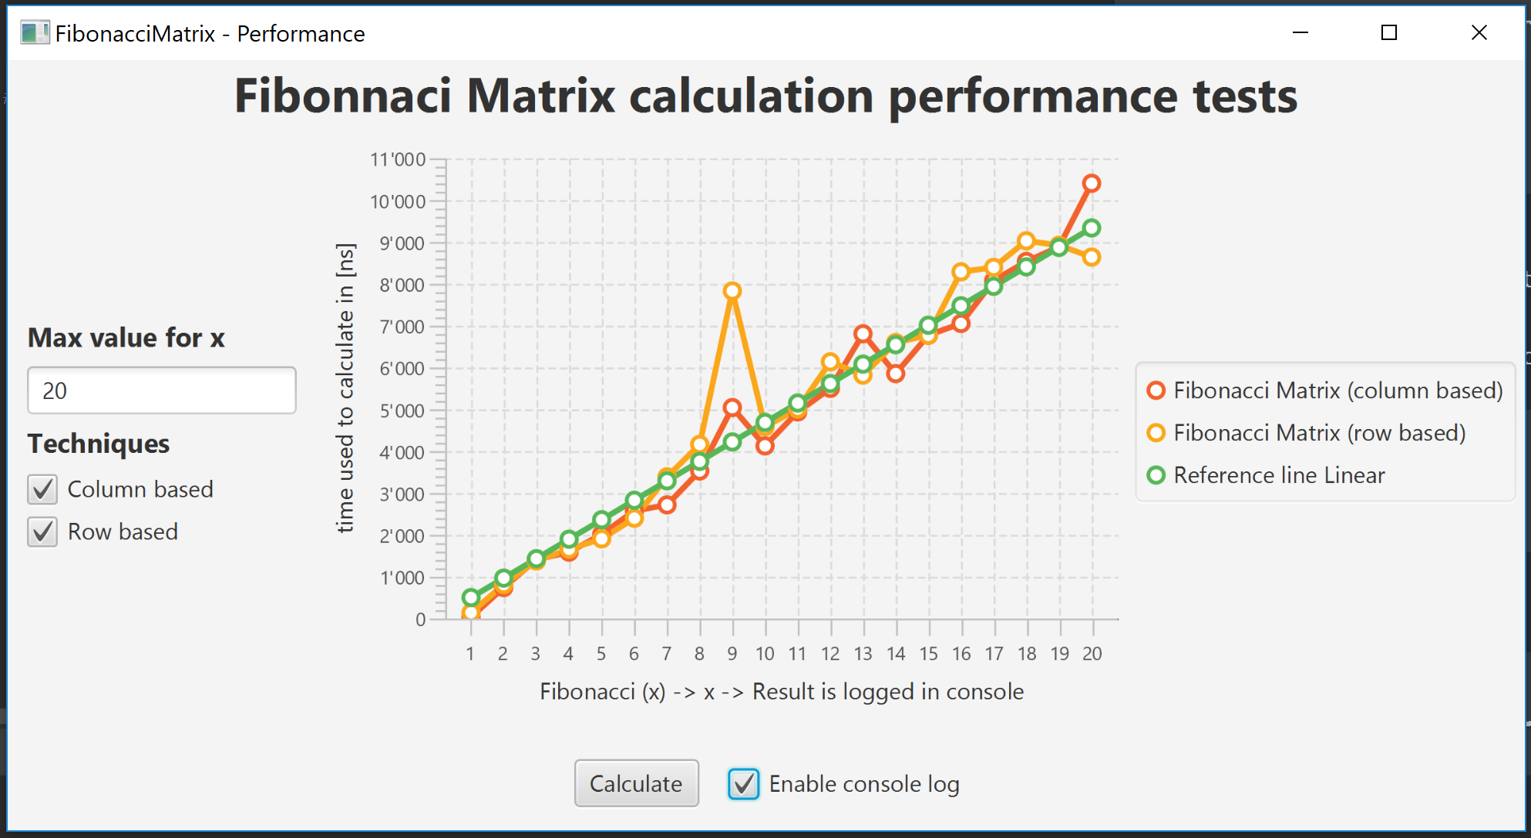

**4) Determine the time complexity**

The complexity is linear. Explanations are documented here:

<https://github.com/kucki10/BTI7062-Algorithms-and-DataStructures/tree/master/09-homework/Algorithms#lessons-learned>

**5) Compare complexity with Fibonacci algorithms of introductory lecture**

**Algorithms of introductory lecture**

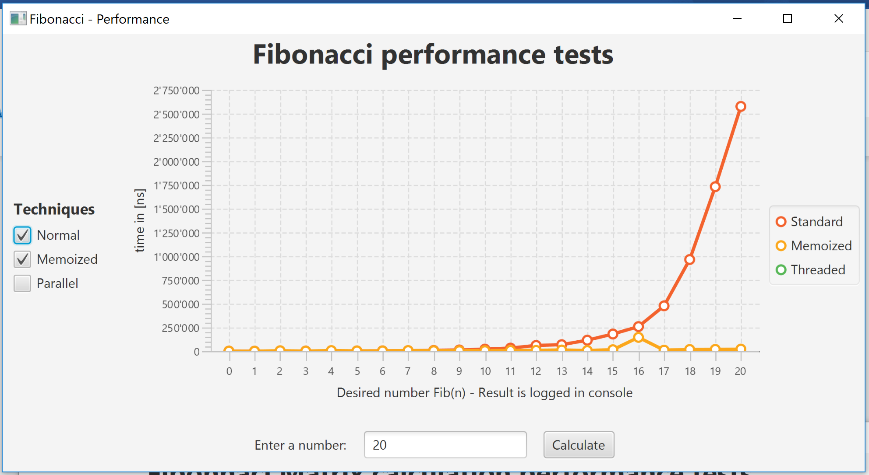

Standard Ө**(n^2)** quadratic  
Memoized Ө**(n)** linear (Steigung = 450)  
Threaded - nicht erkennbar

**Fibonacci matrix** Ө**(n) linear (Steigung = 400 )**

**The winner is the matrix calculated**

**6) Swap column and rows in matrix.**

Explanatios or findings can be found here:

<https://github.com/kucki10/BTI7062-Algorithms-and-DataStructures/tree/master/09-homework/Algorithms#lessons-learned>

Details are available in code.