[Document title]

[Document subtitle]

[School]

[Course title]

1. Develop a PEAS description of the task environment:

|  |  |
| --- | --- |
| (i)  (ii)  (iii)  (iv) | Robot playing soccer. Robot dust collector from classroom. Autonomous mars rover. Part-picking robot |

PEAS stands for Performance measure, Environment, Actuators, Sensors.

1. Robot playing soccer:
   1. Performance Measure: Play the game, score goals, defend opponents, Win the game.
   2. Environment: Soccer, Team, Opponent, Field, Referee
   3. Actuators: Jointed legs
   4. Sensors: camera, joint angle sensors.
2. Robot dust collector from classroom:
   1. Performance Measure: Collect dust from classroom
   2. Environment: Class room, carpet, floor, obstacles, walls.
   3. Actuators: Wheels, vacuum to suck the dust,
   4. Sensors: IR sensors or Ultrasonic sensors, smart dust sensor
3. Autonomous mars rover:
   1. Performance Measure: Collect samples on Mars, analyze it and send the report to the control room on earth.
   2. Environment: Ground of mars, extreme weather condition.
   3. Actuators: All terrain wheels, accelerator, jointed arm and hand to pick up objects, solar recharging facility, battery, body shield.
   4. Sensors: Camera, sonar, IR, information transmission module, Grove- sunlight sensor, [REMS (Rover Environmental Monitoring Station)](https://mars.nasa.gov/msl/spacecraft/instruments/rems/), [RAD (Radiation Assessment Detector)](https://mars.nasa.gov/msl/spacecraft/instruments/rad/), [SAM (Sample Analysis at Mars)](https://mars.nasa.gov/msl/spacecraft/instruments/sam/), [APXS (Alpha Particle X-Ray Spectrometer)](https://mars.nasa.gov/msl/spacecraft/instruments/apxs).
4. Part Picking Robot:
   1. Performance Measure: Percentage of correct part in correct bin.
   2. Environment: Conveyor belt with parts, bins
   3. Actuators: Jointed arm and hand.
   4. Sensors: Camera, joint angle sensors.
5. You are asked to create an “autonomous car”. To create this car, you can choose from  
   either “Model based agent” or “Goal based agent”. Which model will you choose for  
   the above system? Provide comparison to establish facts for your answer.

Answer:

4. Consider the following set of statement:  
(i) Whoever can read is literate  
(ii) Dogs are not literate  
(iii) Some Dogs are intelligent  
(iv) Everyone who is not intelligent is liked by no one  
From the above statements, conclude that “Some who are intelligent cannot read” using  
Resolution.

Answer:

1. Whoever can read is literate -> $∀\left(x\right)[R\left(x\right)⇒L\left(x\right)]$
2. Dogs are not literate -> $∀\left(x\right)\left[D\left(x\right)⇒ ¬L\left(x\right)\right]$
3. Some Dogs are intelligent -> $∃(x)[D\left(x\right)∧I\left(x\right)]$
4. Everyone who is not intelligent is liked by no one -> $∀(x)[¬ I\left(x\right)⟹¬ K\left(x\right)]$

Prove:

Some who are intelligent cannot read -> $∃\left(x\right)[I\left(x\right)⟹R(x)]$

Clause Form:

$¬R\left(x\right)∨L\left(x\right)$

$¬D\left(x\right)∨¬L\left(x\right)$

$D\left(x\right)∨I\left(x\right)$

$I\left(x\right)∨¬ K\left(x\right)$

$D\left(x\right)$

$I(x)$

Prove:

Nil

6. Apply alpha-beta pruning on the following minimax search tree to determine the best  
move for max at the root position. Specify the branches that should be pruned

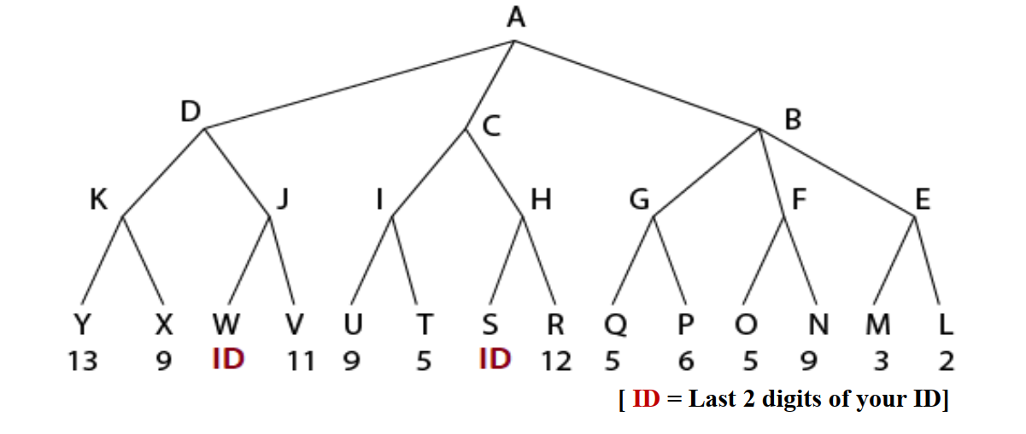

Answer:

Applying alpha beta pruning on the given minmax search tree.

