**Pitch of a winding or winding pitch**

Winding pitch is defined as the distance between two successive conductors which are directly connected together around the armature. It is the beginning of two successive coil sides and is denoted by Y. For lap winding, Y = Yb – Yf and for wave winding, Y = Yb + Yf.

**Back Pitch**

The distance at which a coil advances on the back of the armature is called back pitch, denoted by Yb. It can also be defined as the distance between the first and the last conductors of a coil. It is the same as coil span and is shown in the below figure(a) and (b).

**Front Pitch**

It is the distance between the second conductor of one coil and the first conductor of the next coil. Both the coils should be connected to the same commutator segments on the front, as shown in the figure (a) and (b) below. It is denoted by Yf.

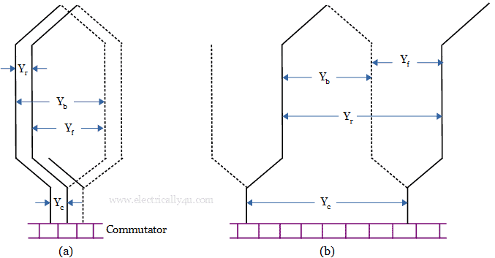Pitch in (a) Lap winding (b) Wave winding