**Magnetic field :**

A magnetic field is a vector field that describes the magnetic influence on moving electric charges, electric currents and magnetic materials. A moving charge in a magnetic field experiences a force perpendicular to its own velocity and to the magnetic field. A permanent magnet′s magnetic field pulls on ferromagnetic materials such as iron, and attracts or repels other magnets.

**Definition of Electric Field Lines:**

An electric field line is an imaginary line or curve drawn through a region of empty space so that its tangent at any point is in the direction of the electric field vector at that point. The relative closeness of the lines at some place gives an idea about the intensity of electric field at that point.

**Properties of Electric Field Lines:**

1. Electric field lines always begin on a positive charge and end on a negative charge, so they do not form closed curves. They do not start or stop in midspace.

2. The number of electric field lines leaving a positive charge or entering a negative charge is proportional to the magnitude of the charge.

3. Electric field lines never intersect.

4. In an uniform electric field, the field lines are straight, parallel and uniformly spaced.

5. The electric field lines can never form closed loops, as line can never start and end on the same charge.

6. These field lines always flow from higher potential to lower potential.

7. If the electric field in a given region of space is zero, electric field lines do not exist.

8. The tangent to a line at any point gives the direction of the electric field at the point. Also, this is the path on which a positive test charge will tend to move if free to do so.

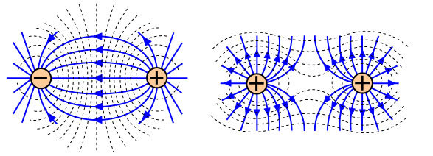

**What is Faraday’s Law**

Faraday’s law of electromagnetic induction (referred to as Faraday’s law) is a basic law of electromagnetism predicting how a magnetic field will interact with an electric circuit to produce an electromotive force (EMF). This phenomenon is known as electromagnetic induction.

**Faraday’s First Law:**

Any change in the magnetic field of a coil of wire will cause an emf to be induced in the coil. This emf induced is called induced emf and if the conductor circuit is closed, the current will also circulate through the circuit and this current is called induced current.

Method to change the magnetic field:

1. By moving a magnet towards or away from the coil

2. By moving the coil into or out of the magnetic field

3. By changing the area of a coil placed in the magnetic field

4. By rotating the coil relative to the magnet

**Faraday’s Second Law:**

It states that the magnitude of emf induced in the coil is equal to the rate of change of flux that linkages with the coil. The flux linkage of the coil is the product of the number of turns in the coil and flux associated with the coil.

**conclusion:** From this experiment, Faraday concluded that whenever there is relative motion between a conductor and a magnetic field, the flux linkage with a coil changes and this change in flux induces a voltage across a coil. ... These laws are called Faraday's laws of electromagnetic induction.

**Generators:**

A generator is a device that converts motive power (mechanical energy) into electrical power for use in an external circuit. The reverse conversion of electrical energy into mechanical energy is done by an electric motor

**AC & DC Generators:**

There are two types of generators, one is ac generator and other is dc generator. Whatever may be the types of generators, it always converts mechanical power to electrical power. An ac generator produces alternating power. A dc generator produces direct power. Both of these generators produce electrical power, based on same fundamental principle of electromagnetic induction. According to this law, when a conductor moves in a magnetic field it cuts magnetic lines force, due to which an EMF is induced in the conductor. The magnitude of this induced EMF depends upon the rate of change of flux (magnetic line force) linkage with the conductor. This EMF will cause an electric current to flow if the conductor circuit is closed.