**GitHub training**

**Exercises**

For these exercises you will need:

* Atom editor <https://atom.io/>
* A Github account <https://github.com/>
* GitHub Desktop <https://desktop.github.com/>

Please download Atom editor prior to GitHub Desktop so you can select Atom as your text editor during the installation procedure.

* Three images (jpeg preferably) that you are happy to show others and describe! (If you can’t access any immediately, just google something interesting and save as a jpeg.)

For more detailed installation instructions refer to the pdf ‘GitHub_training_intro_prior_setup_instructions.pdf’

###############################################################################

If you’ve reached here following the training session/ PowerPoint skip to the next page/ exercise 2…

###############################################################################

**Exercise 1 - ‘Clone my repo!’**

Clone this GitHub training github:

<https://github.com/SBurnard/GitHub_training>

1. Open the ‘Git Bash’ programme.
2. Move to your desktop

cd Desktop

1. Clone the repo

git clone <https://github.com/SBurnard/GitHub_training>

DONE! You’ve now made an exact copy of all this directory and all of it’s files.

1. Go check it out. (And open the exercises doc)

**Exercise 2 - Make you own Repo**

**Aim**: To A) Make you own Repo on GitHub (directly uploaded to GitHub) and B) edit/ modify (via command line)

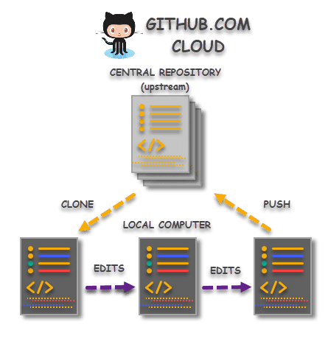

A

B

**A)**

1. 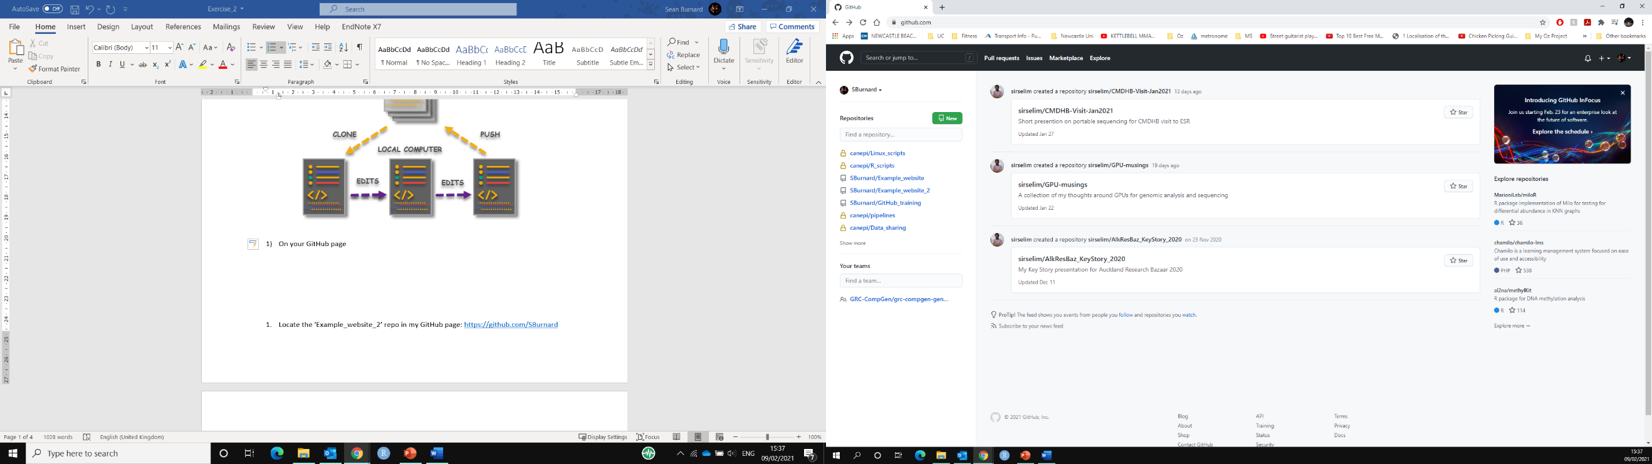On your GitHub webpage click create a new GitHub repo. This can be achieved one of two ways: i) click the top left icon, then to the right of the repositories you’ll see the ‘New’ button. ii) click the top right icon and ‘your profile’ then switch the view to ‘Repositories’ (from ‘Overview’). The same new repo icon will appear on the right of the list.  
     
     
   Name the repo ‘My_GitHub_training’ and click ‘Add a README file’ (it’s always useful to add a readme file so you can instantly see a description of what the directory contains.
2. Now let’s add some files! Copy across all the files from the directory you cloned in exercise 1. HOW? Easiest way… Drag and drop.
3. Under ‘commit changes’ give a brief description/ title
4. Commit changes
5. Notice anything about your README.md file?

**B)**

1. Now we’re going to clone this directory again!  
   copy the weblink to your new repo (ctrl-c)  
   Go to the Git Bash terminal and type:

cd Desktop  
git clone <web_link_to_your_new_repo>  
i.e. Git clone <https://github.com/SBurnard/My_GitHub_training>

1. Open ‘Atom’ (text editor)
2. Drag and drop the folder ‘My_GitHub_training’ into Atom.   
   The folder and it’s contents should now appear on the left hand panel
3. Click on the readme file.
4. Add the two following lines onto lines 18 and 19 (including the hashtags)  
   ## My favourite animal: Hawk

### I like because: it was my school 'house' animal (no, I didn't go to Hogwarts)

Now, replace Hawk and the reason why you like it with your own! 😊

1. Save the file (ctr-s)
2. Go back to the bash terminal and cd into the cloned directory

cd My_GitHub_training

1. Check the status of any modifications by git  
   git status  
   Notice any modifications? Git has tracked these changes in the folder by they are yet to be committed (locally)  
   But first we need to add, then commit these changes!

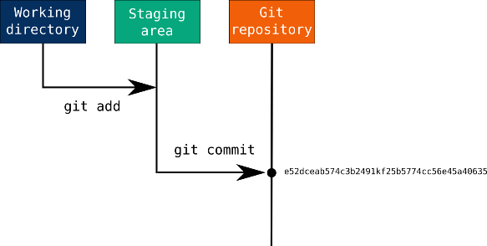

1. To ‘add’ the changes we can either add the specified file or add ALL files/ changes. Choose either option:

git add README.md  
Or  
git add --all  
(use git add all with caution…. You can add unwanted changes…)

1. Check the status again (to compare to the difference)
2. Then commit. With a message (optional)

git commit  
OR (preferably). N.B type this in, rather than copy and pasting)  
git commit -m “editing README.md to disseminate info on my favourite animal”

1. Did it work? Nope. You need to tell git who you are to commit changes to be pushed… To clone you don’t! But to commit and push you need to so other know who has made and suggested these changes…. (yes. Even to your own repo via the command line…) Therefore, follow the prompts:  
   git config --global user.email "myemail@real.com”  
   git config --global user.name "my_name”
2. Then try committing the file again! It should work. 😊
3. Push changes to GitHub   
   git push  
   Follow the initial prompts to access your credentials (this will only need to be done this once…)
4. Now go look at your GitHub repo. Has your edit appeared?!

**Exercise 3 - Find a friend!**

Find and follow each other. Three ‘easy’ methods:

1) use the search bar and click user.

2) type users:<name> directly in the search bar

3) Ask your friend their username and type github.com/<Their_User_Name>

What Exactly Is GitHub Anyway? | TechCrunchWhat Exactly Is GitHub Anyway? | TechCrunchWhat Exactly Is GitHub Anyway? | TechCrunchWhat Exactly Is GitHub Anyway? | TechCrunchWhat Exactly Is GitHub Anyway? | TechCrunchAnd… Most importantly what was their favourite animal?! :D   
(Go search their public repos)

**Exercise 4 - A) Fork, B) edit and C) upload your own website!   
(via GitHub desktop and GitHub.com)**

**A)**

1. Locate the ‘Example_website_2’ repo in my GitHub page: <https://github.com/SBurnard>
2. ‘Fork’ this repo to your own account (upper right screen)

**B)**

1. ‘Clone’ to your desktop, via GitHub desktop (open the app):
   1. Click the arrow next to ‘current repository’.
   2. Add
   3. Clone repository…
   4. Either ‘filter for your repositories’ or use the ‘url’ to your repo!  
       i.e. https://github.com/<your.user.name>/Example_website_2
   5. Choose your local path (where to download it to)
   6. ‘Clone’ and wait!
2. Open this repo on the left bar.
3. Click ‘show in Explorer’. Have a look around. Double click on some of the html files!
4. Click ‘Open in Atom’. Have a look at the directories in the left bar and view the html and text files. You’re now actually seeing what’s ‘underneath’ the html files
5. Delete (or move) the three images pic02-04 in the directory /images/ via file explorer.
6. Locate your images, and change the name of your image names to:  
   pic02.jpg, pic03.jpg and pic04.jpg
7. Move or copy these renamed images into the ‘images’ directory.
8. Now to edit the webpage writing!
   1. Click back onto Atom
   2. We’re going to now the ‘index.html’ file which contains the main code that creates the webpage. Notice the different colours that are autogenerated by atom, which depends on the command being used. These can be changed, but the default setting in Atom have been made to work with GitHub, html, python and other types of code. 😊
   3. Look out for the light gray code - these are notes, similar to those in R when using the hashtag #. But in HTML, these are wrapped with <!-- personal comment not displayed on webpage -->
   4. On line 9, write you name (removing < >)
   5. Now we’re going to write titles and a brief description for the three images you’ve chosen (and recently renamed).  
      I’ve written a comment beside each of these, but for ease you can refer to the line numbers each of these are located. N.B. replace the white text, between the flags that are encased with arrow heads <>. A simple image header and interesting image description will suffice! We will share these with everyone at the end. 😊

~~62 Image_2 File~~  
68 Image_2 Title  
73 Image_2 Description  
~~86 Image_3 File~~  
89 Image_3 Title  
92 Image_3 Description  
~~102 Image_4 File~~  
105 Image_4 Title  
108 Image_4 Description

* 1. Save these changes (notice any colour changes on Atom?) - either ‘ctrl s’ or file save.

1. We are now read to ‘commit’ then ‘push’ the changes back to your remote repo!

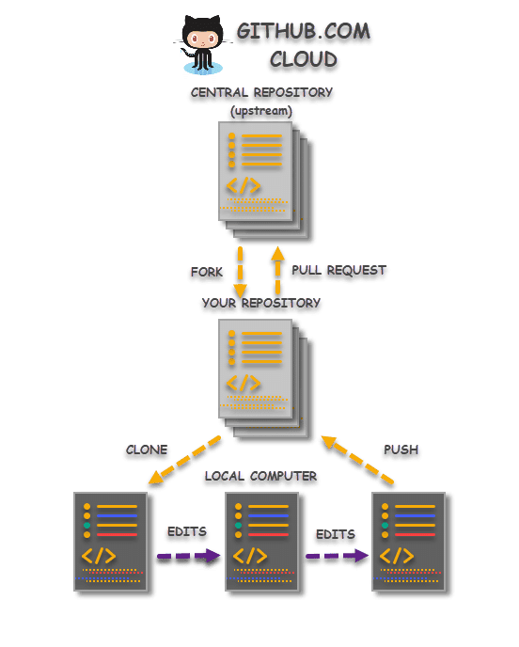

* 1. Close atom (to ensure changes have been saved!)
  2. Click back onto GitHub Desktop - you should now see a screen with green and red lines (with either - or +), on the left of that shows line numbers. This is showing the changes you’ve made.
  3. Before clicking ‘commit to main’ (bottom left) write a title and brief description of the changes, this serves as a reminder as to what you have done. (you can leave this blank though but is a good habit to fill these in with useful info).
  4. Click commit to main. Wait
  5. Now ‘push’ to origin.   
     Either Ctrl P or click ‘push origin’.
  6. Huzzah! These changes have now been sent to your online repo on GitHub!
  7. To confirm - Go to your GitHub repo and refresh. Notice any time-stamp changes on your files?

**C)**

1. Now we want to make our webpage active!
   1. Click on settings in the repo page.
   2. Scroll down to ‘GitHub Pages’
   3. Under ‘Source’ change branch to ‘main’ and save.
   4. Above you should now see a link to your webpage - click it and have a look… (it may take a minute to generate).
2. Awesome! It worked (hopefully). But wait. We’re missing an image next to ‘The future has landed…’. So we’ll fill this in with an image of your favourite animal! Maybe, your spirit animal?!
   1. Google whatever your favourite animal is.
   2. Right click and ‘save as’ jpeg to a location on your computer you can easily access and name it something appropriate such as ‘My_spirit_animal’.
   3. Upload the file into the /images/ directory in the GitHub repo.   
      You have at least three different options to achieve this. What are they? (clue - two are directly via the GitHub website).
   4. Click back to the ‘top level’ of this repo and click on the ‘index.html’ file.  
        
      We’re now going to edit this file from within GitHub and point the circular image to the name of the image file you’ve created.
   5. Click the pen icon at the upper right side of the document on the webpage (when you hover over it, it should say ‘edit this file).
   6. On line 55, change the name of the file that ‘src’ is pointing towards to the name of the file you just uploaded i.e.  
      *<span class="image"><img src="images/pic01.jpg" alt="" /></span>*becomes  
      *<span class="image"><img src="images/My_spirit_animal.jpg" alt="" /></span>*
   7. *Commit those changes (Don’t forget to add some update details)*
3. Now go back to your webpage and refresh. Do you see your animal in the circle now?   
   If you’ve just refreshed the page soon after committing the changes the chances are you won’t see it… It will need a couple of minutes for these changes to then be pushed onto your webpage. Don’t worry, this happens automatically. Just come back to it in a couple more minutes, and, voila! 😊 Your own personal page has landed!

Congratulations on making your own website and learning some of the fundamentals of Git and GitHub!! ^^